BIOMECHANICS STUDY
OF THE HUMAN ARM
Deriving Actuator Parameters from Human Muscle Capability
and Analysis & Simulation of Biomechanics
Technical Internship Report
Presented by
Atharv Nagvekar
Group: ATRC (Student Intern)
Under the guidance of
Arvind Bansode Sir (Sc-E)
Internship period: June 2026 – January 2027

Executive Summary
This report presents a structured study plan for understanding the biomechanics of the human arm, with emphasis on the muscles that drive elbow and forearm motion. The work aims to translate human muscle capability into useful actuator parameters and to analyse the resulting biomechanical system using suitable simulation software. The source material identifies the principal bones, muscles, ligaments, tendons and supporting structures; describes flexion, extension, pronation and supination; and compiles indicative mechanical-property ranges for six muscles.
The planned analysis includes estimating the distribution of muscle forces and joint torque, evaluating the effects of elbow angle and external payload, identifying individual muscle contributions, and deriving force requirements for soft actuators. Simulation results are intended to be compared with published biomechanical data before the parameters are used to inform actuator design.
The numerical values reproduced in this report are those presented in the source presentation and are reported as indicative ranges. They should be checked against the cited literature and the selected model assumptions before being used for engineering design.
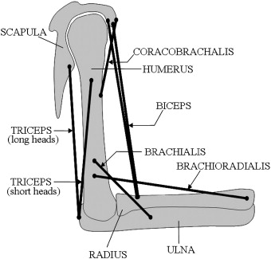

Contents
- Introduction and Background
- Objectives and Scope
- Work Plan and Timeline
- Anatomy of the Human Arm
- Elbow and Forearm Movements
- Mechanical Properties of the Major Muscles
- Functional Muscle Contributions
- Planned Analysis and Simulation Methodology
- Expected Outcomes
- Conclusion
- References

1. Introduction and Background
The human arm is a complex biomechanical system in which muscles generate force and motion through coordinated interaction with bones and joints. The elbow and forearm allow the hand to be positioned for tasks that require reach, manipulation and load handling. Understanding the relationship between muscle properties, joint configuration, force and torque is therefore important when developing an actuator that seeks to reproduce aspects of human movement.
This internship study focuses on reviewing available research, identifying useful muscle and joint parameters, and applying biomechanical or multibody simulation software to examine different configurations. The eventual engineering application is the estimation and selection of a suitable soft actuator based on the force, torque, displacement and motion requirements derived from the study.
2. Objectives and Scope
The overall objective is to study the biomechanics of the human arm, understand the mechanical capability of human muscles, derive relevant actuator parameters, and perform analysis and simulation using available software.
- Review existing research on human-arm biomechanics and muscle characteristics.
- Compile relevant muscle dimensions, force capacity, tendon properties and contraction timing.
- Determine how force and total joint torque are distributed among participating muscles during elbow movements.
- Evaluate the effect of elbow joint angle and external load on muscle-force requirements.
- Identify the contributions of individual muscles during flexion and extension.
- Estimate force requirements relevant to soft-actuator design.
- Simulate selected configurations and compare outputs with published biomechanical data.

3. Work Plan and Timeline
Sr. No. | Task | Methodology | Expected result | Timeline
1 | Biomechanics study of the human arm | Study current research work being carried out worldwide | Detailed understanding of human-arm biomechanics | June–September 2026
2 | Derivation of actuator parameters based on human muscle capability | Study and analyse relevant research and muscle parameters | Detailed report of the study and analysis | October–November 2026
3 | Analysis and simulation of biomechanics using available software | Simulate different configurations | Comparison with standard literature actuator/biomechanical data | December 2026–January 2027

4. Anatomy of the Human Arm

4.1 Major bones
Structure | Description
Humerus | Upper-arm bone.
Radius | Forearm bone on the thumb side.
Ulna | Forearm bone on the little-finger side.

4.2 Major muscles considered
- Biceps brachii
- Brachialis
- Brachioradialis
- Triceps brachii
- Anconeus
- Pronator teres

4.3 Supporting structures
Structure group | Structures identified in the source material
Ligaments | Medial collateral ligament (MCL); lateral collateral ligament (LCL); annular ligament.
Tendons | Distal biceps tendon; triceps tendon; brachialis tendon; common flexor and extensor tendons.
Other structures | Joint capsule and synovial fluid; bursa; articular cartilage; nerves; blood vessels.

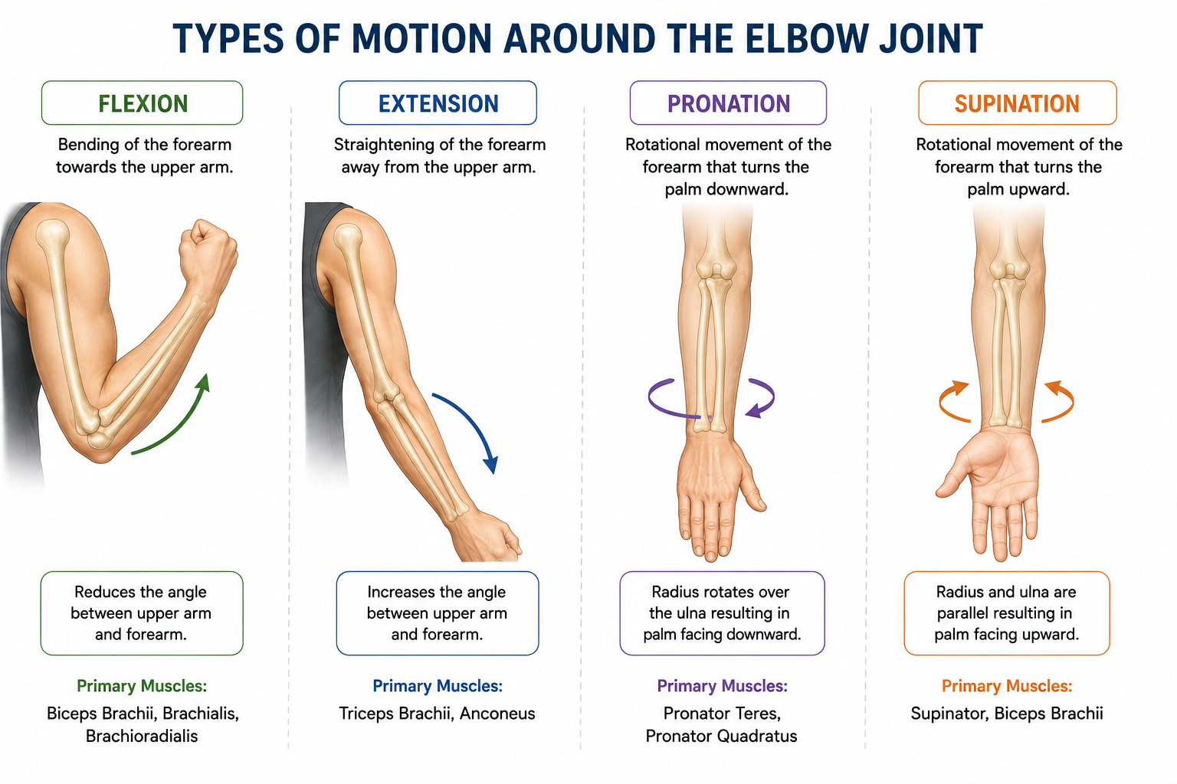
Figure 1. Reference illustration of human-arm anatomy (source google).

5. Elbow and Forearm Movements
Movement | Description
Flexion | Bending the forearm towards the upper arm, decreasing the angle at the elbow joint.
Extension | Straightening the forearm, increasing the angle between the upper arm and forearm.
Pronation | Rotational movement of the forearm that turns the palm downward.
Supination | Rotational movement of the forearm that turns the palm upward.

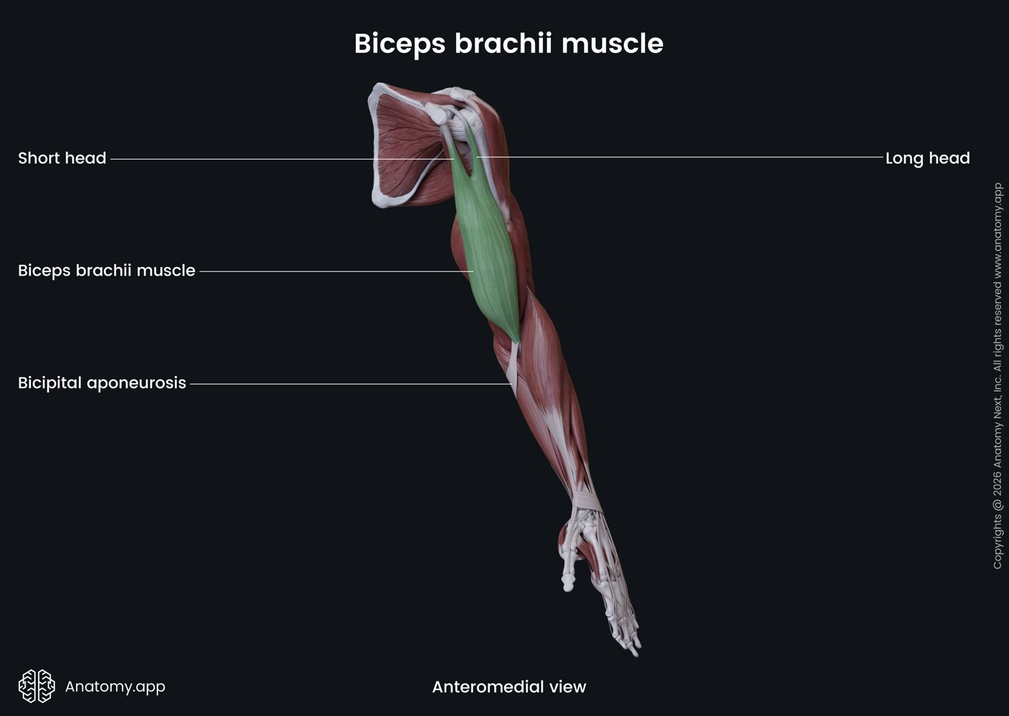
Figure 2. Reference illustration associated with elbow and forearm motion (source presentation).

6. Mechanical Properties of the Major Muscles
The following tables consolidate the ranges shown in the source presentation. The values are reproduced for reference and should be treated as indicative rather than universal constants; actual values can vary with anatomy, measurement method, posture, activation and modelling assumptions.

6.1 Biceps brachii
Mechanical property | Parameter / value range
Optimal fibre length (L₀) | 11.0–13.0 cm
Total muscle–tendon length | 35–42 cm
Resting muscle diameter | 4.0–6.0 cm
Contracted muscle diameter | 5.0–7.5 cm
Maximum shortening displacement | 4.0–5.5 cm
Physiological cross-sectional area (PCSA) | 8.0–12.0 cm²
Joint arc of motion (elbow) | 0° to 145°–160°
Electromechanical delay | 30–50 ms
Twitch contraction time | 40–60 ms
Maximum internal force (F₀) | 600–1,100 N
Maximum external joint torque | 30–60 N·m
Estimated external payload | 15–30 kg
Resting tendon cross-sectional area | 15–25 mm²
Tendon stiffness (k) | 100–300 N/mm
Tendon elasticity / hysteresis | 5%–10% loss

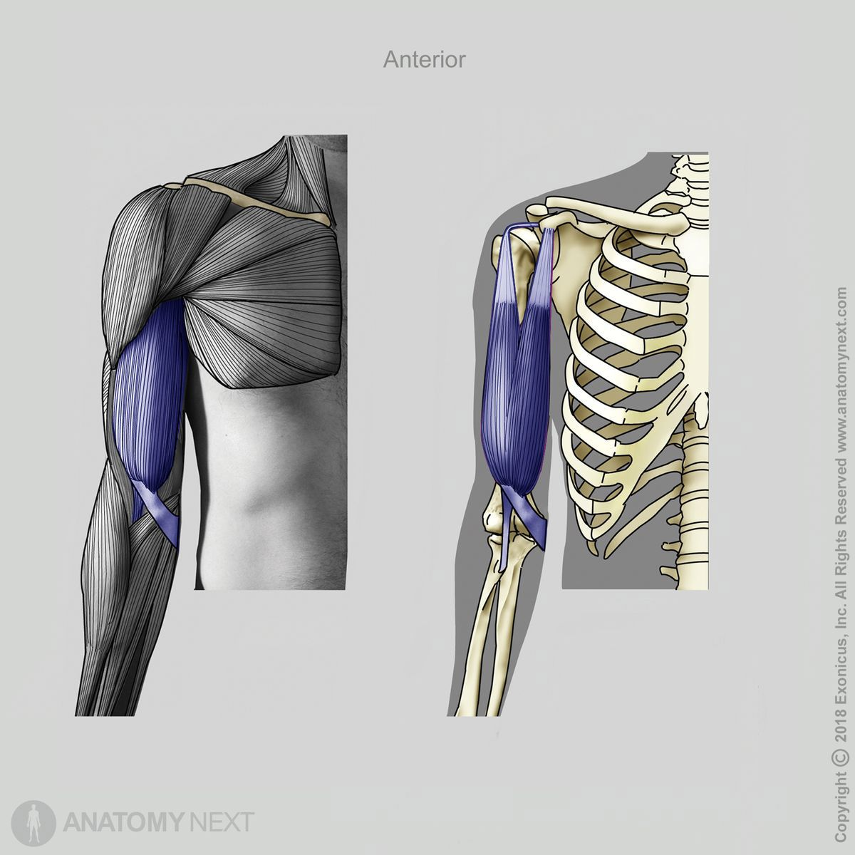

Figure: Biceps brachii reference image from source presentation.

6.2 Brachialis
Mechanical property | Parameter / value range
Optimal fibre length (L₀) | 7.0–9.5 cm
Total muscle–tendon length | 18–24 cm
Resting muscle diameter | 3.5–5.0 cm
Contracted muscle diameter | 4.2–6.0 cm
Maximum shortening displacement | 2.5–4.0 cm
Physiological cross-sectional area (PCSA) | 7.0–11.0 cm²
Joint arc of motion (elbow) | 0° to 150°
Electromechanical delay | 30–45 ms
Twitch contraction time | 35–55 ms
Maximum internal force (F₀) | 700–1,000 N
Maximum external joint torque | 20–40 N·m
Estimated external payload | 10–22 kg
Resting tendon cross-sectional area | 10–20 mm²
Tendon stiffness (k) | 150–350 N/mm
Tendon elasticity / hysteresis | 4%–8% loss
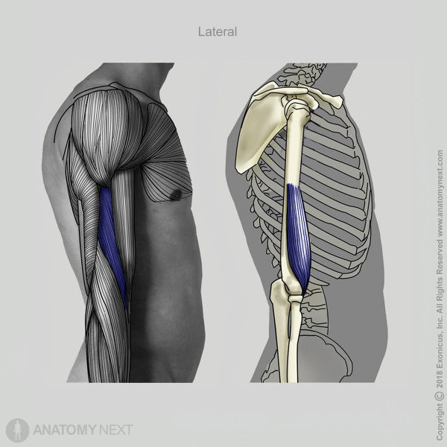
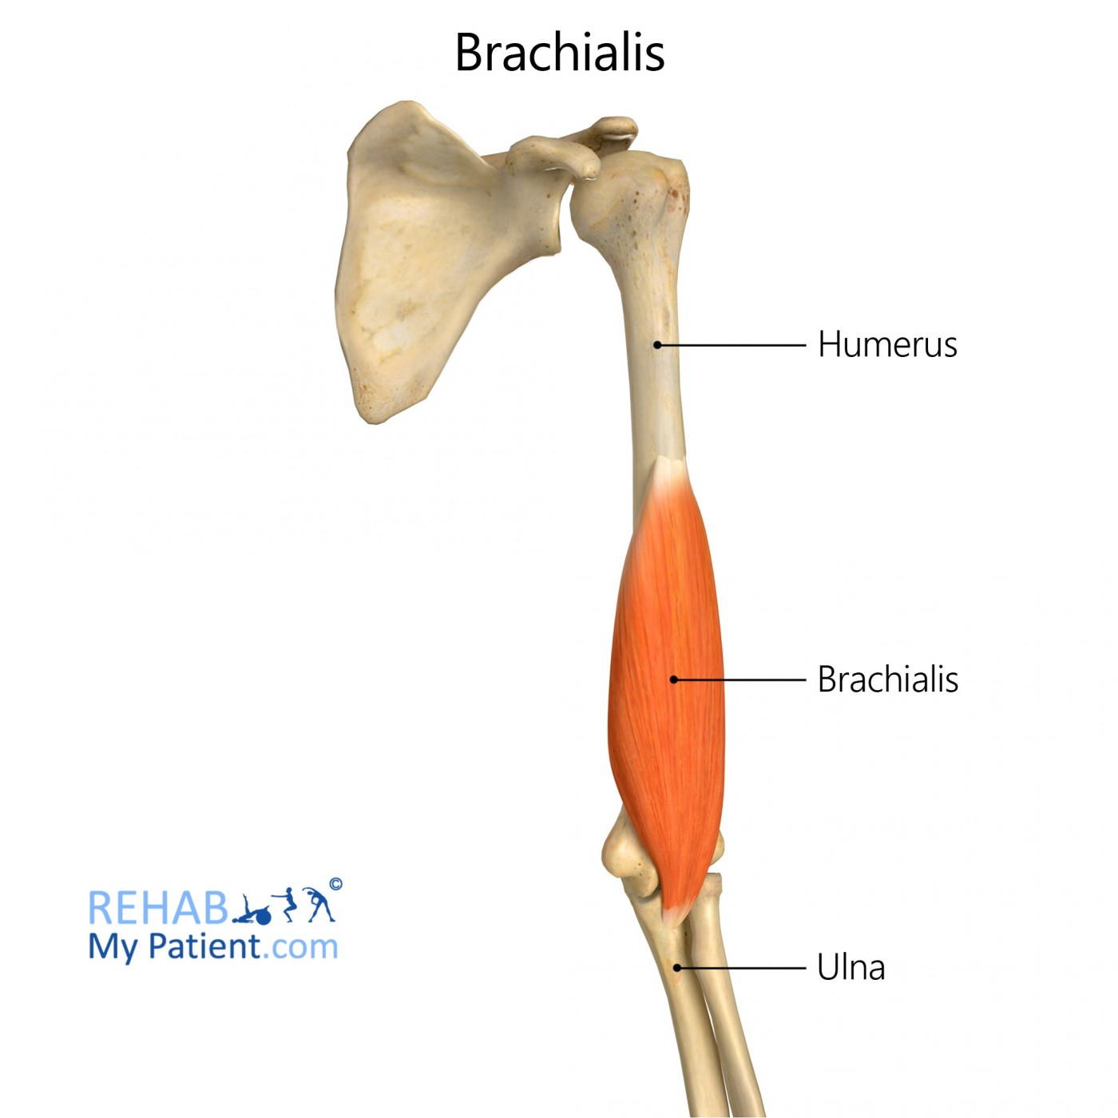

Figure: Brachialis reference image from source presentation.

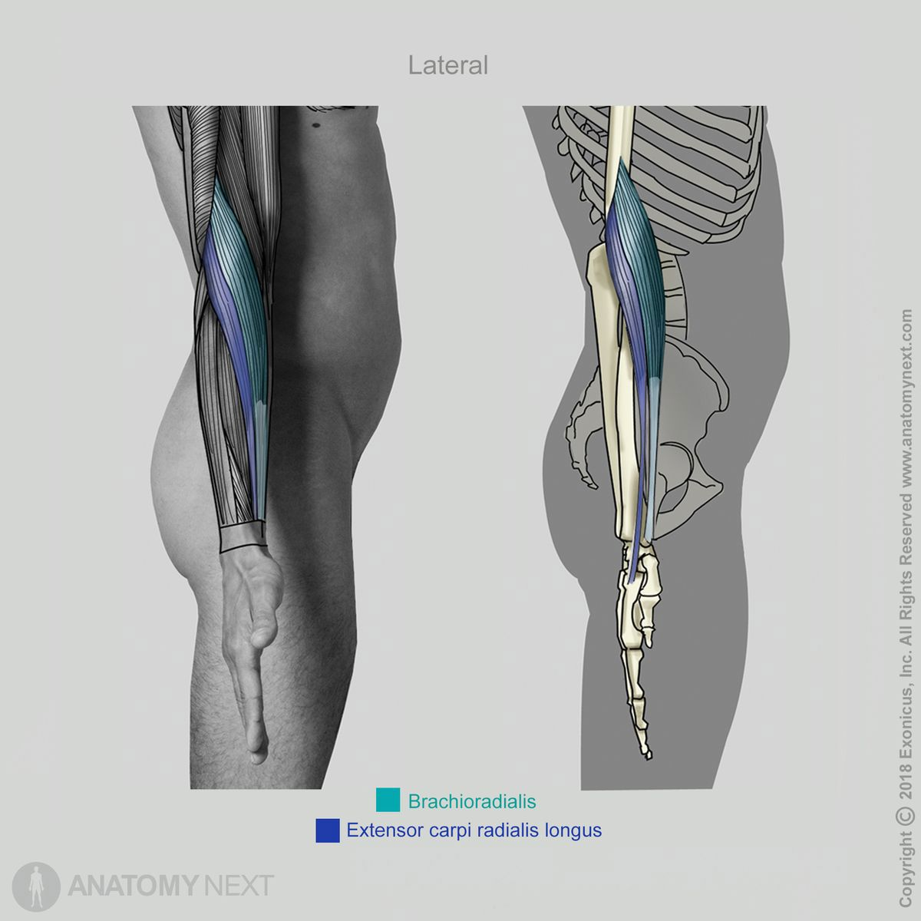
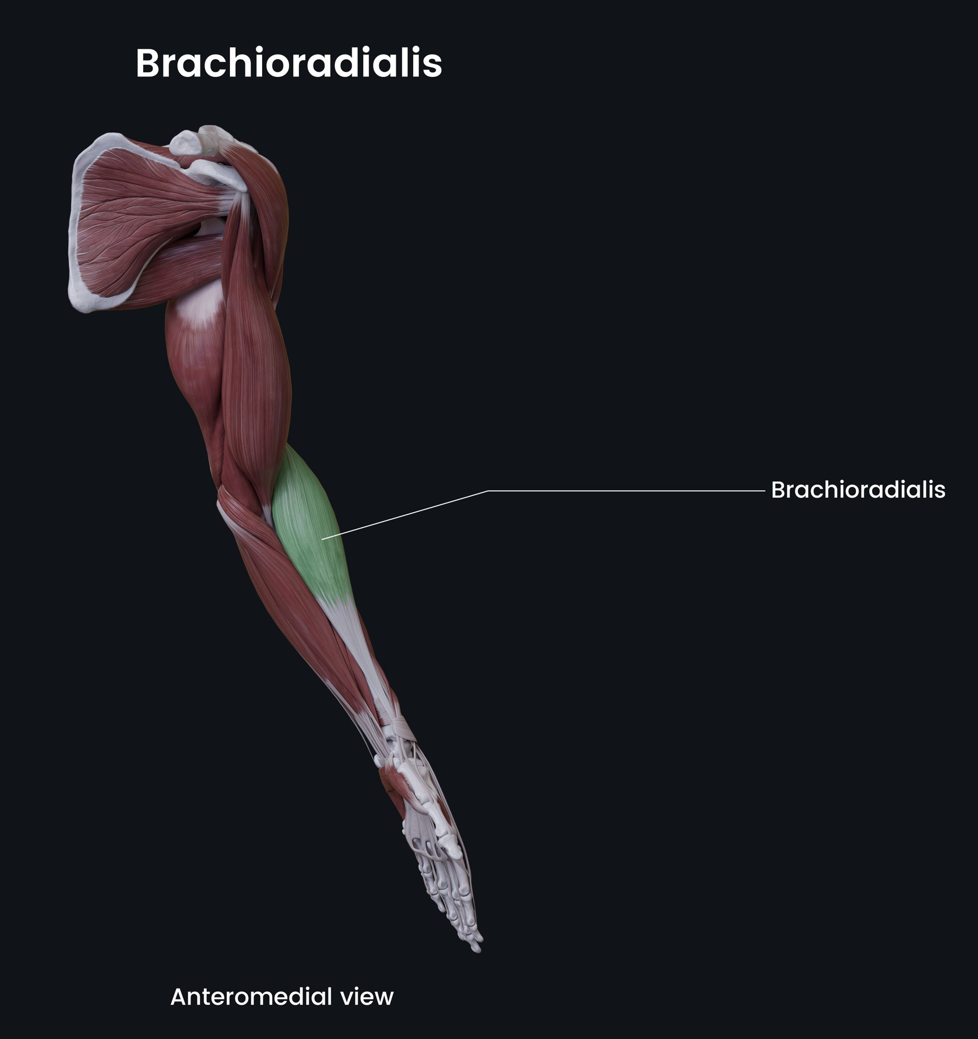
6.3 Brachioradialis
Mechanical property | Parameter / value range
Optimal fibre length (L₀) | 15.0–19.0 cm
Total muscle–tendon length | 25–35 cm
Resting muscle diameter | 2.5–4.0 cm
Contracted muscle diameter | 3.0–4.8 cm
Maximum shortening displacement | 4.0–6.0 cm
Physiological cross-sectional area (PCSA) | 2.0–4.5 cm²
Joint arc of motion (elbow) | 0° to 150°
Electromechanical delay | 30–45 ms
Twitch contraction time | 35–55 ms
Maximum internal force (F₀) | 150–300 N
Maximum external joint torque | 5–15 N·m
Estimated external payload | 3–10 kg
Resting tendon cross-sectional area | 5–12 mm²
Tendon stiffness (k) | 80–200 N/mm
Tendon elasticity / hysteresis | 5%–10% loss

Figure: Brachialis reference image from source presentation

6.4 Pronator teres
Mechanical property | Parameter / value range
Optimal fibre length (L₀) | 4.5–7.5 cm
Total muscle–tendon length | 12–18 cm
Resting muscle diameter | 2.0–3.5 cm
Contracted muscle diameter | 2.5–4.2 cm
Maximum shortening displacement | 2.5–4.0 cm
Physiological cross-sectional area (PCSA) | 3.0–6.0 cm²
Joint arc of motion | Pronation/supination approximately 150°–180°
Electromechanical delay | 30–45 ms
Twitch contraction time | 35–55 ms
Maximum internal force (F₀) | 300–600 N
Maximum external joint torque | 3–10 N·m (pronation)
Estimated external payload | 2–8 kg
Resting tendon cross-sectional area | 5–12 mm²
Tendon stiffness (k) | 100–250 N/mm
Tendon elasticity / hysteresis | 5%–10% loss
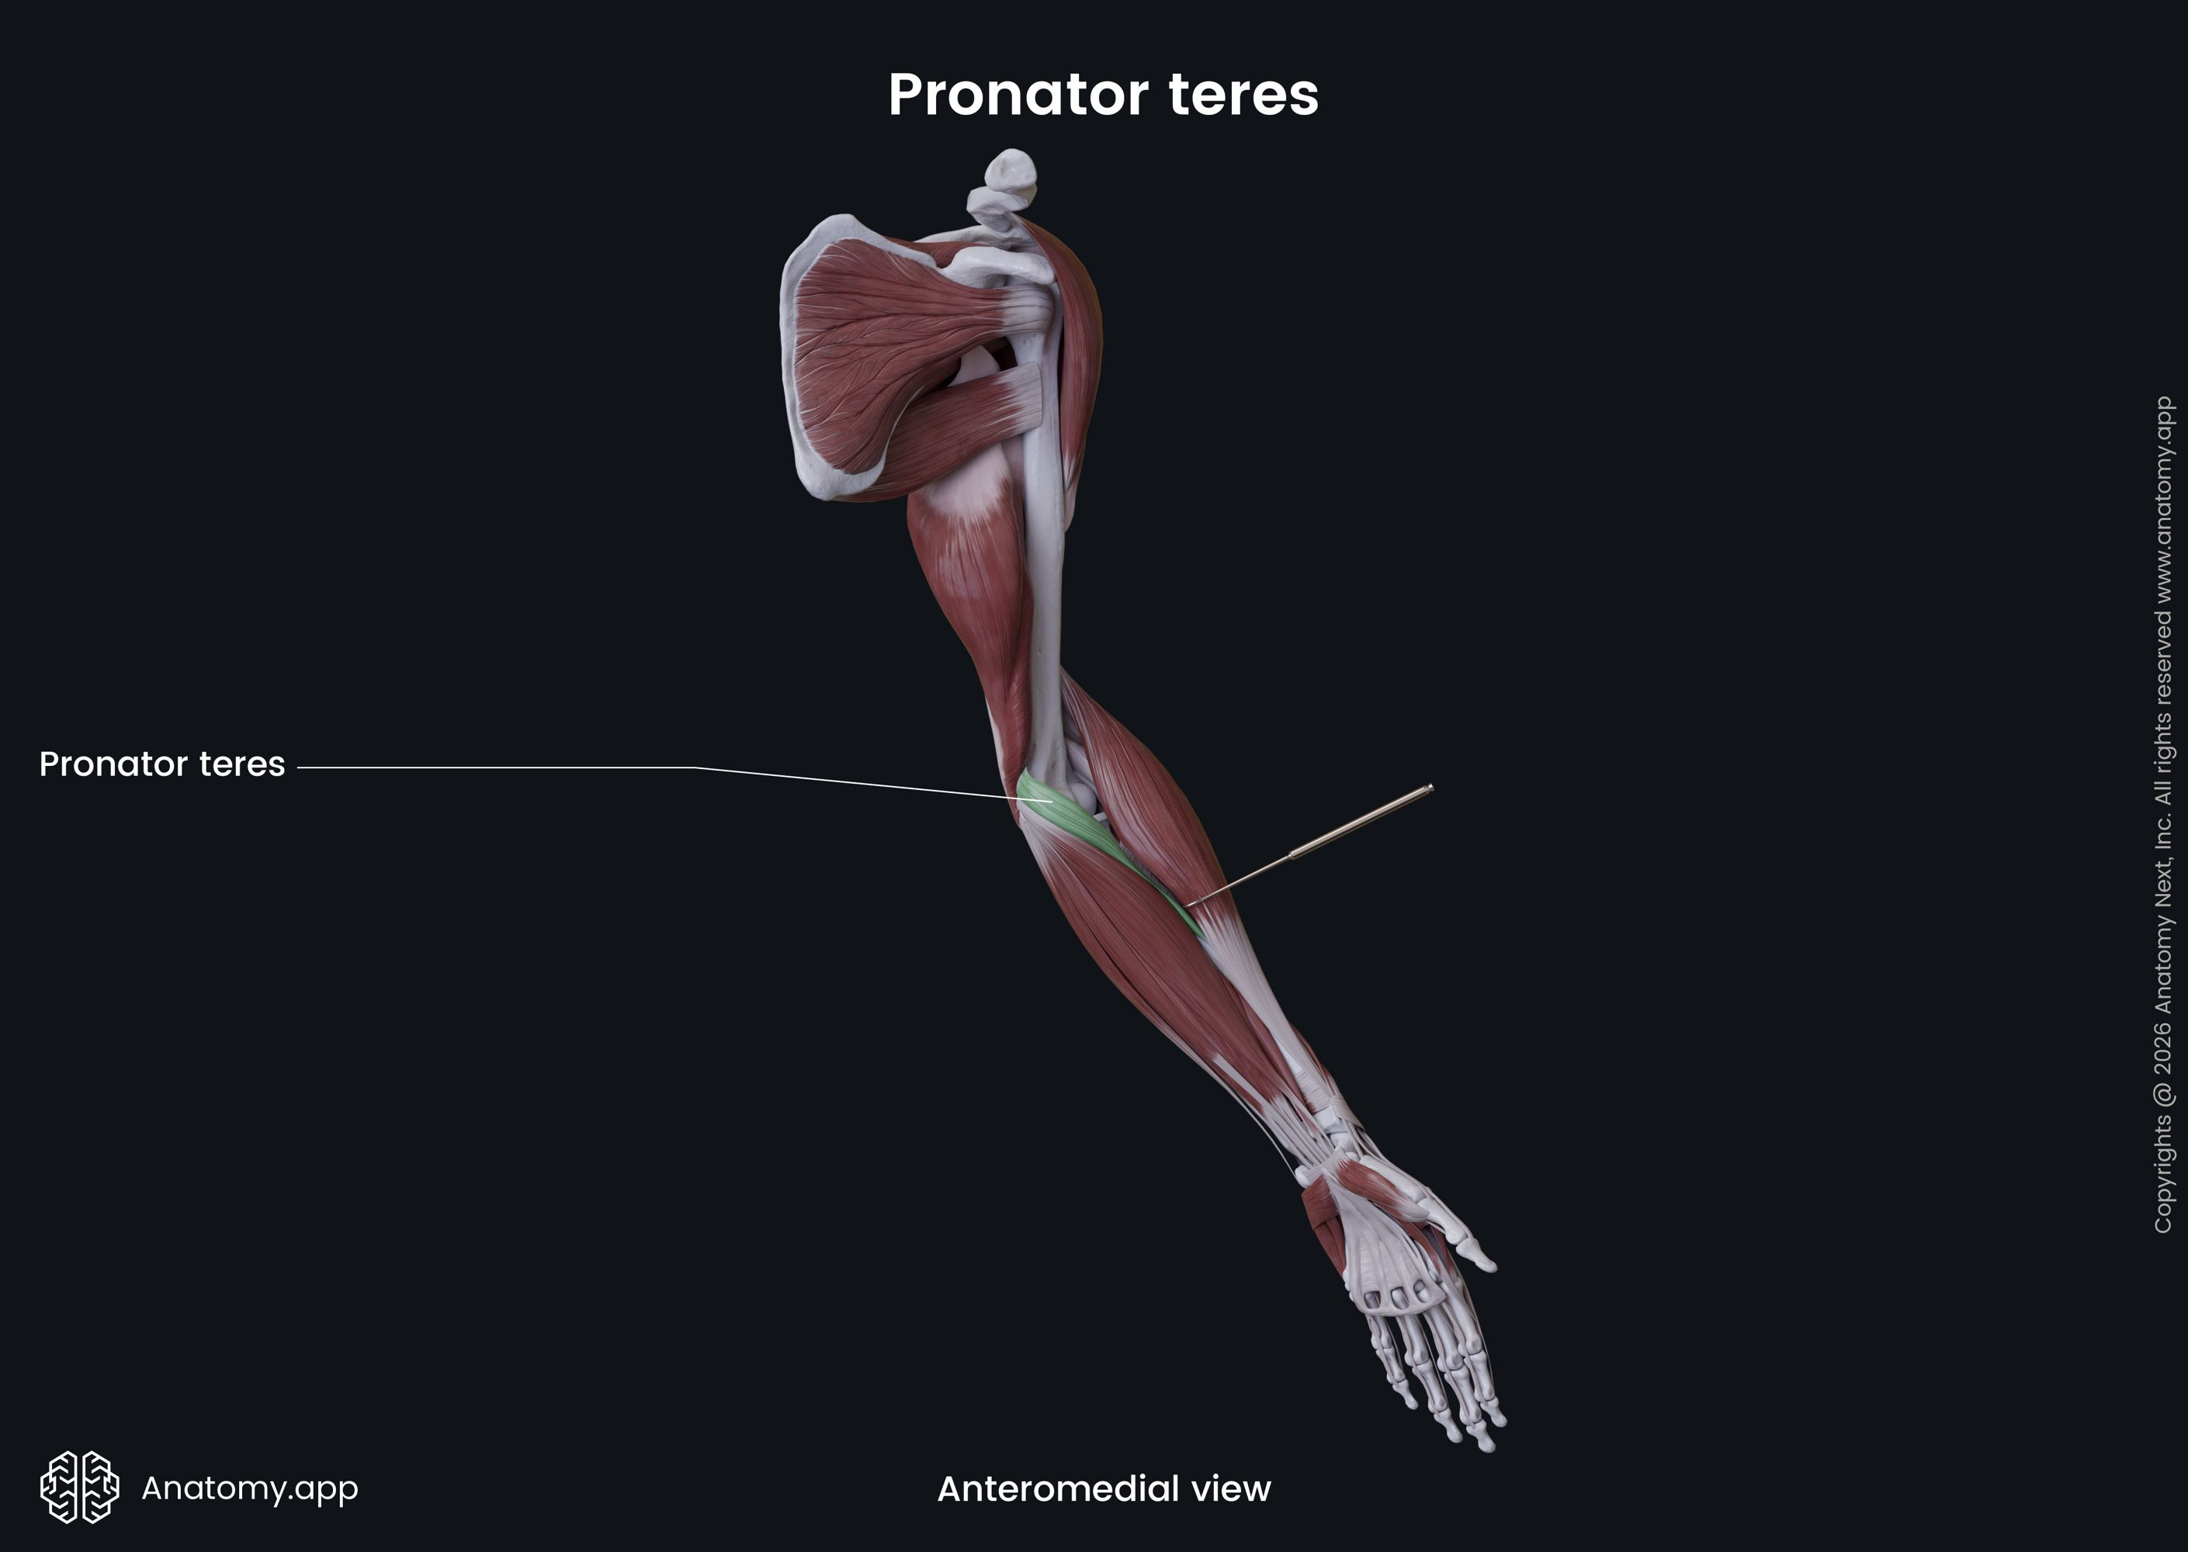
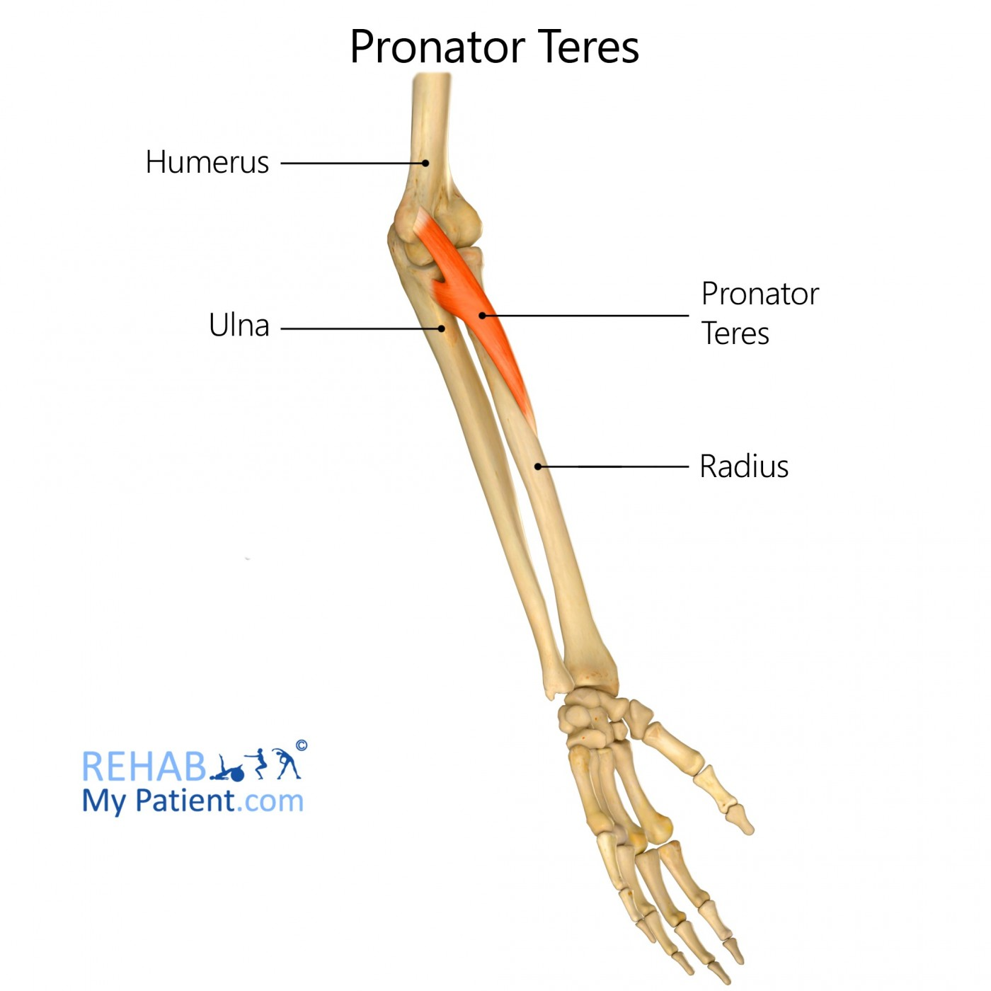

Figure: Pronator teres reference image from source presentation

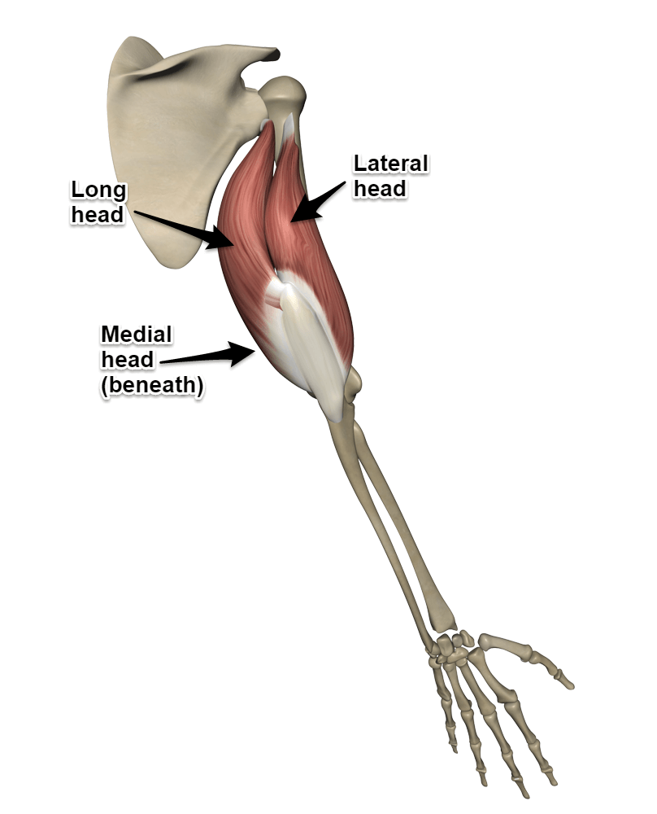
6.5 Triceps brachii
Mechanical property | Parameter / value range
Optimal fibre length (L₀) | 9.0–14.0 cm
Total muscle–tendon length | 30–45 cm
Resting muscle diameter | 4.5–7.0 cm
Contracted muscle diameter | 5.5–8.5 cm
Maximum shortening displacement | 4.0–6.5 cm
Physiological cross-sectional area (PCSA) | 12.0–22.0 cm²
Joint arc of motion (elbow) | 0° (full extension) to 150°
Electromechanical delay | 30–50 ms
Twitch contraction time | 40–60 ms
Maximum internal force (F₀) | 1,000–2,000 N
Maximum external joint torque | 40–90 N·m
Estimated external payload | 20–45 kg
Resting tendon cross-sectional area | 20–35 mm²
Tendon stiffness (k) | 150–400 N/mm
Tendon elasticity / hysteresis | 5%–10% loss
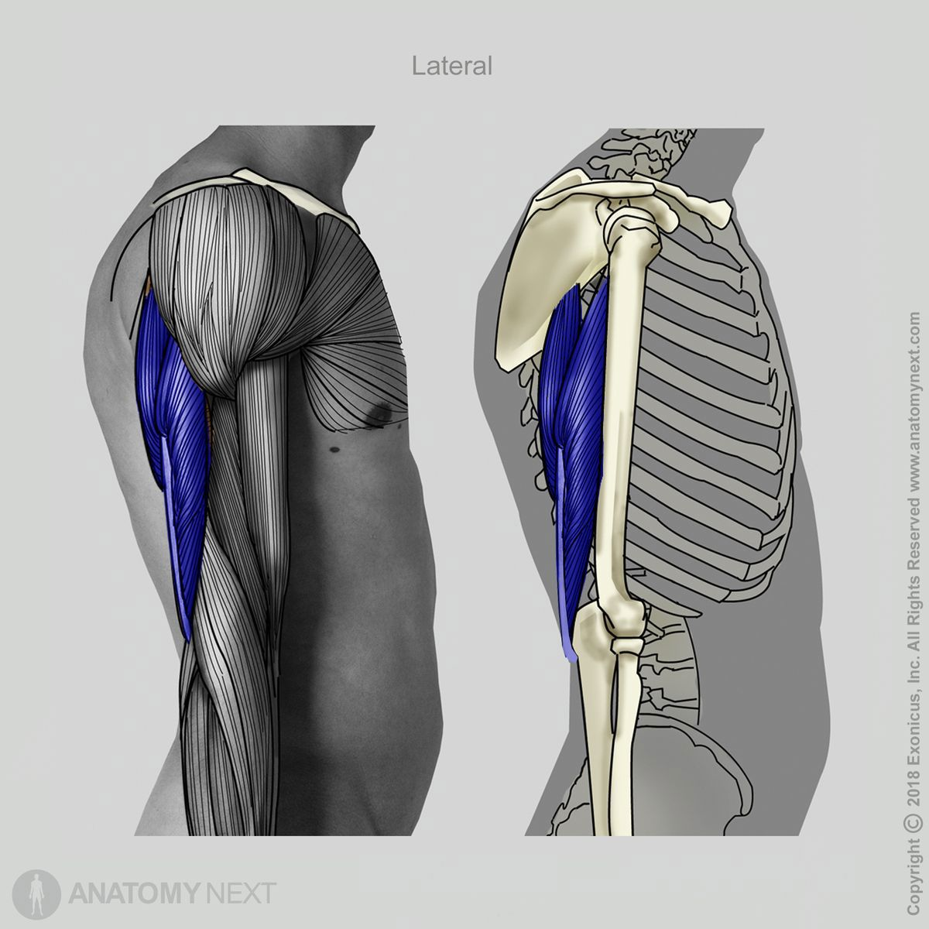

Figure: Triceps brachii reference image from source presentation

6.6 Anconeus
Mechanical property | Parameter / value range
Optimal fibre length (L₀) | 2.5–5.0 cm
Total muscle–tendon length | 7–10 cm
Resting muscle diameter | 1.0–2.0 cm
Contracted muscle diameter | 1.2–2.5 cm
Maximum shortening displacement | 1.0–2.0 cm
Physiological cross-sectional area (PCSA) | 1.0–2.5 cm²
Joint arc of motion (elbow) | 0° to 150°
Electromechanical delay | 30–45 ms
Twitch contraction time | 35–55 ms
Maximum internal force (F₀) | 200–350 N
Maximum external joint torque | 1–5 N·m
Estimated external payload | 1–3 kg
Resting tendon cross-sectional area | 3–8 mm²
Tendon stiffness (k) | 50–150 N/mm
Tendon elasticity / hysteresis | 5%–10% loss

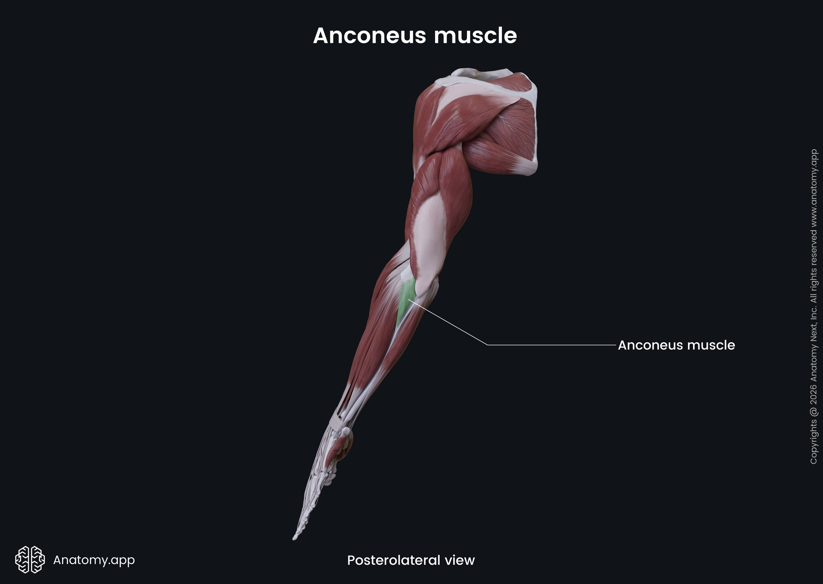
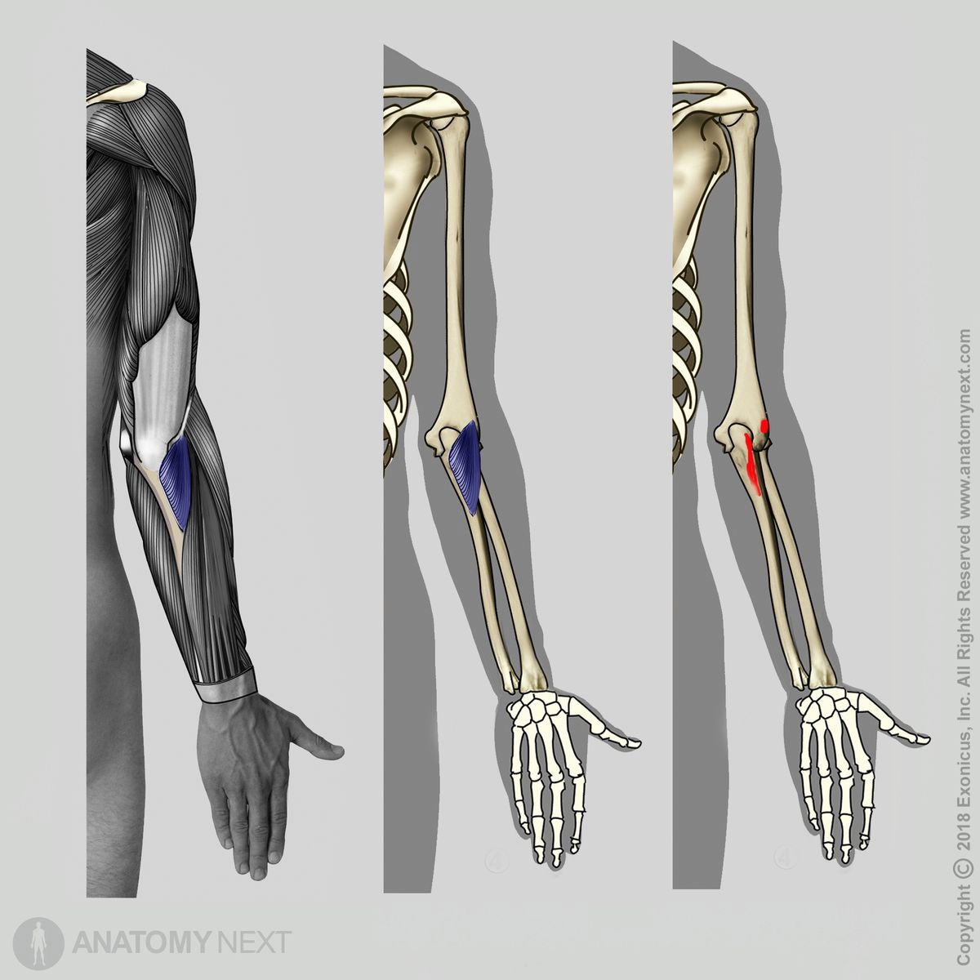

Figure: Anconeus reference image from source presentation

6.7 Consolidated comparison of selected parameters
Parameter | Biceps brachii | Brachialis | Brachioradialis | Pronator teres | Triceps brachii | Anconeus
Optimal fibre length (L₀) | 11.0–13.0 cm | 7.0–9.5 cm | 15.0–19.0 cm | 4.5–7.5 cm | 9.0–14.0 cm | 2.5–5.0 cm
Resting muscle diameter | 4.0–6.0 cm | 3.5–5.0 cm | 2.5–4.0 cm | 2.0–3.5 cm | 4.5–7.0 cm | 1.0–2.0 cm
Contracted muscle diameter | 5.0–7.5 cm | 4.2–6.0 cm | 3.0–4.8 cm | 2.5–4.2 cm | 5.5–8.5 cm | 1.2–2.5 cm
Maximum shortening displacement | 4.0–5.5 cm | 2.5–4.0 cm | 4.0–6.0 cm | 2.5–4.0 cm | 4.0–6.5 cm | 1.0–2.0 cm
Maximum internal force (F₀) | 600–1,100 N | 700–1,000 N | 150–300 N | 300–600 N | 1,000–2,000 N | 200–350 N
Electromechanical delay | 30–50 ms | 30–45 ms | 30–45 ms | 30–45 ms | 30–50 ms | 30–45 ms

7. Functional Muscle Contributions

7.1 Flexion
The source presentation identifies the following muscles in elbow flexion:
- Primary flexors: biceps brachii and brachialis.
- Assistive flexor: brachioradialis.
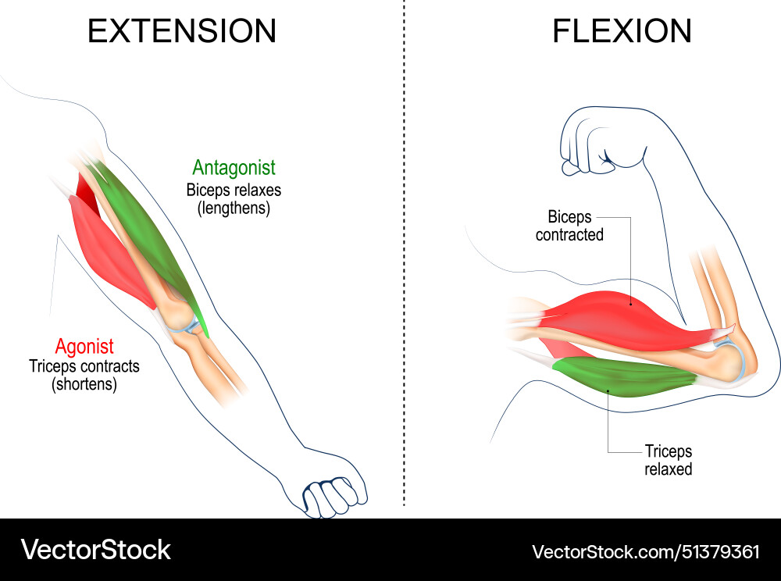
Figure 3. Flexion-related muscle reference image from the source presentation.

7.2 Extension
The source presentation identifies the following muscles in elbow extension:
- Primary extensor: triceps brachii.
- Assistive extensor: anconeus.
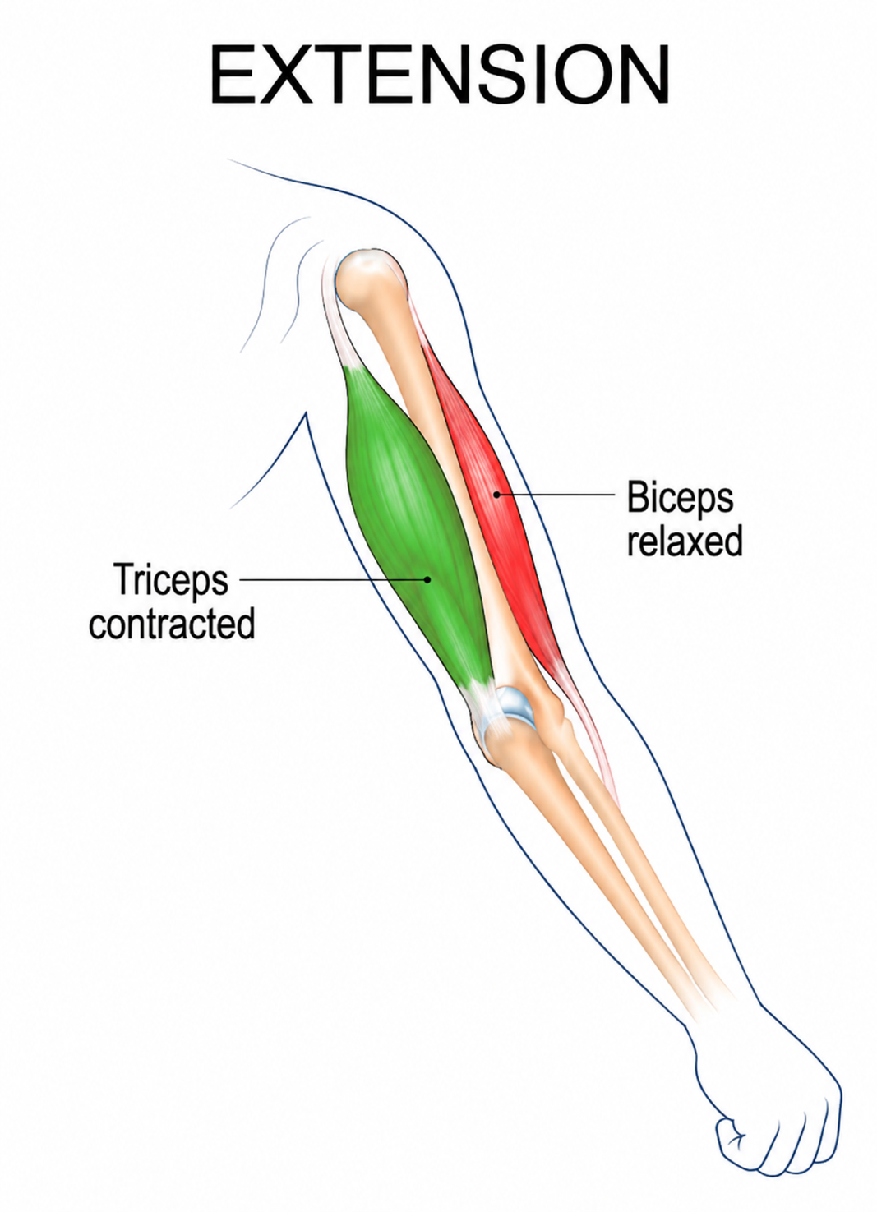
Figure 4. Extension-related muscle reference image from the source presentation.

7.3 Pronation and supination
Pronation and supination are included as major forearm movements in the study scope. The pronator teres is one of the muscles whose mechanical parameters are compiled in this report. Detailed force-sharing and simulation for these rotations remain part of the planned analysis.

8. Planned Analysis and Simulation Methodology

8.1 Analysis questions
- How are force and total joint torque distributed among participating muscles during elbow movements?
- How does elbow joint angle affect the force generated or required from each muscle?
- How does an external payload change muscle-force requirements?
- What is the contribution of individual muscles during flexion and extension?
- What force and motion requirements should be considered for soft actuators?

8.2 Simulation approach
The source presentation proposes simulation using suitable available software, with OpenSim, Biomechanics of Bodies (BOB) and MSC Adams listed as possible options. The selected platform should support the model configuration and outputs needed for the study.
- Define the arm model, joint configuration and relevant muscle parameters from the literature.
- Set up representative configurations for elbow flexion and extension; include forearm rotation where the model permits.
- Evaluate multiple elbow angles and external payload conditions.
- Extract muscle-force estimates, joint torque and relevant displacement/motion outputs.
- Compare the outputs with published biomechanical data and document assumptions and limitations.
- Use validated parameter ranges to inform suitable soft-actuator force, torque and displacement requirements.
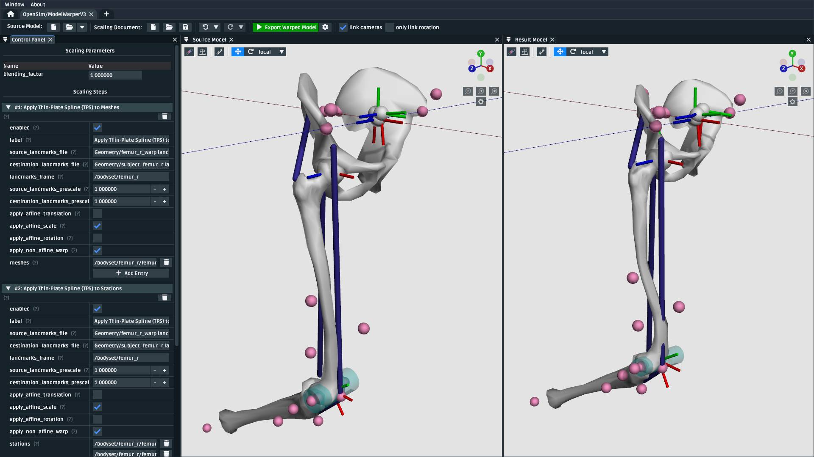
Figure 5. Example simulation references shown in the source presentation; these are illustrative, not results generated by this report.

9. Expected Outcomes
By the end of the internship, the work is expected to:
- Develop a detailed understanding of human-arm biomechanics and muscle characteristics.
- Analyse muscle-force distribution and joint torque during different arm movements.
- Study the effect of elbow joint angle and external payload on muscle-force requirements.
- Perform analysis and simulation using suitable biomechanical or multibody simulation software.
- Compare and validate simulation results with published biomechanical data.
- Establish a reliable range of force, torque, displacement and motion parameters.
- Use the validated parameter ranges to support the design and selection of a suitable soft actuator.

10. Conclusion
The study establishes a foundation for relating human-arm muscle characteristics to actuator design parameters. It combines an anatomical overview, a review of indicative mechanical-property ranges, and a plan for evaluating muscle contributions and joint loading through simulation. The next stage is to formalise the model inputs, run simulations across joint angles and payload conditions, and validate the outputs against published data. Only after this validation should the resulting ranges be used to guide soft-actuator design decisions.

References
- Holzbaur, K. R. S., Murray, W. M., & Delp, S. L. (2005). Upper-extremity model and muscle architecture parameters, including physiological cross-sectional area, optimal fibre length, tendon slack length and peak force.
- An et al. (1981). Biomechanical analysis of elbow muscles, including fibre length, physiological cross-sectional area, volume and moment arms.
- Murray, W. M., Delp, S. L., & Buchanan, T. S. (1995). Position-dependent moment arms of biceps, brachialis, brachioradialis, pronator teres and triceps.
- Buchanan (1995). Specific tension and maximum-force estimation for elbow flexors and extensors.
- Abrams et al. (2005). Experimental architecture data for pronator teres.
- Hodges et al. (2003). Muscle thickness, fascicle length and muscle-geometry changes during contraction.
- Abe et al. (2016). Ultrasound-based measurement of upper-extremity muscle thickness and its relationship with muscle size, cross-sectional area and morphology.
- Maganaris & Paul (1999). In-vivo tendon mechanical properties, including tendon cross-sectional area, force–elongation behaviour and stiffness.
- Maganaris & Paul (2000). Tendon hysteresis and energy dissipation during loading and unloading.
- Cavanagh & Komi (1979). Electromechanical delay and force-development timing in human skeletal muscles.
- Norman & Komi (1979). Electromechanical delay characteristics of biceps brachii and triceps brachii during normal movement conditions.
Note: The reference descriptions above follow the source presentation. Full bibliographic details (such as article titles, journal names, volume, pages and DOI) were not provided in the presentation and should be completed from the original publications before formal submission.

