BIOMECHANICS STUDY
OF THE HUMAN ARM
Deriving Actuator Parameters from Human Muscle Capability
and Analysis & Simulation of Biomechanics
3 Months Progress Report
Presented by
Atharv Nagvekar
Group: ATRC (Student Intern)
Under the guidance of
Arvind Bansode (Sc-E)
Internship period: June 2026 – January 2027

Executive Summary
This report presents a structured study plan for understanding the biomechanics of the human arm, with emphasis on the muscles that drive elbow and forearm motion. The work aims to translate human muscle capability into useful actuator parameters and to analyse the resulting biomechanical system using suitable simulation software. The source material identifies the principal bones, muscles, ligaments, tendons and supporting structures; describes flexion, extension, pronation and supination; and compiles indicative mechanical-property ranges for six muscles.
The planned analysis includes estimating the distribution of muscle forces and joint torque, evaluating the effects of elbow angle and external payload, identifying individual muscle contributions, and deriving force requirements for soft actuators. Simulation results are intended to be compared with published biomechanical data before the parameters are used to inform actuator design.

The numerical values presented in this report have been compiled from various published research papers on human muscle biomechanics. These values represent approximate reference ranges and may vary depending on the experimental methods, individual anatomical differences, and modelling assumptions. Therefore, the values should be verified against the respective research sources before being used for engineering design.
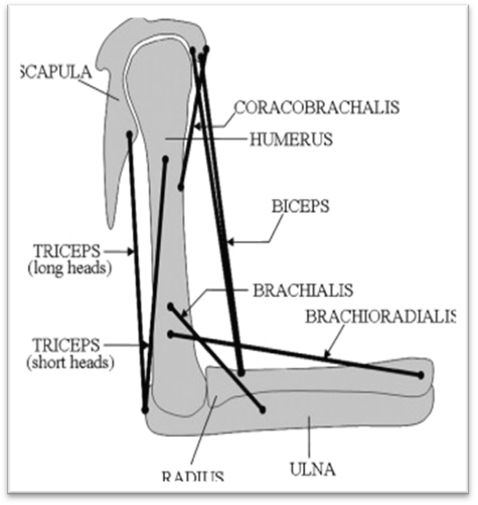

Figure: Reference illustration of human-arm anatomy (source google)

Contents
- Introduction and Background
- Objectives
- Work Plan and Timeline
- Anatomy of the Human Arm
- Elbow and Forearm Movements
- Mechanical Properties of the Major Muscles
- Functional Muscle Contributions
- Things To Do
- Expected Outcomes
- Conclusion
- References

1. Introduction and Background
The human arm is a complex biomechanical system in which muscles generate force and motion through coordinated interaction with bones and joints. The elbow and forearm allow the hand to be positioned for tasks that require reach, manipulation and load handling. Understanding the relationship between muscle properties, joint configuration, force and torque is therefore important when developing an actuator that seeks to reproduce aspects of human movement.
This internship study focuses on reviewing available research, identifying useful muscle and joint parameters, and applying biomechanical or multibody simulation software to examine different configurations. The eventual engineering application is the estimation and selection of a suitable soft actuator based on the force, torque, displacement and motion requirements derived from the study.
2. Objectives
The overall objective is to study the biomechanics of the human arm, understand the mechanical capability of human muscles, derive relevant actuator parameters, and perform analysis and simulation using available software.
- Review existing research on human-arm biomechanics and muscle characteristics.
- Compile relevant muscle dimensions, force capacity, tendon properties and contraction timing.

3. Work Plan and Timeline
Sr. No. | Task | Methodology | Expected result | Timeline
1 | Biomechanics study of the human arm | Study current research work being carried out worldwide | Detailed understanding of human-arm biomechanics | June–September 2026
2 | Derivation of actuator parameters based on human muscle capability | Study and analyse relevant research and muscle parameters | Detailed report of the study and analysis | October–November 2026
3 | Analysis and simulation of biomechanics using available software | Simulate different configurations | Comparison with standard literature actuator/ biomechanical data | December 2026–January 2027

4. Anatomy of the Human Arm

4.1 Major bones
Structure | Description
Humerus | Upper-arm bone.
Radius | Forearm bone on the thumb side.
Ulna | Forearm bone on the little-finger side.

4.2 Major muscles considered
- Biceps brachii
- Brachialis
- Brachioradialis
- Triceps brachii
- Anconeus
- Pronator teres

4.3 Supporting structures
Structure group | Structures identified in the source material
Ligaments | Medial collateral ligament (MCL); lateral collateral ligament (LCL); annular ligament.
Tendons | Distal biceps tendon; triceps tendon; brachialis tendon; common flexor and extensor tendons.
Other structures | Joint capsule and synovial fluid; bursa; articular cartilage; nerves; blood vessels.

.

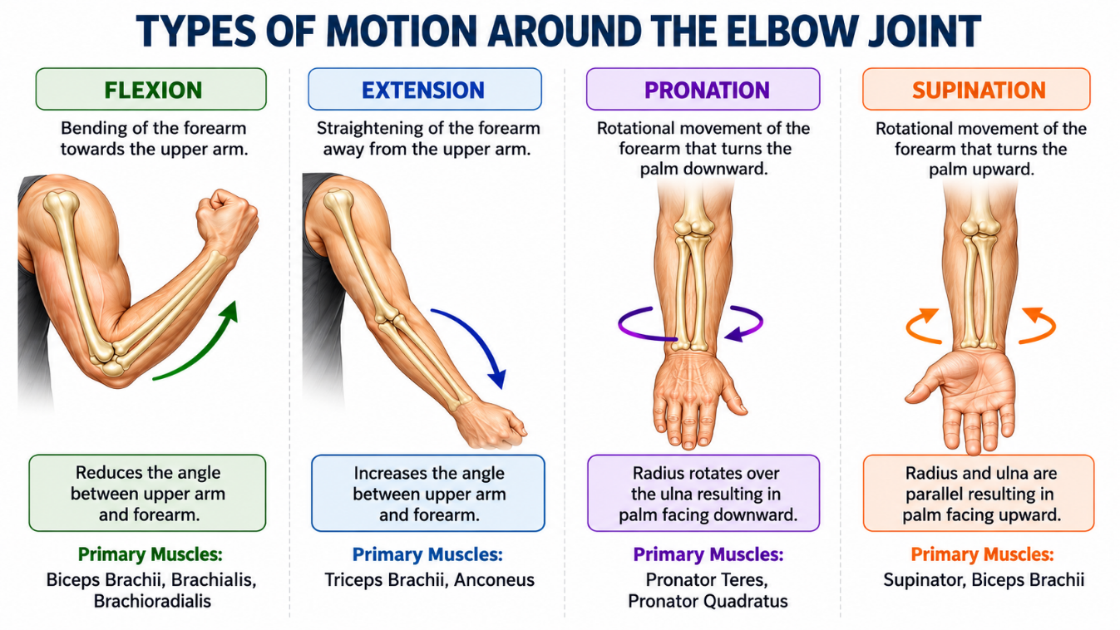
5. Elbow and Forearm Movements
Movement | Description
Flexion | Bending the forearm towards the upper arm, decreasing the angle at the elbow joint.
Extension | Straightening the forearm, increasing the angle between the upper arm and forearm.
Pronation | Rotational movement of the forearm that turns the palm downward.
Supination | Rotational movement of the forearm that turns the palm upward.

Figure : Elbow movements of human-arm (source google)
6. Mechanical Properties of the Major Muscles

Interpretation of Muscle and Tendon Properties
The following definitions clarify the parameters used in the muscle-property tables. They support comparison of human muscle characteristics and the later derivation of design requirements for a soft-actuator robotic arm. Values listed in this report should be treated as preliminary literature based estimates unless verified against a muscle-specific source or experimental measurement.

Parameter | Meaning and relevance to this study
1. Optimal fibre length (L₀) | The muscle-fibre length at which the muscle can generate its greatest active isometric force.
2. Total muscle–tendon length | The combined length of the muscle and its associated tendon(s), measured along the muscle–tendon path.
3. Resting muscle diameter | The approximate muscle thickness or diameter in a relaxed state. It varies with the measurement location and method.
4. Contracted muscle diameter | The muscle thickness during contraction. A muscle may bulge as it shortens, so the value depends on activation and measurement conditions.
5. Maximum shortening displacement | The maximum change in muscle length from a defined reference state under specified conditions.
6. Physiological cross-sectional area (PCSA) | An estimate of the muscle's force-generating cross-sectional area. PCSA is commonly used to estimate maximum force capacity.
7. Joint arc of motion (elbow) | The angular range through which the joint moves, expressed in degrees. The usable range depends on the movement and the individual.
8. Electromechanical delay | The time between electrical activation of a muscle and the onset of measurable force or movement.
9. Twitch contraction time | The time from the onset of a single brief muscle response to the peak twitch force.
10. Maximum internal force (F₀) | The estimated maximum isometric force the muscle can produce at or near its optimal length under stated assumptions.
11. Maximum external joint torque | The rotational moment produced about a joint. It depends on muscle force and the perpendicular moment arm, and changes with joint position.
12. Estimated external payload | An approximate external load that could be supported or moved for a specified posture and task. It is not an intrinsic muscle property and must be estimated from joint torque, leverage, and system geometry.
13. Resting tendon cross-sectional area | The tendon area measured perpendicular to its length in an unloaded or resting condition; it is relevant to estimating tendon stress.
14. Tendon stiffness (k) | The resistance of a tendon to elongation, commonly expressed as the change in force divided by the resulting change in length (N/mm).
15. Tendon elasticity / hysteresis | Elasticity describes the tendon’s ability to stretch and recoil. Hysteresis describes energy dissipated during a loading–unloading cycle, often reported as a percentage.
The following tables consolidate the ranges shown in the source presentation. The values are taken for reference and should be treated as indicative rather than universal constants; actual values can vary with anatomy, measurement method, posture, activation and modelling assumptions.

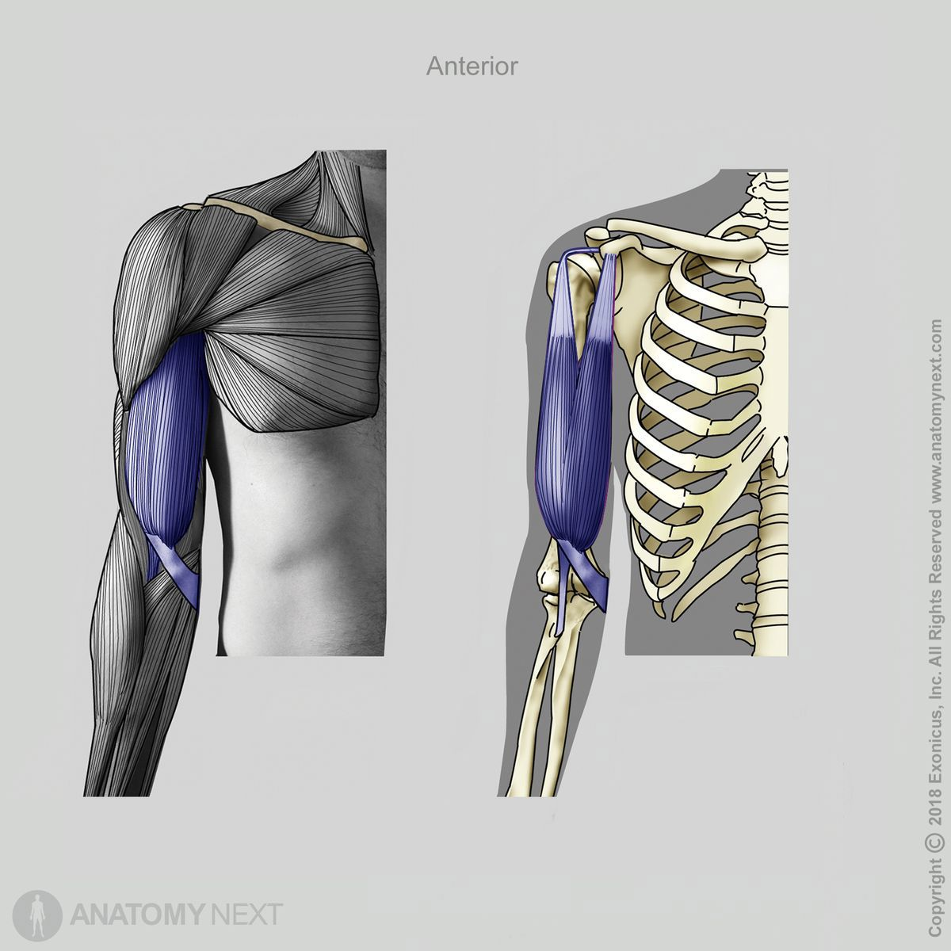
6.1 Biceps Brachii : [Origin-Scapula; Insertion-Radius]
Mechanical property | Parameter / value range
Optimal fibre length (L₀) | 11.0–13.0 cm
Total muscle–tendon length | 35–42 cm
Resting muscle diameter | 4.0–6.0 cm
Contracted muscle diameter | 5.0–7.5 cm
Maximum shortening displacement | 4.0–5.5 cm
Physiological cross-sectional area (PCSA) | 8.0–12.0 cm²
Joint arc of motion (elbow) | 0° to 145°–160°
Electromechanical delay | 30–50 ms
Twitch contraction time | 40–60 ms
Maximum internal force (F₀) | 600–1,100 N
Maximum external joint torque | 30–60 N·m
Estimated external payload | 15–30 kg
Resting tendon cross-sectional area | 15–25 mm²
Tendon stiffness (k) | 100–300 N/mm
Tendon elasticity / hysteresis | 5%–10% loss
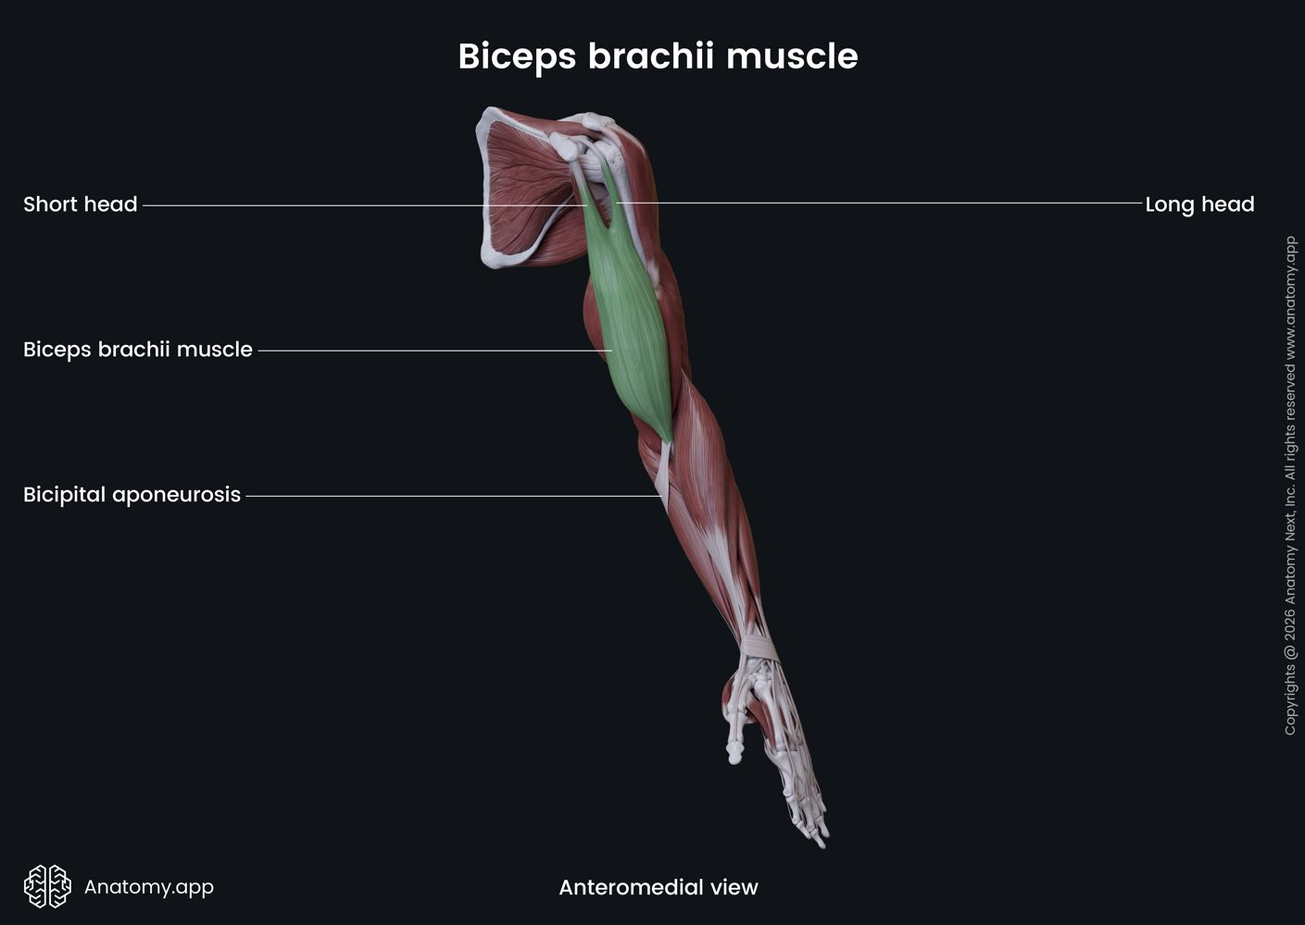
Source:
Data: Adapted from Holzbaur et al. (2005), An et al. (1981) and Murray, Delp & Buchanan (1995)
Images: Google

6.2 Brachialis : [Origin-Humerus; Insertion-Ulna]
Mechanical property | Parameter / value range
Optimal fibre length (L₀) | 7.0–9.5 cm
Total muscle–tendon length | 18–24 cm
Resting muscle diameter | 3.5–5.0 cm
Contracted muscle diameter | 4.2–6.0 cm
Maximum shortening displacement | 2.5–4.0 cm
Physiological cross-sectional area (PCSA) | 7.0–11.0 cm²
Joint arc of motion (elbow) | 0° to 150°
Electromechanical delay | 30–45 ms
Twitch contraction time | 35–55 ms
Maximum internal force (F₀) | 700–1,000 N
Maximum external joint torque | 20–40 N·m
Estimated external payload | 10–22 kg
Resting tendon cross-sectional area | 10–20 mm²
Tendon stiffness (k) | 150–350 N/mm
Tendon elasticity / hysteresis | 4%–8% loss
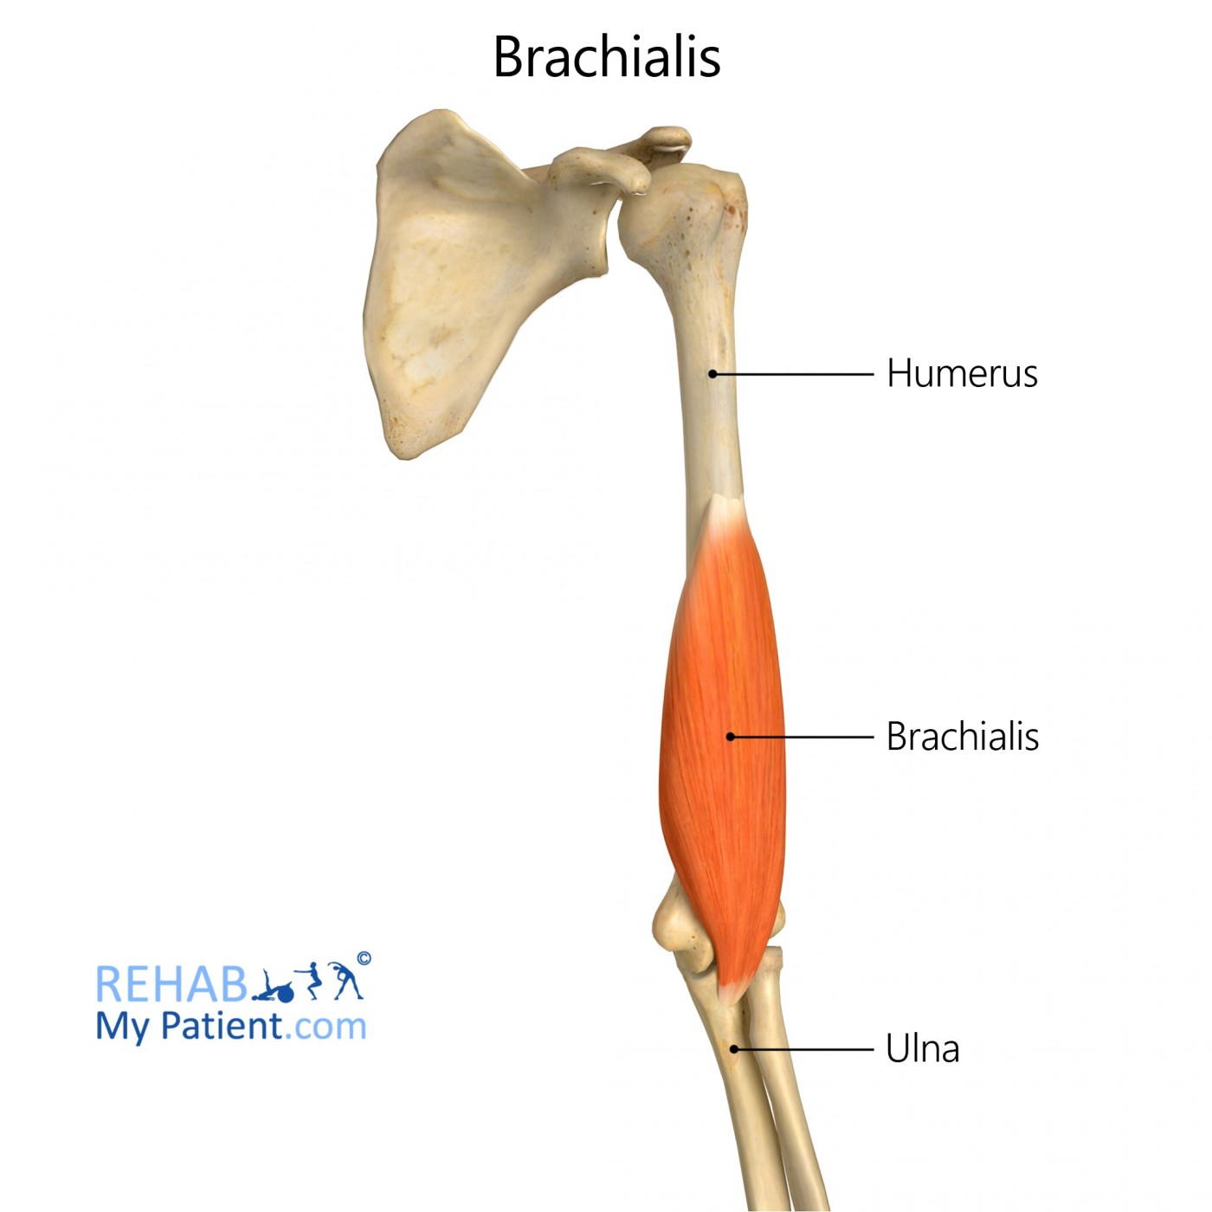
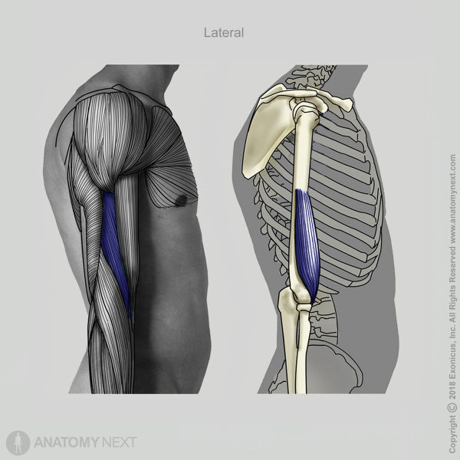

Source:
Data: Adapted from Holzbaur et al. (2005), An et al. (1981) and Murray, Delp & Buchanan (1995)
Images: Google

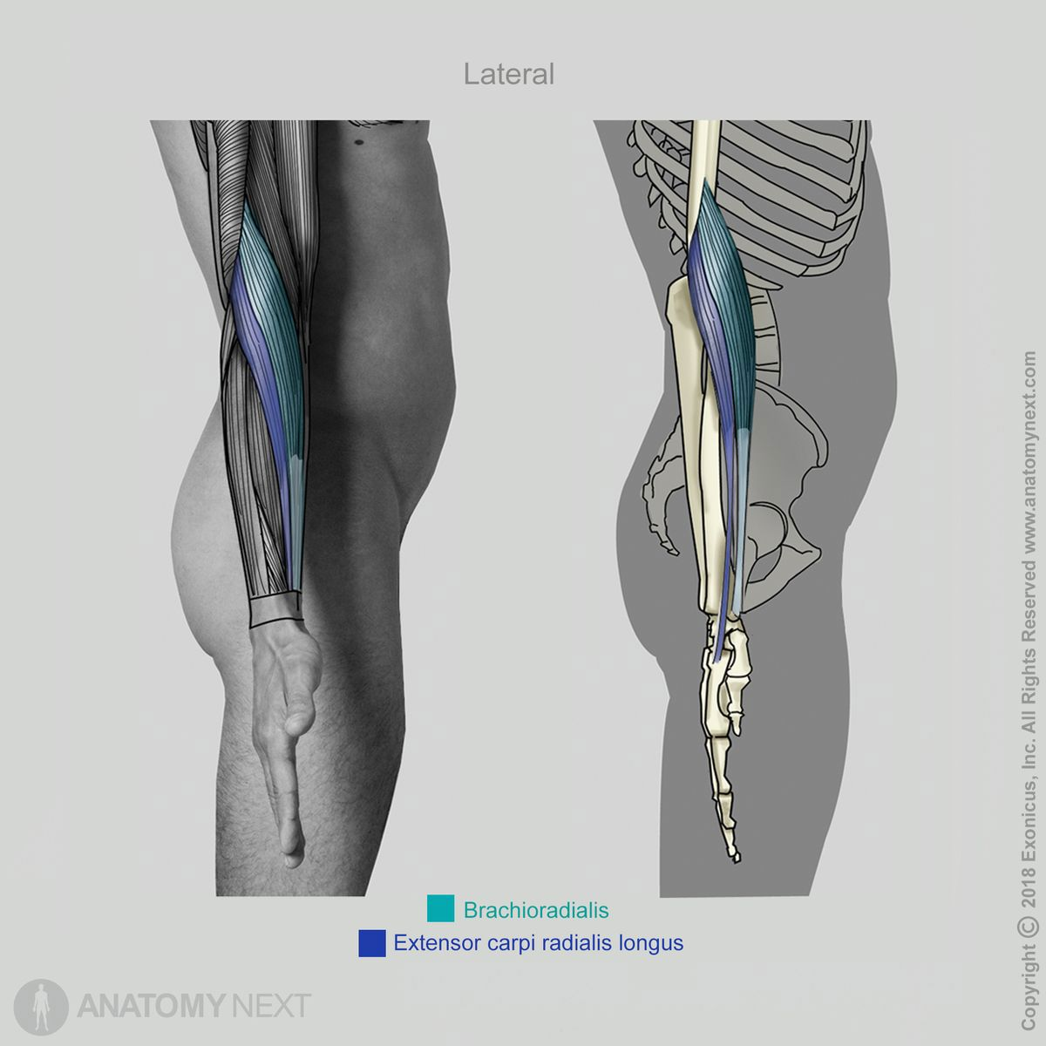
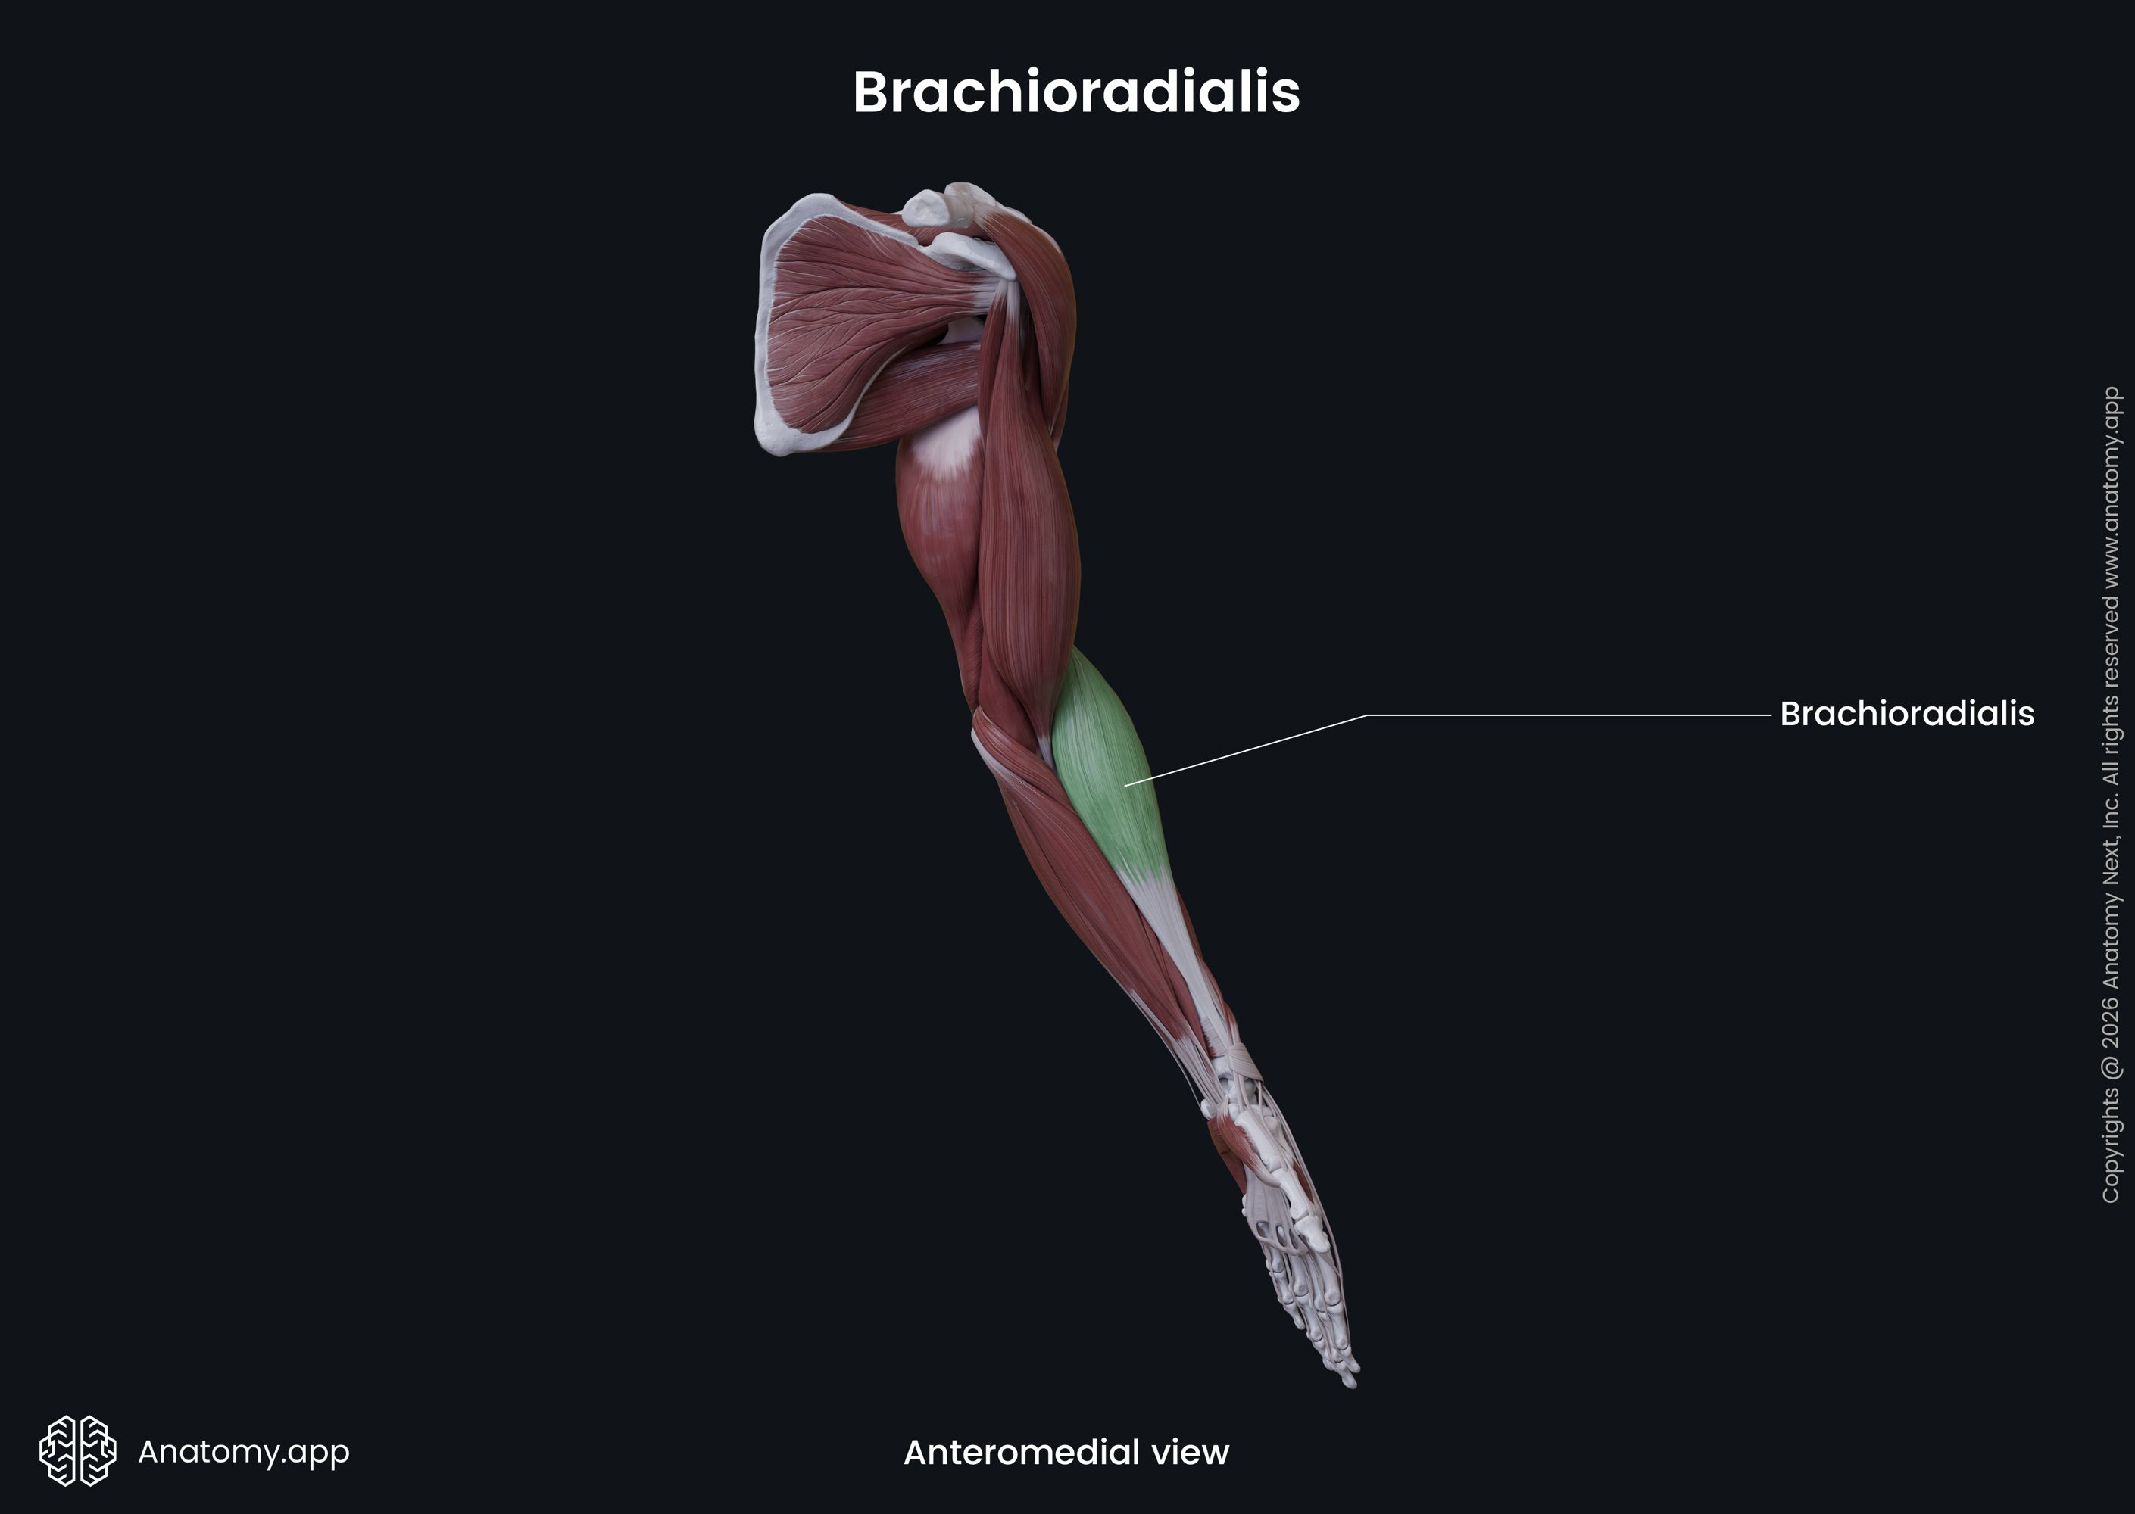
6.3 Brachioradialis : [Origin-Humerus; Insertion-Radius]
Mechanical property | Parameter / value range
Optimal fibre length (L₀) | 15.0–19.0 cm
Total muscle–tendon length | 25–35 cm
Resting muscle diameter | 2.5–4.0 cm
Contracted muscle diameter | 3.0–4.8 cm
Maximum shortening displacement | 4.0–6.0 cm
Physiological cross-sectional area (PCSA) | 2.0–4.5 cm²
Joint arc of motion (elbow) | 0° to 150°
Electromechanical delay | 30–45 ms
Twitch contraction time | 35–55 ms
Maximum internal force (F₀) | 150–300 N
Maximum external joint torque | 5–15 N·m
Estimated external payload | 3–10 kg
Resting tendon cross-sectional area | 5–12 mm²
Tendon stiffness (k) | 80–200 N/mm
Tendon elasticity / hysteresis | 5%–10% loss

Source:
Data: Adapted from Holzbaur et al. (2005), An et al. (1981) and Murray, Delp & Buchanan (1995)
Images: Google

6.4 Pronator Teres : [Origin-Medial epicondyle of Humerus and Coronoid process of Ulna; Insertion-Radius]
Mechanical property | Parameter / value range
Optimal fibre length (L₀) | 4.5–7.5 cm
Total muscle–tendon length | 12–18 cm
Resting muscle diameter | 2.0–3.5 cm
Contracted muscle diameter | 2.5–4.2 cm
Maximum shortening displacement | 2.5–4.0 cm
Physiological cross-sectional area (PCSA) | 3.0–6.0 cm²
Joint arc of motion | Pronation/supination approximately 150°–180°
Electromechanical delay | 30–45 ms
Twitch contraction time | 35–55 ms
Maximum internal force (F₀) | 300–600 N
Maximum external joint torque | 3–10 N·m (pronation)
Estimated external payload | 2–8 kg
Resting tendon cross-sectional area | 5–12 mm²
Tendon stiffness (k) | 100–250 N/mm
Tendon elasticity / hysteresis | 5%–10% loss
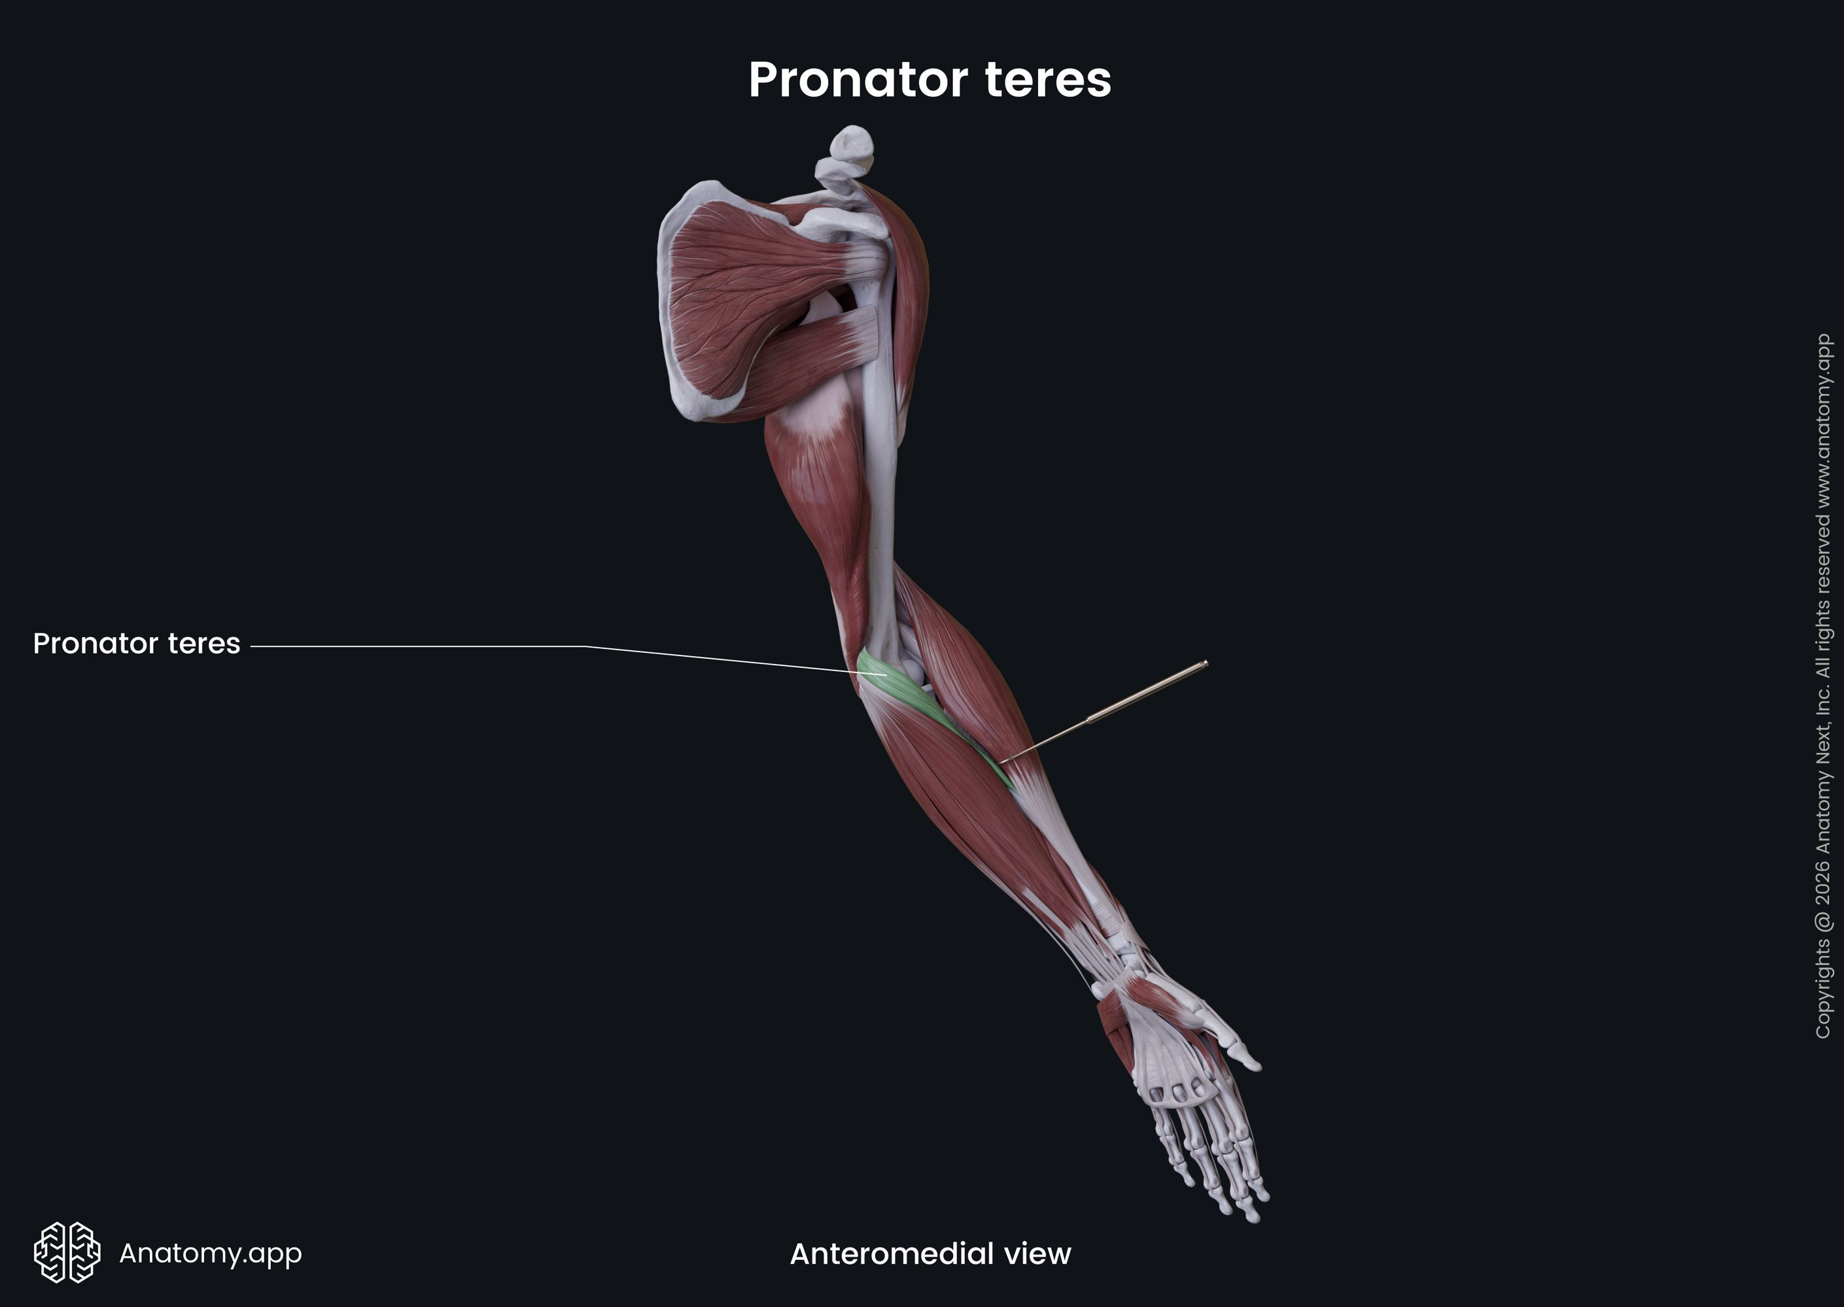
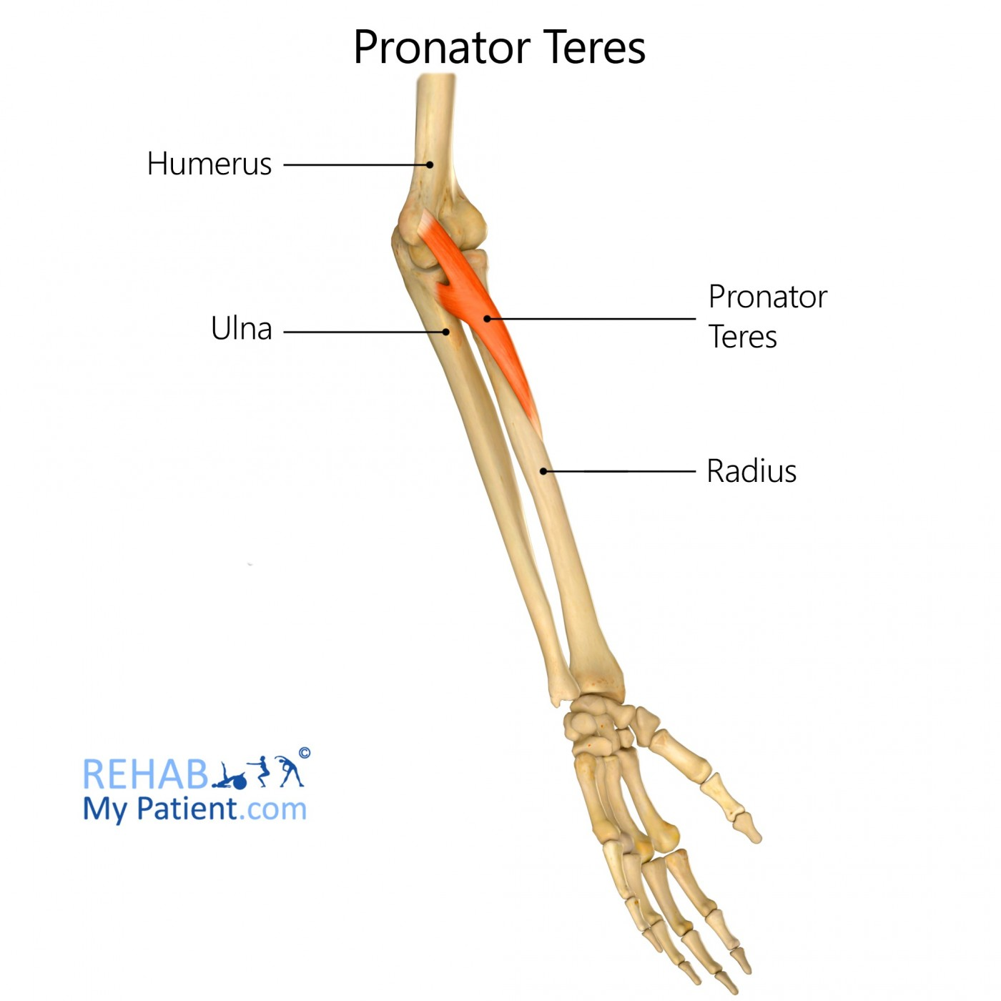
Source:
Data: Adapted from Holzbaur et al. (2005), An et al. (1981) and Murray, Delp & Buchanan (1995)
Images: Google

6.5 Triceps Brachii : [Origin-Scapula and Humerus; Insertion-Olecranon process of Ulna]
Mechanical property | Parameter / value range
Optimal fibre length (L₀) | 9.0–14.0 cm
Total muscle–tendon length | 30–45 cm
Resting muscle diameter | 4.5–7.0 cm
Contracted muscle diameter | 5.5–8.5 cm
Maximum shortening displacement | 4.0–6.5 cm
Physiological cross-sectional area (PCSA) | 12.0–22.0 cm²
Joint arc of motion (elbow) | 0° (full extension) to 150°
Electromechanical delay | 30–50 ms
Twitch contraction time | 40–60 ms
Maximum internal force (F₀) | 1,000–2,000 N
Maximum external joint torque | 40–90 N·m
Estimated external payload | 20–45 kg
Resting tendon cross-sectional area | 20–35 mm²
Tendon stiffness (k) | 150–400 N/mm
Tendon elasticity / hysteresis | 5%–10% loss
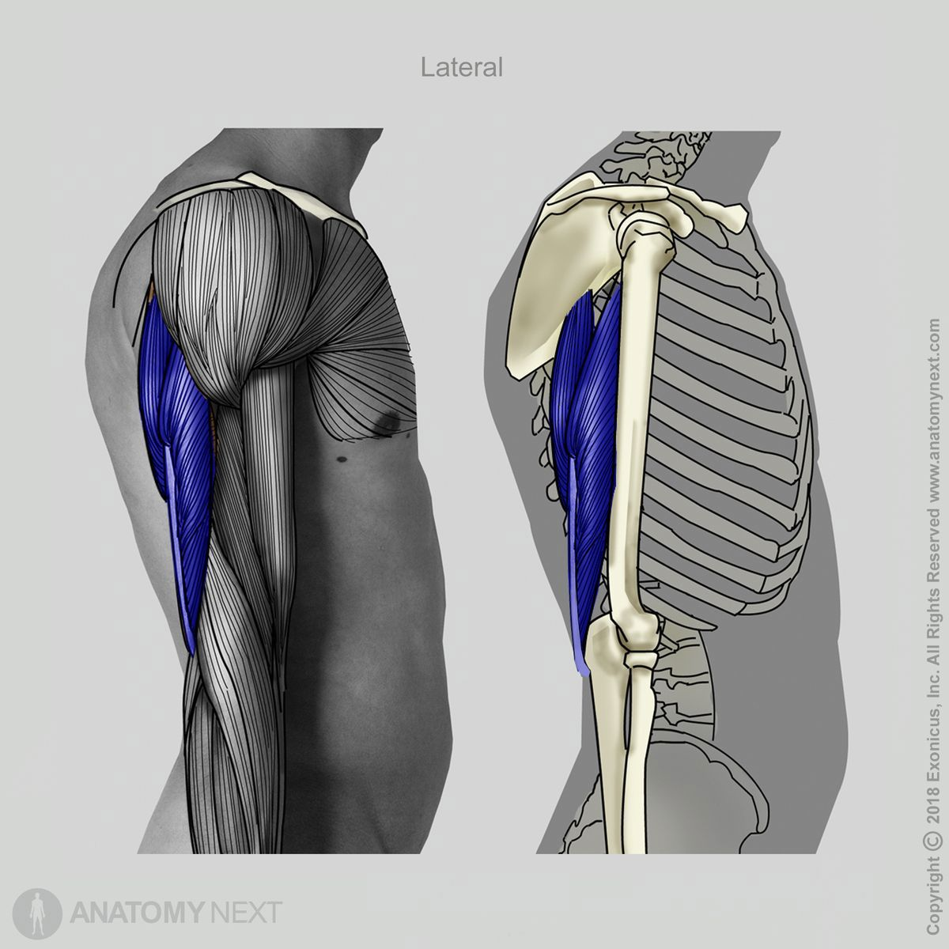
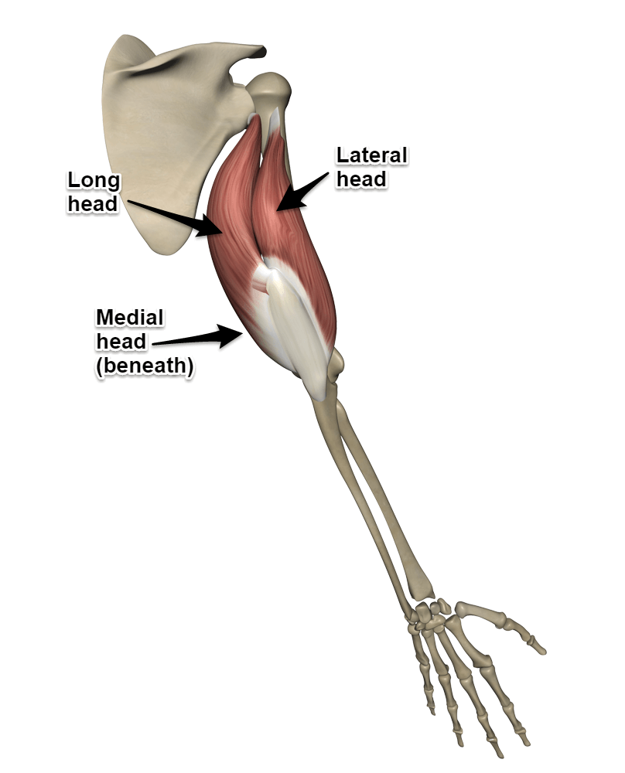

Source:
Data: Adapted from Holzbaur et al. (2005), An et al. (1981) and Murray, Delp & Buchanan (1995)
Images: Google

6.6 Anconeus : [Origin-Lateral epicondyle of Humerus; Insertion-Olecranon and proximal Ulna]
Mechanical property | Parameter / value range
Optimal fibre length (L₀) | 2.5–5.0 cm
Total muscle–tendon length | 7–10 cm
Resting muscle diameter | 1.0–2.0 cm
Contracted muscle diameter | 1.2–2.5 cm
Maximum shortening displacement | 1.0–2.0 cm
Physiological cross-sectional area (PCSA) | 1.0–2.5 cm²
Joint arc of motion (elbow) | 0° to 150°
Electromechanical delay | 30–45 ms
Twitch contraction time | 35–55 ms
Maximum internal force (F₀) | 200–350 N
Maximum external joint torque | 1–5 N·m
Estimated external payload | 1–3 kg
Resting tendon cross-sectional area | 3–8 mm²
Tendon stiffness (k) | 50–150 N/mm
Tendon elasticity / hysteresis | 5%–10% loss

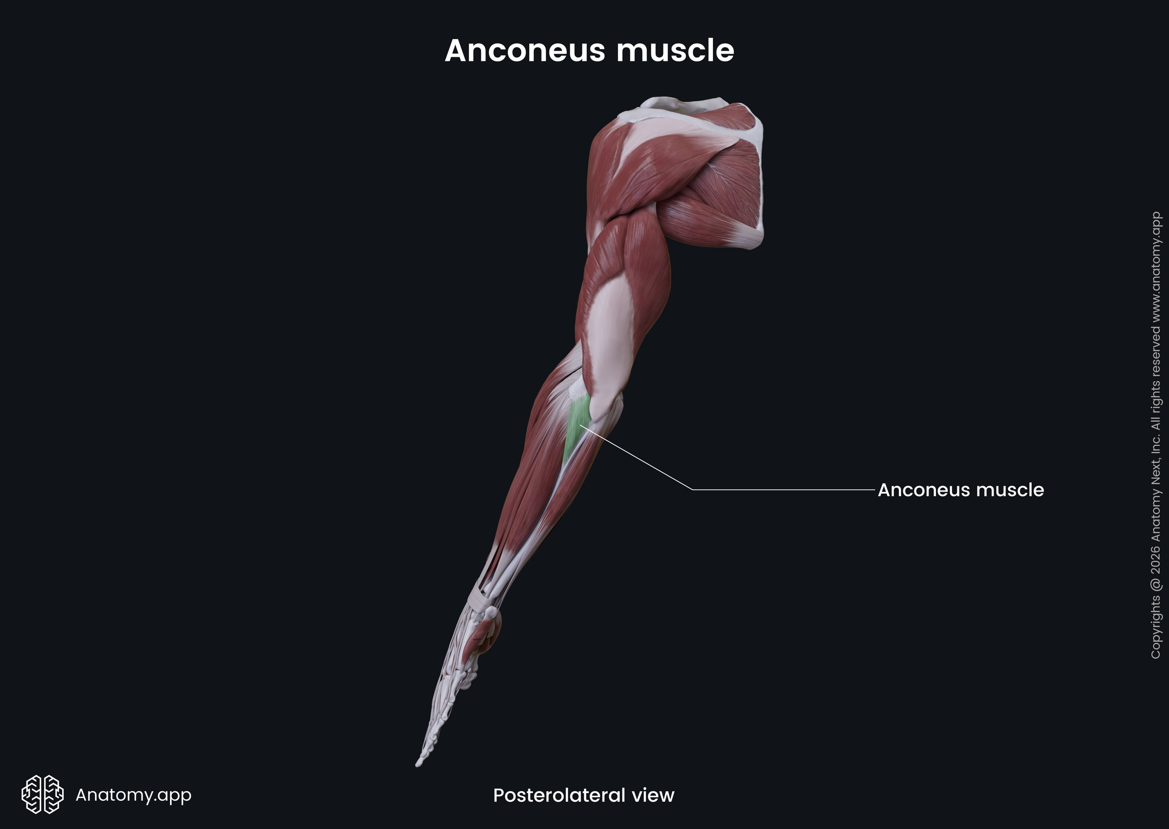
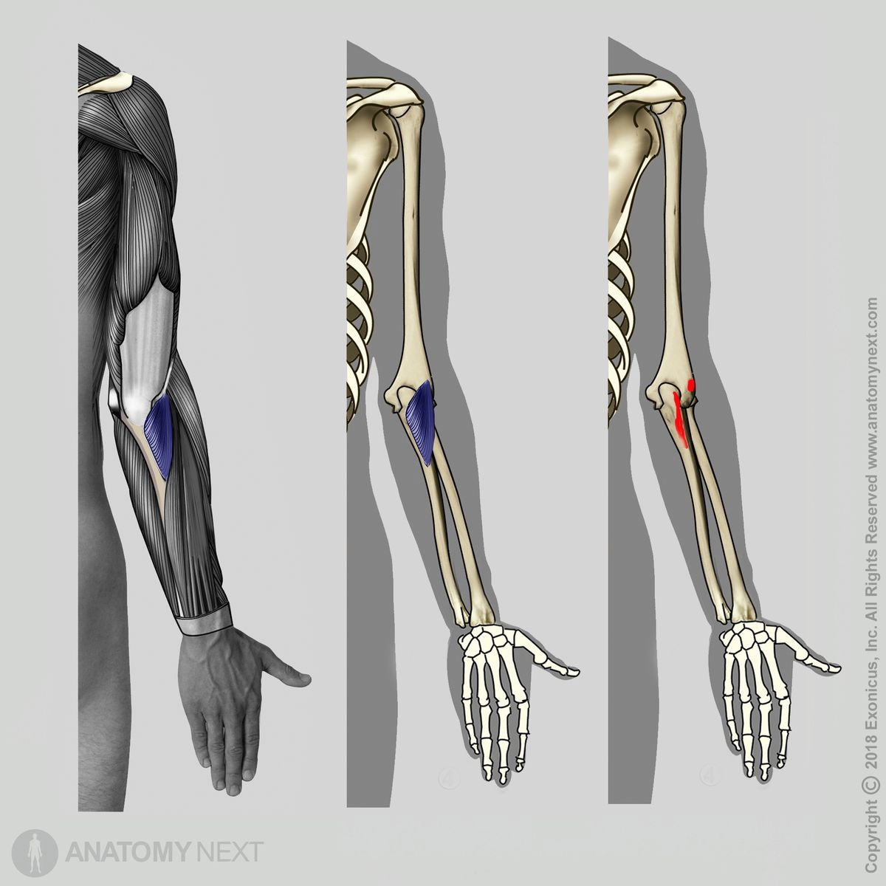

Source:
Data: Adapted from Holzbaur et al. (2005), An et al. (1981) and Murray, Delp & Buchanan (1995)
Images: Google

6.7 Consolidated comparison of selected parameters
Parameter | Biceps brachii | Brachialis | Brachioradialis | Pronator teres | Triceps brachii | Anconeus
Optimal fibre length (L₀) | 11.0–13.0 cm | 7.0–9.5 cm | 15.0–19.0 cm | 4.5–7.5 cm | 9.0–14.0 cm | 2.5–5.0 cm
Resting muscle diameter | 4.0–6.0 cm | 3.5–5.0 cm | 2.5–4.0 cm | 2.0–3.5 cm | 4.5–7.0 cm | 1.0–2.0 cm
Contracted muscle diameter | 5.0–7.5 cm | 4.2–6.0 cm | 3.0–4.8 cm | 2.5–4.2 cm | 5.5–8.5 cm | 1.2–2.5 cm
Maximum shortening displacement | 4.0–5.5 cm | 2.5–4.0 cm | 4.0–6.0 cm | 2.5–4.0 cm | 4.0–6.5 cm | 1.0–2.0 cm
Maximum internal force (F₀) | 600–1,100 N | 700–1,000 N | 150–300 N | 300–600 N | 1,000–2,000 N | 200–350 N
Electromechanical delay | 30–50 ms | 30–45 ms | 30–45 ms | 30–45 ms | 30–50 ms | 30–45 ms

Source:
Data: Adapted from Holzbaur et al. (2005), An et al. (1981) and Murray, Delp & Buchanan (1995)

7. Functional Muscle Contributions

7.1 Flexion
Flexion is the bending movement of the forearm towards the upper arm, which reduces the angle between the upper arm and forearm. [ROM: 0°– 150°]
Muscles activated and engaged:
- Biceps brachii: A major elbow flexor that contributes strongly when the forearm is supinated. It also assists in forearm supination.
- Brachialis: A strong elbow flexor that remains important across different forearm positions.
- Brachioradialis: Assists elbow flexion, particularly when the forearm is in a neutral or thumb-up position.
Antagonistic muscles and reduced activity:
- Triceps brachii: The principal antagonist of elbow flexion. Its activity generally decreases during unresisted flexion.
- Anconeus: Its activity may also decrease during unresisted flexion.
- During loaded tasks, controlled lowering, or joint stabilisation, the elbow extensors may remain partially active. Therefore, they should not be assumed to be completely relaxed.
Functional contribution:
The elbow flexors generate the flexion moment, while antagonist activity helps control movement and stabilise the joint. The level of muscle activation depends on the elbow angle, forearm orientation, movement speed, and external load.
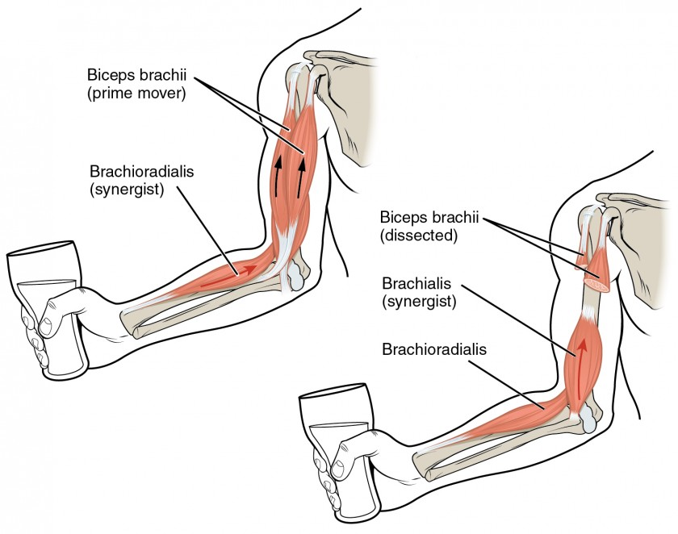

Figure : Major Muscles involved in Elbow Flexion (source google)

7.2 Extension
Extension is the straightening movement of the forearm away from the upper arm, which increases the angle between the upper arm and forearm. [ROM: 150° – 0°]
Muscles activated and engaged:
- Triceps brachii: The primary elbow extensor, producing the force required to straighten the elbow.
- Anconeus: Assists elbow extension and contributes to dynamic elbow-joint stability.
Antagonistic muscles and reduced activity:
- Biceps brachii: Opposes elbow extension and generally reduces its activity during unresisted extension.
- Brachialis: Acts as an elbow flexor and generally reduces its activity during unresisted extension.
- Brachioradialis: Opposes elbow extension and generally reduces its activity during unresisted extension.
- Flexor activity may persist during slow, precise, or loaded movements to control motion and stabilise the joint. This is known as co-contraction rather than complete relaxation.
Functional contribution:
The triceps brachii generates most of the extension moment, while the anconeus assists extension and supports joint control. Muscle activation varies with movement speed, elbow position, and resistance.
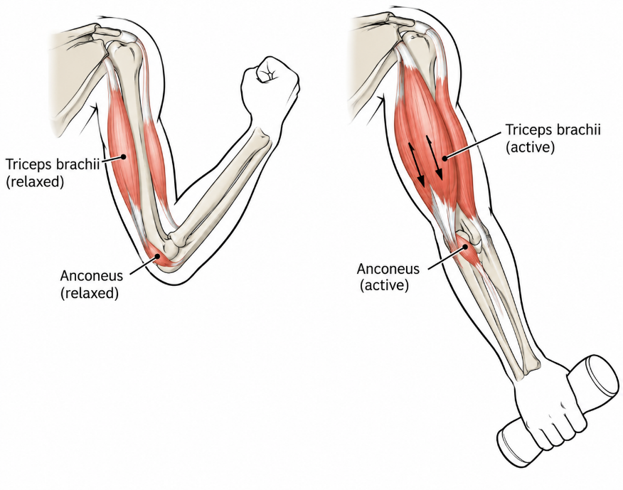

Figure : Major Muscles Involved in Elbow Extension (source google)

7.3 Pronation

Pronation is the rotational movement of the forearm that turns the palm downward when the elbow is flexed. During this movement, the radius rotates relative to the ulna.
[ROM: 0°– 80° to 90°]
Muscles activated and engaged:
- Pronator teres: An important forearm pronator, particularly during faster or resisted pronation. It can also assist elbow flexion.
- Pronator quadratus: A principal pronator that contributes throughout forearm rotation and helps stabilise the radius and ulna.
Antagonistic muscles and reduced activity:
- Supinator: Produces supination torque and generally reduces its activity during unresisted pronation.
- Biceps brachii: Opposes pronation by producing supination torque. Its activity generally decreases during unresisted pronation.
- The biceps brachii may still be recruited if the task also requires elbow flexion or forearm stabilisation.
Functional contribution:
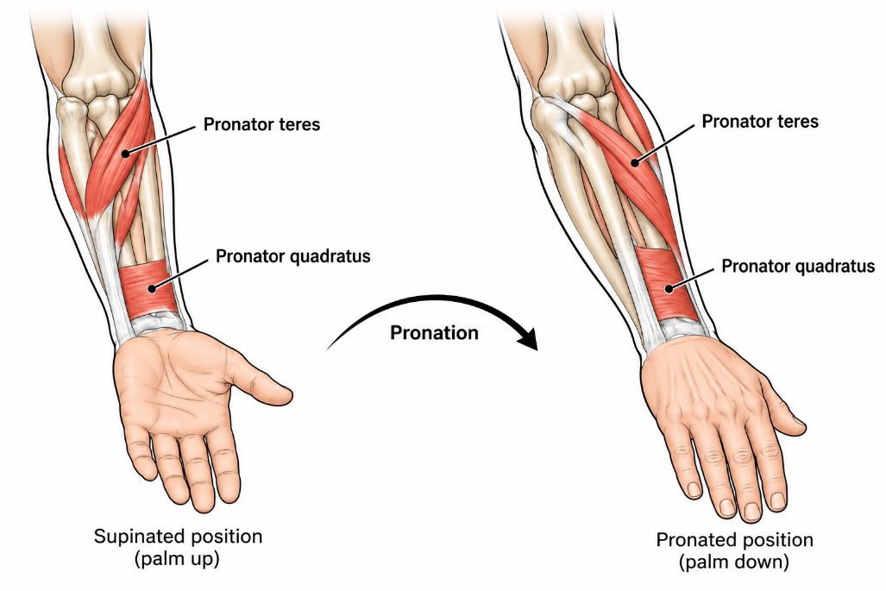
The pronator teres and pronator quadratus share the rotational demand according to forearm position, movement speed, and resistance. Antagonistic co-contraction may occur during precision movements or stabilisation tasks.

Figure : Major Muscles Involved in Elbow Pronation (source google)

7.4 Supination

Supination is the rotational movement of the forearm that turns the palm upward when the elbow is flexed. During this movement, the radius and ulna become more nearly parallel.
[ROM: 0°– 80° to 90°]
Muscles activated and engaged:
- Supinator: The primary muscle for unresisted supination, especially when the elbow is extended or the rotational load is modest.
- Biceps brachii: A powerful supinator, particularly when the elbow is flexed and supination is resisted. It also produces an elbow-flexion moment.
- Brachioradialis: Helps return the forearm towards the neutral, thumb-up position from pronation or supination. It is not a primary supinator throughout the full range of motion.
Antagonistic muscles and reduced activity:
- Pronator teres: Opposes supination and generally reduces its activity during unresisted supination.
- Pronator quadratus: Opposes supination and generally reduces its activity during unresisted supination.
- The pronators may remain partially active during controlled or resisted tasks to regulate movement speed and stabilise the forearm.
Functional contribution:
The relative contributions of the supinator and biceps brachii depend on the elbow angle and external rotational load. Muscle activation is graded rather than a fully on/off process
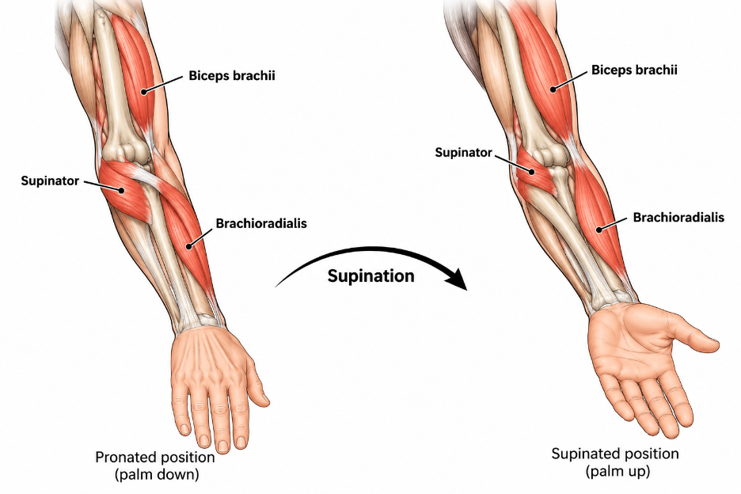

Figure : Major Muscles Involved in Elbow Supination (source google)

8. Things To Do
- Develop a biomechanical model of the human arm using open-source software OpenSim, including the relevant bones, elbow joint, muscle paths and muscle parameters.
- Estimate how the required force is distributed among the muscles when holding external mass (eg. a 5 kg load), accounting for arm posture, elbow angle, moment arms and co-contraction where relevant.
- Simulate different arm positions and payloads, then extract individual muscle forces and joint torque.
- Compare the model and simulation results with published biomechanical data and use validated estimates to inform soft-actuator requirements.
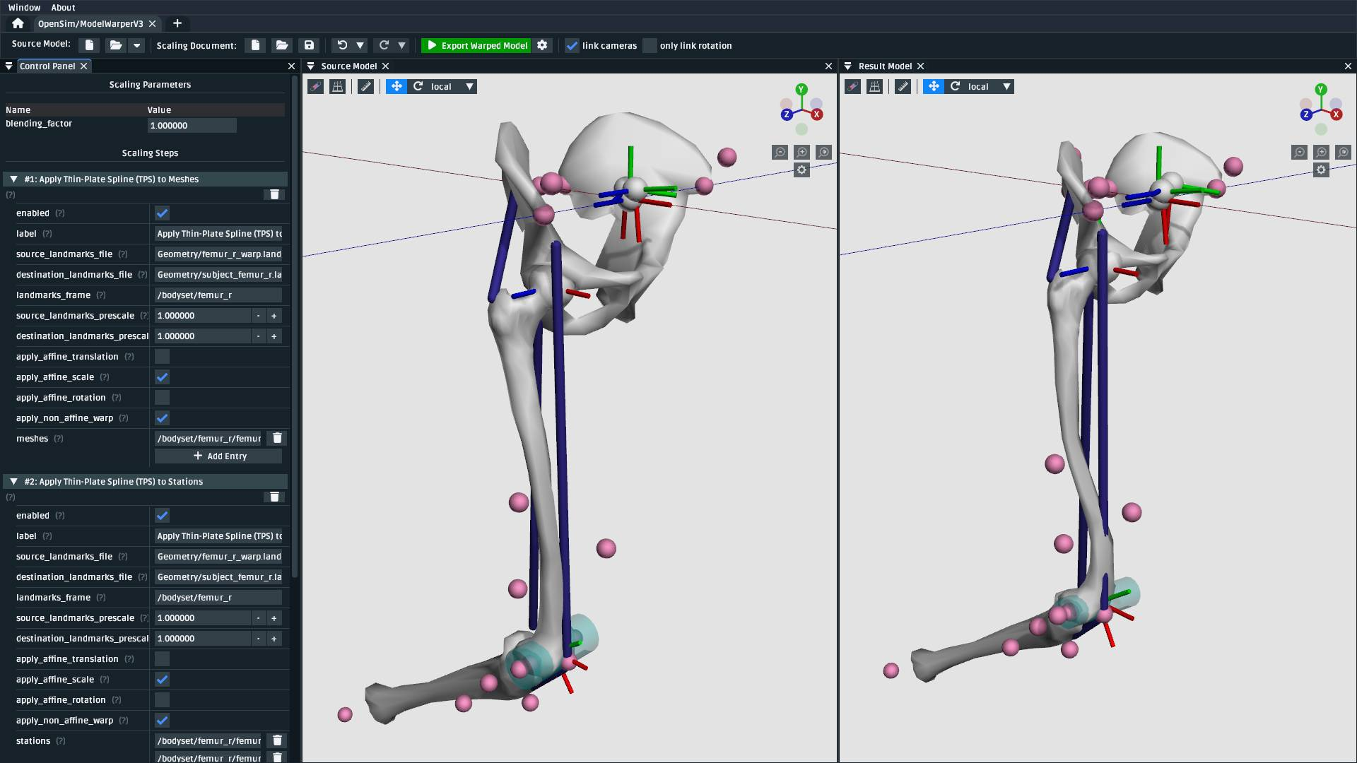
Figure : Example simulation references; these are illustrative, not results generated by this report.

9. Expected Outcomes
By the end of the internship, the work is expected to:
- Develop a detailed understanding of human-arm biomechanics and muscle characteristics.
- Analyse muscle-force distribution and joint torque during different arm movements.
- Study the effect of elbow joint angle and external payload on muscle-force requirements.
- Perform analysis and simulation using suitable biomechanical or multibody simulation software.
- Compare and validate simulation results with published biomechanical data.
- Establish a reliable range of force, torque, displacement and motion parameters.
- Use the validated parameter ranges to support the design and selection of a suitable soft actuator.

10. Conclusion
The study establishes a foundation for relating human-arm muscle characteristics to actuator design parameters. It combines an anatomical overview, a review of indicative mechanical-property ranges, and a plan for evaluating muscle contributions and joint loading through simulation. The next stage is to formalise the model inputs, run simulations across joint angles and payload conditions, and validate the outputs against published data. Only after this validation should the resulting ranges be used to guide soft-actuator design decisions.

11. References
- Holzbaur, K. R. S., Murray, W. M., & Delp, S. L. (2005). Upper-extremity model and muscle architecture parameters, including physiological cross-sectional area, optimal fibre length, tendon slack length and peak force.
- An et al. (1981). Biomechanical analysis of elbow muscles, including fibre length, physiological cross-sectional area, volume and moment arms.
- Murray, W. M., Delp, S. L., & Buchanan, T. S. (1995). Position-dependent moment arms of biceps, brachialis, brachioradialis, pronator teres and triceps.
- Buchanan (1995). Specific tension and maximum-force estimation for elbow flexors and extensors.
- Abrams et al. (2005). Experimental architecture data for pronator teres.
- Hodges et al. (2003). Muscle thickness, fascicle length and muscle-geometry changes during contraction.
- Abe et al. (2016). Ultrasound-based measurement of upper-extremity muscle thickness and its relationship with muscle size, cross-sectional area and morphology.
- Maganaris & Paul (1999). In-vivo tendon mechanical properties, including tendon cross-sectional area, force–elongation behaviour and stiffness.
- Maganaris & Paul (2000). Tendon hysteresis and energy dissipation during loading and unloading.
- Cavanagh & Komi (1979). Electromechanical delay and force-development timing in human skeletal muscles.
- Norman & Komi (1979). Electromechanical delay characteristics of biceps brachii and triceps brachii during normal movement conditions.

