**LINUX**

Name: Atharva Nagesh Jade

ID: 240840325017

**Q.1**

**Q.2**

**1. Created new directory with name as ‘exam-dir’**

**2. Renamed it as ‘new-exam-dir’ using mv command**

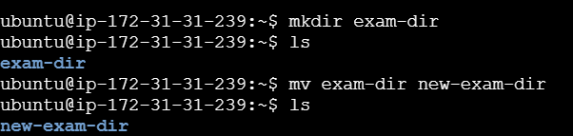

**3. New directory created as ‘new-dir’ and moved ‘new-exam-dir’ into it using mv command**

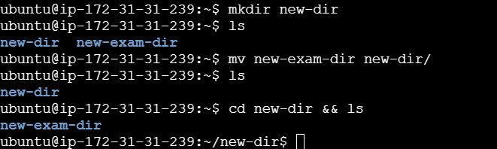

**4. Deleted ‘new-dir’ using rm -r command**

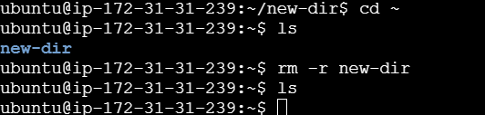

**5. Created file as ‘file1.txt’ , written some line in it using nano command**

**After that created a hard of that file as ‘hard_link_file1.txt’ and showd both of the files content using cat command**

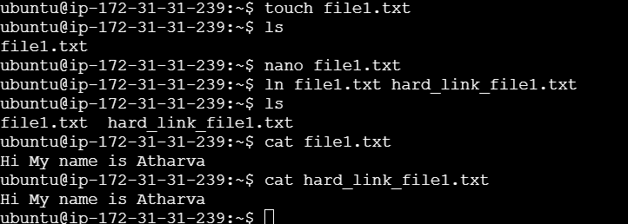

**CLOUD**

**Created an IAM user with name as ‘exam-ath-user-01’**

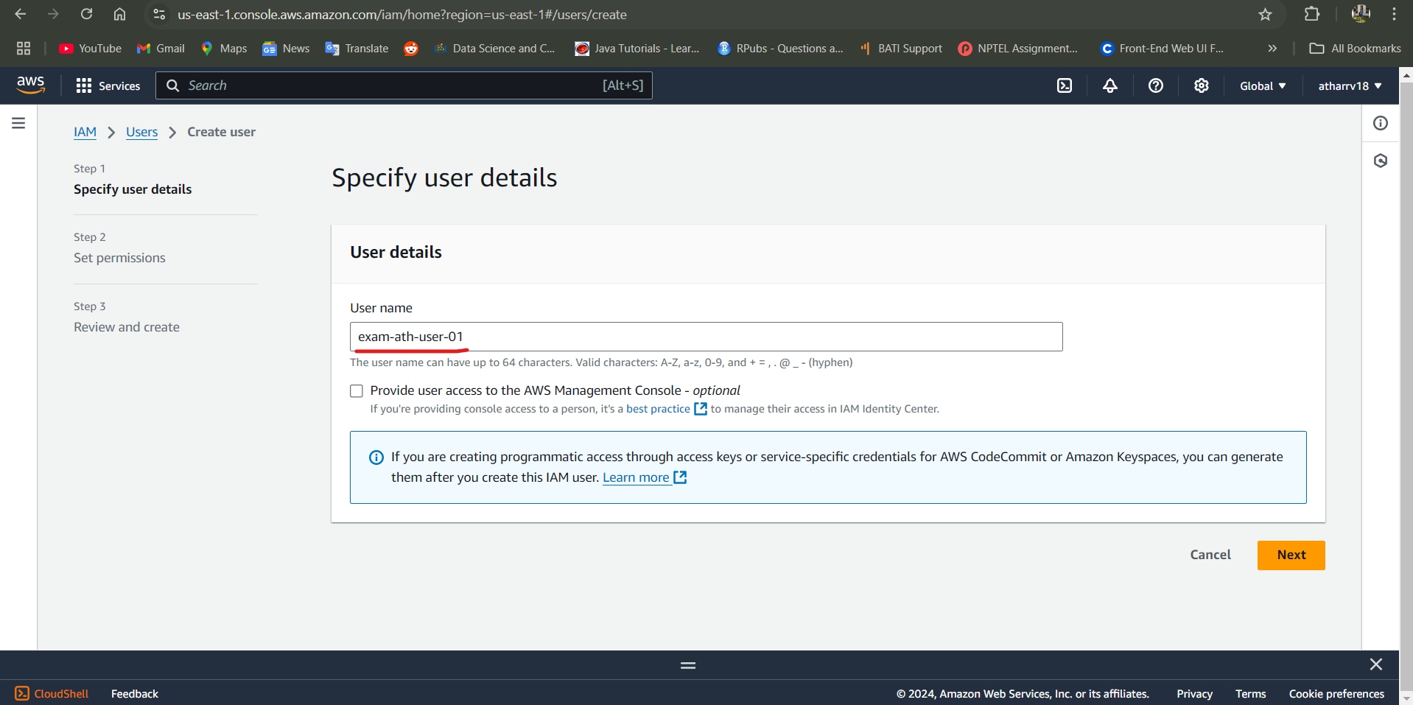

**Attached AmazonEC2FullAccess policy to it**

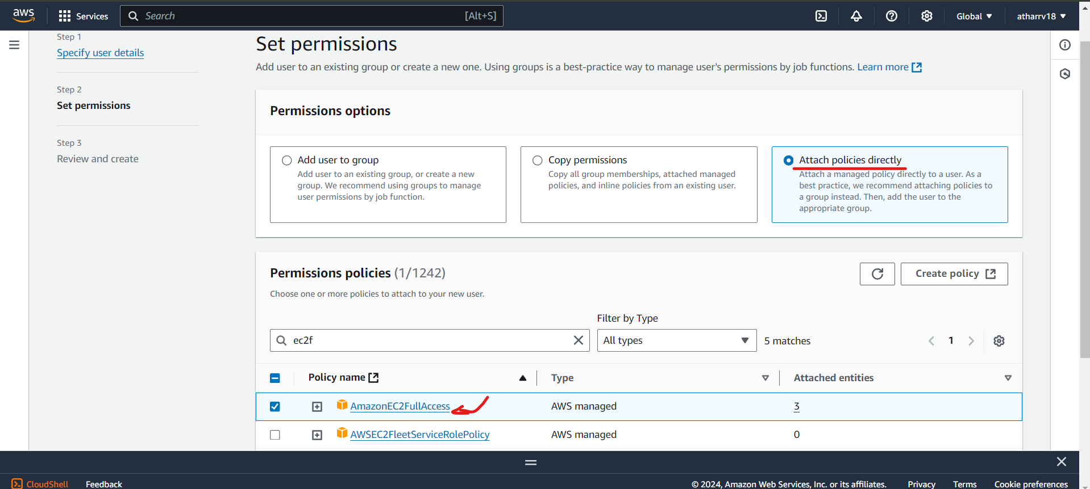

**For creating access key**

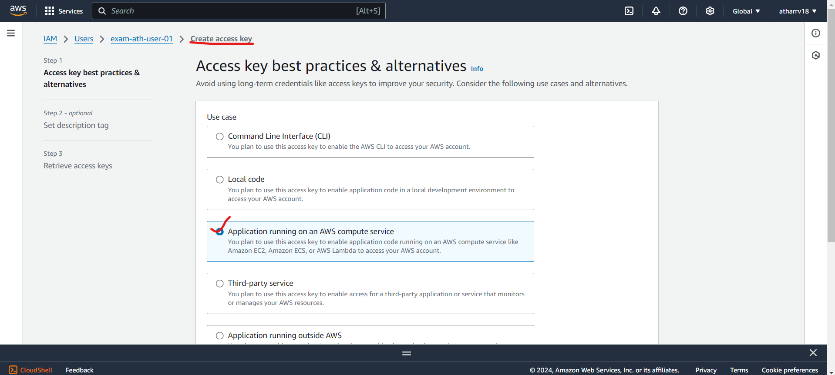

**Access key created**

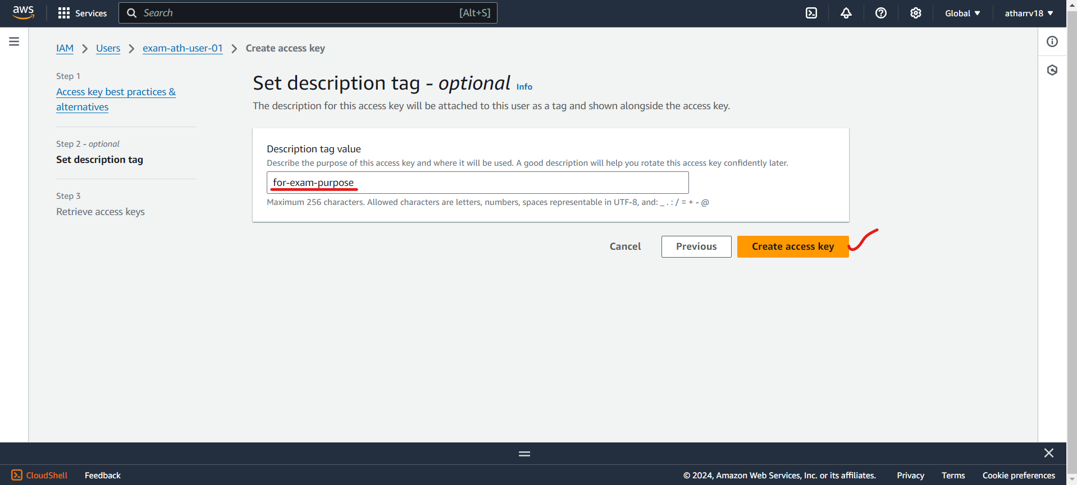

**Copy this access key and secret access for further uses**

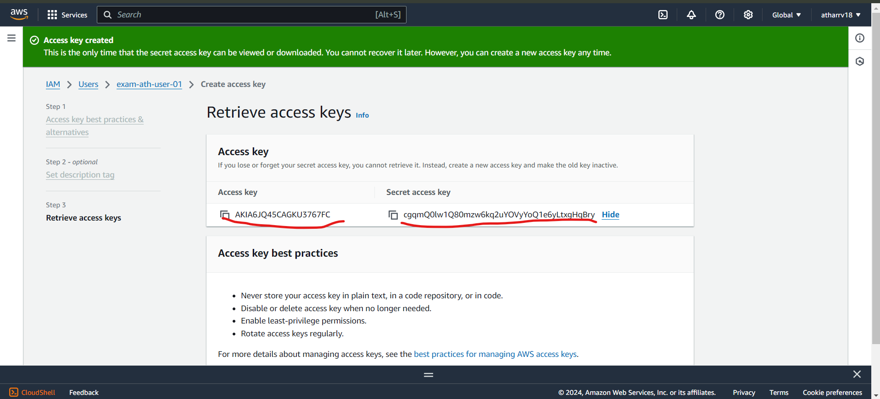

**To get password for IAM user go on Enable console access**

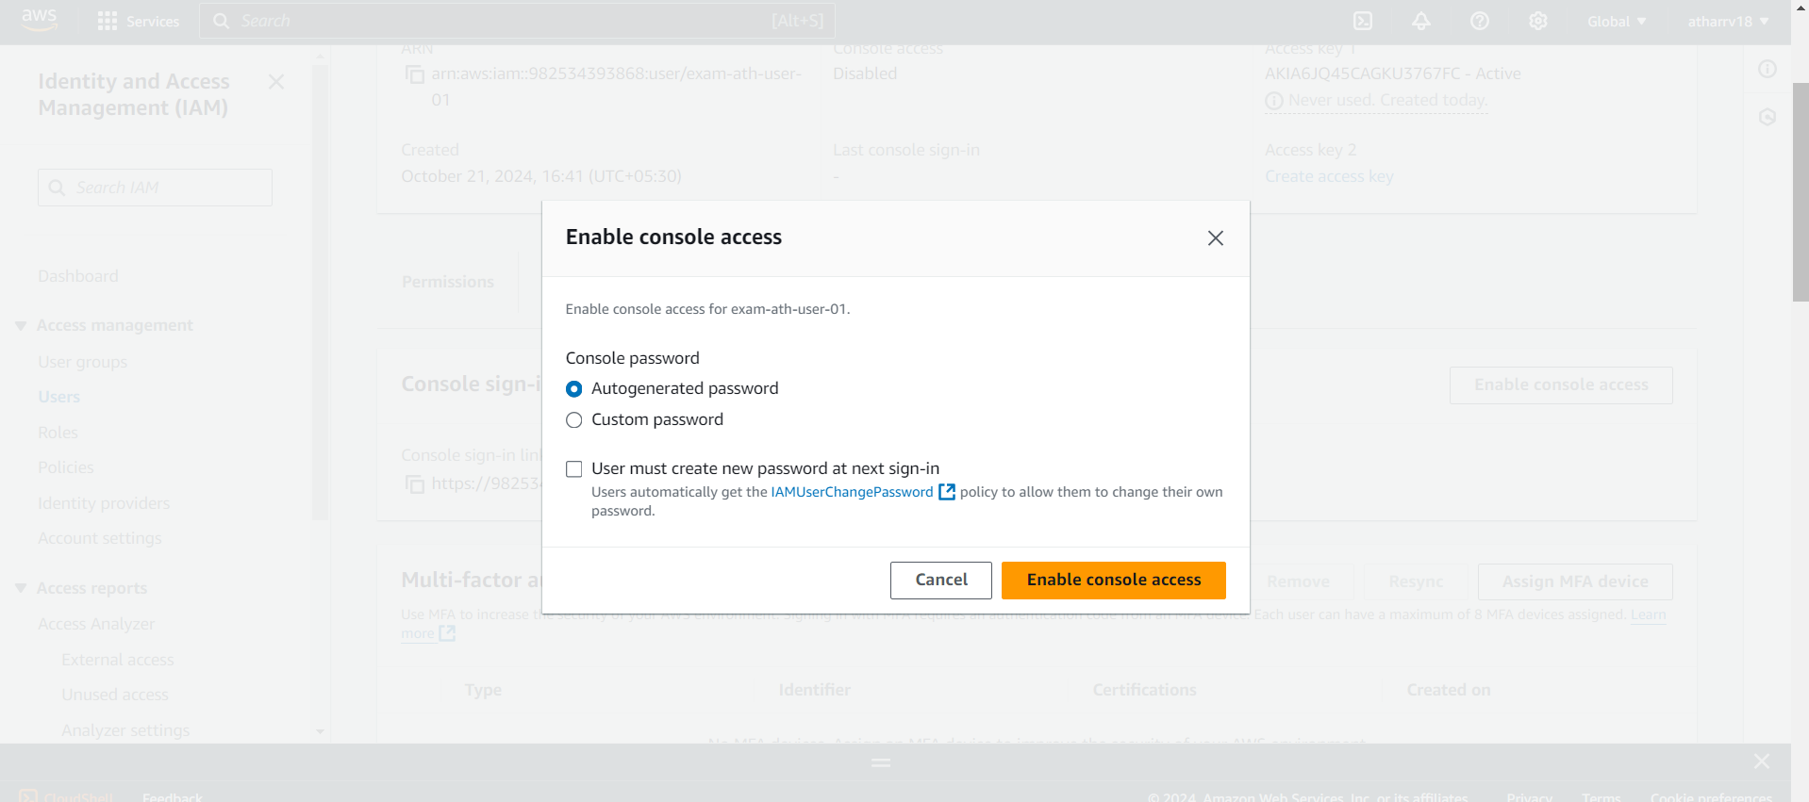

**Download the csv file which contains username and password for IAM user**

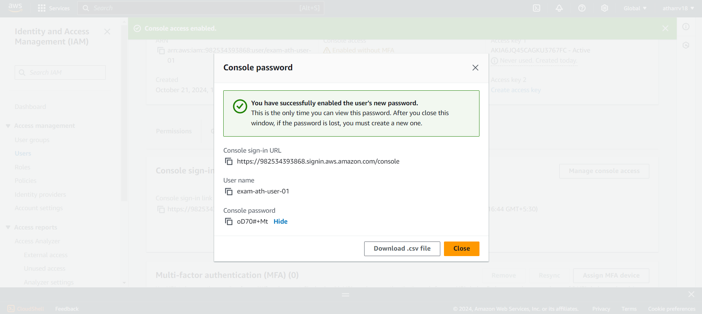

**Logging in with new IAM credentials**

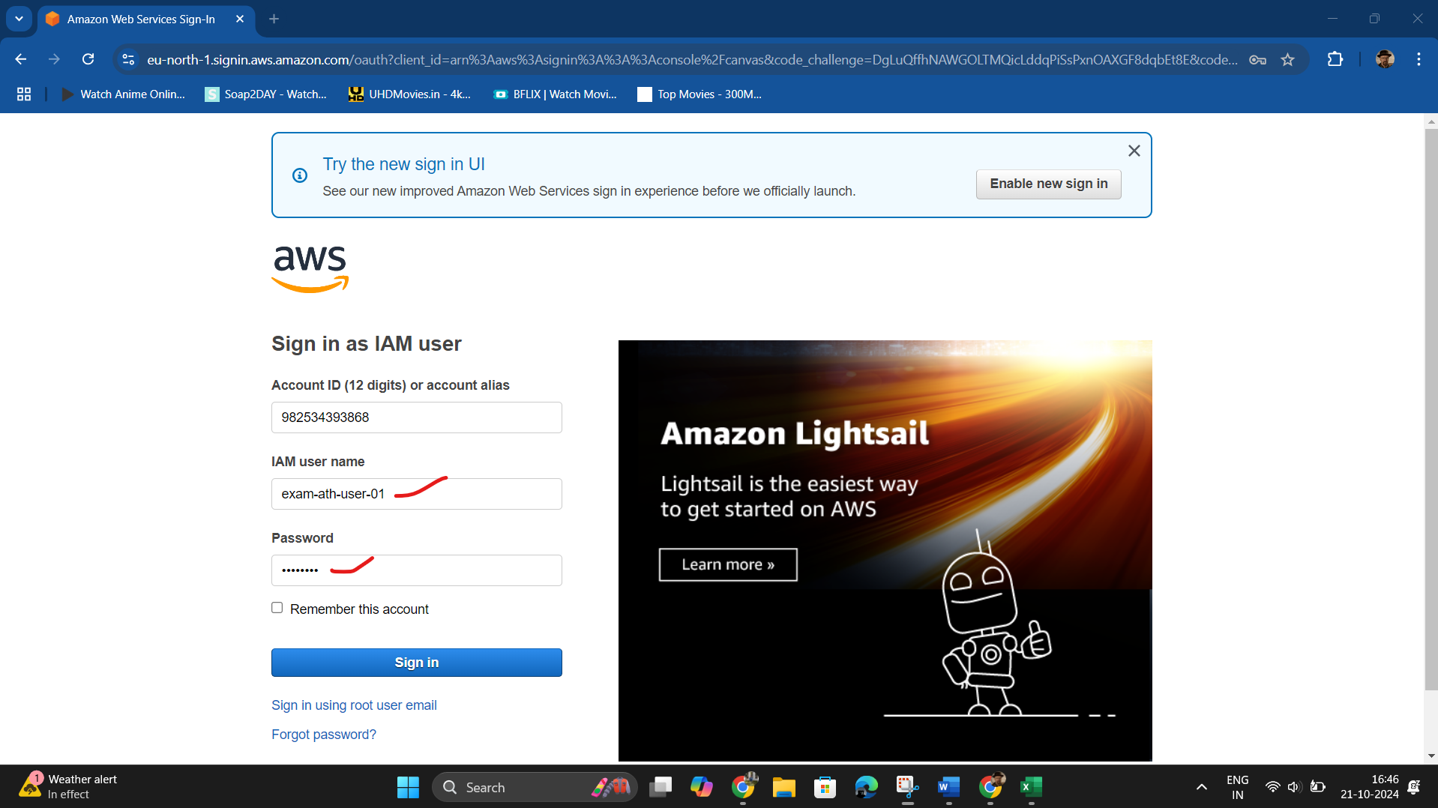

**Verifying you can successfully launch and manage EC2 instances with IAM user**

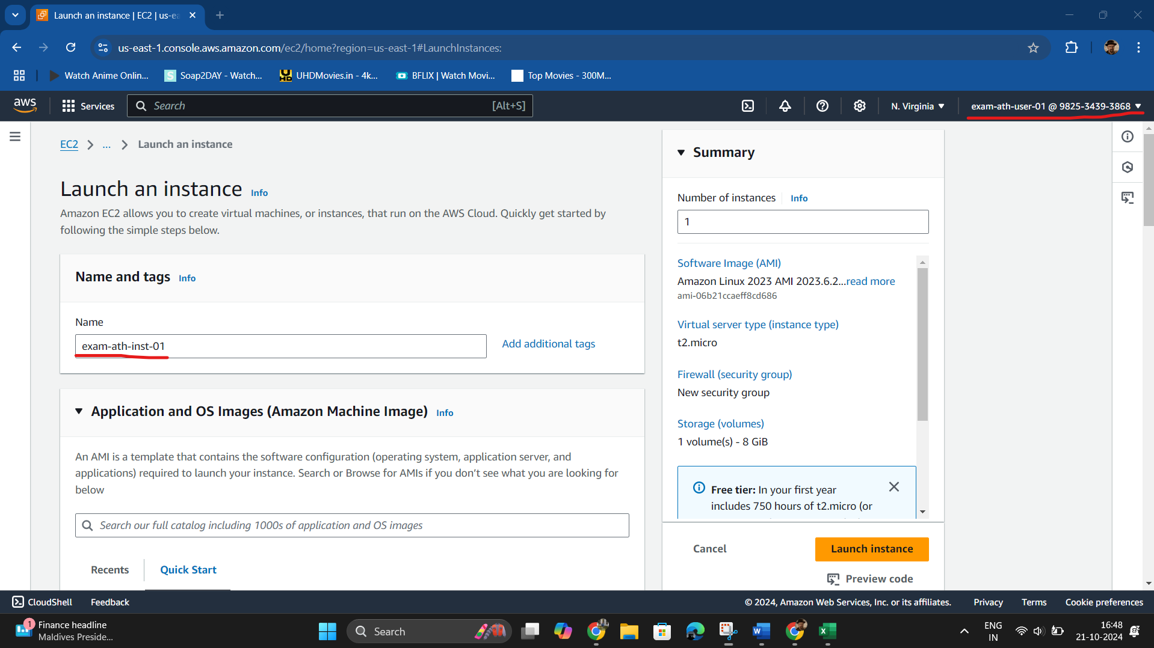

**We can see that EC2 instance can be created by IAM user**

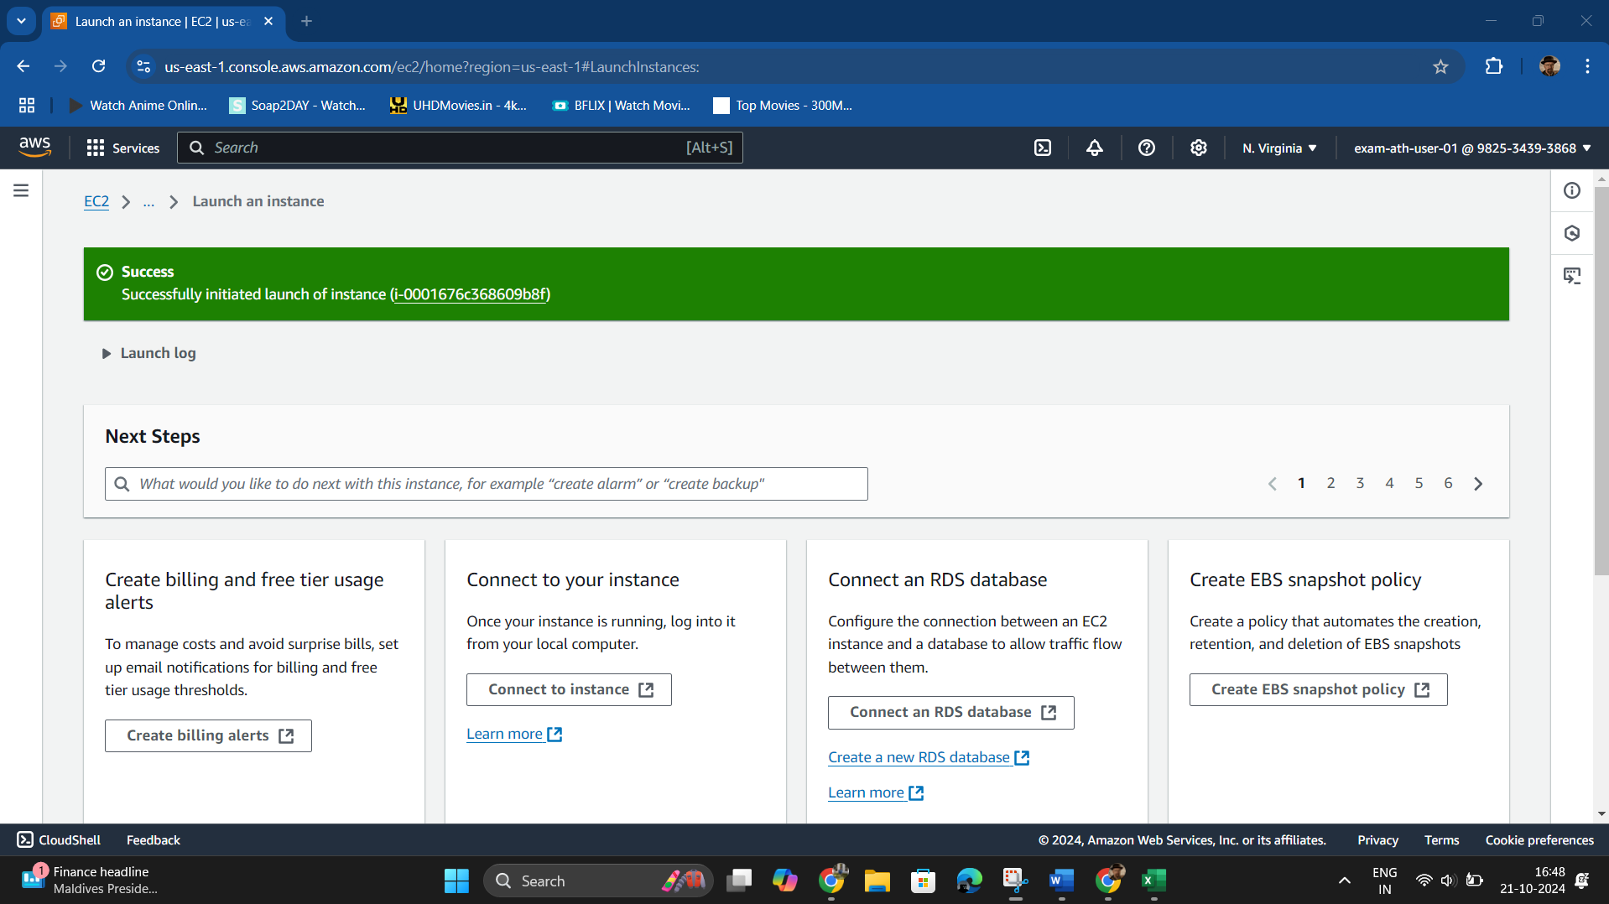

**Creating bucket for uploading HTML file**

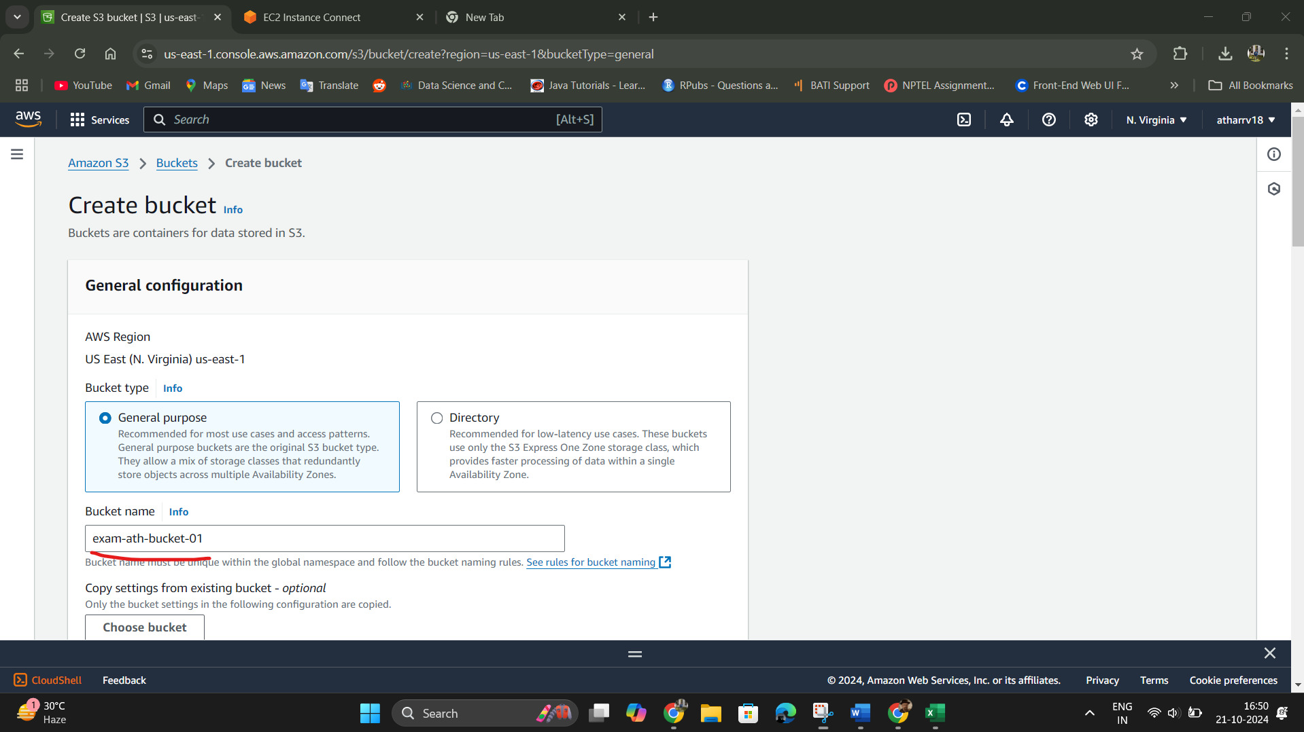

**Disable on Block all public access**

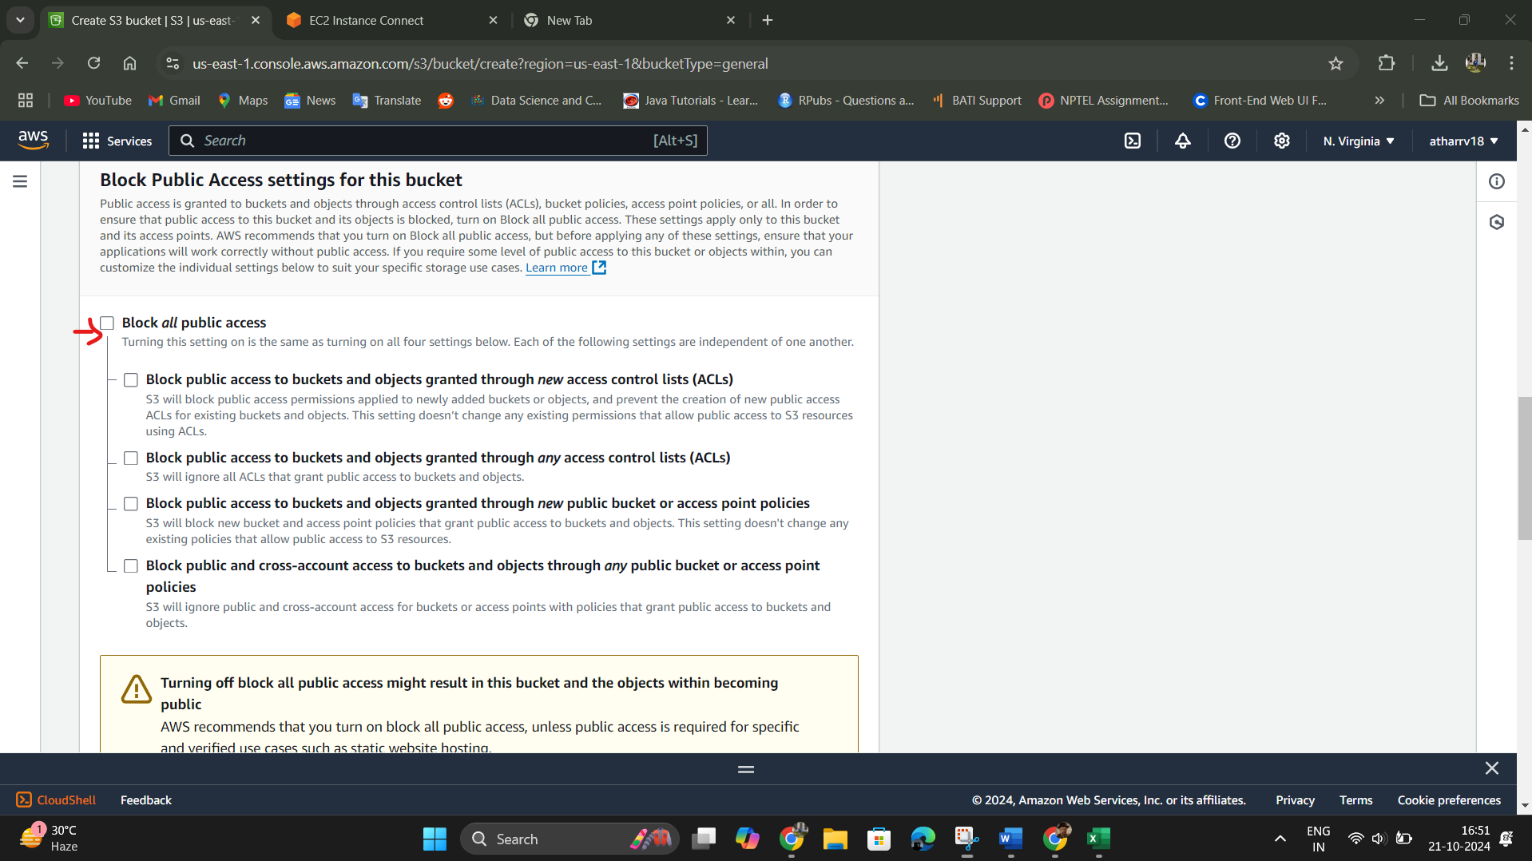

**Creating simple HTML file**

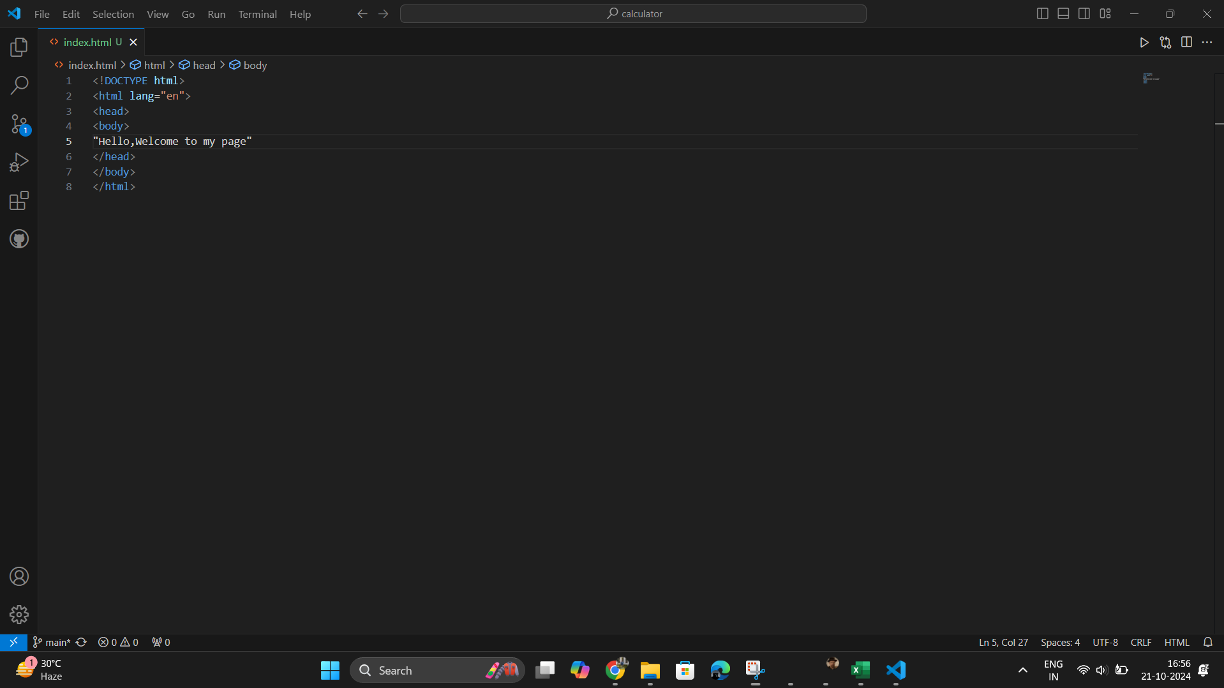

**Uploading HTML file into S3 Bucket**

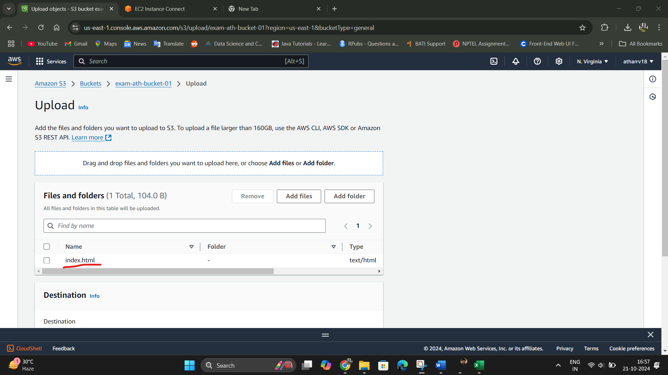

**Assuring that HTML file can be publicly accessed**

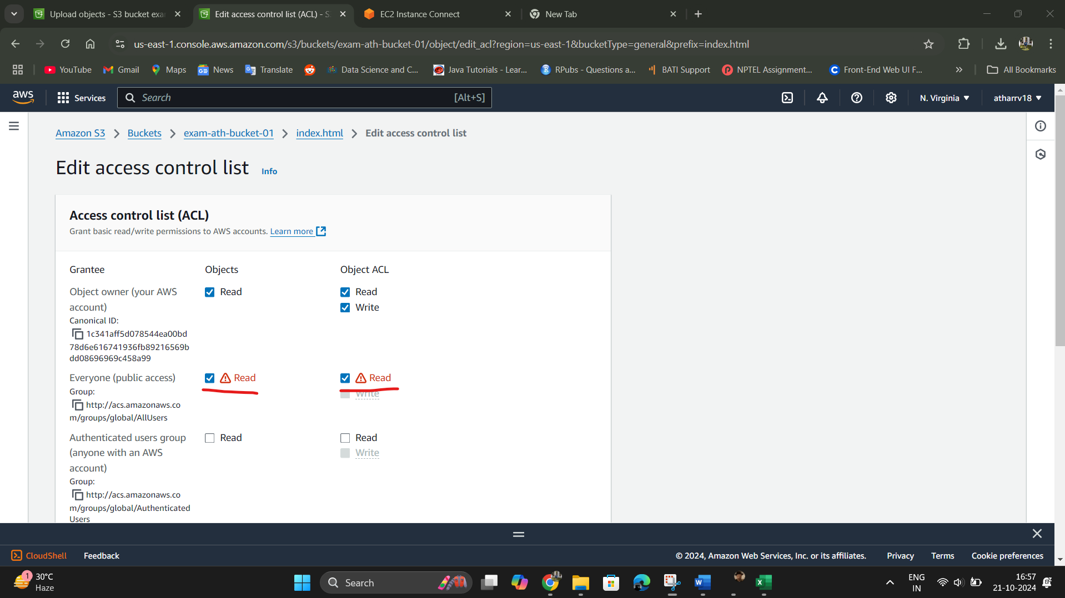

**Enabling static website hosting**

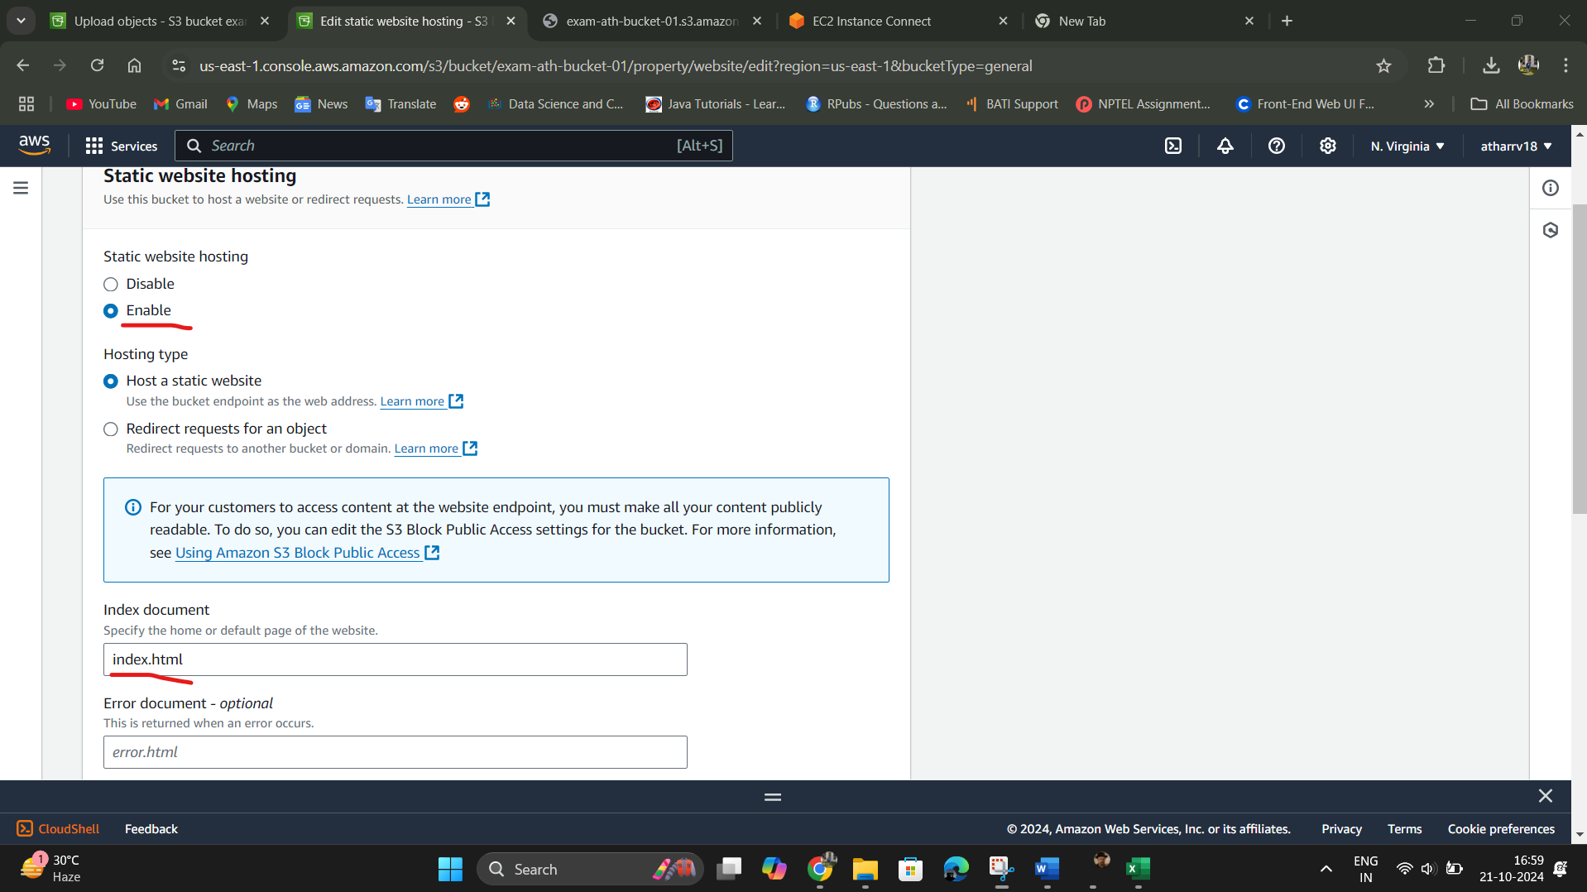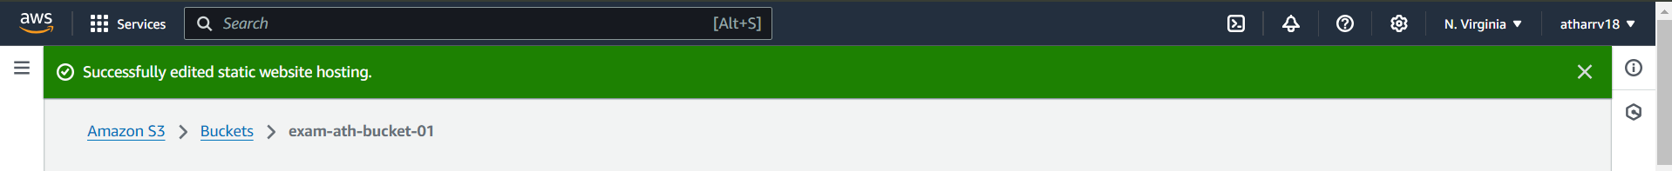

**Object URL that can be accessed by publicly**

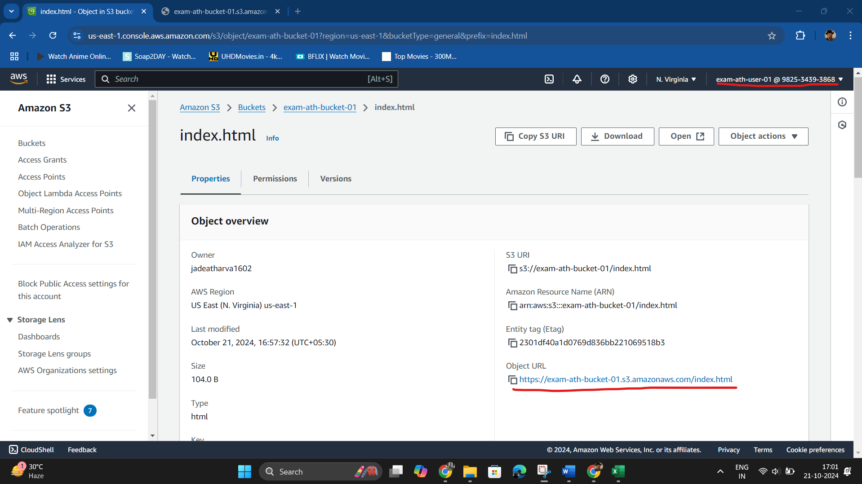

**HTML page displayed**

