TATA TECHNOLOGIES LTD.
TECH PULSE FY-26 | AI/ML Capstone Project
PROJECT SYNOPSIS

Student Details
Institute/University: Pimpri Chinchwad College of Engineering (PCCOE)
Programme / Batch: B.Tech Computer Engineering | Tech Pulse FY-26
Student Name: Atharv Rao
PRN: 123B1B024
1. Case Study ID and Project Title / Topic
Case Study ID (CS1 to CS5): CS1
Project Title / Topic: AUTOSAR Architecture Intelligence Assistant
2. Objectives
Define an evidence-backed AI/ML assistant for traceable AUTOSAR HLD analysis with synthetic/approved inputs, grounded citations, and human review.
Objectives
- Convert HLD documents into structured, project-scoped architecture entities, relationships, and source evidence.
- Combine pgvector retrieval with bounded relational graph traversal for natural-language architecture analysis.
- Support provenance, confidence, explicit/inferred classification, human validation, audit history, impact analysis, and revision comparison.
- Provide a runnable web workspace with declared model/provider dependencies and evaluation evidence without exposing secrets or treating AI output as automatic truth.
3. Scope
Scope is limited to the submitted AUTOSAR HLD-analysis workflow, synthetic demonstration data, grounded answers, graph exploration, impact analysis, revision comparison, and human review.
In Scope – To Be Implemented
- Ingest PDF, DOCX, XLSX, CSV, and Markdown with structural parsing and provenance preservation.
- Generate candidate AUTOSAR entities/relationships, resolve aliases, validate taxonomy, and persist evidence-linked relational graph facts.
- Provide hybrid retrieval (pgvector dense + PostgreSQL full-text, fused), bounded graph traversal, evidence sufficiency checks, cited and claim-verified answers, change-impact analysis, revision comparison, persisted 'potential inconsistency' findings, structured export (JSON/CSV/Excel) and review/audit workflows.
- Run locally or through Docker Compose using configurable LLM/embedding providers; use synthetic BrakeController and ABS HLD fixtures for the demonstration; process uploads through a sequential queue with a visible five-stage pipeline.
Out of Scope – Will Not Be Implemented
- Confidential/customer HLDs, production enterprise identity integration, an approved malware-scanning policy, validation of OCR on real scanned HLDs, and large-scale private deployment.
- Claims of live-model or production retrieval accuracy: results on small synthetic fixtures are reported as indicators only.
- Automatic promotion of model output to trusted architectural knowledge without validation or review.
4. Proposed Approach
Pre-trained model (name, version, local/private hosting)
Groq OpenAI-compatible API | openai/gpt-oss-120b | hosted external provider (synthetic data only); used for candidate extraction, ambiguous entity-merge decisions and answer drafting through LLMProvider. Local Ollama is supported by configuration.

Embedding model
Gemini native embeddings API | gemini-embedding-2 | 768-dimensional output; accessed through EmbeddingProvider; model name and version are stored per chunk and a change requires an explicit re-embed.

Vector store (FAISS / ChromaDB)
PostgreSQL 18 + pgvector (vector(768), HNSW cosine) as the system of record, plus PostgreSQL full-text search (tsvector + GIN) for the lexical channel; relational graph tables are used instead of FAISS/ChromaDB/Neo4j.

RAG pipeline and/or AI-agent design – brief description
Upload queue -> validation/SHA-256 -> parser, section tree, structure-aware chunks (OCR if needed) -> embeddings (pgvector) -> LLM candidate extraction -> entity resolution (blocking, guards, rules, LLM only for ambiguous pairs, Union-Find) -> deterministic validation, confidence and findings -> explicit graph build with provenance. Query: planner -> dense + lexical retrieval and bounded graph traversal -> evidence bundle -> sufficiency check (two rounds at most) -> LLM drafts cited claims -> claims verified against the cited text -> grounded answer or 'insufficient evidence' -> human review (verify / edit / reject).

Service layer and UI (e.g., FastAPI / Flask / Streamlit)
React 18 + TypeScript + Vite (3D graph with three.js); FastAPI + Pydantic v2 service layer; PostgreSQL-backed job queue with a separate worker; SQLAlchemy 2 + Alembic persistence; Docker Compose deployment.

Tools / deterministic rules, if applicable
Pydantic schema validation, controlled relationship taxonomy, entity-resolution guards and rules, confidence as a pure function, project-scoped authorization, provenance validation, bounded recursive-CTE traversal, citation and claim verification, safe untrusted-source handling, retries/timeouts, audit log and review rules.

Proposed System / Architecture
The system architecture is shown below; the editable Mermaid sources are Documentation/SYSTEM_ARCHITECTURE.mmd and Documentation/IMPLEMENTATION_WORKFLOW.mmd (rendered figures in Documentation/figures/).
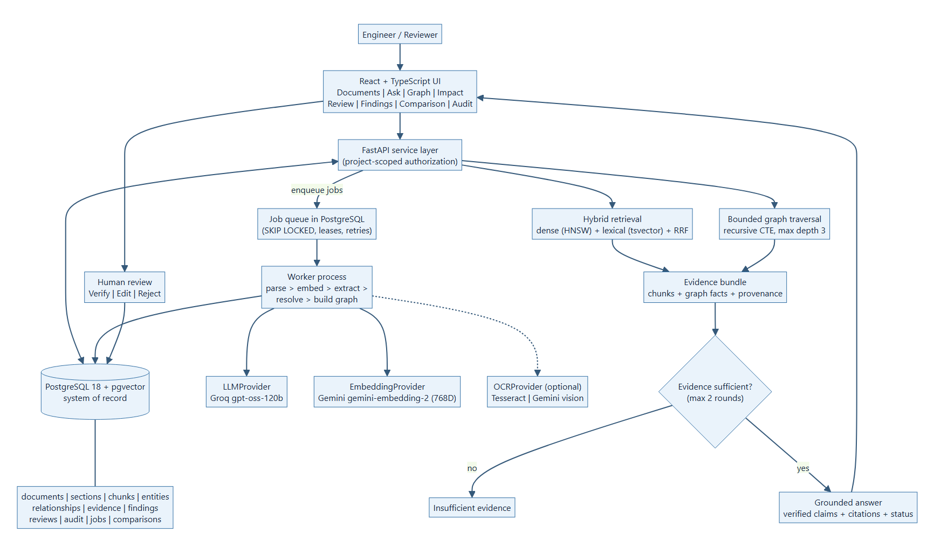
5. Input Data / Knowledge Base
Use approved or synthetic data only.
Data / Knowledge Sources
Synthetic AUTOSAR-style fixtures written for the project: BrakeController_HLD_v1.md and its revision BrakeController_HLD_v2.md, and a separate ABS_Subsystem_HLD.md (with a diagnostics table and a declared status), plus a labelled set of 23 questions for the retrieval evaluation. No confidential customer data.

Approximate Size and Format
Small UTF-8 Markdown fixtures (about 1-2 KB each) representing components, interfaces, ports, signals, functions, dependencies, aliases, tables and revision changes; the pipeline also accepts PDF, DOCX, XLSX and CSV.

Preprocessing and EDA Planned
Validate extension/MIME/size, hash and store source content (identical bytes rejected), clean headers/footers, build a section tree, create structure-aware chunks with an embedded breadcrumb, read declared document metadata, OCR scanned pages through a provider boundary, and record the embedding model/version per chunk. Numerical EDA is not applicable to the document fixtures.

6. Expected Outcomes and Evaluation Plan
Expected Outputs – aligned to the case study
Runnable web workspace; project-scoped knowledge graph with provenance; cited natural-language analysis; review/audit workflow; impact analysis, findings and revision comparison; structured export; reproducible source, configuration and evaluation package with screenshots and PostgreSQL evidence.

Evaluation Method – test question set / ground truth / metrics / validation approach
Retrieval and answer evaluation on a labelled set of 23 questions on the synthetic ABS HLD (19 answerable across components, aliases, interfaces, dependencies, ports, identifiers, timing, diagnostics and hierarchy; 4 unanswerable), run offline and with the live providers: Recall@k, MRR, citation validity, refusal accuracy, false refusals, dropped claims and latency. Manual review of end-to-end answers, graph facts, impact and revision results against a written ground truth, plus automated tests (392 backend, 29 frontend). Recorded live result: Recall@8 100%, MRR 0.97, citation validity 100%, refusal accuracy 4/4, false refusals 10.5% (2 of 19). Small, student-labelled synthetic sample: an indicator, not an accuracy claim.

Responsible AI Measures – grounding and citations / privacy / security / human oversight
Source documents remain authoritative; model outputs are candidates (always PENDING until a human verifies, edits or rejects them, with the original kept); material claims require citations and are verified against them; absent facts are refused; explicit/inferred, confidence and validation state are always shown together; findings use 'Potential inconsistency detected'; synthetic data only with hosted models; project-scoped access, safe source handling, prompt-injection separation and audit.

MLOps / Deployment Elements Planned – versioning / Docker / tracking
Versioned source, specifications and architecture decision records; 12 Alembic migrations with a drift test; Docker Compose; persistent job states with retries; audit log; versioned prompts and recorded embedding model/version; an offline and live evaluation script; a secret-scan script. No MLflow/model registry is claimed.

7. Planned AI-Tool Usage
Coding assistants used under student direction and the runtime models, with purpose and project artifact affected; this information is carried into the AI-tool usage declaration of the Technical Report.
AI Tool / Model
Codex (OpenAI)
Purpose
Specification-guided coding assistance, debugging, test development, documentation drafts, and submission packaging under student direction.
Artifact Affected
Source code, tests, configuration documentation, technical documentation, evaluation/report artifacts, and submission structure.
AI Tool / Model
Claude Code (Anthropic)
Purpose
Later-phase coding assistance under student direction: review against the case study, pipeline, retrieval, entity-resolution, graph and UI implementation, tests, evaluation runs, evidence capture and updates of the report and submission package.
Artifact Affected
Source code, tests, migrations, scripts, technical documentation, evaluation evidence, report and synopsis.
AI Tool / Model
Groq / openai/gpt-oss-120b (runtime model)
Purpose
Candidate extraction, ambiguous entity-merge decisions and grounded answer drafting through LLMProvider (output is validated, never trusted directly).
Artifact Affected
Candidate graph facts and answer drafts.
AI Tool / Model
Google Gemini / gemini-embedding-2 (runtime model)
Purpose
Chunk and query embeddings through EmbeddingProvider (768 dimensions).
Artifact Affected
Vector representations stored in pgvector.
Student Declaration
☐ I will not change the approved case-study scope, major methodology, or implementation approach without prior faculty approval.
☐ I confirm that the work submitted under this synopsis represents my own understanding and contribution, and I will be responsible for explaining every significant part of the selected case study and its implementation.

Name and Signature: Atharv Rao  Date: 7 October 2026

