DevPilot | Agentic AI Project Synopsis | Page 1
PROJECT SYNOPSIS
DevPilot
A Multi-Agent Autonomous Code Review and Debugging System

Submitted by
Yashvardhan Singh
Enrolment Number: 230770
Atharv Jain
Enrolment Number: 230635
Prepared in partial fulfillment of the Agentic AI Course
B.Tech. Computer Science and Engineering | 2023–2027
Department of Computer Science and Engineering
School of Engineering and Technology
BML Munjal University
October 2026

DevPilot | Agentic AI Project Synopsis | Page 2
1. Abstract
Software developers spend considerable time locating bugs across multiple files, analyzing stack traces, and validating patches. DevPilot is an autonomous multi-agent AI assistant designed to automate code review, root-cause diagnosis, and sandboxed test validation for Python repositories. Instead of relying on a single unconstrained LLM prompt, DevPilot divides responsibilities among specialized agents: Coordinator Agent, Codebase Analysis Agent, Debugging Agent, Testing Agent, and Patch Reviewer. The system incorporates all baseline course criteria: a mandatory Blackboard shared-state architecture, Model Context Protocol (MCP) tool integration, structured Pydantic outputs, dual-framework orchestration combining CrewAI and Google ADK via the A2A protocol, security guardrails against adversarial and toxic prompts, callback-driven monitoring, and a 40-run empirical benchmark.
2. Introduction and Problem Statement
Software debugging involves interdependent tasks: inspecting stack traces, locating relevant files, testing hypotheses, writing candidate fixes, and verifying that no existing features break. A single LLM prompt frequently hallucinates non-existent functions or produces fixes that fail regression tests. DevPilot addresses this by orchestrating specialized agents that share intermediate context through a central Blackboard state, invoke standardized tools, and validate patches in an isolated sandbox. The target users are developers and student programmers triaging Python issues.
3. Proposed Agent Design & Framework Interoperability (CrewAI + Google ADK)
To satisfy project constraints, DevPilot exclusively combines CrewAI and Google ADK. CrewAI provides high-level planning, delegation, and safety review, while Google ADK delivers tool execution, ReAct debugging cycles, and containerized testing. Cross-framework communication is achieved using the Agent-to-Agent (A2A) protocol over JSON-RPC.
Agent Name | Framework | Assigned Tools & Responsibilities | Communication / Context Role
Coordinator Agent | CrewAI | Creates investigation plan, assigns subtasks, scores candidate hypotheses, requests review. | Reads/writes global state on Blackboard; dispatches tasks via A2A.
Codebase Analyst | Google ADK | Parses AST tree, extracts functions and import dependencies, searches vector index. | Writes identified file paths, line numbers, and call graphs to Blackboard.
Debugging Agent | Google ADK | Runs ReAct loop, checks stack traces, searches documentation and web via MCP. | Reads code context from Blackboard; posts ranked root-cause hypotheses.
Testing Agent | Google ADK | Executes pytest inside an isolated Docker sandbox with strict resource limits. | Pulls candidate fix from Blackboard; writes test results and regression deltas.
Patch Reviewer | CrewAI | Runs static checks, inspects diffs, redacts secrets, generates structured report. | Pulls test results from Blackboard; creates final Pydantic output for review.
4. Context Sharing: Blackboard Architecture vs. Peer-to-Peer
Blackboard Pattern (Mandatory): Intermediate context sharing is essential for multi-agent debugging. DevPilot uses a centralized Blackboard Architecture as its primary shared-state manager. Every agent reads its inputs from and writes its findings to a shared memory/Redis store. For example, the Codebase Analyst posts repository structure, which the Debugging Agent uses to form hypotheses, and the Testing Agent uses to know which test files to run. Comparison with Peer-to-Peer (P2P): In a P2P setup, agents must message each other directly. With 5 agents, this creates up to N(N-1)/2 = 10 separate communication channels, making message ordering and tracing difficult. In contrast, the Blackboard architecture provides a single source of truth, eliminates duplicate communication, and ensures complete auditability.
5. Tool Integration using Model Context Protocol (MCP)
MCP Tools: DevPilot connects agents to external tools using the Model Context Protocol (MCP), ensuring standard schemas and safe tool execution. Four tools are implemented: (1) Custom AST Code Parser (Custom Tool): Parses Python files, extracts class/function hierarchies, and identifies syntax errors. (2) Vector Codebase DB (Database Tool): ChromaDB/SQLite store holding embedded code chunks for semantic retrieval. (3) Web Search API (External Library Tool): Tavily API lookup for error messages and documentation. (4) Containerized pytest Runner (Sandbox Tool): Executes targeted tests inside an isolated Docker sandbox with network isolation.
6. Agentic Design Patterns & Structured Pydantic Output
Design Patterns & Schemas: Architectural Patterns: DevPilot implements a Hierarchical Architecture where the Coordinator Agent manages worker nodes. This is compared against Sequential (linear pipeline without backtracking) and Parallel (concurrent hypothesis exploration). The Hierarchical pattern provides the best balance: it allows the Coordinator to request additional analysis if initial hypotheses are weak, avoiding the rigidity of sequential flows and the high token cost of unconstrained parallel runs. Structured Output: To prevent unstructured responses, all agent outputs are validated using Pydantic models. The final report is delivered in three structured formats: (a) Machine-readable JSON with diagnosis codes and confidence scores, (b) Tabular summary of modified files and test passes, and (c) Markdown summary with diffs and explanations for human review.

DevPilot | Agentic AI Project Synopsis | Page 3
7. System Architecture & End-to-End Execution Flow Diagram
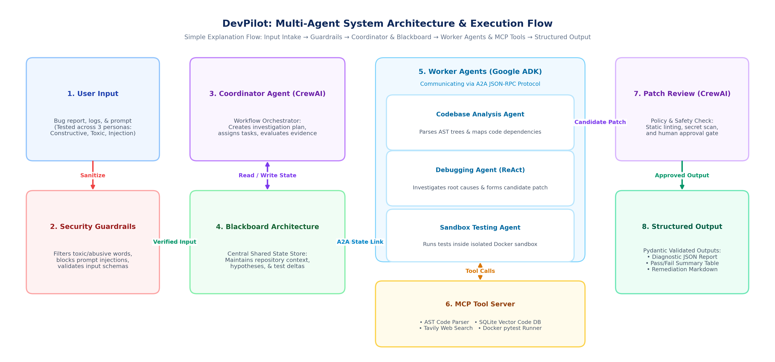
8. Methodology & End-to-End Workflow
1. Intake & Validation: User submits repository path, issue description, and stack trace. Guardrails validate prompt structure. 2. Code Analysis: Codebase Analyst inspects AST symbols via MCP tool and writes repository structure to the Blackboard. 3. Root-Cause Investigation: Debugging Agent runs ReAct loops, searches web/vector stores, and posts ranked hypotheses. 4. Sandbox Reproduction: Testing Agent reproduces the issue in a secure Docker container. 5. Patch Review: Patch Reviewer runs static linter, checks diff safety, redacts secrets, and presents fix for human approval. 6. Verification: Approved patch is executed against the test suite to verify the fix and prevent regressions.
9. Safety Controls, Guardrails & Persona Testing
Guardrails & Safety: Security is enforced at multiple stages: (a) Input Guardrails: Prompts are checked for prompt injection and toxic/abusive language. To test robustness against varied developer personas, the system evaluates three prompt profiles: Persona 1 (Constructive Developer with well-formed prompts), Persona 2 (Stressed/Frustrated Senior Dev with aggressive or toxic wording), and Persona 3 (Adversarial Red-Team user attempting prompt injection). The guardrail neutralizes toxic language and blocks injections while preserving debugging intent. (b) Runtime Callbacks: Callbacks validate tool return types against Pydantic models before data enters the Blackboard. (c) Sandbox Isolation: Code tests execute inside disposable Docker containers with network disabled and strict resource limits.
10. Task Monitoring Callbacks, Logging & MAS Heat Map
Telemetry: Monitoring is implemented using callback hooks across CrewAI and Google ADK (on_step_start, on_tool_start, on_tool_end, on_error). These callbacks log execution latency, token counts, and error occurrences. Agent Heat Map: Telemetry logs are visualized as an Agent-by-Task Execution Heat Map. This matrix highlights which agent is consuming the most execution time or retrying tool calls, making bottlenecks easy to locate and debug.
11. Observability: Tracing, Auditability & Provenance
Tracing: DevPilot integrates OpenTelemetry and Langfuse for distributed tracing. Every debugging run receives a unique run_id that traces the complete chain of agent decisions, tool calls, and state changes. SHA-256 hashes are recorded for inspected files and generated patches, ensuring full auditability and reproducible execution history.
12. Basis of Empirical Evaluation (40 Runs, Boxplot Analysis) & Cloud Deployment
Evaluation & Deployment Basis: Evaluation Basis: DevPilot is evaluated on a curated benchmark of 40 reproducible Python bug scenarios across four failure categories: Syntax/Import Errors, Algorithmic Logic Defects, Runtime Exceptions, and Environment/Configuration Faults. Testing Methodology & Boxplots: Runs compare ReAct-based hierarchical reasoning against sequential execution across three prompt personas (constructive, stressed/toxic, and adversarial). Performance is assessed on root-cause accuracy, regression avoidance, execution duration, and token usage spread. Boxplot visual distributions are used to analyze variance, median completion times, and interquartile ranges across runs. Cloud Deployment Basis: The platform is packaged into containerized microservices for deployment on cloud platforms (e.g. Google Cloud Run or AWS ECS), using a managed Redis/PostgreSQL store for Blackboard shared state and isolated Docker/gVisor sandboxes for safe untrusted test execution.
Benchmark Category | Evaluation Basis & Failure Type | Reasoning Architecture | Tested Persona Profile | Target Performance Criteria
Syntax & Import Errors (10 runs) | Missing packages, syntax mistakes, circular import errors | Hierarchical (ReAct) | Constructive Developer | Clean AST parsing & compile verification
Algorithmic Logic Defects (10 runs) | Boundary conditions, off-by-one errors, state logic bugs | Hierarchical (ReAct) | Stressed / Toxic Dev Persona | Targeted test pass & regression avoidance
Runtime Exceptions (10 runs) | AttributeError, KeyError, unhandled NoneType errors | Hierarchical (ReAct) | Adversarial Injection Persona | Guardrail defense & correct root cause
Environment / Config Faults (10 runs) | Version incompatibilities, relative path config issues | Sequential vs ReAct | Multi-Prompt Variance | Accurate diagnosis & minimal patch proposal

