ARTICLE INFORMATION
Article title
Multilingual first aid dataset: a source-cited procedure corpus with labelled emergency messages and safety test sets in English, Hindi, Hinglish and Marathi
Authors
Atharva Hemade^{a,*}, Taneesha Badheª, Siddhi Karhekarª, Soham Ghodakeª
Affiliations
ªSchool of Computer Engineering and Technology, MIT World Peace University, Kothrud, Pune 411038, Maharashtra, India
Corresponding author’s email address and Twitter handle
[institutional email address of the corresponding author]
Keywords
Emergency triage; Code-mixing; Low-resource languages; Negation detection; Clinical practice guidelines; Natural language processing
Abstract
Untrained bystanders are often the only help in the first minutes of an emergency, and in India they describe what they see in everyday, frequently code-mixed language. This article describes a dataset built to support first aid guidance in four languages: English, Hindi, Hinglish (romanised Hindi mixed with English) and Marathi. The procedure corpus contains five adult first aid situations (unresponsiveness, heart attack, choking, bites and burns) as 68 ordered steps in 10 branches, with 29 do-not rules, 13 harmful home remedies and 9 clarifying questions. Every step cites one of five guidelines published between 2024 and 2026 (IFRC, AHA/American Red Cross, AHA basic life support, ILCOR and India’s National Action Plan for Snakebite Envenoming), and all 268 text strings are available in the four languages. Four word lists (1,838 phrases with negation and uncertainty cues) map everyday phrasing to twelve structured facts. The message corpus contains 3,600 template-generated emergency descriptions (900 per language) labelled with situation, subtype, urgency and facts; a team-written safety suite of 103 messages (85 that must be treated as emergencies); a 100-message probe set of short, misspelt, code-mixed messages with silver labels; and 1,309 sentence pairs that pair each step with a safe rewording or a meaning-changing edit. Pictures and animations for key steps are included with licence records. All files are UTF-8 JSON or JSON Lines with a JSON Schema, and the scripts that generate the messages and the statistics are included. The data can be reused to train and evaluate emergency triage, situation classification, language identification and negation handling for Indian languages, to test whether a model can tell a safe paraphrase of a medical instruction from a dangerous one, and as a cited, structured first aid knowledge base.

SPECIFICATIONS TABLE
Subject | Computer Sciences
Specific subject area | Natural language processing for multilingual first aid guidance: cited procedures and labelled emergency messages in four languages.
Type of data | Table (JSON, JSON Lines), Image (WebP, SVG), Figure  Raw: procedure steps written from guidelines; Processed: labelled and generated messages, sentence pairs
Data collection | Procedure steps were written by four team members from five first aid guidelines, each citing source and page, then translated into Hindi, Marathi and Hinglish. Messages were generated from hand-written templates with a Python script; the safety suite was written by the team; the probe set was drafted with an AI assistant and labelled by rule; verifier pairs were generated from the steps. Files were validated against a JSON Schema and automated tests.
Data source location | Institution: MIT World Peace University  City/Town/Region: Pune, Maharashtra  Country: India  Primary sources: first aid guidelines G1–G5 (IFRC 2025, AHA/Red Cross 2024, AHA 2025, ILCOR 2025, NAPSE 2024) [1–5]
Data accessibility | Repository name: GitHub (firstaid-assitant) [6]  Data identification number: [DOI to be added after archiving the repository, e.g. on Zenodo or Mendeley Data]  Direct URL to data: https://github.com/atharva-1910/firstaid-assitant  Instructions for accessing these data: open access, no registration; data are in backend/content, backend/data and backend/tests.
Related research article | None

VALUE OF THE DATA
- To the authors’ knowledge, this is the first first aid dataset that stores procedures as ordered, branching steps with a guideline citation on every step, in English, Hindi, Hinglish and Marathi, rather than as unordered English question–answer pairs.
- The 3,600 labelled messages, the team-written safety suite and the probe set allow researchers to train and compare emergency triage and situation classifiers per language, including code-mixed Hinglish, and to measure how often an emergency is missed.
- The word lists with language-specific negation and uncertainty cues, together with the facts labelled on every message, support work on negation scope and fact extraction in Indian languages, where the negation cue often follows the verb.
- The 1,309 step pairs, labelled as the same or a different instruction, provide a ready test of whether a paraphrase or entailment model can catch dangerous edits to medical text, such as a removed “do not” or a changed number.
- The cited, translated procedure records and harmful-remedy list can be reused as a knowledge base for first aid apps, chatbots and training materials, and the generation scripts let others extend the data to further languages or situations.

BACKGROUND
First aid guidance is published by international bodies as long documents in English [1–4], while the people who need it in India describe an emergency in everyday Hindi, Marathi or Hinglish and often follow harmful remedies such as tying a rope above a snakebite [5]. Existing first aid datasets are English question–answer lists without step order or sources, and code-mixed Hindi–English resources mostly cover social-media tasks [9,10]. The data were compiled to build and test an assistant that shows only verified, cited first aid steps and uses natural language processing solely to decide which steps to show and when to raise an alarm.
This design required two kinds of data. The first is a structured, hand-checked procedure corpus, so that no step text is ever generated by a model. The second is a set of labelled messages and test sets in four languages to develop and evaluate language identification, fact extraction with negation handling, which clinical text processing treats as a core problem [7,8], and urgency classification. The procedure records follow a JSON Schema that rejects any step without a source, and the message sets were designed so that results can be reported per language.

DATA DESCRIPTION
The dataset [6] is stored in the repository’s backend folder as UTF-8 JSON and JSON Lines files (Table 1). The procedure corpus and its supporting files are in backend/content; the message sets are in backend/data and backend/tests; pictures are in frontend/public/steps.
Table 1. Files in the dataset.
Folder / file | Records | Format | Content
content/situations/*.json (5 files) | 68 steps, 10 branches | JSON | Procedure records: unresponsive, heart_attack, choking, bites, burns
content/lexicons/{en,hi,hinglish,mr}.json | 1,838 phrases | JSON | Phrases for each fact, negation and uncertainty cues, actions, age and time units
content/myths.jsonl | 13 | JSON Lines | Harmful home remedies with reason, source and matching patterns
content/questions.json | 9 | JSON | Clarifying questions with answer options and the facts each answer sets
content/strings.json | — | JSON | Disclaimer and handover-summary text in four languages
content/schema/situation.schema.json | — | JSON Schema | Required fields and allowed values of a procedure record
data/queries/train.jsonl, dev.jsonl | 2,880, 720 | JSON Lines | Template-generated messages with labels
tests/safety_suite.jsonl | 103 | JSON Lines | Team-written must-pass messages
data/queries/probe_labelled.jsonl | 100 | JSON Lines | Short, misspelt, code-mixed messages with silver labels
data/verifier/adversarial.jsonl | 1,309 | JSON Lines | Step / candidate pairs labelled same or different
data/queries/test.jsonl | 0 | JSON Lines | Placeholder for a hand-written test set
frontend/public/steps/ | 14 steps, 3 animations | WebP, SVG | Step pictures and animations with licence records

Each procedure record holds the situation name and recognition signs in four languages, the fact that selects a branch, and the branches with their steps, do-not rules and urgency rules (Table 2). A step stores its text in four languages, its order and the next step, which can depend on a fact (for example, breathing normally leads to the recovery position and not breathing to CPR), and its source as a document code (G1–G5) and page.
Table 2. Fields of a procedure step (content/situations/*.json).
Field | Type | Description / allowed values
id, order | Text, integer | Step identifier (e.g. burns_fire_s2) and position in the branch
text.en / .hi / .hinglish / .mr | Text | The instruction in each language
next | Text or rule | Next step, or {on: fact, cases: {value: step}} for a branch point
source.doc, source.page | Code, integer | G1–G5 or UNSOURCED; page in the source document (null if not yet filled)
also_in | List | Supporting sources
agreement | Categorical | agree, differ, single_source, unchecked
evidence | Categorical | strong, weak, good_practice, unchecked
verified, verify_note | Boolean, text | Whether the step has been checked against the source, and what to check
image, animation | Object | File, author, licence, licence URL, source URL and alt text in four languages
aid, check | Object | Timer, stopwatch, counter or time note; a Yes/No question routing to the matching step

The message files share one record format (Table 3). Each template message carries a situation (six classes: five situations and out_of_scope, which includes child and infant cases), a subtype, an urgency (emergency, clinic or home; empty for out_of_scope) and the facts it states (slots). The 3,600 template messages are balanced at 150 per class per language. The safety suite records whether each message must be treated as an emergency; the verifier pairs record the kind of edit and the label.
Table 3. Fields of the message files.
File | Fields | Example values
train / dev | id, lang, text, situation, subtype, urgency, slots, split, written_by | hinglish, burns, electrical, emergency, {burn_cause: electrical}
safety_suite | id, lang, text, must_be_emergency, expect | true, bites
probe_labelled | id, lang, text, situation, subtype, urgency, labelled_by | bites, insect_sting, emergency
adversarial | premise, hypothesis, lang, kind, label, source | number_changed, different, burns_fire_s2-en

The 68 steps are distributed over branches as shown in Fig. 1; the unresponsive record is the longest (14 steps) because it splits into a CPR path and a recovery-position path. The IFRC guideline (G1) is the main source of 46 steps (67.6%), the AHA guidelines (G2, G3) of 20, and 2 electrical-injury steps have no source yet (Fig. 2a). The 13 harmful remedies cite G1 (9), G5 (3) and G2 (1) (Fig. 2b).
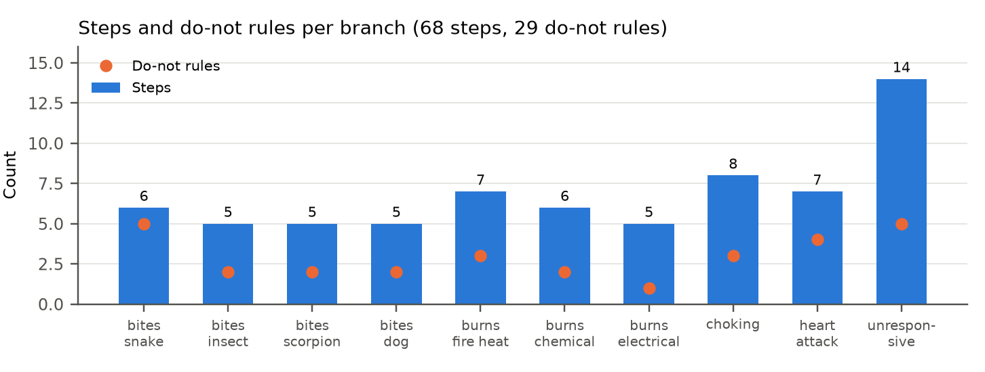
Fig. 1. Number of steps (bars) and do-not rules (dots) in each branch of the procedure corpus.
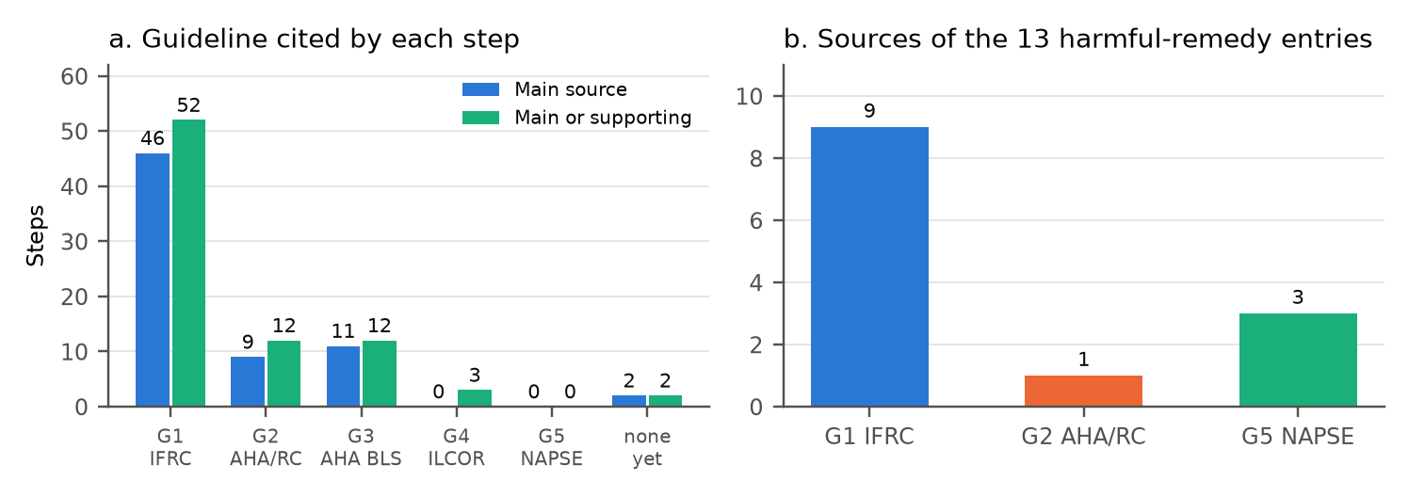
Fig. 2. (a) Guideline cited by each step as main or supporting source; (b) sources of the harmful-remedy entries.
Fig. 3 shows the subtypes and urgency labels of the template messages. Of the 3,600 messages, 2,083 (57.9%) are emergencies, 443 clinic, 250 home, and 824 have no urgency (out of scope). Template messages average 11.0 words in English, 9.9 in Hindi, 9.7 in Hinglish and 7.8 in Marathi; safety-suite and probe messages are shorter and use more distinct words per message (Fig. 4). The 720 English training messages use 135 distinct words. 43% of Hinglish template messages and 28% of Hinglish probe messages contain both Hindi and English words (mean Code-Mixing Index [9] 5.9 and 6.3).
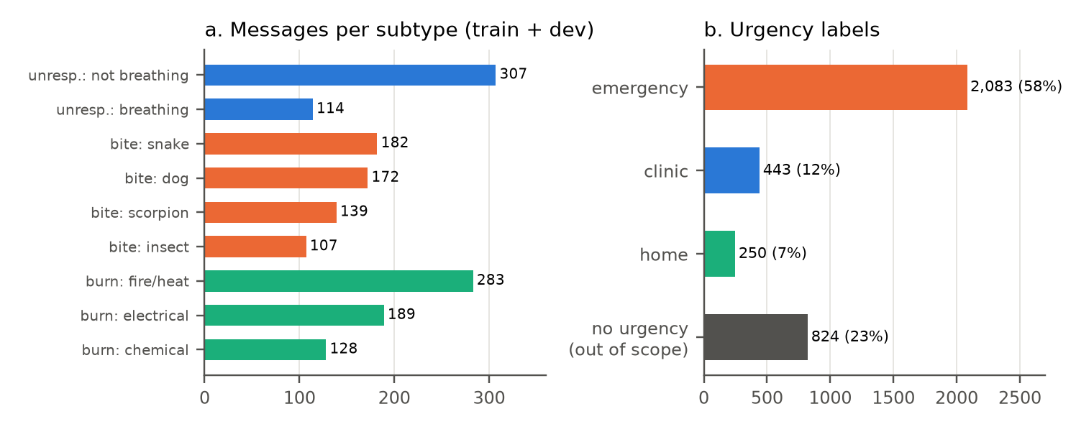
Fig. 3. (a) Template messages per subtype; (b) urgency labels (train + dev, n = 3,600).
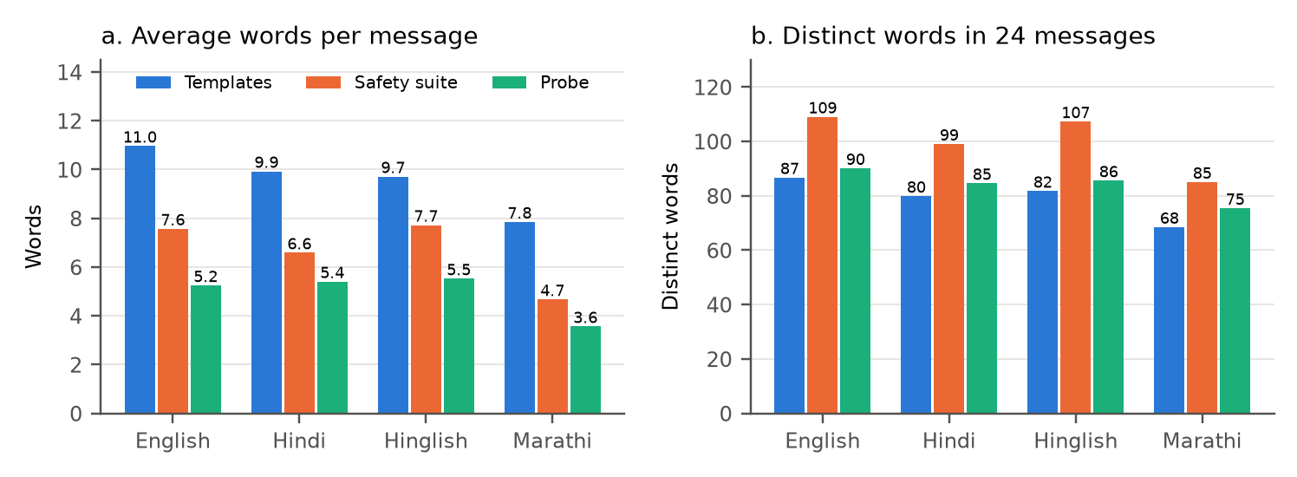
Fig. 4. (a) Average words per message and (b) distinct words in 24 messages, by message set and language.
Table 4. Messages per language in each message set.
Set | English | Hindi | Hinglish | Marathi | Total
Template (train + dev) | 900 | 900 | 900 | 900 | 3,600
Safety suite | 30 | 24 | 25 | 24 | 103
Probe | 25 | 25 | 25 | 25 | 100
Verifier pairs | 315 | 333 | 334 | 327 | 1,309

Of the 1,309 verifier pairs, 804 are labelled same (identity 352, punctuation 352, polite form 100) and 505 different (negation removed 178, negation added 174, antonym 69, number changed 64, call to 112 dropped 20) (Fig. 5a). Page numbers are filled for 45 of 68 steps; agreement and evidence labels are unchecked and no step is yet marked verified, and all five records have review status draft (Fig. 5b). Fig. 6 shows an excerpt of the English template messages and safety suite.
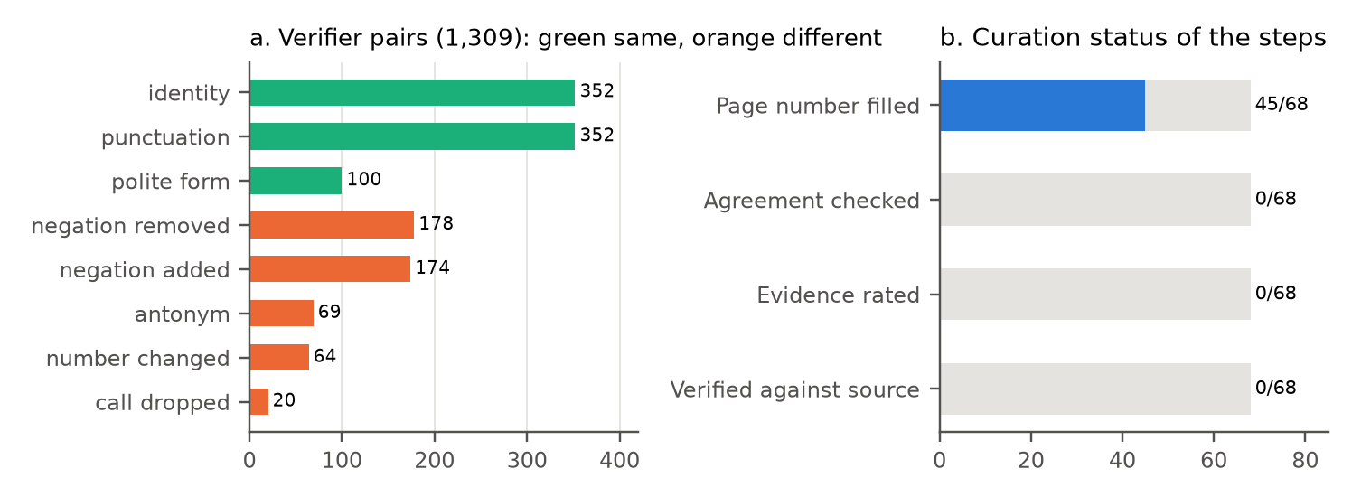
Fig. 5. (a) Verifier pairs by kind of edit; (b) curation status of the procedure steps.
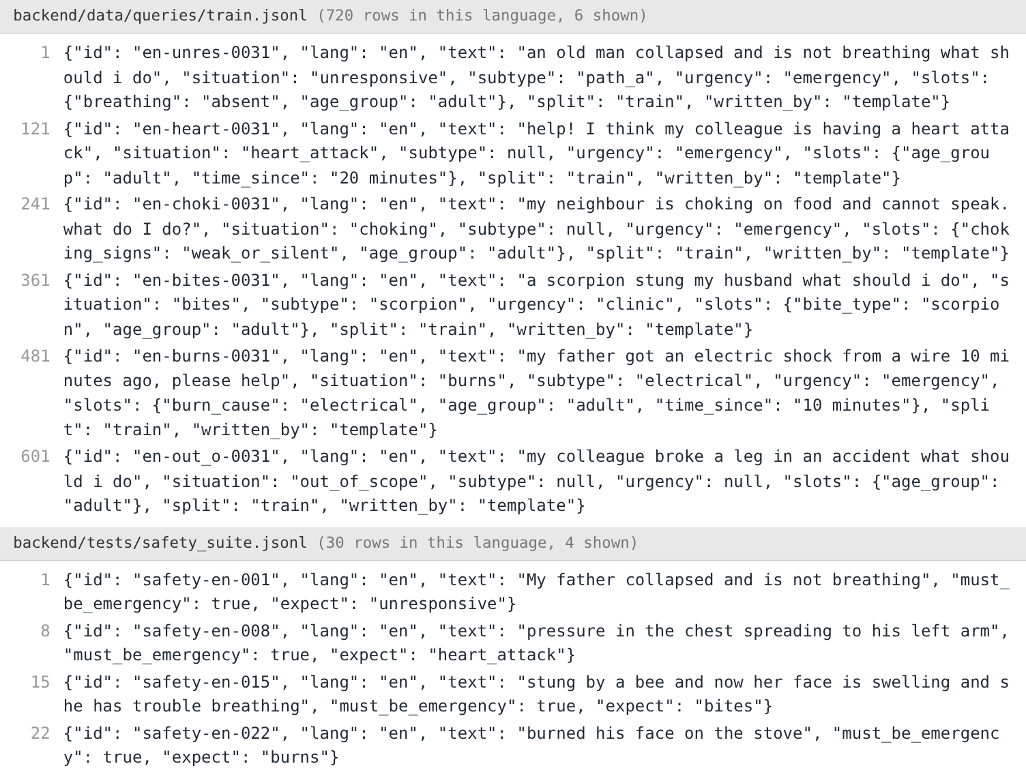
Fig. 6. Excerpt of data/queries/train.jsonl and tests/safety_suite.jsonl (English rows).

EXPERIMENTAL DESIGN, MATERIALS AND METHODS
Fig. 7 summarises how the files were produced.
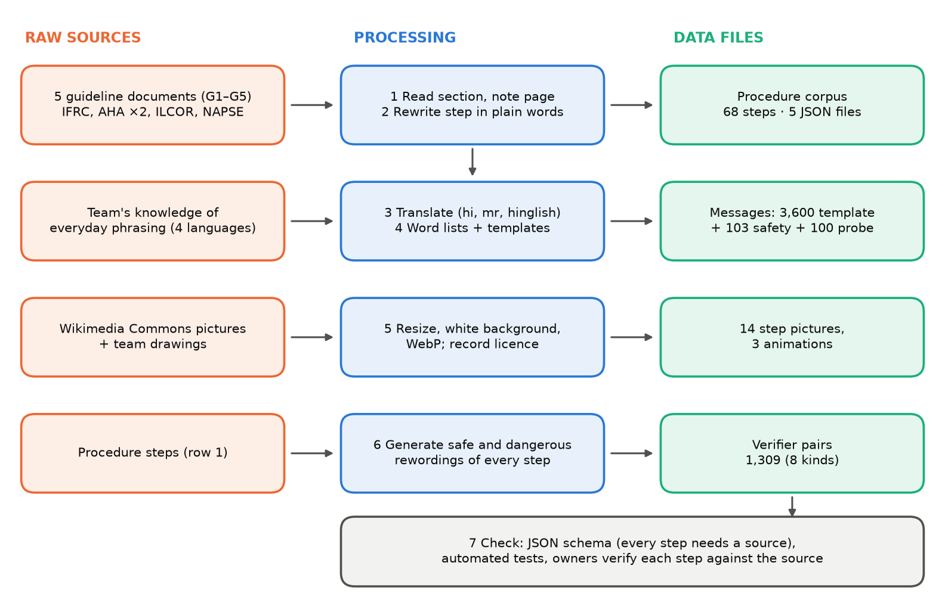
Fig. 7. Workflow from raw sources to the dataset files.
Source selection.
Only first aid guidance published after 2020 by recognised bodies was used: the IFRC International First Aid, Resuscitation and Education Guidelines 2025 (G1) [1], the 2024 AHA and American Red Cross Guidelines for First Aid (G2) [2], the 2025 AHA adult basic life support guidelines (G3) [3], the ILCOR 2025 consensus on first aid science (G4) [4] and India’s National Action Plan for Prevention and Control of Snakebite Envenoming (G5) [5]. Five adult situations were selected: unresponsiveness, heart attack, choking, bites (snake, insect, scorpion, dog) and burns (fire or heat, chemical, electrical).
Procedure records.
Each situation was assigned to one author, who read the relevant sections (for example IFRC Burns, p. 288), listed the recommended actions in order, and rewrote each as one short instruction beginning with a verb. Steps were first written as tables in a project specification with the source and page beside each step, then converted to JSON records following situation.schema.json. Branch points were added where the advice depends on a fact, and do-not rules, urgency rules and harmful remedies were added from the same sources. Supporting sources, agreement and evidence fields were initialised as unchecked, to be completed during verification.
Translation.
All 268 strings were drafted in Hindi, Marathi and Hinglish and assigned to the author responsible for each language for line-by-line checking. Hinglish text is written in natural romanised spelling rather than transliterated from Hindi.
Word lists.
For every structured fact (responsiveness, breathing, chest pain, choking signs, bite type, allergy signs, burn cause, burn area, power, age, time and actions taken), each language owner listed common phrasings and spelling variants, together with negation and uncertainty cues and the direction in which a cue applies (before the word in English, after the verb in Hindi, Hinglish and Marathi). Phrases missed on the probe set (for example “saans ruk gayi”, “छाती जड”) were added once and are covered by regression tests.
Template messages.
backend/scripts/generate_queries.py fills hand-written templates per language and class with people (for example “my father”, “dadaji”), times (“10 minutes ago”) and wrappers (“please help”), assigning the template’s labels to each message. It produces 150 messages per class per language, split 80/20 into train and dev with a fixed random seed. Labels come only from the templates.
Safety suite and probe set.
The safety suite was written by the authors in all four languages, covering each situation, harmful-remedy mentions and non-emergencies such as a small burn or a fever (85 must-be-emergency and 18 other cases). The probe set was drafted with an AI assistant as 25 short, misspelt and code-mixed messages per language and labelled with situation and urgency following the project’s rules; these labels are marked as silver for checking by the authors.
Verifier pairs.
backend/research/e7_verifier.py creates, from every step and do-not rule in each language, safe variants (identity, punctuation change, polite verb form) and dangerous variants (negation removed or added, number changed, call to 112 removed, antonym substitution), each recorded with its kind, label and source step.
Pictures.
Five step pictures were taken from Wikimedia Commons under CC BY-SA 4.0 or CC0 and the remaining pictures and three animations were drawn by the authors and released under CC0. Pictures were resized to 500 px, placed on a white background and saved as WebP; author, licence, source URL and alt text in four languages are stored with each step.
Validation and statistics.
Every procedure record is validated against situation.schema.json, and the repository’s automated tests check that every step has a source and every string exists in all four languages. The statistics and figures in this article were computed with docs/data_article/analyze_data.py using Python 3 and Matplotlib [14]; the Code-Mixing Index follows [9]. The annotation kit in docs/annotation computes Cohen’s kappa [13] for future hand-written test sets. XNLI [11] and IndicXNLI [12] are referenced by the training notebooks but are not redistributed.

LIMITATIONS
No procedure step has yet been verified against its source document (0 of 68 marked verified), 23 steps still lack a page number, and two electrical-injury steps have no post-2020 source. The translations were machine-drafted and are still being checked by native speakers. The template messages repeat a small vocabulary and are longer than real messages, so they do not represent real-world language. The probe set was drafted with an AI assistant, has silver labels and was used once to extend the word lists. The hand-written test set (data/queries/test.jsonl) is empty. The procedures cover adults only.

ETHICS STATEMENT
The authors have read and follow the ethical requirements for publication in Data in Brief and confirm that the current work does not involve human subjects, animal experiments, or any data collected from social media platforms. All messages are invented examples and contain no personal data.

CRediT AUTHOR STATEMENT
Atharva Hemade: Conceptualization, Data curation (choking records, Hindi), Software, Writing – original draft. Taneesha Badhe: Data curation (unresponsive and heart attack records, English), Investigation, Writing – review & editing. Siddhi Karhekar: Data curation (bites records, Marathi), Validation, Writing – review & editing. Soham Ghodake: Data curation (burns records, Hinglish), Formal analysis, Writing – review & editing.

ACKNOWLEDGEMENTS
The authors thank the Wikimedia Commons contributors BruceBlaus, Mrmw, Trakotako and Evolution and evolvability, whose openly licensed illustrations are included. This research did not receive any specific grant from funding agencies in the public, commercial, or not-for-profit sectors.

DECLARATION OF COMPETING INTERESTS
The authors declare that they have no known competing financial interests or personal relationships that could have appeared to influence the work reported in this paper.

REFERENCES
[1] International Federation of Red Cross and Red Crescent Societies, International First Aid, Resuscitation and Education Guidelines 2025, IFRC, Geneva, 2026. https://www.ifrc.org/media/78476
[2] E.K. Hewett Brumberg, M.J. Douma, K. Alibertis, et al., 2024 American Heart Association and American Red Cross guidelines for first aid, Circulation 150 (2024). https://doi.org/10.1161/CIR.0000000000001281
[3] American Heart Association, 2025 American Heart Association guidelines for cardiopulmonary resuscitation and emergency cardiovascular care, Part 7: Adult basic life support, 2025. https://cpr.heart.org/en/resuscitation-science/cpr-and-ecc-guidelines/adult-basic-life-support
[4] International Liaison Committee on Resuscitation, 2025 International consensus on first aid science with treatment recommendations, 2025. https://www.ilcor.org/uploads/FA-2025-COSTR-Full-Chapter.pdf
[5] Ministry of Health and Family Welfare, Government of India, National Action Plan for Prevention and Control of Snakebite Envenoming (NAPSE), 2024. https://ncdc.mohfw.gov.in/wp-content/uploads/2024/07/NATIONAL-ACTION-PLAN-FOR-PREVENTION-AND-CONTROL-OF-SNAKEBITE-ENVENOMING-NAPSE.pdf
[6] A. Hemade, T. Badhe, S. Karhekar, S. Ghodake, Multilingual first aid assistant: procedure corpus, message sets and code [dataset], GitHub, 2026. https://github.com/atharva-1910/firstaid-assitant
[7] W.W. Chapman, W. Bridewell, P. Hanbury, G.F. Cooper, B.G. Buchanan, A simple algorithm for identifying negated findings and diseases in discharge summaries, J. Biomed. Inform. 34 (2001) 301–310. https://doi.org/10.1006/jbin.2001.1029
[8] H. Harkema, J.N. Dowling, T. Thornblade, W.W. Chapman, ConText: An algorithm for determining negation, experiencer, and temporal status from clinical reports, J. Biomed. Inform. 42 (2009) 839–851. https://doi.org/10.1016/j.jbi.2009.05.002
[9] A. Das, B. Gambäck, Identifying languages at the word level in code-mixed Indian social media text, in: Proc. 11th Int. Conf. Natural Language Processing (ICON), Goa, India, 2014, pp. 378–387. https://aclanthology.org/W14-5152
[10] B.S. Harish, R.K. Rangan, A comprehensive survey on Indian regional language processing, SN Appl. Sci. 2 (2020) 1204. https://doi.org/10.1007/s42452-020-2983-x
[11] A. Conneau, R. Rinott, G. Lample, A. Williams, S. Bowman, H. Schwenk, V. Stoyanov, XNLI: Evaluating cross-lingual sentence representations, in: Proc. 2018 Conf. Empirical Methods in Natural Language Processing, 2018, pp. 2475–2485. https://doi.org/10.18653/v1/D18-1269
[12] D. Aggarwal, V. Gupta, A. Kunchukuttan, IndicXNLI: Evaluating multilingual inference for Indian languages, in: Proc. 2022 Conf. Empirical Methods in Natural Language Processing, 2022, pp. 10994–11006. https://doi.org/10.18653/v1/2022.emnlp-main.755
[13] J. Cohen, A coefficient of agreement for nominal scales, Educ. Psychol. Meas. 20 (1960) 37–46. https://doi.org/10.1177/001316446002000104
[14] J.D. Hunter, Matplotlib: A 2D graphics environment, Comput. Sci. Eng. 9 (2007) 90–95. https://doi.org/10.1109/MCSE.2007.55

