

**CP301**

**Developmental Engineering Project**

Topic:

Thermal Performance Optimization of Slum Housing Using Sustainable Insulation Materials

Under the guidance of -

Dr. Navaneeth K Marath & Dr. Devranjan Samanta  
Assistant Professors, Department of Mechanical Engineering  
IIT Ropar

Submitted by:

**Atharv Srivastava (*2022MEB1301)***

**Atharva Sharma** (***2022MEB1302)***

**Darius Johanan** (***2022MEB1305)***

**Mohit Sharma** (***2022MEB1326)***

**Index**

1. **Introduction**
2. **Objectives**
3. **Problem Description**
4. **Background and Literature Review**
5. **Methodology**
6. **Simulation results**
7. **Discussion and analysis**
8. **Future Work**
9. **Conclusion**
10. **References**

**Introduction**

In many slum areas of Punjab, particularly near Rupnagar, extreme weather conditions pose a significant challenge to residents. During the summer, temperatures rise significantly, making houses unbearably hot, while in winter, the lack of proper insulation leads to extremely cold indoor conditions. This results in a heavy dependence on cooling and heating solutions such as desert coolers and heaters, leading to high electricity bills. Most houses in these areas are built using conventional burnt clay bricks, which offer little resistance to heat transfer, making them inefficient in maintaining comfortable indoor temperatures.

Our project aims to address this issue by analyzing the heating and cooling loads of a representative sample house and identifying cost-effective, eco-friendly, and sustainable materials that can be used as insulation. By implementing suitable insulation, we aim to improve thermal comfort and reduce the energy consumption required for heating and cooling. Additionally, we conducted simulations using EnergyPlus to evaluate different insulation materials and their effectiveness under two distinct climatic conditions: Shimla (cold climate) and Chandigarh (hot climate).

Through this study, we hope to provide practical recommendations that can be implemented in slum housing to improve living conditions while reducing energy expenses for residents.

**Objectives**

The key objectives of our project are:

1. To analyze the heating and cooling loads of a typical slum house in Punjab using EnergyPlus simulations.
2. To identify and evaluate cost-effective, eco-friendly, and sustainable insulation materials that can be used to improve thermal comfort.
3. To compare the impact of insulation under two different climatic conditions:
   * Cold climate (Shimla)
   * Moderate to hot climate (Chandigarh)
4. To propose feasible insulation solutions that can be easily implemented in slum housing with minimal cost.
5. To assess the reduction in energy consumption and electricity bills by incorporating insulation in existing brick houses.

**Problem Description**

Many slum dwellers in Punjab, Haryana, and Himachal Pradesh struggle with maintaining comfortable indoor temperatures throughout the year. Most slum houses are built with brick walls, which provide limited insulation against external temperature variations. During summers, houses become extremely hot, forcing residents to rely on desert coolers or fans, while in winters, they experience severe cold, necessitating the use of electric heaters. These appliances significantly increase electricity consumption, leading to higher energy bills, which can be a financial burden for low-income families.

Our study focuses on evaluating the thermal performance of these houses and exploring insulation materials that can improve energy efficiency. We designed a sample house geometry for analysis and used EnergyPlus to simulate heating and cooling loads under different weather conditions. By considering affordable and sustainable insulation materials, our goal is to provide solutions that enhance the livability of slum houses while keeping costs low.

By the end of this project, we aim to recommend practical, implementable solutions that can make slum housing more energy-efficient, reducing both the dependency on external cooling and heating devices and the associated financial burden on residents.

**Background and Literature Review:**

Building energy efficiency is a critical factor in modern sustainable construction. Numerous studies highlight the impact of insulation materials, HVAC system design, and ventilation strategies on heating and cooling loads. Based on insights from computational investigations into energy consumption in buildings, bio-inspired materials and composite walls have emerged as promising solutions for improving thermal performance.

* **Use of Bio-Inspired Materials:** Studies have shown that materials such as rice husk, hempcrete, and sugarcane bagasse can significantly reduce heat transfer through walls, minimizing cooling and heating loads. These materials have lower thermal conductivity and higher insulation properties compared to conventional bricks.
* **Composite Walls for Energy Reduction:** Research on multi-layered walls combining different materials has demonstrated superior thermal insulation, reducing the overall energy consumption of buildings.
* **Impact of Sustainable Wall Materials:** Investigations into bio-based construction materials indicate that incorporating renewable and locally available resources can enhance energy efficiency and lower construction costs while maintaining structural integrity.

By leveraging such findings, this study aims to explore effective wall compositions and insulation strategies that can be implemented in slum areas to reduce energy dependency on HVAC systems.

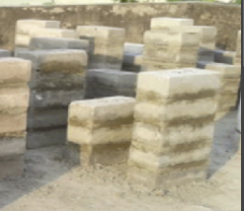

Fig.1 Sugarcane Bagasse Ash(SBA) Brick

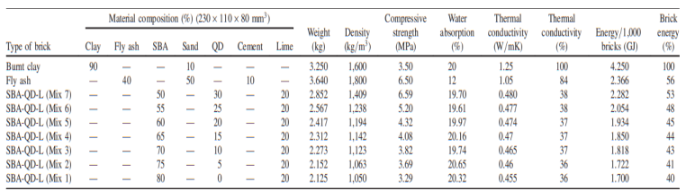

Table1 Properties of SBA Bricks

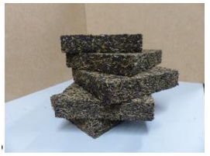

Fig. 2 Rice husk expanded cork



Table 2 Properties of Rice expandable cork

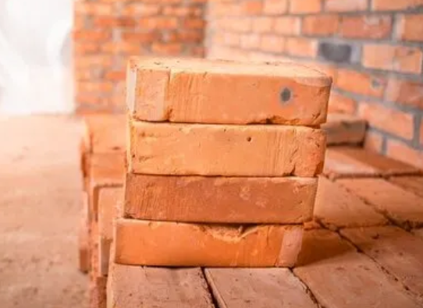

Fig. 3 Clay Brick

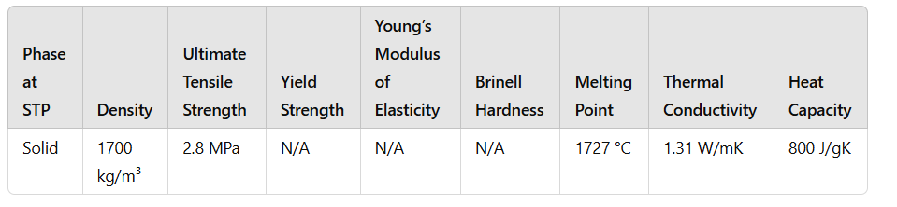

Table 3 Properties of clay brick

**Methodology**

To analyze the heating and cooling loads of a typical slum house, we used EnergyPlus to simulate different insulation setups. A sample house with defined dimensions was created in the software, and simulations were run using weather data for both Chandigarh and Shimla for the year 2023.

**House Model Definition:**

* Dimensions: 5m (length) × 3m (width) × 3m (height)
* Window: Single Pane, Located on the south-facing wall, with dimensions 2m × 1m
* **Window Materials:** Window pane has a 3mm thickness



The south-facing wall was chosen for the window placement because, in the Northern Hemisphere, this orientation allows better passive solar heating during winter. As the sun follows a lower altitude path in winter, a south-facing window can capture more sunlight, keeping the indoor temperature warmer. This passive heating effect reduces the heating load, making it an effective strategy for cold climates like Shimla.

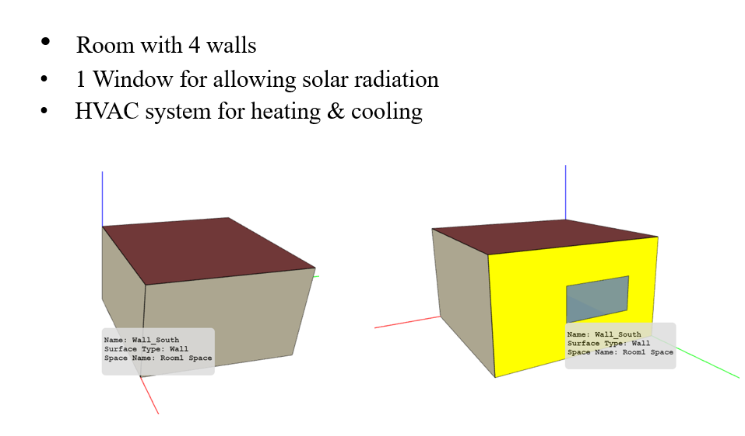

Fig. 4: Sketch of building used in simulation

**Simulation Setups:** Three different wall configurations were simulated:

1. **Control Setup:** Brick walls of thickness 22.5 cm
2. **First Material Addition:** Brick walls (22.5 cm) with an additional 11 cm layer of rice husk expanded cork bricks on all walls and roof
3. **Second Material Addition:** Brick walls (22.5 cm) with an additional 11 cm layer of sugarcane bagasse ash bricks on all walls and roof

**HVAC System for Load Calculation:** An ideal HVAC system was defined in EnergyPlus to calculate the heating and cooling loads required to maintain a comfortable indoor temperature. This was used purely for simulation purposes and does not imply that slum houses would have HVAC systems installed.

**Indoor temperature range:** a comfortable temperature range of 21 to 28 degrees celcius was set to be maintained inside the house at all times and the heating and cooling loads were calculated according to this range.

**Simulation and Data Analysis:**

* The house models were implemented in EnergyPlus, and simulations were run for Chandigarh and Shimla weather conditions using 2023 weather files.
* The heating and cooling loads were extracted in CSV format.
* Python was used to generate relevant plots and analyze the trends in energy consumption for different insulation materials.

By comparing the results from the different setups, we aim to identify the most effective and feasible insulation material that can be implemented in slum houses to improve thermal comfort and reduce energy consumption.

**Simulation results and analysis**

For Chandigarh:

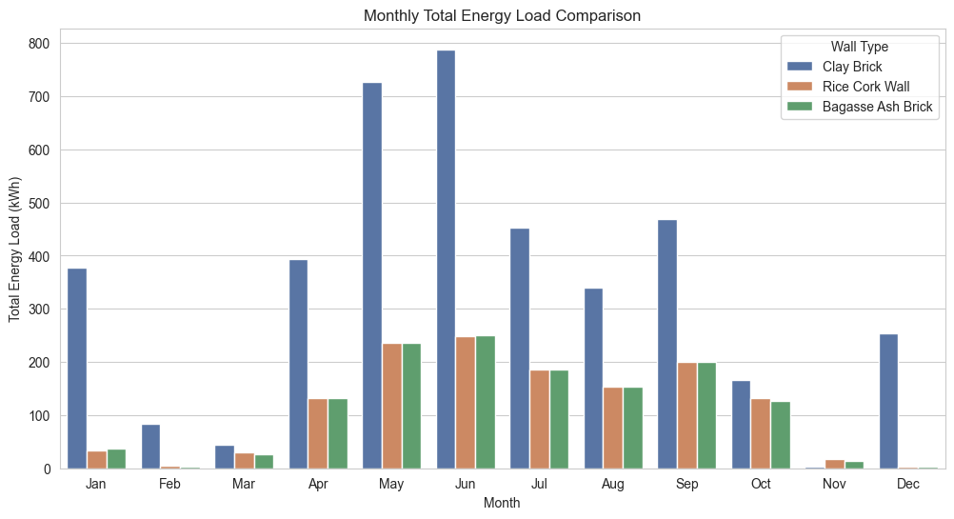

**Plot 1** Graph between Total Energy load with Months

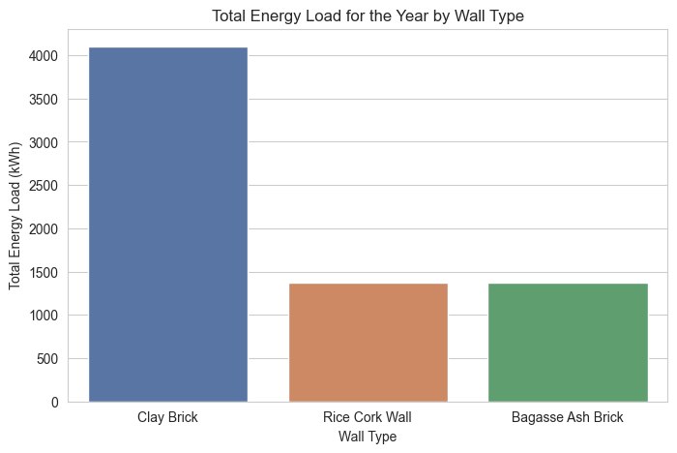

**Plot 2** Graph of Total Energy load of various walls

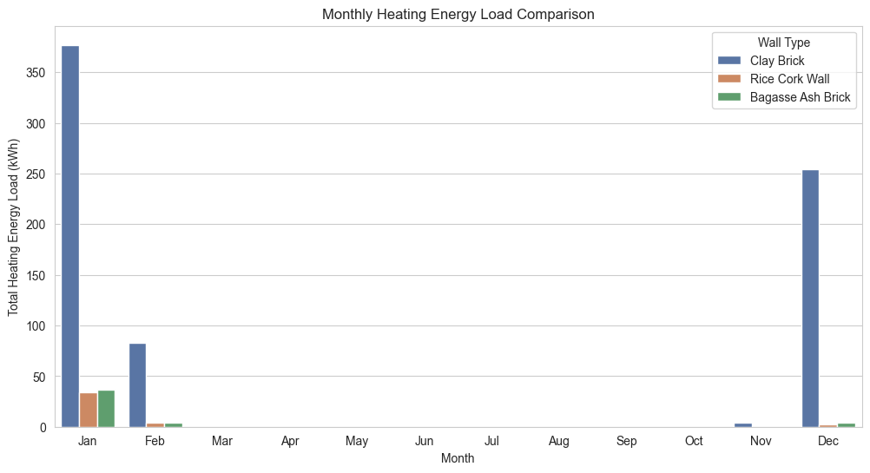

**Plot 3** Graph between Heating load with Months

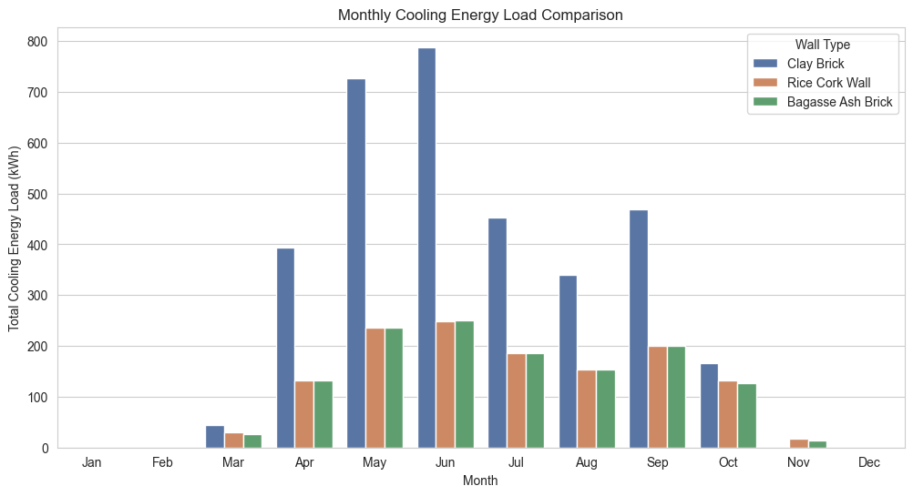

**Plot 4** Graph between Cooling load with Months

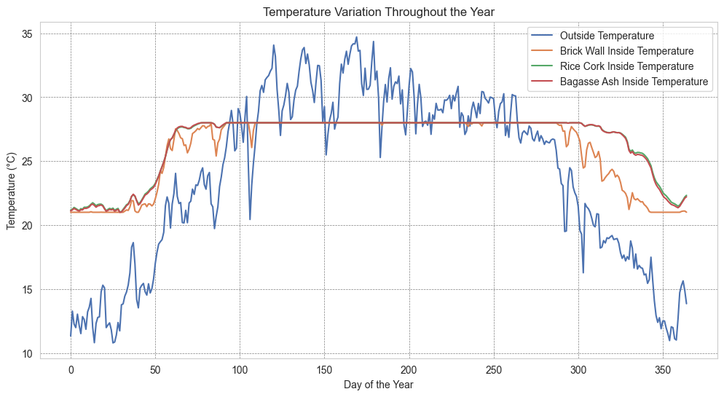

**Plot 5** Graph between Air Temperatures inside and outside building

For Shimla:

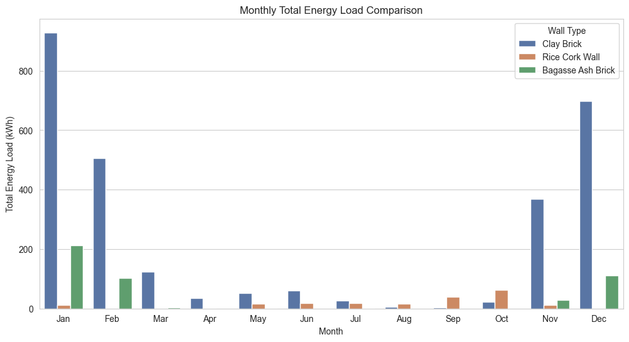

**Plot 6** Graph between Total Energy load with Months

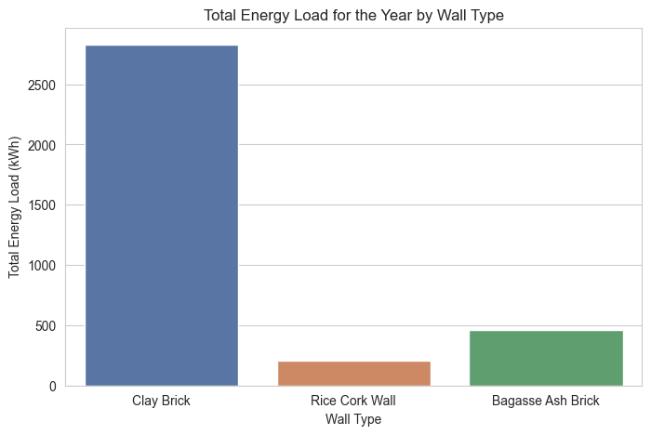

**Plot 7** Graph of Total Energy load of various walls

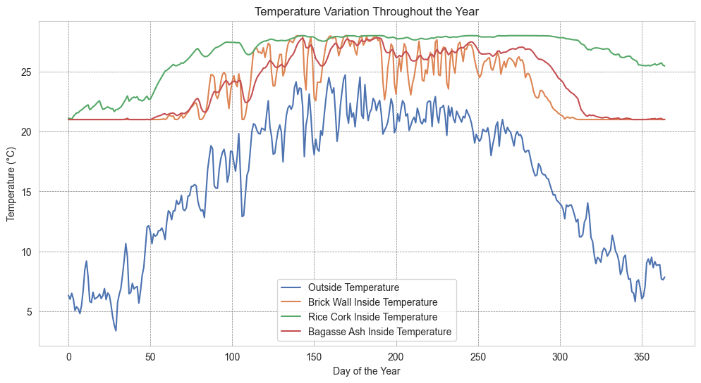

**Plot 8** Graph between Air Temperatures inside and outside building

**Analysis and Discussion**

**For Chandigarh**

**1. Total Energy Load vs. Month**

* The total energy load varies across months, peaking in summer (April–June) and dropping in winter (December–February).
* Clay Brick walls exhibit the highest energy consumption, followed by Bagasse Ash Brick and Rice Cork Wall, indicating that Clay Brick leads to inefficient energy use.
* The sustainable materials (Rice Cork and Bagasse Ash Brick) significantly reduce the energy demand, especially in peak cooling months.

**2. Total Energy Load for the Year by Wall Type**

* Clay Brick walls result in the highest annual energy consumption (~4000 kWh), making them the least energy-efficient option.
* Rice Cork Wall and Bagasse Ash Brick significantly reduce energy usage, with Rice Cork performing the best.
* These findings confirm that sustainable walls reduce both heating and cooling energy consumption, leading to lower operational costs and better thermal performance.

**3. Heating Energy Load vs. Month**

* Heating demand is highest in winter (January and December) and negligible for most of the year.
* Clay Brick requires the most heating energy, whereas Rice Cork and Bagasse Ash Brick provide better insulation, reducing heating needs.
* The superior thermal properties of Rice Cork Wall result in the lowest heating demand.

**4. Cooling Energy Load vs. Month**

* Cooling demand peaks in summer (April–June) and gradually decreases after monsoon.
* Clay Brick walls show the highest cooling energy load, confirming their poor thermal insulation properties.
* Rice Cork Wall and Bagasse Ash Brick significantly reduce cooling energy consumption, making them better for hot climates.

**5. Temperature Variation Throughout the Year**

* The outside temperature (blue line) fluctuates significantly, peaking in summer and dropping in winter.
* Brick Wall Inside Temperature closely follows the external temperature, indicating poor thermal insulation.
* Rice Cork Wall and Bagasse Ash Brick maintain more stable indoor temperatures, reducing fluctuations and improving comfort.
* Rice Cork Wall provides the most stable indoor temperature, reinforcing its superior insulation properties.

1. **Overall Analysis**

* Clay Brick walls result in the highest energy load for both heating and cooling, making them the least energy-efficient option.
* Rice Cork Wall emerges as the best-performing option, reducing both heating and cooling loads while maintaining a stable indoor temperature.
* Bagasse Ash Brick provides moderate energy savings, being better than Clay Brick but slightly less efficient than Rice Cork Wall.
* Sustainable materials (Rice Cork and Bagasse Ash Brick) significantly improve energy efficiency and thermal comfort, making them ideal for reducing energy costs and improving building sustainability.

1. **Final Recommendation**

For optimal energy efficiency and thermal comfort in Chandigarh, Rice Cork Wall is the best choice, followed by Bagasse Ash Brick. Clay Brick should be avoided due to high energy consumption and poor insulation properties.

**For Shimla**

**1.** Total Energy Load vs. Month

* The total energy load is highest in January, February, November, and December, which aligns with the winter months in Shimla.
* Clay Brick walls have the highest energy demand, followed by Bagasse Ash Brick and Rice Cork Wall, indicating poor insulation performance of Clay Brick.
* Cooling energy load is negligible throughout the year due to the inherently cold climate of Shimla, making the total energy load graph equivalent to the heating load graph.
* Rice Cork Wall and Bagasse Ash Brick significantly reduce heating energy demand, making them ideal for cold climates.

**2. Total Energy Load for the Year by Wall Type**

* Clay Brick results in the highest annual energy consumption (~2500 kWh), making it the least energy-efficient option.
* Rice Cork Wall and Bagasse Ash Brick significantly reduce energy usage, with Rice Cork Wall performing the best.
* These findings confirm that sustainable wall materials improve insulation and reduce heating requirements, which is crucial for energy efficiency in cold regions.

**3. Temperature Variation Throughout the Year**

* The outside temperature (blue line) fluctuates significantly, being very cold in winter and moderately warm in summer.
* Brick Wall Inside Temperature closely follows the external temperature, proving that it provides poor thermal insulation.
* Rice Cork Wall and Bagasse Ash Brick maintain a more stable indoor temperature, reducing extreme fluctuations.
* Rice Cork Wall provides the most stable indoor temperature, minimizing heating energy demand.

1. **Overall Analysis**

* Clay Brick walls result in the highest energy load due to poor insulation, making them unsuitable for cold climates.
* Rice Cork Wall emerges as the best-performing option, significantly reducing heating loads while maintaining a stable indoor temperature.
* Bagasse Ash Brick provides moderate energy savings, better than Clay Brick but slightly less efficient than Rice Cork Wall.
* Cooling loads are negligible due to Shimla's year-round cold temperatures, meaning total energy load is essentially the same as heating load.
* Sustainable materials (Rice Cork and Bagasse Ash Brick) significantly improve energy efficiency and thermal comfort, making them the preferred choice for buildings in Shimla.

1. **Final Recommendation**

For optimal energy efficiency and thermal comfort in Shimla, Rice Cork Wall is the best choice, followed by Bagasse Ash Brick. Clay Brick should be avoided due to high heating energy consumption and poor insulation properties.

**Comparative Analysis of Energy Load and Temperature Variation (Chandigarh vs. Shimla)**

* The two locations analyzed, Chandigarh and Shimla, have significantly different climatic conditions. Chandigarh experiences both hot summers and cold winters, requiring both cooling and heating loads, while Shimla remains predominantly cold throughout the year, requiring only heating loads.
* The total energy load graph for Chandigarh was divided into heating and cooling loads, highlighting the seasonal variation. In contrast, Shimla’s total energy load graph was not split since cooling loads were negligible due to its inherently cold climate, making the total energy load equivalent to heating load.
* Across both locations, Clay Brick walls had the highest total energy demand, confirming their poor insulation properties and high thermal conductivity, making them inefficient for both cooling in hot conditions (Chandigarh) and heating in cold conditions (Shimla).
* Rice Cork Wall consistently demonstrated the best thermal performance, minimizing heat gain in summer and heat loss in winter, thus reducing both cooling and heating energy consumption in Chandigarh and heating energy consumption in Shimla.
* Bagasse Ash Brick showed intermediate performance, better than Clay Brick but slightly less effective than Rice Cork Wall in terms of energy efficiency.

**Impact of Wall Materials on Energy Efficiency**

* The thermal mass and insulation properties of building materials directly influence indoor temperature stability and energy consumption.
* Clay Brick has high thermal conductivity, meaning it allows significant heat transfer, causing buildings to overheat in summer and lose heat rapidly in winter, leading to high cooling and heating energy demands.
* Rice Cork Wall, with its low thermal conductivity and high insulation properties, acts as a thermal buffer, reducing temperature fluctuations and energy consumption in both climates.
* Bagasse Ash Brick, due to its porous nature and moderate thermal insulation, provides better energy efficiency than Clay Brick but does not match the superior insulation properties of Rice Cork Wall.

**Conclusion**

This study aimed to analyse the thermal performance and energy efficiency of different wall materials under two distinct climatic conditions—Chandigarh and Shimla. Through comprehensive simulations performed on the EnergyPlus software, we investigated how wall materials, namely clay bricks, rice cork, and bagasse ash bricks, influenced internal temperature regulation and energy loads over a year.

The experimental approach involved evaluating the air temperature variations inside the building, comparing different wall types, and assessing total energy loads required to maintain indoor comfort, between 21 and 28 degree celcius to be precise. The simulations were performed separately for Chandigarh, characterized by a composite climate, and Shimla, which has a predominantly cold climate. Key findings highlight that conventional clay brick walls resulted in higher internal temperature fluctuations, making them less effective at insulation. In contrast, rice cork and bagasse ash bricks demonstrated superior thermal stability, maintaining more consistent indoor temperatures and reducing energy consumption.

For Chandigarh, the results indicated that during peak summers, internal temperatures of buildings with clay bricks closely followed external fluctuations, leading to increased cooling energy demands. In contrast, rice cork and bagasse ash bricks significantly dampened these fluctuations, reducing cooling requirements. The energy load analysis reaffirmed that alternative materials contributed to lower overall energy consumption, improving building sustainability.

In Shimla, where heating demand dominates, the negligible cooling load justified the representation of total energy load as heating load across months. The study showed that clay brick walls required substantially more heating energy compared to rice cork and bagasse ash bricks, confirming their poorer insulation capability. Alternative materials minimized heat loss and maintained a stable indoor environment with reduced heating energy demand.

Overall, the findings advocate for the adoption of rice cork and bagasse ash bricks in energy-efficient building design, particularly in regions experiencing extreme temperatures. Their implementation can significantly enhance thermal comfort, lower energy costs, and contribute to sustainable construction practices.

**Further Works**

To further enhance the study and develop practical solutions for improving thermal comfort in slum housing, the following areas will be explored:

1. **Ventilation and Active Cooling/Heating:** Future studies will incorporate natural ventilation strategies and investigate the impact of adding desert coolers and heaters to estimate electrical load requirements.
2. **Exploration of Alternative Materials:** Additional sustainable and cost-effective materials, or coatings that provide better insulation while reducing wall weight, will be considered.
3. **Optimized Building Designs:** Alternative architectural designs that enhance passive cooling and heating efficiency will be examined.
4. **Cost Analysis:** A detailed cost analysis of the insulation materials used in the study will be conducted to assess affordability and feasibility for large-scale implementation.

**References**

* Bakatovich, A., Davydenko, N., & Gaspar, F. (2018). Thermal insulating plates are produced based on vegetable agricultural waste. Energy and Buildings, 180, 72-82
* Marques, B., Tadeu, A., Almeida, J., António, J., & de Brito, J. (2020). Characterization of sustainable building walls made from rice straw bales. Journal of Building Engineering, 28, 101041.
* ASHRAE Standard 140-2017. Standard method of test for the evaluation of building energy analysis computer programs,(2017).
* Engineering Reference, EnergyPlus manual,2023.
* Madurwar, M. V., Mandavgane, S. A., & Ralegaonkar, R. V. (2015). Development and feasibility analysis of bagasse ash bricks. Journal of Energy Engineering, 141(3), 04014022.
* Marques, B., Tadeu, A., António, J., Almeida, J., & de Brito, J. (2020). Mechanical, thermal and acoustic behavior of polymer-based composite materials produced with rice husk and expanded cork by-products. Construction and Building Materials, 239, 117851.
* Hasan S. (2024), Computational investigation of energy consumption in buildings using different bio-inspired materials as constituent wall material (M. Tech. thesis)
* Rana, B., Pitroda, J., & Umrigar, F. S. (2013). Sugar cane bagasse ash for eco-friendly fly ash bricks. Global Journal of Researches in Engineering, 58, 259-266.