Capstone Project on
IOT BASED SMART SAFETY HELMET
SHIELD SENSE
Submitted in partial fulfilment of the requirements
of the degree of
Bachelor of Technology
By
Electronics And Computer Science
Atharva Patil [EU1247050]
Pavitra Bhadane [EU1247011]
Yash Pale [EU1247042]
Under the Guidance of
Mrs. Hiral Patel, Vishakha Rane
& Dr Md. Imaduddin
ECS, SJCEM

DEPARTMENT OF ELECTRONICS AND COMPUTER SCIENCE ST. JOHN COLLEGE OF ENGINEERING & MANAGEMENT UNIVERSITY OF MUMBAI
2025-2026

Certificate of Approval
This is to certify that Group 6, are Bonafide students of B. Tech in Electronics and Computer Science - Department, St. John College of Engineering and Management, Mumbai. They have satisfactorily completed the requirements of Synopsis as prescribed by ST. JOHN COLLEGE OF ENGINEERING AND MANAGEMENT (An Autonomous College affiliated to University of Mumbai), while working on “Smart Safety Helmet”.
Signature: ____________________
Name: Mrs. Hiral Patel
Mrs. Vishakha Rane
Dr Md. Imaduddin

Signature: ____________________
Name: Dr Md. Imaduddin HOD

Signature: _____________________
Name: Dr. Kamal Shah Principal,
St. John College of Engineering and Management.

Signature: _____________________
External Examiner

Declaration
I/we declare that this written submission represents my/our ideas in my/our own words and where others’ ideas or words have been included, I/we have adequately cited and referenced the original sources. I/we also declare that I/we have adhered to all principles of academic honesty and integrity and have not misrepresented or fabricated or falsified any idea/data/fact/source in my/our submission. I/we understand that any violation of the above will be cause for disciplinary action by the Institute and can also evoke penal action from the sources which have thus not been properly cited or from whom proper permission has not been taken when needed.
-----------------------
Atharva Patil

-----------------------
Pavitra Bhadane

-----------------------
Yash Pale

Date:15/4/2026

ACKNOWLEDGEMENT
We would like to express our sincere gratitude to our guide Mrs. Hiral Patel, Vishakha Rane and Dr. Md. Imaduddin for their constant support, encouragement, and valuable insights throughout the course of this project. We are also grateful to the Head of Department, faculty members, and our peers for their help and feedback. Lastly, we acknowledge the support of our friends who motivated us during this project work.

Atharva Patil [EU1247050]
Pavitra Bhadane [EU1247011]
Yash Pale [EU1247042]
ABSTRACT

The proposed project, “Shield-Sense: IoT Based Smart Safety Construction Helmet,” is designed to enhance worker safety in hazardous environments such as construction sites, mining areas, and industrial plants where traditional helmets provide only physical protection and lack real-time monitoring capabilities; to overcome this limitation, the system integrates Internet of Things (IoT) technology using an ESP32 microcontroller along with sensors like MQ-2 for gas detection, DHT11 for temperature and humidity monitoring, and MPU6050 for fall detection, which continuously collect environmental data and send it via WiFi to Firebase (Real-Time Database and Firestore) for live monitoring and alert logging, while a web-based dashboard displays real-time values, system status, and alert history, enabling quick response during emergencies when parameters exceed predefined thresholds such as gas leakage, high temperature, or sudden falls; the system is powered by a 18650 Li-ion battery with an XL6009 boost converter, making it portable and suitable for real-world applications, and overall, the project provides a cost-effective, reliable, and efficient solution for improving worker safety through continuous monitoring and smart alert mechanisms.

C O N T E N T S
Chapter No. | Topic | Page No.
Chapter 1 | Overview | 1
 | 1.1 Introduction | 1
 | 1.2 Problem Statement | 1-2
 | 1.3 Objectives | 2
Chapter 2 | Literature Survey & Proposed Work | 3
 | 2.1 Introduction | 3
 | 2.2 Literature Survey Table | 3-4
 | 2.3 Methodology Used | 4
Chapter 3 | System Design & Implementation | 5
 | 3.1 Components and Hardware | 5
 | 3.2 Circuit Diagram | 6
 | 3.3 Circuit Diagram Explanation | 7
Chapter 4 | Design & Implementation | 8
 | 4.1 Result | 8
 | 4.2 Photos | 8-9
 | 4.3 Flow Chart | 10
Chapter 5 | Applications and Future Scope | 11
 | 5.1 Applications | 11
 | 5.2 Future Scope | 11
Chapter 6 | Conclusion & References | 12
 | 6.1 Conclusion | 12
 | 6.2 References | 12

Chapter 1: Overview

1.1 Introduction
The rapid development of the Internet of Things (IoT) has enabled the creation of smart systems capable of monitoring and controlling real-world environments in real time, especially in industries such as construction, mining, and manufacturing where worker safety is a major concern due to hazardous conditions like toxic gases, high temperatures, and accidental falls; however, traditional safety helmets provide only physical protection and lack intelligent features for environmental monitoring or emergency detection, which can lead to serious accidents due to delayed awareness and response, therefore, the proposed project “Shield-Sense: IoT Based Smart Safety Construction Helmet” integrates an ESP32 microcontroller with sensors such as MQ-2 for gas detection, DHT11 for temperature and humidity measurement, and MPU6050 for fall detection to continuously collect environmental data and transmit it via WiFi to Firebase for real-time monitoring and alert logging, while a web-based dashboard displays live data and alert history, and the system is powered by a 18650 Li-ion battery with an XL6009 boost converter making it portable, efficient, and suitable for real-world applications, ultimately enhancing worker safety, reducing emergency response time, and providing a reliable and cost-effective solution.

1.2 Problem Statement
Worker safety in hazardous environments is often compromised due to the absence of real-time monitoring and integrated alert systems, as traditional safety helmets are limited to providing physical protection and do not detect environmental risks such as gas leaks, high temperature, or sudden falls, which makes workers unaware of dangerous situations and increases the chances of accidents and delayed emergency response, moreover, in many industrial and construction sites, safety monitoring is either performed manually or through separate systems that are not integrated, leading to inefficiency, increased human effort, and a higher probability of human error, while the lack of continuous monitoring prevents timely detection of sudden environmental changes, thereby creating a need for a smart, automated, and integrated system that can continuously monitor environmental conditions, detect hazards, and provide real-time alerts to improve worker safety and reduce risks.

1.3 Objectives
The main objectives of the proposed IoT Based Smart Safety Helmet system are as follows:
- To design and develop a smart safety helmet using IoT technology.
- To continuously monitor environmental parameters such as gas levels, temperature, and humidity.
- To detect worker falls using an accelerometer sensor.
- To send real-time data to a cloud platform for monitoring and analysis.
- To generate alerts when sensor values exceed predefined threshold limits.
- To develop a web-based dashboard for live monitoring and alert history.
- To reduce response time during emergencies and improve worker safety.
- To create a portable system powered by a battery and boost converter.
- To provide a cost-effective and reliable safety solution for industrial applications.

Chapter 2: Literature Survey & Proposed Work

2.1 Introduction
A literature survey is important to understand the existing technologies and research related to the proposed system, especially in the field of IoT-based safety and monitoring solutions where many systems have been developed for environmental sensing, gas detection, and fall detection, most of these systems use microcontrollers and sensors to monitor specific parameters and provide alerts, however, many existing solutions focus only on a single aspect such as gas detection or fall detection and do not provide a complete integrated system, some systems offer remote monitoring through cloud platforms but lack real-time alert mechanisms or user-friendly dashboards, while others are limited by hardware constraints or are not suitable for portable applications, therefore, the proposed project improves upon these limitations by integrating multiple sensors with an ESP32 microcontroller, enabling real-time data transmission to Firebase, and providing a web-based dashboard for continuous monitoring and alert logging in a single compact and portable system.

2.2 Literature Survey Table
Sr. No. | Reference | Year | Existing System / Approach | Key Contribution | Limitation / Research Gap
1 | Prof. H. R. Dhananjay et al., “IoT Based Smart Helmet” | 2025 | Helmet with gas, temperature, humidity sensors and display | Enables real-time monitoring and alert generation | Limited cloud-based analytics and advanced alert logging (IJRASET)
2 | Divjot Kaur et al., “IoT-Enabled Smart Helmet for Real-Time Crash Detection” | 2025 | Smart helmet for accident detection and emergency alerts | Automatically detects crash and sends real-time alerts | Focuses mainly on road accidents, not industrial safety (SSRN)
3 | Suhas Raghunath et al., “IoT-Enabled Smart Helmet for Worker Safety” | 2025 | Helmet with fall detection and temperature monitoring | Improves response time and safety monitoring | Does not include gas detection or multi-sensor integration (MDPI)
4 | Kabilan M. et al., “Accident Detection System Based on IoT Smart Helmet” | 2019 | Helmet with GPS and accident detection system | Sends location and emergency alerts after accident | Limited environmental monitoring features (IJARIIT)

2.3 Methodology Used
The proposed system follows a sensor-based and IoT-enabled methodology to ensure real-time monitoring and safety of workers. The working of the system is divided into four main stages: data collection, data processing, automatic action, and monitoring.
1. Data Collection
Different sensors are used to collect environmental and motion data. The MQ-2 sensor detects harmful gases such as smoke and LPG, the DHT11 sensor measures temperature and humidity, and the MPU6050 sensor detects motion and sudden falls. These sensors are connected to the ESP32 and continuously send data at regular intervals.
2. Data Processing
The ESP32 microcontroller receives the sensor data and compares it with predefined threshold values. If the gas level exceeds the safe limit, it indicates a gas leak; if the temperature is too high, it shows a hazardous condition; and if abnormal motion is detected, it identifies a fall. This helps in making quick and accurate decisions.
3. Automatic Action
Based on the processed data, the system automatically detects dangerous situations and generates alerts such as gas leakage, high temperature, or fall detection. The ESP32 prepares this information for further transmission without requiring human intervention.
4. Monitoring and Display
The data is sent to Firebase using WiFi for real-time monitoring and storage. A web-based dashboard displays live sensor values, system status, and alert logs, allowing users to monitor the system remotely and respond quickly during emergencies.

Chapter 3: System Design & Implementation

3.1 Components and Hardware Requirements
Component | Quantity | Purpose
ESP32 Microcontroller | 1 | Acts as the main controller to process sensor data and send it to the cloud
MQ-2 Gas Sensor | 1 | Detects harmful gases such as smoke and LPG
DHT11 Sensor | 1 | Measures temperature and humidity
MPU6050 Sensor | 1 | Detects motion and fall using accelerometer and gyroscope
18650 Li-ion Battery | 1 | Provides power supply to the system
XL6009 Boost Converter | 1 | Steps up battery voltage to stable 5V
Jumper Wires | As required | Connects all components together
Resistors | As required | Used for proper circuit operation

3.2 Circuit Diagram
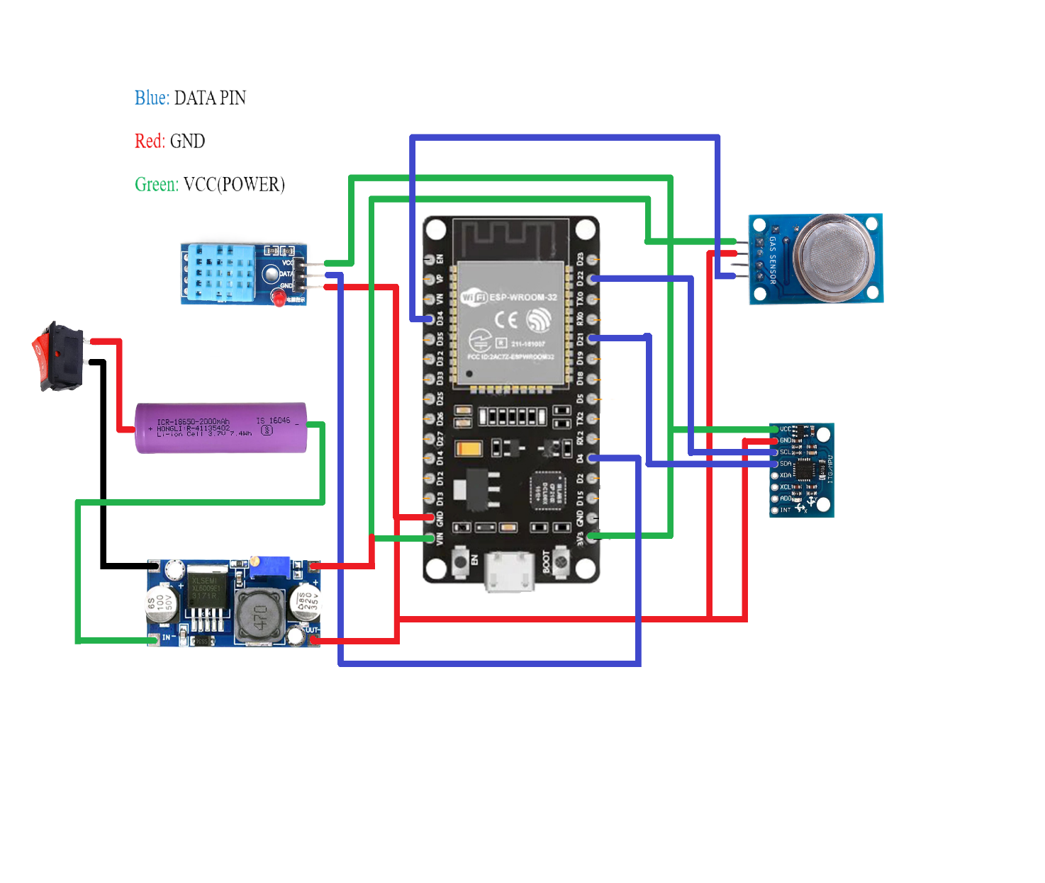

3.3 Circuit Diagram Explanation
- The system is powered using a 18650 Li-ion battery which provides a nominal voltage of around 3.7V.
- Since this voltage is not sufficient, an XL6009 boost converter is used to step up the voltage to a stable 5V.
- The boosted 5V output is supplied to the ESP32 (via VIN pin) and all other components.
- The ESP32 microcontroller acts as the central unit that controls and processes all sensor data.
- The MQ-2 gas sensor gives analog output based on gas concentration, which is read by the ESP32 to detect gas leakage.
- The DHT11 sensor provides digital data for temperature and humidity monitoring.
- The MPU6050 sensor measures acceleration and orientation to detect sudden movement or fall.
- All sensors are connected to the ESP32 and share a common ground.
- The ESP32 processes the sensor data and compares it with predefined threshold values.
- The processed data is sent to Firebase using WiFi for real-time monitoring and alert logging.
- The complete circuit integrates power supply, sensing, processing, and communication in a compact and efficient system.

Chapter 4: Design & Implementation

4.1 Result
The proposed “Shield-Sense: IoT Based Smart Safety Construction Helmet” system was successfully designed and implemented. The system continuously monitored environmental conditions such as gas levels, temperature, and humidity, along with detecting sudden falls using the MPU6050 sensor. During testing, the MQ-2 sensor accurately detected the presence of harmful gases, and alerts were generated when the gas level exceeded the threshold. The DHT11 sensor provided correct temperature and humidity readings in real time. The MPU6050 sensor effectively detected sudden movements and fall conditions. The ESP32 successfully transmitted all sensor data to Firebase using WiFi, and the web-based dashboard displayed real-time values and alert logs without delay. The system performed reliably and helped in identifying hazardous conditions quickly, thus improving worker safety and reducing response time during emergencies.

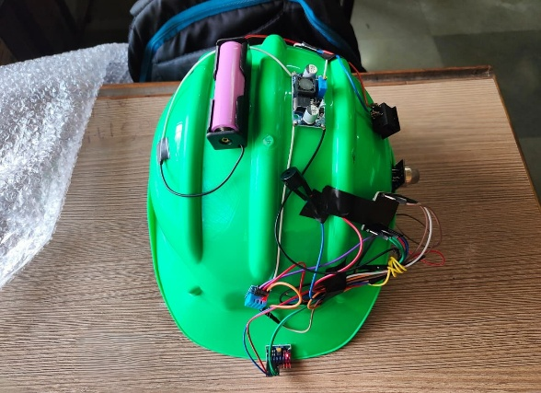
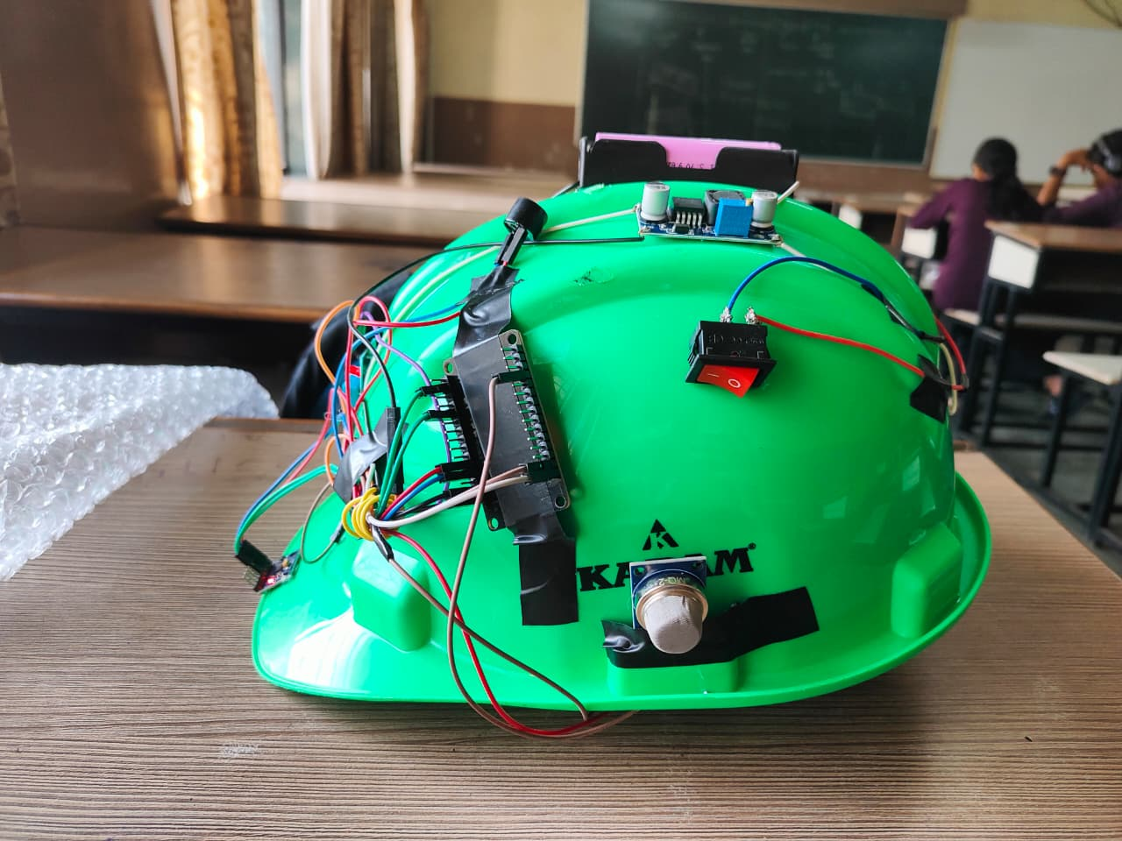
4.2 Photos

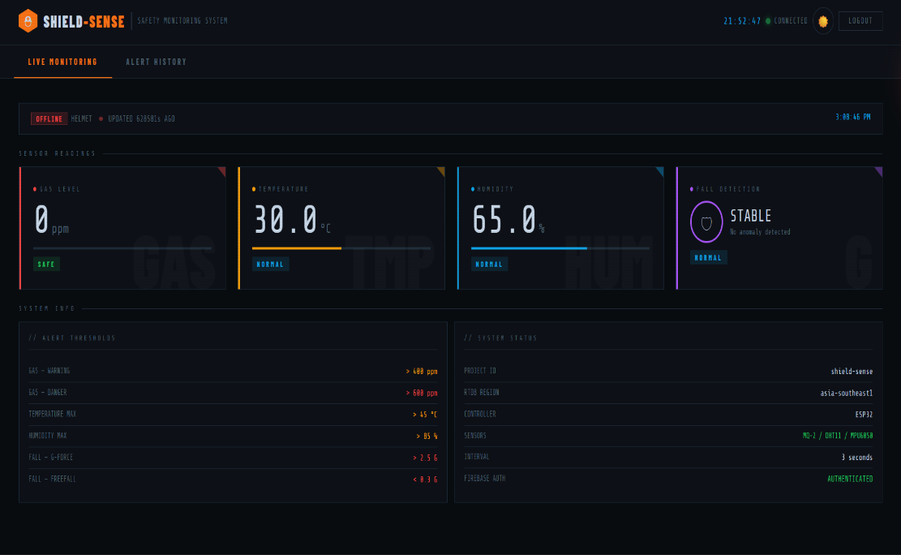

DASHBOARD

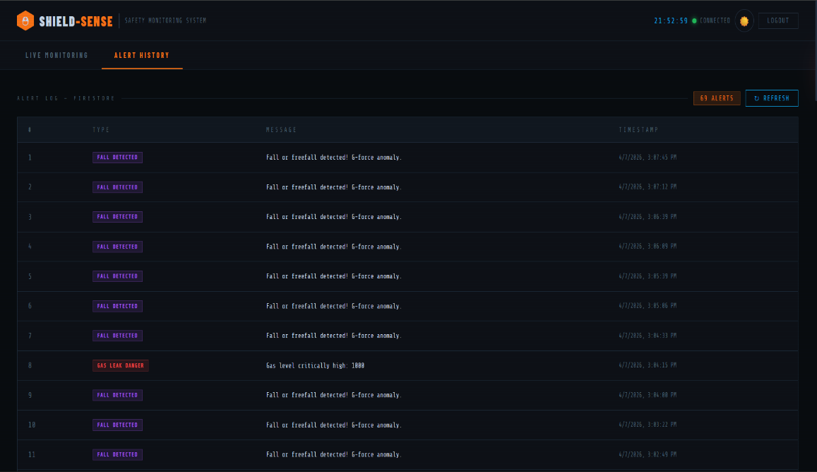
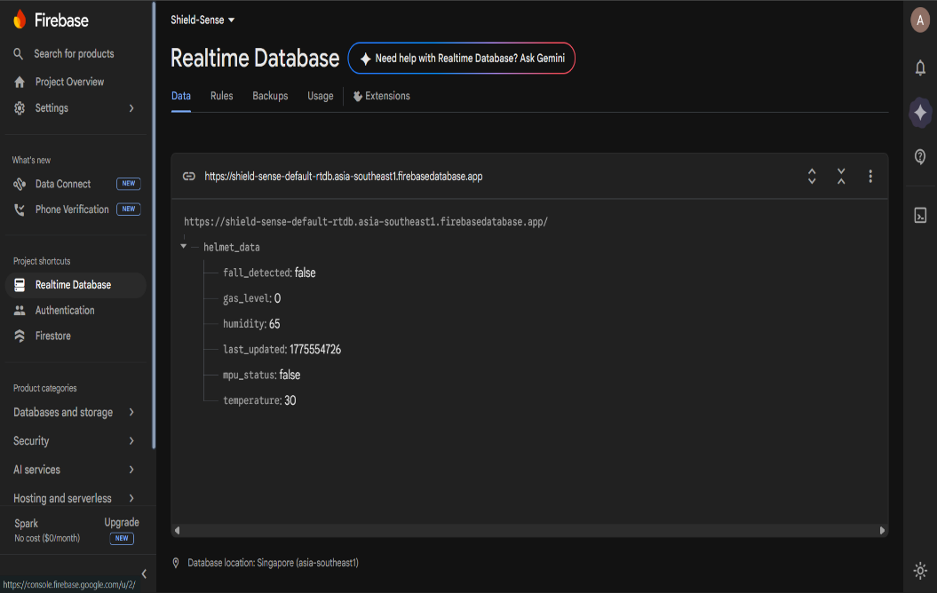
DATABASE
LOGS (ALERTS HISTORY)

4.3 Flow Chart

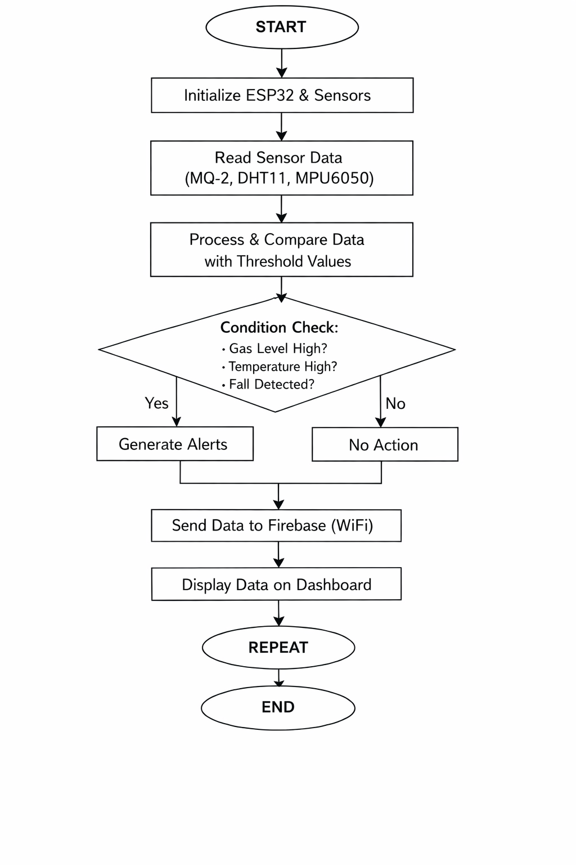

Chapter 5: Applications and Future Scope

5.1 Applications
- Used in construction sites to monitor worker safety and detect hazardous conditions
- Useful in mining industries for detecting toxic gases and preventing accidents
- Applied in manufacturing industries for real-time environmental monitoring
- Used in oil and gas industries where gas leakage detection is critical
- Suitable for chemical plants and factories with harmful substances
- Can be used in industrial safety systems to reduce accidents
- Helpful for research and educational purposes to demonstrate IoT-based safety

5.2 Future Scope
- Integration of GPS module for real-time location tracking
- Adding GSM or mobile notifications for instant alerts
- Use of advanced sensors for detecting more environmental parameters
- Implementation of AI and Machine Learning for predictive safety
- Improvement in power system using solar charging
- Expansion to monitor multiple workers simultaneously
- Enhancement of dashboard with advanced analytics and visualization.

Chapter 6: Conclusion & References

6.1 Conclusion
The proposed “Shield-Sense: IoT Based Smart Safety Construction Helmet” system provides an effective solution for improving worker safety by integrating sensing, processing, and real-time monitoring into a single system, as it uses sensors like MQ-2, DHT11, and MPU6050 to continuously monitor environmental conditions and detect hazards such as gas leakage, high temperature, and sudden falls, while the ESP32 microcontroller processes this data and sends it to Firebase for real-time monitoring and alert logging through a web-based dashboard, the system reduces manual effort, improves response time during emergencies, and enhances overall safety in hazardous environments, and its portable design using a 18650 Li-ion battery with an XL6009 boost converter makes it suitable for real-world applications, thus the project demonstrates a reliable, cost-effective, and efficient IoT-based safety solution.

6.2 References
- H. Supriyanto, I. Rokhim, and V. Eliezer, “Smart Helmet for Monitoring Construction Workers Using IoT-based ESP32 and LoRa,” Indonesian Journal of Computer Science, vol. 13, no. 4, 2024.
- H. R. Rokade, P. G. Ghagre, and V. M. Mandade, “IoT Based Coal Mine Safety Monitoring and Alerting Smart Helmet,” International Journal for Research in Applied Science and Engineering Technology (IJRASET), 2025.
- A. D. T. Alcantara et al., “Internet of Things-Based Smart Helmet with Accident Identification and Logistics Monitoring,” MDPI Engineering Proceedings, 2023.
- D. Kaur, A. Salvi, and J. H. Nirmal, “IoT-Enabled Smart Helmet for Real-Time Crash Detection and Emergency Alert with Live Geospatial Dashboard,” SSRN, 2025.
- Kabilan M., Monish S., and S. Siamala Devi, “Accident Detection System Based on Internet of Things (IoT) – Smart Helmet,” IJARIIT, vol. 5, no. 2, 2019.
- M. A. Rahman et al., “IoT Based Smart Helmet and Accident Identification System,” IEEE Region 10 Symposium (TENSYMP), 2020.
- M. E. Alim et al., “Design and Implementation of IoT Based Smart Helmet for Road Accident Detection,” IEEE Conference, 2020.
- Israel Campero-Jurado et al., “Smart Helmet 5.0 for Industrial Internet of Things Using Artificial Intelligence,” Sensors (MDPI), vol. 20, no. 21, 2020.
- Dr. V. Siva Nagaraju et al., “Intelligent Helmet using IoT,” International Journal of Engineering Research & Technology (IJERT), vol. 13, issue 11, 2024.
- G. Sireesha et al., “Smart Helmet using IoT,” IJERT Conference Publication, 2020.
- R. Pawar et al., “Internet of Things Enabled Smart Helmet,” IJERT, vol. 8, issue 7, 2019.
- Preeti Kuhar et al., “Internet of Things (IoT) based Smart Helmet for Construction,” Journal of Physics: Conference Series, 2021.

