A REPORT ON

“INPLANT TRAINING”



DIPLOMA IN COMPUTER ENGINEERING
AFFILIATED TO MSBTE

Submitted By
Atharva R. Deshmukh
Sarthak K. Patani
Purva P. Ransing
Sharayu R. Jadhav
Under the guidance of
Mrs. Vidya Pingle

DEPARTMENT OF COMPUTER ENGINEERING
PIMPRI CHINCHWAD POLYTECHNIC AKURDI, PUNE.

2026-27
Certificate of Completion of Industrial Training

Maharashtra State Board of Technical Education
Certificate of Completion
Of Industrial Training
This is to certify that
Sr.No | Enrolment No. | Name of Student | Sign
1 | 24211000253 | Atharva R. Deshmukh
2 | 24211000246 | Sarthak K. Patani
3 | 24211000231 | Purva P. Ransing
4 | 24211000245 | Sharayu R. Jadhav

Head of the Department  Mrs. M. S. Malkar | Head of the Institute  Dr. V. S. Byakod
Name of External Examiner  Mrs/Mr | Name of Internal Examiner  Mrs/Mr
has successfully completed Industrial Training (315004) in Linkcode Technologies from 25/05/2026 to 14/08/2026 for partial fulfilment towards completion of Diploma in Computer Engineering from Pimpri Chinchwad Polytechnic.
Institute code 0056.
Seal of Institute

ABSTRACT
Industrial training is one of the requirements to impart technical education at diploma level in computer engineering as per MSBTE. As such, the students are required to write and submit reports at the end of their training.
This report includes the engineering experiences, professional based practices and both TECHNICAL and NON-TECHNICAL knowledge and skilled development gained by me during industrial training at Linkcode Technologies , Pune for 12 weeks from 25 May 2026 to 14 August 2026.
This industrial training consists of 10 chapters which altogether explain the topics, points to be covered during training. Chapter 1 and 2 explains the background study of industry, its organisational structure, responsibilities of different posts, its location etc. Chapter 3 explains about the major equipment's/machines in industry with their function specification and cost along with their maintenance. Chapter 4 consist of material handling and safety procedures. Chapter 5 consists about practical activities undertaken at workshop, common faults and their remedies with controlling procedure. Chapter 6 explains about special experiences encountered during training, recommendations and conclusion. And chapter 7 consists of the references.

ACKNOWLEDGEMENT
We would like to express my gratitude to one and all who contributed me to success in the industrial training programme who helped me in various ways technical, management and all sort of guidance given to improve our professional and technical knowledge.
First, We would like to thank Mr. Rahul Ahire of ‘Linkcode Technologies ’ who allowed us for training experience.
We must give my special thanks to the Head of Department of computer engineering, respected Mrs. M. S. Malkar madam for her invaluable advice and constant encouragement to complete this seminar report in a successful manner then, Mrs. Vidya Pingle madam lecturer, who did all the co-ordination between students and company and thanks to other academic staff members for their great efforts for monitoring our training experience throughout the training period in order to ensure that we gain maximum knowledge out of it.
We would like to express my deep sense of gratitude to our esteemed Principal Dr. V. S. Byakod for her encouragement.
Our special thanks to all the supervisors and developers of ‘Linkcode Technologies ’ who helped me by spending their valuable time and teaching me to resolved problems which we encountered while we was developing. These technical advices not only helped in resolving my problems but also improved our technical experience.
At last but not the least we would like to thank everyone who has made our training experience a pleasant and enjoyable one and helping to overcome the challenges we faced during training.

Sr.No | Enrolment No. | Name of Student | Sign
1 | 24211000253 | Atharva R. Deshmukh
2 | 24211000246 | Sarthak K. Patani
3 | 24211000231 | Purva P. Ransing
4 | 24211000245 | Sharayu R. Jadhav

CONTENTS
Chapter No. | Title | Page No.
1. | Organizational structure of Industry / Organization and General Layout | 7
2. | Introduction to Industry | 9
3. | Types of major equipment/instruments/ machines used in industries | 13
4. | Manufacturing process, planning and control | 15
5. | Testing of Hardware/Software and material Handling procedure | 17
6. | Safety procedures followed, and safety gear used by Industry | 19
7. | Particulars of Practical Experiences in Industry | 21
8. | Detail report of task undertaken (During the training) | 23
9. | Details of Online Courses [all students in group + internship letter] | 27
10. | Bibliography/ References | 29

Chapter 1: Organizational Structure of Industry and General Layout

1.1 General Information Regarding Industry
Linkcode Technologies is Pune's No. 1 IT training and placement institute, committed to shaping careers and bridging the gap between talent and opportunity. With a mission to empower students with in-demand technical skills, we offer comprehensive training programs tailored to the ever-evolving IT industry.
Breaking into the IT industry is becoming increasingly competitive. Simply holding a degree is no longer enough—practical skills, industry knowledge, and hands-on experience are essential to securing a job in top companies. The more you learn and practice, the better your chances of success.
At Linkcode Technologies , we bridge the gap between academics and industry expectations by providing comprehensive placement training. Our expert mentors guide students through technical training, coding assessments, mock interviews, and resume building, ensuring they are fully prepared for off-campus opportunities.

1.2 Vision, Mission and Objectives
VISION: To become a trusted technology education and career-development organization that prepares students with industry-relevant skills and connects them with meaningful career opportunities.
MISSION: Linkcode Technologies ’s mission is to empower students with industry-ready skills and transform careers through quality IT education.
Objectives:
- Preparing students for employment through mock interviews, aptitude preparation and technical interview preparation.
- Supporting students in the placement process through placement drives and recruitment opportunities.
- Introducing students to modern technologies, including full-stack development, cloud, DevOps, data analytics, AI and related technologies.
- Developing programming and problem-solving skills through coding and technical assessments.

1.3 Organizational Structure
Linkcode Technologies follows a relatively small and functional organizational structure rather than the highly layered structure normally found in large IT corporations.
Based on publicly available information, the organization is led by its founder/CEO and directors, with technical trainers and other staff supporting training, placement and operational activities. The official website identifies Rahul Ahire as Founder & CEO and Pritam Kamble as Director, while also describing a team of technical trainers specializsing in areas such as Full Stack Development, Data Analytics and AI.
Major Functional Areas
- 1. Management – Responsible for strategic planning, organizational decisions, business development and overall operations.
- 2. Technical Training Department – Responsible for delivering technical courses, conducting practical sessions, mentoring students and providing project-based learning.
- 3. Placement and Career Support – Responsible for placement preparation, interview preparation, placement drives, recruitment coordination and career guidance.
- 4. Administration and Operations – Handles day-to-day administrative activities, student coordination, scheduling and organizational support.

Chapter 2: Introduction of Industry/Organization

2.1 History of Linkcode Technologies
Linkcode Technologies developed as an organization focused on IT education, technical training and career development in Pune.
Linkcode Technologies , the organization was founded in 2015 and is headquartered in Pune.
The company has 15+ years of experience in the industry and has trained and placed many students till date.
Its current course portfolio includes Java Full Stack, Python Full Stack, MEAN/MERN, Android Development, DevOps, AWS Cloud Infrastructure, Big Data, Blockchain, Data Analytics, Data Science and Gen AI, among others.
The organization also reports having trained 19K+ students and placed 5K+ students till date.
Development of the Organization
The organization has developed its offerings around:
- Programming and software development training
- Full-stack development
- Database technologies
- Data structures and algorithms
- Web development
- Android development
- Cloud and DevOps
- Data analytics and data science
- AI and Generative AI
- Placement preparation
- Internship and live-project opportunities

2.2 Type of Product and Services Provided by Linkcode Technologies
Linkcode Technologies is primarily a service-oriented organization rather than a traditional product-manufacturing company.
Below are some of the services provided by Linkcode Technologies :
- IT Training Services
- Placement Assistance
- Project-Based Learning
- Internship Opportunities
- Career Guidance
- Corporate Training

2.3 Study of Sales, Turnover, Profitability and Number of Employees
Since Linkcode Technologies is a private, relatively small organization, detailed financial information such as annual sales, revenue and net profit is not readily disclosed on its public website. Therefore, for this academic report, no estimated turnover or profit figure has been assumed beyond what the company itself provides.
A. Sales
The company's sales are primarily generated through its service-based business model. Major sources of revenue can include technical training/course fees, professional training programs, corporate training, placement-oriented programs, internship/training programs, online training programs and other IT-related professional services. Unlike a manufacturing company, Linkcode Technologies does not primarily generate sales through physical products — its main commercial offering is knowledge, training, mentorship and career-oriented services.
B. Turnover
The annual turnover of Linkcode Technologies is not publicly disclosed. As the organization operates on a relatively small scale compared with large IT companies, its financial information is not available through common public company disclosures in the same detail as listed corporations.
C. Profitability
Exact profit/net profit is not publicly disclosed. The organization's profitability depends on factors such as number of students enrolled, course fees, corporate training contracts, trainer and employee costs, office and infrastructure expenses, marketing expenses, and technology and operational costs.
D. Number of Employees
Linkcode Technologies has more than 30 employees working across different departments. The workforce includes technical trainers, mentors, placement and career-support staff, administrative personnel and other supporting staff. As a growing organization, the number of employees may change according to its operational and business requirements.

Chapter 3: Types of Major Equipment/Instruments/ Machines Used in Industry

3.1 Important Software Used
The latest tools and software skills are used:
- Software Development: JAVA, Python
- Web Based Development: HTML, CSS, JavaScript, React
- Frameworks: Django, React (as part of the Python Full Stack course)
- Database: SQL Server, MySQL
- Web servers: Apache, Node.js
- Operating systems: Windows (All Versions), Linux, Mac OS

3.2 Infrastructure
- Cloud
- Cloud Watch
- AWS
- Apache Server
- Linux OS
- EC2 Instances

Chapter 4: Manufacturing Process, Planning and Control
Manufacturing Process along with production planning and control methods: Linkcode Technologies Technologies, a global IT Services provider has full-cycle services in the areas of software development, web-based enterprise solutions, web application and portal development. Combining our solid business domain experience, technical expertise, profound knowledge of latest industry trends and quality-driven delivery model, we offer progressive end-to-end web solutions.

4.1 Software Maintenance
We accept maintenance responsibility for any kind of web-based application so that our customer is free of any technical hassles that may need to be dealt with. Some maintenance activities that we take up comprise domain management, email management, shared server hosting, dedicated server hosting, cloud based hosting, bug fixing, database management, data backup and restore management, all server configurations and deployments, any updates or upgrades and 24x7 technical support.

4.2 Software Development
We develop customized software development solutions for our potential customers according to their business requirements, within the defined deadlines and with high quality factor. Our software developers make sure to develop a user friendly and robust software application which can be scaled to any level.

4.3 Web Development
Web development is the process of designing, developing and maintaining websites and web apps. Web development encompasses several different fields, most commonly referring to the programming of websites. Front-end development is the act of developing the user interface and client-side code, while back-end development focuses on the infrastructure behind a website, mainly server-side code.

Chapter 5: Testing of Hardware/Software and Material Handling Procedure
Quality Control Testing of Raw Materials, APIs, and Finished Products. The Quality Control Testing sample should be tested in accordance with the work plan of the laboratory after completion of the preliminary procedures. If this is not feasible the reasons should be noted, e.g. in the analytical worksheet, and the sample should be stored in a special place which is kept locked.
Specific tests required may need to be carried out by another unit or by a specialized external laboratory. The responsible person should prepare the request and arrange for the transfer of the required number of units (bottles, vials or tablets) from the sample. Each of these units should bear the correct registration number.

Evaluation of Test Results
Test results should be reviewed and, where appropriate, evaluated statistically after completion of all the tests to determine whether they are mutually consistent and if they meet the specifications used. The evaluation should take into consideration the results of all the tests (all test data). Whenever doubtful (atypical) results are obtained they should be investigated. The complete testing procedure needs to be checked according to the internal quality management system. When a doubtful result (suspected OOS result) has been identified, a review of the different procedures applied during the testing process is to be undertaken by the supervisor with the analyst or technician before retesting is permitted. The following steps should be followed:
- Confirm with the analyst or technician that the appropriate procedure(s) was (were) applied and followed correctly.
- Examine the raw data to identify possible discrepancies.
- Check all calculations.
- Check that the equipment used was qualified and calibrated, and that the system was appropriate.

Chapter 6: Safety Procedures Followed and Safety Gear Used by Industry
Working in the IT industry involves handling sensitive data and working with complex technology. To ensure safety and maintain professionalism, here are some important procedures to follow:
- Secure Data Handling: Adhere to data protection regulations and company policies when handling sensitive information. Encrypt data when necessary, use strong passwords, and avoid sharing information with unauthorized individuals.
- Access Control: Follow proper access control procedures, including using unique login credentials, regularly updating passwords, and implementing two-factor authentication. Grant access to systems and data on a need-to-know basis.
- Regular System Updates: Regularly update software, operating systems, and applications to ensure security patches are applied. This helps protect against known vulnerabilities and keeps systems up to date.
- Phishing Awareness: Be vigilant about phishing emails and other social engineering techniques used to gain unauthorized access. Verify the legitimacy of requests for personal or sensitive information before responding.
- Device Security: Secure company-issued devices with strong passwords or biometric locks and keep them physically secured when not in use. Avoid using personal devices for work-related tasks unless properly authorized.
- Backup and Recovery: Regularly back up important data to protect against loss or ransomware attacks. Test backups periodically to ensure they can be restored successfully if needed.
- Incident Reporting: Promptly report any security incidents or breaches to the appropriate channels within the organization. Follow incident response protocols to mitigate the impact and prevent further damage.

Chapter 7: Particulars of Practical Experiences in Industry

7.1 Mobile Application
Designing is the foremost part of mobile app development. UI of mobile apps should be as such that it should attract the people who are using it. Even functional designing is also done. After understanding the client requirements and designing, it’s time to develop it. Excellent logical and coding skills are required to develop mobile apps.

7.2 Software Development
We develop customized software development solutions for our potential customers according to their business requirements, within the defined deadlines and with high quality factor. Our software developers make sure to develop a user friendly and robust software application which can be scaled to any level.

7.3 Software Maintenance
We accept maintenance responsibility for any kind of web-based application so that our customer is free of any technical hassles that may need to be dealt with. Some maintenance activities that we take up comprise domain management, email management, shared server hosting, dedicated server hosting, cloud based hosting, bug fixing, database management, data backup and restore management, all server configurations and deployments, any updates or upgrades and 24x7 technical support.

7.4 Domain & Hosting
Our web hosting plans are designed to include all the features you are looking for at the best possible price. All our Hosting plans are ideal for most individuals and client businesses.

7.5 Database Management
Learned how databases such as MySQL/SQLite/PostgreSQL are used to store, retrieve, and manage application data.

7.6 Testing & Debugging
Practiced identifying errors, testing application functions, and improving software reliability.

7.7 Industry Tools & Technologies
Gained exposure to programming tools, development environments, databases, and software technologies used in industry.

Chapter 8: Detail Report of Task Undertaken (During the Training)
Project: Sathify – Smart Society Domestic Workforce Management System
Project Title: Sathify – Smart Society Domestic Workforce Management System

Objective
To develop a mobile-first platform that helps residents of Indian apartment societies hire, verify, schedule and pay domestic workers (maids, cooks, cleaners) in a trustworthy and organized way. The system automates worker onboarding and KYC verification, discovery and hiring, one-day service booking, day-to-day scheduling, gate attendance verification, in-app payments and a trust-score based rating mechanism, while giving society administrators and gate security a role-based view of the same data.

Problem Statement & Motivation
In most Indian apartment societies, hiring a maid, cook, cleaner or nanny still happens informally — through word-of-mouth references, notices on the society board, or local agents — with no structured way to verify a worker's identity, track attendance at the gate, or resolve disputes over payment and work quality. Residents have little visibility into who is entering the society on their behalf, gate security has no reliable way to confirm that a visitor is an approved worker, and society administrators have no consolidated record of who is operating within the premises.
Sathify was conceived to close this gap: a single mobile platform that brings KYC-verified worker onboarding, transparent discovery and hiring, day-to-day scheduling, gate-level identity verification, in-app payments, and a two-sided, trust-score-based rating system together for four kinds of users — residents, workers, gate security and society administrators — on one shared codebase.

Software & Tools Used
- Flutter (Dart) – cross-platform mobile application, Android-first
- Python 3 with Django 5.2 LTS and Django REST Framework – backend JSON API
- PostgreSQL (hosted on Supabase free tier) – primary relational database
- JWT Authentication (djangorestframework-simplejwt) with Role-Based Access Control across 4 roles
- Supabase Storage – persistent storage for worker photos and KYC documents
- Render – free-tier hosting for the Django API
- Firebase Cloud Messaging – push notifications
- Razorpay (test mode) – payments and payouts
- PaddleOCR (with EasyOCR fallback) – OCR for KYC document verification
- DeepFace – face verification for worker identity checks
- A provider-agnostic AI layer with fallback order Gemini → Groq → OpenRouter → Hugging Face
- Git & GitHub – version control and team collaboration
- VS Code / Android Studio – development environment
- Pytest – backend automated testing, with CI checks on GitHub Actions

Project Description
Sathify is an academic project built as a native, cross-platform mobile application (Flutter) backed entirely by a JSON REST API (Django REST Framework) — there are no server-rendered pages. The system is organized into cleanly separated modules, with each Django app in the backend mapped one-to-one to a corresponding feature folder in the Flutter app, which allowed the project team to divide work without conflicts.
The platform serves four types of users through one shared codebase and role-based access control:
- Society Admin – onboards the society (towers, flats, gates, service types), approves worker KYC, and monitors activity through admin dashboards.
- Resident – discovers and hires verified workers, books one-day services, schedules recurring tasks, makes payments, and rates completed work.
- Worker – completes KYC-based onboarding, accepts bookings/engagements, and manages daily schedules and payouts.
- Gate Guard – verifies worker entry/exit at the society gate using an offline-first QR/face verification flow.
Key Modules Implemented
- 1. Identity & Access – phone-number based registration with OTP verification, JWT login, and role-based access control across the four user types.
- 2. Society & Resident Onboarding – setup of society structure — towers, flats, gates and service types — with residents linked to their flats.
- 3. Worker Onboarding & KYC – worker registration with Aadhaar-based document upload, OCR-assisted data extraction (PaddleOCR/EasyOCR) and admin-side approval.
- 4. Discovery & Hiring – residents browse verified, approved workers and initiate a hiring engagement.
- 5. One-Day Service Booking – on-demand, single-day bookings for services outside a regular hiring engagement.
- 6. Scheduling & Task Management – recurring schedules and day-to-day task assignment between residents and hired workers.
- 7. Attendance & Gate Verification – an offline-first guard app that caches approved bookings locally, performs on-device QR scanning, and syncs attendance records to the server once connectivity is available — ensuring gate entry never depends on the backend being awake.
- 8. Payments & Payouts – Razorpay integration (test mode) for resident payments and worker payouts.
- 9. Ratings & Trust Score – a two-sided rating system, available only once a booking is completed or an engagement is formally ended, feeding into a worker trust score.
- 10. Notifications – push notifications via Firebase Cloud Messaging for bookings, approvals and reminders.
- 11. Admin, Reporting & Complaints – dashboards and reporting tools for society administrators, along with a complaint-handling workflow.
- 12. AI Services Layer – a single provider-agnostic AI integration with automatic fallback across Gemini, Groq, OpenRouter and Hugging Face, used to keep AI-dependent features available even if one provider's free tier is exhausted.

System Architecture
The system follows a layered client–server architecture. A single Flutter codebase renders four role-specific experiences — Resident, Worker, Gate Guard and Society Admin — that all talk to one Django REST Framework API over JSON, secured with JWT authentication and role-based access control. The API is backed by a PostgreSQL database hosted on Supabase, and delegates specialised, non-core functionality to managed cloud services: Supabase Storage for KYC documents and photos, Razorpay for payments and payouts, Firebase Cloud Messaging for push notifications, PaddleOCR/EasyOCR with DeepFace for KYC and face verification, and a provider-agnostic AI layer that fails over across Gemini, Groq, OpenRouter and Hugging Face.
This separation keeps the mobile client thin, lets all four roles share one codebase and one set of API contracts, and allows individual cloud dependencies to degrade gracefully without taking the core booking and attendance flow down.
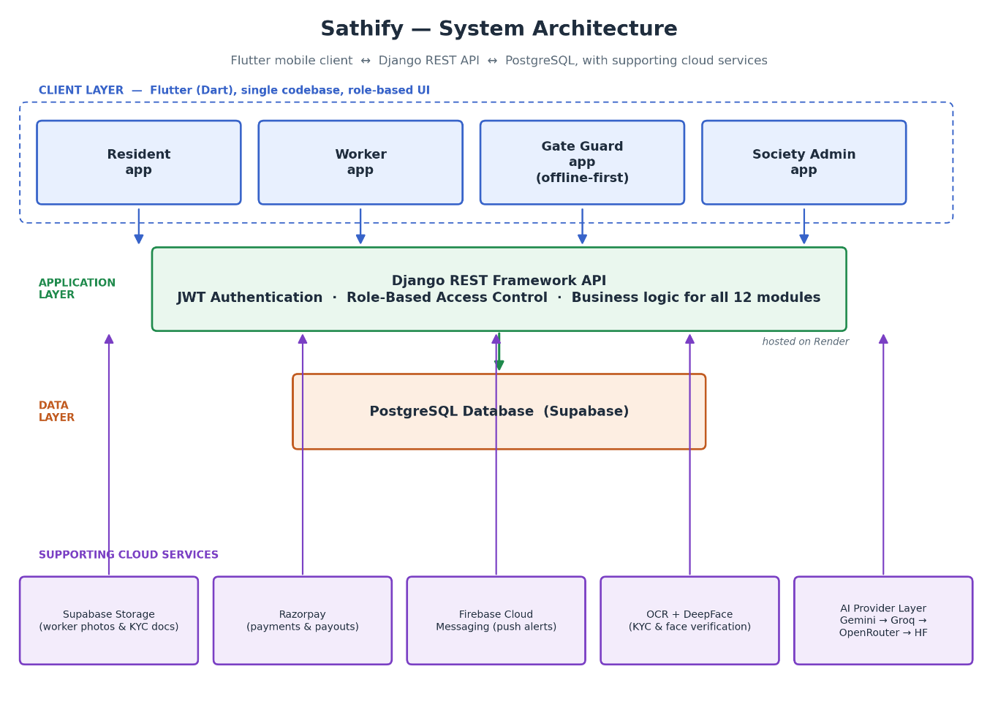
Fig. 8.1 — Sathify system architecture: client, application and data layers with supporting cloud services.

Functional Flow of the System

Although Sathify has twelve modules working behind the scenes, the everyday experience reduces to one short, repeatable flow that touches all four roles, shown below.

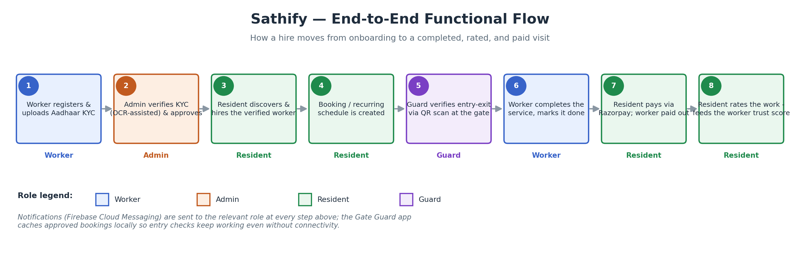

Fig. 8.2 — End-to-end functional flow: from worker KYC to a rated, paid visit.

Steps 1–2 (worker registration and KYC approval) happen once per worker; steps 3 onward repeat for every booking or scheduled visit thereafter. The Gate Guard app is offline-first — it caches each day's approved bookings locally on the device, so entry/exit verification keeps working even when the API or the internet connection is temporarily unavailable, and syncs the attendance log back to the server once connectivity returns.

Application Screenshots
The screens below are captured from the working application and illustrate the implemented functionality for each of the four roles.
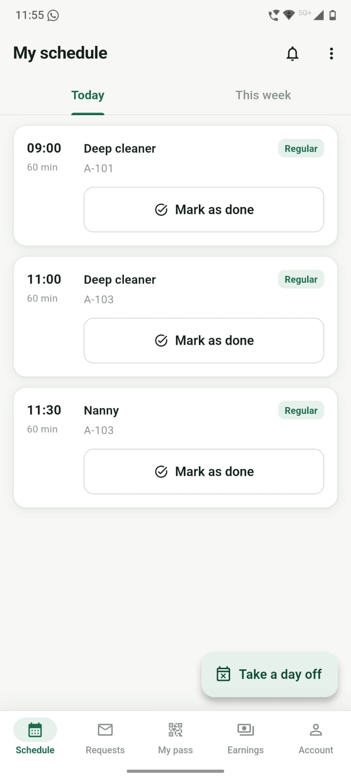  Worker  My Schedule — today's bookings | 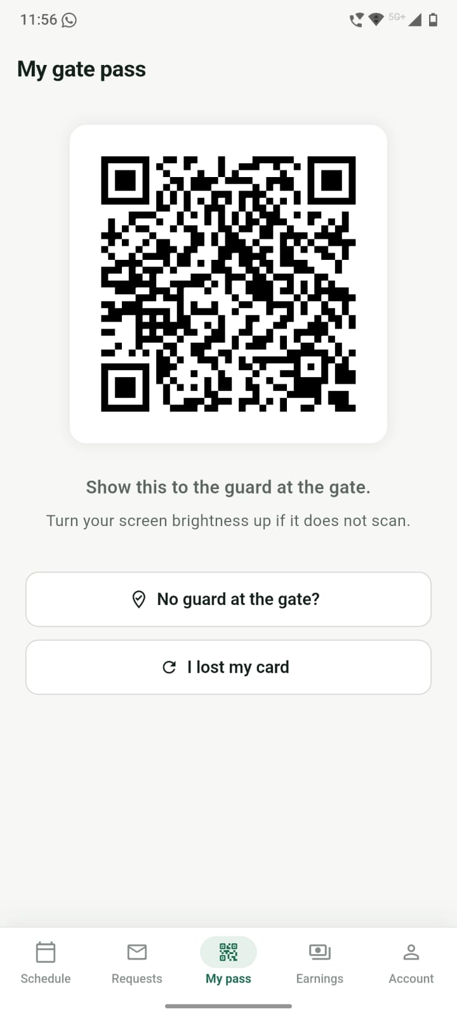  Worker  Gate Pass — QR shown at entry | 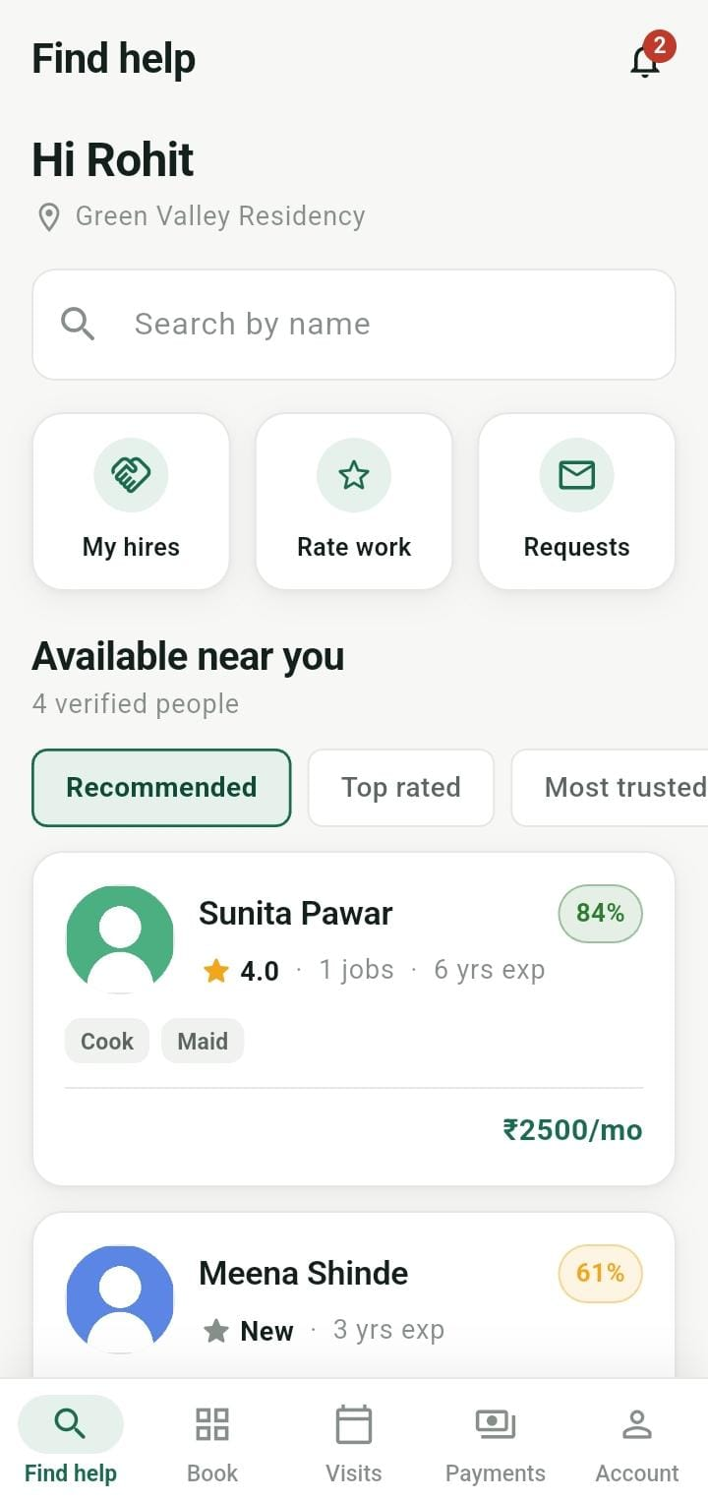  Resident  Find Help — discover & hire workers | 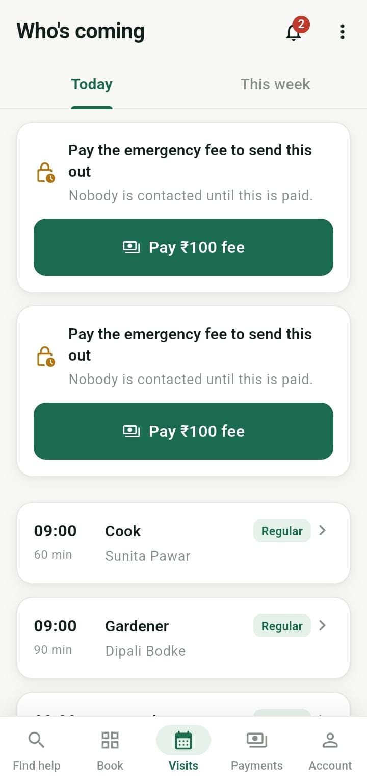  Resident  Who's Coming — today's expected visits
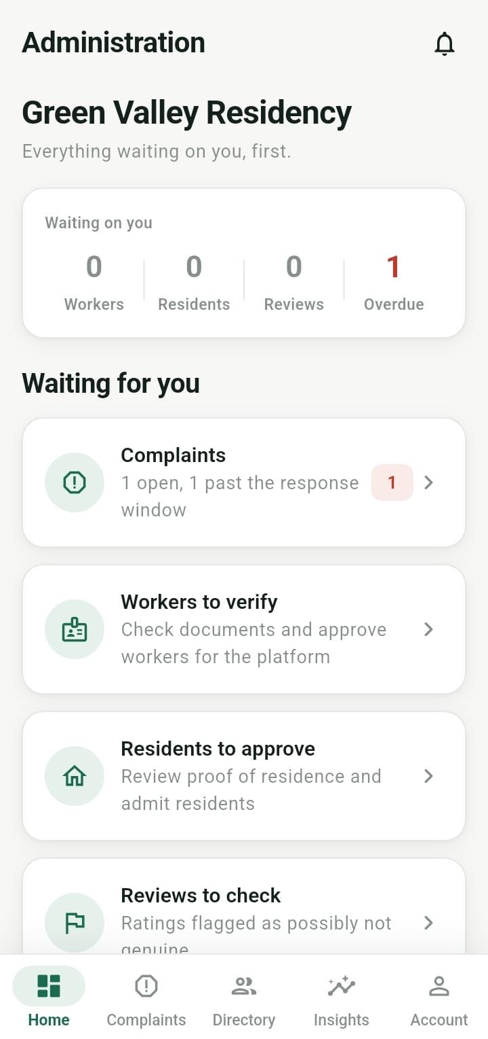  Society Admin  Dashboard — items waiting for action | 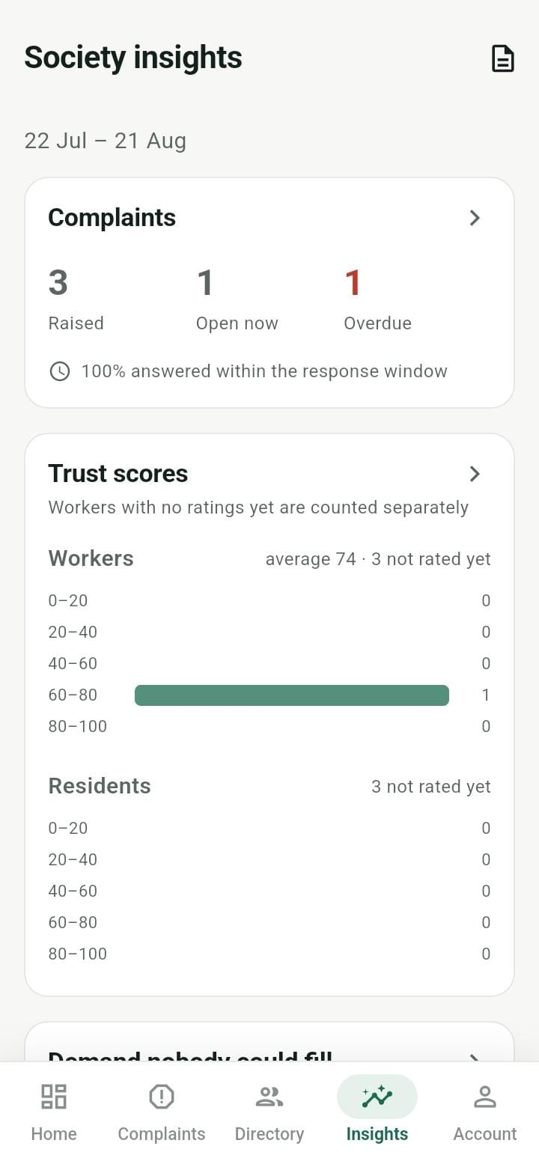  Society Admin  Society Insights — trust scores & complaints | 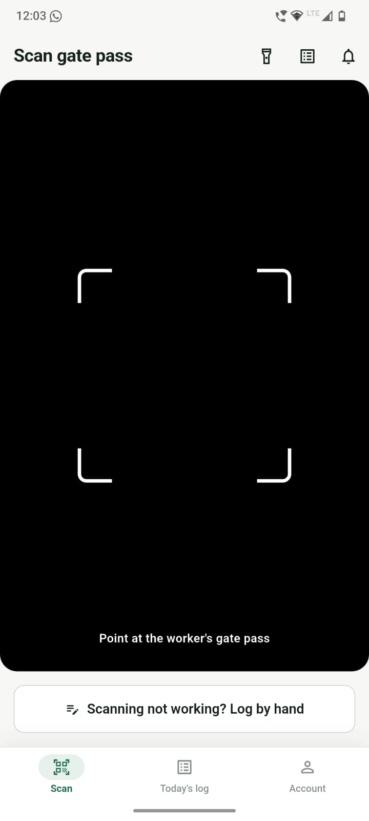  Gate Guard  Scan Gate Pass — QR verification at gate | 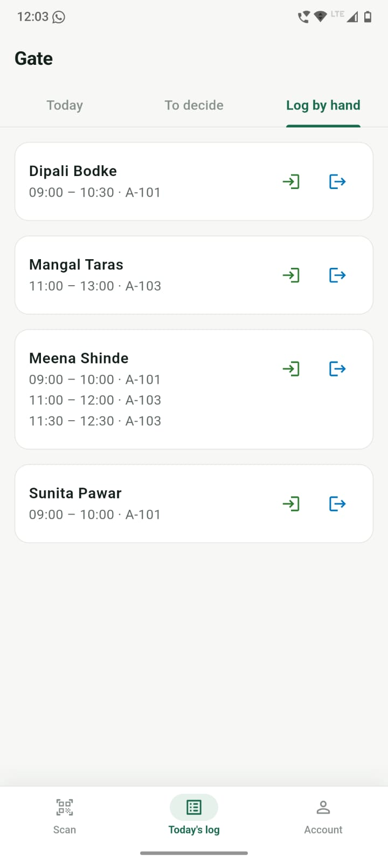  Gate Guard  Gate Log — manual entry / exit log
Fig. 8.3 — Selected application screens across the Worker, Resident, Society Admin and Gate Guard roles.

My Role and Contribution
During the training, I contributed to both the backend and mobile layers of the project as part of a team following a module-wise ownership model:
- Worked on Django REST Framework API endpoints for assigned modules, including request validation, serializers and role-based permission checks.
- Built and consumed REST APIs from the Flutter application, following the project's data/domain/presentation folder structure for each feature.
- Worked with PostgreSQL/SQLite for schema design and querying, and used Django's ORM and migrations to evolve the data model.
- Practiced JWT-based authentication flows and tested role-based access across the Admin, Resident, Worker and Guard roles.
- Wrote and ran backend tests using Pytest, and verified changes locally against the same checks used in the project's CI pipeline before pushing code.
- Used Git and GitHub for version control, following the team's branching and pull-request conventions defined in the project's contribution guidelines.
- Gained exposure to real-world engineering constraints of building on free-tier cloud infrastructure (Render, Supabase) — including designing around service cold-starts and ephemeral storage.

Outcome
Through this project, I gained hands-on, full-stack experience covering mobile app development in Flutter, REST API design and implementation in Django, relational database design, authentication and role-based security, third-party service integration (payments, OCR, face verification, push notifications), and collaborative software development practices such as version control, code review and automated testing — all of which strengthened both my technical and professional skill set.

Chapter 9: Details of Online Courses
As part of skill development during the training period, online courses/certifications relevant to the training were completed by students of the group. The relevant certificates are attached in the following sequence:
- Sarthak K. Patani – Introduction to Python certificate, HTML5 certificate, Industrial Internship Completion Letter
- Atharva R. Deshmukh – Introduction to Python certificate, HTML5 certificate, Industrial Internship Completion Letter
- Purva P. Ransing – Introduction to Python certificate, HTML5 certificate, Industrial Internship Completion Letter
- Sharayu R. Jadhav – Introduction to Python certificate, HTML5 certificate, Industrial Internship Completion Letter

An Industrial Internship Completion Certificate issued by Linkcode Technologies Pvt. Ltd., confirming successful completion of the Industrial Training & Internship (25th May 2026 to 15th August 2026) in Python Full Stack Development, is enclosed with the original submitted report for each student named above.

Chapter 10: References

Linkcode Technologies Technologies, PUNE

Office no.12, 3rd Floor, Barve Memorial Complex, Opposite to Panchali Hotel, JM Road, Shivajinagar, Pune, 411005.

