**SUPER STORE SALES ANALYSIS USING POWER BI**

DATASET SIZE – 5901 RECORDS

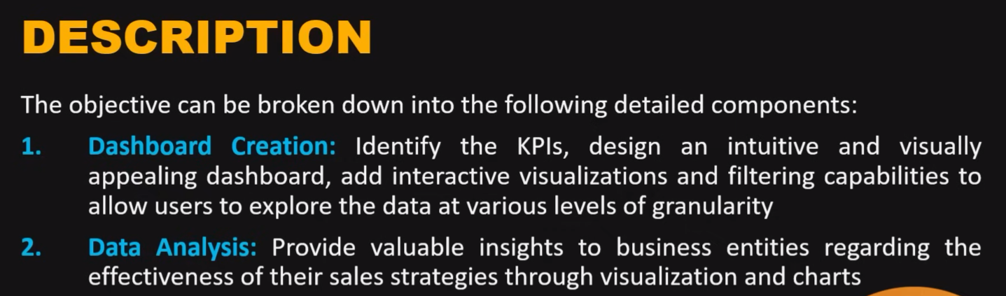

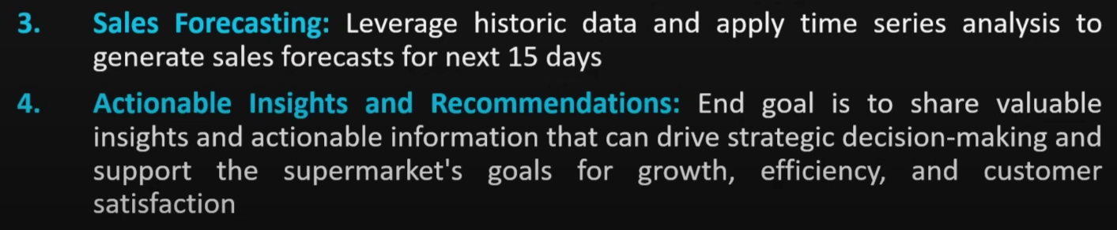

**TRANSFORMATION OF DATA**

**TRANSFORM DATA TYPE:**

Apply the row filter to each row and check the values present in it. Analyse whether they are correct and is there a need to replace/remove them.

* Datatype of the column is shown besides the column name.
* Right click on a column name to change the datatype of the column.
* Select multiple columns >> Transform >> Detect datatypes
* View >> Column Quality checkbox >> shows the number of valid, error and empty datatypes.
* Transform >> use 1st row as header (for cases where column name is represented as Column 1, column 2, etc. and the real column names are written in the 1st row)
* Home >> Remove rows >> remove duplicates
* Right click on column name >> replace values
* Right click on column name >> remove columns

On the right there is a log of all the steps done. This will help us to go back to any previous.

Click on canvas >> format canvas tab above the chart >> **CANVAS BACKGROUND** to add bg image.

Do not select the wallpaper option as it won’t be exported along with the dashboard

CLUSTERED BAR CHART

* Sales vs Category
* Sales vs Sub-category
* Sales vs Shipping Modes

Use LEGEND in STACKED AREA chart to show the month wise sales data comparison between 2019 and 2020.

LINE CHART

* Monthly sales vs Year
* Monthly profit vs Year

CARD

* Sales (summation)
* Profit (summation)
* Quantity (summation)
* Delivery Time (avg in days)

**DONUT CHART**

>> off legend >> go to detail labels >> label contents (to show the category besides the pie)

* Sales vs Segment (Corporate or Home office or Consumer)
* Sales vs Payment Modes (card or COD or online)

FILLED MAP

Drop the states column on the map to get the bubbles on the map of America.

Size and shade of bubble is proportional to that of the sales amount

**DAX QUERY**

to find delivery time in days (ship date – order date)

Add column >> AvgDelivery = DATEDIFF(<table name><ship date>, (<table name><order date>, DAY)

The last parameter is DAY because we want the difference in days.

**FORECASTING**

Only possible in line chart.

Go to Visualizations >> 3rd icon – Analytics >> Forecast

Can turn on Zoom slider for better visibility