A PROJECT REPORT ON
IoT-Enabled Attendance System using RFID


SESSION 2025-26

UNDER THE GUIDANCE OF – Prof. S. A. DESAI

SUBMITTED BY
Bhushan Kadu (Roll No.155-B)
Atharva Latkar (Roll No.152-B)
Prajwal Ingole (Roll No.276-C)

DEPARTMENT OF ELECTRONICS &TELECOMMUNICATION ENGINEERING
YESHWANTRAO CHAVAN COLLEGE OF ENGINEERING, NAGPUR

CERTIFICATE OF APPROVAL
03/11/25

This is Certified that the project thesis entitled IoT-Enabled Attendance System using RFID
has been successfully completed by Bhushan Kadu, Atharva Latkar, Prajwal Ingole under the guidance of Prof. S. A. Desai in recognition to the partial fulfillment for the award of the degree of Bachelor of Engineering in Electronics & Telecommunication Engineering, Rashtrasant Tukdoji Maharaj Nagpur University, Nagpur.

S.A.Desai
Name of (Guide)

DECLARATION
I/we certify that

- The work contained in this project has been done by us under the guidance of our supervisor.
- The work has not been submitted to any other institute for any degree or diploma.
- We have followed the guidelines provided by the institute in preparing the project report.
- I have confirmed to the norms and guidelines given in the ethical code of conduct of the institute.
- Whenever We have used materials (data, theoretical analysis, figures and texts) from other sources, We have given due credit to them by citing them in the text of the report and giving their details in the references.

Signature
Name: Bhushan Kadu
Name: Atharva Latkar
Name: Prajwal Ingole

INDEX

Sr.  No | Title | Pg  No.
1 | Abstract
2 | Introduction
3 | Literature Survey / Existing System
4 | Proposed System
5 | Implementation / Methodology
6 | Results and Discussion
7 | References

​Abstract

This project presents an IoT-based attendance system using RFID technology and the NodeMCU ESP8266 microcontroller. Each user is provided with a unique RFID card. When the card is scanned by the RFID reader, the data is sent to the NodeMCU, which connects to Wi-Fi and updates attendance records automatically in Google Sheets through a web app script. This system eliminates manual data entry, minimizes errors, and provides a real-time attendance monitoring solution accessible from anywhere through the internet.

​Introduction

- Traditional attendance methods involve manual entry, which is time-consuming and error-prone. The integration of IoT and RFID technologies provides a smart, automated, and contactless method for recording attendance. In this project, an RFID reader (RC522) detects card IDs, and a NodeMCU (ESP8266) sends that information to Google Sheets via Wi-Fi. The data is stored along with date and time stamps, allowing administrators to view and manage attendance remotely.
- This project aims to improve attendance management by reducing human intervention, ensuring accuracy, and providing easy access to data online

​Literature Survey / Existing System
- Existing attendance systems typically rely on manual or biometric approaches.
- Manual entry systems are inefficient and prone to human error, while biometric systems, though accurate, are expensive and require regular maintenance.
- The proposed IoT-based RFID system is cost-effective, wireless, and supports remote data monitoring, making it suitable for institutions and offices.

4 . Proposed System

- Block Diagram / Architecture:-
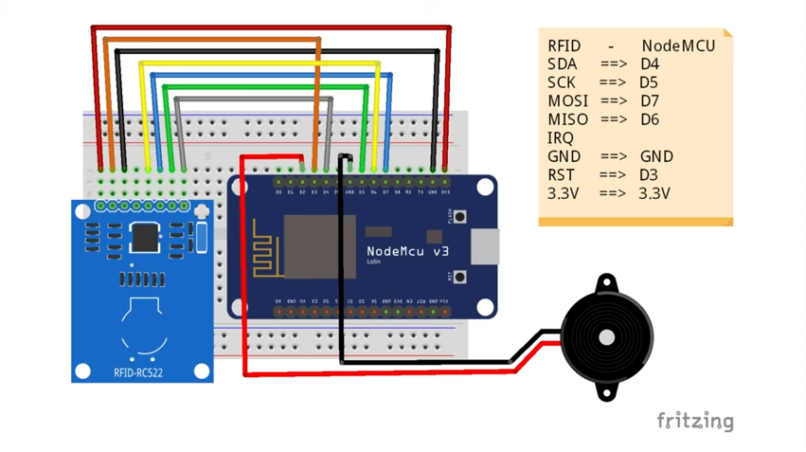
- Working Flow:-
- The RFID tag contains a unique identification number (UID).
- When the tag is placed near the RFID reader (RC522), the reader detects and sends the UID to NodeMCU via SPI communication.
- NodeMCU, connected to Wi-Fi, sends the UID data to a web server (Google Apps Script URL).
- The web script updates the Google Sheet in real-time with the UID, date, and time.
- This data acts as the attendance record, accessible from anywhere via the internet.
- Description of Each Component:-
Hardware Components
- NodeMCU (ESP8266):
  - A microcontroller with built-in Wi-Fi used for IoT applications.
  - It processes data from the RFID reader and sends it to the cloud using the HTTP protocol.
- RFID Reader (RC522):
  - A radio frequency identification module that reads data stored in RFID tags.
  - It works on 13.56 MHz frequency and communicates with NodeMCU via the SPI interface.
- RFID Tags/Cards:
  - Each user is assigned a unique RFID card with an embedded chip that transmits a unique ID when scanned.
- Jumper Wires and Breadboard:
  - Used for circuit connections between NodeMCU, RFID reader, and other peripherals.
- Power Supply (5V):
  - Powers the NodeMCU and RFID module during operation.
Software Components
- Arduino IDE:
  - Used to write and upload code to NodeMCU using C/C++ language.
- Google Sheets & Google Apps Script:
  - The cloud platform used for storing attendance records.
  - Apps Script acts as a web server endpoint to receive data from NodeMCU and automatically append it to the sheet.
- Wi-Fi Network:
  - Enables NodeMCU to communicate with the Google Apps Script server via the internet.
- HTTP Protocol:
  - Used for sending data requests from NodeMCU to Google Apps Script (via GET or POST method).

5 . Implementation / Methodology

- Step-by-step Implementation:
1. Set up NodeMCU and RFID reader wiring on a breadboard.
2. Program NodeMCU using Arduino IDE with RFID and Wi-Fi libraries.
3. Deploy a Google Apps Script Web App linked to a Google Sheet.
4. Connect NodeMCU to Wi-Fi and send RFID data to the Web App.
5. Verify that attendance data is automatically logged in the Google Sheet.
- Circuit connections and wiring diagrams

- Screenshots of code or GUI (if applicable)

- Explanation of communication protocols (MQTT, HTTP, etc.)

​Results and Discussion
- Output screenshots, readings, and graphs
- Cloud dashboard views or mobile app interface

- Observed Results
- The designed IoT-enabled RFID attendance system was successfully implemented and tested in a laboratory environment.
- When each RFID card was scanned near the RC522 reader, the unique ID was instantly transmitted to the Google Sheet via Wi-Fi.
- The system performed smoothly, marking attendance entries with accurate timestamps and minimal delay.

Parameter | Expected Result | Observed Result
RFID Tag Detection | Less than 1 second | 0.5–1 second
Data Upload to Google Sheet | Instant | Within 1–2 seconds
Accuracy of Data Entry | 100% | 100% (no errors observed)
Wi-Fi Connectivity Stability | Continuous | Stable throughout testing
Power Consumption | Low (<1W) | Approximately 0.8W (NodeMCU + RFID)

Discussion:-

- The system demonstrated excellent accuracy, correctly identifying all RFID tags without duplication or missing entries.
- Latency was very low — each scan updated the Google Sheet almost instantly (1–2 seconds delay on average), proving the reliability of IoT communication through HTTP.
- Power consumption was minimal since NodeMCU and RFID modules require very little current (typically under 200 mA during operation).
- The use of Google Sheets as a cloud-based database simplified data visualization and eliminated the need for additional storage hardware.
- Limitations: The system’s performance depends on Wi-Fi strength. If the connection is weak, data transfer may be delayed slightly.
- Overall, the results matched the expected performance, confirming that the project achieves real-time, contactless, and reliable attendance tracking through IoT integration.

​References

1. IoT RFID Attendance System using Google Sheets – YouTube (https://www.youtube.com/watch?v=97samwAA-TA)
2. Arduino.cc Documentation – https://www.arduino.cc/
3. Google Developers – Apps Script Documentation

