**EXPERIMENT NO. 1**

**Problem Statement**: Write a program to implement WSDL service(HelloService.wsdl file)

**Program**:

**WebService1.asmx.cs**

using System;

using System.Collections.Generic;

using System.Linq;

using System.Web;

using System.Web.Services;

namespace HelloWorld

{

/// <summary>

/// Summary description for WebService1

/// </summary>

[WebService(Namespace = "http://tempuri.org/")]

[WebServiceBinding(ConformsTo = WsiProfiles.BasicProfile1_1)]

[System.ComponentModel.ToolboxItem(false)]

// To allow this Web Service to be called from script, using ASP.NET AJAX, uncomment the following line.

// [System.Web.Script.Services.ScriptService]

public class WebService1 : System.Web.Services.WebService

{

[WebMethod]

public string HelloWorld()

{

return "Hello World";

}

}

}

**Output:**

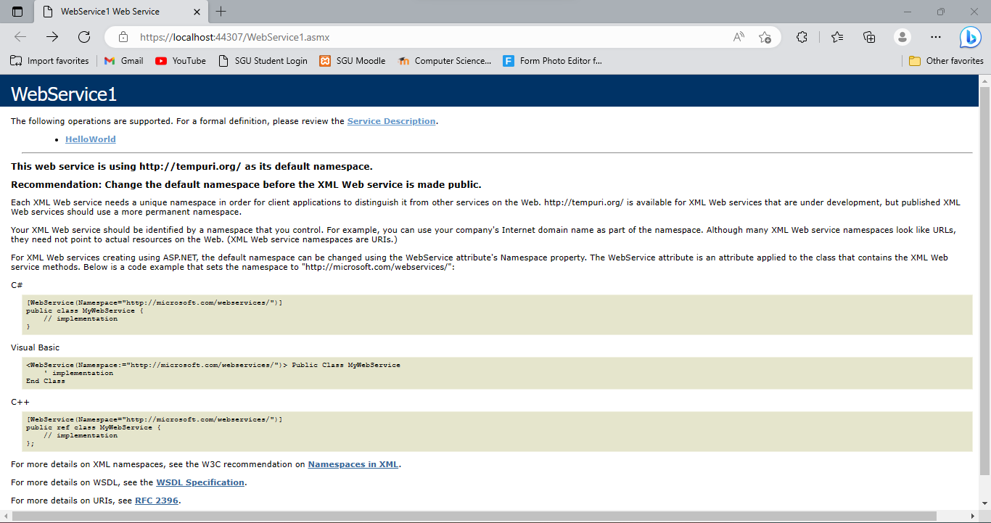

**Service Description:**

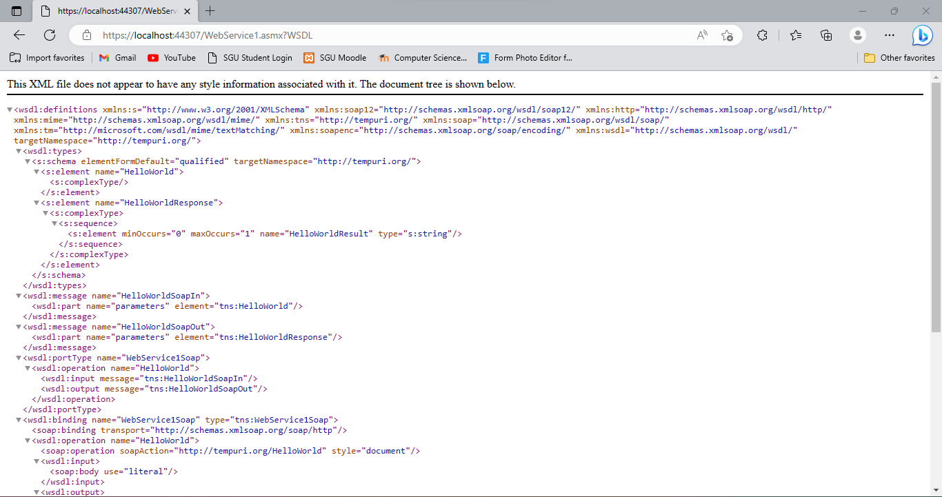

**Output:**

