**Experiment 3**

**Perform following operations in Apache CouchDB.**

1. **Create database ‘student’.**

**Input:**

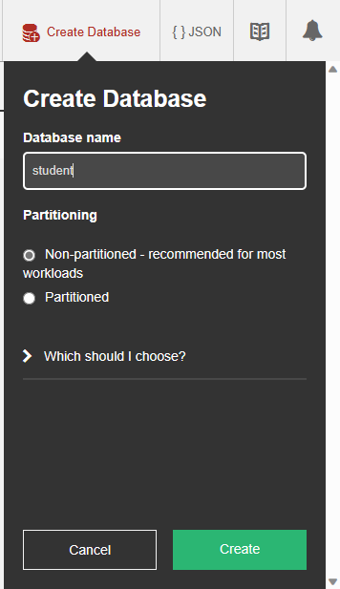

**Output:**

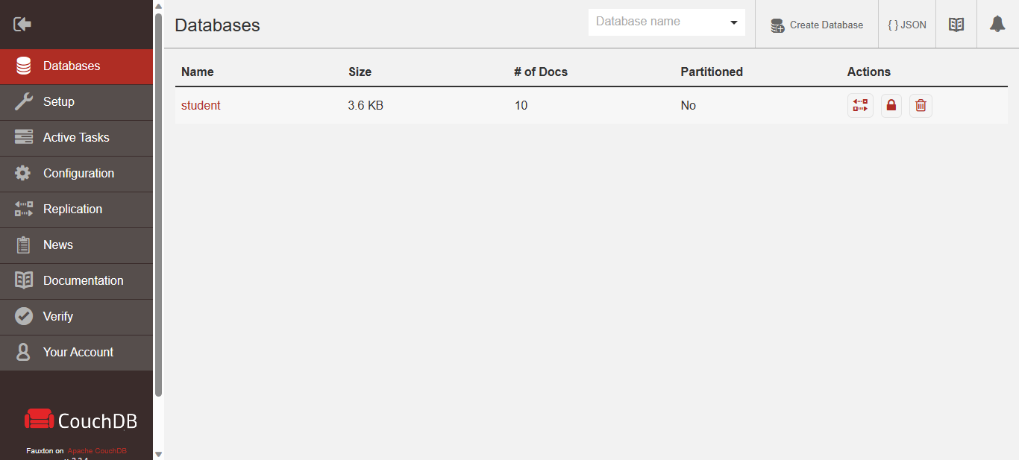

1. **Create 10 documents for database student with key roll_no, stud_name, class, percentage, address.**

**Input:**

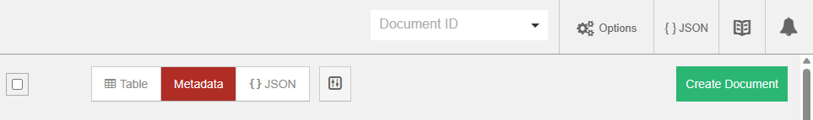

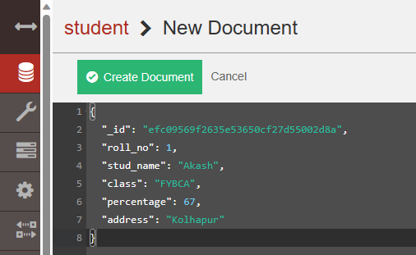

**Output:**

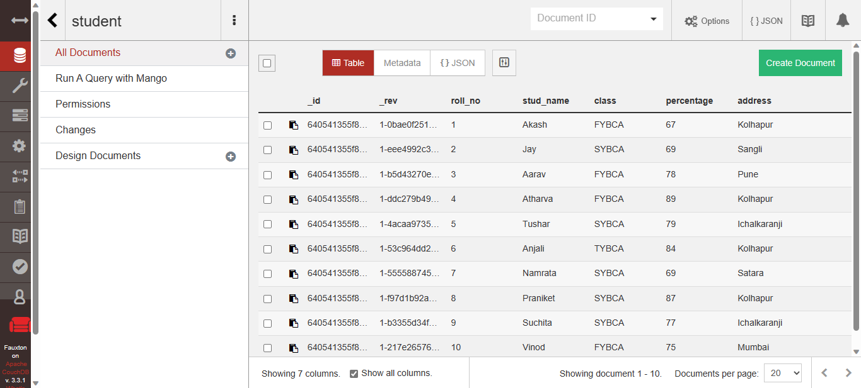

1. **Update key value of class as TYBCA where roll_no is 4.**

**Input:**

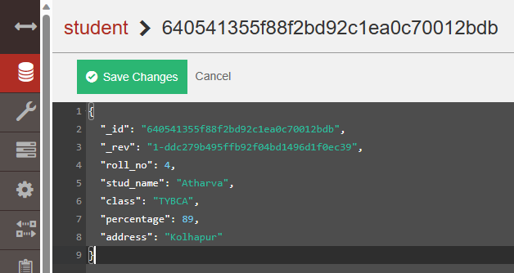

**Output:**

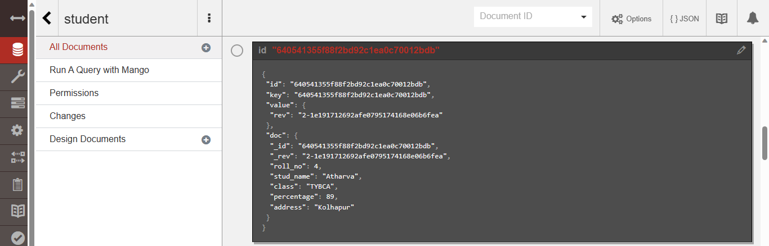

1. **Create a document with roll_no student_name, hobby.**

**Input:**

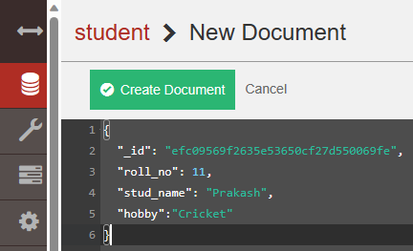

**Output:**

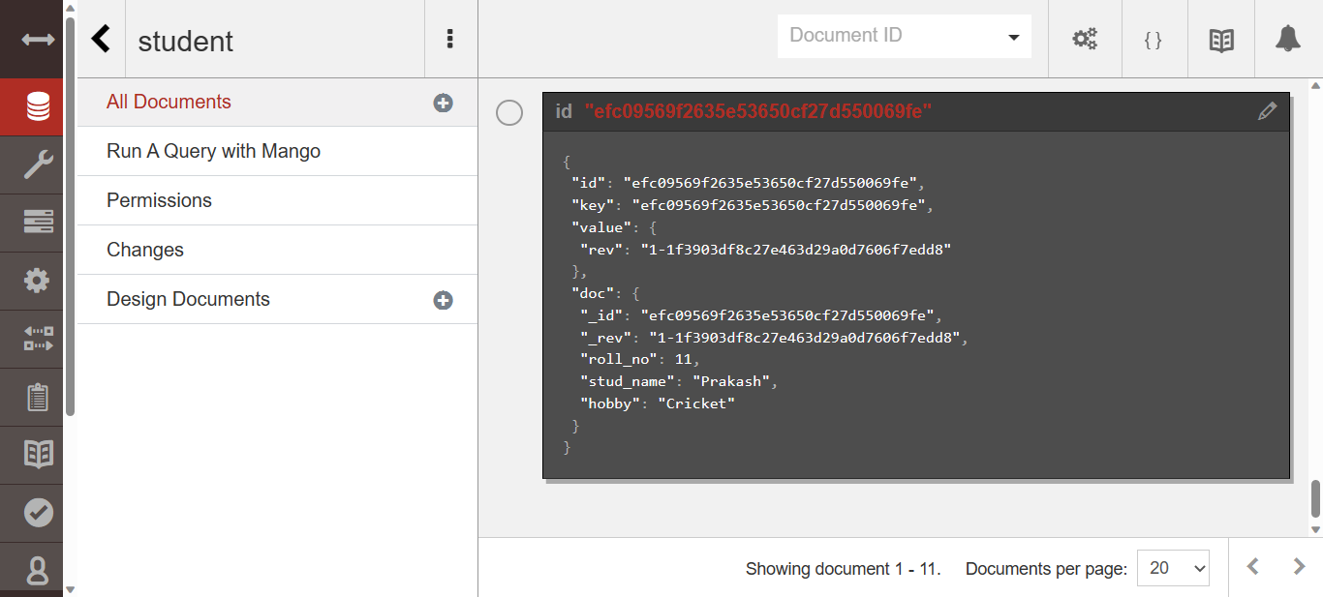

1. **Delete 1 document from student.**

**Input:**

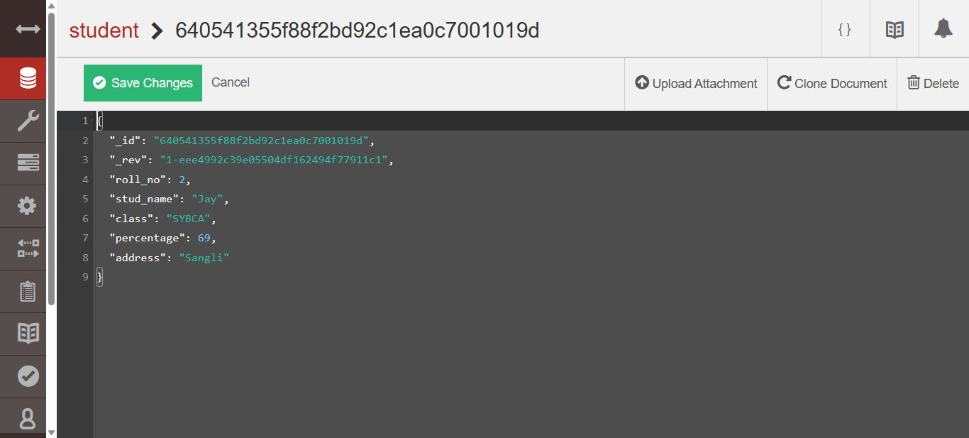

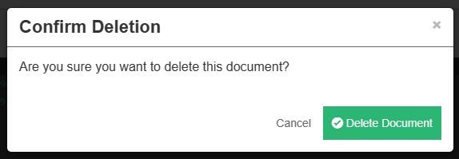

**Output:**

