..

**BT 3040: Bioinformatics**

**Assignment 10**



Indian Institute of Technology Madras

Atharva Mandar Phatak | BE21B009

Department of Biotechnology

## **Q1**) **Obtain the consensus phylogenetic tree for the following two sets of sequences:**

## **Set 1: tim.dat**

*All the files in ‘tim_dat’ folder*

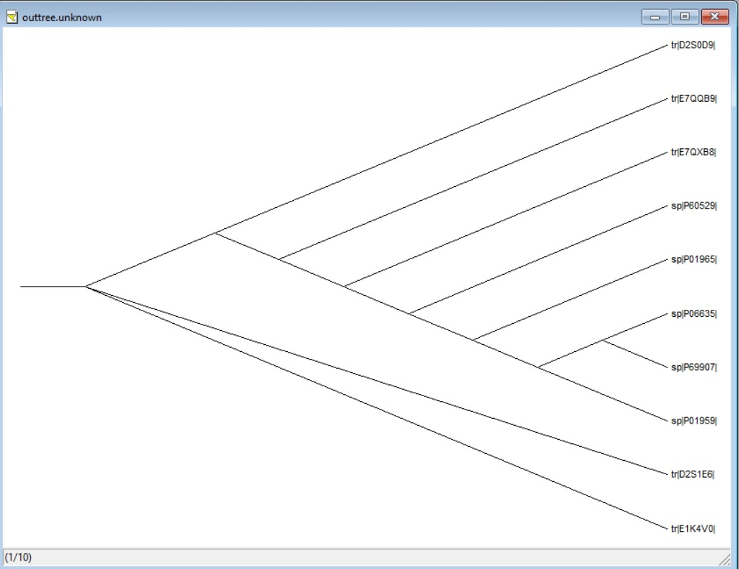

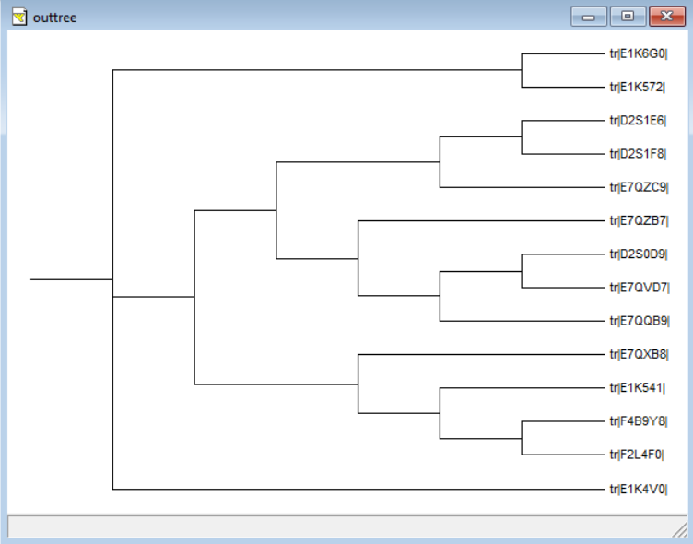

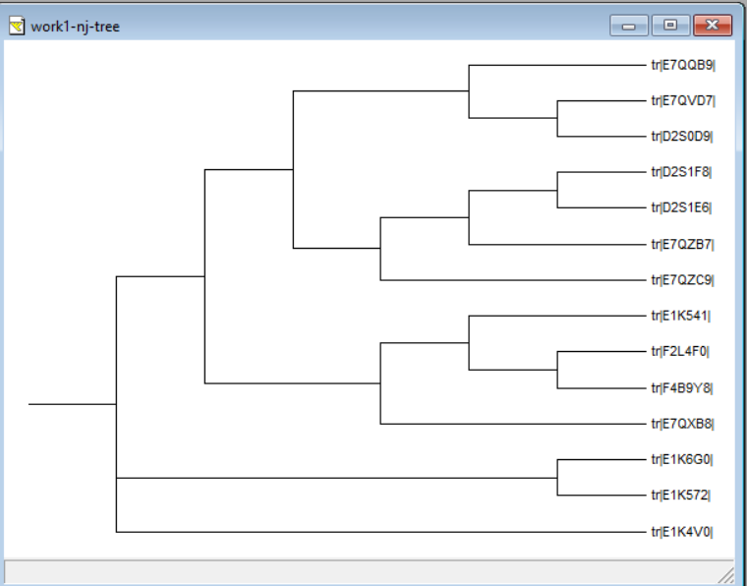

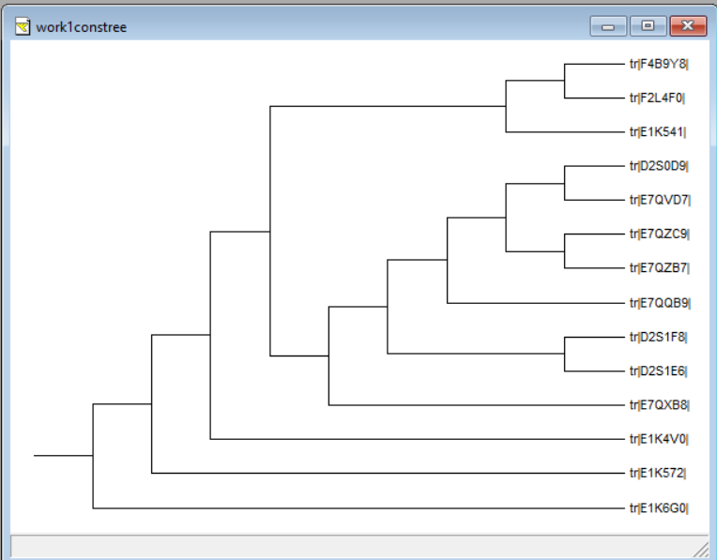

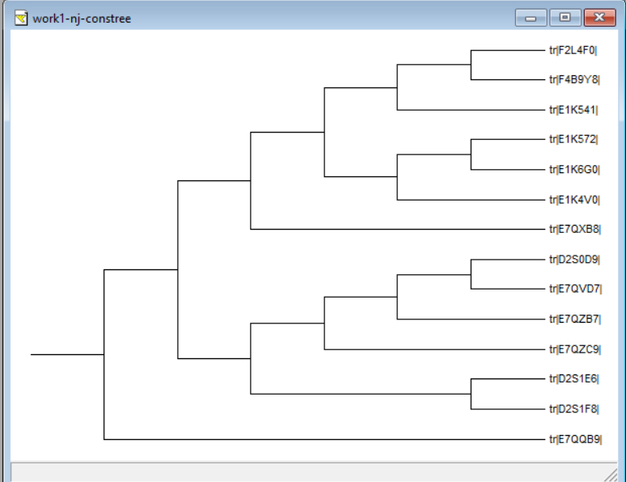

## **Set 2: tim-hemo.dat**

*All the files in ‘tim_dat_hemo’ folder*

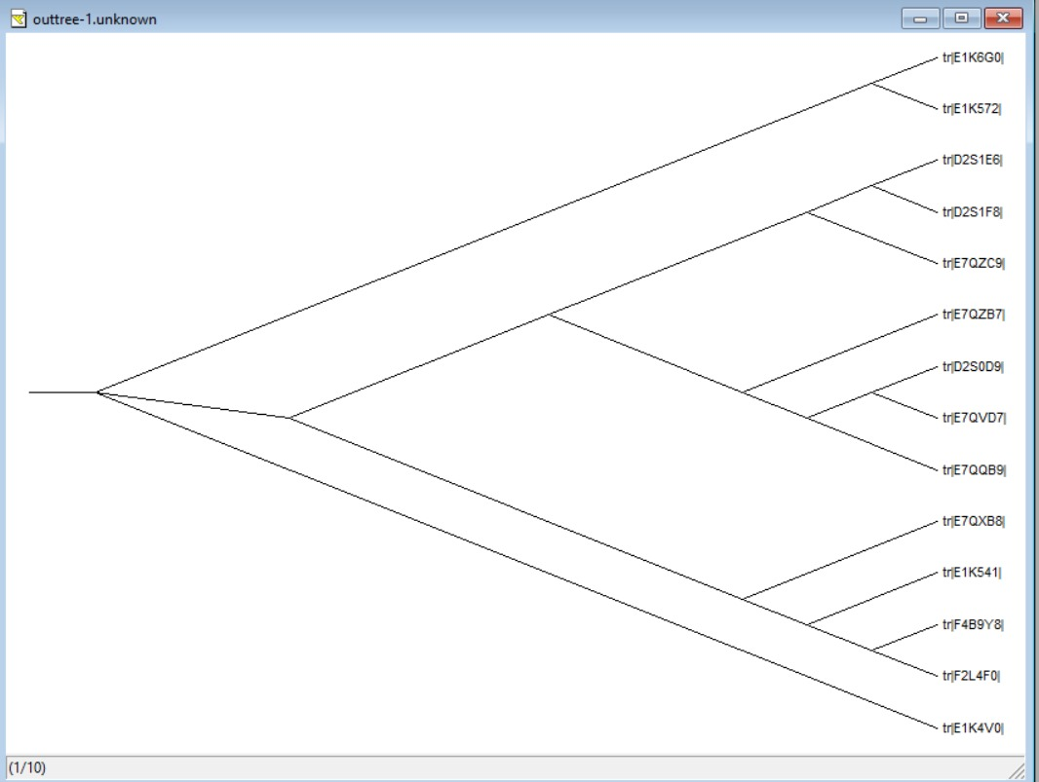

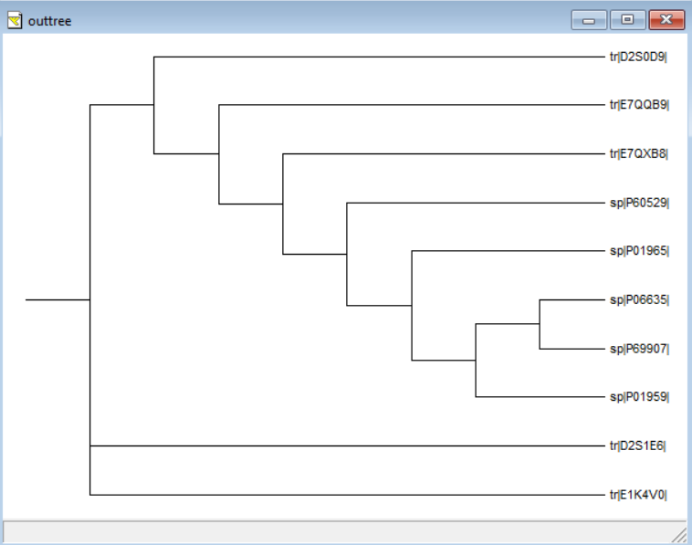

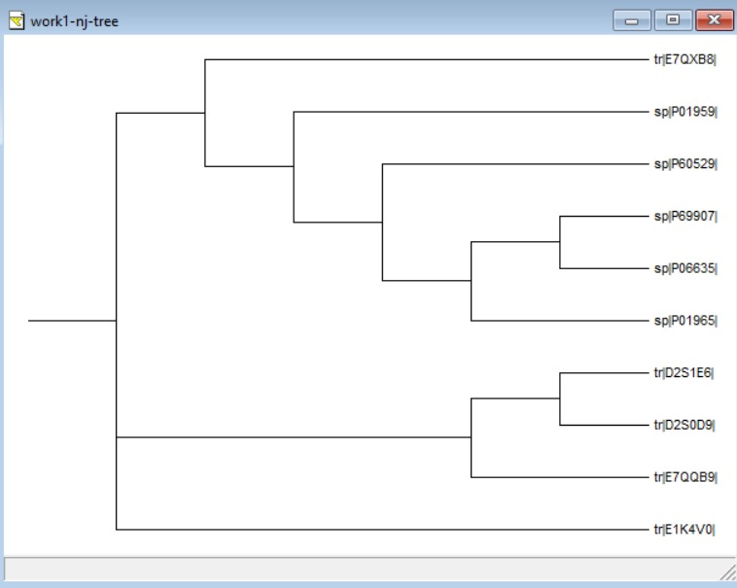

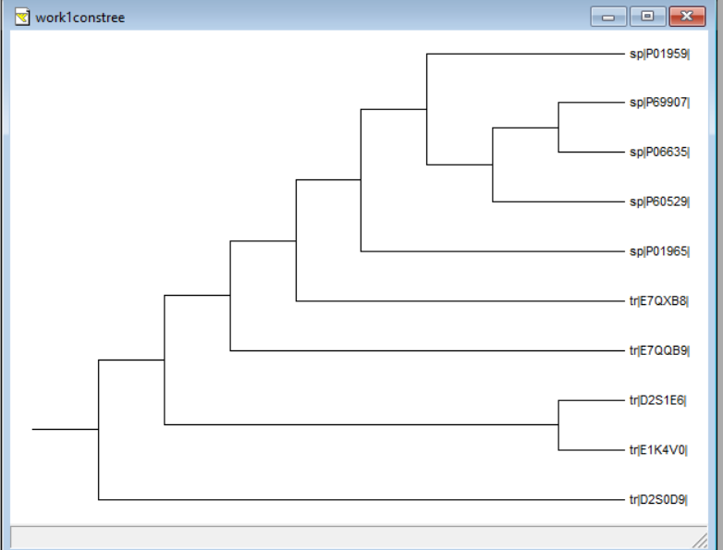

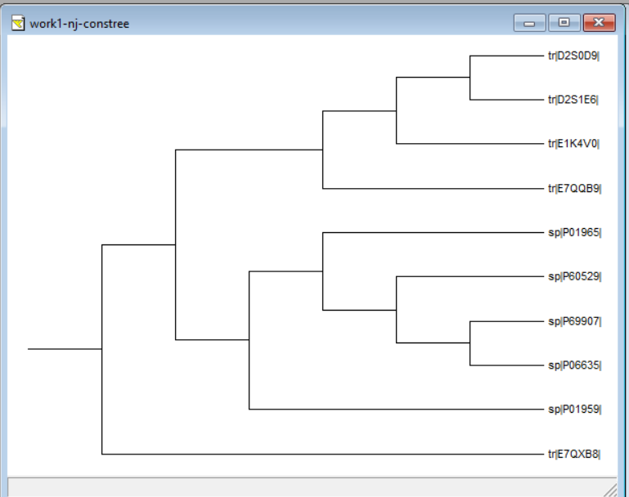

## **Q2) Obtain the weight matrix for the following sequences**

## **MVLSPADKTNVKGKVGAHAGEYGAAAW**

## **MKRLPADPPCVKGKVKAKAGDYGATTW**

## **MALSAADKTNVKSKVGGHAGEYGAATS**

## **MVLSAADKTNVKSKAGGNAGEWWAAAW**

## **MVLSAADKTNVKSKVLANAGEFGAAAW**

## **ALLPIRTTYHKKCASGHIPEEKDLNNV**

**DEASSLKGHHIKKLEADALLIPLSASS**

Code:

#BT3040| Assignemnt 10 | Q2 | Atharva Mandar Phatak | BE21B009 |

import math

def sequence_to_matrix(input_sequence, sequence_length):

    amino_acids = ['A', 'C', 'D', 'E', 'F', 'G', 'H', 'I', 'K', 'L', 'M', 'N', 'P', 'Q', 'R', 'S', 'T', 'V', 'W', 'Y']

    matrix = []

    for i in range(0, len(input_sequence), sequence_length):

        subsequence = input_sequence[i:i+sequence_length]

        row = [0] * len(subsequence)

        for j, aa in enumerate(subsequence):

            row[j] = aa

        matrix.append(row)

    return matrix

input_sequence = 'MVLSPADKTNVKGKVGAHAGEYGAAAWMKRLPADPPCVKGKVKAKAGDYGATTWMALSAADKTNVKSKVGGHAGEYGAATSMVLSAADKTNVKSKAGGNAGEWWAAAWMVLSAADKTNVKSKVLANAGEFGAAAWALLPIRTTYHKKCASGHIPEEKDLNNVDEASSLKGHHIKKLEADALLIPLSASS'

sequence_length = 27

amino_acid_matrix = sequence_to_matrix(input_sequence, sequence_length)

def count_amino_acids(matrix):

    amino_acids = ['A', 'C', 'D', 'E', 'F', 'G', 'H', 'I', 'K', 'L', 'M', 'N', 'P', 'Q', 'R', 'S', 'T', 'V', 'W', 'Y']

    amino_acid_counts = [[0] * len(matrix[0]) for _ in range(len(amino_acids))]

    for row in matrix:

        for i, amino_acid in enumerate(row):

            amino_acid_counts[amino_acids.index(amino_acid)][i] += 1

    return amino_acid_counts

def calculate_weight_matrix(amino_acid_counts):

    num_rows = len(amino_acid_counts)

    num_cols = len(amino_acid_counts[0])

    weight_matrix = [[0] * num_cols for _ in range(num_rows)]

    for i in range(num_rows):

        for j in range(num_cols):

            n = amino_acid_counts[i][j]

            weight_matrix[i][j] = round(math.log((n + 1/20) / (8/20)),2)

    return weight_matrix

# Count amino acids

amino_acid_counts = count_amino_acids(amino_acid_matrix)

# Calculate weight matrix

weight_matrix = calculate_weight_matrix(amino_acid_counts)

from tabulate import  tabulate

print("Alignment Matrix")

print(tabulate(amino_acid_counts, headers=["{}".format(i+1) for i in range(len(amino_acid_matrix[0]))], tablefmt="grid",  numalign="centre"))

print("")

print("")

print("Weight Matrix")

print(tabulate(weight_matrix, headers=["{}".format(i+1) for i in range(len(weight_matrix[0]))], tablefmt="grid",  numalign="centre"))

Output:

1. Alignment Matrix

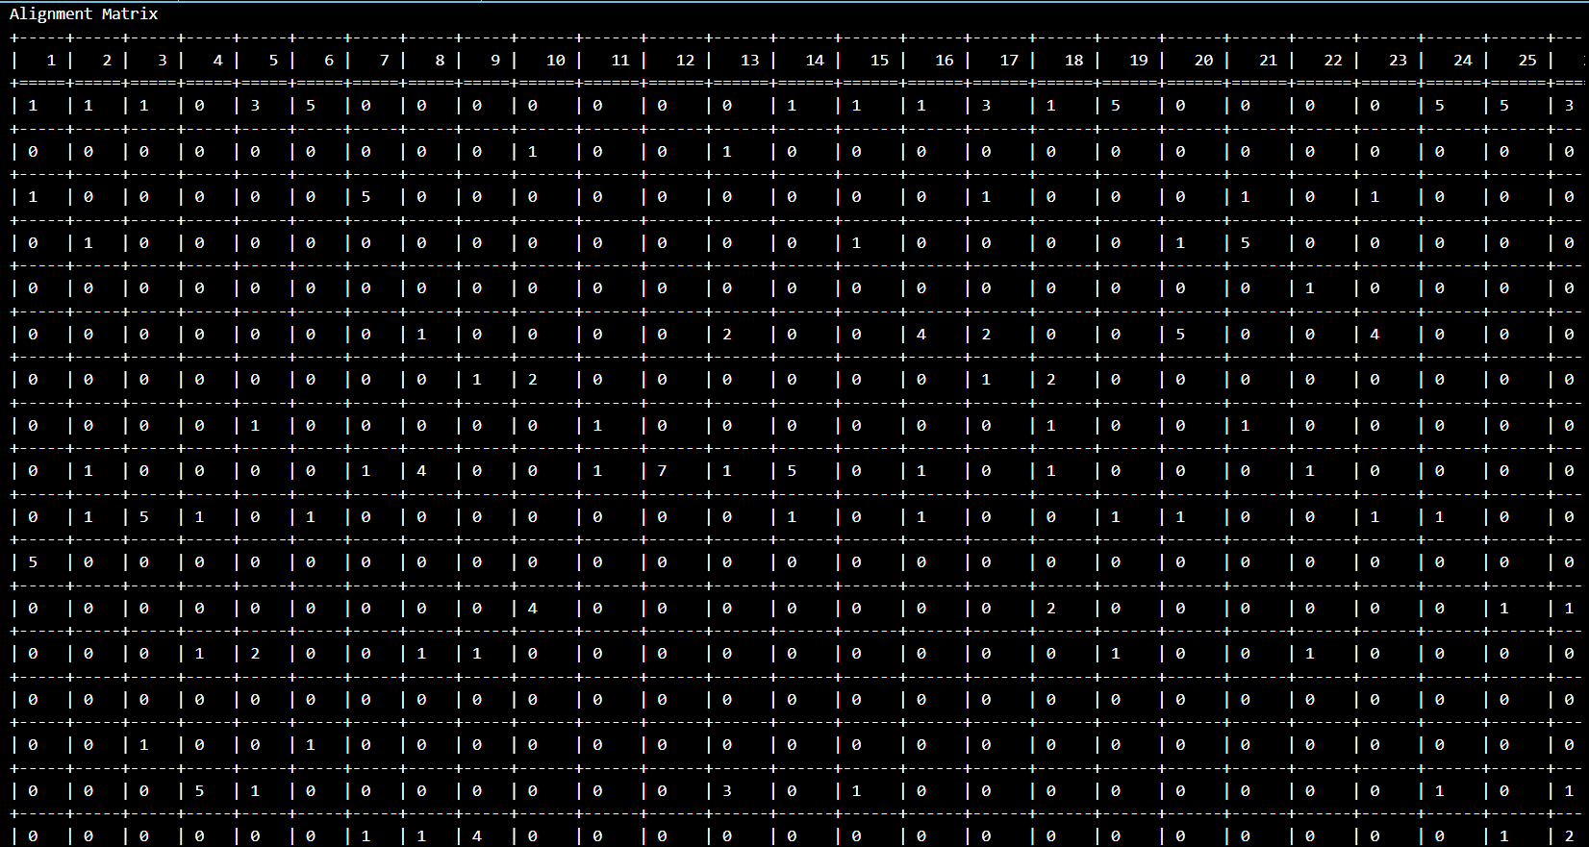

1. 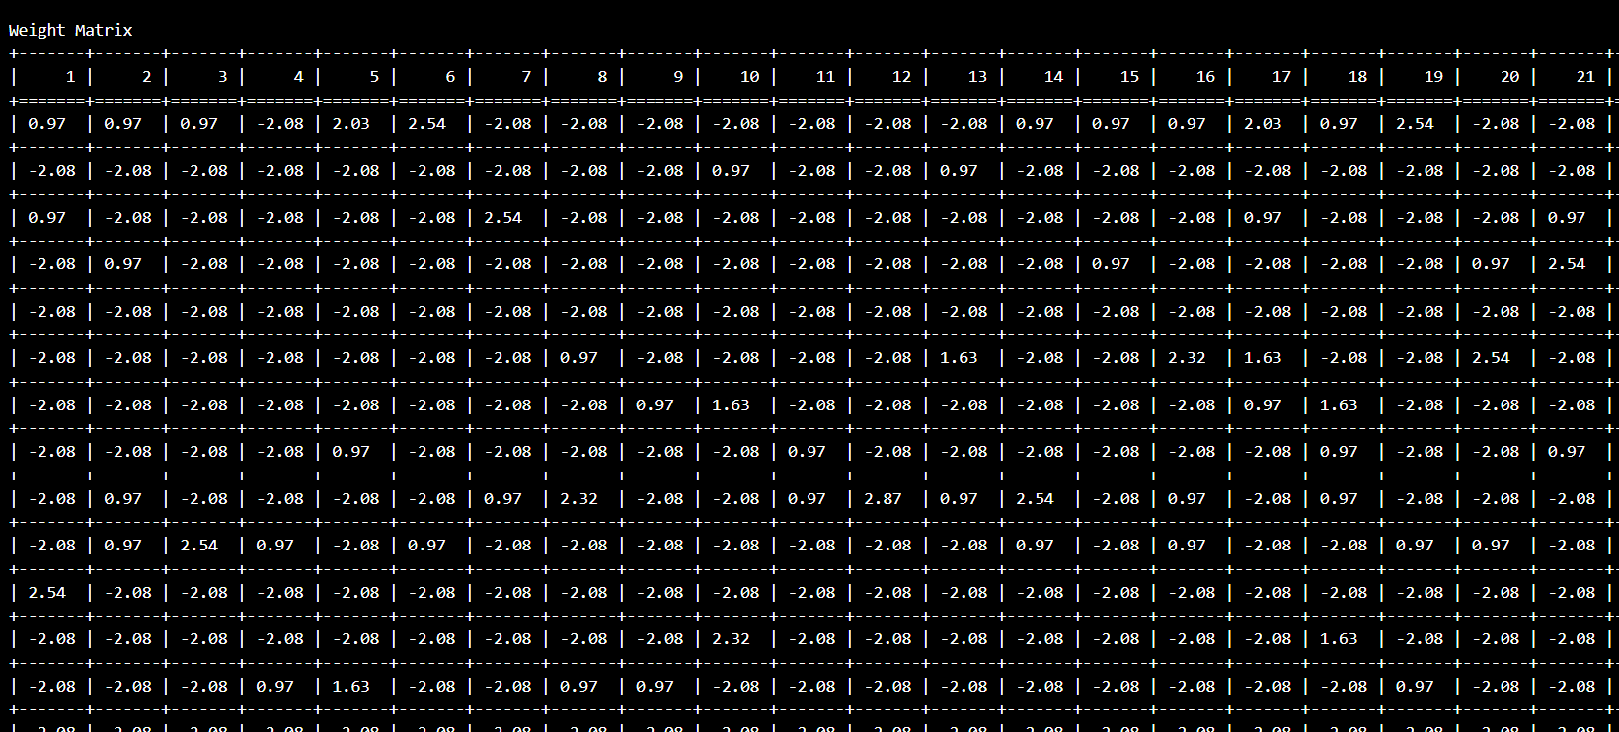Weight Matrix

*Complete output in ‘Q2_Output.txt’*