Practical 3

Kudari Pavani

BE19B023

1)

Procedure:   
Uniprot website and search for “human mitochondrial β barrel membrane protein VDAC” in search box.   
<https://www.uniprot.org/uniprot/P21796>.

Amino Acid Sequence:  
sp|P21796|VDAC1_HUMAN Voltage-dependent anion-selective channel protein 1 OS=Homo sapiens OX=9606 GN=VDAC1 PE=1 SV=2  
MAVPPTYADLGKSARDVFTKGYGFGLIKLDLKTKSENGLEFTSSGSANTETTKVTGSLET KYRWTEYGLTFTEKWNTDNTLGTEITVEDQLARGLKLTFDSSFSPNTGKKNAKIKTGYKR EHINLGCDMDFDIAGPSIRGALVLGYEGWLAGYQMNFETAKSRVTQSNFAVGYKTDEFQL HTNVNDGTEFGGSIYQKVNKKLETAVNLAWTAGNSNTRFGIAAKYQIDPDACFSAKVNNS SLIGLGYTQTLKPGIKLTLSALLDGKNVNAGGHKLGLGLEFQA.

Function:   
It forms a channel through outer membrane of mitochondria along with the plasma membrane whereby the outer mitochondrial membrane channel permits the diffusion of small hydrophilic molecules; in the plasma membrane which is involved in the apoptosis, cell and volume regulation. It accepts an open conformation at very low or zero membrane potential or adopts an closed conformation when potential is above 30-40mV. The closed has a cation selectivity whereas the open state is weak anion-selective. It may also participate in the production of permeability transition pore complex (PTPC) and it could be the triggering agent for release of mitochondrial products that initiates apoptosis.

Number of Transmembrane segments present in this protein= 19.

2) Method:

* Search for “transcription factors” in UniProt. <https://www.uniprot.org/uniprot/?query=%22transcription+factors%22&sort=score>
* Select cluster identities for specific values.  
  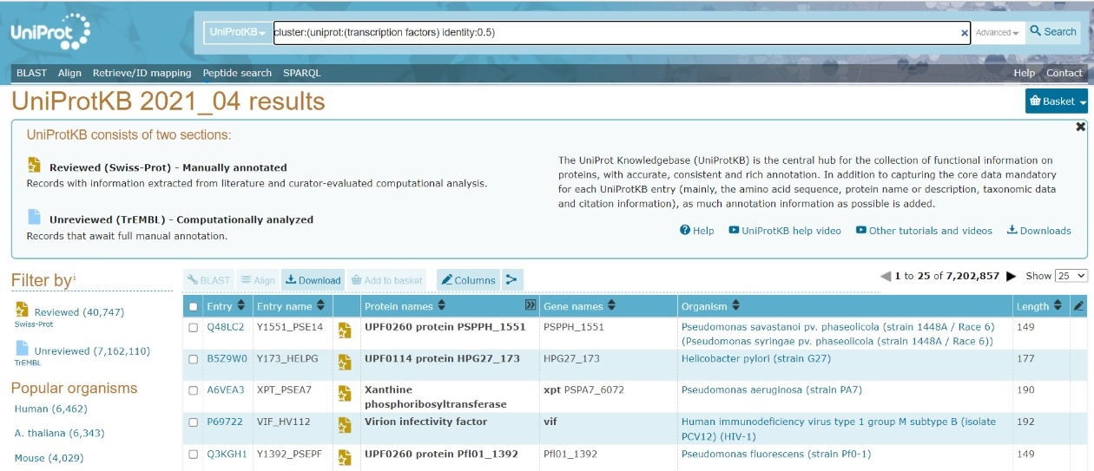

Total number of sequences= 7,202,857,  
50% Identity Clusters= **31,057**clusters

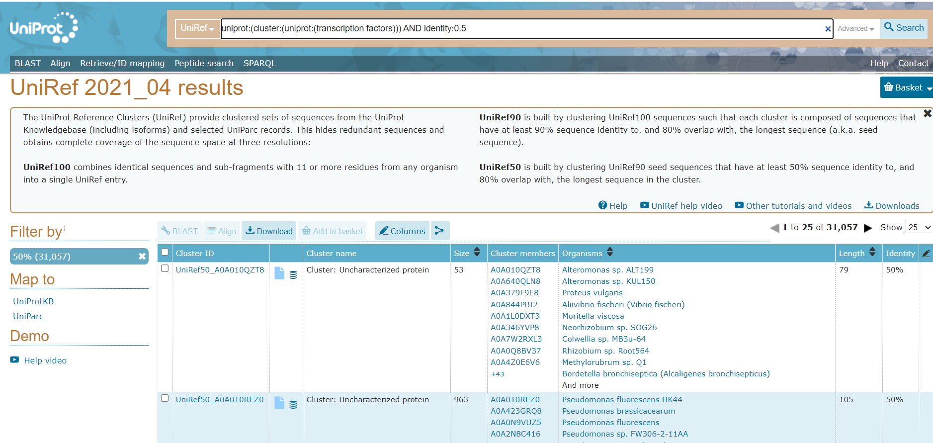

3)

There are a total of sequences of “homo sapiens” in UniProt.

|  |  |
| --- | --- |
| Sequence Identity | Number of clusters |
| 50% | 9258839 |
| 90% | 2216520 |
| 100% | 406431 |

4)

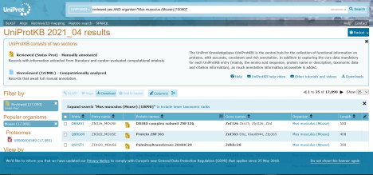

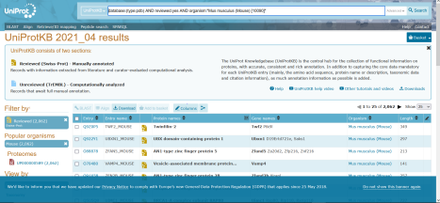

17,090 sequences are manually annotated for “Mus Musculus”.

After applying 3D database filter in pdb we get 2062 results.

5)

Procedure:

1. Search in UniProt with search query –

2. database:(type:pdb) AND reviewed:yes AND organism:"Mus musculus (Mouse) [10090]"

3. Select only the entry column and download the identifiers as a list.

4. In Retrieve/ID Mapping, paste these identifiers.

5. Under select options:

a. From – UniProtKB

b. To – STRING.... And submit.

1957 of 2062 ids were matched

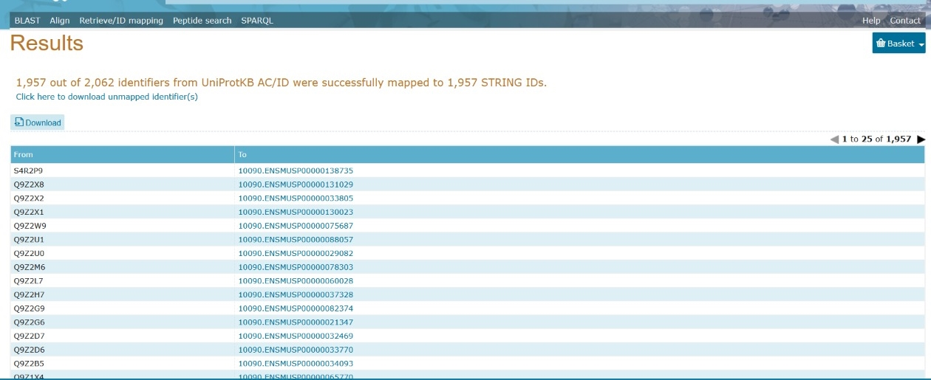

6)

1. a) In **UniProtKB/Swiss-Prot:** average sequence length: 360 amino acids.

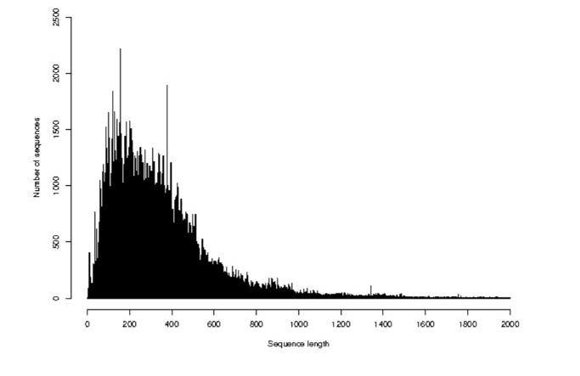

In **UniProtKB/TrEMBL:** average sequence length: 348 amino acids.

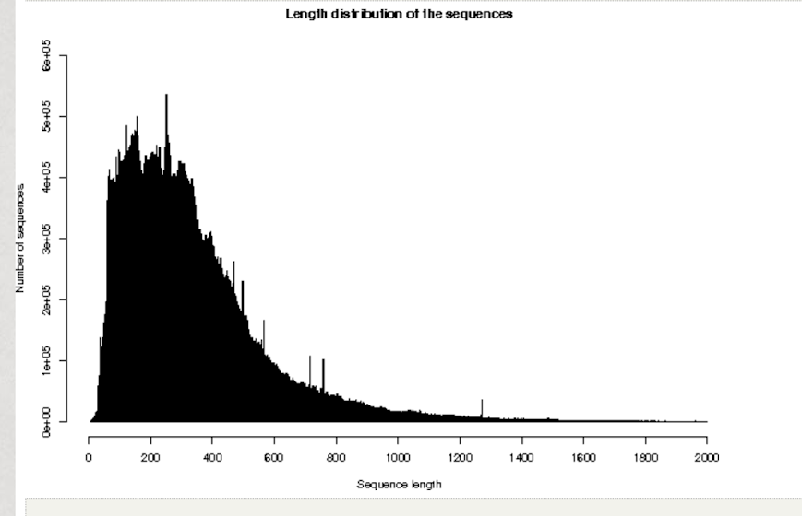

b)   
In TrEMBL:  
The shortest sequence in UniProtKB = 7 AAs, with sequence ID = A0A1Y7VI41 The longest sequence in UniProtKB = 45,354 AAs with sequence ID = A0A5A9P0L4

In Swiss Plot :   
The shortest sequence in UniProtKB = 2 AAs, which sequence ID = P0DPR3  
The longest sequence in UniProtKB = 35,213 AAs with sequence ID=A2ASS6

c)

