**BIOINFORMATICS**

**PRACTICAL – 1**

1. Installed Emboss in Linux using Command line: sudo apt-get install jemboss.
2. Use REVSEQ to find complementary strand  
   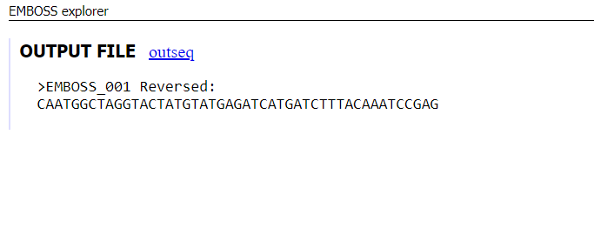
3. Screenshot of Python Code for complementary strand

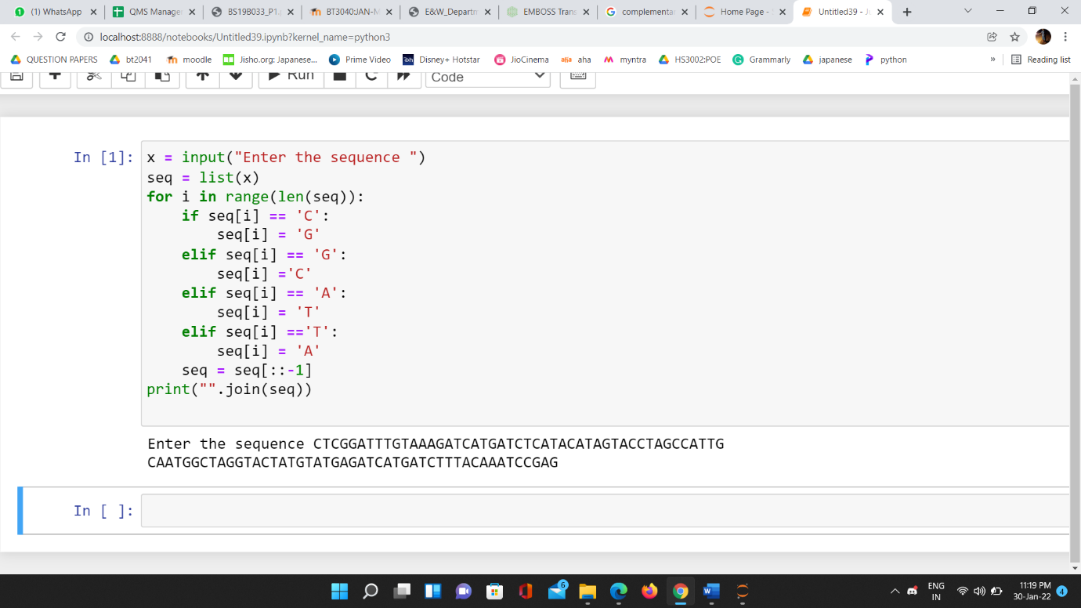

1. Protein Sequence
2. protein sequence using Emboss

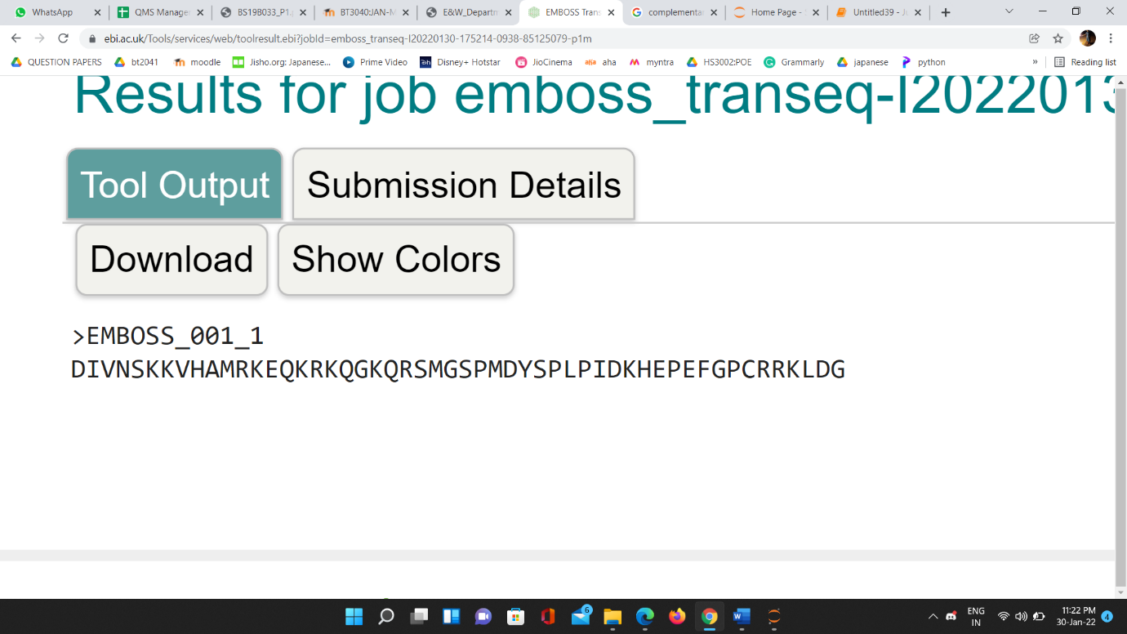

1. DNA sequence for given protein sequence  
   >_4   
   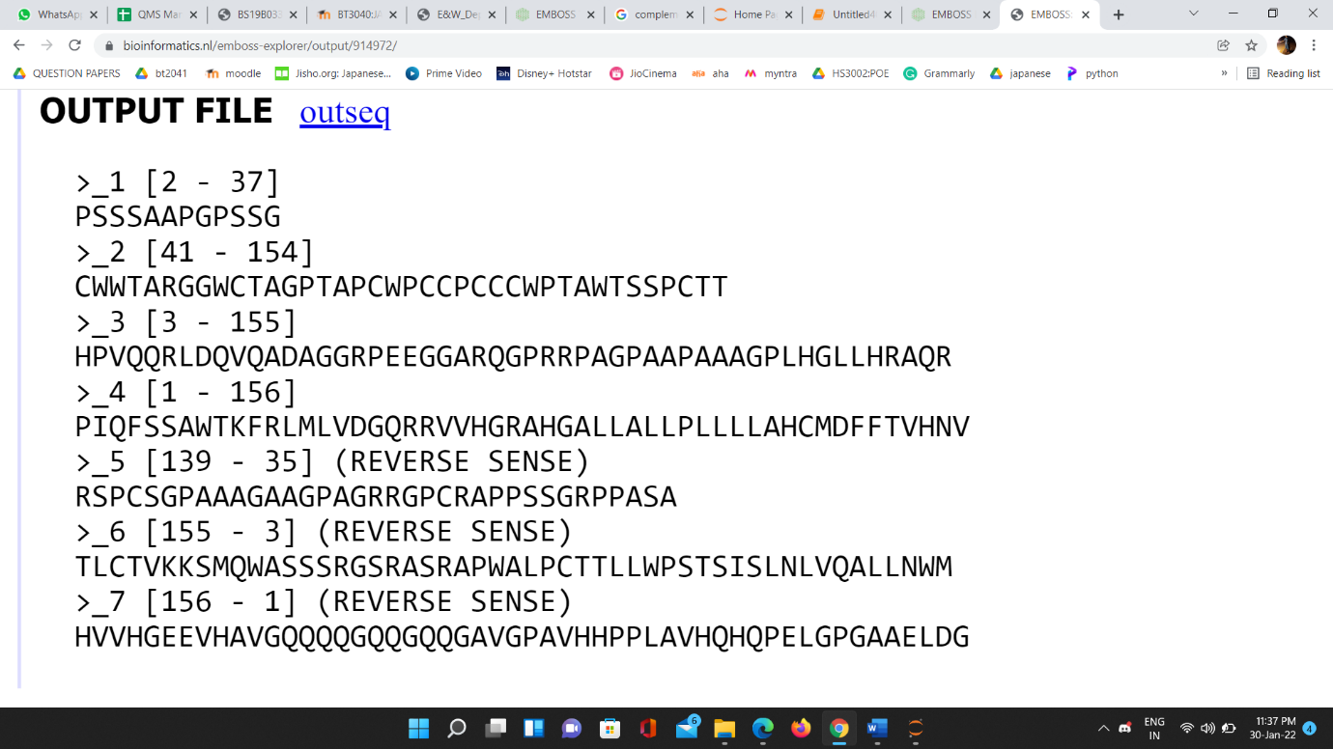
2. Code to find Protein sequence for given DNA Sequence

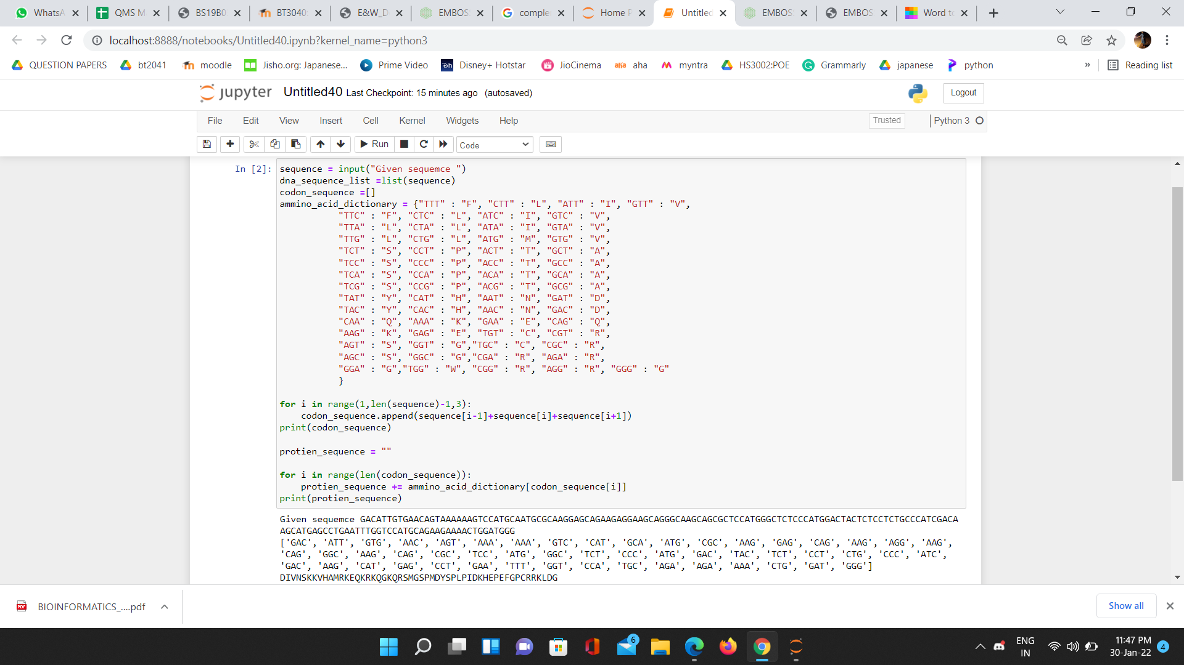

1. Code for finding the pattern. Position of match with indexing starting from 1  
   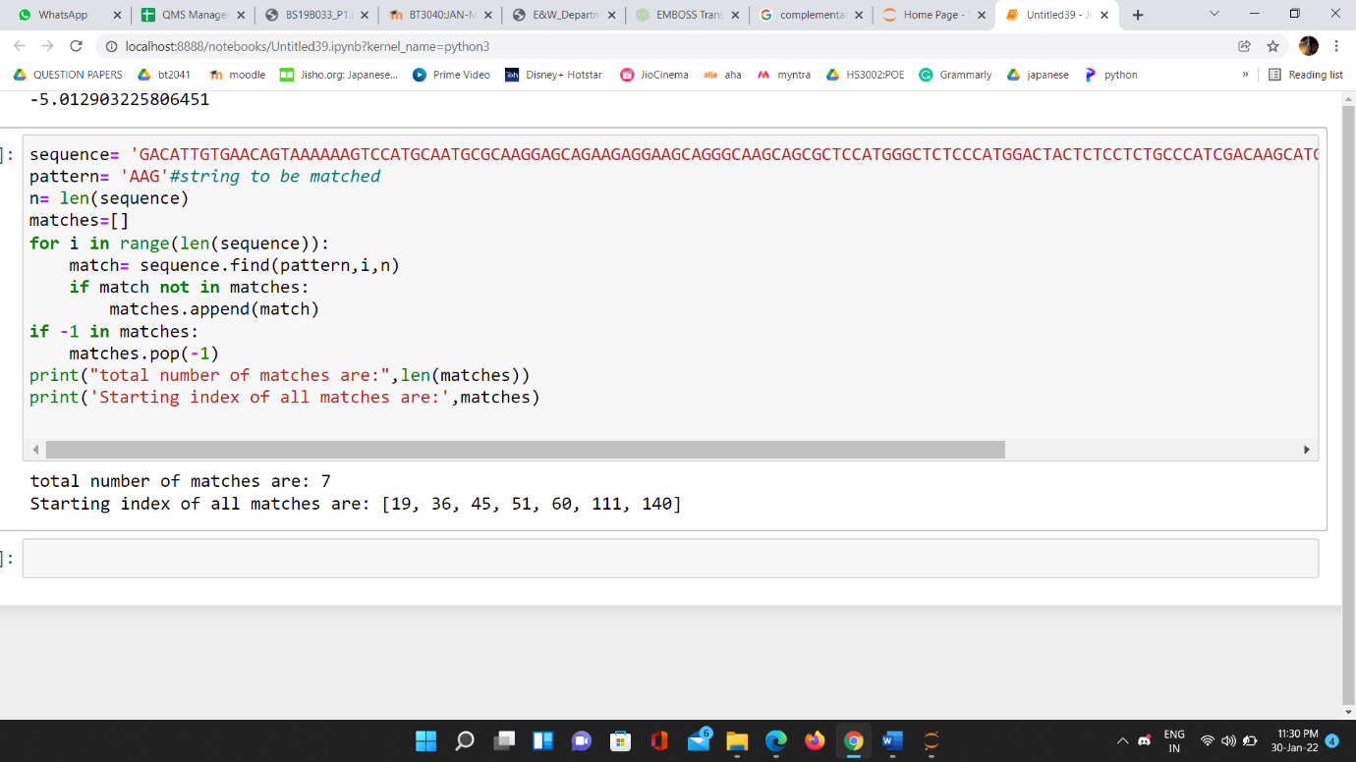
2. Features of Emboss:

Dan: used for calculating the melting temperature of a nucleic acid.

density: used to draw density plot of a nucleic acid.  
remap: used to display the binding sites in each nucleotide sequence.

1. Code for calculation of Average Base Stacking Energy:

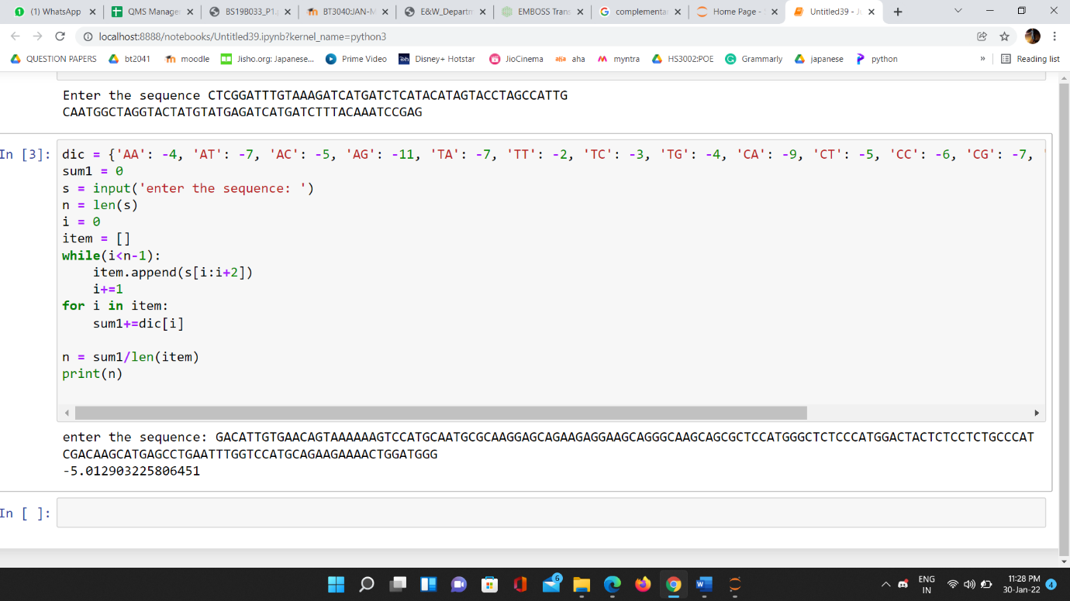

1. (i) For sequence ATATATATA:  
   Average Melting Temperature for ATATATATAT: 48.0022 degree  
   (ii) For sequence GCGCGCGCGC:  
   Average Melting Temperature for GCGCGCGCGC: 107.867 degrees

Because GC pairs form three hydrogen bonds in water whereas AT pairs only establish two hydrogen bonds, they have a larger stacking energy than AT pairs, which explains why GC pairings have a higher melting point.

1. Sequence: AAATGGCCCTA

AT Content: 58.333333 %   
GC Content: 41.666667 %