**BT3040 Practical 10**

**BS19B004 Anchal Pandey**

1. For file

**tim.dat-**

Outtree obtained from proml:

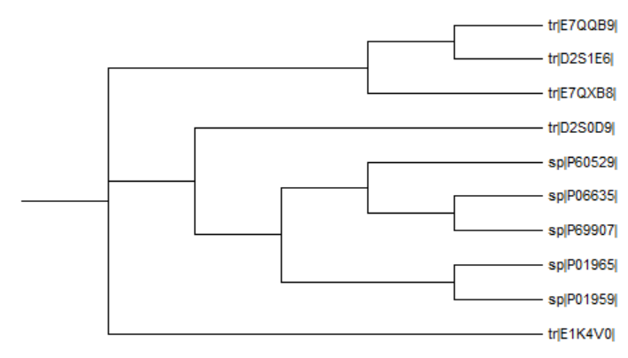

The output obtained from consense:

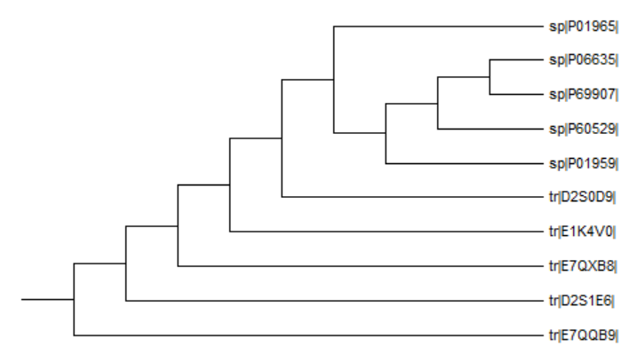

The output obtained from neighbor:

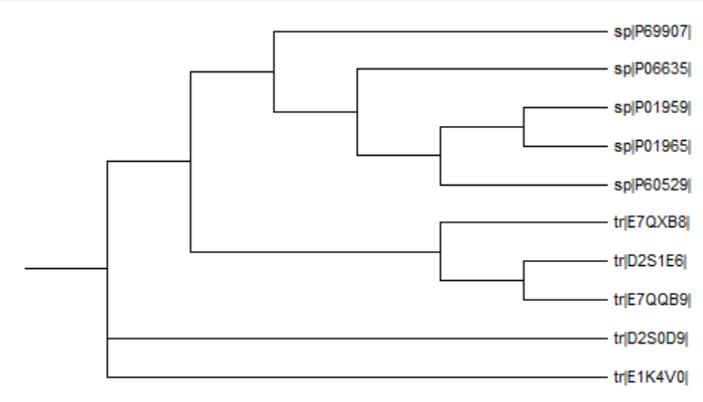

The output obtained from consense with input file work1-nj-tree:

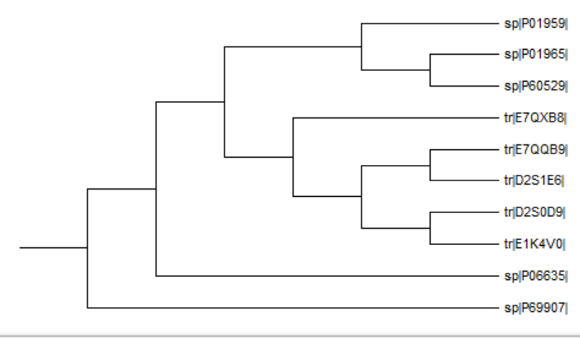

For file **tim.dat.txt**

Output obtained from proml:

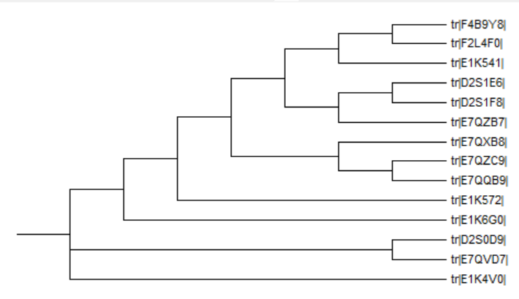

Output obtained from consense:

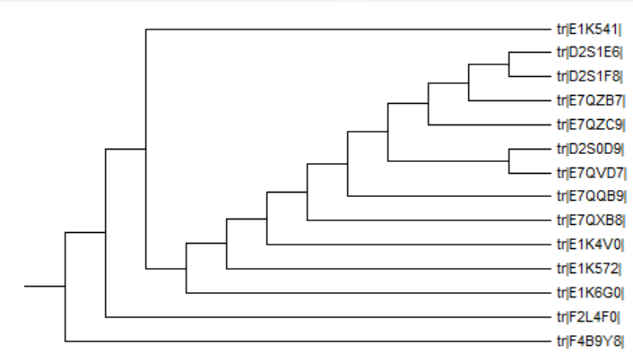

The output obtained from neighbor with input file work2-protdist:

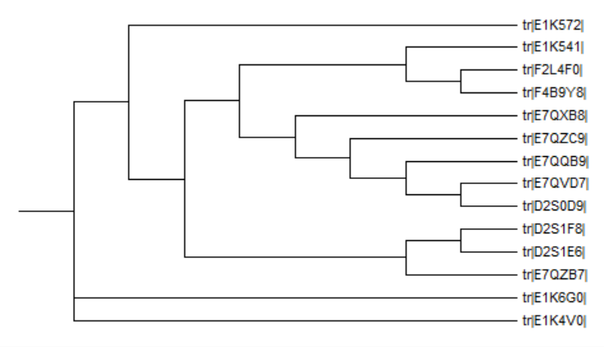

The output obtained from consense with input file work-nj-tree:

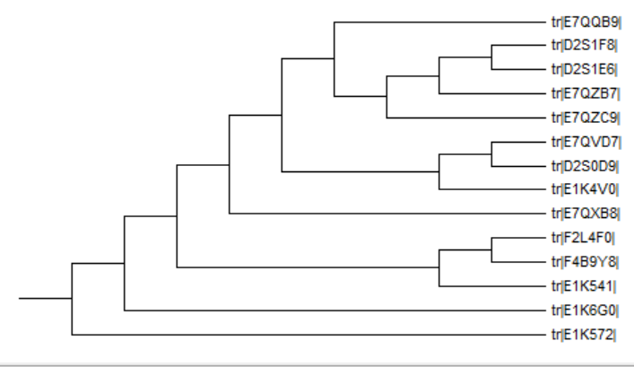

1. Code:

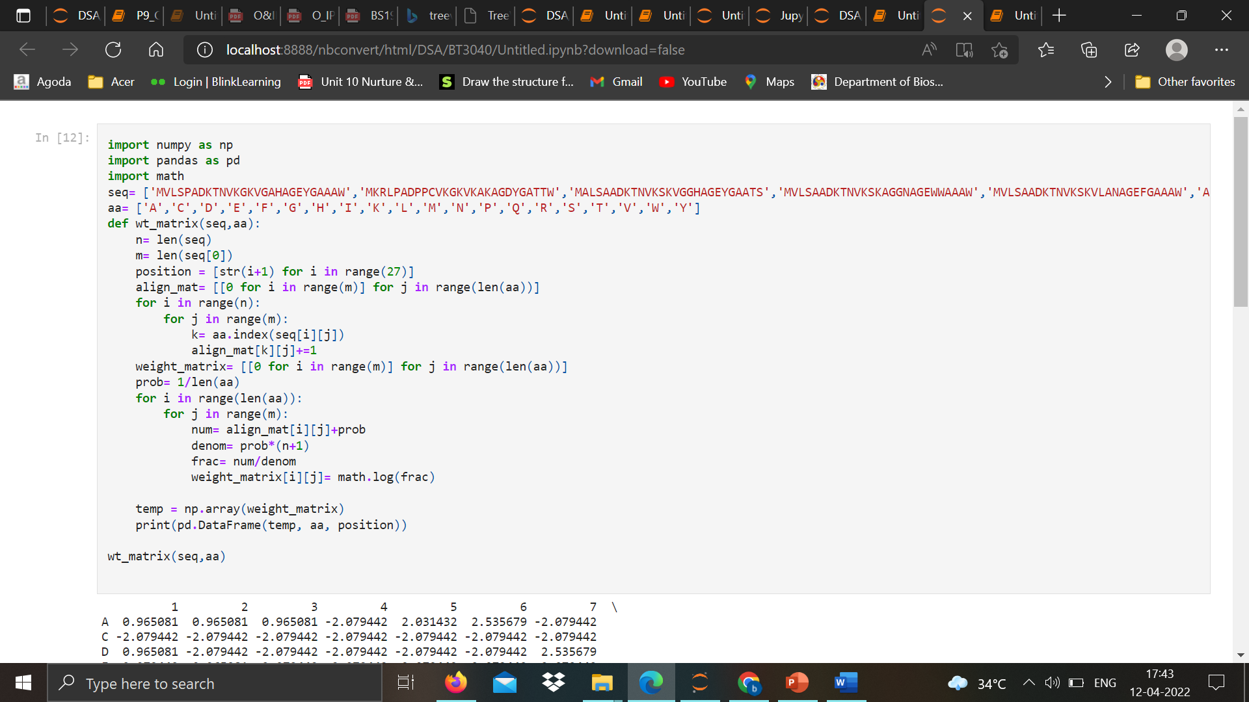

**Output:**

