Practical 10

Date: 03-04-2022 Name: Aswin. V

Day: Sunday Roll Number: BS19B003

Q1 –
For tim-hemo.dat:
- Phylogenetic tree based on maximum likelihood:
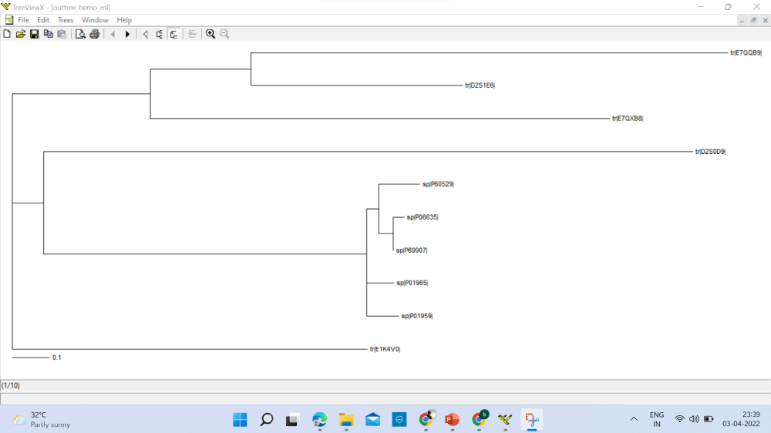

- Phylogenetic tree based on neighbor joining:
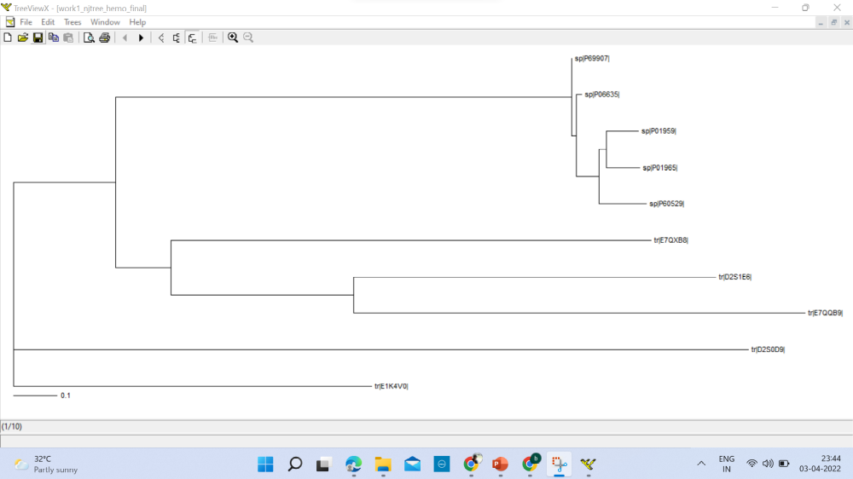

- Consensus tree based on neighbor joining:
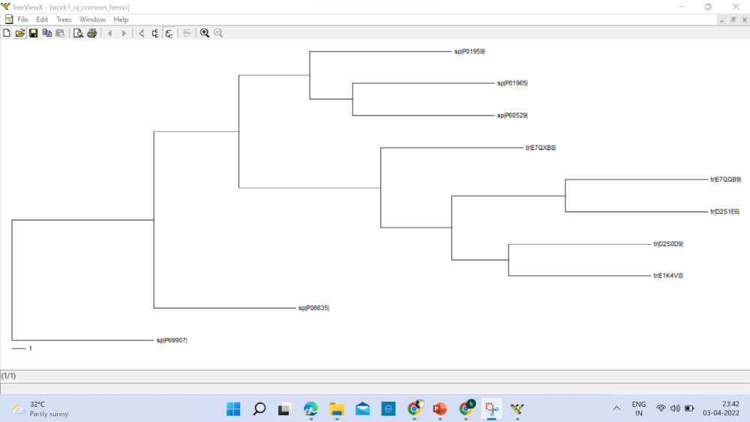

- Consensus tree based on UPGMA

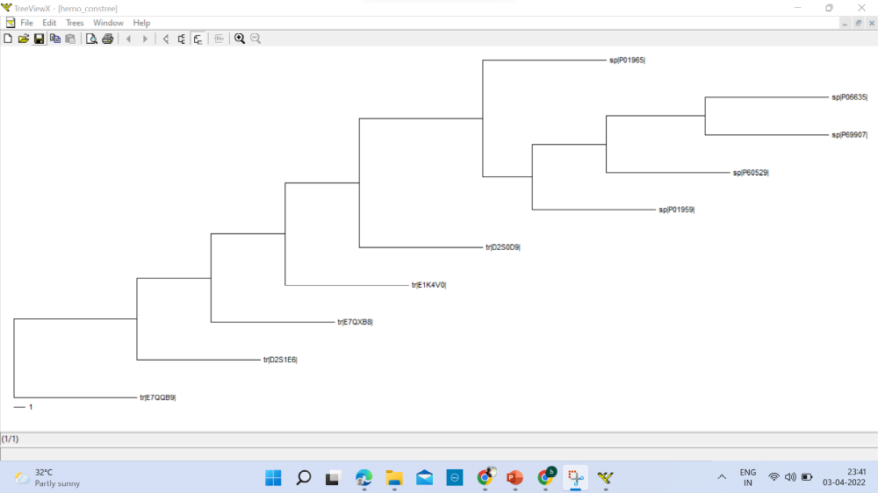

Q2 –
import math
import pandas as pd
import numpy as np
def Q2(A):
AA = ['A', 'C', 'D', 'E', 'F', 'G', 'H', 'I', 'K', 'L',
'M', 'N', 'P', 'Q', 'R', 'S', 'T', 'V', 'W', 'Y']
N, L = len(A), len(A[0])
a, w = [[0 for _ in range(L)] for __ in range(20)], [[0.000 for _ in range(L)] for __ in range(20)]
p = [str(_+1) for _ in range(27)]
for i in range(N):
for j in range(L):
a[AA.index(A[i][j])][j] += 1
d1 = np.array(a)
for i1 in range(20):
for j1 in range(L):
w[i1][j1] = float('%.2f'%(math.log((a[i1][j1]+0.05)/(0.05 * (N+1)))))
d2 = np.array(w)
print('Weight Matrix for the given sequences:\nrows ---> amino acids\tand\tcolumns ---> positional occurances')
print(pd.DataFrame(d2, AA, p))
return pd.DataFrame(d2, AA, p)

A = ['MVLSPADKTNVKGKVGAHAGEYGAAAW',
'MKRLPADPPCVKGKVKAKAGDYGATTW',
'MALSAADKTNVKSKVGGHAGEYGAATS',
'MVLSAADKTNVKSKAGGNAGEWWAAAW',
'MVLSAADKTNVKSKVLANAGEFGAAAW',
'ALLPIRTTYHKKCASGHIPEEKDLNNV',
'DEASSLKGHHIKKLEADALLIPLSASS']
Q2(A)

Output:
Weight Matrix for the given sequences:
rows ---> amino acids and columns ---> positional occurances
1 2 3 4 5 6 ... 22 23 24 25 26 27
A 0.97 0.97 0.97 -2.08 2.03 2.54 ... -2.08 -2.08 2.54 2.54 2.03 -2.08
C -2.08 -2.08 -2.08 -2.08 -2.08 -2.08 ... -2.08 -2.08 -2.08 -2.08 -2.08 -2.08
D 0.97 -2.08 -2.08 -2.08 -2.08 -2.08 ... -2.08 0.97 -2.08 -2.08 -2.08 -2.08
E -2.08 0.97 -2.08 -2.08 -2.08 -2.08 ... -2.08 -2.08 -2.08 -2.08 -2.08 -2.08
F -2.08 -2.08 -2.08 -2.08 -2.08 -2.08 ... 0.97 -2.08 -2.08 -2.08 -2.08 -2.08
G -2.08 -2.08 -2.08 -2.08 -2.08 -2.08 ... -2.08 2.32 -2.08 -2.08 -2.08 -2.08
H -2.08 -2.08 -2.08 -2.08 -2.08 -2.08 ... -2.08 -2.08 -2.08 -2.08 -2.08 -2.08
I -2.08 -2.08 -2.08 -2.08 0.97 -2.08 ... -2.08 -2.08 -2.08 -2.08 -2.08 -2.08
K -2.08 0.97 -2.08 -2.08 -2.08 -2.08 ... 0.97 -2.08 -2.08 -2.08 -2.08 -2.08
L -2.08 0.97 2.54 0.97 -2.08 0.97 ... -2.08 0.97 0.97 -2.08 -2.08 -2.08
M 2.54 -2.08 -2.08 -2.08 -2.08 -2.08 ... -2.08 -2.08 -2.08 -2.08 -2.08 -2.08
N -2.08 -2.08 -2.08 -2.08 -2.08 -2.08 ... -2.08 -2.08 -2.08 0.97 0.97 -2.08
P -2.08 -2.08 -2.08 0.97 1.63 -2.08 ... 0.97 -2.08 -2.08 -2.08 -2.08 -2.08
Q -2.08 -2.08 -2.08 -2.08 -2.08 -2.08 ... -2.08 -2.08 -2.08 -2.08 -2.08 -2.08
R -2.08 -2.08 0.97 -2.08 -2.08 0.97 ... -2.08 -2.08 -2.08 -2.08 -2.08 -2.08
S -2.08 -2.08 -2.08 2.54 0.97 -2.08 ... -2.08 -2.08 0.97 -2.08 0.97 1.63
T -2.08 -2.08 -2.08 -2.08 -2.08 -2.08 ... -2.08 -2.08 -2.08 0.97 1.63 -2.08
V -2.08 2.03 -2.08 -2.08 -2.08 -2.08 ... -2.08 -2.08 -2.08 -2.08 -2.08 0.97
W -2.08 -2.08 -2.08 -2.08 -2.08 -2.08 ... 0.97 0.97 -2.08 -2.08 -2.08 2.32
Y -2.08 -2.08 -2.08 -2.08 -2.08 -2.08 ... 2.03 -2.08 -2.08 -2.08 -2.08 -2.08

[20 rows x 27 columns]

