Practical 11
Questions
4 April 2022

1. Find the propensity of alpha helices using the following sequence and secondary structure assignments.

Sequence: LGASGIAAFAFGSTAILIILFNMAAEVHFDPLQFFRQFFWLGLYPPKAQY
Sec. str: XHHHHHHHHHHHHHHHHHHHHHHHHHXXXXXXXXXXXXXXXXXXXXXXXX

Sequence: GMGIPPLHDGGWWLMAGLFMTLSLGSWWIRVYSRARALGLGTHIAWNFAA
Sec. str: XXXXXXXXXXHHHHHHHHHHHHHHHHHHHHHHHHHHHHHHXXHHHHHHHH

Sequence: AIFFVLCIGCIHPTLVGSWSEGVPFGIWPHIDWLTAFSIRYGNFYYCPWH
Sec. str: HHHHHHHHHXXXXXXXXXXXXXXXXXXXXXXXXXXXXXXXXXXXXXXHHH

Sequence: GFSIGFAYGCGLLFAAHGATILAVARFGGDREIEQITDRGTAVERAALFW
Sec. str: HHHHHHHHHHHHHHHHHHHHHHHXXXXXXXXXXXXXXXXXXXXXXXXXXX

2. Find the propensity of alpha helices manually for the sequence in question 1.

3. Using the rules for helices and strands, identify the helical and strand segments in the following sequence

KVFGRCELAAAMKRHGLDNYRGYSLGNWVCAAKFESNFNTQATNRNTDGSTDYGILQINSRWWCNDGRTPGSRNLCNIPCSALLSSDITASVNCAKKIVSDGNGMNAWVAWRNRCKGTDVQAWIRGCRL
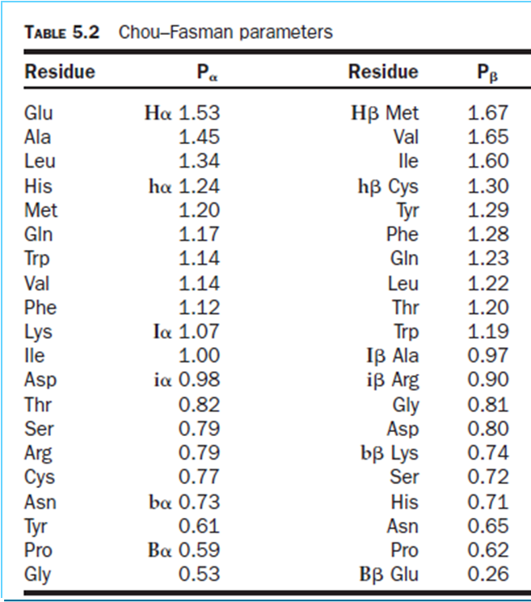
Hint: Helix: Assign 1 for H_{α} and h_{α}; 0.5 for I_{α}; 0 for i_{α}; -1 for B_{α} and b_{α}; identify 6-residue segments with score more than or equal to 4; extend it until the actual value (Table 5.2) for last four residues is less than 4. Continue the search.
Strand:
Assign 1 for H_{β} and h_{β}; 0.5 for I_{β}; 0 for i_{β}; -1 for B_{β} and b_{β}; identify 5-residue segments with score more than or equal to 3; extend it until the actual value for the last three residues is less than 3.

For conflicting situation: compare the values and assign the secondary structure based on the highest value

4. Verify one of the helical and strand segments, manually.
Deadline: 10 April 2022

