**BT6270: COMPUTATIONAL NEUROSCIENCE**

**Assignment 2: Fitz-Hugh Nagumo Model Report**

Atharva Mandar Phatak | BE21B009

Department of Biotechnology

Indian Institute of Technology   
Madras

## Background:

Mathematical models with more variable are indeed more realistic but induce more complexity in computing, thus being untraceable. Hence it is recommended to have simpler models with use of minimum variables.

Fitz-Hugh Nagumo Model is a simple, two variable neuron model, by considering approximations like (as compared to the Hugston Huxley Model)

1. ‘m’ relaxes faster than the other two dating variables, hence we let

$\frac{ⅆm}{ⅆt}$ = 0

1. ‘h’ varies too slowly. i.e., h=h0

Thus, the resulting system reduces to

$\frac{dv}{dt}=f\left(v\right)-w+I_{m}$

where $f\left(v\right)=v(a-v)(v-1)$

$$\frac{dw}{dt}=bv-rw$$

The nullclines of the system are:

$F\left(v,w\right)=f\left(v\right)-w+I_{a}=0$**… (F-nullcline)**

$g\left(v,w\right)=bv-rw=0$**… (g-nullcline)**

Now we will analysis this system for various cases

# 1 Case 1: *Iext* =0

## 1.1 Phase Plot

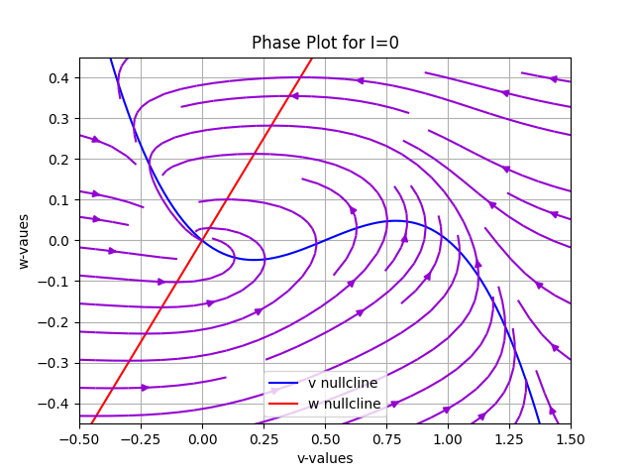

**Figure 1A:** Phase Plot of the system when *Iext* = 0. The stationary point obtained is a stable point.

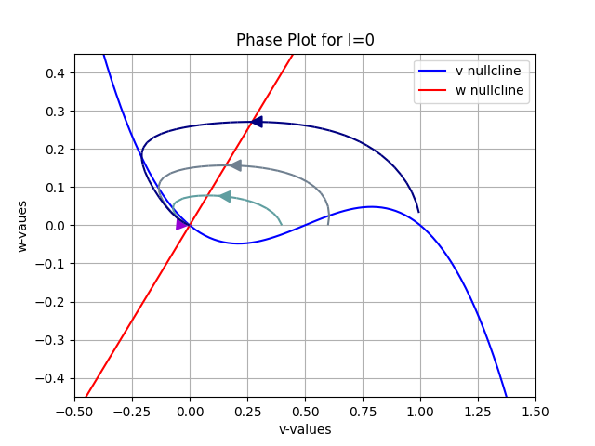

**Figure 1B:** By examining the trajectories with initial points [0, 0.4, 0.6, 1] and setting w = 0, it becomes evident that regardless of slight deviations in the initial starting position, the system converges towards the equilibrium point [0, 0]. Therefore, we can conclude that [0, 0] represents a stable fixed point. The model approaches the equilibrium point irrespective of the initial conditions.

## 1.2 *v*(*t*)*, w*(*t*) vs *t*, Trajectories

When the Iext value is set to zero, no action potentials are detected.

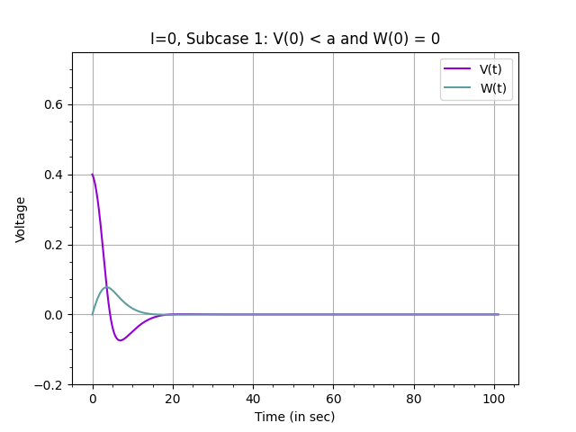

**Figure 1C:** *v(t*)*, w*(*t*) vs *t*, when *v*(0) *< a, (v(0) =0.4)*. With sub-threshold pulse injections, no action potentials are observed.

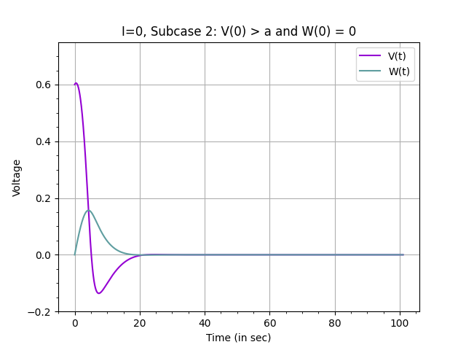

**Figure 2D:** *v*(*t*)*, w*(*t*) across *t*, when *v*(0) *> a (v(0) =0.6)*. With sub-threshold pulse injections, no action potentials are observed.

## 2 Case 2: *Iext* =0*.*51

On finding the I1 and I2 values iteratively, we get

**I1 = 0.311**

**I2 = 0.657**

These range consists of values where limit cycles is achieved

*Note that the range where we get oscillations*

*I1 = 0.261*

*I2 = 0.701*

When the I*ext* value is set to ‘0.51*’, oscillatory membrane potential is seen in the limit cycle region.

Note: Please check the ‘Supporting_file.py’ for finding I1 and I2

* Value taken arbitrary

## 2.1 Phase Plot

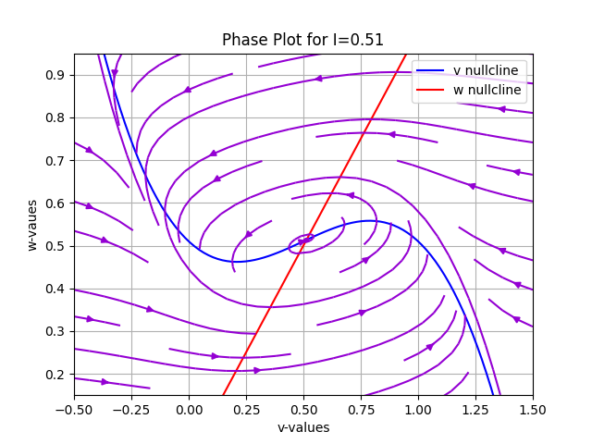

**Figure 2A:** Phase Plot of the system when *Iext* = 0*.*51. This stationary point is found to be an unstable point, as evident from the streamlines

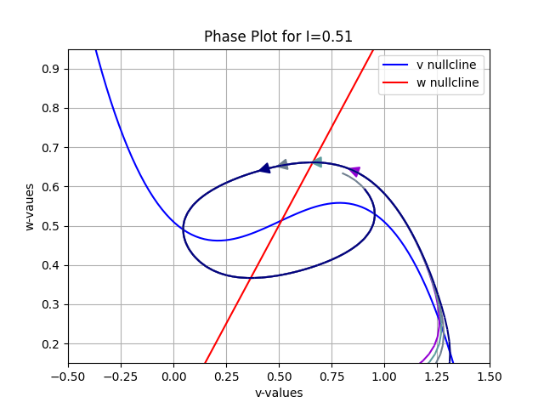

**Figure 2B:** By examining the trajectories with initial points [0, 0.4, 0.6, 1] and setting w = 0, it becomes evident that, irrespective of initial conditions at the point of intersection of the nullclines, there are circulating fields around the unstable stationary point. Limit cycle enclosing the stationary point is also seen.

### 2.2 *v*(*t*)*, w*(*t*) vs *t*, Trajectories

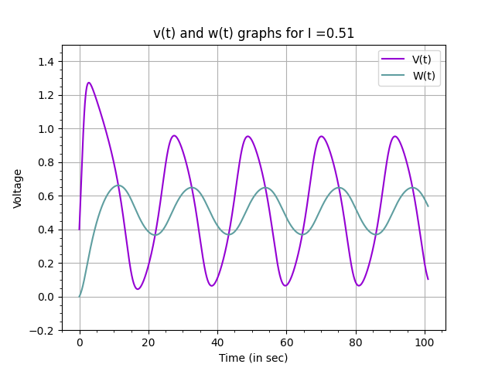

**Figure 2C:** *V*(*t*)*, W*(*t*) vs *t*, Sustained oscillations are observed.

# 3 Case 3: *Iext* =0.81

## 3.1 Phase Plot

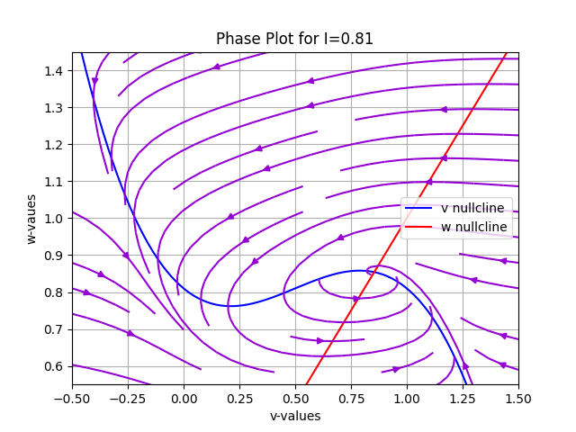

**Figure 3A:** Phase Plot of the system when *Iext* = 0.81. This stationary point is found to be a stable point, as evident from the streamlines

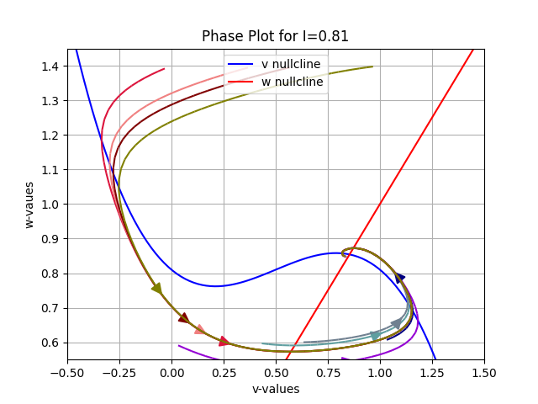

**Figure 3B:** The trajectories were analysed by using initial points - [0*,*0*.*4*,*0*.*6*,*1]*, w* = 0*.*6 and [0*,*0*.*4*,*0*.*6*,*1]*, w* = 1*.*4. it is evident that even for large perturbations in the initial start point, we approach the equilibrium point at [1*,*1], thus the point [1*,*1] is a stable fixed point.

## 3.2 *v(t*)*, w*(*t*) across *t*, Trajectories

For *Iext* = 0.81, depolarization is observed in the membrane potential. The voltage initially rises and then stays at a high value.

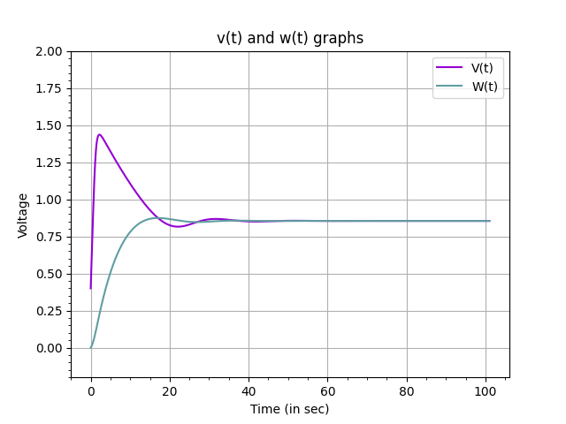

**Figure 3C:** *V*(*t*)*, W*(*t*) vs *t*. With sub-threshold pulse injections, depolarization in the action potential can be observed.

# 4 Case 4: *Iext* =0*.*021

The parameter values used to simulate this case are: *b* = 0*.*011*, r* = 0*.*81. Hence, *b*/*r* = 0.01358.

## 4.1 Phase Plot

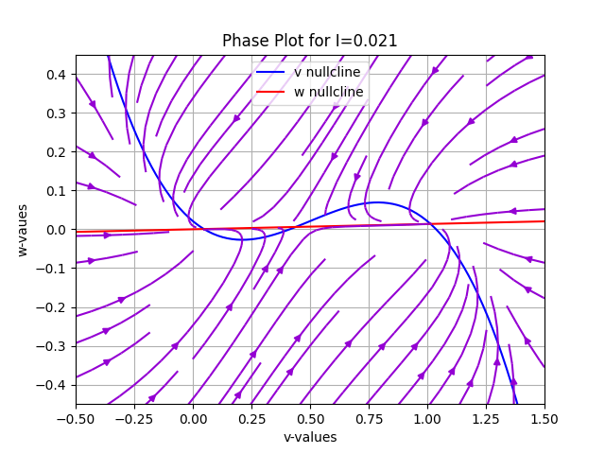

**Figure 4A:** Phase Plot of the system when *Iext* = 0*.*021. The stationary points P1 (stable), P2 (saddle) and P3 (saddle)

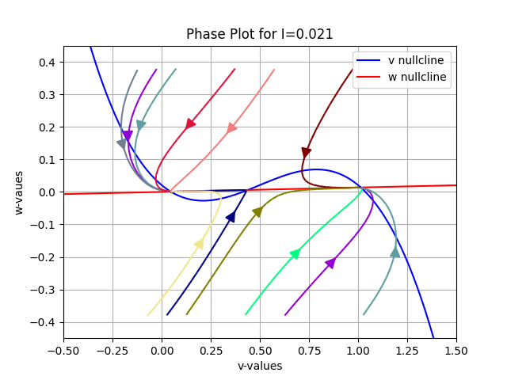

**Figure 4B:** The trajectories were analysed by using initial points - [0*,*0*.*4*,*0*.*6*,1*]*, w* = 0*.*6 and [0*,*0*.*4*,*0*.*6*,*1]*, w* = 1*.*4. In case of P1 and P3 (left to right) - small and intermediate perturbations lead back to P1 and P3 respectively. Hence P1 is a stable point. In case of P2, small perturbations along one axis leads to large change in final point. Hence, P2 is a saddle node.

## 4.2 *v(t*)*, w*(*t*) vs *t*, Trajectories

For *Iext* = 0*.*021*, r* = 0*.*81*, b* = 0*.*011, bi-stability is observed.

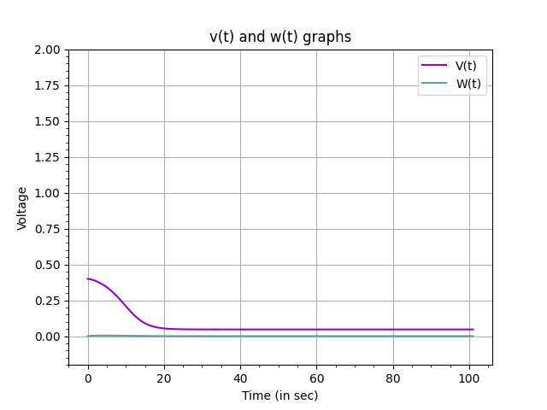

**Figure 4C:** *v*(*t*)*, w*(*t*) vs *t*. The neuron exists in a tonically down state.

**References**

[1] Class Notes