..

**BT6270: COMPUTATIONAL NEUROSCIENCE**

**Assignment 3: Hopf Oscillators**

Atharva Mandar Phatak | BE21B009

Department of Biotechnology

Indian Institute of Technology   
Madras

Table of Contents

1. Background: 3

1.1 Real Coupling: 3

1.2 Complex Coupling: 3

1.3 Power coupling: 4

2. Plots 5

2.1 Complex Coupling 5

2.1.1 Parameters 5

2.1.2 Initial Condition 5

2.2 Power Coupling 14

2.2.1 Parameters 14

2.2.2 Initial Conditions 14

3. Conclusion 18

4. References 18

# 1. Background:

Two main methods are used to investigate how neurons convey information: the spike frequency code, which focuses on how often a neuron fires action potentials, and the spike time code, which focuses on when action potentials occur. The dynamics of a single neuron can be modeled using a Hopf oscillator, which is a complex-domain oscillator with an adaptable frequency. To accommodate the brain's diverse spectral components, oscillatory networks must operate at high frequencies.

## Real Coupling:

Real-valued coupling, a pair of Hopf oscillators with equal intrinsic frequencies can only produce two possible values of phase difference

$$\dot{z_{1}}=z_{1}\left(μ+iω_{i}-{\left|z_{1}\right|}^{2}\right)+W_{12}real\left(z_{2}\right)$$

$$\dot{z_{2}}=z_{2}\left(μ+iω_{i}-{\left|z_{2}\right|}^{2}\right)+W_{21}real\left(z_{1}\right)$$

# 1.2 Complex Coupling:

Two Hopf oscillators with identical natural frequencies when coupled bilaterally through complex coefficients with Hermitian symmetry, they exhibit phase-locked oscillation at a particular angle similar to the angle of complex coupling coefficient.

$$\dot{z_{1}}=z_{1}\left(μ+iω_{i}-{\left|z_{1}\right|}^{2}\right)+W_{12}z_{2}$$

$$\dot{z_{2}}=z_{2}\left(μ+iω_{i}-{\left|z_{2}\right|}^{2}\right)+W_{12}z_{2}$$

$$z_{1}=r_{1}e^{i∅_{1}}$$

$$z_{2}=r_{2}e^{i∅_{2}}$$

## 1.3 Power coupling:

A pair of sinusoidal oscillators (Kuramoto or Hopf oscillators) can entrain at a specific normalized phase difference if they are coupled through complex ‘power coupling’ coefficient.

$\dot{z_{1}}=z_{1}\left(μ+iω_{i}-{\left|z_{1}\right|}^{2}\right)+A_{12}e^{i\frac{θ_{12}}{w_{1}}}{z_{2}}^{\frac{w1}{w2}}$

$$\dot{z_{2}}=z_{2}\left(μ+iω_{i}-{\left|z_{2}\right|}^{2}\right)+A_{21}e^{i\frac{θ_{21}}{w_{1}}}{z_{2}}^{\frac{w2}{w1}}$$

# 2. Plots

## 2.1 Complex Coupling

### 2.1.1 Parameters

$w_{1}=5$

$w_{2}=5$

### 2.1.2 Initial Condition

$$r_{1}=0.5$$

$r_{1}$ = 2.1

$$θ_{1}=0.7$$

$$θ_{2}=0.8$$

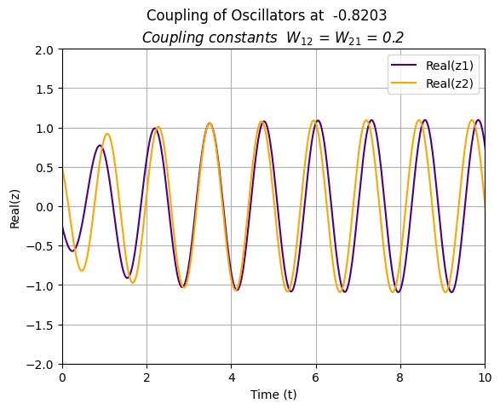

**Figure 1a:** Real part of $z$ vs t. The oscillators couple at time depended on the coupling constant; $W_{12}=W_{12}=0.2$ 
. Time required for coupling is inversely proportional to the magnitude of the coupling constant.

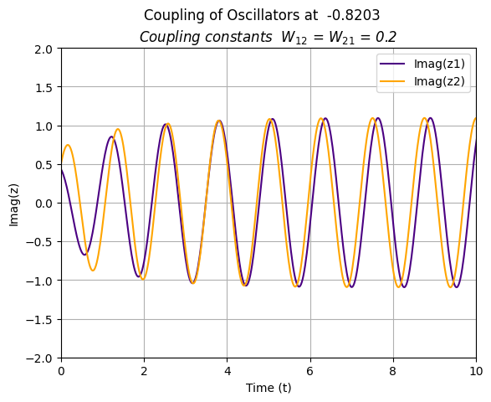

**Figure 1b**: Imaginary part of $z$ vs t. The oscillators couple at time depended on the coupling constant  
 ; $W_{12}=W_{12}=0.2$. Time required for coupling is inversely proportional to the magnitude of the coupling constant

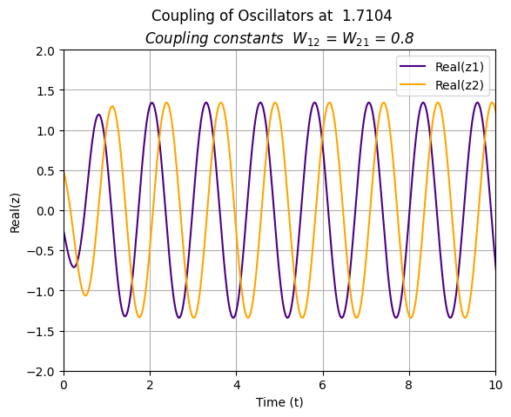

**Figure 2a:** Real part of $z$ vs t. The oscillators couple at time depended on the coupling constant  
 ; $W_{12}=W_{12}=0.8$. Time required for coupling is inversely proportional to the magnitude of the coupling constant.

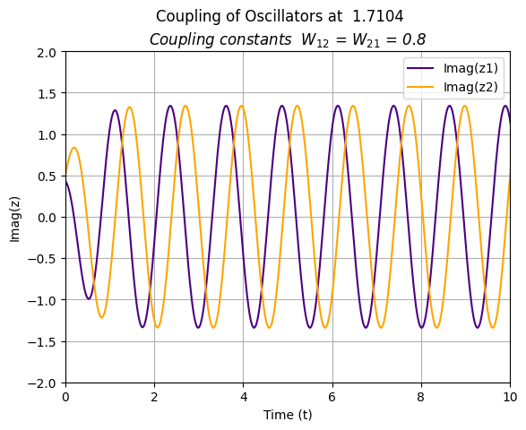

**Figure 2b:** Imaginary part of $z$ vs t. The oscillators couple at time depended on the coupling constant  
 ; $W_{12}=W_{12}=0.8$. Time required for coupling is inversely proportional to the magnitude of the coupling constant

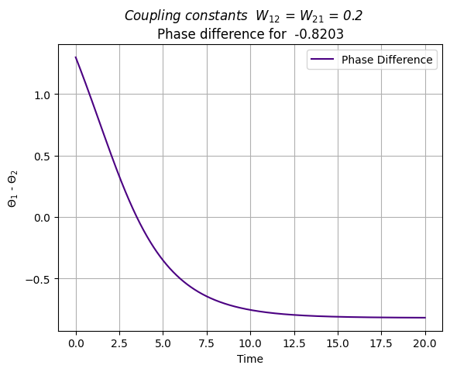

**Figure 3a:** Phase difference (-47°) vs t. This graph helps to find the time when the coupling begins. The graph decreases and attains a straight-line nature indicating that the required phase difference has been achieved and is constant (oscillators have coupled)

- 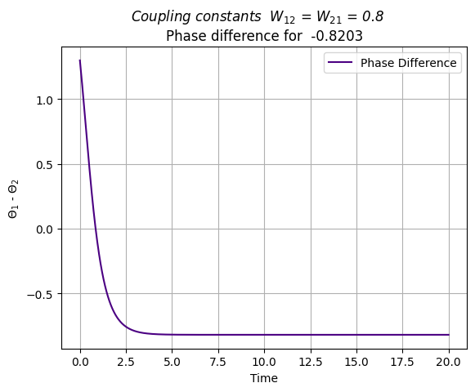

**Figure 3b:** Phase difference (-47°) vs t. This graph helps to find the time when the coupling begins. The graph decreases and attain a straight-line nature indicating that the required phase difference has been achieved and is constant (oscillators have coupled) .

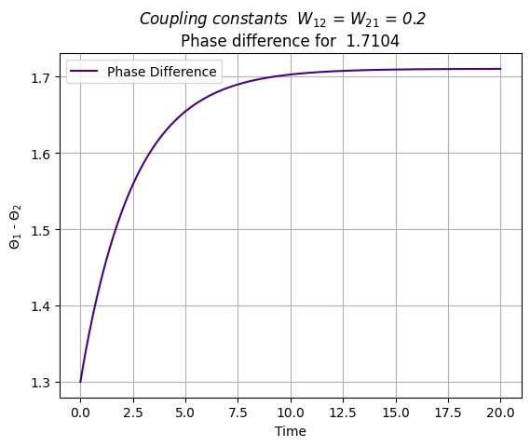

**Figure 4a:** Phase difference (98°) vs t. This graph helps to find the time when the coupling begins. The graph increases and attain a straight-line nature indicating that the required phase difference has been achieved and is constant (oscillators have coupled)

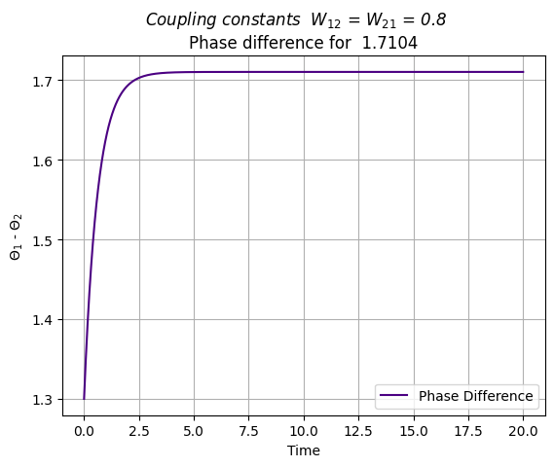

**Figure 4b:** Phase difference (98°) vs t. This graph helps to find the time when the coupling begins. The graph increases and attain a straight-line nature indicating that the required phase difference has been achieved and is constant (oscillators have coupled).

## 2.2 Power Coupling

### 2.2.1 Parameters

$w_{1}=$ 5

$w_{2}=$ 15

$$A_{12}= A_{21}=0.2$$

$φ=$ ${-47}^{o}$ and ${98}^{o}$ respectively

### 2.2.2 Initial Conditions

$$r_{1}=1$$

$r_{1}$ = 3.7

$$θ_{1}=0.5$$

$$θ_{2}=2.31$$

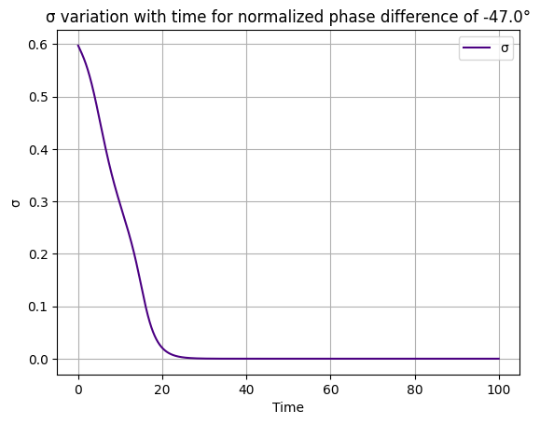

**Figure 5a: $σ=\frac{θ_{1}\left(t\right)}{w_{1}} - \frac{θ_{1}\left(t\right)}{w_{2}}- \frac{φ}{ω_{1}ω_{2}}$** , $ψ\left(t\right) and \dot{ψ}\left(t\right)$ with respect to time for two ‘power coupled’ oscillators for $ψ={-47}^{o}$.

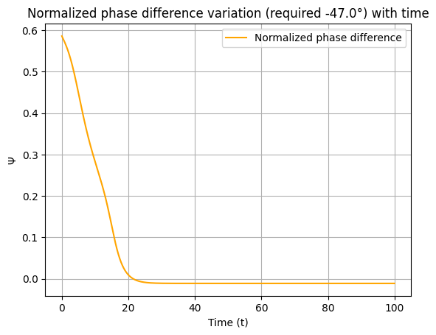

**Figure 5b: $ψ\left(t\right)$** with respect to time for two ‘power coupled’ oscillators, coupling at for $ψ={-47}^{o}$.

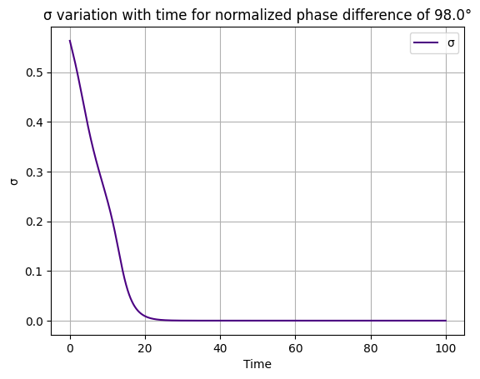

**Figure 6a: $σ=\frac{θ_{1}\left(t\right)}{w_{1}} - \frac{θ_{1}\left(t\right)}{w_{2}}- \frac{φ}{ω_{1}ω_{2}}$** , with respect to time for two ‘power coupled’ oscillators, for $ψ={98}^{o}$.

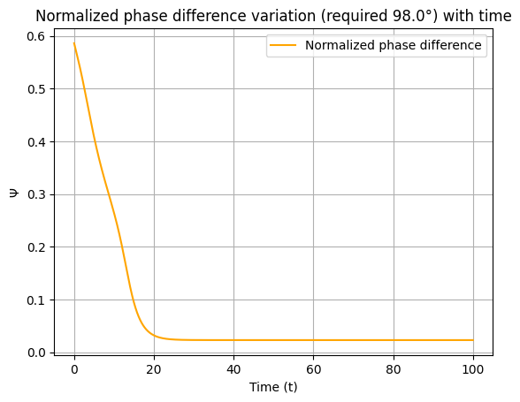

**Figure 6b: $ψ\left(t\right)$** with respect to time for two ‘power coupled’ oscillators, coupling at for $ψ={98}^{o}$.

# 3. Conclusion

The values of coupling constants do not depend on the required phase difference values. The coupling constant governs the time required to couple as well as the amplitude for both the cases.

# 4. References

1. ‘A Complex-Valued Oscillatory Neural Network for Storage and Retrieval of Multidimensional Aperiodic Signals ‘, Biswas et.al