**Chapter 2:  
Mathematical Preliminaries**

**2.1 Eigenvalue & Eigenvectors**

**1) A is a square matrix**

 (1)

 (n – Dimensional complex vector)



Let A be a real symmetric matrix

(2)   
Or



Hermitian matrix

 (3)

**Theorem 1:**

The Eigen values of a hermitian matrix are real.

Proof:







is real

**2) A is skew-symmetric**

 (4)

Or



**3)**  (5)



Tranposing both sides,



is purely imaginary.

**4) Q is an orthogonal matrix.**

 (6)

Then,

 (7)

Proof:













**5)** For every symmetric matrix, A, then exists on orthogonal matrix, Q, such that

 (8)

Where,  are eigenvalues of A.

Proof:

Let be the eigenvector corresponding to 



Let D be a matrix such that,











is called the eigen-decomposition of A.

**6. Orthogonal transformation preserves lengths:**

Proof:

 (9)

Length of X equals length of Y.

**2.2 Quadratic forms**

**2.2.1 Quadratic forms: Explanation**

A quadratic form is a quadratic function associated with a symmetric matrix, A, and is expressed as:

 (10)

A discussion of quadratic forms is relevant to study of neural systems since often it is required to minimize an “error function” that depends on a large number of parameters. To be able to do so, we must first define the minimum of a multivariate function. For a univariate function, f, the minimum is simply a point where f’=0 and f’’>0. To define the minimum of a multivariate function, the concepts of f’ and f’’ must be generalized to multivariate functions.

For a multivariate function:

First derivative is the Gradient., G = 

Second derivative is the Hessian, H, is defined as,

 (11)

Since H is a matrix and not a scalar like f’’, we need to specify how to define a minimum in terms of the Hessian H. It is here that we need quadratic forms. To understand this let us expand a multivariate function as a Taylor series:

 (12)

f(X0) is a constant and therefore does not affect the shape of f(X) around X0.

Since G = 0, we may ignore the linear term .

The higher order terms beyond quadratic are too small and may be ignored.

Therefore, the function f(X) has a minimum at X0, if the function 

has a minimum at h = 0. To verify this, we need to examine the shape of a quadratic function around the origin (X=0).

It is easier to examine the shape of a quadratic function, in transformed coordinates, Y, obtained by rotating the original coordinates X, so that in the new coordinates the “cross-terms” are eliminated.

**2.2.2 Geometric interpretation of eigenvalues in terms of quadratic forms:**

For a real, symmetric matrix, A, let , (13)

where D is a diagonal matrix of eigenvalues.

Let 



Or,

 (14)

Thus in the rotated coordinates, eigenvalues of A are proportional to the second derivatives of E.

Maximize the quadratic form, E, subject to 

This can be done using the method of Lagrangian multipliers as follows. Since there is only one constraint, the Lagrange function may be written as:



That is, the directions along which E is stationary (derivative is 0) under the constraint of ||X||=1,

correspond to the eigenvectors of the matrix A, to which the quadratic form is associated.

Thus we can see that the shape of a quadratic form at the origin depends on the composition of the eigenvalues of A. Here we come to the notion of definiteness. There are 5 kinds of definiteness.

1. **Positive definite** : An ‘n x n’ matrix ‘A’ is said to be positive definite if it meets the following condition:

$\frac{1}{2}X^{T}AX >0, ∀ X≠0, X ∈ R^{n}$ (15)

This implies $λ_{i}>0$.

This case corresponds to the “minimum.” Thus a multivariate function has a minimum at a point X0, if the Hessian of the function at X0, is positive definite.

1. **Positive semi-definite:** An ‘n x n’ matrix ‘A’ is said to be positive semi-definite if it meets the following condition:

$\frac{1}{2}X^{T}AX ≥0, ∀ X≠0, X ∈ R^{n}$ (16)

This implies $λ_{i}≥0$.

1. **Negative definite:** An ‘n x n’ matrix ‘A’ is said to be negative definite if it meets the following condition:

$\frac{1}{2}X^{T}AX <0, ∀ X≠0, X ∈ R^{n}$ (17)

This implies $λ_{i}<0$.

This case corresponds to the “maximum.” Thus a multivariate function has a minimum at a point X0, if the Hessian of the function at X0, is negative definite.

1. **Negative semi-definite :** An ‘n x n’ matrix ‘A’ is said to be negative semi-definite if it meets the following condition:

$\frac{1}{2}X^{T}AX ≤0, ∀ X≠0, X ∈ R^{n}$ (18)

This implies $λ_{i}≤0$.

1. **Indefinite:** An ‘n x n’ matrix ‘A’ is said to indefinite if it does not meet any of the above four conditions.

Illustrations of various kinds of definiteness for two-variable functions.

|  |  |
| --- | --- |
| *Case 1*: $λ_{1 }$ and $λ_{2 }$ are both positive:  **postive.png** | *Case 2*: and are both negative:  **negative.png** |
| *Case 3*: is positive, is negative:  posnegative.png | *Case 4*: is positive, is zero:  poszero.png |

**Figure 1: Example: For n=2, $X∈R^{2}$, $z= \frac{1}{2}(λ_{1}y_{1}^{2}+λ_{2}y_{2}^{2} )$, plot z for all possible values of $λ$**

**Solution of linear equations: AX=b**

Where, A ϵRn*m, bϵRn, X ϵRm

**Case 1**

If n=m (Unique solution)

Let A-1 exist.

X= A-1B (19)

**Case 2**(Least squares solution)

If n>m (Under-determined case: more equations than unknowns)

Since there may not be a perfect solution, we attempt a Least Squares solution, by minimizing E.

E = (b-AX)T(b-AX). Minimizing E gives the following solution,

XLS=(ATA)-1ATb=A+b, (20)

WhereA+ is called the pseudo inverse. Since b =AXLS=A(ATA)-1ATb=AA+b

**Case 3**

m>n (Infinite solutions)

Add minimum norm condition.

Min (||x||2) such that Ax = b. (21)

**Example Problem:**

E=x2+ y2, constraint ax+by=c.

Let us use the method of Lagrangian Multipliers.

E’=x2+ y2 + (ax+by-c)

x=-aλ/2, y=-bλ/2

$$λ=\frac{-2c}{a^{2}+b^{2}}$$

$$x=\frac{ac}{a^{2}+b^{2}}$$

$$y=\frac{bc}{a^{2}+b^{2}}$$

E=XTX

$$E’=X^{T}X-Λ^{T}(AX-b)$$

$$δE’=2X-{\left(Λ^{T}A\right)}^{T}=0$$

X=AT

Since AX=b

$$\frac{1}{2}AA^{T}Λ-b=0$$

$Λ=({AA^{T})}^{-1}$ b

$X= A^{T}({AA^{T})}^{-1}$ b

**2.3 Dynamic Systems and fixed points:**

**2.3.1 Dynamical Systems**

Concepts from dynamic systems are most essential to study neural models. Ideas of stability, attractors, limit cycles, chaos appear again and again in discussions of brain dynamics. A few examples:

1. Memories in the brain are often modeled as *attractors* of brain dynamics.
2. The resting state of a neuron is considered as *stable node*, since the neuron returns to that state on small perturbations.
3. Periodic spiking activity of a neuron is modeled as a limit cycle.

A general dynamic system is defined as:

 (22)

Stationary Points (also called, critical points, equilibrium points etc) are those where:

 (23)

The behavior of the system around xs, depends on the Jacobian of f(x),

 (24)

If you linearize (22) around x = xs,

 (25)

= Ax

 = a11x1 + a12x2 + a13x3 + …

 = a21x1 + a22x2 + a23x3 + …

 = a31x1 + a32x2 + a33x3 + …

.

.

.

Hence

 = an1x1 + an2x2 + an3x3 + … ……….. … + annxn

Whose solution would be,

X(t) = c1q1 + c2q2 + … (26)

Verifying:

(t) =  ciqi

=  ciA qi

= A  ci qi

= A x(t)

Types of stationary points (n = 2):

Description in terms of eigenvalues of A,

(Plots generated in Matlab using quiver function):

1. Both eigenvalues are real, -ve (Fig. 2)

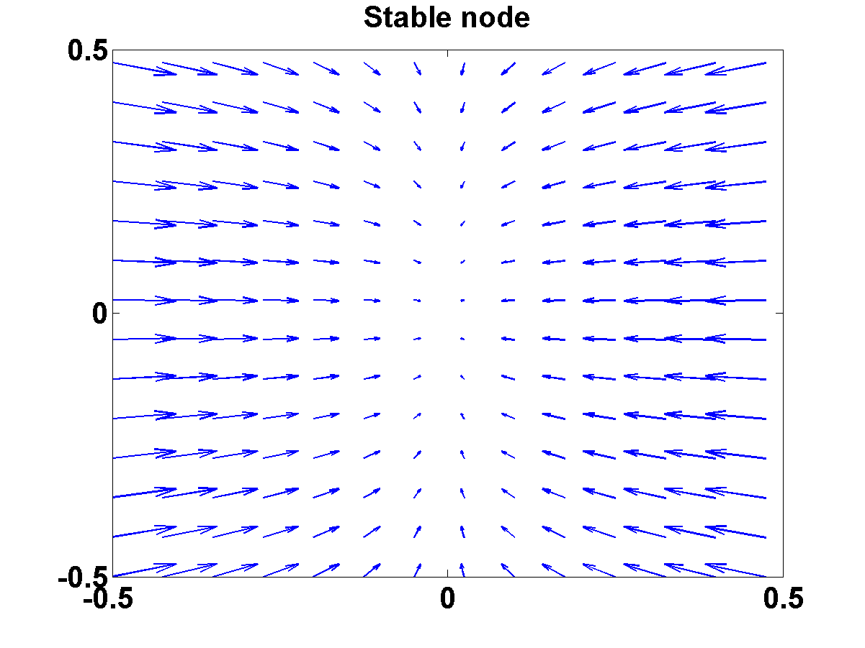

**Figure 2: Stable node**

1. Both eigenvalues real, +ve.

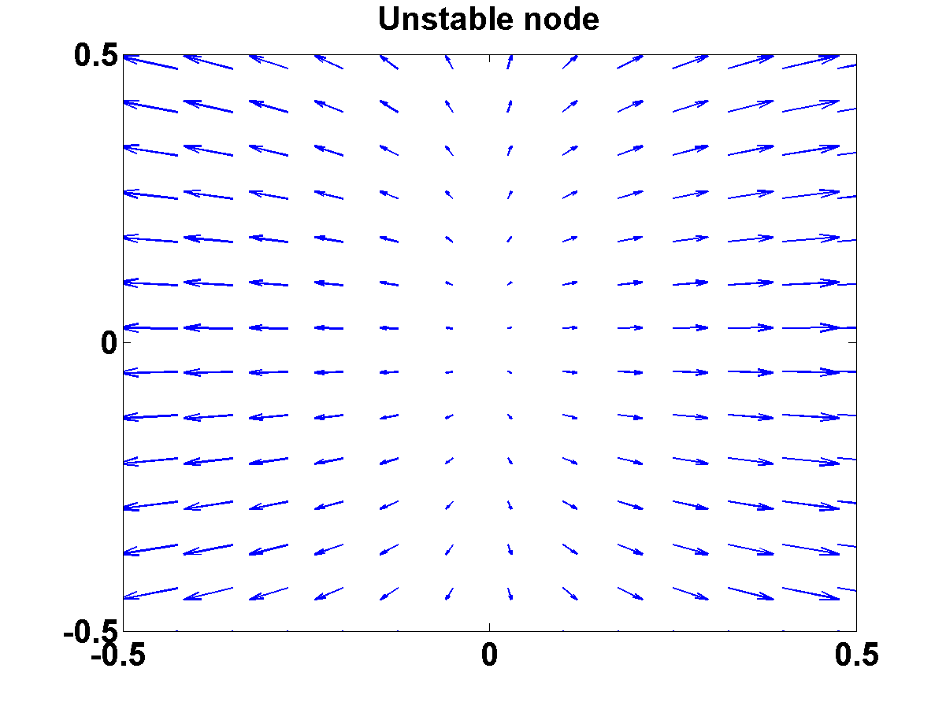

**Figure 3: Unstable node**

1. One +ve eigenvalue, one –ve eigenvalue

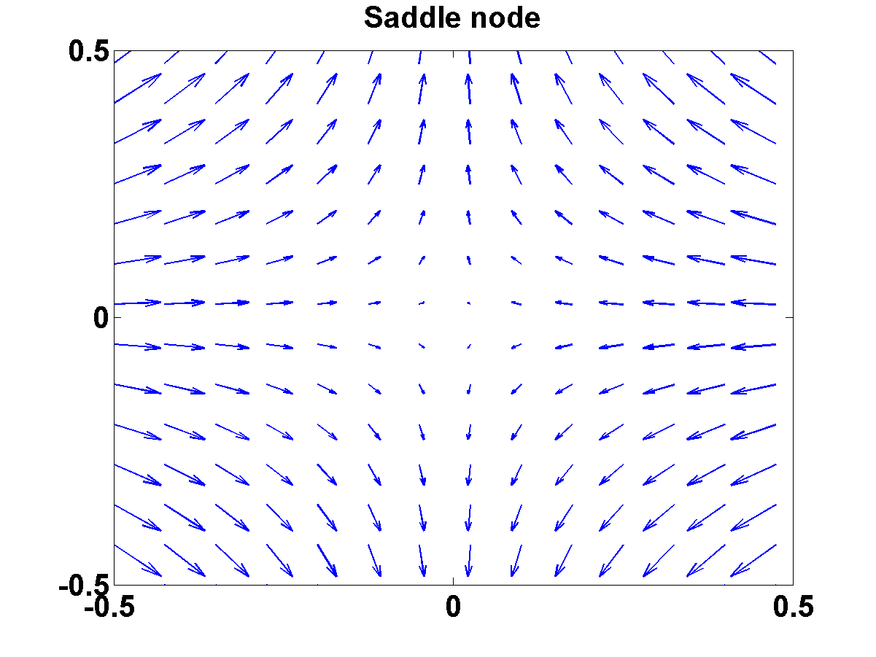

**Figure 4: Saddle node**

1. Both eigenvalues complex with –ve real parts.

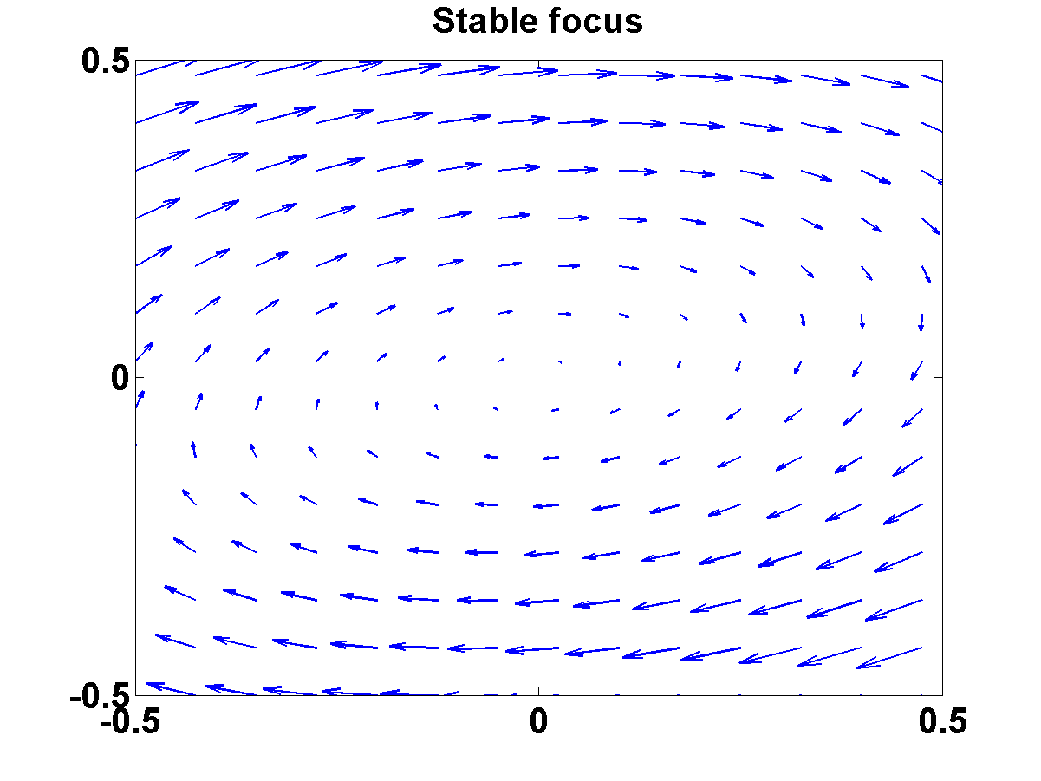

**Figure 5: Stable focus**

1. Both eigenvalues complex, +ve real parts.

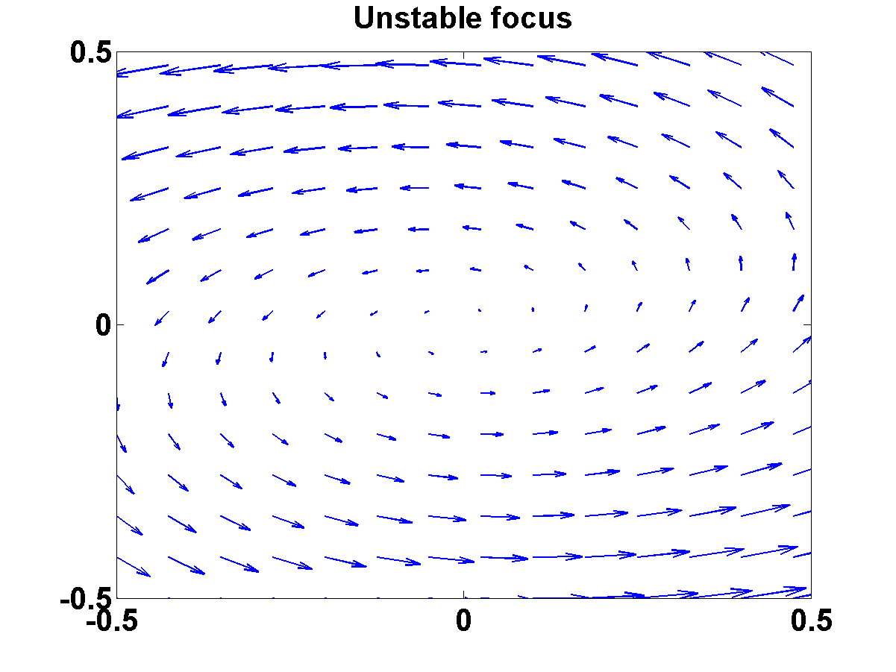

**Figure 6: Unstable focus**

1. Purely imaginary.

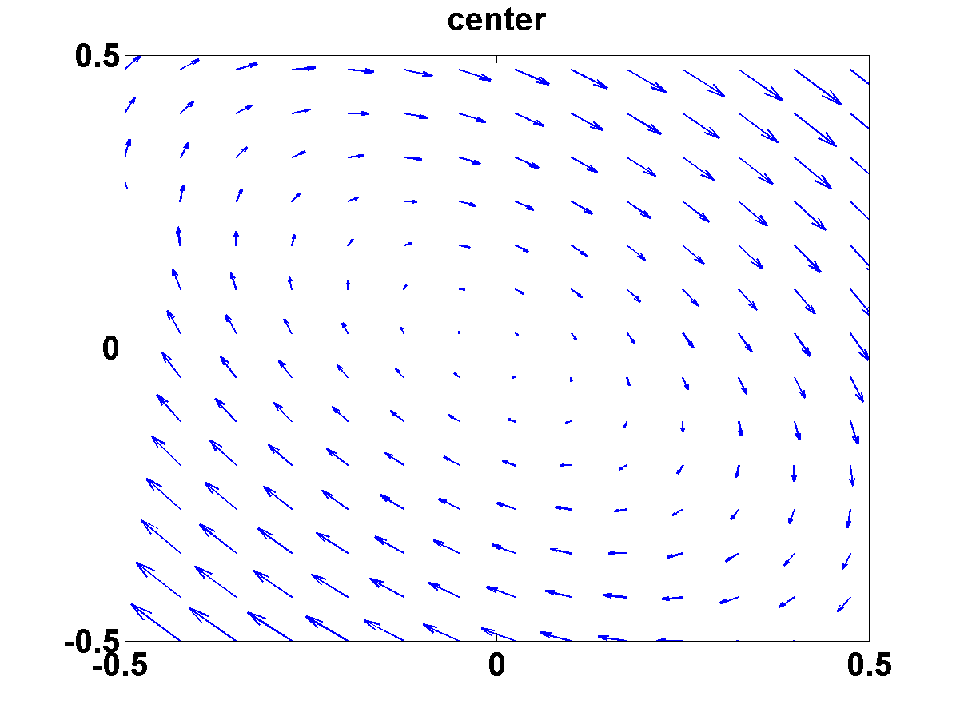

**Figure 7: Center**

**Other cases:**

**7.** Star: Both the eigenvalues being real, equal, negative

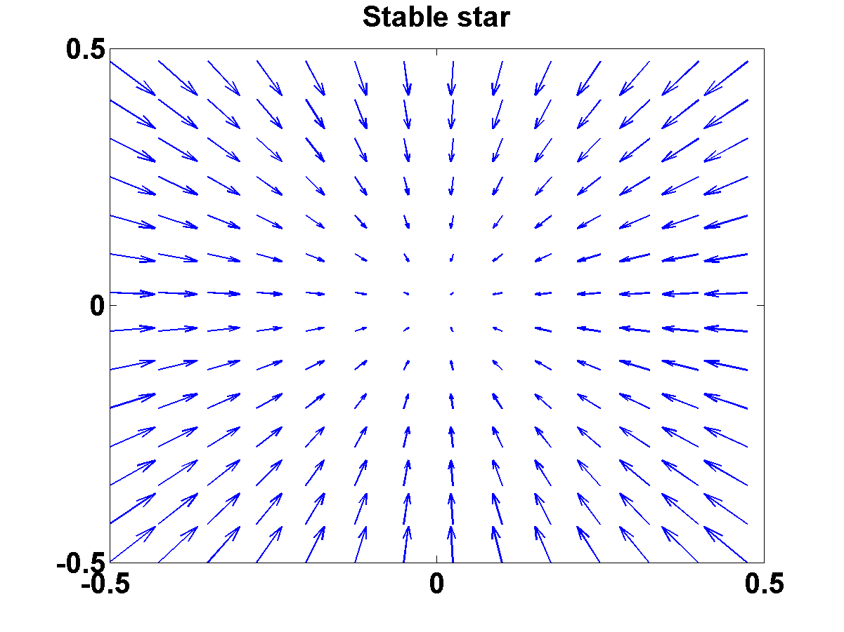

**Figure 8: Stable star**

**8.** One of the eigenvalues is zero.

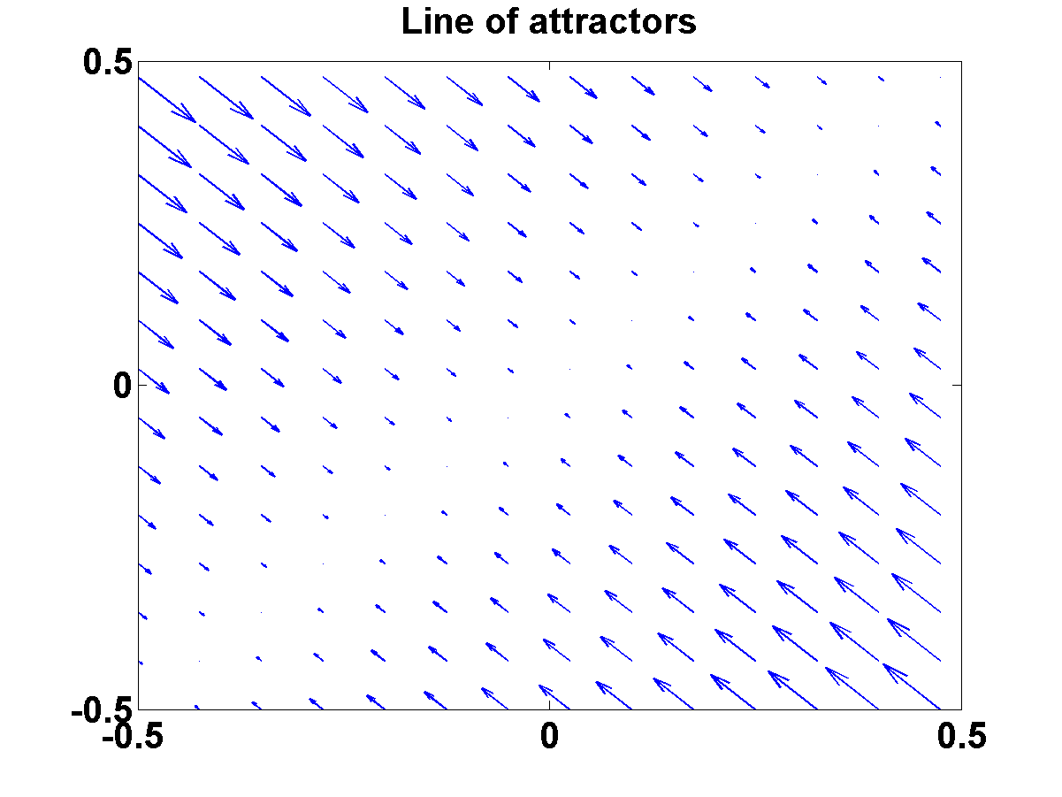

**Figure 9: Line of attractors**

**2.3.2 Classification of Fixed Points:**

For a linear dynamic system,

= Ax (27)

the type of fixed point at the origin can be related to the trace and determinant of A.

This relationship can be easily derived when A is a 2 X 2 matrix, but the result applies to the general n X n matrix.

Let

. The characteristic equation is,

, (28)

Expanding the determinant, we get the following quadratic equation

 (30)

Where



Solving for λ, we have,

 (31)

From the above form of the expression for the eigenvalues,, of the Jacobian of the dynamic system, = Ax, at the origin, we can infer a few things.

Case λ<0:

Eigenvalues are real and have opposite signs. Therefore, the fixed point is a saddle node.

Case λ>0:

If >0, both the roots are real. Further,  is less than |τ|. Therefore,

* if τ is positive, both the roots are positive 🡪 unstable nodes.
* if τ is negative, both the roots are negative 🡪 stable nodes.

If <0, the roots are complex conjugates. Furthermore,

* If τ is positive, the real part of the roots is positive 🡪 unstable focus
* If τ is negative, the real part of the roots is negative 🡪 stable focus
* If τ is 0, the roots are purely imaginary 🡪 center

If =0, the roots are equal 🡪 line of fixed points.

The above scheme of classification is summarized in the “map” shown below.

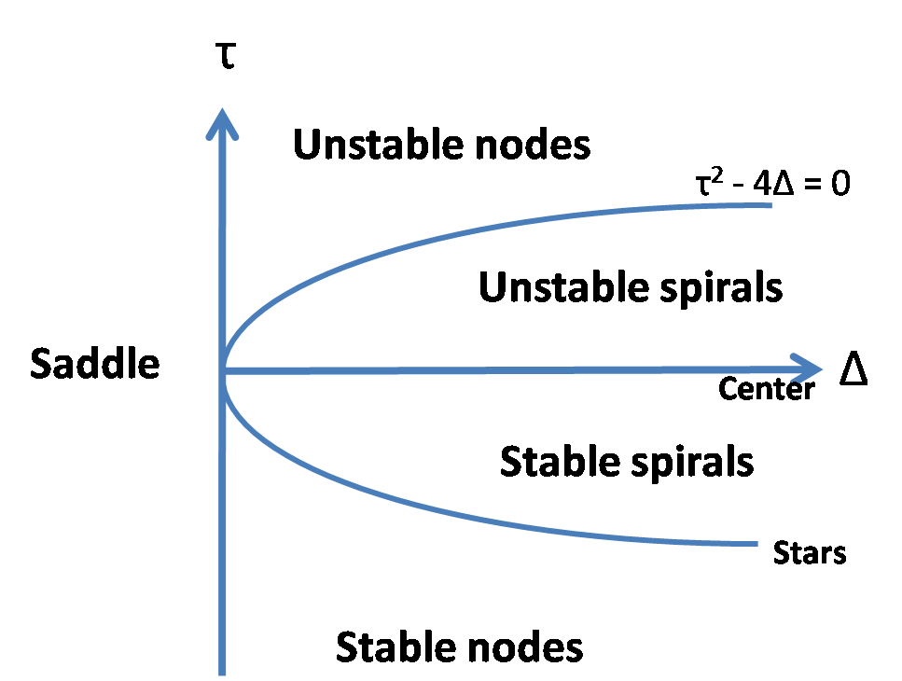

**Figure 10: Map of Δ vs τ**

**2.3.3 Phase-plane Analysis:**

Above we have briefly listed out the types of fixed points that occur in a linear n-dimensional dynamic system. The origin is the only fixed point in such systems. But a nonlinear dynamic system can have multiple fixed points with a much larger repertoire of behaviors, and therefore much harder to analyze than a linear system. Therefore it is convenient to study to two-dimensional nonlinear systems which offer several advantages:

* They can be easily visualized
* They have rich dynamics and are sufficiently interesting study (for example, they exhibit limit cycle behavior, which can be used to model rhythmic behavior in real systems)
* They have a limited range of dynamics compared to n-dimensional (n>2) nonlinear dynamic systems. (for example, two-dimensional continuous, differentiable dynamic systems do not exhibit chaos).

For these reasons, two-dimensional systems occupy a special place in study of dynamic systems.

A general form of a two-dimensional dynamic system can be expressed as:

 (32)

 (33)

The simplest kind of analysis that can be performed on such a system is to identify all the fixed points and classify each of them by local analysis.

Fixed points of eqns. (32-33) may be calculated by solving,

 (34)

 (35)

Eqns (34-35) represent curves in the x-y plane and are known as null-clines.

is the x-nullcline and  is the y-nullcline. The intersection points of the two null-clines are the fixed points of the system.

Let (xo, yo) is a fixed point of the system described by eqns. (34-35). Dynamics in the neighborhood of the fixed point may be expressed as:

 (36)

 (37)

A linear approximation of the above system is given as,

 (38)

Where J denotes the Jacobian of the system eqns. (32-33)

The above equation may be expressed more compactly as,



The fixed point at ε = 0, can be classified by performing eigenvalue analysis of the above 2D system.

**2.3.4 Limit Cycles:**

Limit cycles are a type of oscillatory behavior characterized by two properties:

* Periodicity:  
  A system exhibiting limit cycle behavior is confined to a closed loop trajectory and periodically visits every point on that loop. Thus, if a system whose state variable is denoted by x(t), visits a point, a, at time, t, and if ‘a’ is on a limit cycle, then

x(t) = x(t+T)=a, (39)

where T is the period of the limit cycle.

* Isolatedness

This property refers to the behavior of the system when it is slightly perturbed from the limit cycle. When a system begins at a point that is in the neighborhood of a limit cycle, it either approaches the limit cycle asymptotically, or moves away from it. In this respect, a limit cycle is different from a ‘center.’ In case of a center, when the system is slightly perturbed, it continues on a new periodic orbit and does not return to the previous orbit.

Limit cycles are relevant to neural dynamics because neural spiking activity may be conveniently modeled as a limit cycle.

There are several ways in which it can be proved that a system exhibits limit cycle behavior, some of which are discussed below.

1. Special systems
2. Lienard Systems
3. Poincare-Benedixson Theorem

Explanation:

1. **Special systems**: There is no general rule for determining if a system has limit cycle behavior. This absence of general, universal methods is characteristic of nonlinear systems. But some systems have a convenient form so that it can be easily shown that they have limit cycle behavior.

Example: We can easily show the system given below has limit cycles –

 (40)

 (41)

Let us rewrite the above equations in polar form by substituting:

and (42)

 (43)

Combining eqns. (40-41) as shown below

 (44)

and expressing the result in polar coordinates we have

 (45)

Or,

 (46)

Now consider,

 (47)

Differentiating both sides,

 (48)

Using eqns. (40-41) we have,

 (49)

Combining eqn. (48) and eqn. (49) we have,

 (50)

Thus eqns. (40-41) are re-expressed as, eqns. (46) and eqn. (50).

From eqn. (46) we can see that r approaches the stable of value 1: dr/dt is positive for r < 1, and is negative for r >1.

Thus we have a limit cycle which is a circle of unit radius and angular velocity of 1.

1. **Lienard systems**: This represents a slight improvement over showing limit cycles only in individual systems. Lienard systems are a general class of systems that exhibit limit cycles under certain conditions.

Liénard’s equation is equivalent to the system

$\dot{x}$ = $y$ (51)

$\dot{y}= -g\left(x\right)-f\left(x\right)y.$ (52)

The following theorem states that this system has a unique, stable limit cycle under appropriate hypotheses on $f$ and g. For a proof, see Jordan and Smith (1987), Grimshaw (1990), or Perko (1991).

Liénard’sTheorem: Suppose that $f\left(x\right)$ and $g\left(x\right)$ satisfy the following conditions :

1. $f\left(x\right)$ and $g\left(x\right)$ are continuously differentiable for all $x$;
2. $g\left(-x\right)= -g\left(x\right)$ for all $x$ (i.e., $g\left(x\right)$ is an odd function) ;
3. $g\left(x\right)>0$ for $x>0$;
4. $f\left(-x\right)=f\left(x\right)$ for all $x$ (i.e., $f\left(x\right)$ is an even function) ;
5. The odd function F($x$) = $\int_{0}^{x}{f(u)}du$ has exactly one positive zero at $x=a,$ is negative for $0<x<a,$ is positive and nondecreasing for $x>a,$ and F $(x)→∞$ as $x→∞$.

Then the system (51-52) has a unique, stable limit cycle surrounding the origin in the phase plane.

1. **Poincare-Benedixson Theorem:**

This theorem specifies conditions in 2D systems under which limit cycle exists. It is based on the idea that in a dynamic system dx/dt = f(x), where f(x) is continuous, no two trajectories intersect. Therefore, if there is a limit cycle, then all trajectories that start from inside the limit cycle will remain confined within the limit cycle. They can never come out of the limit cycle since to come out they have to cross the limit cycle, which is disallowed.

A formal statement of Poincare-Benedixson theorem is given below.

represents a continuously differentiable vector field on an open set containing a region R, where R is a closed, bounded subset of the plane, which is devoid of any fixed points, and

There exists a trajectory C that is “confined” in R (if it starts in R it stays in R forever).

If the above conditions are satisfied, C is a closed orbit.

It is not straightforward to apply Poincare-Benedixson theorem to a given system and show presence of limit cycles. Such demonstration depends crucially on construction of a trapping region, R, such that vector field on the borders of R points inwards everywhere.

There is a theorem from Index theory that any closed orbit must enclose one or more fixed points. Since Poincare-Benedixson requires that R must not include any fixed points, we need to construct an R that excludes all fixed points. Typically a ring-like, annular region is chosen such that vector field is pointed inwards on the outer boundary, and outwards on the inner boundary. If such a region can be constructed, Poincare-Benedixson assures us that a limit cycle exists inside R. Exact construction of R depends on the details of the equations that describe the system.

**2.3.5 Limit Cycle generation by Bifurcation:**

As the parameters of a dynamic system are changed gradually, at certain critical values of the parameters, the dynamics can change qualitatively.(For example, in the map of fig. 10, a stable focus changes into an unstable focus when we cross the Δ axis from below). Such qualitative changes in dynamics are known as bifurcations. The parameter values where such changes occurs are called bifurcation points.

The map of Fig. 10 which shows different types of fixed points on the τ   plane is a simple example of bifurcations. The plane is divided into several regions, where each region represents one type of fixed point, or a dynamical regime. When we crossover from one region to a neighboring region, dynamics suddenly changes, and a bifurcation occurs. For example, when we cross the Δ axis (τ = 0 line), saddle node become either stable or unstable nodes.

Four important types of bifurcations by which limit cycles can be produced are:

1. Supercritical Andronov-Hopf bifurcation
2. Subcritical Andronov-Hopf bifurcation
3. Saddle-node bifurcation
4. Saddle-node on invariant circle bifurcation

**a) Andronov-Hopf Bifurcation – supercritical**

In Andronov-Hopf bifurcation, a stable focus gets converted into an unstable focus giving rise to a limit cycle in the process. A stable focus, as we know from the previous section, has complex valued eigenvalues with negative real parts; the eigenvalues of the unstable focus has positive real parts. Thus Andronov-Hopf bifurcation occurs when a pair of complex conjugate eigenvalues cross over from the left halfplane to the right.

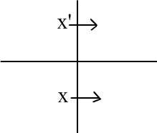

Depending on the precise manner in which a stable focus gets destabilized and leads to a limit cycle, the Andronov-Hopf bifurcation can be classified into two types.

In supercritical Andronov-Hopf bifurcation, when a stable focus becomes a limit cycle, the limit cycle first starts with a small/infinitesimal amplitude and gradually increases in size.

This behavior can be seen in an example.

Example:

 (53)

 (54)

Note that θ does not influence evolution of r (in Eqn. 53) but r influences  θ (in eqn. 54). Therefore changes in amplitude may be studied solely by studying Eqn. (53).

Note how the steady state value of r changes as  is increased from a negative value to a positive value. For μ0, the only real solution is r = 0; for μ >0, there are three real solutions: r = 0, +sqrt(μ  Since r has to be positive, the solutions are r = 0 and sqrt(μ). Eqn. (54) simply says that angular velocity increases with increasing radius.

Therefore, if we express the steadystate radius, rs, as a function of bifurcation parameter, μ ,

for μ >0, and (55)

It can be easily verified that in the system defined by eqns. (53-54), the eigenvalues at the origin cross over from the left half-plane to the right, as μ crosses over from negative to positive values.

**Eigen values analysis for eqns. (53-54)**

  (56)



 (57)



 (58)



**Properties of supercritical Andronov-Hopf bifurcation**

1. Size of the limit cycle, r0, grows as  for  close to and greater than(Fig. 11)

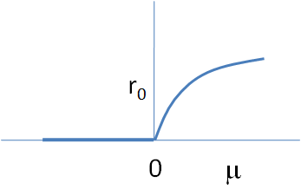

**Figure 11: Size of the limit cycle $r_{o} vs μ$**

1. Frequency, evaluated at  =.

Formula is exact at birth of the limit cycle.

 (59)



= 

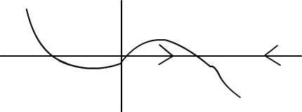 µ > 0

**b) Subcritical Andronov-Hopf bifurcation:-**

In a subcritical Andronov-Hopf bifurcation, when the unstable focus destabilized, a limit cycle of finite size sudden appears, unlike in the supercritical case the limit cycle starts of small and grows gradually as the bifurcation parameter increases.

An example of a system which exhibits subcritical Andronov-Hopf bifurcation is given below:

 (60)

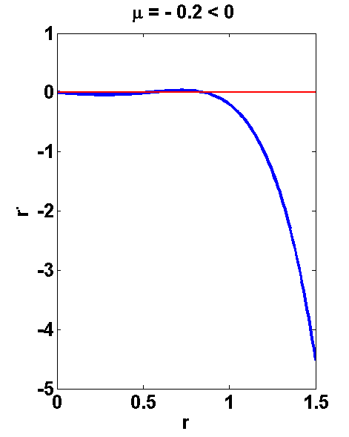

**Figure 12: For μ< 0**

Thus for μ< 0, there is no limit cycle; there is a stable fixed point at the origin (Fig. 12)

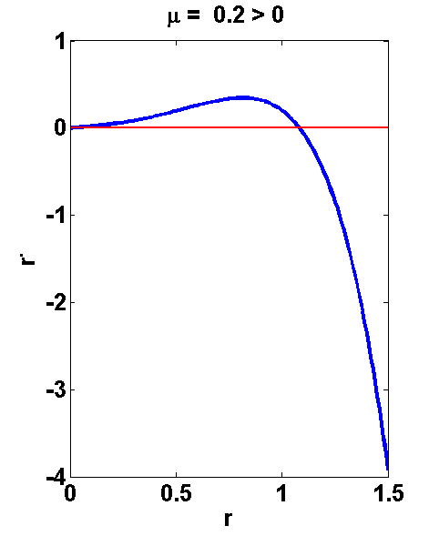

**Figure 13: For μ> 0**

But when μ >0, there is suddenly a limit cycle at r = r0, a finite value (Fig. 13)

Thus, in supercritical Andronov-Hopf bifurcation, the size of limit cycle varies as a function of μ as follows: (Fig. 14)

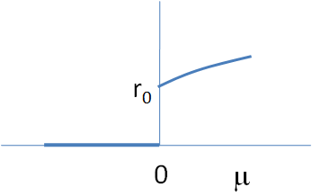

**Figure 14: rovsμ**

**c) Saddle node bifurcation of cycles**:

In saddle node bifurcation of cycles (also called a fold bifurcation), two limit cycles coalesce and annihilate each other. A simple example system that exhibits Saddle node bifurcation of cycles is,



Note the system is the same as the one used in case of the subcritical Andronov-Hopf bifurcation above. But the difference lies in the value of bifurcation parameter at which the bifurcation occurs.

In case of subcritical Andronov-Hopf bifurcation, the bifurcation occurred at μ= 0. For μ < 0, there is a stable focus at the origin, an unstable limit cycle of lesser radius, and a stable limit cycle of larger radius. When μ > 0, the unstable limit cycle merges with the origin and disappears. The stable limit cycle only remains.

In case of Saddle node bifurcation of cycles, the bifurcation occurs at μ = -1/4. (Fig. 15)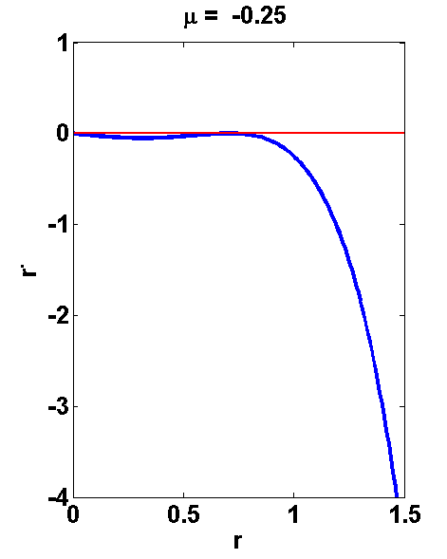

**Figure 15: For μ= -0.25**

For μ < -1/4 (μ < μ c), (Fig. 16) (origin is the only stable point. There are no limit cycles (stable or unstable).



**Figure 16: For μ< 0**

For μ (μ = μ c) (Fig. 17),

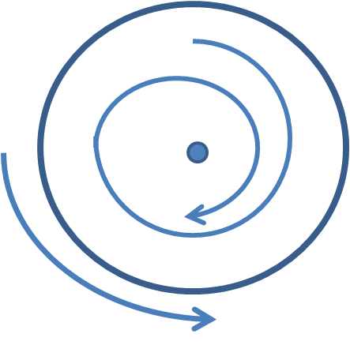

**Figure 17: For μ= μc**

For (μ > μ c): For μ > -1/4, (Fig. 18) origin is still a stable point. But in addition there are now two limit cycles (one stable and the other unstable).

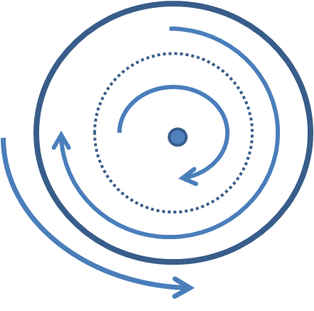

**Figure 18: For μ>μc**

Therefore a key difference between subcritical Andronov-Hopf bifurcation and Saddle node bifurcation of cycles is that in the former, the stable focus at the origin becomes unstable after bifurcation, whereas in the latter the focus at the origin remains stable throughout.

**d) Saddle node on invariant Circle:**

In this type of bifurcation, a node and saddle are located on a loop – the invariant circle. By varying a bifurcation parameter, the saddle and the node come together, coalesce and annihilate each other leaving the loop, the limit cycle, intact.

A sample system that displays Saddle node on invariant Circle behavior:

 (61)

For μ < 1, the phase dynamic equation has two solutions – saddle and a node located on the unit circle (r = 1). Phase portrait is shown in the figure below. As μ 🡪 1, the saddle and the node approach each other and coalesce. When μ > 1, the saddle and the node annihilate each other leaving a limit cycle at r = 1.(Fig. 19)

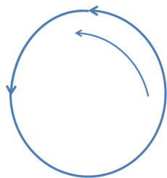 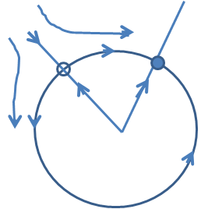

μ > 1 μ < 1

**Figure 19: Saddle node on invariant circle**

**Homoclinic Bifurcation:**

A homoclinic orbit is one in which a trajectory starts at a saddle node, makes a loop, and returns to the same saddle node. In a homoclinic bifurcation, a closed loop approaches a saddle node. At bifurcation, the saddle touches the loop, transforming the loop into a homoclinic orbit. Thus trajectories that start from the saddle go along the loop and return to the saddle in the opposite direction (Fig. 20).

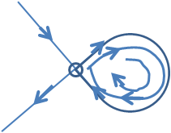

**Figure 20: The limit cycle with the saddle outside**

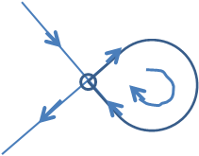

**Figure 21: The saddle had merged with the limit cycle. The cycle has now become a homoclinic orbit.**

**Reference:**

S. Strogatz., Nonlinear Dynamics and Chaos, Addison-Wesley publishing company, 1994.