**3 Hodgkin-Huxley Model**

The Hodgkin-Huxley model explains how the dynamics of ion channels (Na+, K+ etc) contribute to the generation of an Action Potential in a neuron.

An Action Potential is a sharp voltage spike elicited by stimulating a neuron with a current that exceeds a certain threshold value. The current amplitude is increased gradually, at a threshold amplitude, the voltage response does not increase proportionally. It shows a sharp, disproportionate increase. Once the membrane voltage reaches a threshold value, it increase further rapidly to maximum value and drops again rapidly to a value that is less than resting value, before returning to the baseline value after a delay.

 To describe the processes that lead to the generation of an AP from the introduction on Nernst Potential, we present a simple ion channel model which expresses how the channel conductance contributes to the membrane potential, and conversely, in case of voltage-sensitive channels, how the membrane potential controls channel conductance. Finally we place the above components in a full circuit model of neural membrane - the Hodgkin-Huxley model.

Now let us calculate the typical values of Nernst potentials of Na+ and K+ for a neuron.

**3.1 Nernst potential:**

**Sodium Nernst potential:**

Under resting conditions sodium concentration outside the neuron ([Na+]o ) equals 440 mM, while inside (([Na+]i ) it is 60 mM. From eqn. (1.1) we calculate Na+ Nernst potential (ENa) to be about 50 mV.

Potassium Nernst potential:

Similarly under resting conditions, [K+]o equals 20 mM, while [K+]i is 400 mM. Therefore, EK is about -77 mV.

The Nernst potentials, like the membrane potential, are always measured inside, with the extracellular space as the reference. Also note that Na+ Nernst potential is positive inside, and K+ Nernst potential is negative inside. In addition to Nernst potential, an ion channel also has a conductance, which is higher when it is in OPEN state than when it is closed. Channel conductance is usually expressed not in ‘per channel’ terms, but the total conductance of a whole patch of the membrane containing that channel, expressed in ‘Siemens/area’. Thus, again under resting conditions, Na+ conductance is about 120 mS/cm2 and K+ conductance is about 36mS/cm2.

**3.2 Modeling the neural Membrane:**

Electrical response of a neuron depends on the ion channels present and the membrane itself. Once we know the Nernst potential associated with a channel and the channel conductance we are in a position to build a basic model of an ion channel. The model is meant to capture the voltage-current (V-I) characteristics of the ion channel. Since a battery (Nernst potential) and a conductance are associated with the channel, we can represent the channel in of the following two ways: the battery in series (or parallel) (fig 3.2.1) with the conductance. Let us determine which of the two are correct. When the conductance is 0, as when the channel is closed, current through the channel is 0, irrespective of the value of the Nernst potential. This rule is satisfied only when the battery and conductance are in series and not in parallel. Therefore, as a first cut we represent an ion channel as a series of a battery and a conductance.

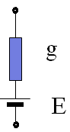

**Figure 3.2.1:** A basic model of an ion channel.

Since there are a variety of ion channels with distinct values of E and g, we have a separate branch for each of them. All these branches must be connected in parallel since all the channels stagger across the membrane, and share the same membrane voltage. In addition to the ion channels, the membrane itself is another electrical component that controls the dynamics of the membrane potential. The neural membrane is a lipid bilayer with insulating properties. Due to its bilayer structure, the membrane is modeled as a parallel plate capacitor. Thus the various ion channels and the membrane together may be depicted as an electrical equivalent circuit as follows:

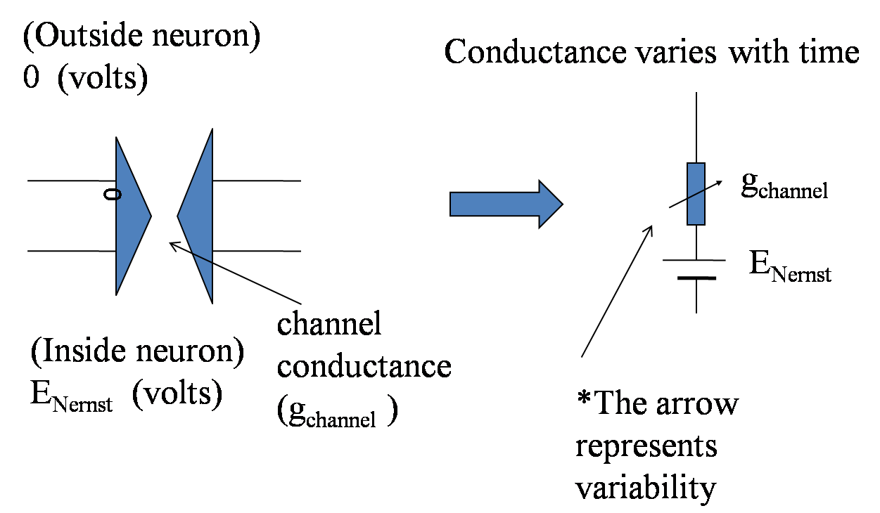

**Figure 3.2.2:** An ion channel has voltage dependant conductance.

Now if all the circuit components (capacitance, conductances, batteries) are time-invariant, then all the branches corresponding to ion channels can be combined into a single equivalent branch consisting of a single conductance and a battery. This can be done by invoking a well-known result from electrical engineering known as Thevenin’s theorem. With such simplification a model of the membrane looks as shown in fig 3.2.3

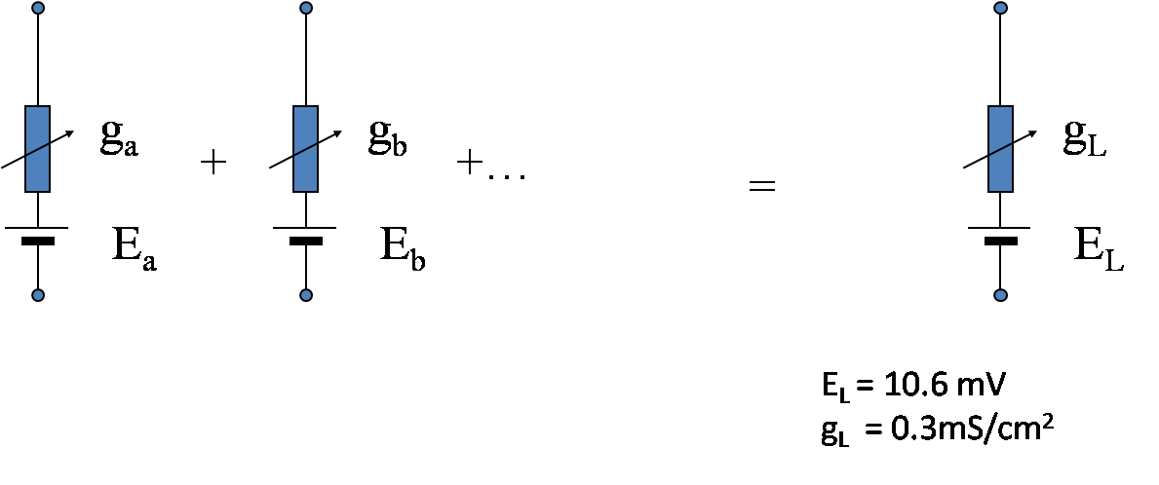

**Figure 3.2.3:** Resultant branch equivalent for time invariant branches, corresponding to ion channels

This is a simple, linear RC circuit and is not likely to exhibit the interesting voltage dynamics underlying AP generation, which is basically a nonlinear behavior. The root cause of AP behavior is presence of voltage-dependent ion channels, which may be regarded as nonlinear conductances since their conductance depends on membrane voltage. Particularly voltage-dependent Na+ and K+ channels play a crucial role in AP generation. These are shown in Fig. 3.2.4

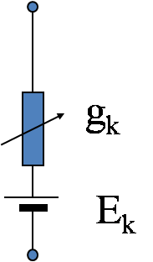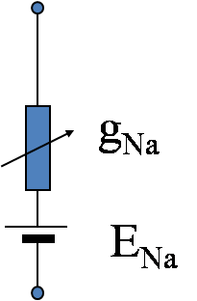

**Figure 3.2.4:** Circuit equivalents for sodium and potassium channels

We now take up the question of modeling a general voltage-sensitive channel first, followed by specific models for voltage-sensitive Na+ and K+ channels.

**3.3 A general model of a voltage-sensitive channel:**

Mathematical treatment of voltage dependent gating of channels has two parts. First, we describe the dynamics of switching between open/close states. This description is kept general, without reference to a specific gating mechanism. Next, we describe voltage-gating, or, the manner in which switching dynamics is influenced by membrane voltage.

**3.3.1 Channel switching:**

When we set out to describe switching between open and closed states of channel there is an implicit assumption that the channel has only two states. This assumption is not true. Complex channels do have a large number of intermediate states that are not strictly ‘open’ or ‘closed.’ Channel switching in those cases involves switching among all those states. But for the moment we consider only simple channels with only two states – open and closed.

Channel switching can described as a unimolecular chemical reaction where a molecule – the channel protein – switches between two states in fig 3.3.1.1

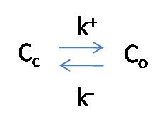

**Figure 3.3.1.1:** Channel Switching

where Cc and Co denote the channel in open and closed states, and k+ and k- are the forward and reverse rate coefficients. If x is the fraction of the channels in open state, and (1-x) is the fraction of channels in closed state, dynamics of state transition may be described as a first order chemical reaction as follows:

 (3.3.1.1)

The above equation can also be written as,

 (3.3.1.2)

where,

 ,

 (3.3.1.3)

Note that the above simple description is applicable for a statistical ensemble of channels. Since a cell membrane typically has a few thousand ion channels the above description is justified. Switching behavior in single channels, which can be measured using techniques like patch-clamping, is far more complex. Since our objective is to study membrane voltage changes it is sufficient to treat channels as an ensemble.

Complete solution of eqn. (3.3.1.1) requires knowledge of K+ and K-. In voltage-sensitive channels these quantities are functions of membrane voltage and that is the mechanism by which membrane voltage controls channel gating.

Since ion channels are proteins which contain charged amino acid side chains, membrane potential can influence the rate of open/close transitions. Using Arrhenius expressions, the rate constants can be expressed in terms of the membrane potential as:

 and  (3.3.1.4)

whereand are independent of membrane voltage.

Substituting the above formulae for and  in eqn. (3.3.1.2, 3.3.1.3) above, we have

 (3.3.1.5)

 (3.3.1.6)

Now let us define,

 and  (3.3.1.7)

Substituting S0 and V0 in eqns. (3.3.1.5, 3.3.1.6) we obtain,

 (3.3.1.8)

 (3.3.1.9)

Using hyperbolic functions, the last two expressions can be rewritten as,

 (3.3.1.10)

 (3.3.1.11)

Eqn. (3.3.1.10) tells us how many channels are open once the entire population of channels comes to equilibrium at a given steady state membrane voltage. Fig. 3.3.1.1 depicts the dependence of open probability (x) on membrane voltage for various values of V0 and S0. If S0 is positive, channels open with increasing membrane voltages. Such gates are known as *activation* gates. When S0 is negative, gates close with increasing membrane voltages. Such gates are known as inactivation gates. V0 determines the voltage at which the transition from ‘mostly open’ to ‘mostly closed’ takes place.

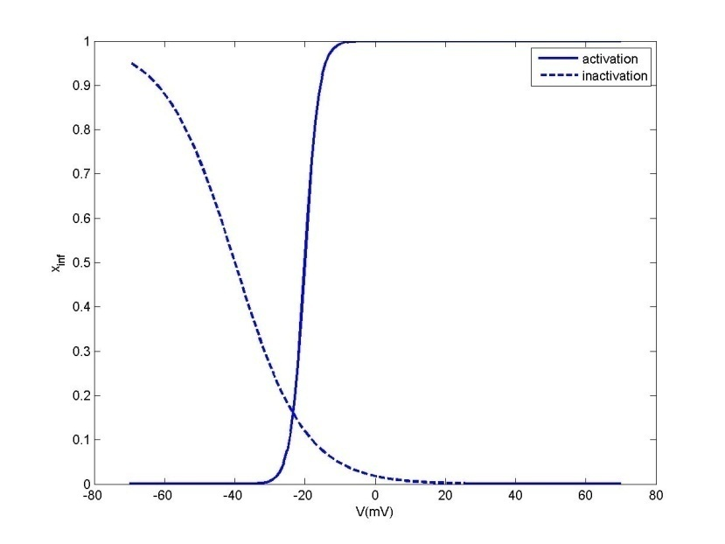

**Fig. 3.3.1.1:** the effect of membrane voltage (V) on .

The solid line corresponds to an activation gate (S0 = 2) and the dashed line corresponds to an inactivation gate (S0 = -10). Note the smaller the magnitude of S0, the steeper the curve. V0 for the activation and inactivation gates are -20 mV and -40 mV respectively.

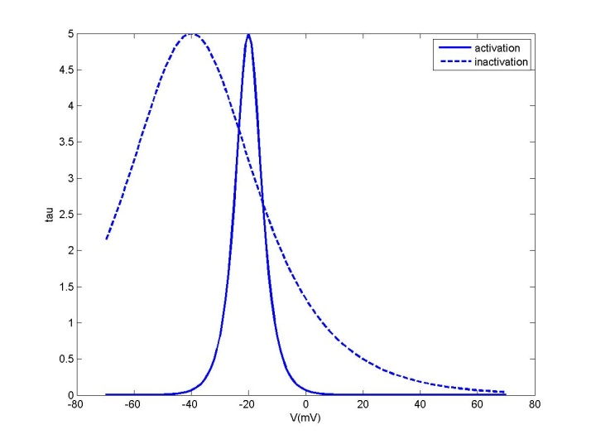

**Fig.3.3.1.2** Effect of membrane voltage on the time constant of relaxation (t).

Forthe two curves shown in fig. 3.3.1.2, it is assumed that α+β = 0, and

, where =0.2 ms-1. (3.3.1.12)

In fig. 3.3.1.2, for the solid line, S0 = 2; V0 = -20, whereas for the dotted line, S0 = 10; V0 = -40. Note that the sign of S0does not affect t since it is an even function of S0. V0 denotes the voltage at which t is maximum. The magnitude of S0 determines the sharpness of the peak.

**3.3.2 Channel gating**

In the above account of channel switching we have given the impression that there is a single “bottle-neck” in the pore which closes the channel. However, such a description is not completely accurate. There can be several local “bottle-necks,” simply referred to as *gates*, which can control channel closure.

To describe channel switching then we must be able to express the kinetics of all the gates in the channel. The question now is to describe the dynamics of single gates – the gate kinetics – and express the switching of the whole channel in terms of the component gates.

Our work is made easy by the fact that gate kinetics is also treated just as we have treated channel switching in eqns. (3.3.1.1 - 3.3.1.12). If we consider only channels with single gates, equations for gate kinetics would looks identical to eqns. (3.3.1.1 - 3.3.1.12) with the only difference that ‘x’ now represents the fraction of open *gates*, which is also interpreted as *probability* of the gate being in open state. The same quantity is also called the *gating variable*. Since we are considering at the moment channels with only a single gate, fraction of open channels is the same as fraction of open gates.

Channels with multiple gates:

If a channel has K gates, with open probabilities of the gates denoted, by x1, x2, xK, then the open probability, denoted by x, of the entire channel is given as:

x = x1* x2*… xK since the channel is open only when all the gates are open.

**3.3.3 Modeling a voltage-dependent Na+ channel:**

The voltage-dependent Na+ channel in the Hodgkin-Huxley model is thought to have 4 gates – three of them being activation gates, and the last one being an inactivation gate. The three activation gates are thought to be identical, denoted by a common gating variable, m. The inactivation gate is denoted by the gating variable h. Thus the open probability of the entire gate is m3 h. If the conductance of a population of Na+ channels in which all Na+ channels are fully open is ${g_{Na}}^{max}$ then the conductance, $g_{Na}$ of the population in general conditions (some Na+ channels are closed) is,

$g_{Na}={g_{Na}}^{max}m^{3}h$ (3.3.3.1)

The gate kinetics of m variables may be described as,

 (3.3.3.2)

Alternatively, the above equation may be written in the form of (3.3.1.2) in terms of the time constant and steady state value of the gating variable m. But the form of eqn. (3.3.3.2) above is more commonly used in literature. Similarly, the gate kinetics of h variable may be written as,

 (3.3.3.3)

**3.3.4 Modeling a voltage-dependent K+ channel:**

The voltage-dependent K+ channel used in the HH model is thought to have 4 identical activation gates, denoted by the gating variable n. Thus the open probability of the entire gate is n4. If the conductance of a population of K+ channels in which all K+ channels are fully open is ${g_{K}}^{max}$ then the conductance, $g_{K}$, of the population is,

$g_{K}={g_{K}}^{max}n^{4}$ (3.3.4.1)

Dynamics of the gating variable, n, is expressed as,

 (3.3.4.2)

The alpha and beta functions () are estimated from voltage clamp experiments.

**3.4 The Hodgkin-Huxley model**

With this background, we are ready to introduce the Hodgkin-Huxley model equations. To this end, we redraw the circuit of fig. 3.2.3 with a slight modification. In the circuit of fig. 3.2.3, we have combined all the ion channels using the Thevenin’s theorem. However, such compression is possible only when the all the components (conductances and batteries) are constant. But since conductances of voltage-sensitive channels vary through time, such compression is invalid. Thus we have to maintain the distinctness of voltage-sensitive Na+ and K+ channels. All the remaining channels, which are voltage-independent, can still be compressed to a single branch, consisting of a conductance and battery. This branch is thought to represent an notional ion channel that is equivalent to the sum total of all the voltage-independent ion channels in the membrane. This ion channel is called a ‘leakage channel’ since it is constantly open, allowing ‘leakage’ of current from the neuron. We thus have four branches in the circuit: the capacitor, the voltage-sensitive Na+ channel, the voltage-sensitive Na+ channel and the leakage channel (fig. 3.4.1). External current, Iext, applied to the neuron can be split into four components:

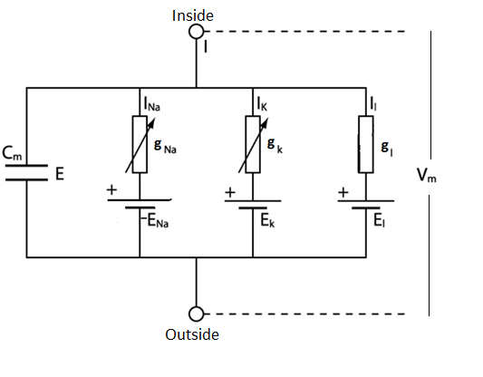

**Figure 3.4.1:** Equivalent circuit of a HH model

Iext = IC + INa + IK + Il (3.4.1)

IC – current through the capacitance

INa - current through the Na+ channel

IK – current through the K+ channel

Il – current through the leakage conductance

The above current equation may be expanded as,



Or,

 (3.4.2)

The above equation that describes membrane voltage dynamics must be supplemented by the following equations to complete the definition of the Hodgkin-Huxley model.

 (3.4.3)

 (3.4.4)

 (3.4.5)

$g_{Na}={g_{Na}}^{max}m^{3}h$ (3.4.6)

$g_{K}={g_{K}}^{max}n^{4}$ (3.4.7)

, (3.4.8)

, (3.4.9)

 , (3.4.10)

Dependencies among the variables involved in the HH model are depicted in fig. 3.4.2

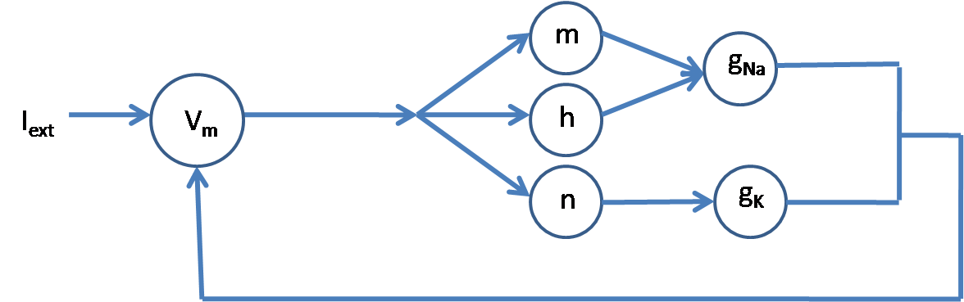

**Figure 3.4.2:** Dependencies among the variables involved in the HH model

The Voltage, Conductances, gating variables vs. time for different I values showing various dynamics have been simulated below (figs 3.4.3 - 3.4.6). Fig 3.4.7 shows the complete frequency dynamics of the HH model.

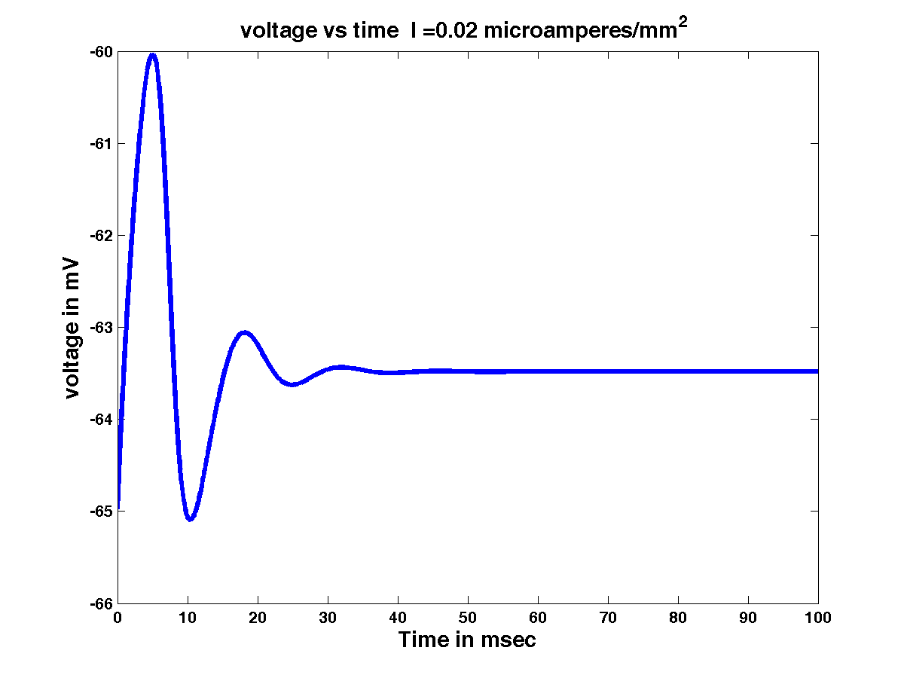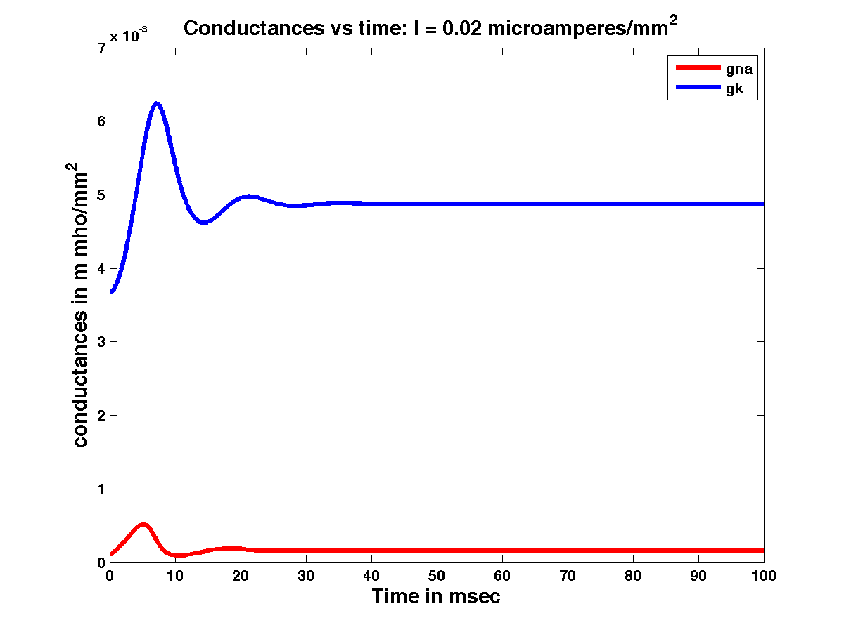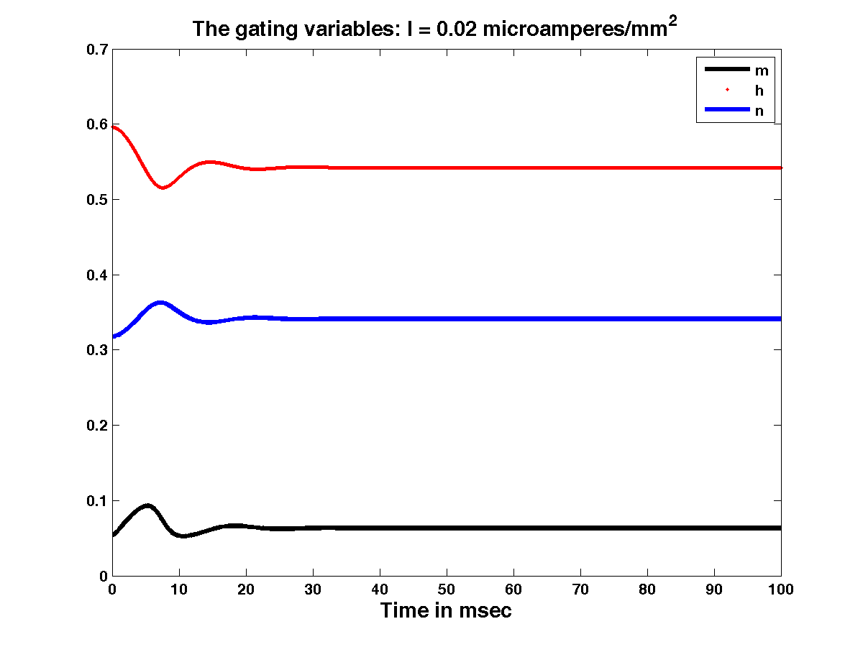

**Figure 3.4.3:** Voltage vs. time; Conductances vs.time;gating variables vs. time for I = 0.02 µA/mm2

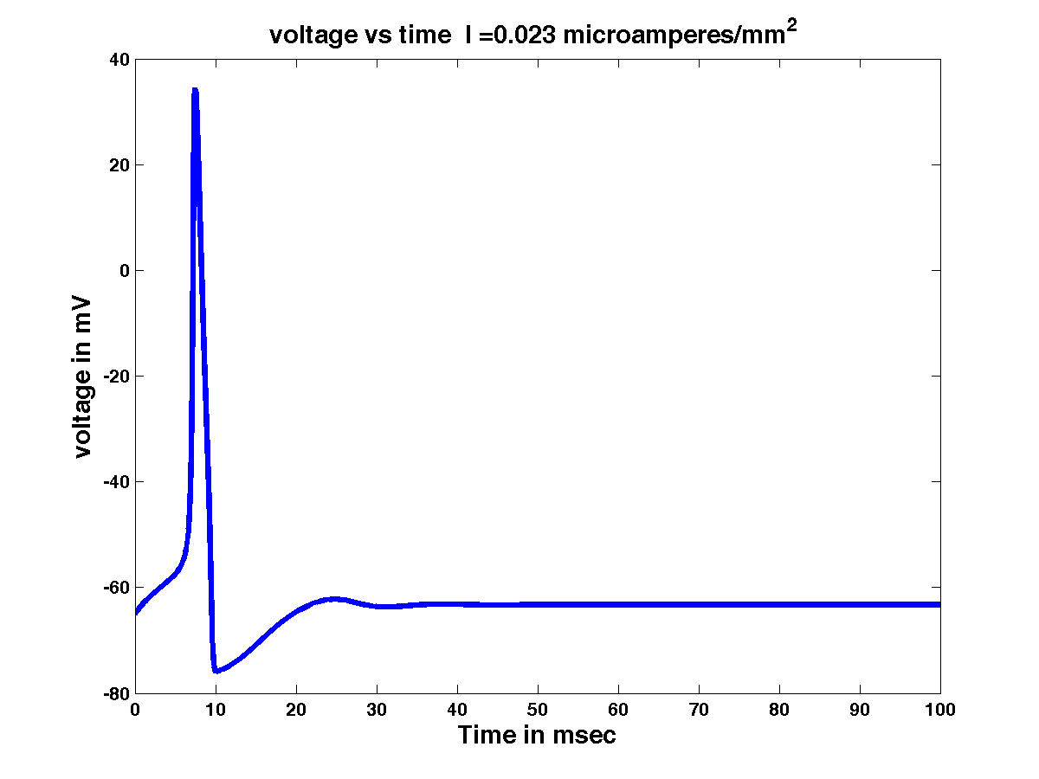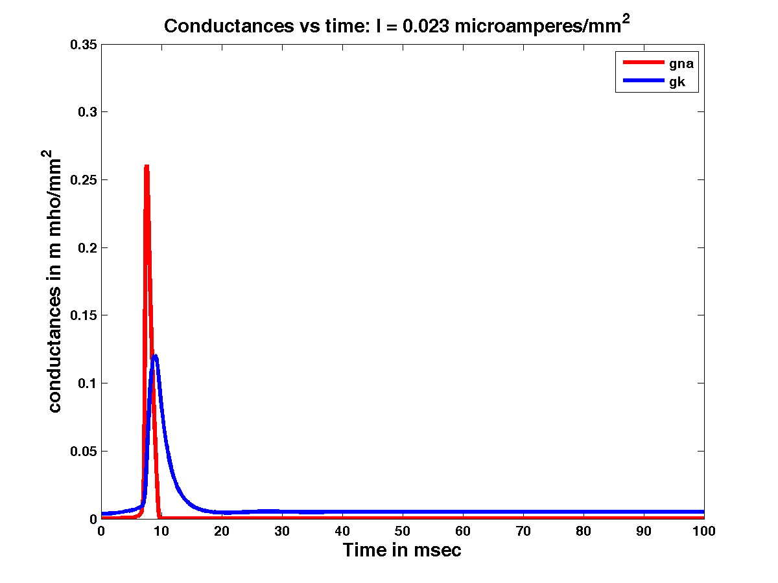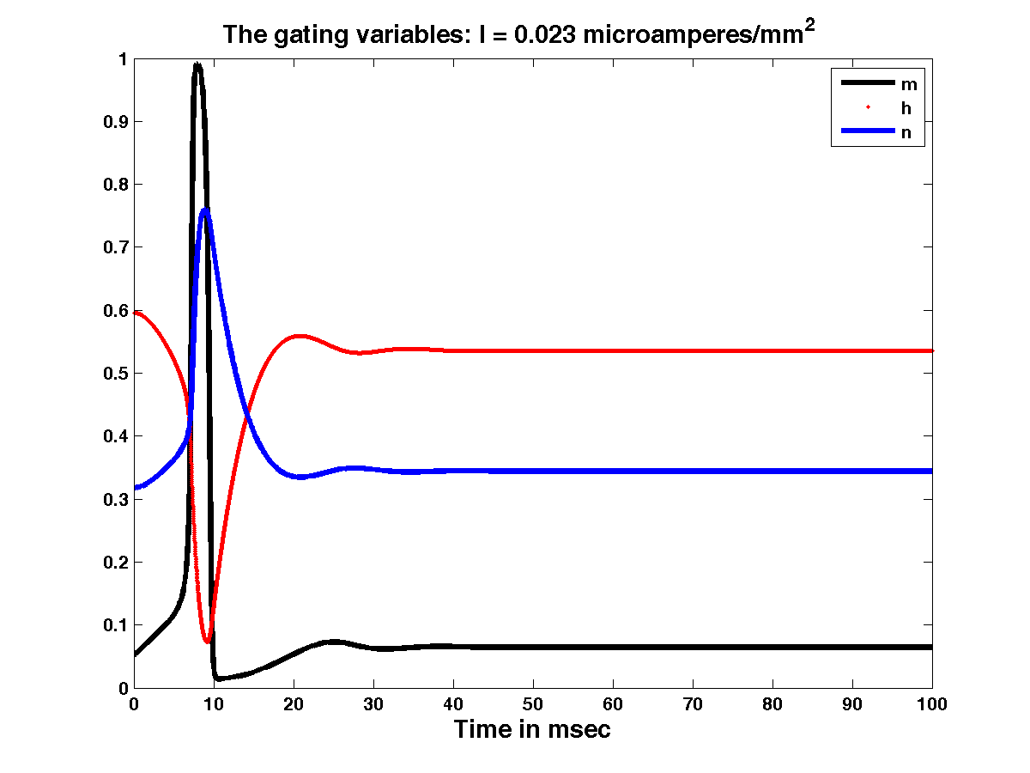

**Figure 3.4.4:** Voltage vs. time; Conductances vs. time;gating variables vs. time for I = 0.023 µA/mm2

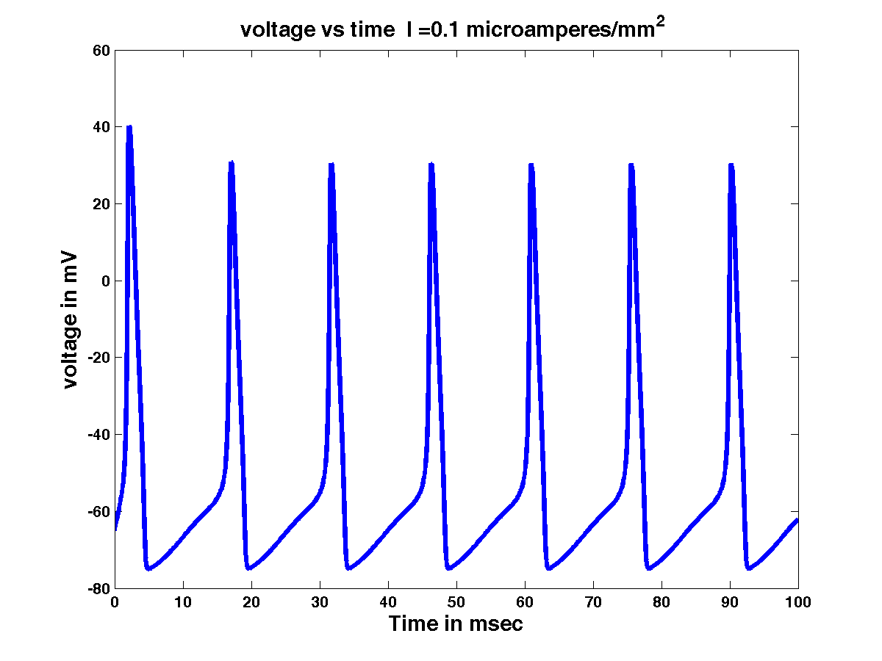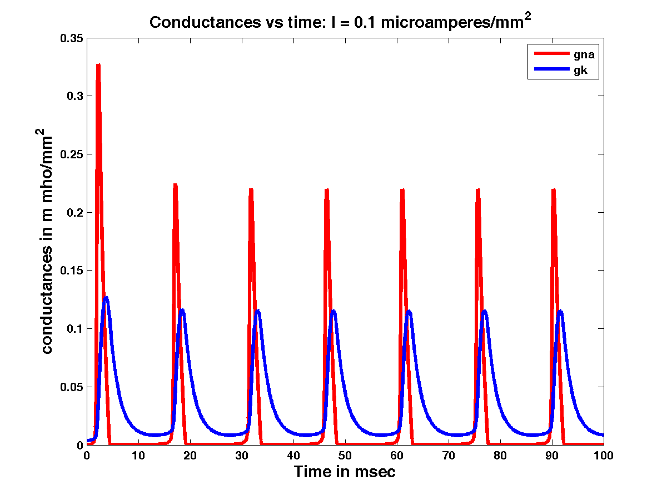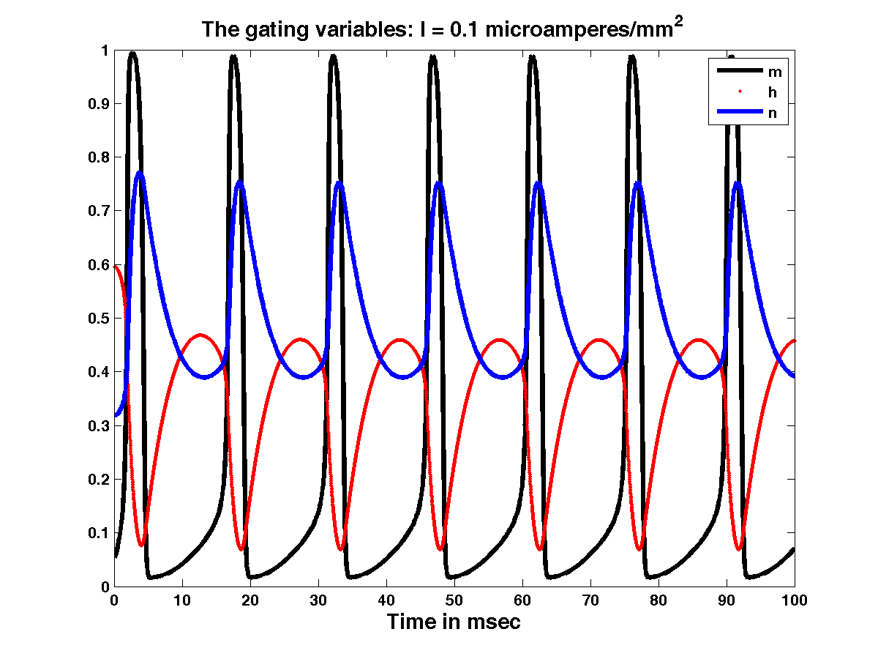

**Figure 3.4.5:** Voltage vs. time; Conductances vs. time;gating variables vs. time for I = 0.1 µA/mm2

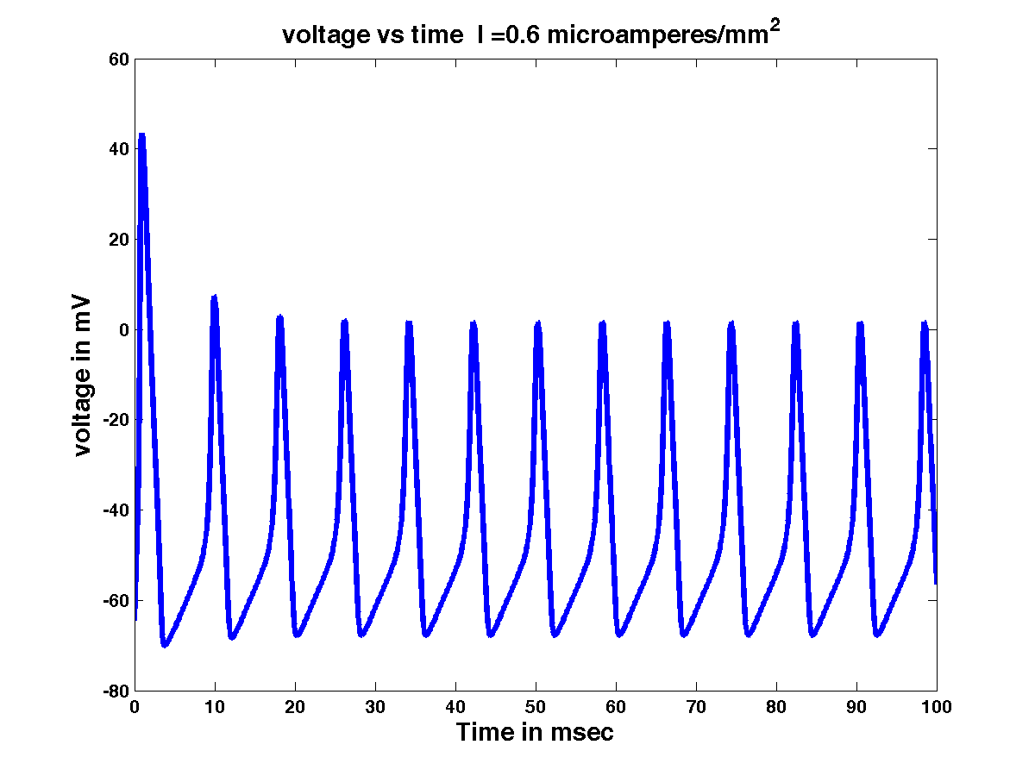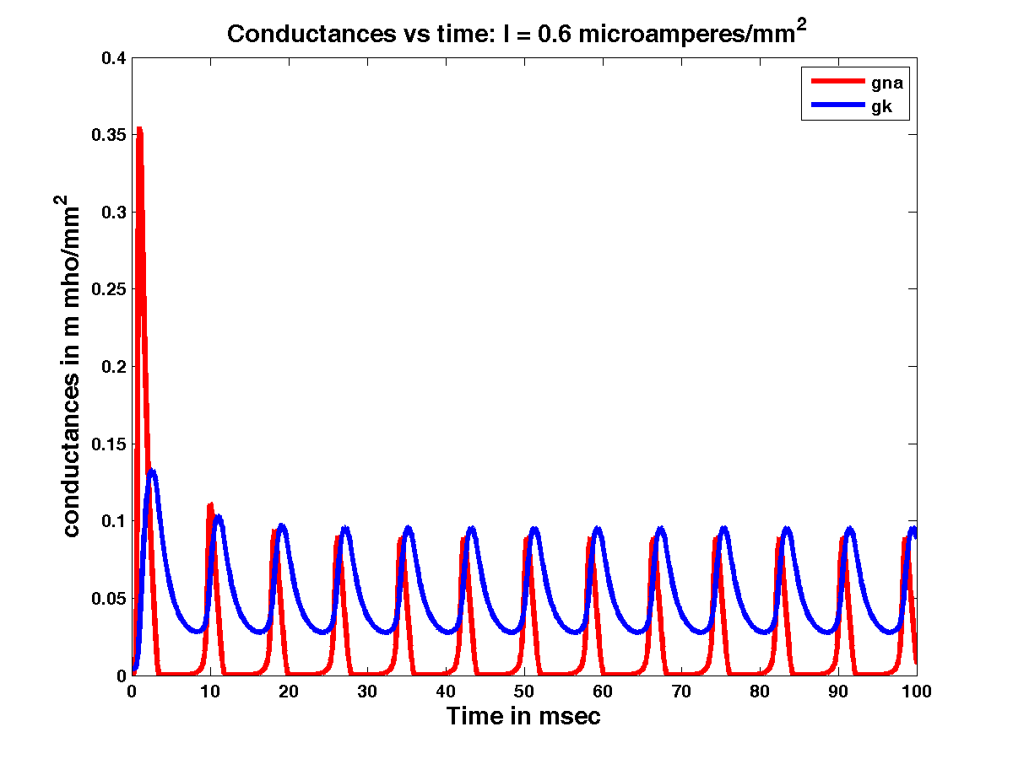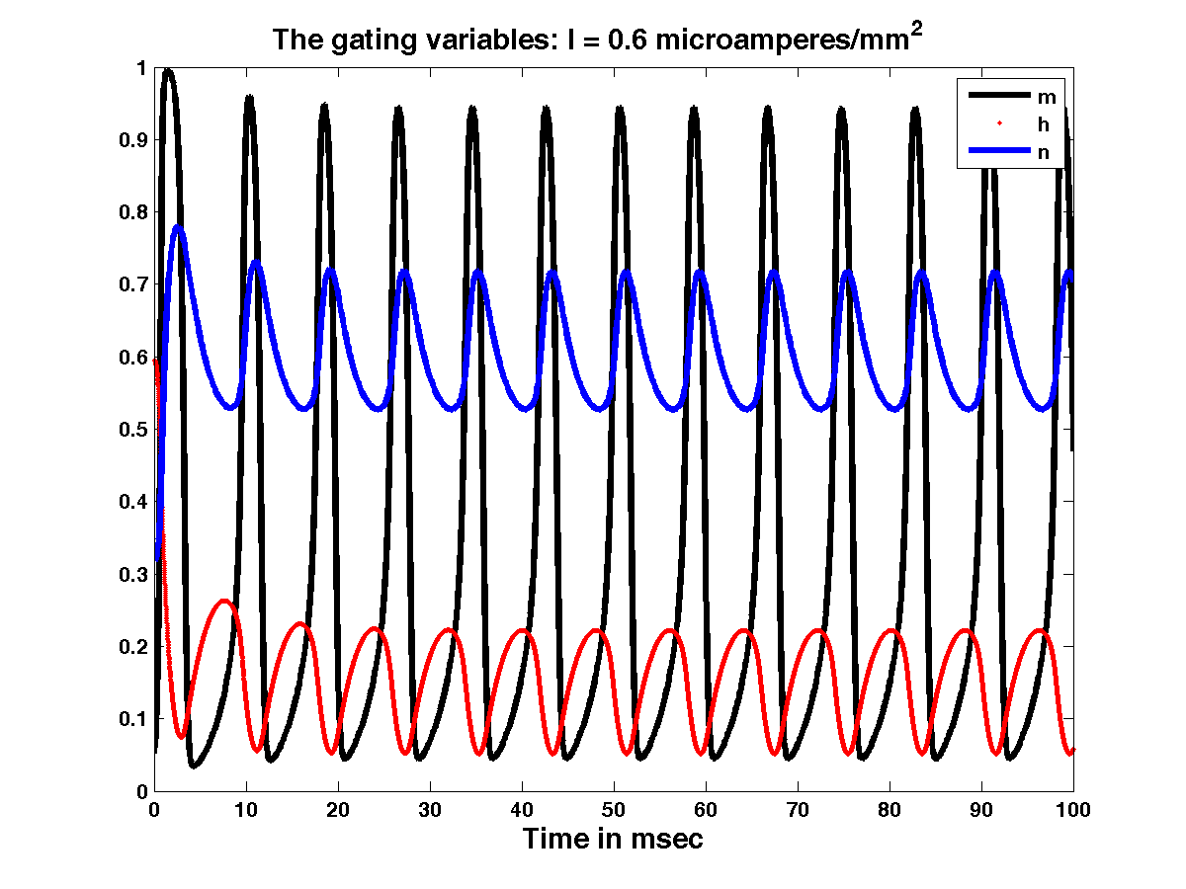

**Figure 3.4.6:** Voltage vs. time; Conductances vs. time;gating variables vs. time for I = 0.6 µA/mm2

The HH model Action potential dynamics see the following fixed points. Before I1, no AP’s are seen. Between I1 and I2, finite number of Action potentials are seen, and between I2 and I3, Limit cycle behavior is noticed. After I3, no Action potentials are seen.

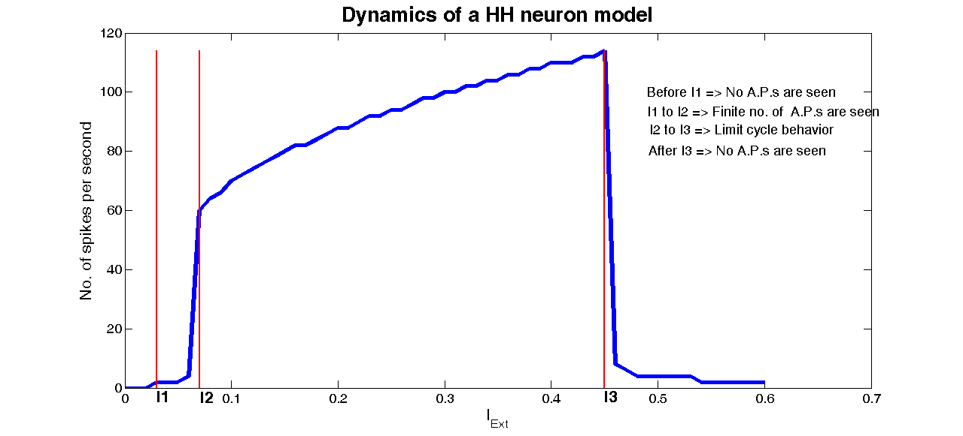

**Figure 3.4.7**: Dynamics of HH neuron model

Code:

%THIS PROGRAM DEMONSTRATES HODGKIN HUXLEY MODEL IN CURRENT CLAMP EXPERIMENTS AND SHOWS ACTION POTENTIAL PROPAGATION

%Time is in msecs, voltage in mvs, conductances in m mho/mm^2, capacitance in microF/mm^2

% threshold value of current is 0.0223

k=1;

istep=0.01;

forImpCur=0:istep:0.6

%TimeTot=input('enter the time for which stimulus is applied in milliseconds');

gkmax=.36;

vk=-77;

gnamax=1.20;

vna=50;

gl=0.003;

vl=-54.387;

cm=.01;

dt=0.01;

niter=50000;

t=(1:niter)*dt;

iapp=ImpCur*ones(1,niter);

%for i=1:100

% iapp(1,i)=ImpCur;

%end;

v=-64.9964;

m=0.0530;

h=0.5960;

n=0.3177;

gnahist=zeros(1,niter);

gkhist=zeros(1,niter);

vhist=zeros(1,niter);

mhist=zeros(1,niter);

hhist=zeros(1,niter);

nhist=zeros(1,niter);

foriter=1:niter

gna=gnamax*m^3*h;

gk=gkmax*n^4;

gtot=gna+gk+gl;

vinf = ((gna*vna+gk*vk+gl*vl)+ iapp(iter))/gtot;

tauv = cm/gtot;

v=vinf+(v-vinf)*exp(-dt/tauv);

alpham = 0.1*(v+40)/(1-exp(-(v+40)/10));

betam = 4*exp(-0.0556*(v+65));

alphan = 0.01*(v+55)/(1-exp(-(v+55)/10));

betan = 0.125*exp(-(v+65)/80);

alphah = 0.07*exp(-0.05*(v+65));

betah = 1/(1+exp(-0.1*(v+35)));

taum = 1/(alpham+betam);

tauh = 1/(alphah+betah);

taun = 1/(alphan+betan);

minf = alpham*taum;

hinf = alphah*tauh;

ninf = alphan*taun;

m=minf+(m-minf)*exp(-dt/taum);

h=hinf+(h-hinf)*exp(-dt/tauh);

n=ninf+(n-ninf)*exp(-dt/taun);

vhist(iter)=v; mhist(iter)=m; hhist(iter)=h; nhist(iter)=n;

gnahist(iter) = gna;

gkhist(iter) = gk;

end

j=1;

realpeaks=zeros;

[peaks, locs]=findpeaks(vhist);

for temp=1:length(peaks)

if peaks(temp) >=10 % minimum value at which a waveform is considered AP.

realpeaks(j)=peaks(temp);

j=j+1;

end;

end;

ifrealpeaks ~= 0

no_of_peaks(k)=length(realpeaks);

else

no_of_peaks(k)=0;

end;

k=k+1

end;

figure(1)

%subplot(2,1,1)

plot(t,vhist)

title('voltage vs time')

figure(2)

%subplot(2,1,2)

plot(t,mhist,'y-', t,hhist,'g.',t,nhist,'b-')

legend('m','h','n')

figure(3)

gna=gnamax*(mhist.^3).*hhist;

gk=gkmax*nhist.^4;

clf

plot(t,gna,'r');

holdon

plot(t,gk,'b');

legend('gna','gk')

holdoff

figure(4);

X=0:istep:0.6;

plot(X,no_of_peaks*1000/(niter/100));

xlabel('I_{Ext}');

ylabel('No. of spikes per second')

holdon;

for l=2:length(no_of_peaks) %to define I1, I2, I3.

ifno_of_peaks(l)>0 &&no_of_peaks(l-1)==0

I1=(l-1)*istep

end;

ifno_of_peaks(l)>no_of_peaks(l-1)+4

I2=(l-1)*istep

end;

ifno_of_peaks(l)<no_of_peaks(l-1)-2

I3=(l-2)*istep

end;

end;

I1=0*no_of_peaks*1000/(niter/100)+I1;

plot(I1,no_of_peaks*1000/(niter/100),'r');

text(I1(1),-3,'I1');

I2=0*no_of_peaks*1000/(niter/100)+I2;

plot(I2,no_of_peaks*1000/(niter/100),'g');

text(I2(1),-3,'I2');

I3=0*no_of_peaks*1000/(niter/100)+I3;

plot(I3,no_of_peaks*1000/(niter/100),'y');

text(I3(1),-3,'I3');

text(0.5,100,'Before I1 => No A.P.s are seen');

text(0.5,95,'I1 to I2 => Finite no. of A.P.s are seen');

text(0.5,90,'I2 to I3 => Infinite no.of A.P.s are seen');

text(0.5,85,'After I3 => No A.P.s are seen');