**BT6270: Computational Neuroscience**

**Assignment 1: Hodgkin Huxley model Report**



Indian Institute of Technology Madras

Atharva Mandar Phatak |BE21B009

Department of Biotechnology

**Background**

The given python code stimulates a Hodgkin-Huxley Model. This model was proposed by Alan Hodgkin and Andrew Huxley, and provides a fair approximation to the biological model, my comparing various cell organelles to an equivalent electrical circuit. It was derived through clamp experiments were carried out on giant squid, as these organisms have a significant sized neuron, thus making them easy to work with.

The given code solves the HH-Model through analytical technique and gives the respective graphs (wiz Voltage vs Time, Conductance vs Time, Gating variables vs time, Frequency vs time.

Based on the model, the following outputs were received

**A) Threshold Value:**

The threshold current values are as follows:

* I1 = 0.0224 mA/mm2
* I2 = 0.0625 mA/mm2
* I3 = 0.4578 mA/mm2

These values are obtained by running the code, with current range from (0,0.6) and sampling interval 0.0001. Smaller sampling interval ensures higher accuracy, upto 4 decimals requires higher computation

**B) Assumptions:**

* The threshold value of the voltage peak is taken to be **10mV**. Thus, only peaks greater than the threshold values are considered for further plotting and computations
* The differential equation in Hodgkin Huxley model was solved analytical to reduce computation resources
* The currents I1, I2, I3 were captured at the pointes were the graph Iext vs. Firing rate (f) showed abrupt changes.

**I1:** Blue, **I2:** Orange, **I3:** Green, colors respectively

* The step size for the iterations was take as **0.01**, to reduce computation time.

**C) Plot:**

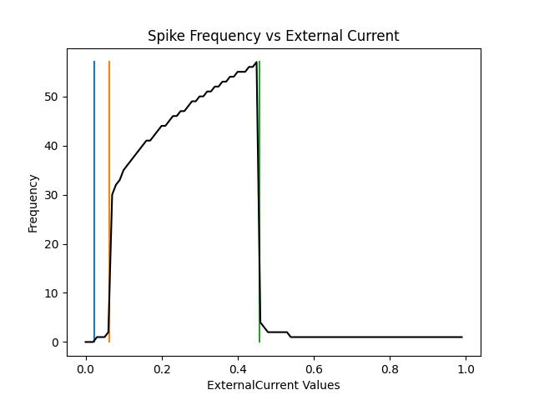

**Figure 1**: A graph which depicts the firing rate (frequency) in response to the applied external current (i.e., Iext vs. Firing rate (f)). The number of iterations performed for each external current instance is 50000.The vertical lines show the threshold current.

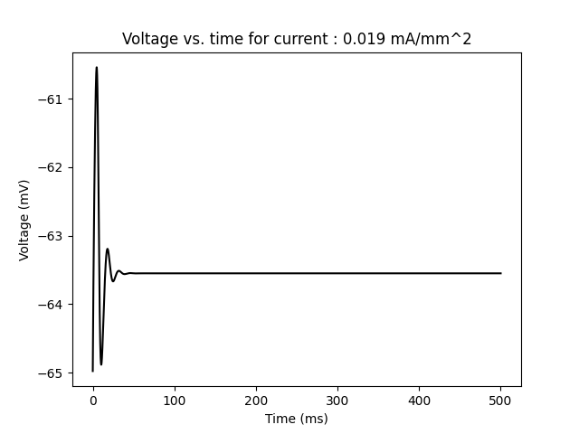

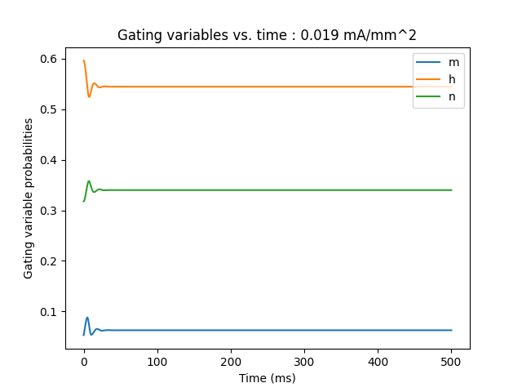

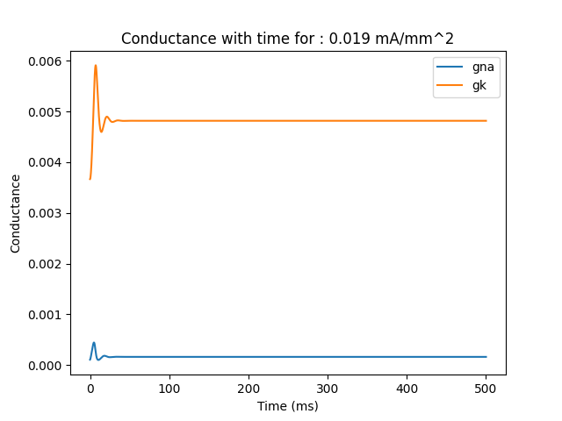

**Figure 2**: Voltage vs. time; Gating Variables vs. time; Conductance vs. time for I < I1

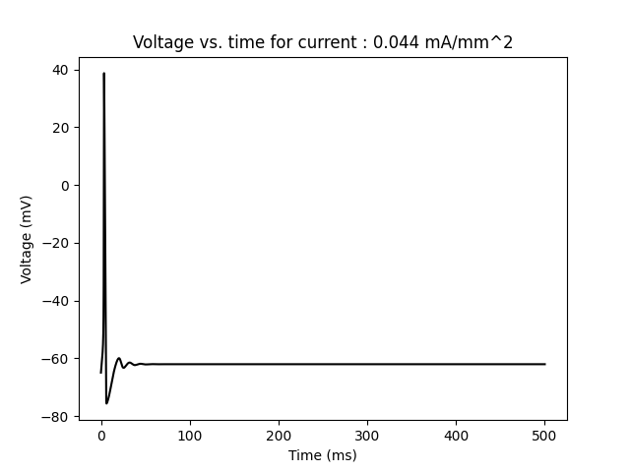

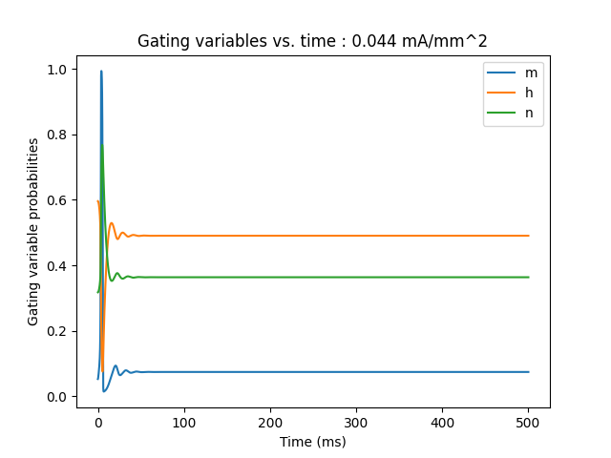

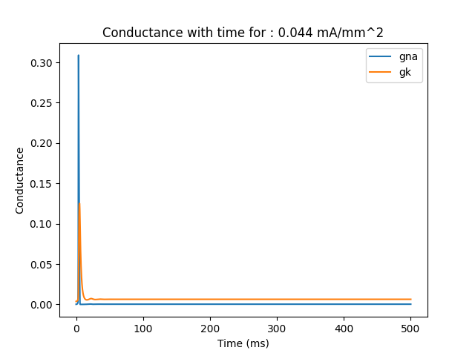

**Figure 3**: Voltage vs. time; Gating Variables vs. time; Conductance vs. time for I < I2

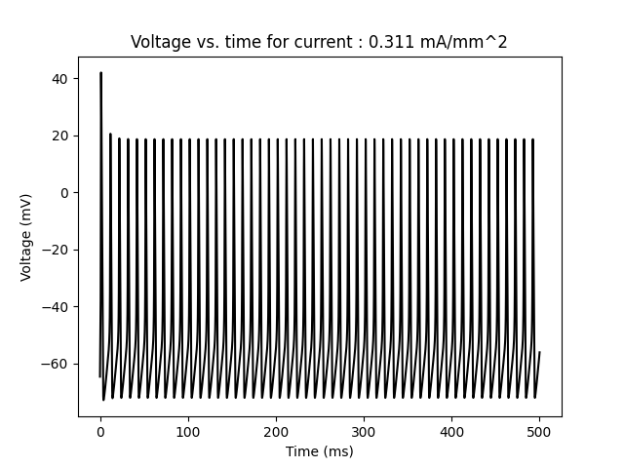

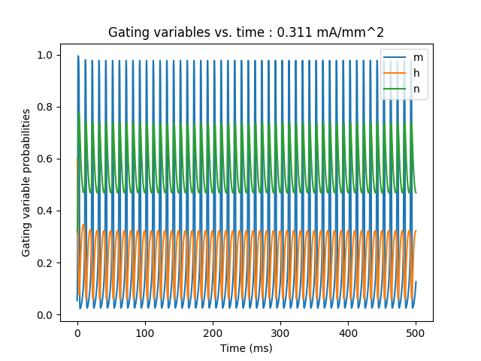

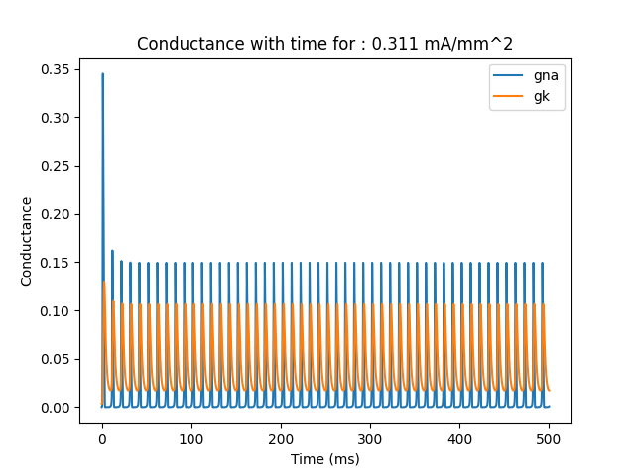

**Figure 4**: Voltage vs. time; Gating Variables vs. time; Conductance vs. time for I < I3

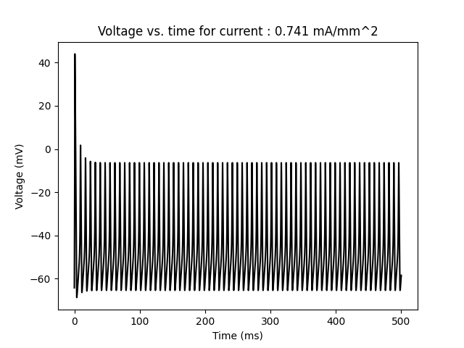

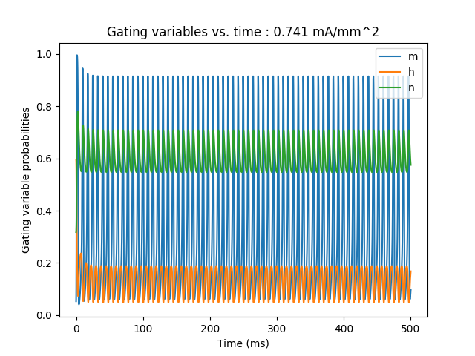

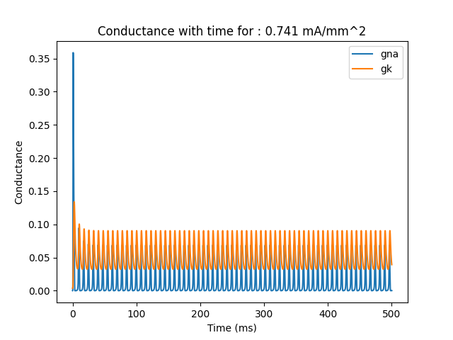

**Figure 5**: Voltage vs. time; Gating Variables vs. time; Conductance vs. time for I > I3