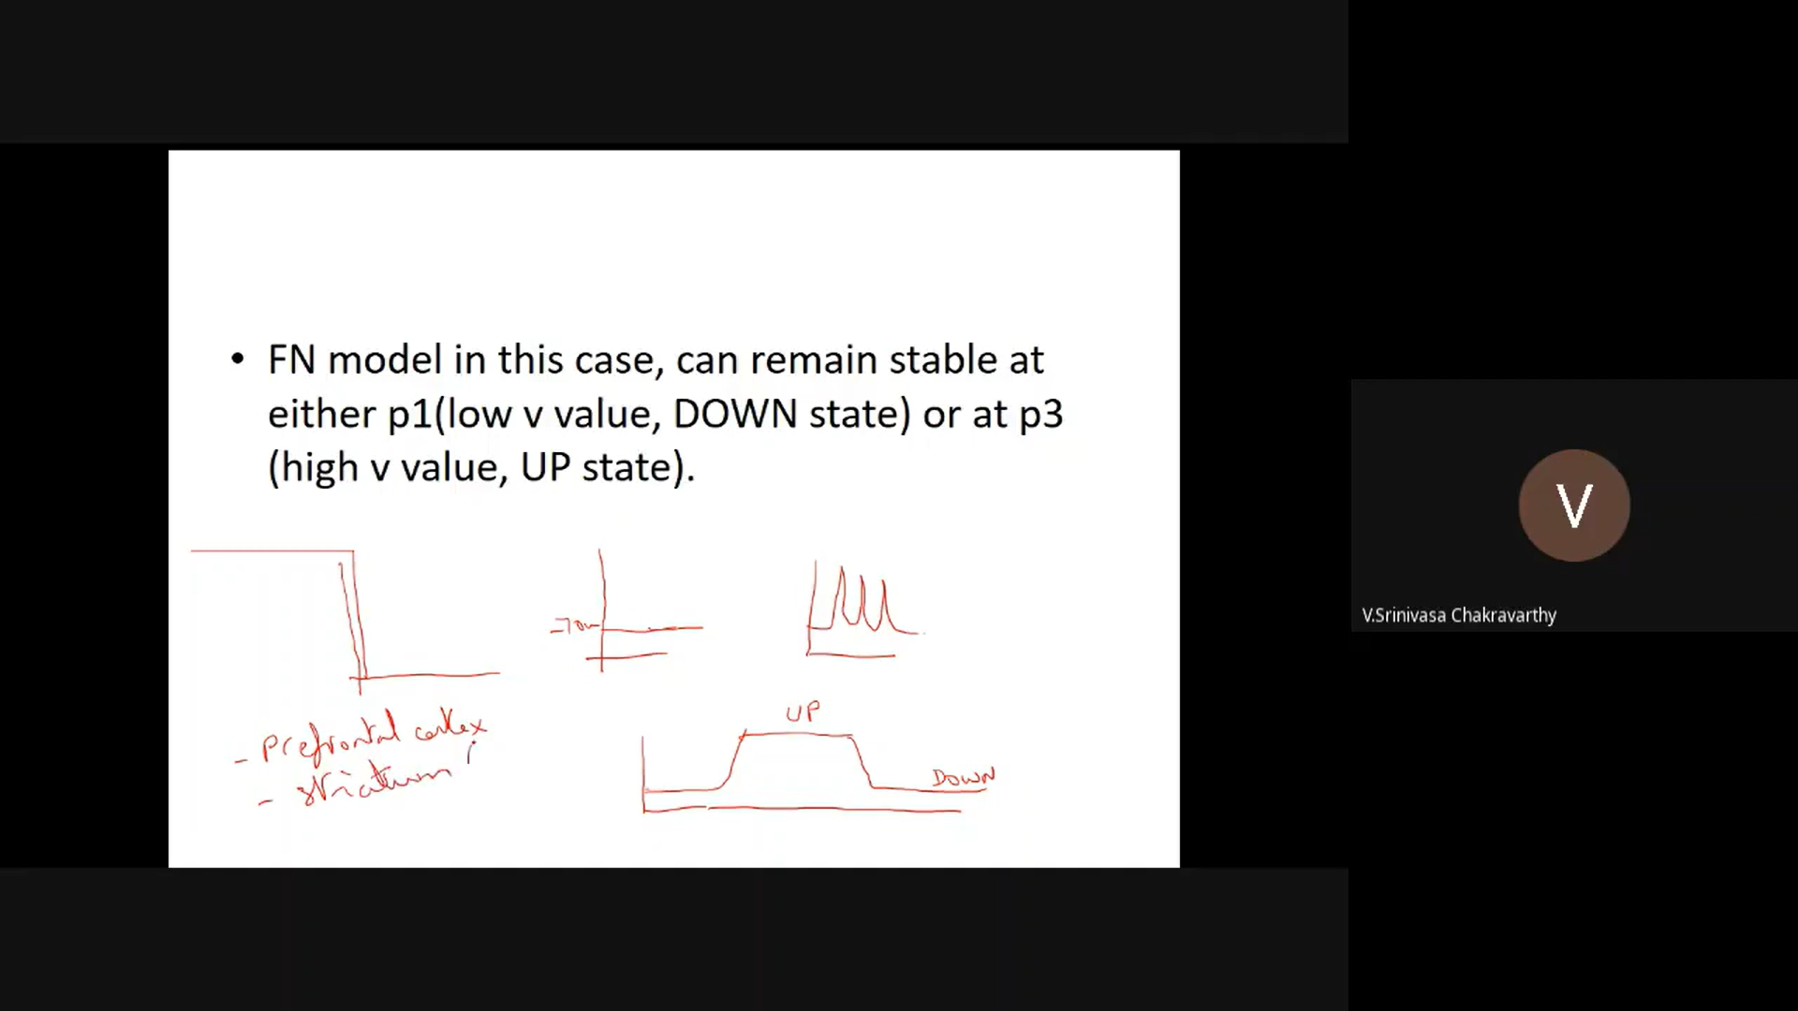

Capable in holding in memory ,straitum(Sub corticle structure)

Can latch the voltage values , hence used as memory devices.

HH-->FN-->ML

Healthy neuron the resting potiential is negative

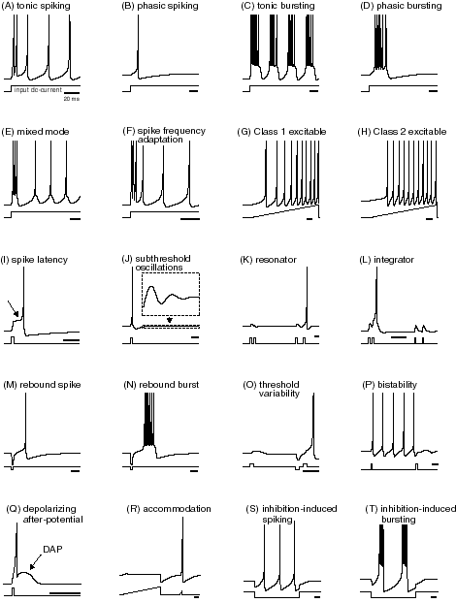

Resetting step makes the system highly non linear

Quadratic model

When I is small, frequency of firing becomes very small : Barely touching case (Crawling under the case )

Refractory period: Time taken by neuron to recharge

Assume Ninfitiniy value as given

No clear cut threshold

Gradual action potiential

V is inverted n

W is sigmoidal or straight line