**ATHARVA SHIRODE**

**2018140058**

**SE EXP 8:**

**PROTOTYPE**

**Smart Home Systems:**

CASE STUDY:

The aim of the product is to optimize utilisation of Power supply provided to the residents in a society or buildings. The residents will have an application both on Andriod and IOS operating system where they are supposed to login. The app would require name, mobile no. , email and flat number of the respective society or building residing in. The details entered will be verified especially regarding address i.e Flat number .The app is responsible for notifying the residents the ideal AC temperature ,fan speed to be maintained according to the temperature ,humidity & other factors outside. In addition to this app will also suggest the prescribed lighting levels inside

the flat according to light and sunshine outside. This is done using sensors which measure the factors outside and this respective readings will be provided as input to the server as an input. The server then processes this input and determines what ideal parameters should be set inside the residence. Daily limit can be set on the usage of electronic devices and alert signals can be sent on crossing the limit whereby residents can be prompted on minimizing consumption on daily basis. The app also provides features whereby the user can compare his power consumption between 2 months and will be provided with detailed analysis of power consumption by major electronic devices whereby its unnecessary use may be prevented and the bill for electricity would be minimum. The user can also utilize this platform for paying the bills using net banking or credit card. Additional feature of reporting any defect is also provided which would be rectified in future updates and hence assuring maintainability.

**DEMO:**

1. Login page for users

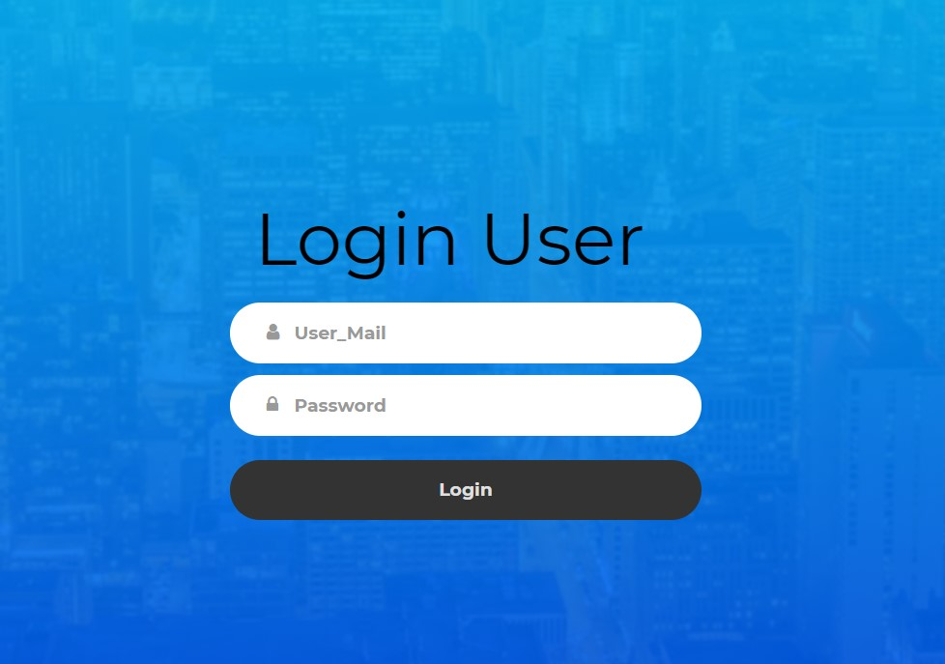

Authentication table for verified residents

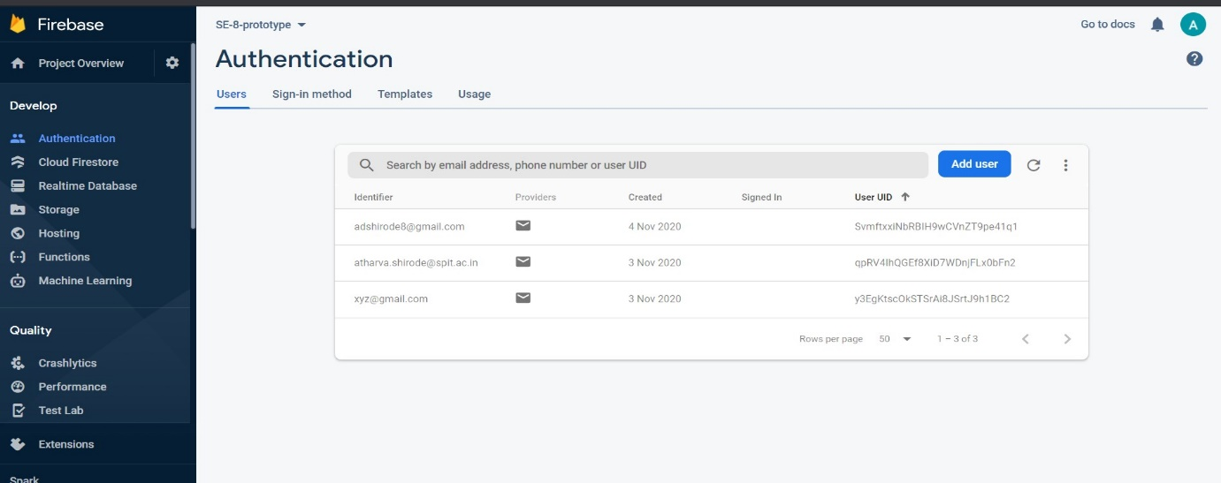

1. After Login User is directed to main page where he can use 4 functionalities.

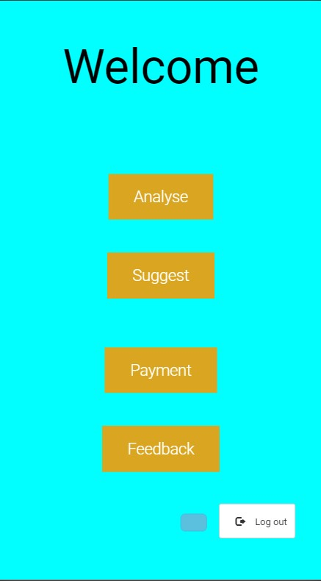

1. User can analyse his daily usage by giving input to the form .

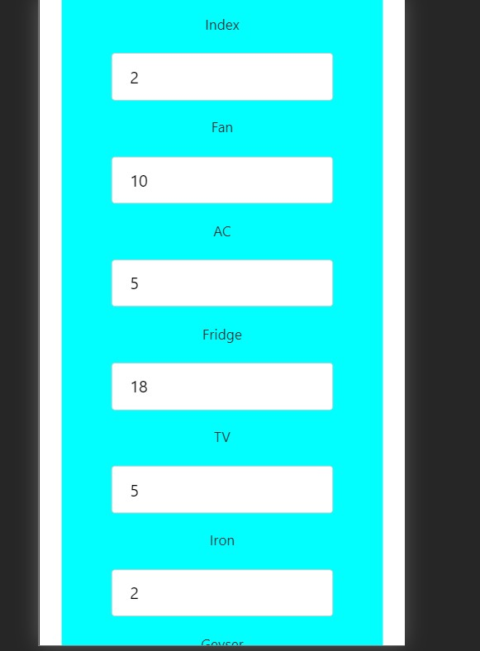

User will be provided with predicted Bill and Ideal case scenarios of comparison where by he can optimise consumption.

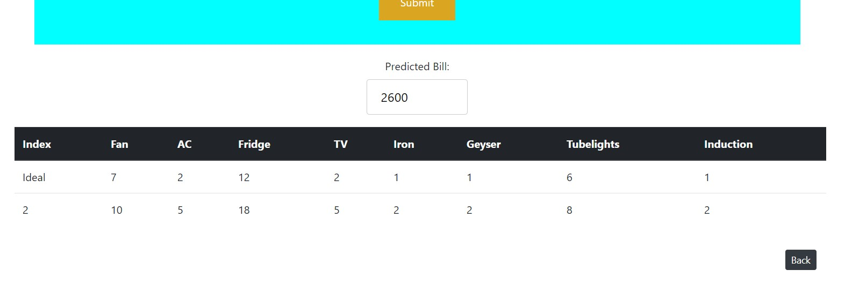

Entered field gets updated in firebase database and the fields entered and ideal fields are only displayed after submitting.

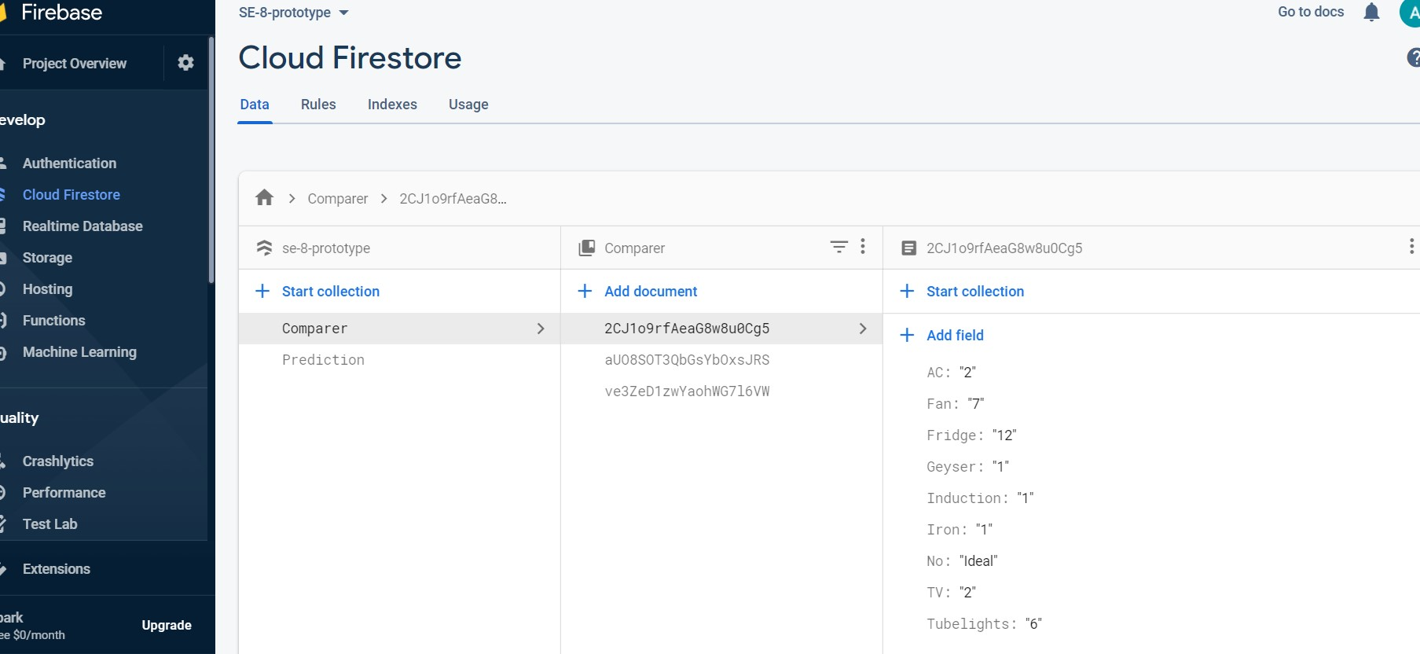

1. Users can get suggestions based on the current temperature.

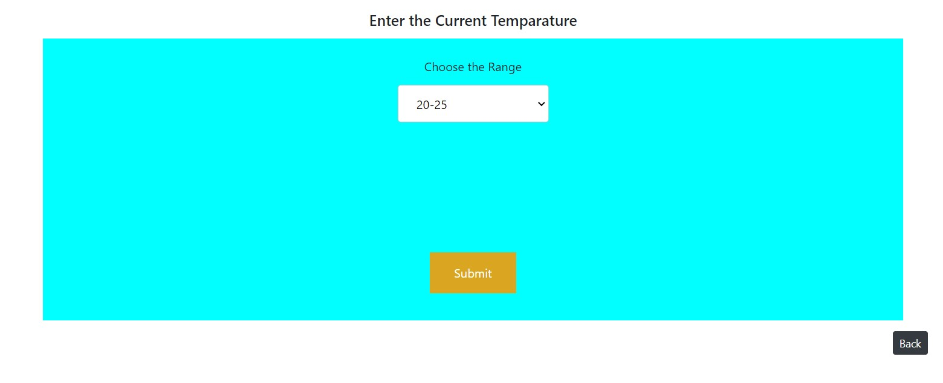

.

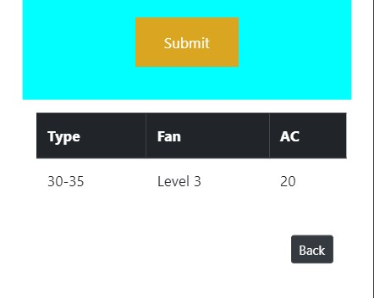

The suggestions are derived from the other collection in firebase database depending on the drop down selected.

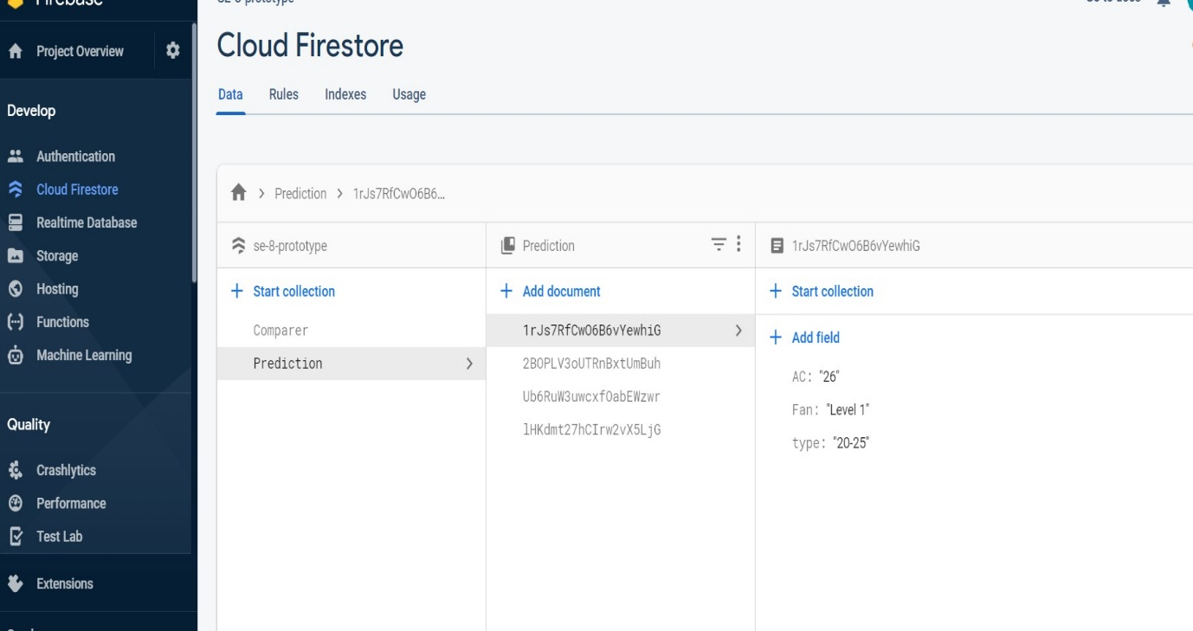

1. Based upon the predicted bill payment can be made to the service provider via some modes.

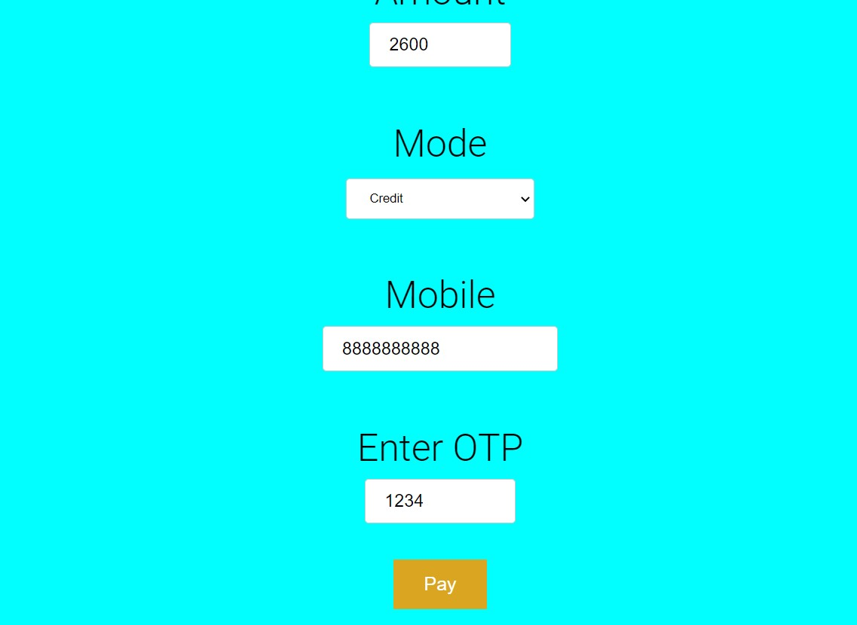

1. In case of any complaint or feedback or report user can submit his reviews or opinion.

