Task 1: Project Planning

Project Title: EduTrack Pro - Advanced Student Management System
Project Objective: To provide a robust, interactive web interface for educators to comprehensively manage, edit, and track student records with persistent data storage.
Target Users: Teachers, School Administrators, and Educational Staff.
Main Features:
- Add new students with strict form validation.
- Edit and update existing student records.
- Persistent data storage using browser Local Storage.
- Real-time search and filter functionality.
- Sort students alphabetically by name.
- Dynamic statistics showing the total student count.
- Interactive Dark Mode theme toggle.
Technologies Used: HTML5, CSS3, JavaScript (Vanilla, ES6+).
Brief Description: EduTrack Pro is a feature-rich front-end application that leverages advanced JavaScript DOM manipulation, Array methods, and Local Storage. It allows users to perform full CRUD (Create, Read, Update, Delete) operations on student objects while maintaining state across browser sessions.

Task 6: Project Documentation & Reflection

Project Overview: EduTrack Pro is an advanced, interactive Student Management System built to handle complete CRUD (Create, Read, Update, Delete) operations. It provides educational administrators with a seamless interface to manage student records, with the added benefit of persistent data storage so no information is lost when the browser is closed or refreshed.
Features Implemented:
- CRUD Functionality: Users can add new students, view them in a dynamic grid, edit existing details, and delete records safely with confirmation prompts.
- Persistent Data: Integration with the browser's localStorage ensures data is saved across sessions.
- Advanced Filtering & Sorting: Real-time search functionality by name and an alphabetical (A-Z) sorting toggle.
- Dynamic Statistics: A live counter displays the total number of enrolled students.
- UI Enhancements: A fully functional Dark/Light mode theme toggle using CSS variables.
Technologies Used:
- HTML5: Semantic structure and form inputs.
- CSS3: CSS Grid/Flexbox for responsiveness and CSS Variables (:root) for the dark mode theme toggle.
- JavaScript (Vanilla ES6+): Core logic, state management, and DOM manipulation.
JavaScript Concepts Used: The project utilizes variables, arrow functions, template literals, and complex objects. Heavy emphasis was placed on Higher-Order Array methods (map, filter, sort, forEach). I also implemented the Web Storage API (localStorage & JSON.stringify/parse) and comprehensive Event Handling (submit, click, input).
Screenshots of the Project:
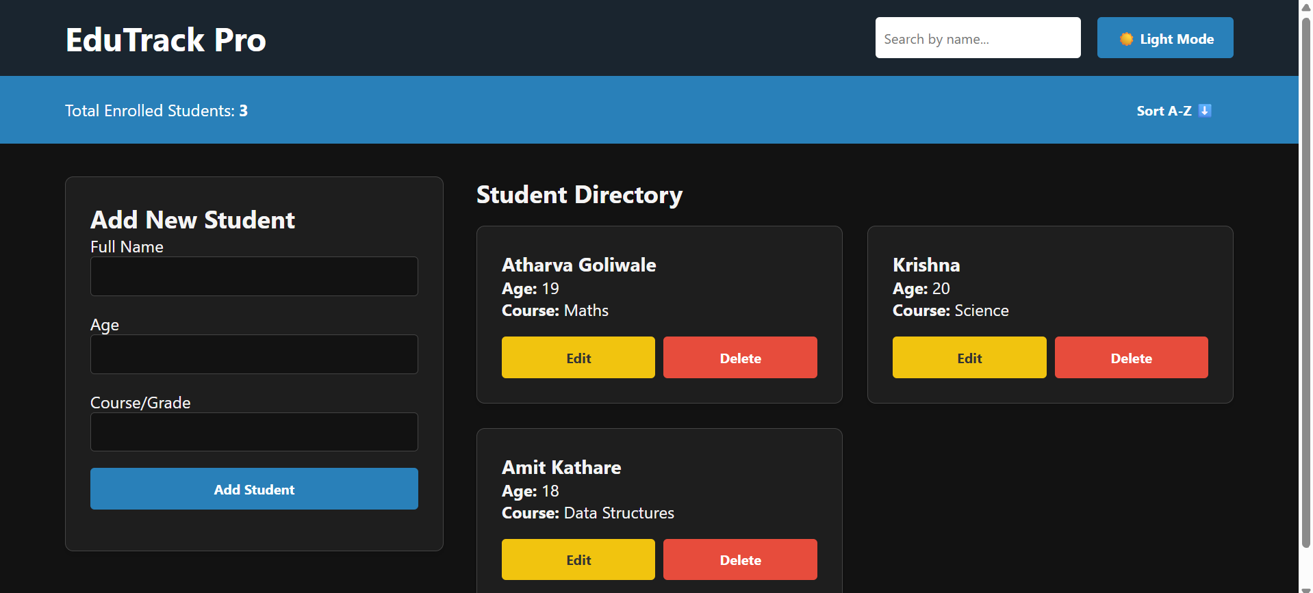

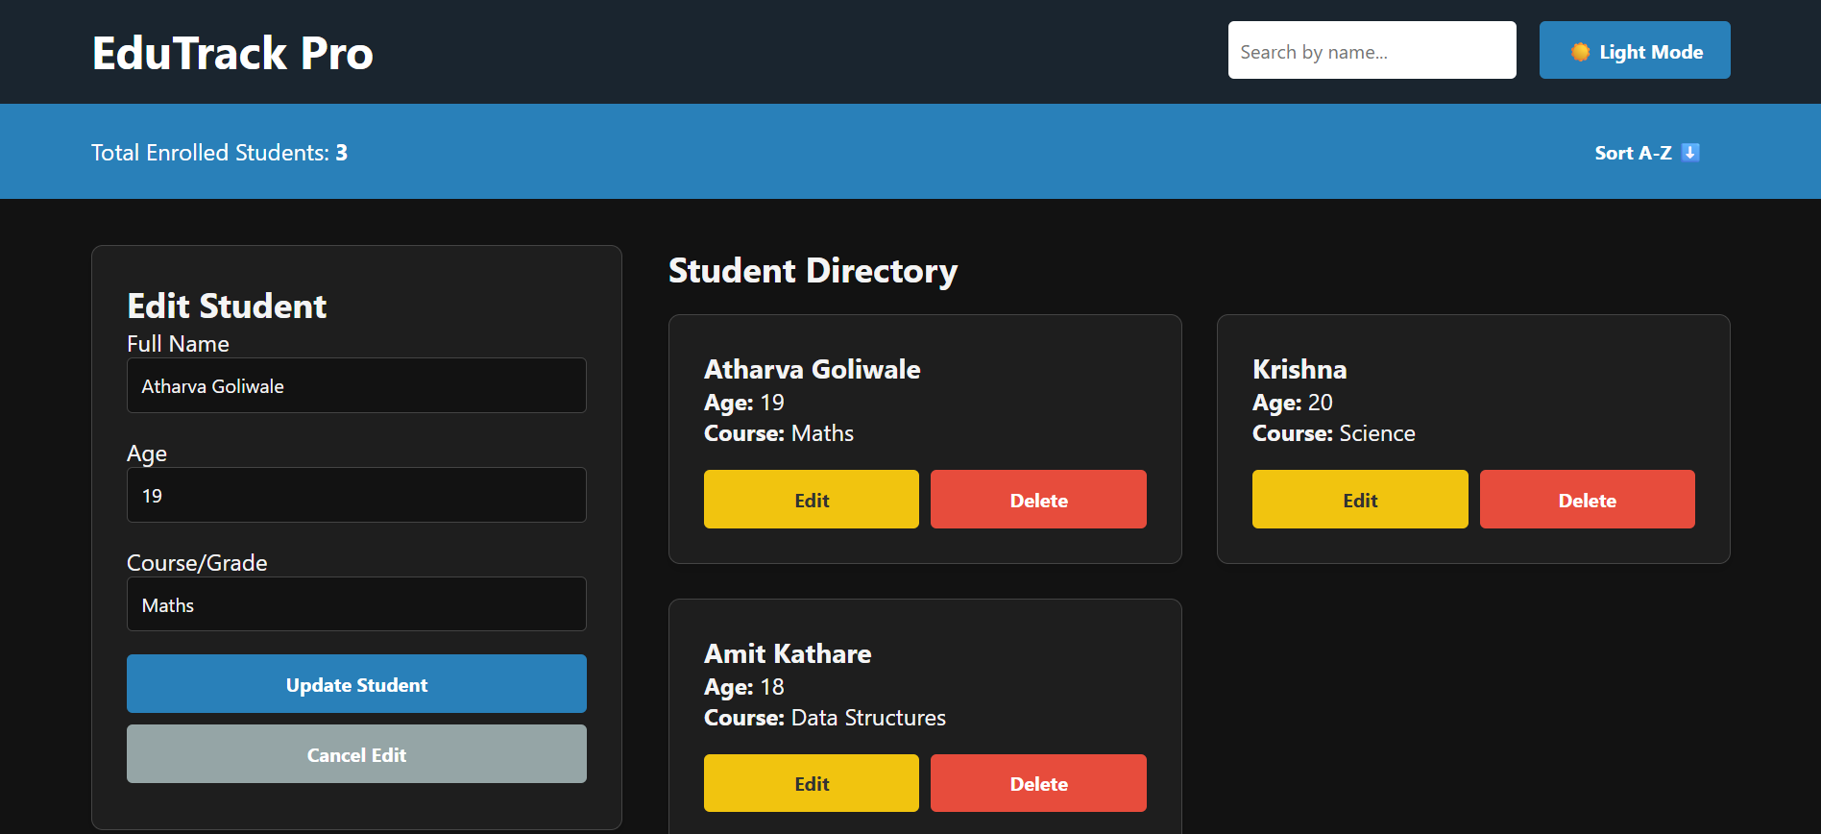
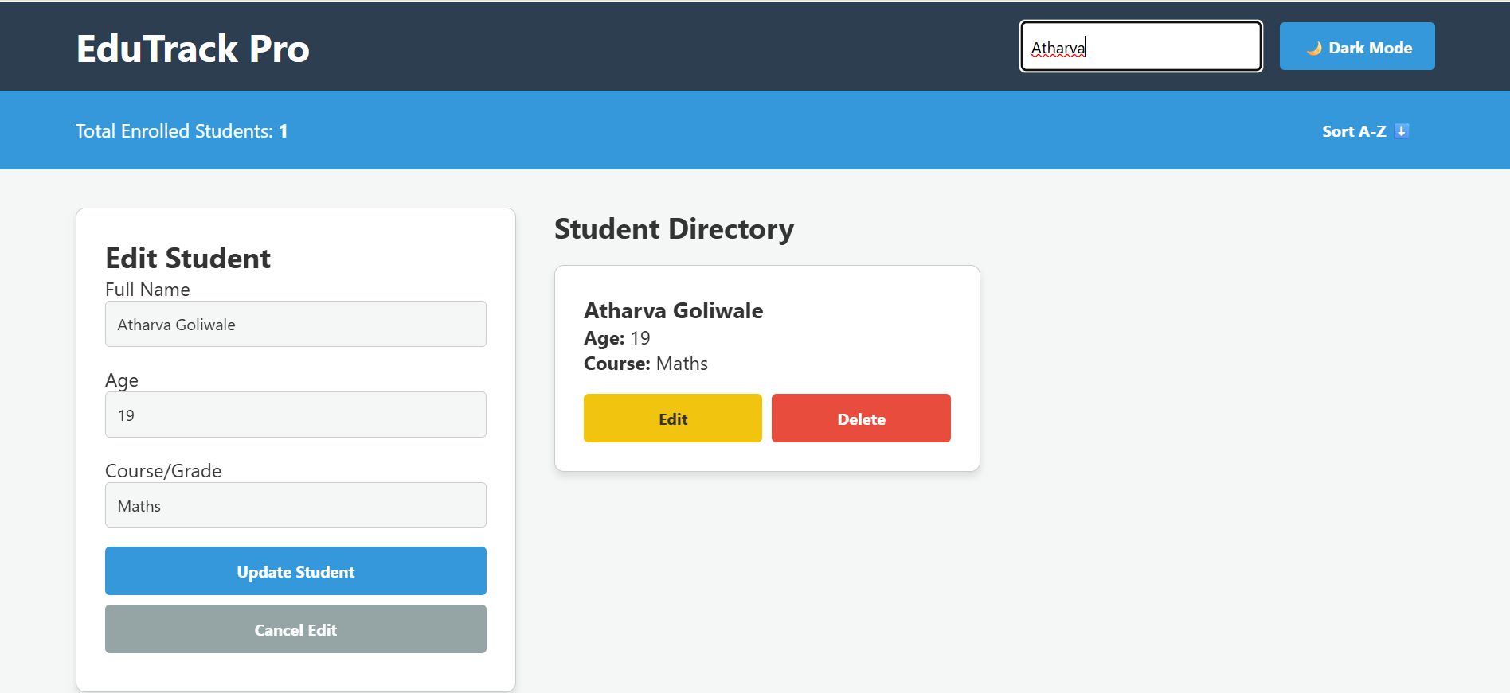

Challenges Faced: The main challenge was handling the "Edit" functionality without creating duplicate records. Initially, submitting an edited form pushed a brand-new object into the array instead of updating the existing one. Additionally, sorting the array directly altered the default order permanently.
Solutions Implemented: To fix the edit bug, I introduced a global editStudentId state variable. Upon form submission, the script checks if this ID exists; if so, it uses the .map() method to overwrite the specific object. For the sorting issue, I used the ES6 spread operator ([...students].sort()) to create a shallow copy, allowing the UI to toggle between sorted and original states without mutating the base data.
What You Learned: This project solidified my understanding of state management in Vanilla JavaScript. I learned how closely the data array (state) must mirror the DOM (UI) and how to leverage localStorage to build a production-ready, persistent application.
Future Improvements: In the future, I plan to add pagination for larger datasets, a feature to export the student list to a CSV file, and form validation using Regular Expressions (Regex) to ensure names contain no numbers.

