**ENG19CS0052**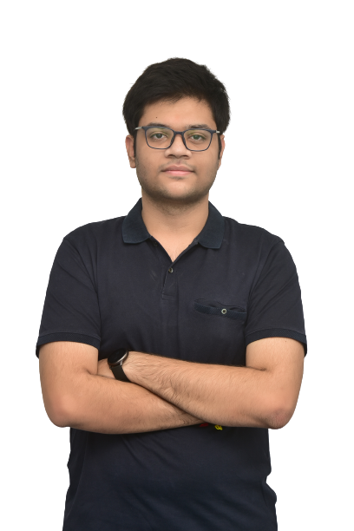

**Atharva Patil**

7349213845

atharva1051@gmail.com

[Personal Website](https://atharvapatil.super.site/)

[LinkedIn](https://www.linkedin.com/in/atharva-patil-766432191/)

University USN - ENG19CS0052

**Educational Qualifications**

| **Course Title** | **Institution** | **Percentage/CGPA** | **Year Of Passing** |
| --- | --- | --- | --- |
| B.Tech | Dayananda Sagar University | 7.65 till 6th Semester | 2023 Pursuing |
| 12th | Mahesh PU College | 92% | 2019 |
| 10th | Lourdes Central School | 10 CGPA | 2017 |

**Technical/Core Competencies**

C++, Python, Data Science, Software Engineering, Solidity, Blockchain, MySQL, Object Oriented Programming,Microsoft Excel, Powerpoint, Word, Git and GitHub

**Certifications  
*Introduction to Data Science in Python***University of Michigan offered by Coursera[Verify](https://coursera.org/verify/2W34LGZVCMQY)

**Job/Internship Experience**

***KIRA eSports*** April 2022 - June 2022 [Cover Letter](https://drive.google.com/file/d/1g2ync6dex2Jl8FKSN2UP1u3VrlIaxykt/view?usp=sharing)

Data Analyst Intern for a StartUp  
 Responsibilities : Cleaned, Analyzed Sales Data.  
 Gave insights on social media engagement.

**Projects**

***Auto-Correction of words using NLTK*** [Python]

Lead Developer / Project Owner

Developed an Application which would take in misspelled words from user and correct them using python and NLTK Library.

***Traffic Sign Classification*** Lead Developer / Project Owner

[Python,Data Science,TensorFlow,Numpy,Pandas,Keras]  
Created a convolution neural network containing two blocks.

Data Set Worked on : GTSRB German Traffic Sign Recognition Benchmark  
Accuracy : 92.49%

***Hangman Game using Python*** [Python]

Lead Developer / Project Owner

**Co-curricular Activities**

* Course on *Introduction to Data Science using Python by University of Michigan*
* Attended many Seminars on Personality Development, topics related to my studies.

**Extra-Curricular Activities**

* Played as professional eSports athlete for KIRA esports leading the team to #1 in entire South Asia
* Played for Tournaments in many colleges like MIT Manipal and KIIT Bhubaneswar
* Organized an Event for College.
* Traveled to hill stations and beaches and even did paragliding once.

**Personal Details**

Date of Birth : 10th May 2001

Father’s Name : Shrikant Patil

Mother’s Name : Jyoti Patil

Nationality : Indian

Languages : English, Hindi and Marathi

Address : 2B Arihant Vikram Nagar, Sethi Nagar, Ujjain, MP, 456010

**Date**  **:**

**Place : [Atharva Patil]**