**NAME: Saksham Pilane**

**ROLLNO: 72**

**DIV: E3**

**SRN: 202201962**

**AWTL LAB**

**Ass-3- Create a web page for any application using different HTML tags and apply CSS to it, create a form and add validation to it using AngularJS.**

**Source Code:**

**Feedback.html**

<!DOCTYPE html>

<html lang="en">

<head>

<meta charset="UTF-8">

<meta name="viewport" content="width=device-width, initial-scale=1.0">

<title>Feedback Form</title>

<style>

body {

font-family: Arial, sans-serif;

background-color: #f4f4f4;

margin: 0;

padding: 0;

}

.container {

max-width: 600px;

margin: 20px auto;

padding: 20px;

background-color: #fff;

border-radius: 5px;

box-shadow: 0 0 10px rgba(0, 0, 0, 0.1);

}

h1 {

text-align: center;

}

label {

display: block;

margin-bottom: 5px;

}

input[type="text"], textarea, input[type="submit"] {

width: 100%;

padding: 10px;

margin-bottom: 10px;

border: 1px solid #ccc;

border-radius: 3px;

}

textarea {

height: 150px;

}

input[type="submit"] {

background-color: #007bff;

color: #fff;

cursor: pointer;

}

input[type="submit"]:hover {

background-color: #0056b3;

}

.error {

color: red;

margin-top: 5px;

}

</style>

</head>

<body ng-app="feedbackApp">

<div class="container" ng-controller="feedbackController">

<h1>Feedback Form</h1>

<form name="feedbackForm" ng-submit="submitFeedback()" novalidate>

<label for="fullName">Full Name:</label>

<input type="text" id="fullName" name="fullName" ng-model="feedback.fullName" required>

<div class="error" ng-show="feedbackForm.fullName.$error.required && (feedbackForm.fullName.$dirty || feedbackForm.$submitted)">Full name is required.</div>

<label for="email">Email:</label>

<input type="email" id="email" name="email" ng-model="feedback.email" required>

<div class="error" ng-show="(feedbackForm.email.$error.required || feedbackForm.email.$error.email) && (feedbackForm.email.$dirty || feedbackForm.$submitted)">

<span ng-show="feedbackForm.email.$error.required">Email is required.</span>

<span ng-show="feedbackForm.email.$error.email">Invalid email address.</span>

</div>

<label for="message">Message:</label>

<textarea id="message" name="message" ng-model="feedback.message" required></textarea>

<div class="error" ng-show="feedbackForm.message.$error.required && (feedbackForm.message.$dirty || feedbackForm.$submitted)">Message is required.</div>

<input type="submit" value="Submit Feedback">

</form>

</div>

<!-- AngularJS Library -->

<script src="https://ajax.googleapis.com/ajax/libs/angularjs/1.8.2/angular.min.js"></script>

<script>

angular.module('feedbackApp', [])

.controller('feedbackController', function($scope, $window) {

$scope.submitFeedback = function() {

if ($scope.feedbackForm.$invalid) {

var errorMessage = "Please fill out all required fields correctly:\n";

if ($scope.feedbackForm.fullName.$error.required) {

errorMessage += "- Full Name is required.\n";

}

if ($scope.feedbackForm.email.$error.required) {

errorMessage += "- Email is required.\n";

} else if ($scope.feedbackForm.email.$error.email) {

errorMessage += "- Invalid email address.\n";

}

if ($scope.feedbackForm.message.$error.required) {

errorMessage += "- Message is required.\n";

}

$window.alert(errorMessage);

} else {

// Logic to submit feedback goes here

$window.alert('Feedback submitted successfully!');

// Clear form fields after submission

$scope.feedback = {};

$scope.feedbackForm.$setPristine();

}

};

});

</script>

</body>

</html>

**OUTPUT:**

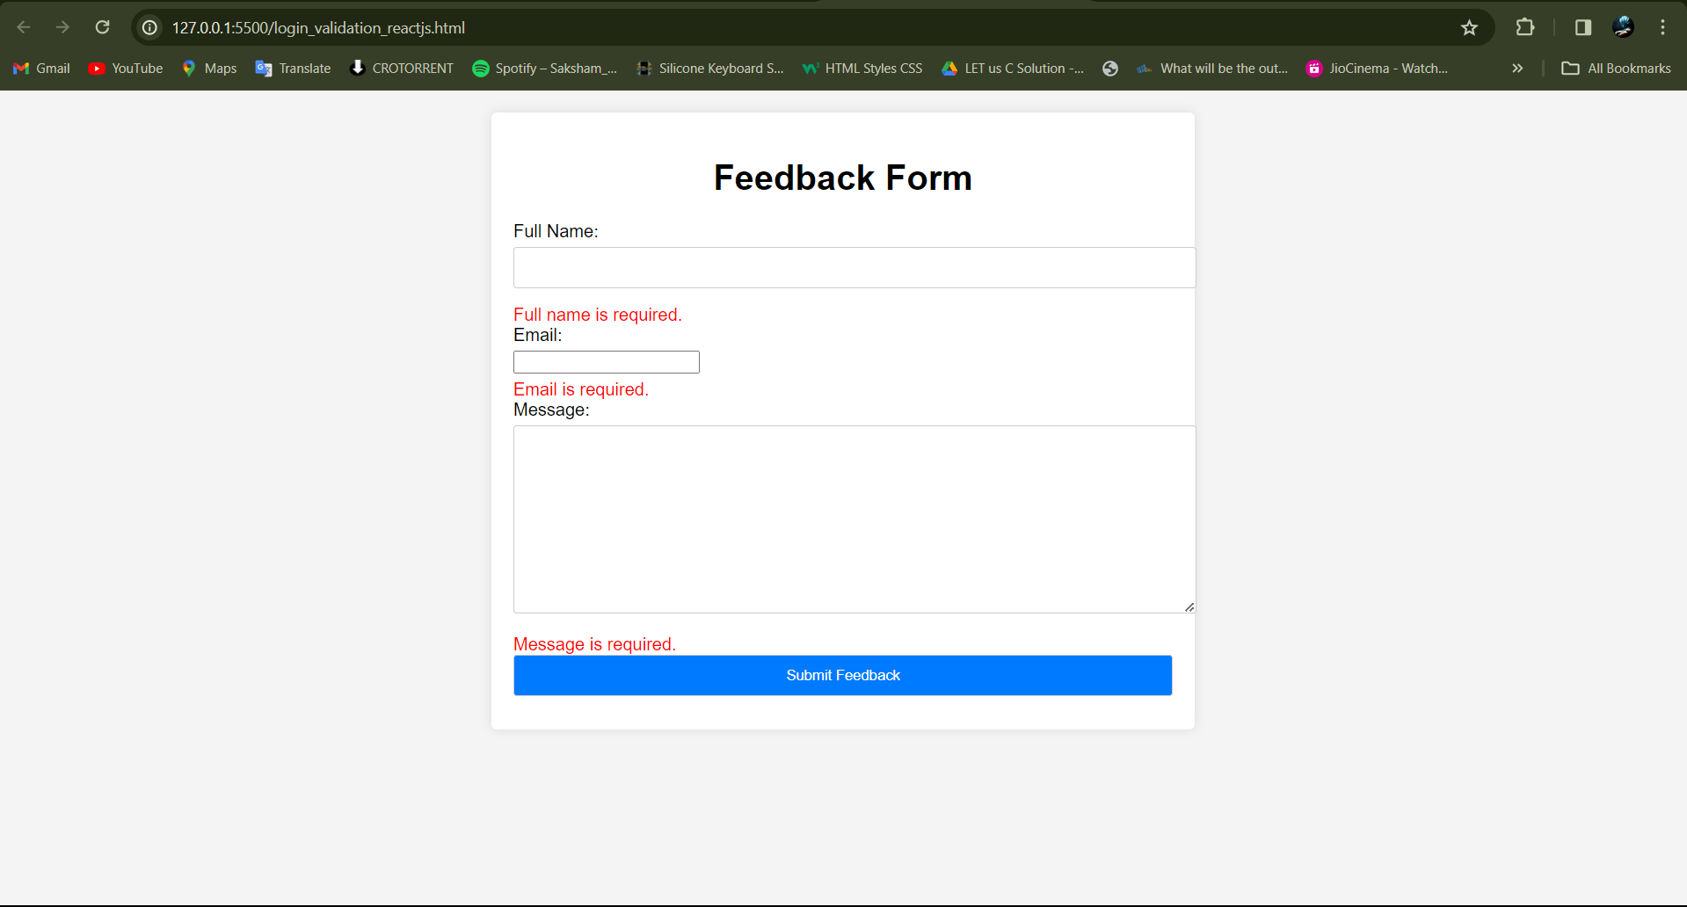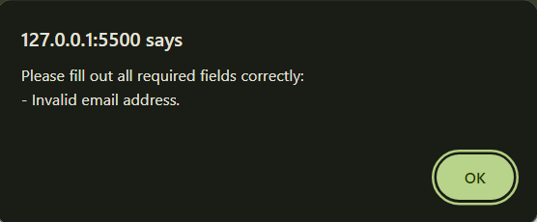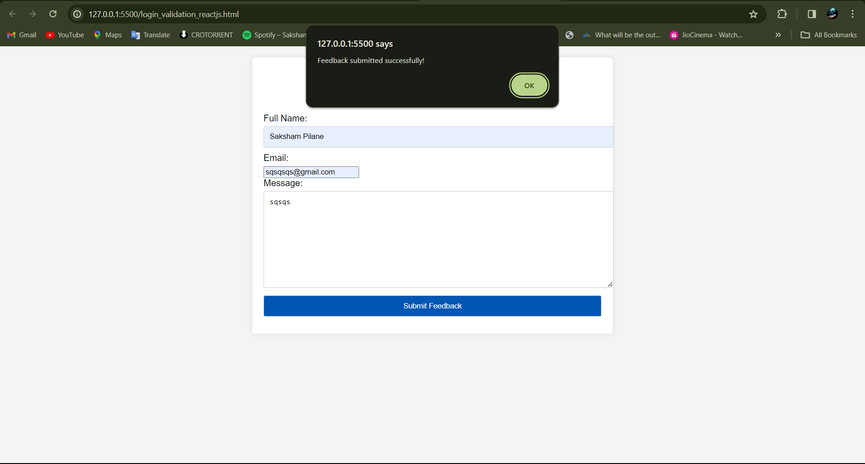

**Explanation:**

**HTML Structure:**

The HTML structure defines a simple feedback form with fields for full name, email, and message .Each field has an associated error message container that will be displayed if there's an error in the field.

**AngularJS Application Setup:**

We define an AngularJS module named feedbackApp .Inside the module, we define a controller named feedbackController .We inject $scope and $window into the controller. $window is an AngularJS service that provides a reference to the browser's window object.

**Form Submission Logic:**

The submitFeedback() function is defined on the scope. It's called when the form is submitted. Inside this function, we check if the form is invalid using $scope.feedbackForm.$invalid. If it is, it means there are validation errors. If there are validation errors, we construct an error message string that includes all the validation errors for each field. We then use $window.alert() to display this error message in an alert dialog. If the form is valid, we display a success message using $window.alert() and clear the form fields by resetting the $scope.feedback object and setting the form's $pristine state.

**Error Message Display:**

Error messages for each field are displayed conditionally using AngularJS's ng-show directive. These directives evaluate expressions that determine whether to display the error message. For example, ng-show="feedbackForm.fullName.$error.required && (feedbackForm.fullName.$dirty || feedbackForm.$submitted)" displays the error message for the full name field if it's required and either the field has been interacted with ($dirty) or the form has been submitted ($submitted). Similar expressions are used for email and message fields.

**Form Validation:**

Form validation is done using HTML5 required attribute for mandatory fields and type="email" for email validation. AngularJS automatically adds classes and properties to form elements based on their validation state, which we use to display error messages dynamically.