**Experiment 1**

Atharva Prabhu

D15A 43

1. Open AWS Academia and select launch instance

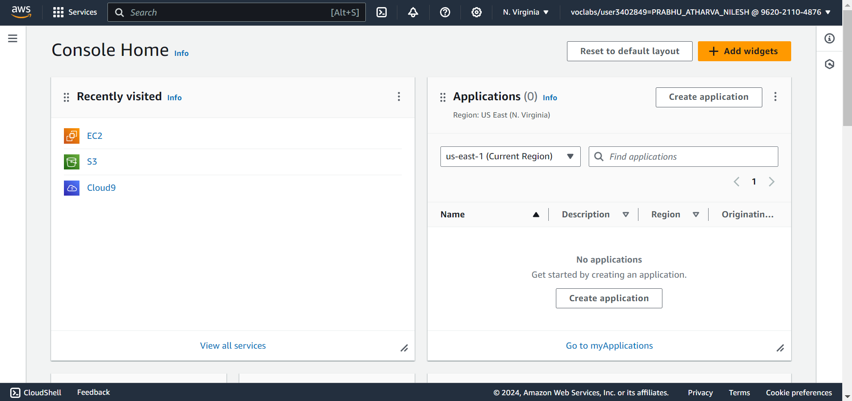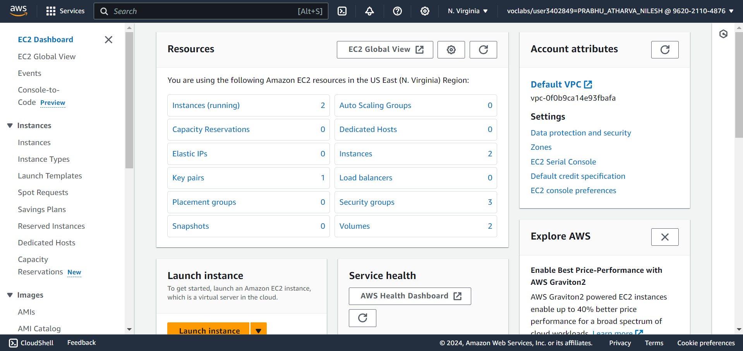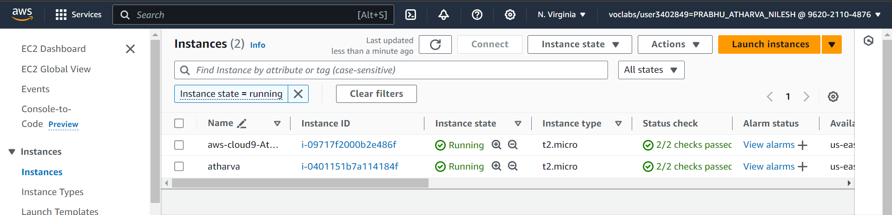

2. Execute the following commands in the aws console.

Commands :

sudo su

sudo apt install

sudo apt-get update

apt install apache2

systemctl status apache2

cd /var/www/html/

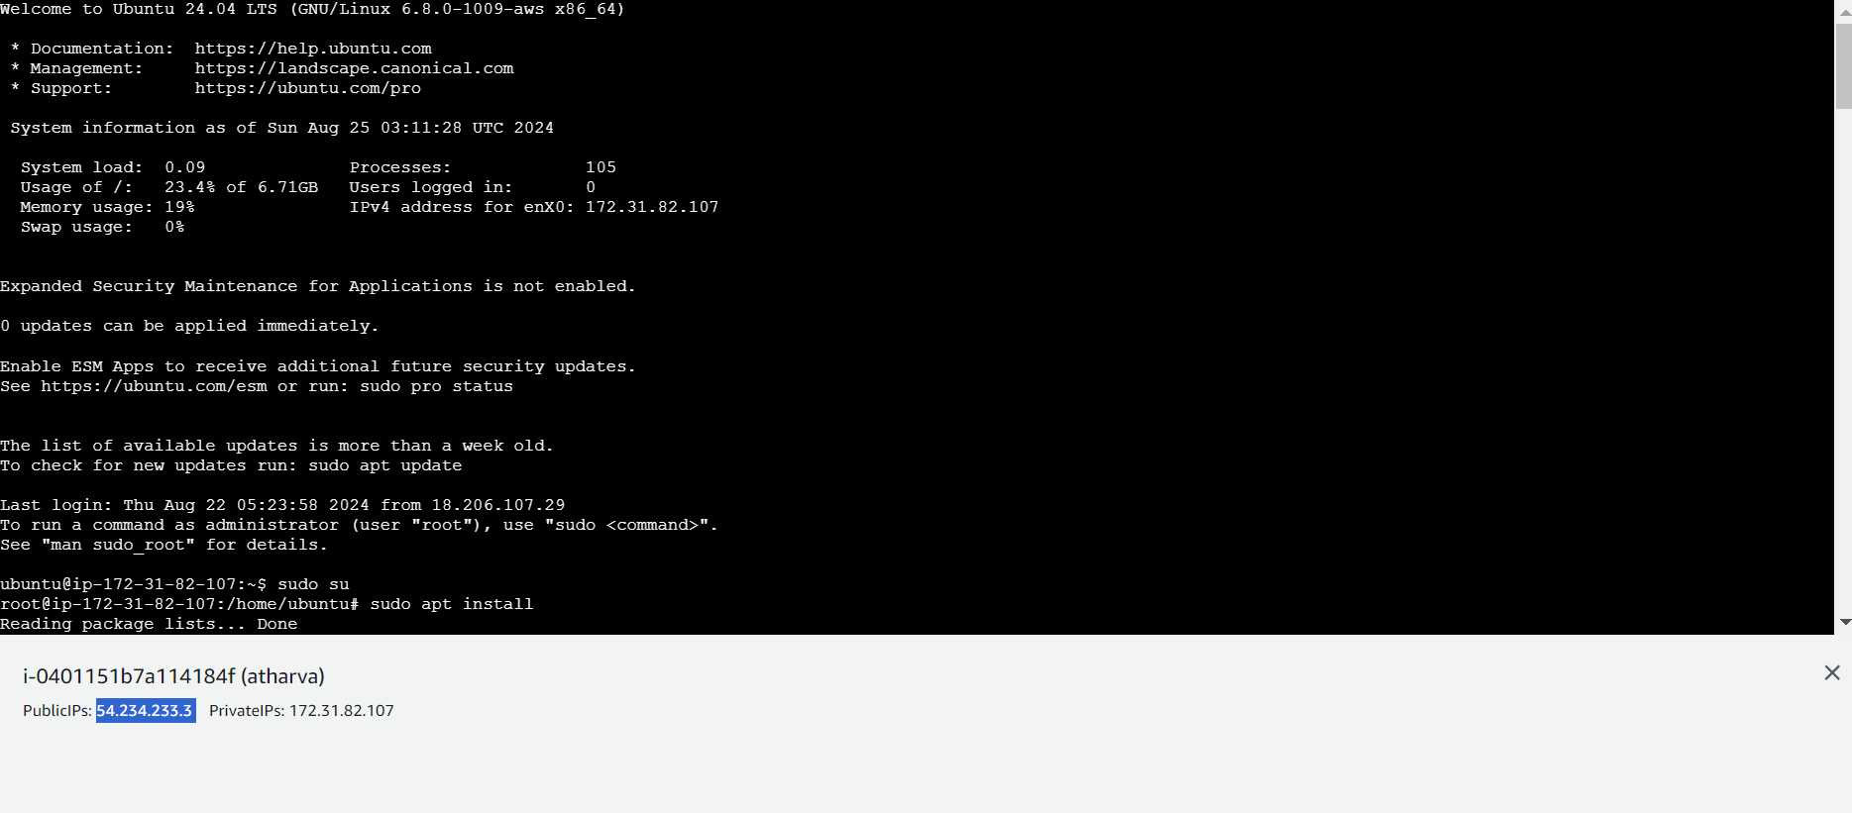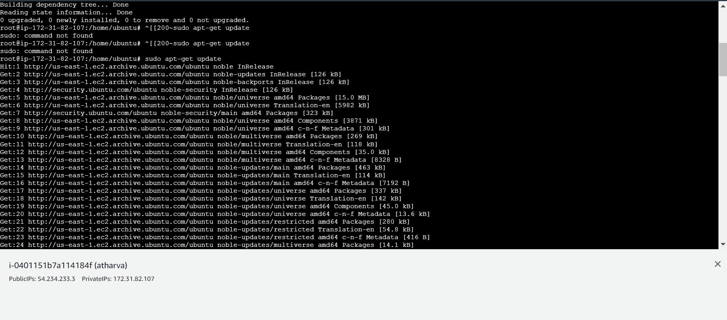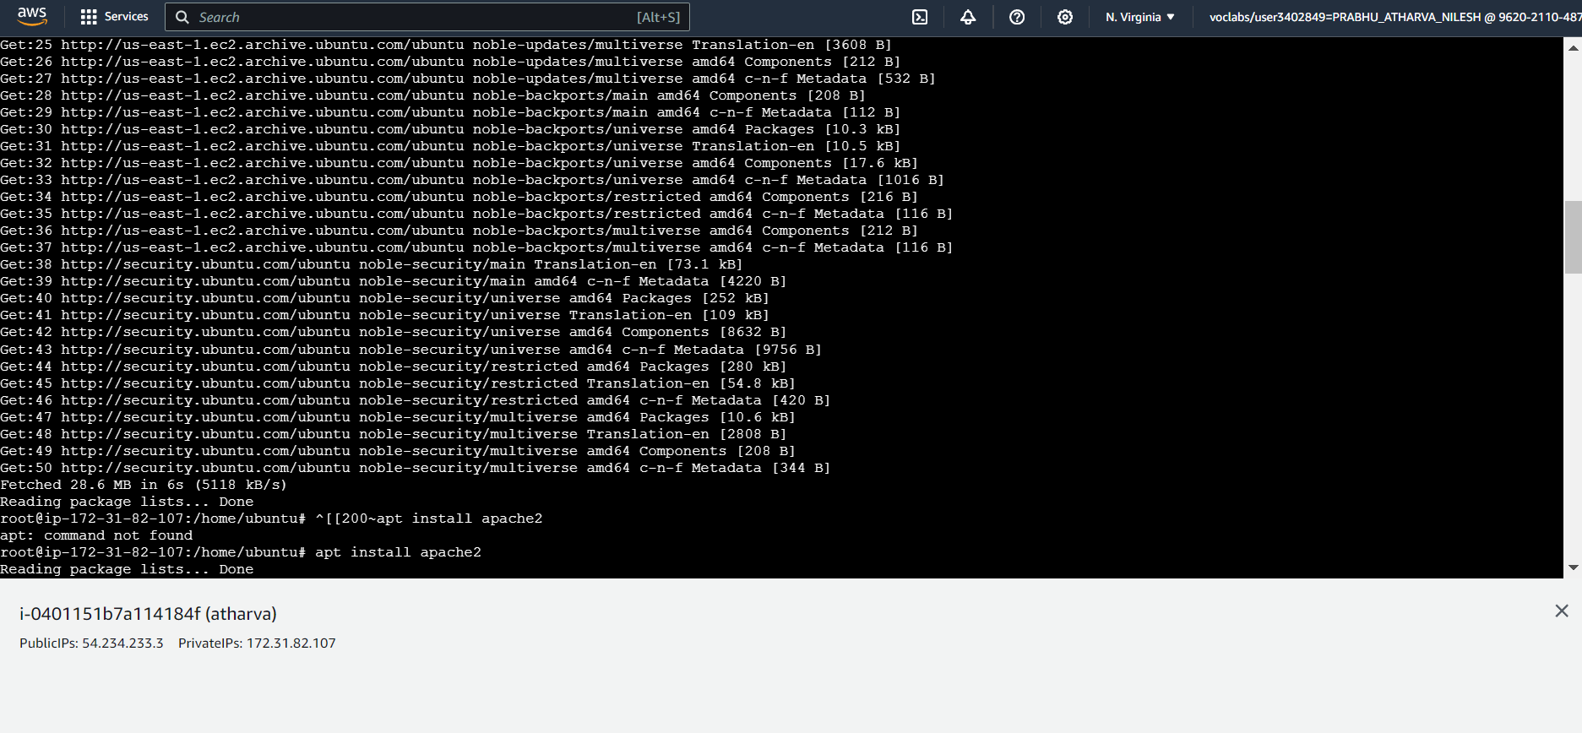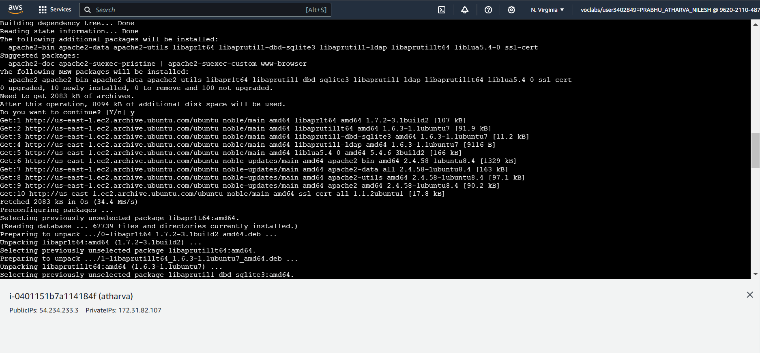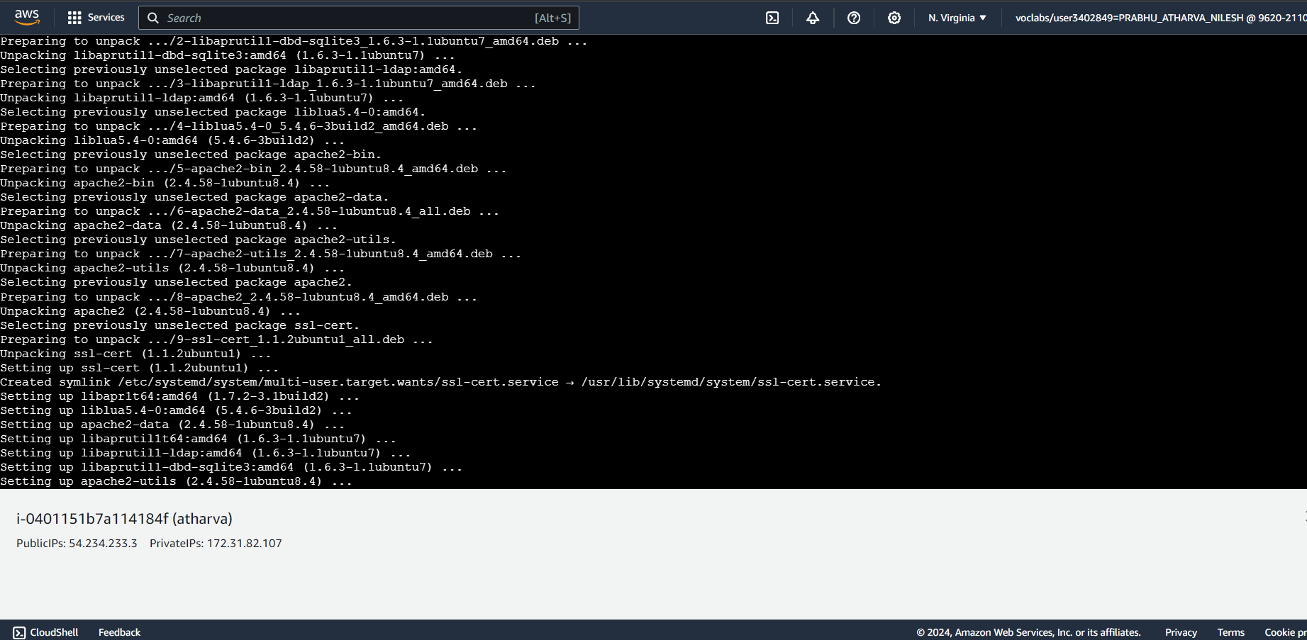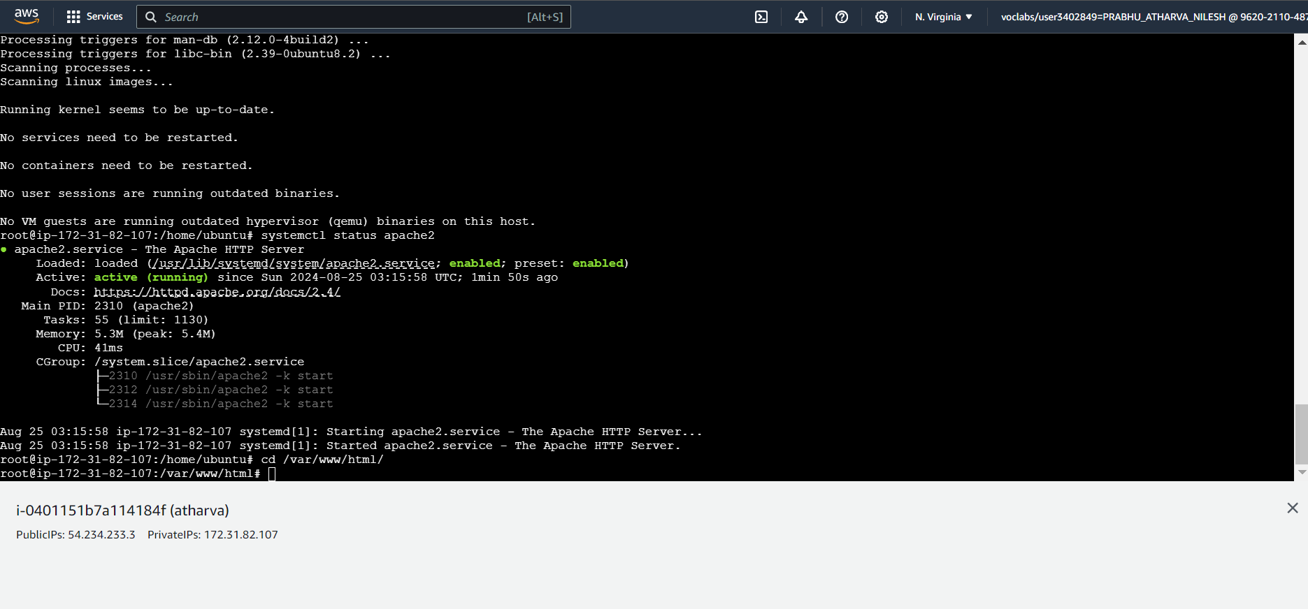

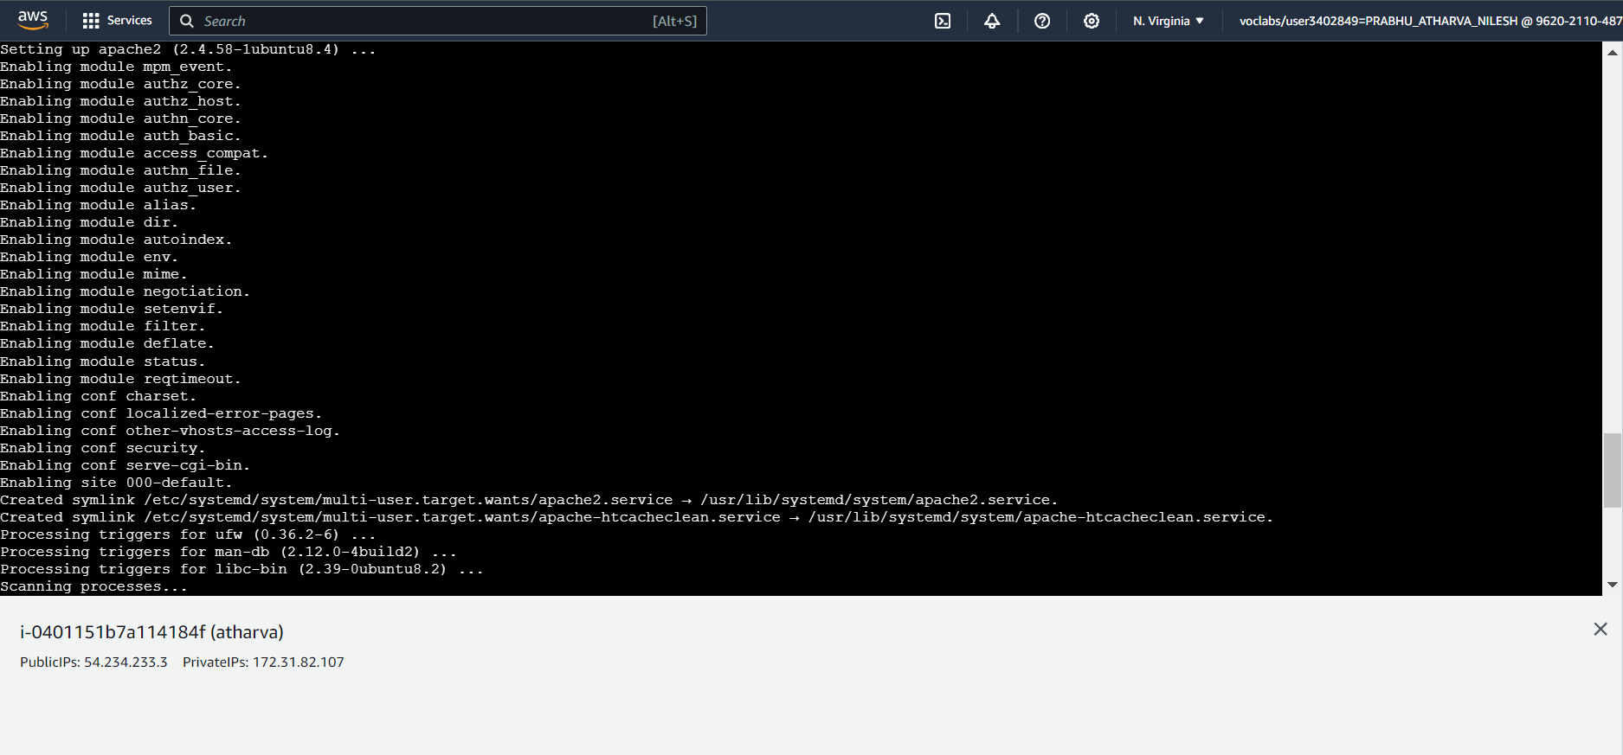

3.Edit the inbound and outbound rules.

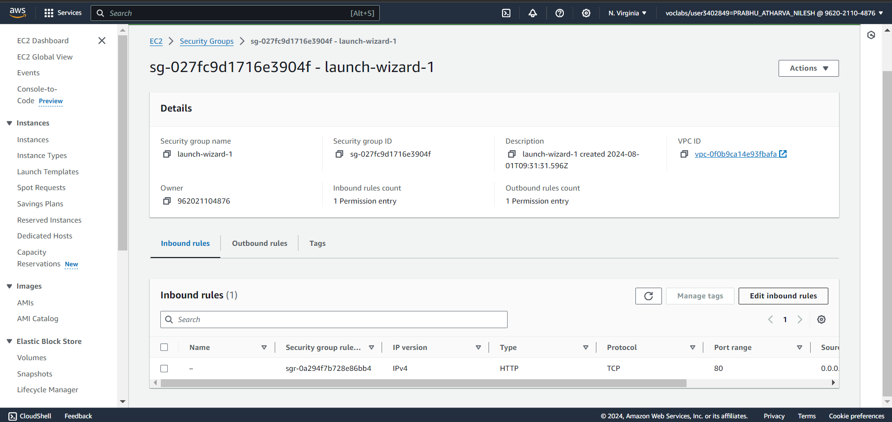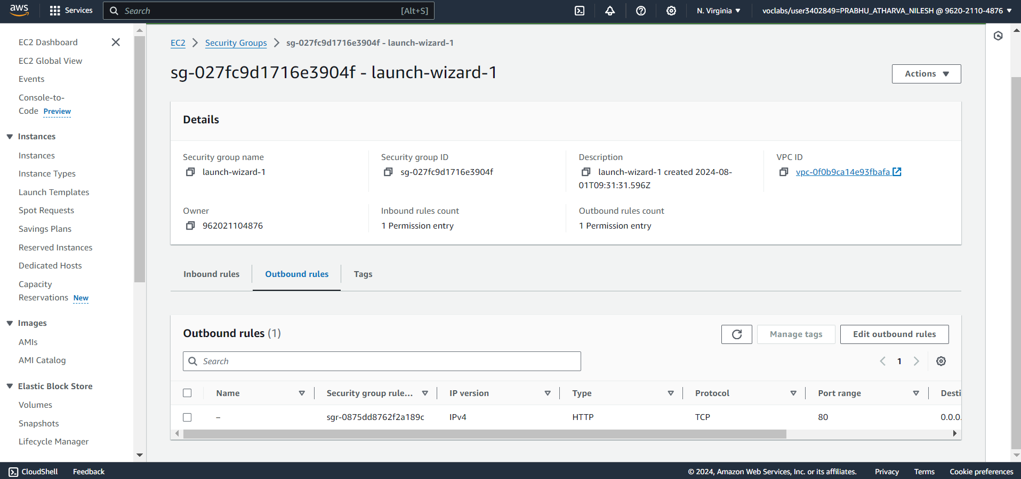

4. This is the hosted Static Website.

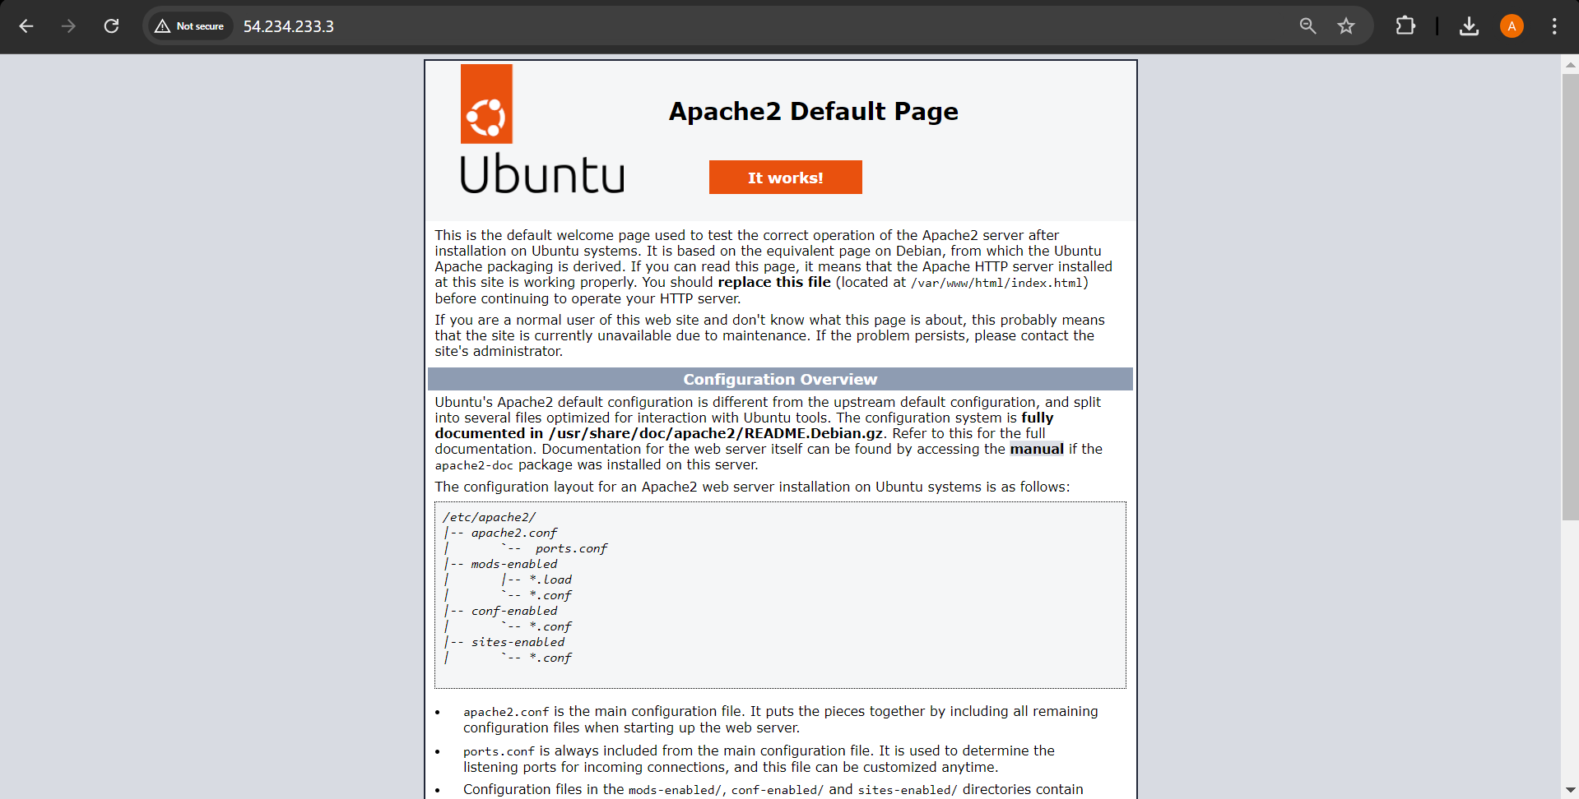

**Static Site Hosting using S3 bucket**

1. Visit S3 under the developer tools and create a Bucket.Click on the Edit Static Website Hosting under the properties tab

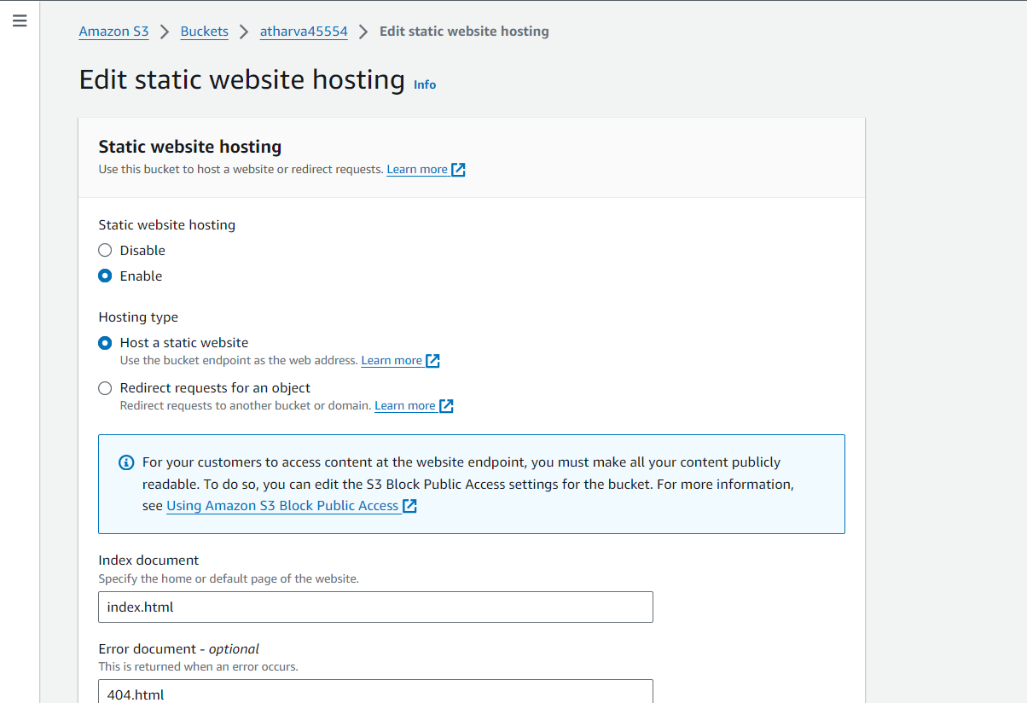

2. Upload a file

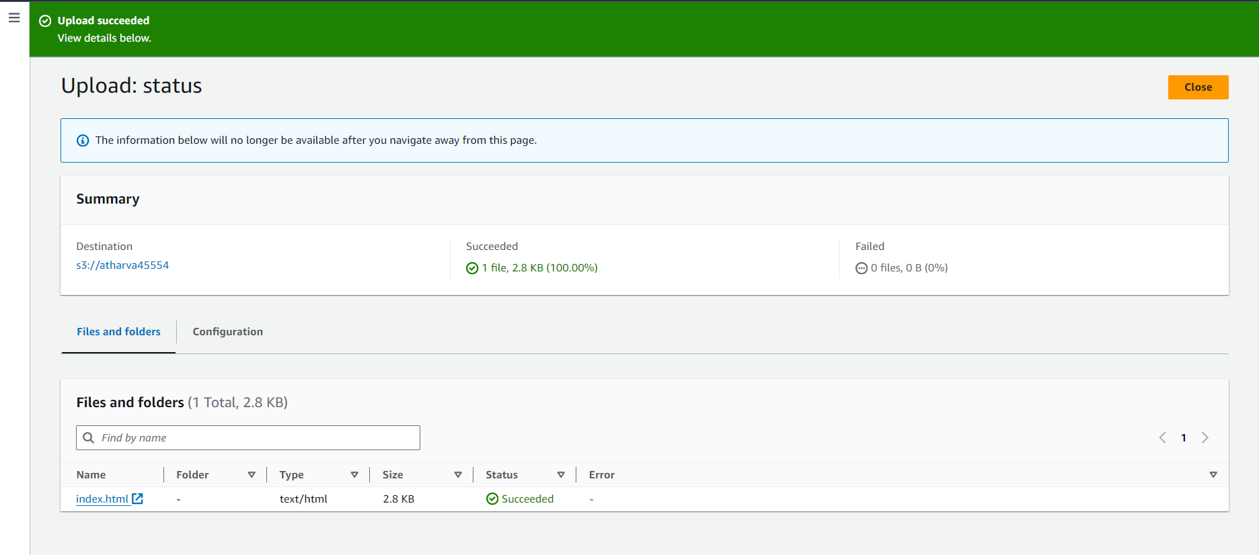

3. Click on the Edit block public access under the Permissions tab

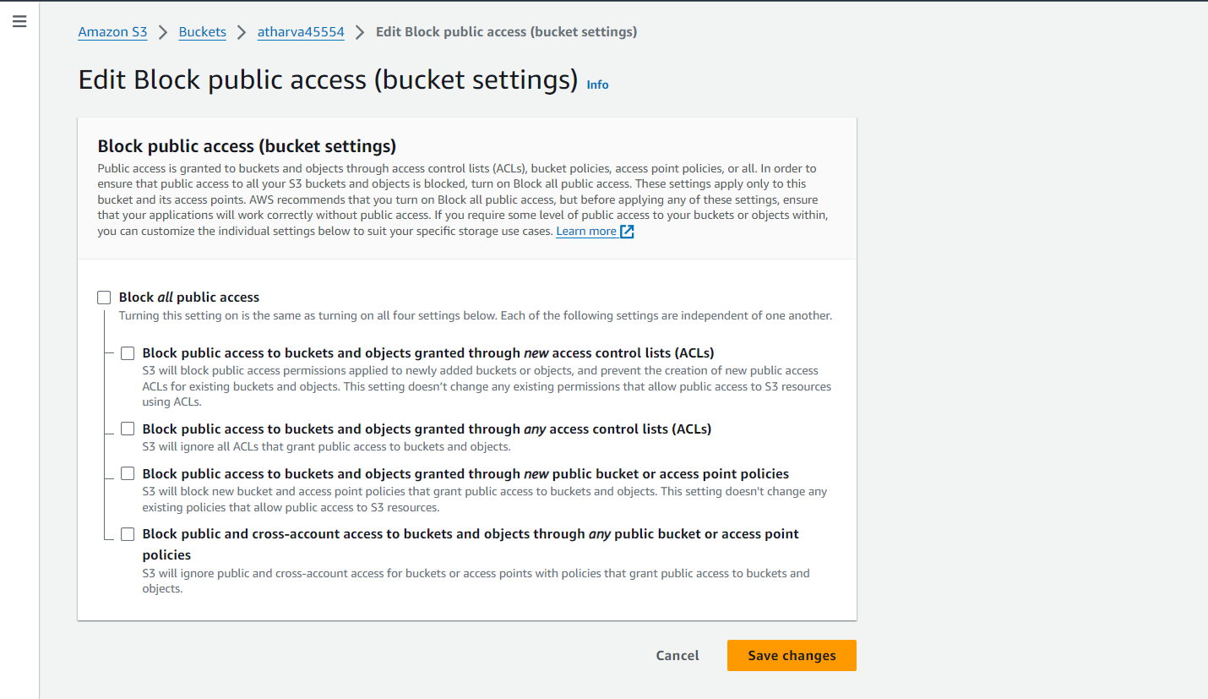

4. Click on Object Ownership under Permission Tab

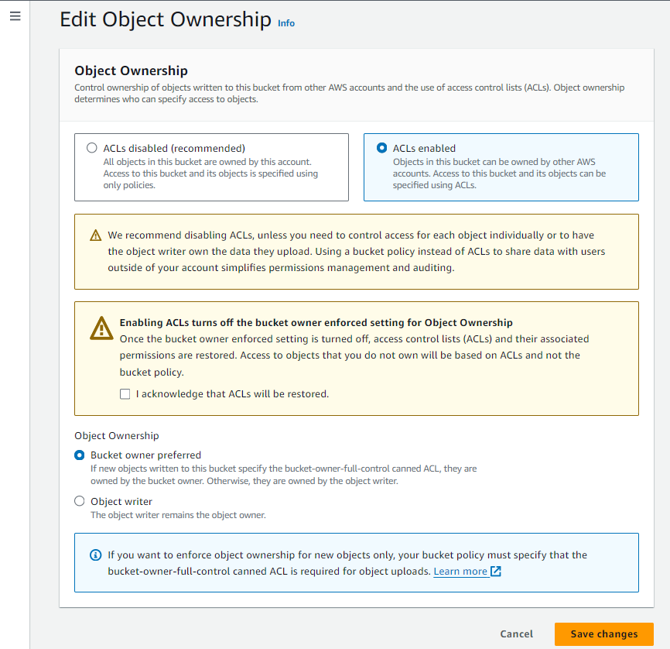

5. Select the file and click on Actions and select the option Make Public using ACL from the dropdown

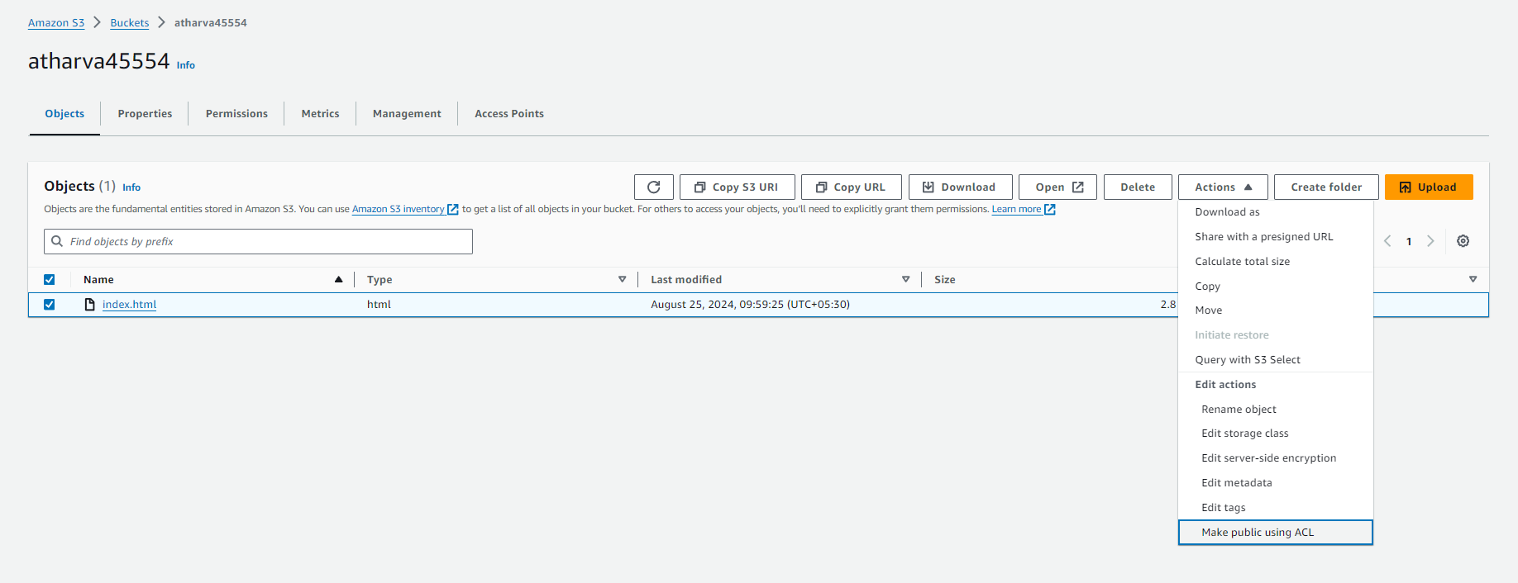

6. Select on Make Public

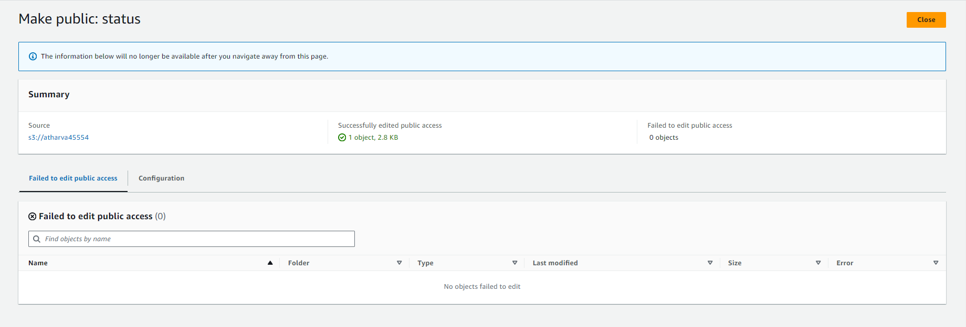

7. Visit the domain and the website hosted.

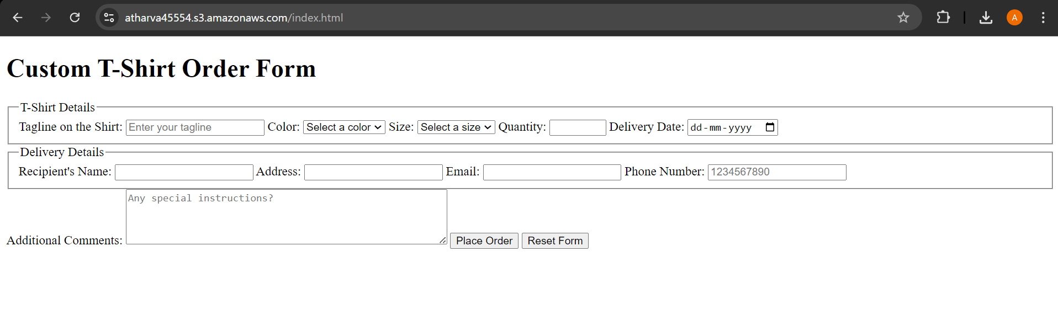

**Cloud 9 IDE Site Hosting**

Step 1: Create Environment

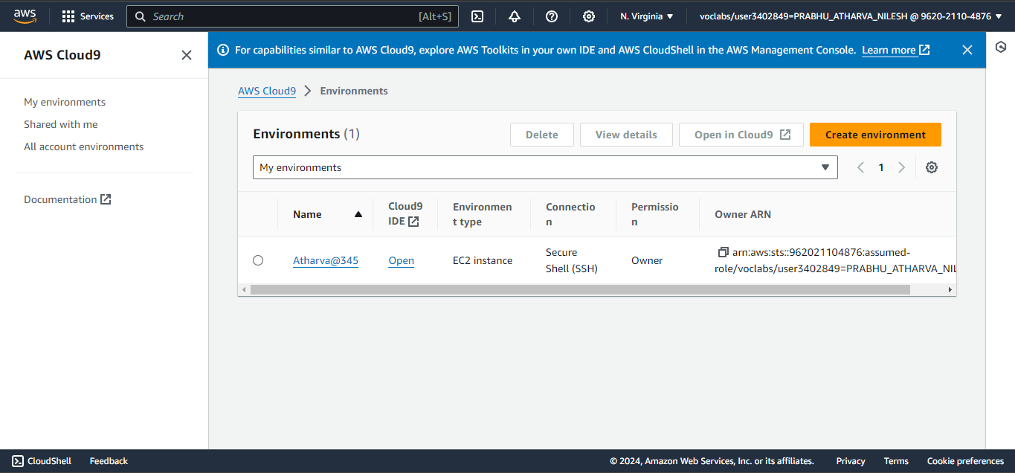

Step 2 :Open the Environment IDE and add the code and run the code

