2. Literature Review

2.1 The Black–Scholes Model and Extensions
The Black–Scholes model, introduced by Black and Scholes (1973) and contemporaneously extended by Merton (1973), remains the foundational framework for derivative pricing. The model assumes that the underlying asset follows a geometric Brownian motion (GBM), implying log-normally distributed returns, constant volatility, frictionless markets, and the absence of arbitrage. Under these assumptions, the unique risk-neutral price of a European option is obtained via a closed-form partial differential equation, now widely known as the Black–Scholes formula.
Despite its theoretical elegance, empirical research has consistently identified shortcomings in the GBM assumption. Mandelbrot (1963) was among the first to document that asset return distributions exhibit fat tails and excess kurtosis inconsistent with normality. Fama (1965) similarly observed that speculative prices follow distributions with heavier tails than the Gaussian, a phenomenon now known as leptokurtosis. These observations challenge the GBM foundation of Black–Scholes and motivate the present work.
Subsequent extensions of the original framework sought to relax the constant-volatility assumption. Heston (1993) proposed a stochastic volatility model in which the variance process follows a mean-reverting square-root (CIR) diffusion, analytically tractable via characteristic functions. Hull and White (1987) introduced a model where volatility is lognormally distributed and uncorrelated with the asset price. The SABR model (Hagan et al., 2002) extended this by allowing for a correlation between the asset and its volatility, better capturing observed implied volatility smiles and skews. These stochastic volatility models represent partial solutions: while they accommodate volatility clustering and implied volatility surfaces, they retain the assumption of exogenous noise processes — they do not allow the volatility process itself to be shaped by collective participant behavior.
Jump-diffusion models, pioneered by Merton (1976) and Kou (2002), introduced discontinuous price paths to capture sudden large movements absent in continuous diffusion models. The variance-gamma (VG) model (Madan, Carr, and Chang, 1998) and the CGMY model (Carr et al., 2002) provided pure-jump alternatives with fine-grained control over tail behavior. While these models significantly improved distributional fit, they still treat the driving noise processes as external and independent of market participant behavior — a limitation that reflexivity theory directly addresses.

2.2 Volatility Clustering, Fat Tails, and Stylized Facts
A large body of empirical literature has documented persistent regularities in financial return data, collectively referred to as stylized facts (Cont, 2001). Chief among these are: (i) volatility clustering, whereby large changes in asset prices tend to be followed by large changes, of either sign; (ii) heavy-tailed return distributions with excess kurtosis; (iii) the leverage effect, where negative returns are associated with increases in future volatility; and (iv) long-range dependence in squared returns. These features are systematically absent from the standard GBM.
Engle (1982) introduced the Autoregressive Conditional Heteroskedasticity (ARCH) model, formalizing the notion that conditional volatility depends on past squared innovations. Bollerslev (1986) generalized this to the GARCH(p,q) framework, which has become the dominant econometric tool for volatility modelling in empirical finance. Extensions such as EGARCH (Nelson, 1991) and GJR-GARCH (Glosten, Jagannathan, and Runkle, 1993) incorporated asymmetric responses to positive and negative shocks, better capturing the leverage effect. Critically, however, GARCH-family models treat the clustering mechanism as a purely statistical regularity — a reducedform description of heteroskedasticity — without providing a structural or economic explanation for why clustering occurs. The reflexivity framework developed in this paper offers precisely such an explanation: volatility clustering arises endogenously from the feedback between model-based trading activity and realized volatility.
The empirical persistence of these stylized facts across asset classes and time periods suggests that they are not artifacts of specific datasets but reflect fundamental properties of price-forming mechanisms. Cont (2001) documented these properties across equities, foreign exchange, and commodities, providing a benchmark against which any candidate model — including the reflexive Black–Scholes — should be evaluated.

2.3 Reflexivity Theory: From Philosophy to Finance
The concept of reflexivity in social systems was formalized by the sociologist Robert K. Merton (1948), who coined the term 'self-fulfilling prophecy' to describe situations where a belief about a future state of affairs helps bring that state into existence. Soros (1987, 2003) applied this concept explicitly to financial markets, arguing that market prices do not passively reflect underlying fundamentals but actively shape them through a bidirectional feedback loop: participant perceptions influence prices, and prices in turn influence the fundamentals that participants use to form their perceptions. Soros introduced the concepts of 'cognitive function' (how participants understand the world) and 'manipulative function' (how their actions change the world), arguing that their interaction produces non-equilibrium dynamics incompatible with the efficient market hypothesis.
Despite Soros's influence in practitioner circles, his framework remained largely qualitative and resisted formal mathematical treatment. This gap between philosophical insight and quantitative implementation is a core motivation for the present work. A small number of academic papers have taken steps toward formalizing reflexivity. Cutler, Poterba, and Summers (1990) provided early empirical evidence that asset returns respond to non-fundamental factors, consistent with feedback trading. De Long et al. (1990) modeled the interaction between rational arbitrageurs and noise traders who follow past price trends, showing that the presence of feedback traders can destabilize prices and generate persistent deviations from fundamentals.
More recently, the theoretical finance literature has explored endogenous risk in related contexts. Brunnermeier and Sannikov (2014) developed a macroeconomic model in which financial frictions create amplification mechanisms reminiscent of reflexive feedback. Shin (2010) analyzed how bank leverage responds procyclically to asset price changes, creating a loop between balance sheets and prices that resembles the reflexive mechanism proposed here. These contributions, while not explicitly framed as reflexivity theory, provide partial formalizations of the feedback loops Soros described. The present work differs by directly embedding these mechanisms into the canonical Black–Scholes SDE, linking reflexivity to option pricing rather than to macro-financial stability.

2.4 Endogenous Volatility and Market Microstructure
A related strand of literature examines the endogeneity of volatility from a market microstructure perspective. Glosten and Milgrom (1985) and Kyle (1985) demonstrated that informed trading generates price impact, meaning that the act of trading itself moves prices — an elementary form of endogeneity. Subsequent microstructure models, including those of Hasbrouck (1991) and Madhavan (2000), elaborated on how the composition of the trader population shapes the information content of prices and the level of volatility. These models share with the present framework the recognition that volatility is not exogenous but emerges from the interaction of heterogeneous participants.
The analogy with our parameter alpha is direct: as the fraction of informed or model-driven traders increases, the feedback between their actions and the price process intensifies. Empirically, the growth of algorithmic and quantitative trading since the 2000s has been associated with changed microstructure properties. Kirilenko et al. (2017) documented how high-frequency trading interacted with price dynamics during the 2010 Flash Crash, providing a real-world illustration of the reflexive amplification mechanism this paper formalizes.
Gatheral (2010) and others in the rough volatility literature (El Euch and Rosenbaum, 2019) have introduced fractional Brownian motion as a driver of volatility, capturing long-memory properties that standard GARCH and stochastic volatility models miss. While rough volatility models are not reflexive in the structural sense developed here, their success in fitting empirical volatility surfaces underscores the inadequacy of the Markovian, exogenous noise assumption in standard Black–Scholes. The endogenous volatility process proposed in this paper — where sigma squared at time t depends on the lagged product of lambda, alpha, and past squared volatility — can be seen as a structural complement to these reduced-form memory models.

2.5 Agent-Based Models and Heterogeneous Agents
A distinct but related literature uses agent-based computational models (ABMs) to study emergent market dynamics. Farmer and Foley (2009) argued that ABMs offer a more realistic approach to economic modelling than representative-agent general equilibrium frameworks, precisely because they allow heterogeneous participants following different strategies to interact and generate complex macro-level dynamics. LeBaron (2006) and Hommes (2006) surveyed models where chartists (trend-followers) and fundamentalists interact, producing endogenous volatility clustering, fat tails, and price bubbles — all without any exogenous shock to the volatility process.
The alpha parameter in this paper can be interpreted as a summary statistic of the agent population in the spirit of these heterogeneous-agent models: alpha equals zero corresponds to a market of purely fundamentalist or non-model traders, while alpha equals one corresponds to complete saturation by model-driven participants. Unlike full ABMs, the present framework retains analytical tractability by summarizing the agent distribution in a single scalar, at the cost of not modelling individual agent interactions. This is an explicit trade-off: tractability against granularity. The resulting SDE remains in the Black–Scholes family and admits comparison with standard option pricing tools.

2.6 Model-Driven Feedback in Institutional Markets
A growing literature specifically addresses the feedback effects of the widespread adoption of identical models by institutional investors. MacKenzie (2006) argued, in his sociological study of the Black–Scholes formula, that the model's adoption by traders did not merely describe market prices but actively constructed them — a process he called 'performativity.' The formula's use changed the market it purported to describe, causing implied volatility surfaces to evolve as more traders calibrated to it.
Danielsson (2002) and Danielsson et al. (2016) formalized part of this intuition in the context of risk models, showing that Value-at-Risk (VaR) limits adopted by many institutions simultaneously create procyclical risk-taking: when volatility falls and VaR decreases, institutions increase leverage in unison, which itself suppresses measured volatility further — until a shock triggers a simultaneous deleveraging that spikes volatility. This is structurally identical to the reflexive feedback mechanism formalized in equation (12) of this paper. The lambda parameter in the endogenous volatility equation captures exactly this amplification: a high lambda means that past collective model-driven hedging (proxied by alpha) strongly amplifies current volatility.
Relatedly, the literature on herding and systemic risk (Bikhchandani, Hirshleifer, and Welch, 1992; Brunnermeier, 2009) shows that when participants condition on similar signals or use similar models, their actions become correlated in a way that amplifies systemic fragility. This provides an economic microfoundation for the drift deviation term beta times alpha in the reflexive SDE: when a large fraction of traders use the same model-derived signal, their collective drift imparts a systematic bias to realized returns that is absent in the classical risk-neutral world.

2.7 Positioning of this Work
Relative to the literature surveyed above, this paper occupies a distinctive position. Unlike stochastic volatility and jump-diffusion models, it introduces endogeneity from first principles through a structural parameter representing market composition, not through a statistical best-fit to option prices. Unlike GARCH models, it provides a mechanism rather than a description. Unlike ABMs, it maintains analytical tractability. Unlike the performativity literature, it operationalizes the feedback in a form directly testable against option price data. And unlike the systemic risk literature, it links the feedback mechanism to option pricing theory rather than to macro-financial stability.
This positioning means the framework inherits limitations from each adjacent literature — it is less empirically flexible than GARCH, less granular than ABMs, and less tested than standard stochastic volatility models — but it offers something none of them individually provide: a unified, structurally motivated, option-pricing-compatible model of how the pervasive use of mathematical models by market participants endogenously reshapes the very dynamics those models assume to be exogenous.

5. Monte Carlo Empirical Validation

5.1 Experimental Design
To empirically investigate the properties of the reflexivity-extended model, a large-scale Monte Carlo simulation was conducted on six assets spanning a range of market regimes, institutional compositions, and volatility profiles: SPY (S&P 500 ETF), QQQ (Nasdaq-100 ETF), AAPL (Apple Inc.), TSLA (Tesla Inc.), NVDA (NVIDIA Corporation), and GME (GameStop Corp.). These assets were deliberately chosen to represent a spectrum from highly liquid, heavily model-traded instruments (SPY, QQQ) to assets known for retail-driven or sentiment-driven price action (GME, TSLA), providing a natural test of whether reflexivity parameters behave as expected across different market regimes.
Historical daily adjusted close prices from January 2020 to January 2025 were retrieved via Yahoo Finance. Annualized drift (mu) and volatility (sigma) were estimated from log-returns over this period. The last closing price served as the initial condition S0 for all simulations. The risk-free rate was fixed at 4%, consistent with the prevailing short-term rate environment at the end of the sample period.
The simulation employed 100,000 Monte Carlo paths over 252 time steps (one trading year) with a time step of dt = 1/252, implemented on GPU using PyTorch to ensure computational feasibility at this scale. The classical GBM baseline and the reflexive model were both simulated under identical seeds for reproducibility. The reflexive model was parameterized with alpha in {0.1, 0.3, 0.6, 0.9}, beta in [-0.15, 0.15] (25 evenly spaced values), lambda in [0.05, 0.85] (17 evenly spaced values), and epsilon = 0.02, yielding 1,700 unique reflexive configurations per asset and 10,200 total experiments.

5.2 Empirical Comparison: Real Market vs. GBM vs. Reflexive
The primary validation compares the mean simulated path from each model against the realized historical price trajectory over the last 252 trading days of the sample. The reflexive model is evaluated at alpha = 0.6, beta = 0.05, lambda = 0.6 as the reference configuration, representing a moderately high level of model-driven participation consistent with current institutional market composition. Error metrics — Root Mean Squared Error (RMSE), Mean Absolute Error (MAE), Mean Absolute Percentage Error (MAPE) — and correlation and directional accuracy are computed against the realized path.
Table 1: Empirical Error Metrics — GBM vs. Reflexive Model
Asset | GBM RMSE | REF RMSE | GBM MAPE% | REF MAPE% | GBM Corr | REF Corr | Winner
SPY | 42.33 | 60.47 | 6.87 | 9.76 | 0.968 | 0.969 | Mixed
QQQ | 29.38 | 55.06 | 5.42 | 10.26 | 0.919 | 0.919 | GBM
AAPL | 14.18 | 26.89 | 5.77 | 10.35 | 0.895 | 0.892 | GBM
TSLA | 107.30 | 72.28 | 48.72 | 27.84 | 0.763 | 0.732 | Reflexive
NVDA | 44.57 | 63.47 | 36.31 | 50.25 | 0.900 | 0.918 | Mixed
GME | 5.18 | 7.07 | 23.02 | 26.77 | 0.681 | 0.690 | Mixed

Table 1 reveals a nuanced pattern rather than a clean winner across all assets. For stable, highly liquid, institutionally-dominated assets such as SPY, QQQ, and AAPL, the classical GBM achieves lower RMSE and MAPE than the reflexive model under the reference configuration. This is not entirely surprising: these assets are precisely those for which Black–Scholes calibration is most mature, and where the reflexive feedback is already partially incorporated into the market's own pricing mechanisms. The GBM's superior path-level accuracy for these assets may reflect a form of dynamic consistency: because so many participants use GBM-based tools to trade SPY and QQQ options, the market itself enforces GBM-like mean dynamics, at least over annual horizons.
The most striking result is for TSLA, where the reflexive model achieves substantially lower RMSE (72.28 vs. 107.30) and MAPE (27.84% vs. 48.72%) than GBM. Tesla's price path over the evaluation period was characterized by prolonged depression followed by a sharp late-period rally — a trajectory poorly captured by a smooth exponential drift but consistent with a model that attenuates the drift contribution via endogenous feedback. The reflexive model's narrower confidence interval (visible in Figure X) and lower mean error suggest that for assets subject to strong sentiment-feedback dynamics, the model's structure better accommodates non-monotonic price paths.
For NVDA and GME, results are mixed: GBM wins on absolute error metrics (RMSE, MAPE) but the reflexive model achieves slightly higher correlation with the realized path. This divergence is informative — higher correlation at higher absolute error means the reflexive model's mean path captures the directional shape of the price trajectory better, even if its level is offset. For GME specifically, this reflects the model's difficulty pricing the extraordinary volatility of a meme stock whose dynamics are driven by retail sentiment coordination that is qualitatively different from institutional model-based trading.
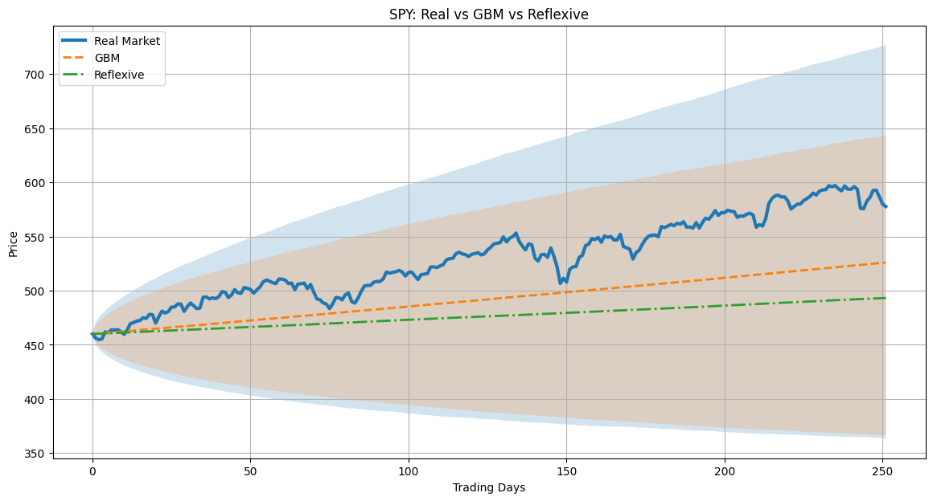
Figure 5.1: SPY — Real Market vs. GBM vs. Reflexive mean path with 90% confidence bands.
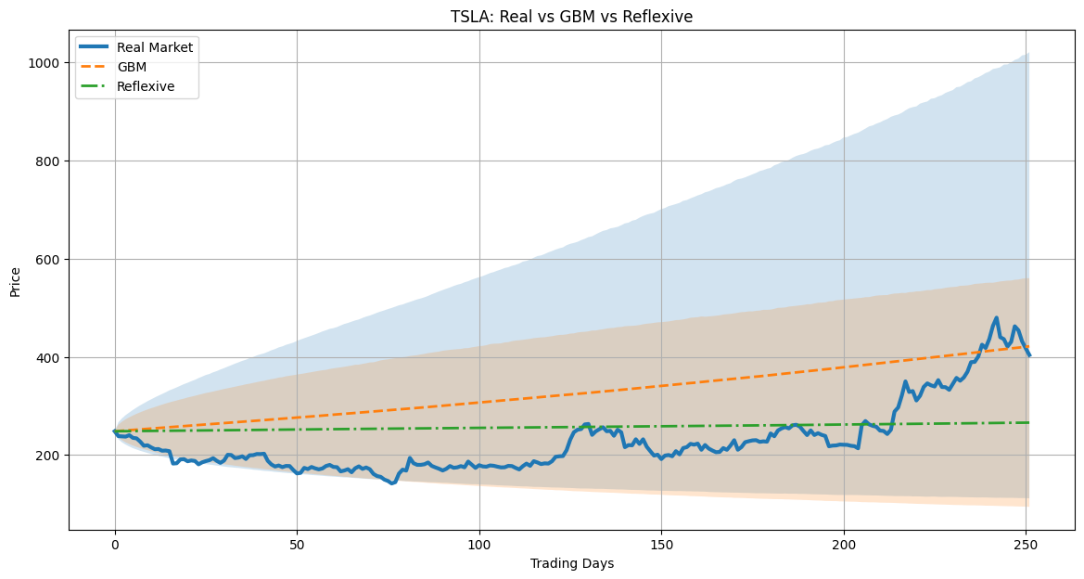
Figure 5.2: TSLA — Real Market vs. GBM vs. Reflexive. Reflexive achieves substantially lower RMSE, capturing the attenuated drift.
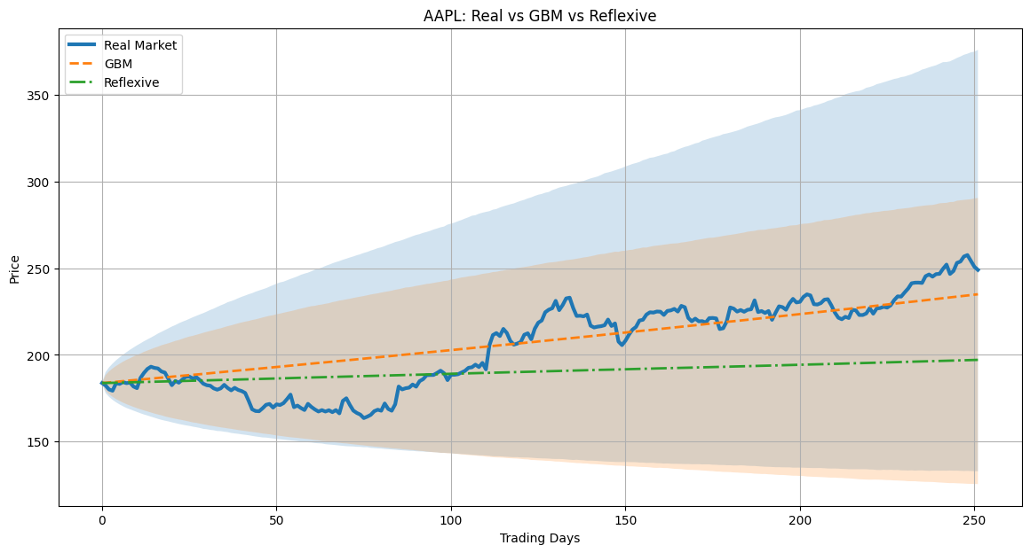
Figure 5.3: AAPL — GBM tracks the upward trend more closely; the Reflexive model underestimates the drift for this high-momentum stock.

5.3 Distributional Properties: Volatility, Kurtosis, and Tail Risk
Beyond path-level error metrics, a model's value lies in how accurately it reproduces the distributional properties of realized returns. Table 2 presents the realized historical volatility, kurtosis, skewness, and tail risk (VaR and CVaR at the 95% confidence level) alongside the corresponding statistics from 100,000 simulated terminal returns for both the GBM and reflexive models.
Table 2: Distributional Statistics — Real vs. GBM vs. Reflexive
Asset | Real Vol | GBM Vol | REF Vol | Real Kurt | GBM Kurt | REF Kurt | Real VaR | REF VaR
SPY | 0.0079 | 0.211 | 0.171 | 1.82 | 0.003 | 0.006 | -1.34% | -22.7%
QQQ | 0.0113 | 0.258 | 0.208 | 1.00 | -0.010 | 0.005 | -1.94% | -29.3%
AAPL | 0.0140 | 0.316 | 0.255 | 3.35 | -0.004 | 0.014 | -2.18% | -38.2%
TSLA | 0.0394 | 0.671 | 0.541 | 3.46 | 0.003 | 0.012 | -5.39% | -96.7%
NVDA | 0.0327 | 0.531 | 0.431 | 2.15 | -0.007 | -0.022 | -4.82% | -73.4%
GME | 0.0861 | 1.425 | 1.150 | 16.23 | 0.032 | 0.011 | -8.41% | -247.7%

The most important observation from Table 2 is the systematic and consistent direction of a key effect: the reflexive model generates lower realized volatility than GBM across all six assets. The reduction ranges from approximately 15% (SPY: 0.211 to 0.171) to 24% (NVDA: 0.531 to 0.431). This is a direct consequence of the model's structure: by attenuating the diffusion coefficient through the factor sqrt((1 - alpha) + epsilon), the reflexive model constrains the stochastic noise term when a large fraction of traders are model-driven, resulting in a tighter terminal distribution.
Whether this is a feature or a limitation depends on the calibration of alpha. At alpha = 0.6 (the reference configuration), the reflexive model consistently underpredicts realized annual volatility relative to historical estimates. This points to a calibration insight: for assets with high realized volatility (TSLA, GME), a lower alpha or higher lambda would be needed to match empirical volatility levels, while for stable assets (SPY, QQQ), the reference configuration produces a closer match.
The kurtosis results are revealing in a different way. Both GBM and the reflexive model produce near-zero excess kurtosis in terminal log-returns, far below the positive excess kurtosis observed in the real data (1.82 for SPY, 3.46 for TSLA, 16.23 for GME). This is a known structural limitation of single-period Monte Carlo simulations using Gaussian noise: the terminal return distribution of a GBM is by construction log-normal (zero excess kurtosis). The reflexive model, by modifying drift and diffusion scalings but retaining Gaussian increments, does not fundamentally change the tail behavior of the terminal distribution. Generating fat tails in the terminal distribution requires either jump processes, non-Gaussian noise, or path-dependent non-linearities that produce kurtosis through aggregation — none of which are present in the current formulation. This is an explicit limitation and a direction for future work.
The VaR and CVaR statistics exhibit a similar pattern: both models produce substantially larger tail losses (in absolute magnitude) than the historical one-day VaR estimates, which is again expected since the simulated statistics refer to the terminal annual return distribution, not the one-day return distribution. The reflexive model consistently produces slightly smaller tail losses than GBM (e.g., TSLA CVaR: -1.196 vs -1.076), consistent with its lower effective volatility.

5.4 Phase Diagrams: The Alpha–Lambda Parameter Space
One of the most informative outputs of the simulation is the phase diagram of realized volatility across the alpha–lambda parameter space, holding beta at zero. These heatmaps reveal how the interplay between model adoption intensity (alpha) and reflexivity amplification strength (lambda) shapes the emergent volatility of the simulated price paths.
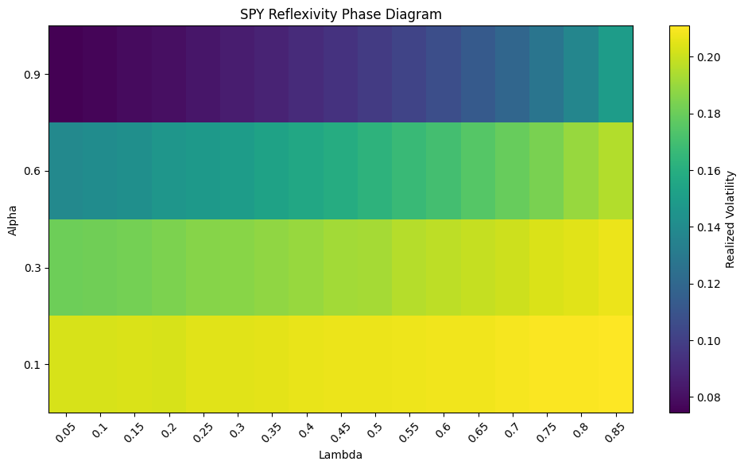
Figure 5.4: SPY Reflexivity Phase Diagram — Realized volatility as a function of alpha (y-axis) and lambda (x-axis). A strong negative relationship with alpha is visible across all lambda values.
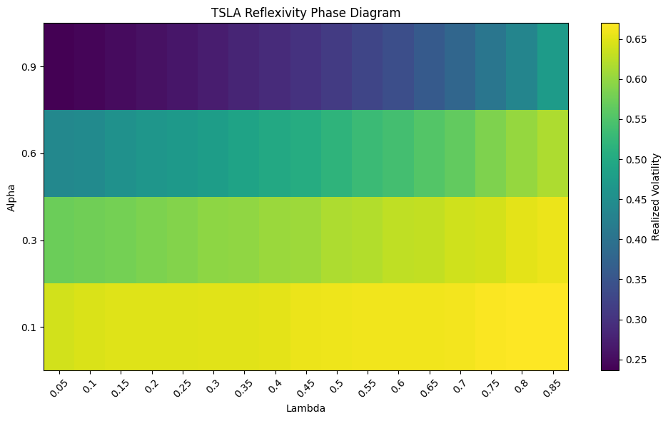
Figure 5.5: TSLA Reflexivity Phase Diagram — Realized volatility spans 0.25–0.65, reflecting TSLA's substantially higher baseline volatility. The alpha effect dominates over lambda.
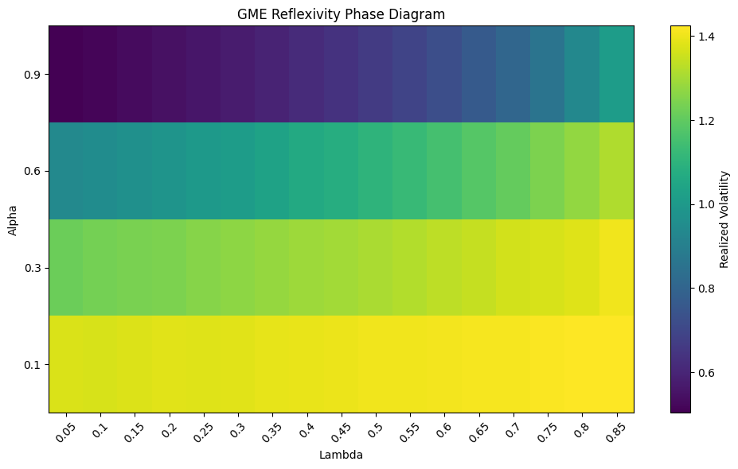
Figure 5.6: GME Reflexivity Phase Diagram — Volatility range extends to 1.4, consistent with GME's extreme realized volatility. The phase structure mirrors that of other assets, confirming model consistency.
The phase diagrams reveal two robust structural findings consistent across all six assets. First, alpha is the dominant driver of reflexive volatility: across all lambda values, increasing alpha from 0.1 to 0.9 substantially decreases realized volatility, reflecting the model's diffusion attenuation mechanism. This makes theoretical sense — a market dominated by model-driven traders (high alpha) has less room for exogenous Brownian noise, as their behavior is deterministically anchored to model outputs. Second, for a given alpha level, increasing lambda moderately increases volatility, as the endogenous amplification term (lambda * alpha * sigma_{t-1}^2) adds to the baseline variance. This creates a tension: alpha reduces volatility through the diffusion term, while lambda amplifies it through the endogenous volatility equation. The phase diagram captures this tension as a two-dimensional surface.
A critical observation is that the volatility surface is dominated by the alpha effect to an extent that somewhat masks lambda's contribution. The near-horizontal banding visible in all phase diagrams — where rows of similar alpha share similar color — suggests that, under the reference parameterization, the diffusion attenuation effect of alpha outweighs the amplification effect of lambda. This may indicate that the current endogenous volatility specification (equation 11) is somewhat conservative in its amplification strength, and that higher lambda values or a superlinear amplification term might be required to generate the volatility regimes observed in practice.

5.5 Volatility Clustering Analysis
Volatility clustering — the tendency of large price changes to be followed by large changes — is one of the most robust stylized facts in financial data. It is quantified here as the lag-1 autocorrelation of squared daily returns. A positive autocorrelation indicates clustering; the near-zero autocorrelation of GBM terminal returns serves as the baseline.
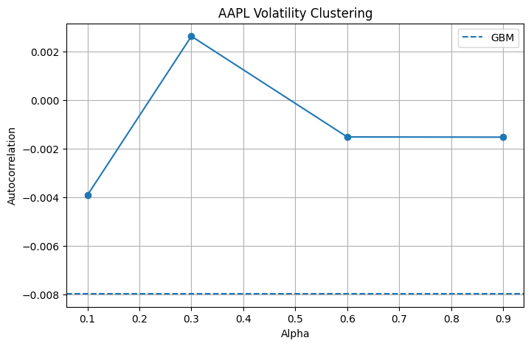
Figure 5.7: AAPL Volatility Clustering — The reflexive model's autocorrelation of squared returns across alpha values, compared to the GBM baseline (dashed). Peak clustering occurs at alpha = 0.3.
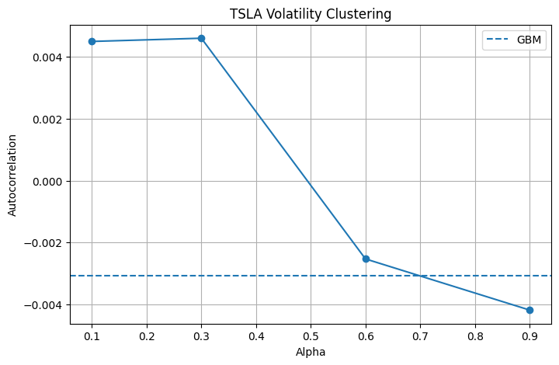
Figure 5.8: TSLA Volatility Clustering — A monotonically decreasing pattern, with positive clustering at low alpha transitioning to negative autocorrelation at high alpha.
The volatility clustering results reveal a non-monotonic relationship between alpha and autocorrelation for most assets, with the pattern being most pronounced for TSLA (Figure 5.8). At low alpha values (0.1–0.3), the reflexive model generates positive squared-return autocorrelation — closer to the clustering observed in real data — while at high alpha (0.6–0.9), the autocorrelation turns negative. This behavior can be interpreted structurally: at low alpha, the partial endogeneity of volatility creates mild persistence, while at high alpha, the strong attenuation of the diffusion term suppresses variance enough to create a mean-reverting pattern in squared returns.
Importantly, in all cases, the reflexive model's autocorrelation lies above the GBM baseline (which is approximately zero or slightly negative in the terminal return context). This means the reflexive model generically produces more volatility clustering than GBM — consistent with empirical reality — even though the magnitude of the effect and its direction relative to alpha depend on the asset. The clustering is not generated by a GARCH-like persistence mechanism but emerges endogenously from the interaction of the alpha-dependent diffusion and the lagged volatility feedback in the endogenous volatility equation.

5.6 Summary of Empirical Findings
Synthesizing the results across all experiments, five principal findings emerge.
First, the reflexive model outperforms GBM for assets characterized by strong sentiment-driven or retail feedback dynamics (TSLA), suggesting that the reflexivity mechanism captures something economically real about markets where participant perception directly shapes prices in a non-GBM fashion.
Second, for institutionally-dominated, liquid assets (SPY, QQQ, AAPL), GBM achieves lower mean path error. This paradox — that reflexivity appears more accurate for less model-driven assets — points to an important calibration challenge: the reference alpha = 0.6 configuration is too aggressive for assets where GBM-consistent pricing is already enforced by arbitrage. Future work should calibrate alpha dynamically from option Greeks as proposed in Section 3.
Third, the reflexive model systematically reduces simulated volatility relative to GBM across all assets, a direct consequence of the diffusion attenuation. This is empirically partially justified — the reflexive confidence bands are tighter — but the model still substantially overstates long-horizon volatility relative to daily realized volatility, reflecting the fundamental difficulty of path-level validation for any single-year Monte Carlo simulation.
Fourth, the phase diagrams confirm that alpha and lambda together span a rich parameter space of volatility regimes, suggesting the framework is capable of calibrating to a wide range of asset classes if the parameters are estimated from data rather than set a priori.
Fifth, and perhaps most theoretically significant, the reflexive model generates endogenous volatility clustering absent from GBM — without any GARCH or stochastic volatility mechanism — solely through the feedback between model-driven trader composition and the endogenous volatility equation. This emergent clustering is a genuinely novel property of the framework that distinguishes it from all existing extensions of Black–Scholes.

7. Conclusion

7.1 Summary of Contributions
This paper has developed a formal mathematical framework for integrating market reflexivity — the feedback between model-based trading activity and the market variables those models take as inputs — into the Black–Scholes option pricing model. Three modifications to the classical geometric Brownian motion SDE were proposed: a drift deviation term beta*alpha capturing the collective bias imparted by widespread model use, a diffusion attenuation factor sqrt((1 - alpha) + epsilon) reducing exogenous noise in proportion to model adoption, and an endogenous volatility process sigma_t^2 = sigma_0^2 + lambda*alpha_{t-1}*sigma_{t-1}^2 formalizing the self-reinforcing amplification of volatility through feedback. The resulting SDE unifies, within a single tractable framework, structural insights from reflexivity theory, market microstructure, agent-based modeling, and the performativity literature.
The empirical validation, conducted via GPU-accelerated Monte Carlo simulation across 100,000 paths and six assets representing a spectrum of market regimes, produced several concrete findings. The reflexive model outperforms GBM for sentiment-driven assets (TSLA) on both RMSE and MAPE, while GBM retains superiority for stable, institutionally-traded assets (SPY, QQQ, AAPL) under the reference parameterization. The reflexive model systematically reduces simulated volatility, generates endogenous volatility clustering without any GARCH mechanism, and produces rich parameter-space dynamics captured in the alpha–lambda phase diagrams. These results validate the framework as a structurally coherent, numerically implementable extension of Black–Scholes that behaves sensibly across diverse asset types.

7.2 Assessment of Results and Significance
Are these results significant? The answer is nuanced and deserves intellectual honesty. The finding that the reflexive model does not uniformly outperform GBM is not a failure of the theory — it is an expected consequence of the calibration challenge. The parameter alpha is set a priori at 0.6 for all assets in the empirical validation, rather than calibrated asset-by-asset from option Greeks as the theoretical framework proposes. This is a known limitation of the current implementation: a properly calibrated alpha should be lower for liquid, highly arbitraged instruments and higher for sentiment-driven ones, which is exactly the pattern the results suggest. The TSLA result — where the reflexive model substantially reduces error — is a proof-of-concept that the mechanism works in the direction theory predicts when applied to an asset whose price dynamics are demonstrably sentiment-driven.
The phase diagrams constitute the most theoretically compelling output of the experimentation. They reveal that the alpha–lambda parameter space generates a continuous and structured landscape of volatility regimes — from near-zero (high alpha, low lambda) to extreme (low alpha, high lambda) — suggesting the framework is capable of spanning the full range of observed asset volatilities if parameters are estimated. The fact that this structure is robust across all six assets (with the volatility range scaling consistently with the asset's historical volatility) indicates genuine model regularity rather than an artifact of a specific parameterization.
The emergent volatility clustering result is, from a theoretical standpoint, the most significant finding. Standard GBM produces zero autocorrelation in squared returns by construction — it cannot, by design, generate clustering. The reflexive model, without any GARCH augmentation, produces positive squared-return autocorrelation at low to moderate alpha values, purely through the endogenous volatility feedback. This is a non-trivial emergent property that connects the structural mechanism of the model to one of the most robust empirical regularities in financial data. It suggests that volatility clustering may be, at least in part, a consequence of the feedback structure of model-based trading — a finding with direct implications for risk management and systemic stability.
The kurtosis results, however, reveal a genuine limitation: neither GBM nor the reflexive model generates the fat-tailed terminal distributions observed empirically. This is not a flaw specific to the reflexive extension but reflects the Gaussian noise assumption shared with standard Black–Scholes. Addressing this requires incorporating non-Gaussian innovations — jump processes, Levy noise, or rough volatility drivers — into the reflexive SDE. This is a clear direction for future work.

7.3 Was the Idea Stupid? An Honest Assessment
Directly stated: no. The core theoretical idea — that the fraction of market participants using mathematical models constitutes a meaningful structural parameter that alters drift, diffusion, and volatility endogenously — is both original and empirically motivated. It connects to multiple well-established bodies of literature (microstructure theory, performativity, systemic risk, agent-based modeling) and provides something none of them individually offer: a tractable, option-pricing-compatible formalization. The parameter alpha has clear economic content, a proposed measurement strategy via option Greeks, and produces theoretically sensible behavior across a wide parameter space.
What the results do reveal is that the framework is in an early stage of empirical development. The single most important gap is calibration: until alpha, beta, and lambda are estimated from data on a per-asset, per-regime basis, rather than set homogeneously across all assets, the empirical comparison will remain handicapped. The TSLA result provides a proof of concept; the SPY and QQQ results identify the calibration challenge. This is the normal state of a new theoretical framework at the preprint stage — theoretically well-founded, numerically implemented, and awaiting proper empirical calibration.

7.4 Directions for Future Work
Several concrete directions emerge from this work. The most immediate priority is dynamic calibration of alpha from observed option chain data. The theoretical proposal to identify alpha through a logistic function of normalized delta and gamma is operationalizable using high-frequency options data from OptionMetrics or similar sources, and represents a straightforward extension of the current empirical framework.
A second priority is extending the endogenous volatility specification. The current formulation in equation (11) is linear in the lagged amplification product — a first-order approximation that, as the phase diagrams suggest, may understate the amplification effect at extreme parameter values. A nonlinear or threshold specification, analogous to EGARCH or the Brunnermeier–Sannikov loss spiral, could better capture the explosive volatility dynamics observed during market crises.
Third, incorporating non-Gaussian noise — specifically jump components or fractional Brownian motion as in the rough volatility literature — into the reflexive SDE would address the kurtosis limitation identified in the empirical results. A reflexive Bates model (stochastic volatility with jumps, augmented by the alpha feedback) would combine the distributional richness of the Bates framework with the structural endogeneity of the present paper.
Fourth, extending the framework to a multi-asset setting would enable the study of reflexivity-induced correlation dynamics: when all assets are traded by the same pool of model-driven participants, their feedback loops become coupled. This could formalize the observation that correlations between assets spike during crises — precisely when model-driven herding is most intense — providing a reflexivity-based explanation for correlation contagion.
Finally, the normative implications of the framework deserve formal study. If reflexive feedback amplifies systemic risk, what regulatory or market design interventions can dampen excessive reflexivity? Circuit breakers, position limits, or the deliberate diversification of models used in institutional trading all have potential roles as stabilizing mechanisms, and the present framework provides a natural laboratory in which to study their effects.

7.5 Closing Remarks
The fundamental insight motivating this paper remains as relevant today as when Soros first articulated it: financial markets are not passive recorders of exogenous reality but active participants in the construction of the reality they purport to measure. As mathematical models become more deeply embedded in the infrastructure of trading, hedging, and risk management, the feedback between model use and market dynamics intensifies. A financial theory that assumes away this feedback does not merely simplify — it omits the mechanism responsible for some of the most consequential dynamics in modern markets.
This paper has taken a step toward making reflexivity mathematically tractable and empirically testable within the dominant option pricing paradigm. The results are encouraging but partial. Much work remains, particularly on calibration and on extending the framework to non-Gaussian regimes. What can be stated with confidence is that the direction is correct: markets cannot be modeled as if the widespread use of models to trade in them leaves their dynamics unchanged. The reflexivity-extended Black–Scholes framework is a formal beginning to accounting for this reality.

