Assignment 1a : Create a responsive web page using HTML, CSS and Bootstrap

Name: Atharva Agrawal
RollNo: 33303
Batch: K-11

Final Output:

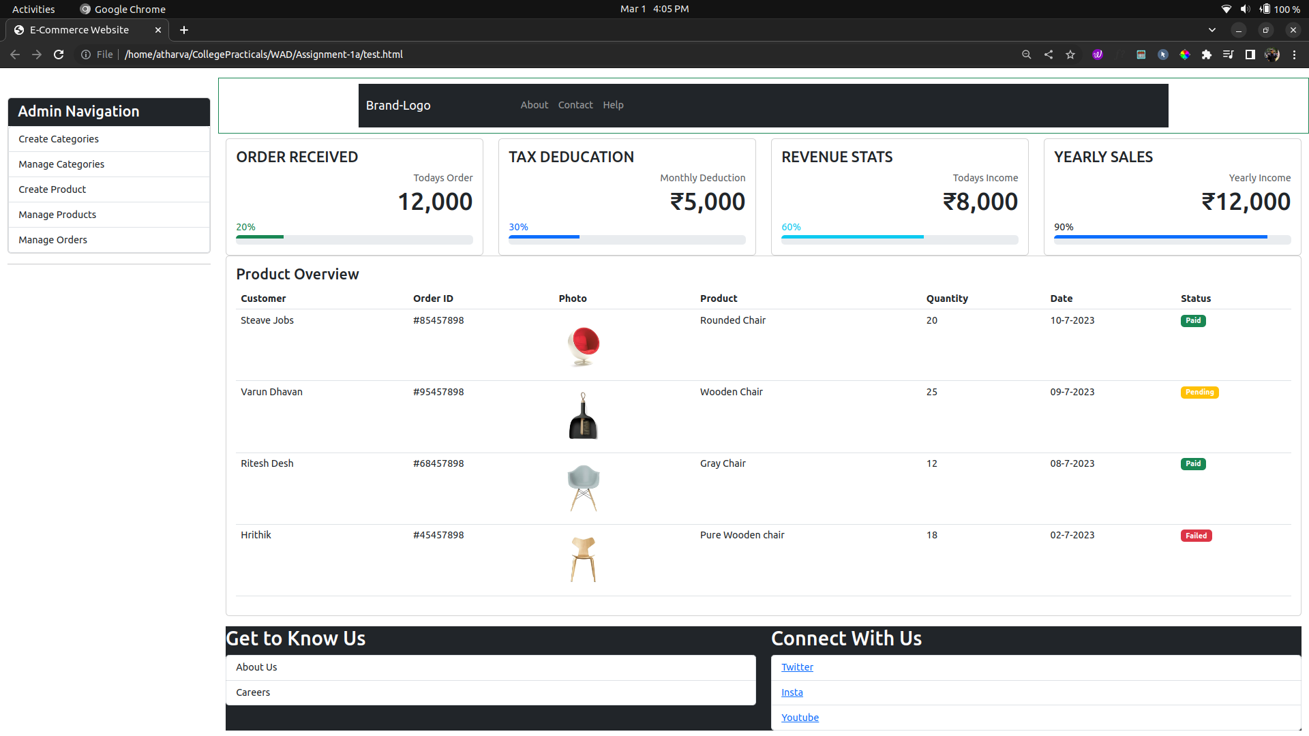

Index.html:

<html>
<head>
<link href="https://cdn.jsdelivr.net/npm/bootstrap@5.3.0-alpha1/dist/css/bootstrap.min.css" rel="stylesheet">
<link href="https://getbootstrap.com/docs/5.3/assets/css/docs.css" rel="stylesheet">
<title>E-Commerce Website</title>
<script src="https://cdn.jsdelivr.net/npm/bootstrap@5.3.0-alpha1/dist/js/bootstrap.bundle.min.js"></script>
<link rel="stylesheet" href="./index.css" />
<!-- The above code defines a meta tag that tells the browser to set the width of the website according to the device width. It also set scaling to 1 which equates to default website. In short, we tell the browser that we are going to build a responsive website. -->
<meta name="viewport" content="width=device-width, initial-scale=1.0">
</head>
<body>
<div class="container-fluid">
<div class="row">
<div class="col-2 mt-lg-5">
<div class="card overlay" id="myNav">
<h4 class="card-header bg-dark text-white">Admin Navigation</h4>
<ul class="list-group overlay-content">
<li class="list-group-item">
<Link class="nav-link text-success" to="/admin/create/category">
Create Categories
</Link>
</li>
<li class="list-group-item">
<Link class="nav-link text-success" to="/admin/categories">
Manage Categories
</Link>
</li>
<li class="list-group-item">
<Link class="nav-link text-success" to="/admin/create/product">
Create Product
</Link>
</li>
<li class="list-group-item">
<Link class="nav-link text-success" to="/admin/products">
Manage Products
</Link>
</li>
<li class="list-group-item">
<Link class="nav-link text-success" to="/admin/orders">
Manage Orders
</Link>
</li>
</ul>
</div>
<hr>
</div>
<div class="col-10">
<div class="col py-3">
<!-- Main Content -->
<div class="row">
<header class="border border-success p-2 mb-2">
<div class="container bg-dark">
<nav class="navbar w-100 navbar-dark navbar-expand-sm">
<a href="#" class="navbar-brand">Brand-Logo</a>
<button class="navbar-toggler" type="button" data-bs-toggle="collapse" data-bs-target="#menuItems" aria-controls="menuItems" aria-expanded="false" aria-label="Toggle Navigation">
<span class="navbar-toggler-icon"></span>
</button>
<h1 class="text-center"> T-Shirt </h1>
<div class="collapse navbar-collapse float-left" id="menuItems">
<ul class="navbar-nav">
<li class="nav-item">
<a href="#" class="nav-link">About</a>
</li>
<li class="nav-item">
<a href="#" class="nav-link">Contact</a>
</li>
<li class="nav-item">
<a href="#" class="nav-link">Help</a>
</li>
</ul>
</div>
</nav>
</div>
</header>
</div>
<div class="row">
<!-- Column -->
<div class="col-lg-3 col-md-6">
<div class="card">
<div class="card-body">
<h4 class="card-title">ORDER RECEIVED</h4>
<div class="text-end">
<span class="text-muted">Todays Order</span>
<h1 class="font-light"><sup><i class="ti-arrow-up text-success"></i></sup> 12,000</h1>
</div>
<span class="text-success">20%</span>
<div class="progress">
<div class="progress-bar bg-success" role="progressbar" style="width: 20%; height: 6px;" aria-valuenow="25" aria-valuemin="0" aria-valuemax="100"></div>
</div>
</div>
</div>
</div>
<!-- Column -->
<!-- Column -->
<div class="col-lg-3 col-md-6">
<div class="card">
<div class="card-body">
<h4 class="card-title">TAX DEDUCATION</h4>
<div class="text-end">
<span class="text-muted">Monthly Deduction</span>
<h1 class="font-light"><sup><i class="ti-arrow-up text-primary"></i></sup> ₹5,000</h1>
</div>
<span class="text-primary">30%</span>
<div class="progress">
<div class="progress-bar bg-primary" role="progressbar" style="width: 30%; height: 6px;" aria-valuenow="25" aria-valuemin="0" aria-valuemax="100"></div>
</div>
</div>
</div>
</div>
<!-- Column -->
<!-- Column -->
<div class="col-lg-3 col-md-6">
<div class="card">
<div class="card-body">
<h4 class="card-title">REVENUE STATS</h4>
<div class="text-end">
<span class="text-muted">Todays Income</span>
<h1 class="font-light"><sup><i class="ti-arrow-down text-info"></i></sup> ₹8,000</h1>
</div>
<span class="text-info">60%</span>
<div class="progress">
<div class="progress-bar bg-info" role="progressbar" style="width: 60%; height: 6px;" aria-valuenow="25" aria-valuemin="0" aria-valuemax="100"></div>
</div>
</div>
</div>
</div>
<!-- Column -->
<!-- Column -->
<div class="col-lg-3 col-md-6">
<div class="card">
<div class="card-body">
<h4 class="card-title">YEARLY SALES</h4>
<div class="text-end">
<span class="text-muted">Yearly Income</span>
<h1 class="font-light"><sup><i class="ti-arrow-up text-inverse"></i></sup> ₹12,000</h1>
</div>
<span class="text-inverse">90%</span>
<div class="progress">
<div class="progress-bar bg-inverse" role="progressbar" style="width: 90%; height: 6px;" aria-valuenow="25" aria-valuemin="0" aria-valuemax="100"></div>
</div>
</div>
</div>
</div>
<!-- Column -->
</div>
<div class="row">
<div class="col-md-12 col-lg-12 col-sm-12 col-xs-12">
<div class="card">
<div class="card-body">
<h4 class="card-title"> Product Overview </h4>
<div class="table-responsive m-t-30">
<table class="table product-overview">
<thead>
<tr>
<th>Customer</th>
<th>Order ID</th>
<th>Photo</th>
<th>Product</th>
<th>Quantity</th>
<th>Date</th>
<th>Status</th>
<!-- <th>Actions</th> -->
</tr>
</thead>
<tbody>
<tr>
<td>Steave Jobs</td>
<td>#85457898</td>
<td>
<img src="./img/chair.jpg" alt="iMac" width="80">
</td>
<td>Rounded Chair</td>
<td>20</td>
<td>10-7-2023</td>
<td>
<span class="badge bg-success">Paid</span>
</td>
</tr>
<tr>
<td>Varun Dhavan</td>
<td>#95457898</td>
<td>
<img src="./img/chair2.jpg" alt="iPhone" width="80">
</td>
<td>Wooden Chair</td>
<td>25</td>
<td>09-7-2023</td>
<td>
<span class="badge bg-warning">Pending</span>
</td>
</tr>
<tr>
<td>Ritesh Desh</td>
<td>#68457898</td>
<td>
<img src="./img/chair3.jpg" alt="apple_watch" width="80">
</td>
<td>Gray Chair</td>
<td>12</td>
<td>08-7-2023</td>
<td>
<span class="badge bg-success">Paid</span>
</td>
</tr>
<tr>
<td>Hrithik</td>
<td>#45457898</td>
<td>
<img src="./img/chair4.jpg" alt="mac_mouse" width="80">
</td>
<td>Pure Wooden chair</td>
<td>18</td>
<td>02-7-2023</td>
<td>
<span class="badge bg-danger">Failed</span>
</td>
</tr>
</tbody>
</table>
</div>
</div>
</div>
</div>
</div>
</div>
<!-- Footer Section -->
<footer class="bg-dark">
<div class="row">
<div class="col-6 text-white">
<h2>Get to Know Us</h2>
<ul class="list-group">
<li class="list-group-item"> About Us </li>
<li class="list-group-item"> Careers </li>
</ul>
</div>
<div class="col-6 text-white">
<h2>Connect With Us</h2>
<ul class="list-group">
<li class="list-group-item"> <a href="#"> Twitter</a> </li>
<li class="list-group-item"> <a href="#"> Insta</a> </li>
<li class="list-group-item"> <a href="#"> Youtube</a> </li>
</ul>
</div>
</div>
</footer>
</div>
</div>
</div>
</body>
</html>

