Assignment 2b: Create a Docker Container

Name: Atharva Agrawal
RollNo: 33303
Batch: K11

(1) What is Docker?

Docker is an open platform for developing, shipping, and running applications. Docker enables you to separate your applications from your infrastructure so you can deliver software quickly. With Docker, you can manage your infrastructure in the same ways you manage your applications. By taking advantage of Docker’s methodologies for shipping, testing, and deploying code quickly, you can significantly reduce the delay between writing code and running it in production.

* Pre-requisite before installing docker:

1) Check KVM virtualization support:

What is KVM?
KVM (for Kernel-based Virtual Machine) is a full virtualization solution for Linux on x86 hardware containing virtualization extensions (Intel VT or AMD-V). It consists of a loadable kernel module, kvm.ko, that provides the core virtualization infrastructure and a processor specific module, kvm-intel.ko or kvm-amd.ko.
Using KVM, one can run multiple virtual machines running unmodified Linux or Windows images. Each virtual machine has private virtualized hardware: a network card, disk, graphics adapter, etc.
KVM is open source software. The kernel component of KVM is included in mainline Linux, as of 2.6.20. The userspace component of KVM is included in mainline QEMU, as of 1.3.

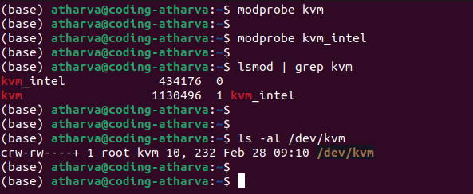

2) QEMU must be version 5.2 or newer. We recommend upgrading to the latest version.
What is QEUM?
QEMU is a free and open-source emulator. It emulates the machine's processor through dynamic binary translation and provides a set of different hardware and device models for the machine, enabling it to run a variety of guest operating systems.

3) Setup the Repository:
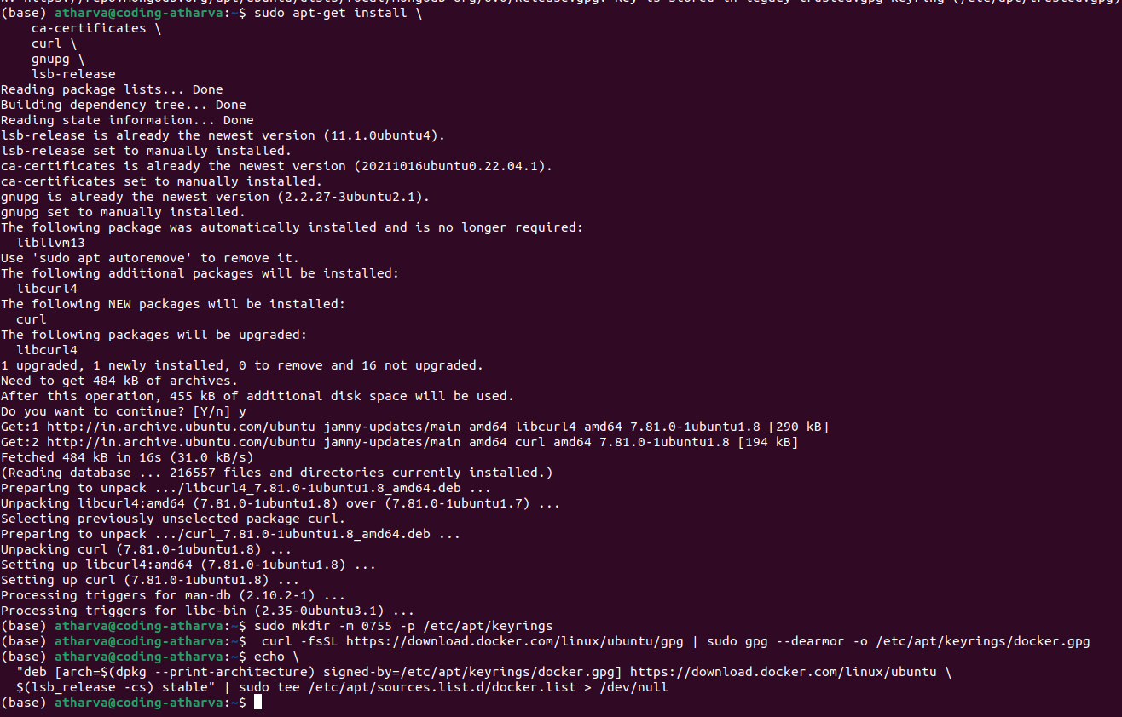

4) Install Docker Engine, containerd, and Docker Compose.

sudo apt-get update

sudo apt-get install docker-ce docker-ce-cli containerd.io docker-buildx-plugin docker-compose-plugin

5) Verify that the Docker Engine installation is successful by running the hello-world image:

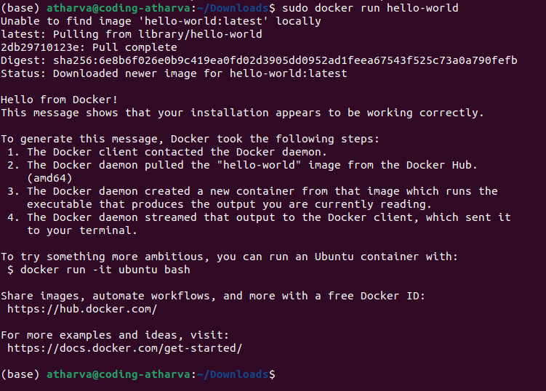
6) Install: sudo apt-get install ./docker-desktop-4.17.0-amd64.deb

7) Run: systemctl --user start docker-desktop

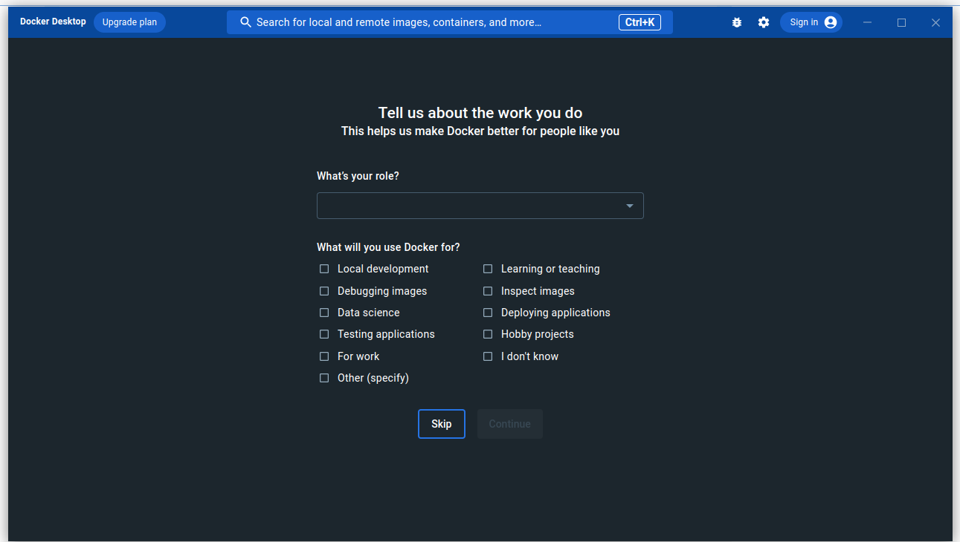

Creating First Container:

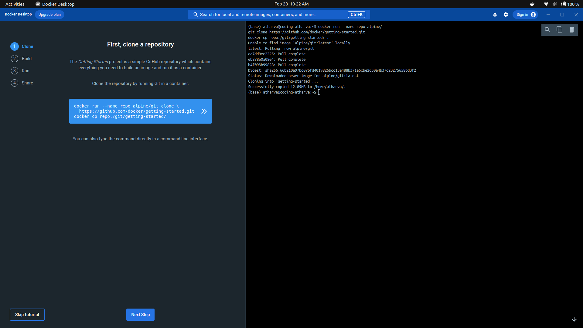
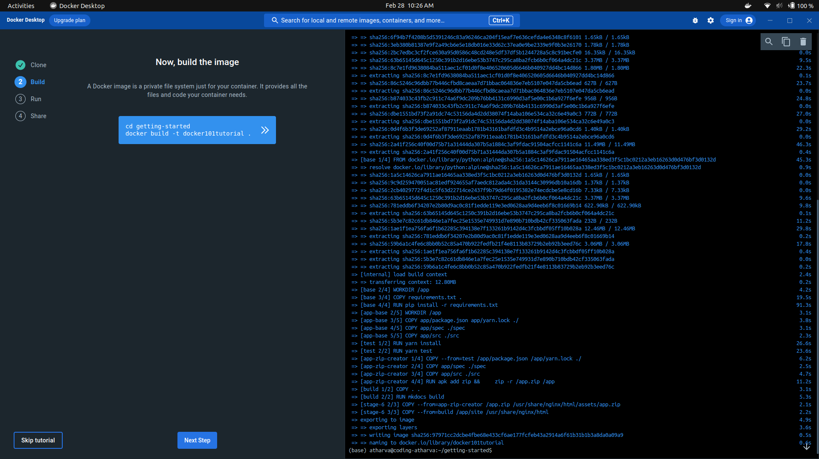

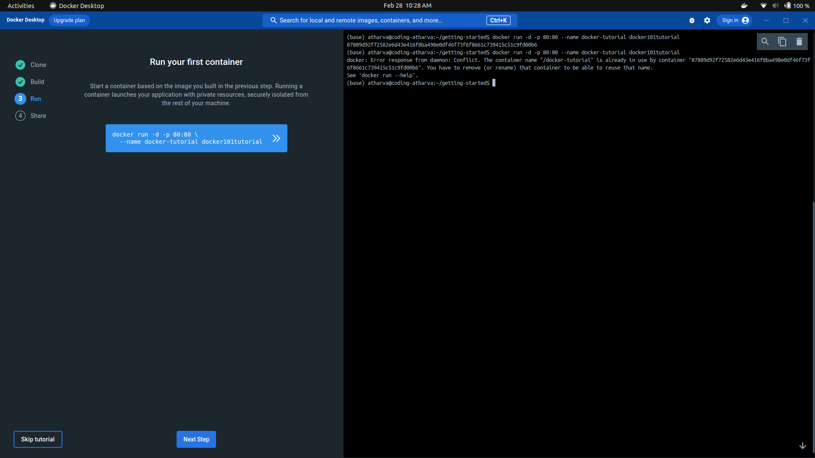

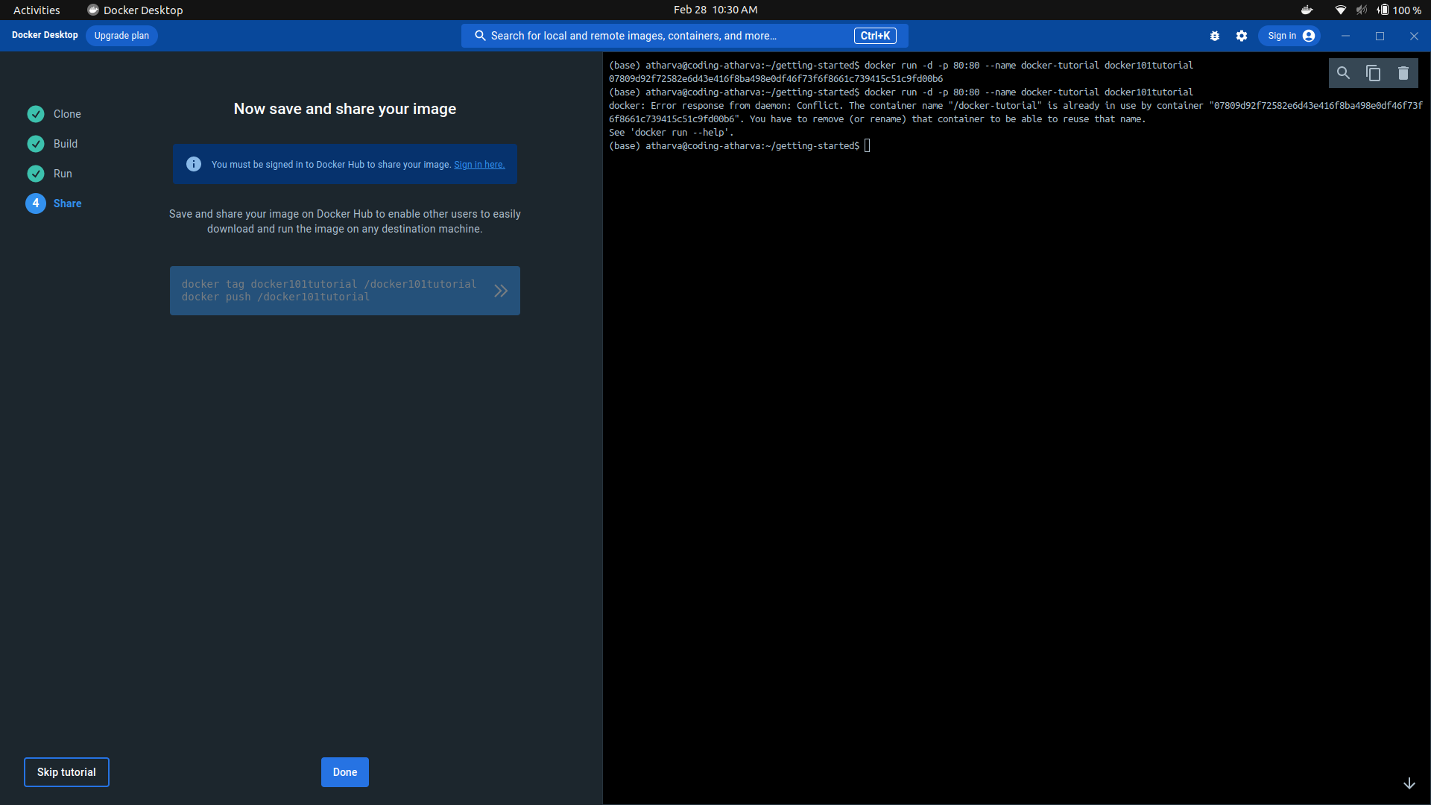

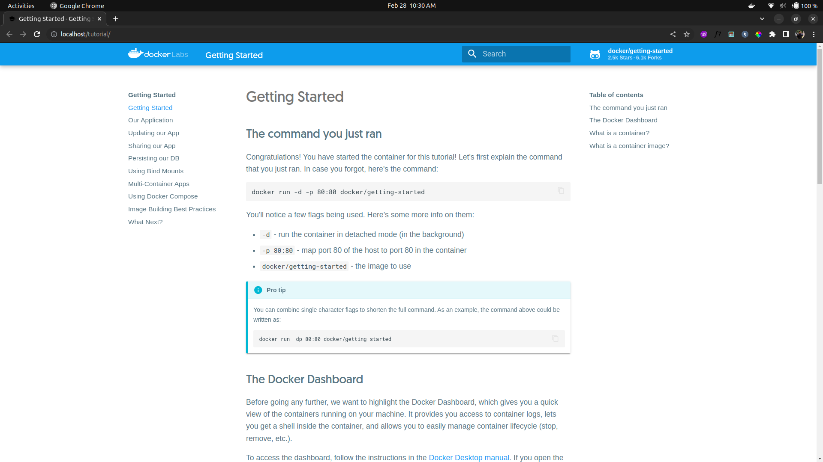
Successfuly Started the Container:

Running Container:
