Assignment 2C

Name: Atharva Agrawal
RollNo: 33303
Batch: K-11

Angular Files:

home.component.ts:

import { Component } from '@angular/core';
import { CookieService } from 'ngx-cookie-service';
import { Router } from '@angular/router';

@Component({
selector: 'app-home',
templateUrl: './home.component.html',
styleUrls: ['./home.component.css'],
})
export class HomeComponent {
message: string;

constructor(private cookieService: CookieService, private router: Router) {
let user: string = localStorage.getItem('user') ?? '{}';
const userDetails = JSON.parse(user);
this.message = userDetails.username
? 'Hello ' + userDetails.username
: 'LOGIN';
this.validate();
}

validate() {
// verify
const jwt = this.cookieService.get('jwt');
console.log(jwt);
const myHeaders = new Headers({
'Content-Type': 'application/json',
Cookie: `jwt=${jwt}`,
});

var requestOptions: Object = {
method: 'GET',
headers: myHeaders,
redirect: 'follow',
credentials: 'include',
};

fetch('http://localhost:2324', requestOptions)
.then((response) => {
if (!response.ok) {
throw new Error(String(response.status));
}
return response.json();
})
.then((result) => {
console.log(result);
if (result.message == 'Token is not valid') {
// redirect to login
localStorage.removeItem('user');
this.router.navigate(['/login']);
} else if (result.message == 'Token is not provided') {
// redirect to login
localStorage.removeItem('user');
this.router.navigate(['/login']);
}
if (this.message == 'LOGIN') {
this.router.navigate(['/login']);
}
})
.catch((error) => console.log('error', error));
}

logout() {
localStorage.removeItem('user');
this.router.navigate(['/login']);
}
}

login.component.ts:

import { Component } from '@angular/core';
import { Router } from '@angular/router';

@Component({
selector: 'app-login',
templateUrl: './login.component.html',
styleUrls: ['./login.component.css'],
})
export class LoginComponent {
usernameError: string = '';
passwordError: string = '';

constructor(private router: Router) {}

async getData(username: any, password: any) {
this.usernameError = username ? '' : 'Username is required';
this.passwordError = password ? '' : 'Password is required';

if (username && password) {
var myHeaders = new Headers();
myHeaders.append('Content-Type', 'application/json');

var raw = JSON.stringify({
username: username,
password: password,
});

var requestOptions: Object = {
method: 'POST',
headers: myHeaders,
body: raw,
redirect: 'follow',
};

fetch('http://localhost:2324/login', requestOptions)
.then((response) => response.json())
.then((result) => {
if (result.token) {
document.cookie = 'jwt=' + result.token;
localStorage.setItem('user', JSON.stringify(result.user));
this.router.navigate(['']);
} else {
this.usernameError =
result.message == 'Username Not Found' ? result.message : '';
this.passwordError =
result.message == 'Incorrect Password' ? result.message : '';
}
})
.catch((error) => console.log('error', error));
}
}
}

signup.component.ts:

import { Component } from '@angular/core';
import { Router } from '@angular/router';

@Component({
selector: 'app-signup',
templateUrl: './signup.component.html',
styleUrls: ['./signup.component.css'],
})
export class SignupComponent {
usernameError: string = '';
passwordError: string = '';

constructor(private router: Router) {}

async getData(username: any, password: any) {
this.usernameError = username ? '' : 'Username is required';
this.passwordError = password ? '' : 'Password is required';

if (username && password) {
var myHeaders = new Headers();
myHeaders.append('Content-Type', 'application/json');

var raw = JSON.stringify({
username: username,
password: password,
});

var requestOptions: Object = {
method: 'POST',
headers: myHeaders,
body: raw,
redirect: 'follow',
};

fetch('http://localhost:2324/signup', requestOptions)
.then((response) => {
if (response.ok) {
return response.json();
} else {
this.usernameError = 'Username Already Exists';
throw Error('Not OK');
}
})
.then((result) => {
if (result.token) {
document.cookie = 'jwt=' + result.token;
localStorage.setItem('user', JSON.stringify(result.user));
this.router.navigate(['']);
}
})
.catch((error) => console.log('error', error));
}
}
}

Server Running Database:

index.js:

import express from "express"
import User from "./User.js"
import cookieParser from "cookie-parser";
import jwt from "jsonwebtoken";
import connection from "./mongodb.js";
import cors from 'cors';

import dotenv from "dotenv"
dotenv.config();

const app = express();

//middleware
app.use(express.json());
app.use(cookieParser());

app.use(function (req, res, next) {
// Website you wish to allow to connect
res.setHeader('Access-Control-Allow-Origin', '*');
// Request methods you wish to allow
res.setHeader('Access-Control-Allow-Methods', 'GET, POST, OPTIONS, PUT, PATCH, DELETE');
// Request headers you wish to allow
res.setHeader('Access-Control-Allow-Headers', 'X-Requested-With,content-type');
// Set to true if you need the website to include cookies in the requests sent
// to the API (e.g. in case you use sessions)
res.setHeader('Access-Control-Allow-Credentials', true);
// Pass to next layer of middleware
next();
});

app.use(cors({
origin: 'http://localhost:4200',
credentials: true
}));

const authMiddleware = (req, res, next) => {
const jwToken = req.cookies.jwt
if (jwToken) {
jwt.verify(jwToken, "This is My Secret", (error, decode) => {
if (error) {
res.json({ message: "Token is not valid" })
} else {
req._id = decode._id;
next()
}
})
} else {
res.json({ message: "Token is not provided" })
}
}

// functions
async function createToken(_id, res) {
const token = await jwt.sign({ _id }, "This is My Secret", {
expiresIn: "2d"
})
res.cookie("jwt", token, {
maxAge: 1000 * 60 * 60 * 24 * 2,
httpOnly: true
});
return token;
}

//routes
app.post("/login", async (req, res) => {
try {
const user = await User.login(req.body);
if (user == 1) {
res.clearCookie("jwt");
return res.send({ message: "Username Not Found" })

} else if (user == 2) {
res.clearCookie("jwt");
return res.send({ message: "Incorrect Password" })
}

const token = await createToken(user._id, res)
return res.send({ user, token });
} catch (error) {
res.status(404).send({ error })
}
})

app.post("/signup", async (req, res) => {
const { username, password } = req.body;
if (username && password) {
try {
const user = await User.create({ username, password });
const token = await createToken(user._id, res)
return res.send({ user, token });
} catch (error) {
return res.status(404).send({ error })
}
} else {
return res.status(404).json({ message: "`username` and `password` are required" })
}
})

app.get("/", authMiddleware, async (req, res) => {
try {
const user = await User.findOne({ _id: req._id })
res.status(200).json({ username: user.username })
} catch (error) {
res.status(494).json({ error })
}
})

//server connection
connection.then(() => {
app.listen(2324, () => {
console.log("server started: http://localhost:2324")
})
}).catch(err => {
console.log(err)
})

Output:

Angular Running Terminal:

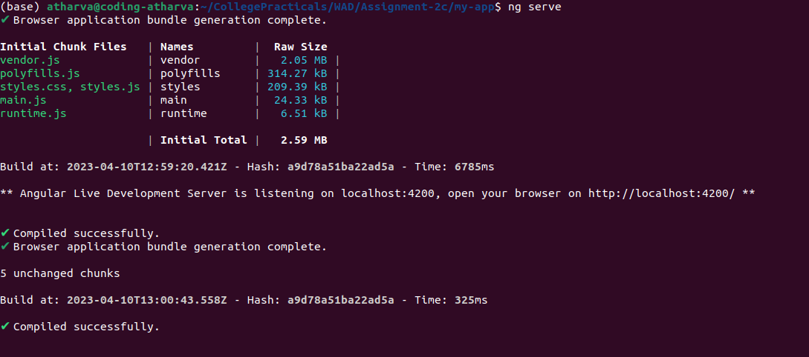

Server Running Terminal:

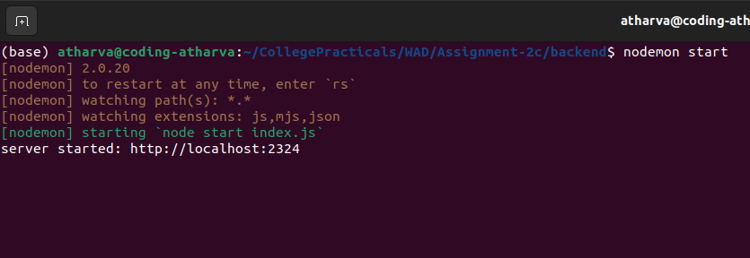

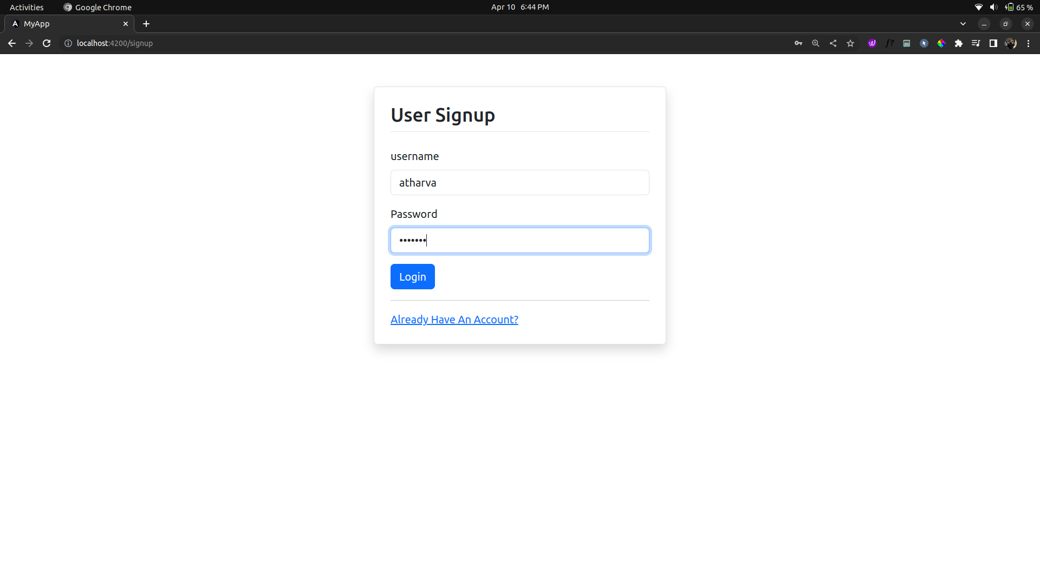
Web Output:

