Assignment 3a

Name: Atharva Agrawal
RollNo: 33303
Batch: K-11

index.js

const http = require("http");
const url = require("url");
const fs = require("fs");
const path = require("path");

// Port on which the server will create
const PORT = 1800;

// Maps file extension to MIME types which
// helps the browser to understand what to
// do with the file
const mimeType = {
".ico": "image/x-icon",
".html": "text/html",
".js": "text/javascript",
".json": "application/json",
".css": "text/css",
".png": "image/png",
".jpg": "image/jpeg",
".wav": "audio/wav",
".mp3": "audio/mpeg",
".svg": "image/svg+xml",
".pdf": "application/pdf",
".doc": "application/msword",
".eot": "application/vnd.ms-fontobject",
".ttf": "application/font-sfnt",
};

// Creating a server and listening the port 5000
http
.createServer((req, res) => {
// Parsing the requested URL
const parsedUrl = url.parse(req.url);

console.log(parsedUrl.pathname);

// If requested url is "/" like "http://localhost:5000/"
if (parsedUrl.pathname === "/") {
var filesLink = "<ul>";
res.setHeader("Content-type", "text/html");
var filesList = fs.readdirSync("./");
filesList.forEach((element) => {
if (fs.statSync("./" + element).isFile()) {
filesLink += `<br/><li><a href='./${element}'>
${element}
</a></li>`;
}
});
filesLink += "</ul>";
res.end("<h1>List of files:</h1> " + filesLink);
} else {
/* processing the requested file pathname to
avoid directory traversal like,
http://localhost:1800/../fileOutofContext.txt
by limiting to the current directory only */
const sanitizePath = path
.normalize(parsedUrl.pathname)
.replace(/^(\.\.[\/\\])+/, "");
let pathname = path.join(__dirname, sanitizePath);

if (!fs.existsSync(pathname)) {
// If the file is not found, return 404
res.statusCode = 404;
res.end(`File ${pathname} not found!`);
} else {
// Read file from file system limit to the
// current directory only.
fs.readFile(pathname, function (err, data) {
if (err) {
res.statusCode = 500;
res.end(`Error in getting the file.`);
} else {
// Based on the URL path, extract the file
// extension. Ex .js, .doc, ...
const ext = path.parse(pathname).ext;
// If the file is found, set Content-type
// and send data
res.setHeader("Content-type", mimeType[ext] || "text/plain");
res.end(data);
}
});
}
}
})
.listen(PORT);

Output:

Console:
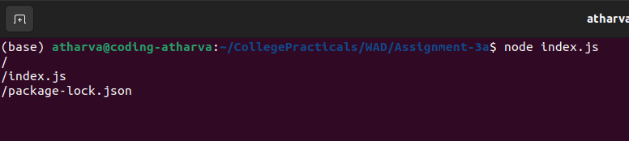

Web:
