Assignment 3B

Name: Atharva Agrawal
RollNo: 33303
Batch: K-11

Index: server.js

const express = require("express");
const bodyParser = require("body-parser");

const app = express();
app.use(bodyParser.urlencoded({ extended: true }));

app.use(bodyParser.json());

const UserRoute = require("./routes/User");
app.use("/user", UserRoute);

const dbConfig = require("./config/database.config.js");
const mongoose = require("mongoose");

mongoose.Promise = global.Promise;
mongoose
.connect(dbConfig.url, {
useNewUrlParser: true,
})
.then(() => {
console.log("Databse Connected Successfully!!");
})
.catch((err) => {
console.log("Could not connect to the database", err);
process.exit();
});
app.get("/", (req, res) => {
res.json({ message: "Hello Crud Node Express" });
});
app.listen(3000, () => {
console.log("Server is listening on port 3000");
});

Routes: User.js

const express = require("express");
const UserController = require("../controllers/User");
const router = express.Router();

router.get("/", UserController.findAll);
router.get("/:id", UserController.findOne);
router.post("/", UserController.create);
router.patch("/:id", UserController.update);
router.delete("/:id", UserController.destroy);

module.exports = router;

Model: User.js

var mongoose = require("mongoose");
var schema = new mongoose.Schema({
email: { type: String, required: true, unique: true },
firstName: { type: String, default: "" },
lastName: { type: String, default: "" },
phone: String,
});
var user = new mongoose.model("User", schema);
module.exports = user;

Output:

Create User:

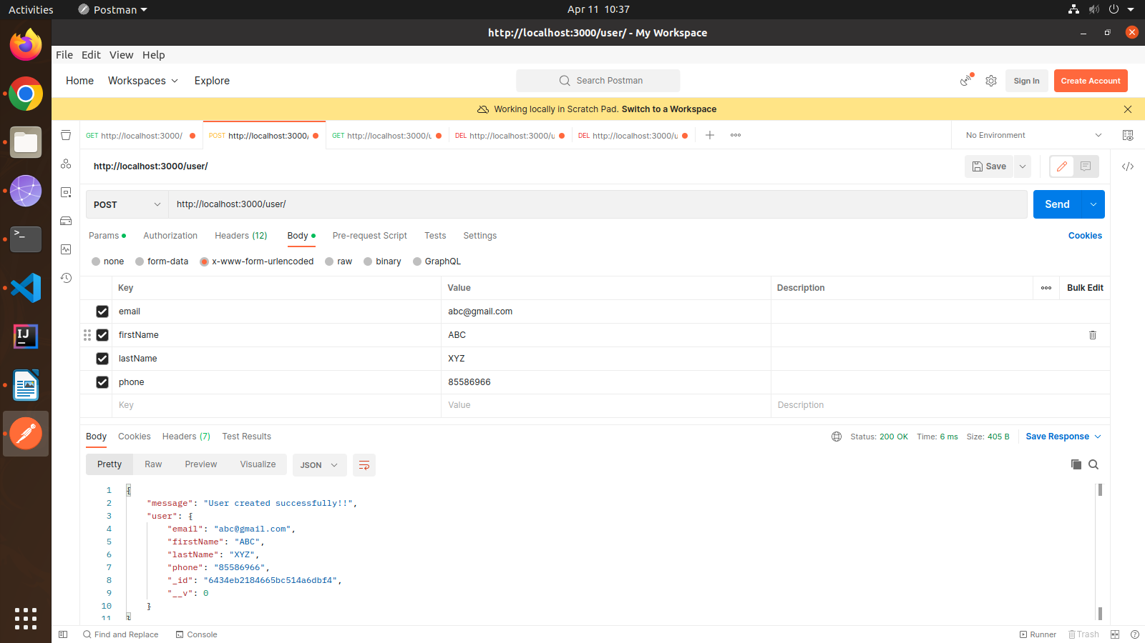

Display Single User:

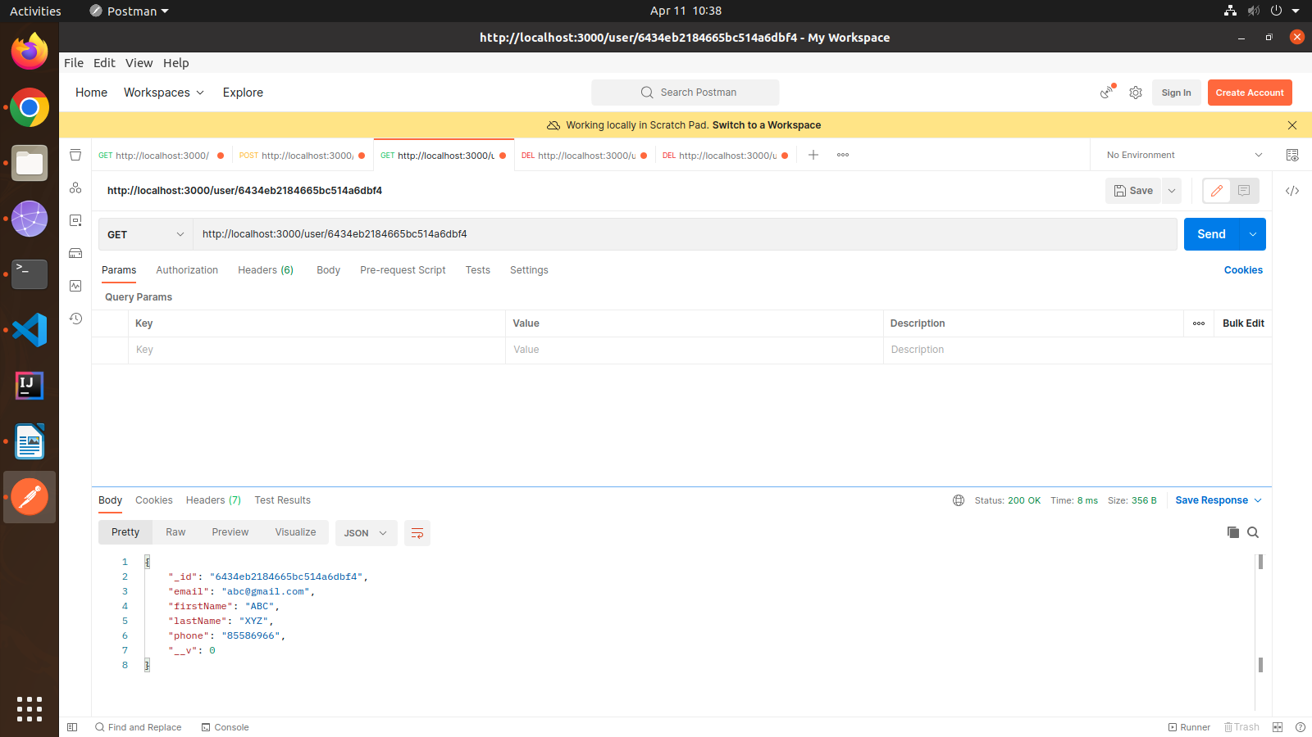
Update User:

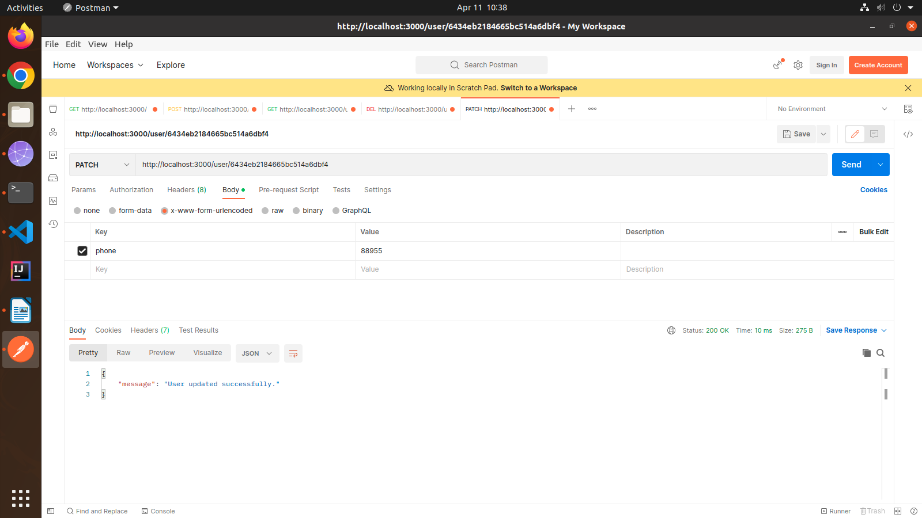

Delete User:

