**Drowsy Driver Detection System**

Naisargi Bagal, Kashish Dingreja, Atharva Atterkar, Prasad Bachhav, Anuradha Yenkikar,Nilesh P. Sable

Department of Computer Science Engineering – Artificial Intelligence, Vishwakarma Institute of Information Technology, Pune

# ABSTRACT:

*Major traffic accidents are attributed to driver fatigue, according to study on the topic. Driver drowsiness is a state in which the driver of a car is on the verge of falling asleep or losing consciousness. It can be brought on by a number of variables, including biological, physical, psychological, and other factors, all of which can impede and inhibit safe driving.The several methods that can be applied to the implementation of a system for the detection of driver sleepiness will be reviewed in this paper. Improving the ability to identify drowsiness in real time through computer vision is the main objective of all technologies. Thus, our work also pertains to the identification of driver drowsiness, whereby a motorist's tiredness can be ascertained by first recognizing their face, followed by eye tracking .The system compares the extracted eye image with the dataset. The system used the dataset and predicts using transfer learning with our base model as InceptonV3 to identify that it could alert the driver with an alarm if the driver's eyes were closed for a predetermined amount of time, and it could resume monitoring if the driver's eyes were open following the alarm alert. We established a score that grew if the eyes were closed and dropped if they were open. This study aims to reduce traffic accidents by solving the sleepiness detection problem with InceptionV3 with an accuracy of 95.46% compare to 92.11% of VGG16.Thus, driving drowsiness detection—which assesses a driver's degree of fatigue using facial recognition and eye tracking becomes the main focus of our research.*

*Keywords: fatigue, computer vision, face recognition, eye tracking, transfer learning, InceptionV3,VGG16, alarm alert, score.*

# INTRODUCTION:

Sleepiness when driving is a major contributing cause to major traffic accidents, according to studies on the topic. These days, it's been observed that the main reason for drowsiness when driving is weariness. The main cause of the increase in traffic accidents these days is tiredness. According to the report by “Ministry of Road Transport & Highways” there were 4,552 accidents reported every year in India, that took lives of thousands of people because of sleepy drivers(Road Accidents in India 2016). There are two effective methods for determining a person's level of sleepiness. The driver's face is first photographed, after which the blinking values are computed, the eye retina detection, facial feature extraction, and threshold values are set. Second, the driver hand pressure on the car steering wheel is calculated in real-time and the threshold value is set using the Aurdino module, which is integrated with elastomeric sensors. However , in this paper we are focusing on the first method only. The goal of this project is to create a real-time system for detecting driver drowsiness that can recognize symptoms of inattention in drivers and notify them to take appropriate safety measures. The technology analyzes eye movements and facial expressions using computer vision algorithms to find patterns that suggest tiredness. Our goal is to lower the number of incidents caused by sleepy driving and improve road safety by incorporating this technology into cars or driver assistance.The face detection technology breaks down a continuous video feed into individual frames while also recognizing the eye condition. Preprocessing is applied to every frame to guarantee uniform analysis.This could entail normalizing pixel values for best processing, switching to grayscale for improved contrast, or scaling for uniformity. Subsequently, each frame is scanned by a pre-trained Haar cascade classifier, which is renowned for its effectiveness in object detection, to identify faces. The technology focuses on the ocular region of the recognized face if face detection is accomplished. This process is made easier by the robust computer vision library OpenCV.

The model training script and the real-time detection script are the two primary parts of the driver drowsiness detection system. The TensorFlow and Keras libraries are used in the model training script to create and train a deep learning model for sleepiness detection. For feature extraction, we specifically use the InceptionV3 convolutional neural network architecture, which has been pre- trained on ImageNet. A dataset of photos showing people in both awake and sleepy phases is used to train the model, and data augmentation techniques are used to increase robustness.We use Pygame for audio alerts and OpenCV for image processing and facial detection in the real- time detection script. Pre-trained cascade classifiers are available from OpenCV to identify faces and eyes in live webcam video feeds. In order to forecast drowsiness, the system first detects faces, then it extracts the region of interest that contains the eyes and runs it through the trained deep learning model. Pygame is used to play an audio alarm to notify the driver if drowsiness is detected. The aim of this project is to create an automated system for detecting driver drowsiness. Specifically, it will assess how well the InceptionV3 deep learning model recognizes indicators of driving exhaustion or drowsiness. Our ultimate objective is to improve road safety by lowering the likelihood of accidents brought on by intoxicated driving by giving drivers real-time alerts.

Applications include:

**1. Driver Monitoring Systems**-The most obvious use is in automobiles, particularly long-distance buses and trucks. By warning tired drivers to take a break or rest, drowsiness detection devices can help reduce the number of accidents.

**2. Aviation**-Hundreds of passengers' lives are in the hands of pilots. Pilot alertness during extended flights can be greatly enhanced by drowsiness detection, which can be extremely important for aviation safety.

**3. Medical Care**-The detection of drowsiness is not just used in transportation. It can also be used to keep an eye on patients' attentiveness in medical settings, particularly those recovering from surgery or under the influence of sedatives.

**4. Workplace Safety**- Drowsiness detection devices can help minimize the risk of fatigue-related incidents in industries where personnel must operate heavy machinery or conduct safety-critical jobs.

Our contributions are-

**1)High Accuracy with InceptionV3:** Compared to other approaches, our effort is unique in that it makes use of the InceptionV3 deep learning model, which provides a higher level of accuracy in identifying patterns connected to sleepiness. Our technology delivers remarkable results in real-time sleepiness detection by utilizing deep learning, which guarantees prompt alerts to drivers and improves overall road safety.

**2)Custom Dataset Preparation:** In contrast to numerous other methods that utilize generic datasets, our study makes use of a specially produced and annotated unique dataset for drowsiness detection. Images of people taken in a variety of lighting settings, sensor kinds, and eye states are included in this dataset. Our approach demonstrates robustness and adaptability by customizing the dataset to certain drowsiness detection conditions, which results in more dependable performance in real-world driving scenarios.

**3)Real-time Implementation and Alert System:** Our project's real-time alert system and practical implementation are two of its strongest points. Our solution provides a user-friendly interface and sends immediate alerts to drivers when it detects signs of tiredness by smoothly integrating with TensorFlow, OpenCV, and Python. Our concept is unique because it takes a proactive approach to driving safety, which helps avoid accidents before they happen and ultimately saves lives on the road.

# LITERATURE SURVEY:

The significance of driver drowsiness detection in ensuring road safety cannot be overstated, especially given its role in preventing accidents and saving lives. Nearly 20 papers were surveyed by us. The information gained from these papers is given as follows:

A Real-Time Driver Drowsiness Detection System based on Convolutional Neural Networks (CNN) using the Inception V3 model is proposed in the paper in [1]. Its main method of detecting driver fatigue is eye state analysis, with an alarm set off when appropriate. The collection most likely contains facial motion data for drowsiness detection, such as eye movements, head movements, yawning, and eye blinks. It may also contain photos or videos of drivers' faces for analysis of their level of sleepiness. With CNNs assisting on the Inception V3 model, the goal of the measured outcome is real-time detection of drowsiness based on eye state.

In [2], a different method for detecting driver drowsiness in real time is demonstrated using transfer learning. In order to detect drowsiness, this study uses the DenseNet model on the MRL eye dataset, which consists of 84923 images. Because it can diagnose driver drowsiness with 91.56% accuracy, the DenseNet model is used. The emphasis is on using cameras to identify fatigue and send out timely alerts to reduce the risk of accidents.

In order to identify driver sleepiness more accurately than current techniques, an Automatic System for Driver sleepiness Detection System utilizing Deep Learning is presented in [3]. Using the Eye Dataset, which is divided between closed and open eyes, the study uses CNN, OpenCV, and transfer learning techniques to examine drowsiness. The goal of the measurement is to use CNN to detect driver drowsiness with a precision of more than 87.4%.

A unique model is proposed to outperform other transfer learning algorithms in a Deep CNN Based Approach for Driver Drowsiness Detection [4]. The work presents a two-dimensional CNN-based classification model for drowsiness detection, comparing its performance with other transfer learning approaches like VGG-16 and ResNet-50, albeit the dataset used is not stated explicitly. F1-score, recall, precision, and validation accuracy are among the outcomes that are measured.

In [5], a CNN model is used to use deep learning for driver drowsiness detection with the goal of improving the classification of the driver's eye condition. For training, 48000 pictures from the MRL eye dataset are used. The emphasis is on attaining an accuracy of 86.05% in identifying closed eyes, contributing to improved sleepiness detection systems, even though the precise algorithm or software is not specified.

In order to achieve an overall accuracy of 95%, the paper proposes a Driver Drowsiness Detection System using Convolutional Neural Networks (CNN) in [6]. Pictures obtained from a significant fraction of the MRL eye dataset are used. Real-time facial landmark tracking makes use of computer vision techniques like dilatation, edge detection, and grayscale conversion in conjunction with the Google MediaPipe Face mesh model. The outcome that is being measured is the CNN model's 95% accuracy rate in identifying drowsiness.

The VGG16 model is used to investigate the detection of driver dynamics in [7]. The YAWDD dataset is used, which consists of pictures of 322 drivers with different types of faces. The VGG16 model is used to identify driver tiredness in four classes: open-eye, closed-eye, no-yawn, and yawn. Accuracy and F1-score are used to assess the results.

Analysis of Driver Behavior In [8], it is suggested to utilize deep learning to assess driver behavior by using a security camera to focus on the driver's face and track movements of their mouth and eyes. The study uses the CNN algorithm for training, prediction, and driver state assessment; however, the dataset used is not disclosed. The results include using behavior analysis to detect driver fatigue and sending out alerts when needed.

A driver drowsiness detection system using deep convolutional neural networks is presented in the paper [9], with the goal of achieving high sleepiness recognition accuracy and speed. Algorithms such as Convolutional Neural Networks (CNN) with transfer learning and Haar feature-based cascade classifiers are used, utilizing the Real RLDD dataset. The end result is improved road safety through the rapid and high accuracy detection of driver drowsiness.

The main goals of An Eye-Based Drowsiness Detection System for Drivers [10] are to reduce error rates related to lighting conditions and eye features and optimize kernel size for driver's eye detection. Computer vision techniques using the OpenCV package and the Haar Cascade Classifier algorithm are used, albeit the dataset used is not stated explicitly. Determining the ideal eye detection parameters and related error rates is one of the outcomes that is measured.

In order to detect the driver's face and eyes, Driver Drowsiness Monitoring using Convolutional Neural Networks [11] uses Haar cascade classifiers, maybe with the help of camera photos. There is no mention of any specific dataset data. In order to help with the monitoring of drowsiness, specially constructed Convolutional Neural Networks (CNN) are used to track the percentage and score of eye closure.

In an effort to improve drowsiness detection rates, the work in [12] investigates driver drowsiness detection using a variety of deep learning models. An ensemble technique is used to mix the output of deep learning models such as AlexNet, VGG-FaceNet, FlowImageNet, and ResNet. The goal is to detect driver drowsiness with an accuracy of 85%, despite the fact that the dataset is not specified.

In order to improve road safety, the proposed Intelligent Driver Drowsiness Detection System in [13] seeks to identify and notify the driver's level of weariness in real-time. The study uses the OpenCV library and the Haar Cascade technique to detect driver weariness based on eye movement monitoring; the dataset is not specified. The result is the ability to identify driver weariness by observing the driver's eyes, which helps prevent accidents by taking preventative action.

In [14], Intelligent Driver Drowsiness Detection for Traffic Safety presents an ensemble model that operates on subsamples of the lips and eyes that are taken from facial images using the MTCNN. The training and assessment sets use the NTHU-DDD video dataset. The goal of the InceptionV3 modules in the ensemble deep learning architecture is to achieve high accuracy rates while identifying driver drowsiness. High accuracy rates on a variety of datasets are the result, which improves driver safety.

In order to improve driver safety, an enhanced image processing and fuzzy logic approach is presented in [15] for driver drowsiness detection optimization. The approach's goal is to effectively deliver alerts on the status of the drowsy driver. The research makes use of MatlabR2016a for implementation, using the MRL Eye Dataset for offline data and a Yawning Detection Dataset for online data. Different driver fatigue detection techniques are investigated.

The introduction of the Driver Drowsiness Detection System Using Machine Learning in [16] highlights the need of addressing driver fatigue as a primary contributor to traffic accidents. Softmax, OpenCV, and TensorFlow are employed in the study's implementation, albeit the precise dataset is not stated. The emphasis is on using alcohol pulse detection and PERCLOS (percentage of eye closure) to identify driver tiredness.

With 50 samples per image, an Eye Fatigue Algorithm for Driver Drowsiness Detection System is proposed in [17] and achieves 92.5% accuracy in eyes open image detection. The collection includes 50 samples for photos with and without eyes closed, as well as real-time video data for the purpose of detecting drowsiness. To achieve precise detection, a variety of methods are used, including PERCLOS, CHT, and Viola-Jones.

In [18], the topic of Detecting Driver Sleepiness using Convolutional Neural Networks is examined, highlighting the potential of an intelligent operating system to lower the number of traffic accidents. The dataset is made up of webcam pictures of the driver's face and eyes that have been enhanced and pre-processed in order to train a CNN model that can anticipate when the driver will close their eyes. To achieve high accuracy in feature extraction and classification, a range of models and techniques are used.

[19] discusses the combination of yawning and eye closure for intelligent driver sleepiness detection. A camera mounted in the vehicle records the driver's face features. Computer vision algorithms are utilized to identify eye closure and yawning, although the dataset used is not mentioned. This helps to prevent accidents involving drivers.

The numerous causes contributing to driver sleepiness and impaired driving are finally investigated in [20]: Driver sleepiness Detection via Machine Learning. The work uses computer vision (CV) technology to create a blink frequency detection algorithm, which helps monitor eye blink frequency to determine driver attention, albeit the specific dataset is not disclosed.

# PROPOSED METHOD:

One of the most important projects to improve road safety is the driver drowsiness detection project, which aims to detect and notify drivers who show signs of exhaustion or sleepiness in advance. To achieve this goal, a thorough analysis of two different deep learning models—InceptionV3 and VGG16—both used for object recognition and classification, has been conducted.

**Dataset:**

Using the vast MRL Eye Dataset, the training and testing dataset was painstakingly sourced and constructed. This dataset, which consists of 84,898 infrared pictures of people's eyes taken in various lighting and equipment scenarios, is a useful tool for evaluating features and evaluating trainable classifiers.

**Data Preparation**:

The included Python script iterates through the dataset directory, skillfully classifying images into folders according to eye states. those with closed eyes are filed under one directory, whereas those with open eyes are filed under another. This careful categorization approach offers supervised learning access to labeled data, expediting the model training process.

**Preprocessing:**

Preprocessing operations have been carefully carried out, including dataset organization, relevant characteristic extraction, and data enrichment and augmentation by using rescale,rotate,shear,zoom and shifts, in order to guarantee the robustness of the models. Moreover, each image has had its metadata, such as subject ID, glasses status, eye state, reflection states, sensor ID, and lighting conditions, carefully annotated to enable comprehensive analysis and model training.

**Model Training:**

The pre-trained weights from ImageNet are used to initialize the InceptionV3 backbone in the model architecture. The final layers, which are made up of dropout, dense, and flattening layers, are adjusted for the particular classification task. The categorical cross-entropy loss function and Adam optimizer are used to compile the model. During iterative epochs, performance metrics like accuracy and loss are optimized as part of the model training process. Furthermore, callbacks are used to track and enhance training progress, including model checkpointing, early stopping, and learning rate decrease. To evaluate the trained model's performance, distinct datasets for testing, validation and training are used.

**Real time Implementation:**

Using Python, TensorFlow, and OpenCV, the real-time implementation of the drowsiness detection system is painstakingly designed to maximize the power of these frameworks for effective image processing and facial recognition. Faces and eyes are recognized in real-time webcam feeds by using pretrained cascade classifiers from OpenCV. This allows the region of interest containing the eyes to be extracted. The trained deep learning models for sleepiness prediction then receive this region as input. Pygame is used to detect drowsiness and generate auditory alerts, which effectively notify the driver and reduce the likelihood of accidents caused by intoxicated driving.

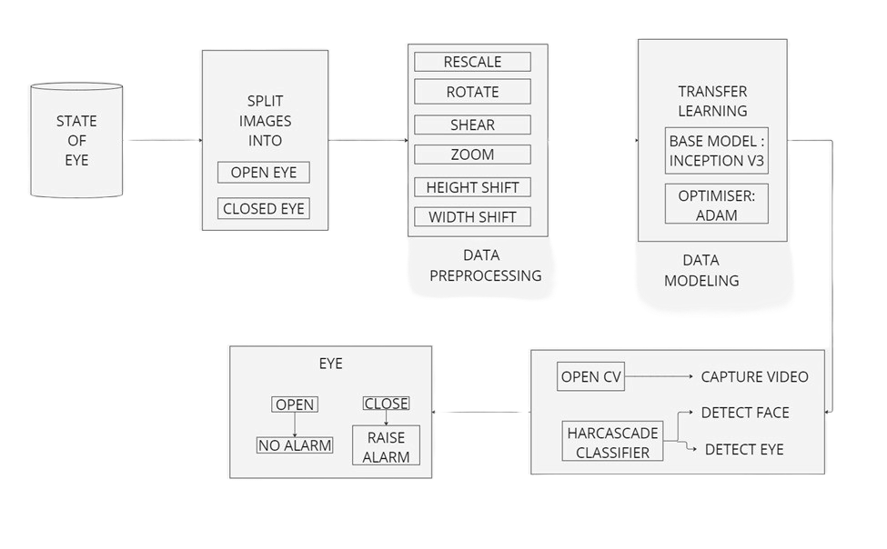



Fig1.Working of the detection system

# MODEL ARCHITECTURE:

**1.InceptionV3:**

A number of essential elements are combined in the model architecture of a drowsiness driver detection system that uses InceptionV3 to ensure accurate and effective real-time driver alertness monitoring. The system leverages Haar cascade classifiers for initial facial and eye state recognition and integrates OpenCV for real-time picture capture. These two methods provide crucial input to the InceptionV3-based model. With this configuration, the system may focus on the driver's face and eyes, which are the main signs of drowsiness, and isolate crucial regions of interest (ROIs).We have used transfer Learning with InceptionV3. The system employs a pre-trained InceptionV3 model, utilizing transfer learning to refine the model for sleepiness detection after separating the pertinent ROIs. This method extracts fine-grained features from the eye and face regions by utilizing InceptionV3's deep architecture and inception modules.The cropped ROIs are processed by the improved InceptionV3 model to extract important characteristics that point to symptoms of fatigue. These characteristics include the tired-looking state of the eyes (open or closed).A classification layer constructed using Keras, a high-level neural network toolkit coupled with TensorFlow, is a final component of the model design. This layer classifies the driver's state (e.g., alert or tired) using the characteristics extracted by InceptionV3. The final classification is usually produced using a softmax activation function and global average pooling.Based on the classification results, the system triggers an audible alert(alarm), if drowsiness is detected. The real-time nature of the system ensures that these alerts are issued promptly to reduce the risk of accidents due to driver fatigue.

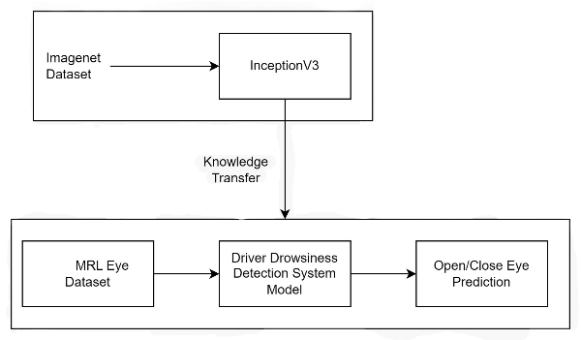

Fig2.Transfer learning using InceptionV3 as basemodel

**2.Approach 2: VGG16**

In order to create an driver detection system with VGG16, the model architecture must maintain similar properties while taking advantage of the simpler and more linear structure of VGG16. This architecture replaces the InceptionV3 model with VGG16, another popular Convolutional Neural Network (CNN) known for its deep but understandable design characterized by sequential 3x3 convolutional layers and 2x2 convergence layers. The following describes an alternative model architecture for sleep detection with VGG16:

Real-time image capture with OpenCV: The system starts by capturing real-time video feeds from a camera pointed at the driver's face. OpenCV, an open source computer vision library, is used to manage video capture and frame extraction, providing continuous monitoring.Detection of Faces and Eyes Using Haar Cascade Classifiers: After a frame is captured, Haar Cascade Classifiers are used to detect faces and eyes. These classifiers are computationally efficient, enabling rapid identification of facial regions that are then isolated for further processing.

Transfer learning with VGG16: After isolating the face and eye region, the system uses a pre-trained VGG16 model that uses transfer learning to tune the model to detect drowsiness. This approach allows rapid adaptation of the basic model to identify fatigue-related properties. The VGG16 architecture with stacked convolutions and pooling layers provides an easy way to extract important features from limited regions.

Feature extraction and classification using VGG16:A fine-tuned model, VGG16, processes the removed face and eye regions to detect patterns that indicate sleepiness, such as the degree of eye closure or facial muscle relaxation. Through consistent sequential convolutions and fusion, VGG16 can efficiently process these ROIs and create meaningful map objects.

Classification with Keras and TensorFlow: The final classification layer is implemented with Keras, an advanced neural network framework integrated with TensorFlow. This layer uses extracted features from VGG16 to classify the state of the driver as alert or sleepy. The structure usually involves global averaging, which simplifies feature maps for dense representation, and a softmax activation function for multiclass classification.

Real-time alerts for drowsiness detection:The system output will trigger an alarm or other alarm when drowsiness is detected. The linear structure and controllable computing requirements of the VGG16 enable the system to operate in real time and provide quick warnings to reduce the risk of accidents due to driver fatigue.This model architecture using the VGG16 to detect drowsiness provides a simplified solution but a powerful alternative to InceptionV3. It retains the critical features of real-time imaging, face and eye state detection, and efficient transfer learning using VGG16's uniform and simple convolutional layers for driver attention classification..

**Comparison of InceptionV3 and VGG16:**

The unique requirements and limits will choose which of the two sleepiness detection algorithms, InceptionV3 or VGG16, to use. The design of InceptionV3 is more intricate and adaptable, including Inception modules that enable dimensionality reduction and parallel processing, which could result in increased accuracy and computing efficiency. This makes it appropriate for applications that require the acquisition of a wider variety of visual features and have access to computing resources. However, VGG16 offers a more straightforward, linear design that may require more processing power due to its consecutive layers of 3x3 convolutions and pooling. This makes it easier to understand and change.VGG16 works best in situations where resource restrictions and simplicity are key considerations. While VGG16 works well in settings that favor clarity and adaptability, InceptionV3 may be a better option if you need to strike a compromise between efficiency and accuracy. Which method is "better" depends on your priorities: simplicity and ease of integration (VGG16) or computational efficiency and complicated feature extraction (InceptionV3).

# RESULTS:

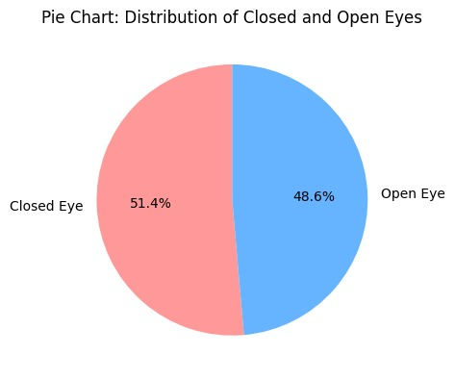

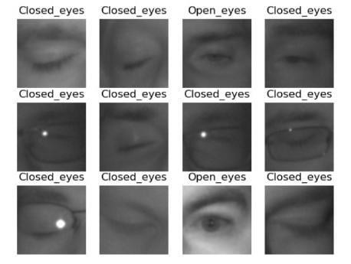

Fig3.Distribution of open and closed eyes in dataset

Fig4.Classification of dataset into

open eye and closed eye

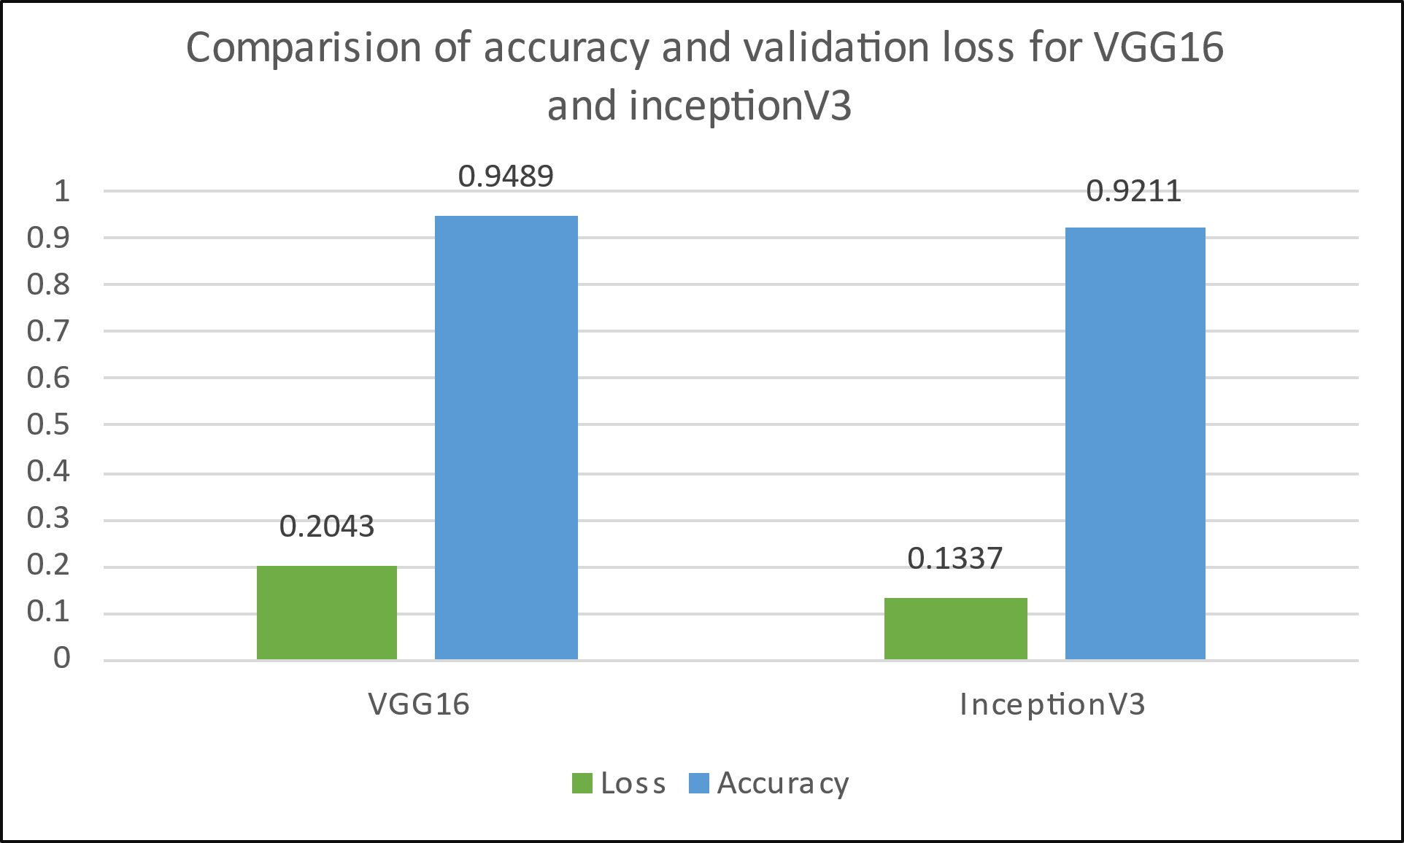

Fig 5.Comparison of accuracy and validation loss for VGG16 and InceptionV3

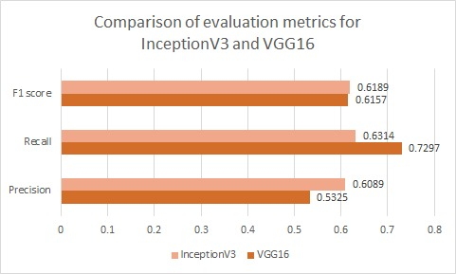

Fig6.Comparison of evaluation metrics(F1 score,Recall,Precision) for InceptionV3 and VGG16

|  |  |  |  |
| --- | --- | --- | --- |
|  | **Precision** | **Recall** | **F1 Score** |
| **Closed eye** | 0 | 0.7814 | 0.7558 |
| **Open eye** | 0.2773 | 0.2264 | 0.2493 |
| **Overall** | 0.6089 | 0 | 0.6189 |

Table1.Evaluation metrics for InceptionV3(preffered model)

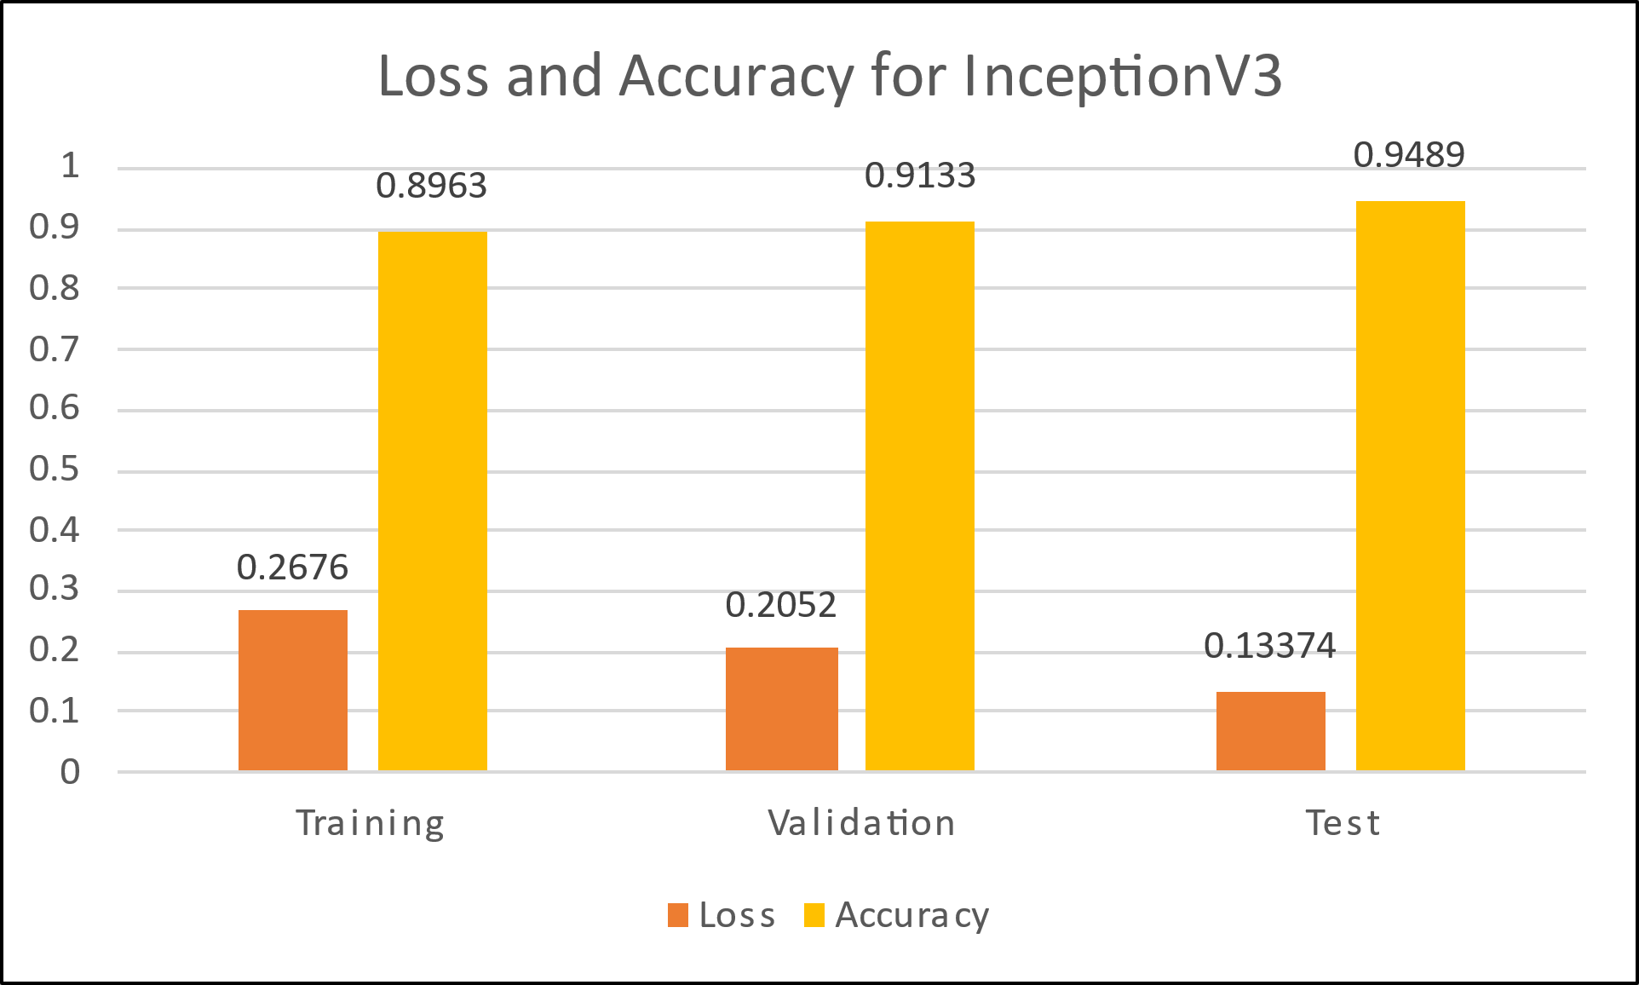

Fig7.Loss and accuracy for InceptionV3

|  |  |  |  |  |
| --- | --- | --- | --- | --- |
|  | **Title of Paper** | **Name of Authors** | **Dataset Used** | **Accuracy** |
| Ref.no. [2] | Real Time Driver Drowsiness Detection using Transfer learning | N. Gupta, F. Khan, and B. Saini | MRL eye dataset of 84923 images | 91.56% |
| Ref.no. [3] | Automatic System for Driver Drowsiness Detection System using Deep Learning | Sasi Preetham Ch, Shanmanth Guduru, Vinay Ronagala, Harisudha Kuresan, and Samiappan Dhanalakshmi | 87.4% |
| Ref.no. [5] | Driver Drowsiness Detection using Deep Learning | Y. Suresh, R. Khandelwal, M. Nikitha, M. Fayaz, and V. Soudhri, | 86.05% |
| Ref.no. [17] | Driver Drowsiness Detection using Deep Learning Eye Fatigue Algorithm for Driver Drowsiness Detection System | Teik Jin Lim, Hung Yang Leong, Jia Yew Pang, and M. Juhari | 92.5% |
| Our proposed model | Drowsy Driver Detection System |  | 95.46% |

Table 2.Cross comparison for existing models on same dataset with our proposed model

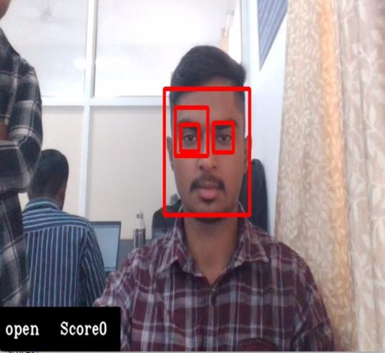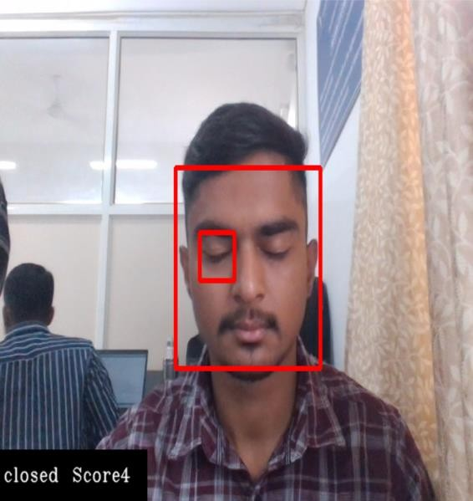

Fig8.Closed eye state Fig9.Open eye state and raising of alarm

# CONCLUSION:

In conclusion, the use of TensorFlow and OpenCV for drowsiness detection demonstrates how computer vision and machine learning may be applied to real-world safety issues. These technologies offer an essential additional level of security in sectors like transportation and healthcare since they can identify early indicators of sleepiness in real time. Future advancements in drowsiness detection for drivers will focus on improving real-time processing with faster algorithms, reducing false positives and negatives. Privacy concerns will be addressed with secure handling of facial data. Adaptive systems will enhance accuracy by accommodating individual differences. Innovative neural network architectures will improve understanding of video data. Data augmentation and transfer learning from large datasets will boost accuracy. Human factors research will optimize systems for various lighting, demographics, and environmental factors. Integrating drowsiness detection with Advanced Driver Assistance Systems (ADAS) could lead to proactive alerts and interventions, enhancing road safety. Through the use of sophisticated neural network topologies and adaptive algorithms, these technologies provide a reliable and effective method of lowering the likelihood of accidents brought on by driver weariness. Drowsiness detection systems can reduce false positives and negatives by emphasizing efficiency and precision, which increases their dependability for daily use. Ultimately, these innovations represent a significant step forward in promoting safety and reducing the risks associated with drowsiness, creating a safer experience for drivers and other stakeholders.

# REFERANCES:

[1] S. Ramesh, R. Jain, and Sanjay Tippannavar, “RTD3 – Real Time Driver Drowsiness Detection System Using CNN on Inception V3 Model,” *International journal of innovative research in advanced engineering*, vol. 10, no. 03, pp. 106–111, Mar. 2023, doi: <https://doi.org/10.26562/ijirae.2023.v1003.09>.

[2] N. Gupta, F. Khan, and B. Saini, “Real Time Driver Drowsiness Detecion using Transfer learning,” Jan. 2023, doi: <https://doi.org/10.1109/icct56969.2023.10075913>.

[3] Sasi Preetham Ch, Shanmanth Guduru, Vinay Ronagala, Harisudha Kuresan, and Samiappan Dhanalakshmi, “Automatic System for Driver Drowsiness Detection System using Deep Learning,” Jan. 2023, doi: <https://doi.org/10.1109/iconat57137.2023.10080067>.

[4]J. R and C. Jacob, “Deep CNN Based Approach for Driver Drowsiness Detection,” *IEEE Xplore*, Dec. 01, 2022. <https://ieeexplore.ieee.org/document/10059547>

[5]Y. Suresh, R. Khandelwal, M. Nikitha, M. Fayaz, and V. Soudhri, “Driver Drowsiness Detection using Deep Learning,” *2021 2nd International Conference on Smart Electronics and Communication (ICOSEC)*, Oct. 2021, doi: <https://doi.org/10.1109/icosec51865.2021.9591957>.

[6] Mohammad Elham Walizad, Mehreen Hurroo, and Divyashikha Sethia, “Driver Drowsiness Detection System using Convolutional Neural Network,” Apr. 2022, doi: <https://doi.org/10.1109/icoei53556.2022.9777182>.

[7]A. Aytekin and V. Mençik, “Detection of Driver Dynamics with VGG16 Model,” *Applied Computer Systems*, vol. 27, no. 1, pp. 83–88, Jun. 2022, doi: <https://doi.org/10.2478/acss-2022-0009>.

[8] P. Kumar and S. A. M, “Driver Behavior Analysis Using Deep Learning,” *2022 International Conference on Computer Communication and Informatics (ICCCI)*, Jan. 2022, doi: <https://doi.org/10.1109/iccci54379.2022.9740778>.

[9]Farshad Farahnakian, Janika Leoste, and Fahimeh Farahnakian, “Driver Drowsiness Detection Using Deep Convolutional Neural Network,” *2021 International Conference on Electrical, Computer, Communications and Mechatronics Engineering (ICECCME)*, Oct. 2021, doi: <https://doi.org/10.1109/iceccme52200.2021.9591029>.

[10] P. D. Purnamasari, A. Kriswoyo, A. A. P. Ratna, and D. Sudiana, “Eye Based Drowsiness Detection System for Driver,” *Journal of Electrical Engineering & Technology*, vol. 17, no. 1, pp. 697–705, Oct. 2021, doi: <https://doi.org/10.1007/s42835-021-00925-z>.

[11] D. R. S. Victoria and D. G. R. Mary, “Driver Drowsiness Monitoring using Convolutional Neural Networks,” *IEEE Xplore*, Feb. 01, 2021. <https://ieeexplore.ieee.org/document/9397070/>

[12] Ioana-Raluca Adochiei *et al.*, “Drivers’ Drowsiness Detection and Warning Systems for Critical Infrastructures,” Oct. 2020, doi: <https://doi.org/10.1109/ehb50910.2020.9280165>.

[13]M. Dua, Shakshi, R. Singla, S. Raj, and A. Jangra, “Deep CNN models-based ensemble approach to driver drowsiness detection,” *Neural Computing and Applications*, Jul. 2020, doi: <https://doi.org/10.1007/s00521-020-05209-7>.

[14]M. Ahmed, S. Masood, M. Ahmad, and A. A. A. El-Latif, “Intelligent Driver Drowsiness Detection for Traffic Safety Based on Multi CNN Deep Model and Facial Subsampling,” *IEEE Transactions on Intelligent Transportation Systems*, pp. 1–10, 2021, doi: <https://doi.org/10.1109/tits.2021.3134222>.

[15]W. AlKishri, A. Abualkishik, and M. Al-Bahri, “Enhanced Image Processing and Fuzzy Logic Approach for Optimizing Driver Drowsiness Detection,” *Applied Computational Intelligence and Soft Computing*, vol. 2022, pp. 1–14, Mar. 2022, doi: <https://doi.org/10.1155/2022/9551203>.

[16] Ms. K. G. Walke, H. Shete, A. Mulani, D. Asknani, and R. Gadekar, “Driver Drowsiness Detection System Using Machine Learning,” *International Journal for Research in Applied Science and Engineering Technology*, vol. 10, no. 5, pp. 4306–4310, May 2022, doi: <https://doi.org/10.22214/ijraset.2022.43105>.

[17]Teik Jin Lim, Hung Yang Leong, Jia Yew Pang, and M. Juhari, “Eye Fatigue Algorithm for Driver Drowsiness Detection System,” *Advances in intelligent systems and computing*, pp. 638–652, Jul. 2020, doi: <https://doi.org/10.1007/978-3-030-51859-2_58>.

[18] Shaik Tousif, Abdul Saboor, Ahmed, and Sumayya Begum, “Detecting Driver Sleepiness using Convolutional Neural Networks,” *International journal of innovative research in engineering & multidisciplinary physical sciences*, vol. 11, no. 1, Jan. 2023, doi: <https://doi.org/10.37082/ijirmps.v11.i1.230318>.

[19] M. Omidyeganeh, A. Javadtalab, and S. Shirmohammadi, “Intelligent driver drowsiness detection through fusion of yawning and eye closure,” *IEEE Xplore*, Sep. 01, 2011. <https://ieeexplore.ieee.org/abstract/document/6053857>

[20] H. Nirwan, “Driver Drowsiness Detection using Machine Learning,” *INTERANTIONAL JOURNAL OF SCIENTIFIC RESEARCH IN ENGINEERING AND MANAGEMENT*, vol. 06, no. 12, Dec. 2022, doi: <https://doi.org/10.55041/ijsrem17295>.

# ACKNOWLEDGMENT:

We would like to express our sincere gratitude to the creators of the Mrleye dataset for providing valuable resources for our research. Additionally, we extend our appreciation to the contributors of open-source libraries and frameworks that were instrumental in the development and implementation of our methodology.