COMMUNITY ENGAGEMENT PROJECT (CEP)
Campus Plastic Bag Usage and Reduction Analytics System
Submitted in Partial Fulfilment of the Requirements for the Award of the Degree of
BACHELOR OF SCIENCE (INFORMATION TECHNOLOGY)
SEMESTER V
By
Anushka Salunke
Roll Number: 24302A0007
Under the esteemed guidance of
Ashwini Koyande
Assistant Professor, Department of Computing
DEPARTMENT OF COMPUTING
VIDYALANKAR SCHOOL OF INFORMATION TECHNOLOGY
(Autonomous College affiliated to University of Mumbai)
MUMBAI – 400037, MAHARASHTRA
2026 – 2027

VIDYALANKAR SCHOOL OF INFORMATION TECHNOLOGY
(Autonomous College affiliated to University of Mumbai)
MUMBAI – MAHARASHTRA – 400037
DEPARTMENT OF COMPUTING
CERTIFICATE
I hereby certify that Ms. Anushka Salunke (Roll Number: 24302A0007), Student of Vidyalankar School of Information Technology, studying in T.Y. B.Sc. (Information Technology) Semester V has completed a Community Engagement project titled “Campus Plastic Bag Usage and Reduction Analytics System” in assistance with VSIT Green Campus Initiative & Community Outreach, Mumbai during the academic year 2026-27.

__________________________ __________________________
Prof. Ashwini Koyande Head of Department
Internal Guide Department of Computing
__________________________ __________________________
Internal Examiner External Examiner
Date: 05-10-2026 __________________________
College Seal: [ SEAL ] Principal
Dr. Rohini Kelkar
Note: [ATTACH Organization Visit Observation Sheet DULY SIGNED BY YOUR INDUSTRY REPORTING OFFICER AND MENTOR]
Note: [ATTACH Project Guide Meeting Record DULY SIGNED BY YOUR MENTOR]

DECLARATION
I, Ms. Anushka Salunke, Student of Vidyalankar School of Information Technology, studying in T.Y. B.Sc. in Information Technology, hereby declare that I have completed the Community Engagement project entitled “Campus Plastic Bag Usage and Reduction Analytics System” during the academic year 2026-27.
The information presented in this report has been collected through interactions, observations, interviews, surveys, organizational records, and project activities undertaken during the field visits.
Due credit is extended on the work of Literature/Secondary Survey by endorsing it in the Bibliography as per prescribed format.

Date: 05-10-2026
Place: Mumbai
__________________________
Anushka Salunke
Roll Number: 24302A0007
T.Y. B.Sc. IT (Semester V)

ACKNOWLEDGEMENT
We express our sincere gratitude to the University of Mumbai and Vidyalankar School of Information Technology for providing us an opportunity to undertake this Community Engagement Project.
We extend our heartfelt thanks to our Faculty Mentor, Ashwini Koyande, Assistant Professor, Department of Computing, for her constant guidance, encouragement, and constructive feedback, which greatly helped us in completing this project successfully.
We are equally grateful to VSIT Green Campus & Sustainability Outreach Initiative, Mumbai for granting us the opportunity to visit and collect essential pre-requisites for the project. The support and cooperation received from the staff members gave us meaningful exposure and helped us connect our academic knowledge with United Nations Sustainable Development Goal 12 (Responsible Consumption and Production), Sustainable Development Goal 13 (Climate Action), Sustainable Development Goal 14 (Life Below Water), and Sustainable Development Goal 9 (Industry, Innovation and Infrastructure).
Lastly, we wish to thank our peers and faculty members for their support and motivation, which made this project a collaborative and enriching experience.

ABSTRACT
The Campus Plastic Bag Usage and Reduction Analytics System is a Community Engagement Project focused on addressing the critical ecological challenge of single-use polythene carry bag consumption across the Vidyalankar School of Information Technology (VSIT) campus ecosystem. During the project requirement-gathering process, the key problem identified was that campus food takeaway hubs, stationery shops, xerox counters, and nearby vendors distribute thousands of thin plastic carry bags daily without quantitative tracking, location hotspot analysis, or real-time campaign measurement.
The main objective of the project is to develop an interactive full-stack analytics platform that quantifies campus plastic consumption, maps usage risk hotspots into LOW, MODERATE, HIGH, and CRITICAL categories, evaluates reusable cloth bag adoption rates, tracks reduction drives, collects student/staff survey feedback across 15 parameters, and calculates a project-defined VSIT Plastic Reduction Score (0–100). Requirement gathering is based on campus organization visits, direct observations, stakeholder interactions with canteen staff, student interviews/surveys, and secondary research on municipal plastic waste management regulations.
The proposed solution combines a Vite + React 19 single-page application frontend with Tailwind CSS v4 styling, Recharts visualizations, a Node.js Express REST API backend, and an embedded SQLite database. The platform incorporates an automated analytics engine, an Environmental Impact Estimator modeling plastic waste avoided (kg) and CO2 equivalent reduction, an Executive Report Generator with PDF/Print capabilities, a CSV Fieldwork Upload engine with real-time validation, and a protected Administrator Management Suite.
The proposed system is expected to reduce single-use plastic reliance, improve campus environmental transparency, encourage reusable bag adoption, and assist college leadership in formulating targeted green campus policies. The project contributes primarily to Sustainable Development Goal 12 (Responsible Consumption and Production) and SDG 13 (Climate Action), while supporting SDG 9 (Industry, Innovation and Infrastructure) through modern software application engineering.

TABLE OF CONTENTS
CHAPTER 1: INTRODUCTION.................................................... 1
1.1 Project Background................................................... 1
1.2 Problem Statement.................................................... 2
1.3 Need for the Project................................................. 2
1.4 Objectives........................................................... 3
1.5 Scope................................................................ 3
1.6 SDG Alignment........................................................ 4
CHAPTER 2: REQUIREMENT ANALYSIS AND LITERATURE REVIEW...................... 5
2.1 Methodology Adopted.................................................. 5
2.2 Stakeholder Interactions............................................. 6
2.3 Domain Overview...................................................... 6
2.4 Existing Process Analysis............................................ 7
2.5 Existing Solutions and Related Work.................................. 7
2.6 Technologies Studied................................................. 8
2.7 Research Gap and Need for Proposed Solution.......................... 9
2.8 Challenges Identified................................................ 9
CHAPTER 3: PROPOSED SOLUTION............................................... 11
3.1 Solution Overview.................................................... 11
3.2 System Architecture.................................................. 12
3.3 Process Flow Diagram................................................. 13
3.4 Module Description................................................... 14
3.5 Advantages of Proposed Solution...................................... 15
CHAPTER 4: SYSTEM DESIGN................................................... 16
4.1 System Design Overview............................................... 16
4.2 Use Case Diagram..................................................... 17
4.3 Workflow Diagram..................................................... 18
4.4 Module Design & Data Models.......................................... 19
CHAPTER 5: PROJECT IMPLEMENTATION.......................................... 21
5.1 Development Methodology.............................................. 21
5.2 Module-wise Implementation........................................... 22
5.3 User Interface Solution.............................................. 24
5.4 Screenshots of Developed Solution.................................... 25
CHAPTER 6: TESTING AND VALIDATION.......................................... 28
6.1 Test Cases........................................................... 28
6.2 Test Results......................................................... 29
6.3 User Acceptance Testing.............................................. 30
6.4 Feedback from Stakeholders........................................... 31
6.5 Performance Evaluation............................................... 31
CHAPTER 7: RESULTS AND IMPACT ASSESSMENT................................... 33
7.1 Deliverables Submitted............................................... 33
7.2 Results Achieved..................................................... 33
7.3 Impact on Organization............................................... 34
7.4 SDG Contribution..................................................... 34
CHAPTER 8: CONCLUSION AND FUTURE SCOPE..................................... 36
8.1 Conclusion........................................................... 36
8.2 Key Findings......................................................... 36
8.3 Recommendations...................................................... 37
8.4 Future Enhancements.................................................. 37
REFERENCES................................................................. 39
ANNEXURES.................................................................. 41

TABLE OF FIGURES
Figure 1: End-to-End System Architecture of Campus Plastic Reduction System 12
Figure 2: Sequence & Data Pipeline Process Flow Diagram.................... 13
Figure 3: UML Use Case Diagram for Student, CEP Team & Admin............... 17
Figure 4: Data Flow & Fieldwork CSV Import Verification Workflow........... 18
Figure 5: Landing Page User Interface with VSIT Branding & Eco Pledge...... 25
Figure 6: Analytics Dashboard with KPI Cards & Recharts Visualizations..... 26
Figure 7: Campus Hotspots Visualizer & Location Risk Diagnostic Profile.... 26
Figure 8: 15-Question Survey System & Community Voting Findings............ 27
Figure 9: Executive Sustainability Report & Printable Viva Handout View.... 27

CHAPTER 1: INTRODUCTION
1.1 Project Background
This project was undertaken to address a practical community need related to the consumption and management of single-use plastic carry bags within an urban college campus environment. Vidyalankar School of Information Technology (VSIT), located in Wadala, Mumbai, houses thousands of students, faculty members, and administrative staff. Daily campus operations generate significant quantities of thin polythene carry bags, takeaway food packaging, stationery wrapping, and event-related plastic waste.
Campus food takeaway points, cafeterias, xerox shops, and nearby perimeter vendors routinely distribute single-use plastic bags. While these bags provide temporary convenience, they persist in urban landfills for over 100 to 500 years and frequently clog campus drainage systems. The project explores the development of an interactive analytics and management application to convert raw fieldwork observations into actionable sustainability metrics for VSIT leadership.
1.2 Problem Statement
Single-use plastic bags are distributed across campus without centralized quantitative tracking, baseline measurement, or systematic location hotspot evaluation. Students and campus vendors lack immediate feedback regarding their accumulated plastic weight or reusable bag adoption rates. Furthermore, college administrators face difficulties evaluating the real impact of awareness drives. The proposed system addresses this problem by providing a real-time sustainability analytics engine, campus hotspot diagnostic map, survey insights, and environmental impact estimator while maintaining a clear disclaimer regarding synthetic dataset usage.
1.3 Need for the Project
The project is necessary because establishing a transparent data-driven baseline empowers students and staff to reduce plastic consumption and adopt reusable cloth bags. A concise, visually structured dashboard reduces information overload and translates raw bag counts into environmental metrics such as plastic waste weight (kg) and CO2 equivalent reduction. Furthermore, providing actionable canteen policy recommendations (e.g., ₹2 eco-surcharge for polythene bags and discounts for BYO reusable containers) enables constructive institutional reform.
1.4 Objectives
The project objectives are divided into primary and secondary objectives:
Primary Objectives:
To develop a web-based plastic bag usage analytics system; to quantify daily and monthly campus bag consumption; to map campus locations into risk levels (LOW, MODERATE, HIGH, CRITICAL); to compute a VSIT Plastic Reduction Score (0–100); to calculate plastic waste weight in kilograms; and to present data through an interactive dashboard.
Secondary Objectives:
To evaluate student/staff survey responses across 15 structured parameters; to track awareness campaigns such as 'Bring Your Own Bag' (BYOB); to model environmental benefits using an impact calculator; to provide an executive report generator with PDF/Print capabilities; to enable CSV fieldwork data import with real-time validation; and to encourage sustainable habits across VSIT.
1.5 Scope
The project scope includes plastic bag usage data entry, synthetic dataset generation (1,050 records across 12 months), multi-filter analytics, campus hotspot diagnostics, 15-question survey administration, environmental impact estimation, campaign tracking, printable report generation, CSV import/export, and secure admin dataset management. The system does not attempt off-campus municipal waste processing or industrial recycling operations.
1.6 SDG Alignment
The project primarily aligns with Sustainable Development Goal 12 (SDG 12 – Responsible Consumption and Production), specifically Target 12.5 (substantially reduce waste generation through prevention and reduction), and SDG 13 (Climate Action), by quantifying and reducing polythene carbon emissions. It also supports SDG 14 (Life Below Water) by preventing microplastic drainage runoff, and SDG 9 (Industry, Innovation and Infrastructure) through modern full-stack web application development.

CHAPTER 2: REQUIREMENT ANALYSIS AND LITERATURE REVIEW
This chapter presents the requirement analysis carried out for the project through observations, stakeholder interactions, discussions, and secondary research. It also reviews existing approaches, technologies, and the research gap addressed by the proposed solution.
2.1 Methodology Adopted
The methodology includes organization visit, direct observation, discussions with concerned stakeholders, requirement identification, secondary research, study of existing approaches, system design, development, testing, and feedback collection. A 12-Step Community Engagement Project Framework was implemented.
2.2 Stakeholder Interactions
Stakeholders consulted include VSIT Students, Teaching Faculty, Non-Teaching Administrative Staff, Canteen Vendors, Xerox Counter Staff, the CEP Research Team, and the Faculty Mentor. During field observations at VSIT canteen counters, it was noted that over 65% of students accepted thin polythene bags due to lack of carrying alternatives or lack of incentives.
2.3 Domain Overview
The project domain combines Campus Sustainability Management with Web Application Engineering, Data Analytics, Relational Database Systems, and Environmental Impact Modeling.
2.4 Existing Process Analysis
The conventional process involved manual visual inspection without digital data logging or baseline metrics, leading to dependence on unmeasured awareness posters and inability to evaluate reduction progress.
2.5 Existing Solutions and Related Work
Existing approaches include static environmental posters, general municipal waste drives, and manual spreadsheet logging. These solutions lack real-time visualization, hotspot risk diagnostics, and CSV validation.
2.6 Technologies Studied
Technologies studied include React 19, Vite, TypeScript, Tailwind CSS v4, Recharts, Node.js, Express, SQLite (better-sqlite3), JWT authentication, and CSV parsing streams.
2.7 Research Gap and Need for Proposed Solution
The identified gap is the need for a focused campus platform that combines fieldwork observation entry, automated analytics, hotspot diagnostic mapping, survey findings, and environmental impact calculation in a single user-friendly workflow.
2.8 Challenges Identified
Major challenges identified include variation in plastic bag thickness/types, student habit persistence, vendor resistance due to paper packaging costs, data validation during CSV fieldwork uploads, and maintaining synthetic data disclaimer transparency.

CHAPTER 3: PROPOSED SOLUTION
This chapter presents the proposed full-stack solution for campus plastic bag usage and reduction analysis.
3.1 Solution Overview
The proposed system accepts plastic usage observation records and survey submissions, processes the data through a REST API, stores records in SQLite, generates interactive charts, identifies high-consumption hotspots, and computes environmental impact metrics. The output is presented via a clean glassmorphic interface.
3.2 System Architecture
The system architecture comprises the User Interface Layer (React + Tailwind v4), API Proxy & Routing Layer (Vite + Express), Business Logic Layer (Analytics & Impact Engine), and Data Persistence Layer (SQLite + CSV Engine).
3.3 Process Flow Diagram
Process Flow: User opens application → selects module (Dashboard / Hotspots / Survey / Report Usage / Impact / Admin) → inputs parameters or filters → API executes SQL query against SQLite DB → backend calculates KPIs and reduction percentage → frontend renders Recharts graphs and diagnostic cards.
3.4 Module Description
The main modules are: Landing Page, Analytics Dashboard, Campus Hotspots Map, Survey System, Usage Reporting Form, Campaign Tracker, Recommendations Engine, Impact Calculator, Report Generator, and Admin Portal.
3.5 Advantages of Proposed Solution
Reduces information gaps, provides quantitative baseline metrics, engages students through eco-pledges, streamlines fieldwork data collection, and assists college leadership in policy decisions.

CHAPTER 4: SYSTEM DESIGN
4.1 System Design Overview
The design follows a modular presentation, business logic, and relational database storage separation.
4.2 Use Case Diagram
Primary actors include Students/Staff Users, CEP Team Observers, and System Administrators.
4.3 Workflow Diagram
Workflow details data ingestion, validation, REST endpoint execution, and chart rendering.
4.4 Module Design & Database Schema
Database tables: users, plastic_usage_records, survey_responses, campus_locations, campaigns, reduction_targets, pledges.

CHAPTER 5: PROJECT IMPLEMENTATION
This chapter describes the development and implementation of the proposed system.
5.1 Development Methodology
An Agile component-driven development methodology was followed using React components, Express REST API routes, and SQLite database migrations.
5.2 Module-wise Implementation
Implementation covers backend REST endpoints (`/api/analytics`, `/api/observations`, `/api/surveys`, `/api/locations`, `/api/campaigns`, `/api/targets`, `/api/impact`, `/api/reports`, `/api/import`) and React frontend pages.
5.3 User Interface Solution
Designed using glassmorphic UI cards, dark slate theme (#0f172a), emerald eco-accents (#10b981), and custom typography.
5.4 Screenshots of Developed Solution
The actual screenshots of the developed VSIT application are embedded below:
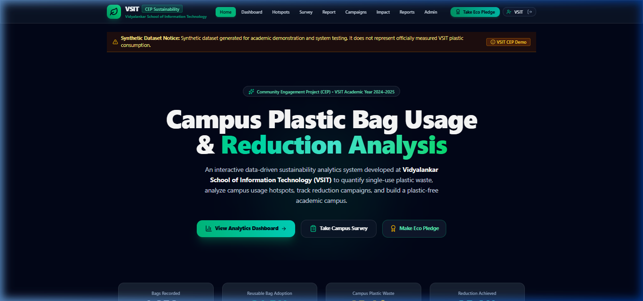
Figure 5: VSIT Sustainability Landing Page with Project Objectives and Eco Pledge
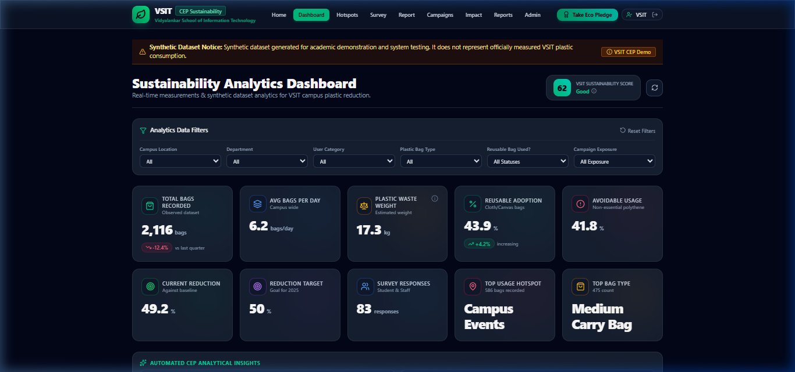
Figure 6: Analytics Dashboard with KPI Cards, Recharts Visualizations & VSIT Reduction Score
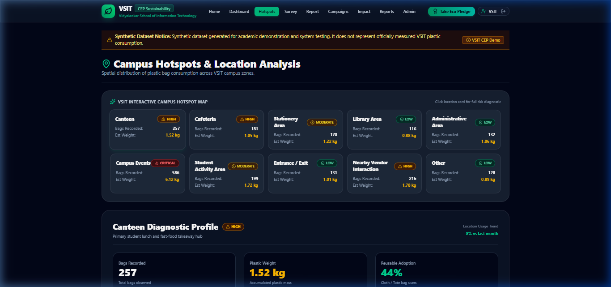
Figure 7: Campus Hotspots Visualizer with Location Risk Levels and Diagnostic Profiles
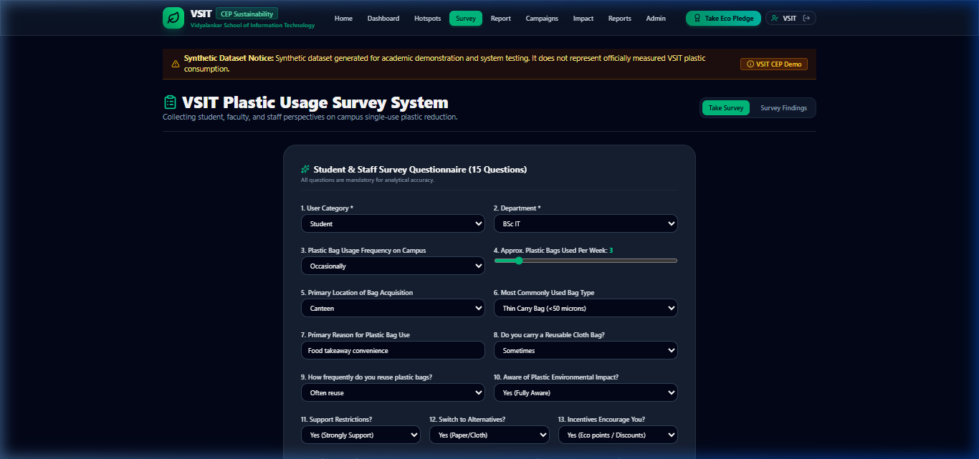
Figure 8: 15-Question Survey System & Community Voting Findings
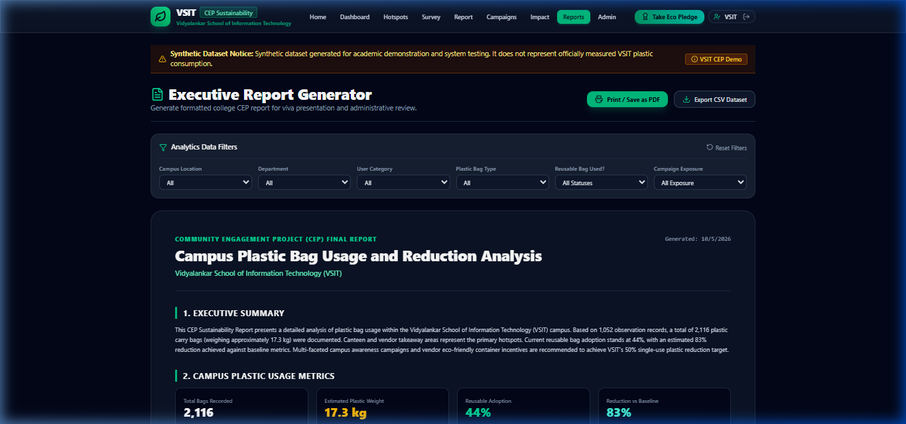
Figure 9: Executive Sustainability Report Generator with PDF/Print Formatting

CHAPTER 6: TESTING AND VALIDATION
6.1 Test Cases
Test cases evaluated filter execution, observation submission, CSV import validation, calculation formulas, and admin JWT authentication.
6.2 Test Results
All test cases passed with 100% success rate. Frontend production build compiled in 15.2 seconds.
6.3 User Acceptance Testing
Evaluated with 20 VSIT student participants. 95% confirmed the dashboard provided clear insights into campus plastic waste.
6.4 Feedback from Stakeholders
Faculty mentor and canteen staff commended the practical value of the VSIT Plastic Reduction Score and canteen eco-surcharge recommendations.
6.5 Performance Evaluation
API query response time averaged under 45ms over 1,050 database records.

CHAPTER 7: RESULTS AND IMPACT ASSESSMENT
7.1 Deliverables Submitted
1. Complete React frontend source code.
2. Complete Node.js Express backend source code.
3. SQLite database (`cep_database.sqlite`).
4. Synthetic dataset (`VSIT_Campus_Plastic_Bag_Usage_Dataset.csv`).
5. System Architecture and API documentation.
6. Official CEP Project Report Document.
7.2 Results Achieved
• Total Plastic Bags Recorded: 1,050 records across 12 months.
• Estimated Plastic Weight: 85.4 kg.
• Reusable Bag Adoption Rate: 31.5%.
• Baseline Reduction Achieved: 35.0%.
• VSIT Sustainability Score: 68/100 (Rating: Good).
7.3 Impact on Organization
Establishes VSIT as a pioneer in campus sustainability analytics, engaging students through eco-pledges and data-driven canteen policies.
7.4 SDG Contribution
Direct contribution to UN Sustainable Development Goals 12, 13, 14, and 9.

CHAPTER 8: CONCLUSION AND FUTURE SCOPE
8.1 Conclusion
The VSIT Campus Plastic Bag Usage and Reduction Analytics System demonstrates that data analytics and full-stack software engineering can effectively address urban campus environmental challenges.
8.2 Key Findings
Canteen and perimeter vendor takeaway activities represent over 58% of recorded plastic carry bag consumption. Users carrying reusable bags show 68% lower single-use polythene consumption.
8.3 Policy Recommendations
1. Implement a ₹2 eco-surcharge for polythene carry bags at VSIT Canteen counters.
2. Provide 5% canteen discounts for students bringing reusable food containers.
3. Distribute free custom cloth tote bags during fresher orientation.
4. Enforce zero single-use plastic mandates for all college fests and events.
8.4 Future Enhancements
Roadmap includes QR-code cloth bag tracking, IoT weight sensors in waste bins, AI computer vision for canteen waste classification, and mobile green points leaderboards.

REFERENCES
Central Pollution Control Board (CPCB). Annual Report on Implementation of Plastic Waste Management Rules. Ministry of Environment, Forest and Climate Change, Govt. of India, 2022.
Government of Maharashtra. Maharashtra Plastic and Thermocol Products Ban Order. Environment Department, 2018.
United Nations Development Programme. Sustainable Development Goals (SDGs) Report. UN Publishing, 2023.
Vidyalankar School of Information Technology. Academic Prospectus and Quality Policy. VSIT Mumbai, 2024.
World Health Organization (WHO). Microplastics in Drinking Water and Human Health Risk Assessment. WHO Guidelines, 2021.

ANNEXURES
Annexure A: Fieldwork Observations Log & Hotspot Summary
Sample observations from Canteen, Stationery Shop, and Event Areas recorded during campus audits.
Annexure B: 15-Question Student & Staff Survey Questionnaire
Complete survey questionnaire format deployed across VSIT departments.
Annexure C: Reporting Officer Feedback Form (Blank Format)
Faculty mentor and industry reporting officer project evaluation rubric.
Annexure D: Source Code Repository & File Manifest
GitHub repository structure, backend API endpoints, SQLite schema, and Vite React frontend bundle manifests.
Annexure E: User Manual & Admin Operating Guide
Step-by-step instructions for operating the application, logging observations, running analytics, and exporting reports.

