Adapt AI — Product Requirements Document
AI-native platform-specific content adaptation with A/B variant generation and rationale

User and Pain Point
In-house social leads at AI-forward B2B companies (Series B–D, 1–3 marketers, 4–5 platforms). Spend 2–3 hrs rewriting 1 post for 5 platforms — mechanical work needing platform fluency, not strategy. Existing tools cross-post or trim. Alternative: $100–150K hire for reformatting. ICP has budget ($16–20K/yr), recurring need, validated WTP.
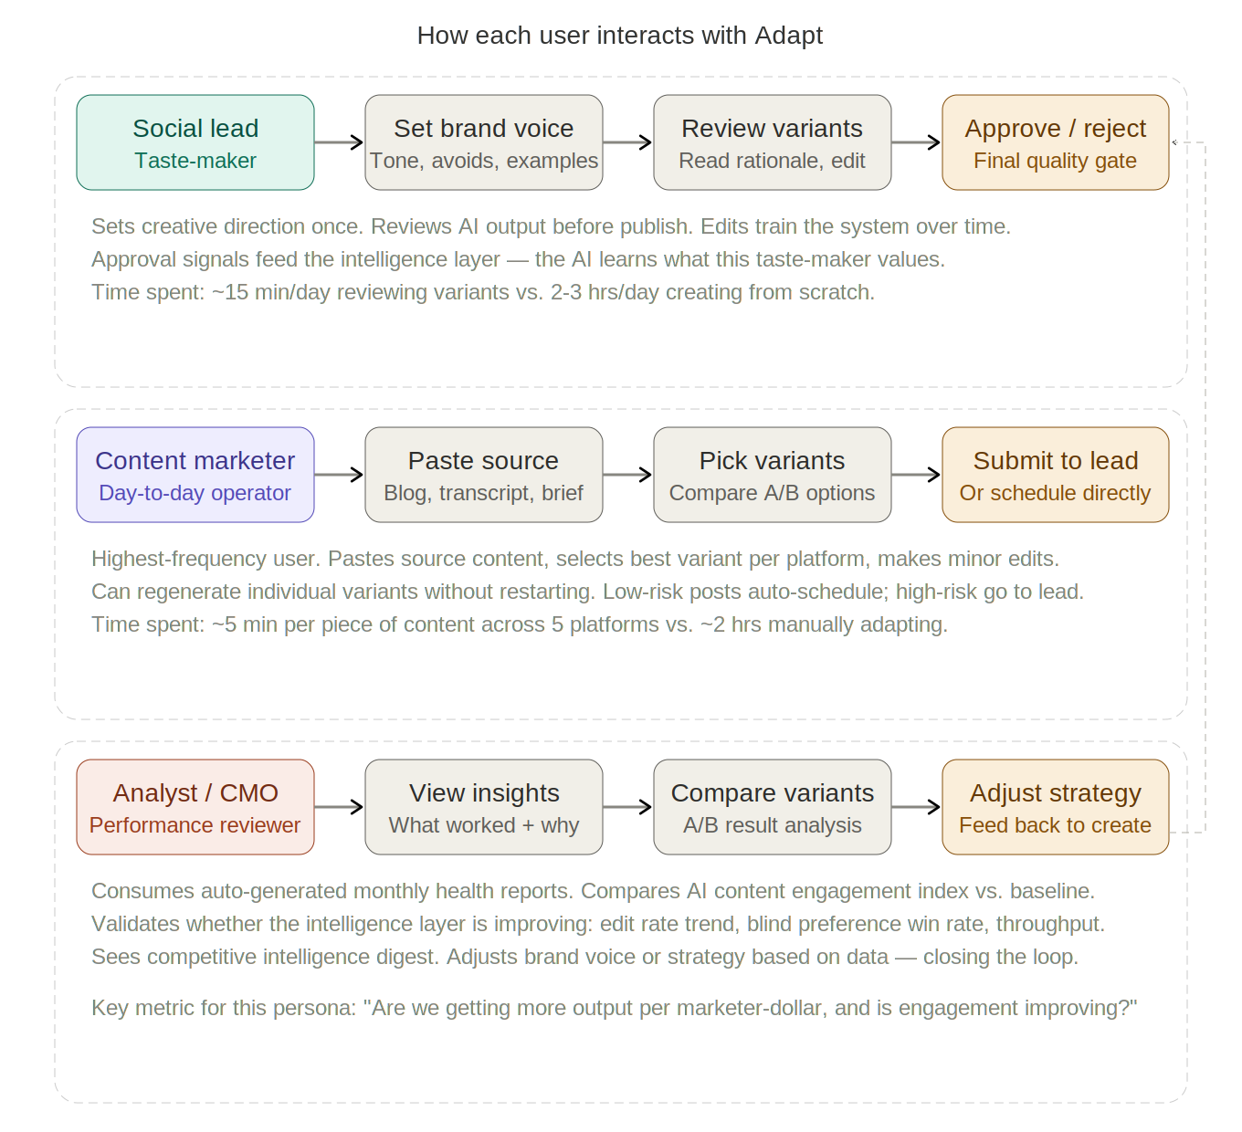

Market Wedge
Not generation — every AI tool does that. Adapt’s wedge is 3 compounding levers:
Lever | What | Why | How
Improved performance | - Content re-created per platform’s ranking function  - 2–3 A/B variants per platform  - Improves via engagement feedback | - Incumbents cross-post or trim  - Invisible algorithmic rules (LI dwell, X link penalties, TT completion)  - Cross-posted content gets buried | - Platform Signal Registry: pre-built + custom + cross-brand learned rules  - Re-creates, not reformats — learns from edits + engagement per-brand  - A/B tests hooks; engagement index vs. baseline from day 1
Faster time to final draft | - 1 source → 5 drafts in <5 min  - Reusable workflows with per-platform composition  - Human review built into DAG | - Overstaffed for throughput, understaffed for strategy  - Mechanical adaptation is the bottleneck  - 1 person × 3 people’s work = ROI vs. $150K hire | - Pipelines: source → composition (voice+agent+audience+rules) → gen → review → publish  - Human checkpoints configurable per content type  - Auto-scheduling from per-brand engagement data
Insight into what works and why | - Rationale for every variant  - Post-publish prediction tracking  - Intelligence compounds per-brand | - No incumbent closes creation → analytics loop  - Insights don’t flow back to creative  - Buyers want reasoning, not just output | - Rationale + engagement attributed to content features  - Per-brand learning refines recommendations  - Accumulated intelligence = switching costs = moat

MVP Scope
1 source → adapted outputs for LI, X, IG, TT, FB. Platform-native adaptation with signal encoding. 2–3 A/B variants per platform with rationale. Accept/edit/regenerate per-variant. Side-by-side comparison.

Sequencing
Phase | Scope | Why This Order
MVP | Adaptation + A/B with rationale, 5 channels | Content flowing. A/B rationale seeds intelligence.
V1 | Brand voice learning + analytics baseline | Capture what performs. Backfill 6–12mo at onboarding.
V1.5 | Intelligence feedback loop + health report | Moat compounds. Switching costs grow.
V2 | Experimentation, scheduling, inbox | Requires volume + data. Multiplies the loop.
V3 | Ads, agency support, creator tier | Organic is the wedge; ads are the budget.

Why A/B With Rationale as Depth Area

- Demonstrates quality + measurement instinct. Rationale = system showing reasoning = enterprise trust.
- Seeds the intelligence layer. Engagement data makes rationale predictions testable. That loop is the moat.
- Validated by enterprise buyers. Compatible with all future depth areas.

Product Metrics
Organized by market wedge lever. Leading indicators (per-run) to lagging indicators (compounding over months).
Lever | Metric | What It Measures | Target | Why It Matters
Improved performance | Engagement index | Avg engagement of Adapt content vs. pre-Adapt baseline, per platform | >1.2x mo 2 | Core value prop. Proves adapted content performs better, not just faster.
 | Variant acceptance | % of variants accepted (with or without edit) vs. rejected/regen’d | >80% | Are outputs usable starting points? Low = composition or voice needs work.
 | Blind preference | % AI content preferred over human in blind test (20 posts monthly) | >60% | Ultimate quality proof. AI preferred more often than not = quality bar crossed.
 | Edit time | Minutes spent per edit (click “edit” to save). Measures remaining friction. | <2 min mo 3 | Time is the honest quality measure. Quick tweaks vs. rewrites.
 | Edit distance | Token diff between AI-generated and human-final (0–1). Decomposed by type: tone, length, hook, CTA, structure. | <0.15 mo 3 | Precision: 0.05 = word swap, 0.40 = rewrite. Type decomposition shows where AI fails.
 | Tone edit rate | Of all edits, % that are tone/vocabulary fixes (“doesn’t sound like us”). From edit delta classifier. | <10% mo 3 | Product proxy for voice consistency. If taste-maker isn’t fixing tone, voice is calibrated. Cosine sim is the engine; this is the outcome.
 | Voice blind audit | 10 AI + 10 human posts rated “sounds like us” (1–5) without knowing source. Quarterly. | AI ±0.5 of human | Direct voice test. AI rated near-human = voice system working.
Faster time to final draft | Time to final draft | Minutes from source input to all variants review-ready. Excludes human review. | <5 min | Headline efficiency: 2–3 hrs → <5 min. Justifies spend in first demo.
 | Content throughput | Posts published per marketer per month via Adapt | >3x pre-Adapt | Efficiency multiplier. 1 marketer doing 3 people’s work.
 | Platform coverage | % of connected platforms with active content flowing monthly | >80% | Stickiness. Connected 5 but using 2 = adaptation not landing on unused platforms.
 | Workflow reuse | % of runs from existing definitions (vs. creating new each time) | >70% | Composition model stickiness. High reuse = per-platform combos that work.
Insight into what works | Rationale accuracy | % of rationale predictions matching actual engagement outcomes | >50% mo 6 | Proves the loop: predictions match reality = genuine insight, not just generation.
 | Pattern adoption | % of auto-detected taste-maker patterns accepted (not dismissed) | >70% | Is the intelligence layer learning the right things?
 | Composition convergence | % of runs where user keeps default composition (no mid-run swaps) | >80% mo 3 | Are per-platform defaults well-calibrated? Rising = system learned what works where.
 | Net intelligence | Composite: corpus size × data depth × pattern count × edit distance improvement | Always rising | The moat as a number. Higher = more intelligence = harder to leave.

Performance: are variants good and getting better? (engagement, blind pref, edit time/distance, tone edit rate, voice audit). Time: is it saving real time? (draft speed, throughput, coverage, reuse). Insight: is intelligence compounding? (rationale accuracy, pattern adoption, convergence, net intelligence).

