Adapt AI — Technical Design Document
Architecture, composition model, wireframe deep-dive, and evolution path

1. Architecture Overview
React frontend + Python (FastAPI) backend + Claude Sonnet. The architecture is intentionally simple for the 48-hour MVP but every design decision supports the intelligence feedback loop that becomes the moat at scale. The system is structured around four primary surfaces — Accounts, Intelligence Hub, Workflows, and Analytics — each backed by distinct services that compose at the workflow execution layer.
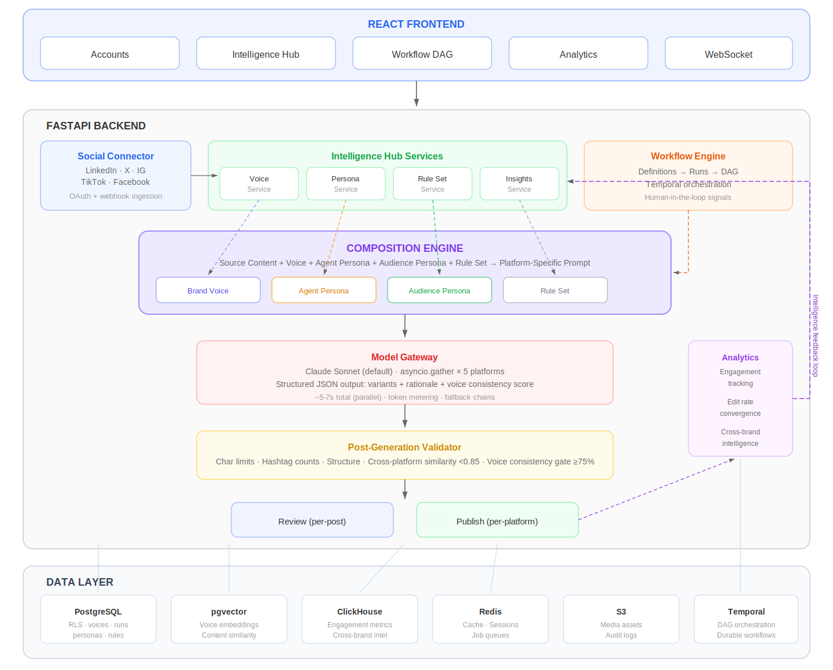

2. Request Flows
Each major operation in the system follows a distinct request flow. Below are the step-by-step flows for the five core operations.

2.1 Onboarding Data Sources
Triggered when a user connects their first social account. In V1, all data sources are social platform accounts. Onboarding auto-creates a starter kit (brand voice, default agent, template rule sets) so the user can run their first workflow immediately.

- Step 1 — OAuth initiation: Frontend redirects to platform’s OAuth consent screen (LinkedIn, X, IG, TikTok, FB). Backend stores a pending_connection record with PKCE verifier.
- Step 2 — Token exchange: Callback hits /v1/accounts/callback/:platform. Backend exchanges auth code for access_token + refresh_token. Tokens encrypted with AES-256 and stored in social_accounts table.
- Step 3 — Historical import (async): Background job queued via Redis Streams. Social Connector Service fetches posts in reverse-chronological batches (100/request, paginated). Each post normalized into common schema: {content_text, media_type, published_at, metrics}. Stored in social_posts table.
- Step 4 — Hook classification: For each imported post, a lightweight classifier (rule-based for MVP) tags the hook_type (data, question, narrative, hot_take, curiosity). Stored alongside the post.
- Step 5 — Inference generation: Once import completes, Analytics Service runs per-account inference queries: top formats by engagement, best posting times, hook performance by type. Results stored in account_inferences table.
- Step 6 — Auto-create starter kit: System automatically generates three artifacts from the imported data:
- 6a. Template rule sets: One per connected platform (e.g., “LI Professional”, “X Engagement”) pre-populated with platform-specific rules from the Platform Signal Registry. Stored in rule_sets + rule_set_rules tables.
- 6b. Brand voice: Auto-generated from the imported posts using the voice creation pipeline (steps 3–7 from section 2.2). Uses the last 6 months of posts by default. User can refine later.
- 6c. Default agent: A general-purpose agent persona (“Adapt Default”) pre-configured with balanced tone, standard hooks, and the auto-created rule sets attached per platform. User can customize or replace.
- Step 7 — WebSocket push: Frontend receives real-time notification. Account card updates to “Connected.” Starter kit artifacts appear in Intelligence Hub. User is guided to run their first workflow.

The goal of auto-creation is zero-config time to first run. The user connects accounts, the system bootstraps everything, and the user can immediately start generating content. All auto-created artifacts are fully editable.

2.2 Creating / Updating Brand Voice
Creating a voice is a multi-step pipeline. The user selects which social accounts to train from and the time period to use.

Create flow (3-step wizard):
- Step 1 — Source + time period selection: User toggles connected social accounts to include and selects a time period: last 3 months, last 6 months, last 12 months, or all time. This controls which posts feed the voice pipeline. Frontend sends POST /v1/voices with {name, purpose, account_ids[], time_period}. Backend creates voice_profiles record with status: “generating,” filters social_posts by account_ids and published_at within the time window, and queues the pipeline.
- Step 2 — Ingestion: Voice Service collects posts matching the selected accounts + time period from social_posts table. Time period matters because a brand’s voice may have evolved — training on the last 6 months captures the current voice, while all-time captures the full range.
- Step 3 — Embedding: Each post is embedded using a sentence transformer (all-MiniLM-L6-v2, 384-dim). Embeddings stored in content_embeddings table (pgvector). Batch processing: ~500 posts/sec on CPU.
- Step 4 — Clustering: k-means (k=3–5, optimized by silhouette score) on the embedding space to identify distinct tonal clusters. Each cluster represents a voice mode (e.g., formal-LI vs. casual-X).
- Step 5 — Attribute extraction: LLM call (Claude) with a sample of 20 posts per cluster. Prompt: “Analyze these posts and extract: tone descriptors (as percentage scores), vocabulary patterns, phrases to avoid, and how the voice differs from the overall average.” Structured JSON response.
- Step 6 — Override detection: Compare per-platform cluster centroids. If LI centroid diverges from X centroid by >0.15 cosine distance, surface as a per-platform override with a human-readable description (“More formal on LinkedIn, punchier on X”).
- Step 7 — Profile assembly: Compute the overall voice centroid (weighted average of cluster centroids). Store attribute scores, avoid list, overrides, time_period used, and centroid embedding in voice_profiles. Generate a human-readable voice description via LLM call. Set status: “generated.”
- Step 8 — User refinement: Frontend displays the generated profile with the time period noted (“Trained on 847 posts from the last 6 months”). User can edit name, purpose, description, attribute scores, avoid list, overrides. On save, backend updates voice_profiles.
- Step 9 — Rule set attachment: User optionally attaches rule sets that auto-apply when this voice is used. Stored in voice_rule_set_attachments table.

Update flow:
- Edit metadata (name, purpose, avoid list, overrides): Direct update to voice_profiles. No retraining needed.
- Change time period: User can shift the training window (e.g., from “all time” to “last 6 months”). Re-runs steps 2–7 with the new time filter. Old centroid preserved for comparison.
- Retrain from data: Re-runs steps 2–7 with the current corpus within the selected time window. Voice training history record logged.
- Taste-maker refinement: When a user edits AI-generated content before publishing, the edit delta is captured in taste_maker_edits table. Weekly batch job analyzes deltas for patterns. Patterns above confidence threshold are auto-applied or pending human approval.

2.3 Creating / Updating Personas

Audience Persona — two creation paths::

- Path A — Auto-infer from social account: User selects a connected social account and clicks “Auto-generate.” System analyzes follower demographics (from audience_demographics table), commenter profiles (headlines on LI, bios on X), and engagement patterns to build the persona automatically. LLM call synthesizes: name suggestion, description, seniority/function breakdown, platform behavior per channel, what they respond to (tags_positive), what they ignore (tags_negative). User reviews and refines. POST /v1/personas with {type: “audience”, source_account_id, auto_infer: true}.
- Path B — Manual creation: User fills form directly: name, description, seniority, function, platform behavior (free text per platform), tags_positive, tags_negative. POST /v1/personas with {type: “audience”, ...}. No social account needed.
- Both paths store the same schema. Auto-inferred personas are flagged with source_account_id for future re-inference when new demographic data arrives.
- At workflow execution time, the audience persona is injected as: “You are writing for [description]. On [platform], they [platform_behavior]. They respond well to [tags_positive] and poorly to [tags_negative].”

Agent Persona — the full agent configuration::
Agent personas are not just tone directives — they are the complete agent configuration. An agent persona defines how the AI behaves, what tools and information it can access, and how it’s configured per platform. This IS the agent.

- Creation via guided form with dropdowns: Name, description, writing approach (dropdown: Thought Leader, Community Builder, Educator, Provocateur, Storyteller, or custom), tone (dropdown: professional, conversational, casual, authoritative, playful, or custom blend), structure preference (dropdown: insight→evidence→implication, question→exploration→takeaway, story→lesson→CTA, or custom).
- Per-platform configuration: Each connected platform gets its own config block. The user sets per platform: which writing approach to use (can differ from default), which rule set to attach, which audience persona(s) to target, and any platform-specific behavior overrides. Stored as per_platform_config (JSONB) on the agent persona.
- Tool and information access: The user configures which retrieval paths this agent can use. Checkboxes: voice exemplars (RAG), performance data, taste-maker patterns, audience context, trending signals, cross-brand benchmarks. An agent configured without trending signals won’t receive trending context in its prompt. An agent without cross-brand access generates based only on this brand’s data.
- Multiple audience personas: An agent can target 1 or more audience personas. When targeting multiple, the agent generates variants tailored to each audience. E.g., an agent targeting both “B2B Decision Maker” and “Developer/IC” on LinkedIn produces variants optimized for each audience, with the rationale explaining the targeting choice.
- POST /v1/personas with {type: “agent”, writing_approach, tone, structure, per_platform_config: {linkedin: {rule_set_id, audience_ids[], overrides}, x: {...}, ...}, tools: [voice_exemplars, performance_data, ...]}

Data model (agent persona)::
Field | Type | Notes
id, tenant_id, name, description | standard
type | enum | Always “agent” for agent personas
writing_approach | enum + custom text | Thought Leader | Community Builder | Educator | Provocateur | Storyteller | custom
tone | JSONB | Blend of: {professional, conversational, casual, authoritative, playful} as weights, or custom
structure_preference | text | How the agent structures content (insight→evidence, question→exploration, etc.)
per_platform_config | JSONB | {linkedin: {rule_set_id, audience_persona_ids[], behavior_overrides}, x: {...}, ...}
enabled_tools | text[] | [voice_exemplars, performance_data, taste_maker_patterns, audience_context, trending, cross_brand]
default_audience_ids | uuid[] | Default audience persona(s) when platform config doesn’t specify

Update flow:
- Agent persona edits (approach, tone, structure, tools): Direct update. Future workflow runs use the new config.
- Per-platform config changes: Add/remove platforms, change rule sets, swap audience personas per platform.
- Performance tracking: Engagement data joined against which agent persona + audience persona combination was used. Performance tab shows which combos work best per platform.

2.4 Creating / Updating Rule Sets
Rule sets are bundles of individual rules. The creation flow involves defining the bundle and selecting rules from the library.

Create flow:
- Step 1: User provides name, description, default platform. POST /v1/rule-sets with metadata.
- Step 2: User selects rules from the full rule library (organized by type: Platform, Custom, Compliance, Learned). Each selection creates a rule_set_rules join record with position and enabled flag.
- Step 3: Rules can be created inline during set creation. New custom or compliance rules are created via POST /v1/rules, then immediately attached to the set.
- Step 4: Rule set is now available for attachment to voices (auto-apply) and selection in workflow DAG nodes.

Rule enforcement at generation time:
- Prompt-level: Platform and custom rules are injected into the platform-specific prompt as explicit constraints (“Do NOT include external links in the post body. Limit to 3–5 hashtags.”).
- Learned rules are injected as recommendations (“Data-driven hooks outperform question hooks by 1.8x for this brand on LinkedIn. Prefer data hooks.”).
- Compliance rules with approval gates are enforced post-generation: if a trigger condition is met (e.g., competitor name detected in output), the variant is routed to the specified reviewer before publishing.
- Post-generation: Validator checks character limits, hashtag counts, structural rules. Violations trigger auto-retry with error context (max 1 retry) or flag for user edit.

Update flow:
- Add/remove rules from set: Update rule_set_rules table. Changes propagate to all future workflow runs using this set. In-flight runs retain the snapshot of rules at execution time (stored in workflow_node_state).
- Learned rules auto-update: When the Intelligence Layer detects a new statistically significant pattern, it creates a learned rule and optionally adds it to relevant rule sets. The user is notified and can accept or dismiss.

2.5 Creating / Triggering / Updating Workflows
Workflows operate at two levels: definitions (the reusable template) and runs (individual executions).

Create definition:
- Step 1: User provides name, description, selects target platforms (e.g., LI, X, IG, TT, FB). POST /v1/workflows.
- Step 2: User configures defaults: voice_id, agent_persona_id, audience_persona_id. Per-platform overrides stored in per_platform_config (JSONB): e.g., {LI: {agent: “Thought Leader”, audience: “B2B DM”, rules: “LI Professional”}, X: {agent: “Thought Leader”, audience: “Developer”, rules: “X Engagement”}}.
- Step 3: Definition stored in workflow_definitions table. Available in the Workflows list view.

Trigger a run:
- Step 1: User clicks “+ Start new run” on a definition, or double-clicks to open the DAG editor and pastes source content. POST /v1/workflows/:id/runs with {source_content}.
- Step 2: Backend creates workflow_runs record with status “active”. Creates workflow_node_state records for each node (source, platform nodes, review, publish) with a snapshot of the composition at that moment.
- Step 3: Temporal workflow is started. The DAG executes node-by-node:
- 3a. Source node: Parse source content. Extract core message, arguments, tone markers. Store parsed output.
- 3b. Platform nodes (parallel): For each platform, resolve composition — load voice profile, agent persona, audience persona, and rule set from the node_state snapshot. Construct prompt. Call Model Gateway. Claude returns structured JSON with 2–3 variants + rationales + voice consistency scores. Post-generation validator runs. Variants stored in variants table.
- 3c. Review node: Workflow pauses (Temporal signal). Per-platform reviewer assignments created based on definition config. Reviewers receive notifications. As each reviewer approves/rejects, a Temporal signal resumes that platform’s publish path.
- 3d. Publish nodes (independent per platform): On approval, content is queued for publishing at the optimal time (from account_inferences) or at a manually set time. Social Connector Service calls the platform API. On success, published_at is recorded. On failure, retry with backoff (max 3).
- Step 4: WebSocket pushes DAG state updates to the frontend in real-time. Node status badges update: pending → running → done/failed.

Update a run (in-flight editing):
- Change composition on a node: User double-clicks a platform node in the DAG, opens the Composition tab, clicks “Change voice/agent/audience/rules.” PUT /v1/runs/:id/nodes/:nodeId with updated IDs. Backend updates workflow_node_state. If variants were already generated, they are discarded and regeneration is triggered with the new composition.
- Edit a variant: User edits variant text inline. PUT /v1/runs/:id/nodes/:nodeId/variants/:variantId with {edited_text}. Variant status changes to “edited.” The edit delta is logged in taste_maker_edits for voice model refinement.
- Regenerate a variant: User clicks “Regen.” POST /v1/runs/:id/nodes/:nodeId/variants with {context: “user adjusted tone toward X”}. New variant generated with the edit context injected into the prompt. Old variant preserved for comparison.
- Reassign reviewer: User clicks “Reassign” in the Review node. PUT /v1/runs/:id/review with updated assignments. New reviewer receives notification.

2.6 Key Design Choices

- Single LLM call per platform (not per variant): One structured prompt generates all 2–3 variants + rationales in a single call. Reduces latency from ~15s to ~5s per platform.
- Parallel platform calls: All 5 platform calls fire concurrently (asyncio.gather). Total time bounded by slowest call (~5–7s), not the sum.
- Structured JSON output: Typed fields (variant_text, rationale, hook_type, voice_consistency_score, platform_signals_applied). Deterministic parsing, machine-readable for analytics.
- Stateless regeneration with context: Edit context sent as additional instruction preserving user intent without backend session state.
- Composition snapshot at run time: Node composition is resolved and stored when a run starts. Subsequent changes to the voice/persona/rule set definitions do not retroactively affect in-flight runs.
- Temporal for durability: Each run is a Temporal workflow. Node failures are retried with backoff. Human-in-the-loop checkpoints are Temporal signals. Full execution history is preserved for audit.

3. Composition Model
Content generation is the composition of four independently configurable elements. Each is visible and editable per platform node in the workflow DAG. This is the core architectural insight: the same source content + same brand voice produces fundamentally different output depending on which agent persona, audience persona, and rule set are composed at a given node.
Element | What It Controls | How It’s Used
Brand voice | How the brand sounds. Tone attribute scores (embeddings), vocabulary constraints, avoid list, per-platform overrides. Measured by voice consistency score. | Selected per workflow definition. Can be overridden per platform node. Attached rule sets auto-apply when voice is used.
Agent persona | How the AI approaches writing. Behavioral rules, structural preferences, hook strategies. “Thought Leader” takes positions with evidence. “Community Builder” asks questions and sparks conversation. | Selected per workflow definition. Commonly overridden per node: Thought Leader for LI, Community Builder for IG.
Audience persona | Who the content is written for. Shapes content strategy, platform prioritization, hook selection, depth level. “B2B Decision Maker” responds to data. “Developer/IC” responds to technical depth. | Selected per workflow. Often varies by node: DMs on LI, Developers on X.
Rule set | Reusable bundle of platform, custom, compliance, and learned rules. Enforced at prompt construction and post-generation validation. Named and versioned. | Attached to voices (auto-apply) and selectable per node. Multiple types: Platform (algorithmic signals), Custom (brand rules), Learned (intelligence layer), Compliance (approval gates).

Example: Same source, same “Primary” voice. LinkedIn node: Thought Leader + B2B Decision Maker + LI Professional rules → authoritative data-backed post. Instagram node: Community Builder + B2B Decision Maker + IG Default rules → conversational story with question hook. The composition is the differentiator, not the generation model.

4. Wireframe Deep-Dive: Accounts
The Accounts page is the data ingestion surface. It connects social platform accounts, imports historical content, and surfaces per-account inferences that feed the Intelligence Hub.

7.1 UI Structure

- Card grid showing connected accounts (LinkedIn, X, Instagram, TikTok, Facebook) with connection status indicator (green = synced, gray = not connected).
- Click account → detail pane with three tabs: Overview (post count, date range, avg engagement, data health %, format mix), Posts (sortable table with date, type, hook, impressions, engagement rate), Inferences (per-platform learnings: top formats, best posting times, hook performance, audience signals).
- “+ Connect” button in top bar for adding new accounts via OAuth.

7.2 Technical Implementation

- Social Connector Service: Abstraction layer over platform APIs (Meta Graph API, X API v2, LinkedIn Marketing API, TikTok Display API). Each platform has an adapter module handling authentication, rate limiting, and data normalization.
- Data ingestion pipeline: On account connection, a background job fetches historical posts (up to 24 months or API limit). Posts are normalized into a common schema: {id, platform, content, media_type, published_at, metrics: {impressions, engagement, likes, comments, shares}}.
- Inferences are computed by the Analytics Service on ingestion and updated daily. Stored as per-account inference records in PostgreSQL.
- Data health score: percentage of posts with complete metrics. Some platforms restrict historical metric access; score reflects data completeness.

6.3 Data Model
Table | Key Fields | Notes
social_accounts | id, tenant_id, platform, handle, access_token (encrypted), refresh_token, status, last_sync_at | One per connected account. Tokens refreshed on schedule.
imported_posts | id, account_id, platform, content_text, media_type, published_at, metrics (JSONB), hook_type (computed) | Denormalized for fast queries. Hook type classified on ingestion.
account_inferences | id, account_id, inference_type (top_format, best_time, hook_perf, audience_signal), data (JSONB), computed_at | Refreshed daily or on significant data change.

5. Wireframe Deep-Dive: Intelligence Hub
The Intelligence Hub is the brain of the system. It contains four sub-sections accessible via sidebar navigation: Brand Voice, Personas, Rules, and Insights. Everything configured here composes at the workflow layer.

7.1 Brand Voice
Brand voice profiles are the most complex entity in the system. Each voice is a reusable artifact that encapsulates how the brand sounds, with purpose, description, tone attributes, avoid list, per-platform overrides, attached rule sets, connected data sources, and a voice consistency score that tracks how reliably the AI reproduces it.

7.1.1 UI Structure

- Card gallery showing all voices with: name, purpose, voice consistency %, posts trained on, attached rule sets count, connected data sources count.
- Click voice → detail pane with six tabs: Overview (purpose, attributes as slider bars, consistency explanation, avoid list, platform overrides), Edit (full form with save/retrain/delete), Rule Sets (attach/detach reusable rule sets), Data Sources (connected social accounts with toggle-to-include and sync status), Create Post (generate content using this voice with platform selection and variant preview), History (model update log + taste-maker edit patterns with auto-applied/pending status).
- “+ Create voice” opens a 3-step wizard: Step 1 — Select social accounts (toggle which connected accounts to train from). Step 2 — Generate (system analyzes imported posts and auto-generates voice profile with detected attributes, description, avoid list, and platform overrides). Step 3 — Refine (everything editable, attach rule sets, save).

7.1.2 Voice Creation Pipeline
When a user connects social accounts and triggers voice generation, the following pipeline executes:

- 1. Ingest: Fetch all posts from connected accounts via Social Connector Service. Normalize into common schema.
- 2. Embed: Generate embeddings for each post using a sentence transformer (all-MiniLM-L6-v2 or similar). Store in pgvector.
- 3. Cluster: Run k-means on the embedding space to identify distinct tonal clusters (e.g., the brand sounds different on LI vs. X).
- 4. Extract attributes: For each cluster, use an LLM call to extract human-readable tone descriptors, vocabulary patterns, and an avoid list. Aggregate across clusters weighted by post count.
- 5. Detect overrides: Compare per-platform cluster centroids to identify how the brand’s voice shifts across platforms. Surface as per-platform overrides.
- 6. Generate description: LLM call to synthesize a human-readable voice description from the extracted attributes.
- 7. Build profile: Store as a voice_profile record with attribute scores, embedding centroid, avoid list, overrides, and metadata.

7.1.3 Voice Consistency Scoring

- On generation: compute embedding of the generated content, measure cosine similarity against the voice profile centroid.
- Score = percentage of generated content that exceeds a configurable threshold (default 0.75).
- Reported per-variant in the DAG editor. Trended over time. Used as a quality gate: content below threshold is flagged.
- Model retraining: weekly batch job re-computes the voice profile centroid from the latest corpus (including new posts ingested and taste-maker edits).

7.1.4 Data Model
Table | Key Fields | Notes
voice_profiles | id, tenant_id, name, purpose, description, attributes (JSONB), avoid_list (text[]), overrides (JSONB), embedding (vector(384)), consistency_score, posts_trained_on, created_at | Core voice entity. Embedding is the centroid of all training posts.
voice_data_sources | id, voice_id, account_id (FK → social_accounts), platform, status, last_sync_at, post_count | Which social accounts train this voice. V2: expand to support blog RSS, Google Docs, Notion, file uploads.
voice_rule_set_attachments | voice_id, rule_set_id | Rule sets that auto-apply when this voice is used.
voice_training_history | id, voice_id, event_type (created, retrained, source_added), old_score, new_score, timestamp | Audit trail for voice model evolution.
taste_maker_edits | id, voice_id, variant_id, original_text, edited_text, edit_delta (JSONB), pattern_detected, auto_applied, timestamp | Captures human edits for model refinement.

7.2 Personas
Two types: Audience personas (who you write for) and Agent personas (how the AI behaves). Both are visible in the Intelligence Hub and selectable in the workflow DAG.

7.2.1 UI Structure

- Two sections: Audience (B2B Decision Maker, Developer/IC) and Agent (Thought Leader, Community Builder). Separate “+ Audience” and “+ Agent” create buttons.
- Each persona card shows: name, type badge, description, avg engagement, trend. Click → Details/Edit/Performance tabs.
- Agent personas include behavior rules (how the AI should approach writing) and best-used-for context (which platforms/campaigns).

7.2.2 Technical Implementation

- Audience personas are injected into the prompt as “audience context”: who they are, what they value, how they consume content on this platform.
- Agent personas are injected as “behavior directives”: structural patterns, hook preferences, tone rules. These override the model’s default behavior.
- Performance data is computed by joining published content metadata (which persona was used) with engagement metrics from the Analytics Service.

7.2.3 Data Model
Table | Key Fields | Notes
personas | id, tenant_id, name, type (audience|agent), description, behavior_rules (text, agent only), platform_behavior (JSONB, audience only), tags_positive (text[]), tags_negative (text[]), created_at | Unified table for both types.
persona_performance | id, persona_id, platform, avg_engagement, best_hook, trend_pct, period_start, period_end | Aggregated weekly from published content.

6.3 Rules (Rule Sets)
Rules are not individual rules — they are reusable rule sets, each bundling multiple rules of different types into a named artifact. A rule set is the unit of configuration: you attach a rule set to a voice or select one per DAG node.

6.3.1 UI Structure

- Card grid showing rule sets: LinkedIn Professional (7 rules), X Engagement (5), TikTok Native (5), Crisis Mode (5, tagged “Emergency”), Product Launch (6). Each card shows rule count, platform, workflow usage count.
- Click → Rules tab (list of individual rules with type-coded dots: blue=Platform, green=Learned, amber=Custom, red=Compliance, each with toggle), Edit tab, Usage tab (which workflows and DAG nodes use this set).
- “+ New rule set”: name, description, platform, then checkbox-select from the full rule library organized by type.

6.3.2 Rule Types
Type | Source | Examples | Enforcement
Platform | Pre-built, updated monthly from algorithmic research | No external links on LI, hook in 3s on TikTok, 1–2 hashtags on X | Hard: post-generation validator blocks violations
Learned | Intelligence Layer, auto-generated from engagement data | Data hooks +1.8x on LI, threads +1.6x on X, question hooks underperform B2B | Soft: influences prompt construction, not blocking
Custom | User-defined brand rules | No emojis on company page, always tag company handle, energetic tone for launches | Configurable: hard (block), soft (warn), advisory (suggest)
Compliance | User-defined, usually with approval gates | Competitor mentions → CMO review, no pricing in organic, crisis mode all-approve | Hard: routes to approval queue

6.3.3 Data Model
Table | Key Fields | Notes
rule_sets | id, tenant_id, name, description, default_platform, is_emergency, created_at | The bundle entity.
rules | id, tenant_id, name, description, type (platform|learned|custom|compliance), enforcement (hard|soft|advisory), platform, trigger_condition (JSONB) | Individual rules.
rule_set_rules | rule_set_id, rule_id, enabled, position | Many-to-many with ordering and per-set toggle.
rule_set_usage | rule_set_id, workflow_def_id, node_id | Tracks where sets are used for the Usage tab.

6.4 Insights
Unified tab combining cross-platform patterns (derived from the customer’s own data) and cross-brand intelligence (anonymized patterns across all Adapt customers).

6.4.1 UI Structure

- Four insight cards: Hook Performance (which hooks win per platform, engagement % matrix), Format Comparison (text vs. carousel vs. thread vs. video), Timing (optimal day/time per platform with peak engagement), Trending (cross-brand weekly signals with directional arrows and % change).
- Click any card → detail pane with data table or trend list.

6.4.2 Technical Implementation

- Hook performance and format comparison: ClickHouse queries aggregating engagement metrics by hook_type and media_type, grouped by platform. Refreshed daily.
- Timing: Time-series analysis of engagement by day-of-week and hour-of-day per platform. Stored as materialized views in ClickHouse.
- Trending (cross-brand): Anonymized aggregation across all tenants. Only aggregate statistics are shared; no individual content crosses tenant boundaries. Implemented as a separate ClickHouse database with tenant_id stripped at ingestion.
- Learned rules are auto-generated from insight data: when a pattern reaches statistical significance (e.g., data hooks outperform question hooks by >1.5x with p<0.05), it is surfaced as a learned rule and optionally added to rule sets.

6. Wireframe Deep-Dive: Workflows
The Workflows page is the operational surface. It implements a two-level hierarchy (definitions → runs) with a composition-aware DAG editor that makes the adaptation pipeline visible and configurable.

7.1 UI Structure: Definition List

- Collapsible workflow definition cards showing: name, active run count badge, description, platform pipeline (LI → X → IG → TT → FB as small chips), total runs, agent persona, voice.
- Click arrow to expand → run list showing: run ID, source content title, status badge (active/done/scheduled), timestamp, progress dots (5 stages: source → adapt → review → publish → complete, colored green/amber/gray).
- “+ Start new run” at bottom of each definition’s run list.
- “+ New workflow” for creating definitions from scratch.

7.2 UI Structure: DAG Editor
Double-click a run → opens the DAG editor with breadcrumb navigation (← Workflows / Definition Name / Run #12).

- Horizontal flow: Source → [Platform nodes] → Review → [Publish nodes].
- Each platform node shows composition at a glance with four color-coded rows: Voice (blue dot), Agent (amber dot), Audience (green dot), Rules (gray dot) — each showing the selected element name.
- Double-click any platform node → detail pane with three tabs: Composition (four editable cards with “Change →” links for each element), Variants (A/B/C variants with text, rationale, voice consistency score, accept/edit/regen buttons), Rules (applied rule set with type-coded individual rules).
- Review node shows per-platform reviewer assignments with status (approved/pending). Supports reassign and remind actions.
- Publish nodes are independent per platform with platform-specific scheduling (optimal time from engagement data) and manual override.
- New runs open with empty DAG pre-configured with the definition’s platforms, voice, and agent defaults.

6.3 Technical Implementation

- Workflow definitions are stored as JSON documents in PostgreSQL, defining: platform list, default voice_id, agent_persona_id, audience_persona_id, and per-platform rule_set_id overrides.
- Each run creates an immutable DAG Run record with: source_content, dag_state (JSONB tracking per-node status), variant outputs, reviewer assignments, publish schedule.
- DAG execution is orchestrated by Temporal. Each node maps to a Temporal activity. The workflow pauses at human-in-the-loop checkpoints (review nodes) via Temporal signals.
- Variant generation: for each platform node, the backend constructs a prompt by composing: source content + voice profile (from voice_profiles table) + agent persona behavior rules + audience persona context + rule set rules. All four elements are resolved at execution time, not definition time.
- Real-time status: WebSocket connection from frontend to backend pushes DAG state updates as nodes complete. Frontend re-renders node status badges without polling.

6.4 Data Model
Table | Key Fields | Notes
workflow_definitions | id, tenant_id, name, description, platforms (text[]), default_voice_id, default_agent_id, default_audience_id, per_platform_config (JSONB), created_at | The reusable template.
workflow_runs | id, definition_id, source_content (text), source_type, dag_state (JSONB), status (draft|active|review|done|failed), created_at | Immutable run record.
workflow_node_state | id, run_id, node_type (source|platform|review|publish), platform, voice_id, agent_id, audience_id, rule_set_id, status, started_at, completed_at | Per-node execution state with composition snapshot.
variants | id, node_state_id, label (A|B|C), text, rationale, hook_type, voice_consistency_score, status (generated|accepted|edited|rejected) | Generated content with metadata.
review_assignments | id, run_id, platform, reviewer_user_id, status (pending|approved|rejected), reviewed_at, notes | Per-post reviewer tracking.
publish_schedule | id, run_id, platform, scheduled_at, optimal_time_source, variant_id, status (queued|published|failed), published_at | Independent per-platform scheduling.

7. Wireframe Deep-Dive: Analytics
The Analytics page is the measurement surface. It shows platform performance, adaptation engine health, and aggregate intelligence.

7.1 UI Structure

- Three headline metrics: Engagement Index (1.42x — aggregate engagement vs. pre-Adapt baseline), Time-to-Platform (4.2 min — from source content to all 5 platforms), Posts/Month (127 — 3.1x throughput vs. manual).
- Platform breakdown: per-platform cards showing best hook type and engagement multiplier, optimal posting time, and key metric change.
- Adaptation engine section: edit rate convergence trend (41% → 18% over 3 months), blind preference test result (AI 62%), cross-brand insight (question hooks underperform B2B).

7.2 Technical Implementation

- Engagement Index: computed as the ratio of current 30-day average engagement to the baseline 30-day period before Adapt was connected. Stored as a time-series in ClickHouse.
- Time-to-Final-Draft: measured as the p50 latency from workflow run creation to all variants generated and validated. Tracked per-run.
- Edit rate: percentage of generated variants that the taste-maker edits before publishing. Tracked per-variant. The convergence trend is computed as a rolling 30-day window.
- Blind preference: periodic automated test where a random sample of historical human-written posts are compared against AI-generated variants (same source). Evaluators (human or LLM-as-judge) choose the preferred version without knowing which is which.
- All metrics are materialized views in ClickHouse, refreshed on a schedule (hourly for fast metrics, daily for trend calculations).

8. Prompt Strategy Per Platform
Each platform has a dedicated prompt template with three layers: system prompt (shared), platform-specific context (from rule set), and variant strategy directive.
Platform | Prompt Strategy | Enforced Constraints
LinkedIn | Professional tone. Lead with insight or data. Dwell time optimization. Variants: (A) data hook, (B) narrative, (C) question. No external links in body. | Max 3,000 chars. 3–5 hashtags. Line breaks. No emojis.
X / Twitter | Conversational, punchy. Hook in first line. Variants: (A) hot take, (B) thread opener, (C) standalone. No link in first tweet. | 280 chars standalone. 1–2 hashtags. Thread auto-splits.
Instagram | Visual-first language. Personal tone. Variants: (A) story, (B) listicle, (C) question-driven. Heavy hashtags. | Max 2,200 chars. 15–25 hashtags. Hook in first line. CTA last.
TikTok | Ultra-casual, spoken-word. Hook in 3s. Variants: (A) curiosity, (B) pattern interrupt, (C) story arc. | Max 4,000 chars. 5–10 hashtags. Short sentences.
Facebook | Community-oriented, shareable. Share/comment optimized. Variants: (A) debate, (B) story, (C) informational. | 100–250 words. 2–3 hashtags. Question at end.

9. Platform-Native Enforcement

9.1 Soft: Prompt-Level
Each platform prompt includes explicit format rules, character budgets, and negative examples. Meta-instruction: “You are generating content that will be published directly. Violating constraints means it cannot be posted.”

9.2 Hard: Post-Generation Validation

- Character limit validation: auto re-prompt with constraint error + original variant context. Max 1 retry; then flagged for user edit.
- Hashtag count: counted and trimmed/expanded to platform norms.
- Structure: thread boundaries, line-break density, TikTok cadence.
- Cross-platform similarity: cosine similarity between outputs. >0.85 triggers re-generation with explicit differentiation instruction.
- Voice consistency gate: content embedding vs. voice profile centroid. Below 75% threshold = flagged with attribute drift explanation.

10. API Design
RESTful public API (JSON over HTTPS) versioned as /v1/. Internal service-to-service uses gRPC for latency-sensitive paths.
Endpoint | Methods | Description
/v1/accounts | GET, POST, DELETE | Social account connection, listing, and disconnection.
/v1/voices | GET, POST, PUT, DELETE | Brand voice CRUD. POST triggers the voice creation pipeline.
/v1/voices/:id/generate | POST | Generate voice profile from connected sources (async, returns job ID).
/v1/voices/:id/create-post | POST | Generate content using this voice. Accepts source text and platform list.
/v1/personas | GET, POST, PUT, DELETE | Persona CRUD (audience and agent types).
/v1/rule-sets | GET, POST, PUT, DELETE | Rule set CRUD with nested rule management.
/v1/rules | GET, POST, PUT, DELETE | Individual rule CRUD (used to populate rule sets).
/v1/insights/:type | GET | Query insights by type (hooks, formats, timing, trending).
/v1/workflows | GET, POST, PUT, DELETE | Workflow definition CRUD.
/v1/workflows/:id/runs | GET, POST | List runs for a definition. POST creates a new run.
/v1/runs/:id | GET, PUT | Run detail with DAG state. PUT updates node configuration.
/v1/runs/:id/nodes/:nodeId | GET, PUT | Node detail. PUT changes composition (voice, agent, audience, rules).
/v1/runs/:id/nodes/:nodeId/variants | GET, POST | List variants. POST triggers regeneration with edit context.
/v1/runs/:id/review | GET, PUT | Review assignments. PUT approves/rejects per-platform.
/v1/runs/:id/publish | POST | Trigger publish for approved platforms.
/v1/analytics/summary | GET | Headline metrics (engagement index, time-to-final-draft, throughput).
/v1/trending | GET | Current trending signals filtered by platform and brand vertical. Includes hashtag velocity, format trends, topic trends.
/v1/trending/:platform | GET | Platform-specific trending with relevance scores for this brand.
/v1/cross-brand | GET | Cross-brand benchmarks for this brand’s cohort. Hook perf, format perf, timing, volume benchmarks.
/v1/cross-brand/cohort | GET | Cohort details: which brands are in this cohort (anonymized count + profile match criteria).

11. Data Architecture Summary
Store | Purpose | Technology
Primary OLTP | Users, tenants, voices, personas, rule sets, workflows, runs, variants, reviews, social_posts, post_comments, audience_demographics, account_followees, taste_maker_patterns, trending_signals | PostgreSQL 16 (RDS), row-level security for tenant isolation
Vector Store | Voice profile embeddings (centroid), content embeddings for similarity search, consistency scoring | pgvector extension (HNSW index at V1)
Analytics OLAP | Engagement metrics, content feature vectors, cross-brand intelligence (anonymized cohort aggregation), materialized views: mv_hook_perf, mv_format_perf, mv_timing_perf, mv_feature_corr, cross_brand_insights | ClickHouse
Object Storage | Media assets, source content attachments, audit logs | S3 with intelligent tiering
Cache | Hot voice profiles + centroids, recent performance recommendations, trending signals, rate limit counters | Redis Cluster (ElastiCache)
Job Queue | Voice generation pipeline, scheduled publishing, async analytics, model retraining, trending signal detection, cross-brand aggregation | Redis Streams + Temporal task queues

12. Intelligence & Generation Layer
The Content Agent, RAG pipeline, in-graph editing, and human feedback loop are detailed in a separate deep-dive document: Adapt AI — Intelligence & Generation Layer. Diagrams and key points below.
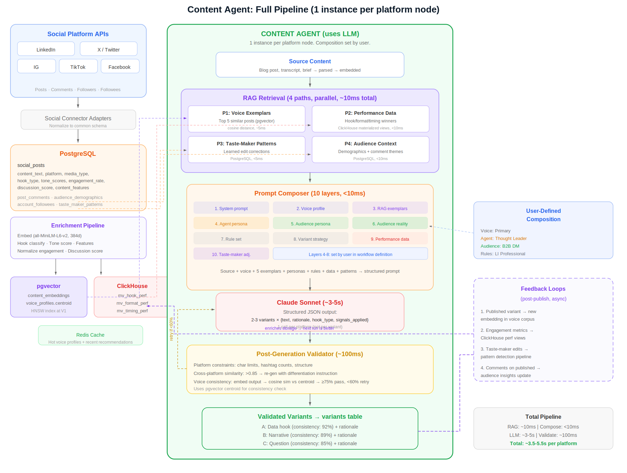

12.1 Workflow Execution

- No Orchestrator Agent. The user defines the workflow (platforms, voice, persona, rules per node). Temporal executes it deterministically.
- Content Agents (1 per platform) are the ONLY AI components. Everything else is infrastructure: parsing, signal gates, API calls, background jobs.
- Per-platform pipeline: RAG Retrieve (~10ms) → Compose Prompt (12 layers, <10ms) → LLM Generate (2–3 variants, ~3–5s) → Validate (~100ms) → Store. All platforms parallel, ~5–7s total.
- Human-in-the-loop via Temporal signals. Partial approval: platforms publish independently. Composition snapshot at run start.

12.2 RAG Pipeline (6 Retrieval Paths)

- Path 1 — Voice exemplars (pgvector): Top 5 similar posts from voice corpus by cosine distance. Dynamic few-shot examples. V2: performance-weighted retrieval.
- Path 2 — Performance data (ClickHouse): Materialized views for hook, format, timing, and feature performance per brand + platform.
- Path 3 — Taste-maker patterns (PostgreSQL): Learned edit corrections from human feedback pipeline. Auto-applied or pending review.
- Path 4 — Audience context (PostgreSQL): Follower demographics + comment theme clusters. Grounds the audience persona in real data.
- Path 5 — Trending signals (PostgreSQL): Hashtag velocity, format trends, vertical topic trends. What’s hot on each platform right now and in the brand’s vertical.
- Path 6 — Cross-brand benchmarks (ClickHouse): Anonymized aggregation across similar brands in the same cohort. Hook performance, format benchmarks, timing patterns. Network effect: more Adapt customers → richer benchmarks.

12-layer prompt assembly: system prompt → voice profile → RAG exemplars → agent persona → audience persona → audience reality (demographics + comments) → rule set → variant strategy → performance data → taste-maker adjustments → trending context → cross-brand benchmarks.
Voice consistency: embed output → cosine similarity vs. voice centroid. ≥75% pass, 60–75% warned, <60% retry with exemplar-foregrounding instruction. Compounding effect: more content → richer corpus → better retrieval → higher consistency → fewer edits.
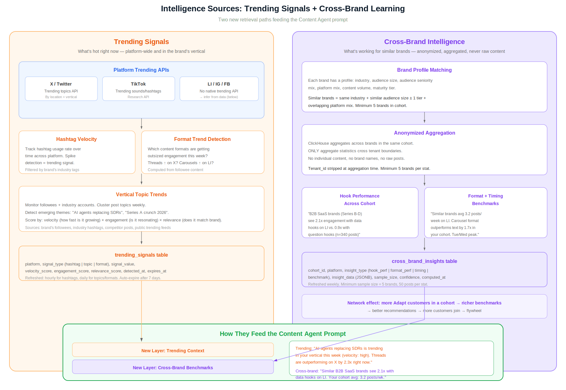

12.3 Trending Signals

- Platform trending APIs where available (X trending topics, TikTok trending sounds/hashtags). LinkedIn, IG, FB: inferred from followee content and engagement patterns.
- Hashtag velocity: track usage rate over time, spike detection filtered by brand’s industry tags. Refreshed hourly.
- Format trend detection: which content formats are getting outsized engagement this week across the brand’s followee network.
- Vertical topic trends: monitor followees + industry accounts, cluster post topics weekly, score by velocity × engagement × relevance. Detect emerging themes before they hit the brand’s own feed.
- Storage: trending_signals table (platform, signal_type, signal_value, velocity_score, engagement_score, relevance_score). Auto-expire after 7 days.

12.4 Cross-Brand Intelligence

- Brand profile matching: same industry + similar audience size ± 1 tier + overlapping platform mix. Minimum 5 brands per cohort.
- Anonymized aggregation: ClickHouse aggregates across cohort. ONLY aggregate statistics cross tenant boundaries. No individual content, no brand names, no raw posts. Tenant_id stripped at aggregation time.
- Outputs: hook performance across cohort (“B2B SaaS brands see 2.1x with data hooks on LI, n=340”), format + timing benchmarks (“carousel outperforms text 1.7x in your cohort”).
- Storage: cross_brand_insights table (cohort_id, insight_type, insight_data, sample_size, confidence). Refreshed weekly. Minimum 5 brands and 50 posts per stat.
- Network effect: more Adapt customers in a cohort → richer benchmarks → better recommendations → more customers join. This is a second moat alongside per-brand intelligence.

12.5 In-Graph Editing & Human Feedback

- Three flows: Change Composition (swap + regen), Edit Inline (delta capture + re-score), Regenerate (context + negative example).
- Five signal types: accept, edit+accept, regenerate, reject, composition change. All feed pattern detection.
- Weekly pipeline: aggregate → cluster → detect patterns → auto-apply or propose → retrain voice model → measure convergence.
- Four reinforcing loops: voice convergence, strategy convergence, preference convergence, composition convergence. All create switching costs.

13. What I Would Change With More Time
Priority | Area | What | Why
1 | Intelligence loop | Connect engagement data back to generation. Each variant becomes a training signal. Per-brand model predicts engagement. Rationale evolves from heuristic to empirical. | This is the moat. Intelligence compounds per-brand and creates switching costs.
2 | Marketing eval | Three-tier measurement: per-variant engagement (1–7 day), channel health (1–3 month), operational efficiency. Blind preference tests + edit rate convergence. | Customers need proof. Edit rate 41%→18% and blind pref 62% are the trust-builders.
3 | Experimentation | Multi-armed bandit across audience segments. Auto-promote winners. Cross-platform format experimentation. | Transforms A/B from heuristic to validated recommendation engine.
4 | Reranking | Cross-encoder reranking on initial pgvector retrieval (top-20 → rerank → top-5). Fine-tuned embedding model on brand’s own content pairs. | 10x more accurate exemplar selection. Embedding space tuned for “sounds like this brand AND performs well.”
5 | Ongoing sync | Scheduled job (every 15 min) polling for new posts and updated metrics via platform webhooks or API polling. Incremental updates to social_posts and account_inferences. Comment ingestion (hourly for recent posts). Demographic snapshot (daily). | MVP does a one-time historical import. Ongoing sync keeps the corpus fresh, performance data current, and audience insights updated without manual re-import.
6 | Non-social sources | Expand voice training beyond social accounts: blog RSS, Google Docs, Notion, file uploads (PDF, DOCX, TXT). Each needs an adapter, content parser, and ingestion pipeline. | Brands have voice artifacts beyond social — blog posts, internal docs, press releases. Richer corpus = better voice profile.
7 | Production infra | Multi-tenant on AWS. PostgreSQL RLS, ClickHouse, Kafka, Temporal, Model Gateway with BYOM. Platform Signal Registry as versioned config. | Platform rules evolve without code deploys. BYOM reduces vendor lock-in for enterprise.

