 | Sanjivani Rural Education Society's  SANJIVANI COLLEGE OF ENGINEERING  (An Autonomous Institution)  Kopargaon – 423 603, Maharashtra. | ACAD-F-15 K
Academic Year:  2026-27 | CIA ACTIVITY REPORT | Revision : 00
Department : | Computer Engineering | Date of  Preparation  25.09.2026
Course Code &  Name: | PCCO201 : Discrete Mathematics | Year/Sem: S.Y B.  Tech/ 3rd
Activity Title: Traffic Signal Synchronization Using the Chinese Remainder Theorem
Submitted by:
Group Id- ______________
Roll No | PRN No | Name of the Student | Signature
[Roll No] | [PRN No] | [Name of the Student]
[Roll No] | [PRN No] | [Name of the Student]
[Roll No] | [PRN No] | [Name of the Student]
[Roll No] | [PRN No] | [Name of the Student]
Dr. S. N Gunjal
Course Incharge

Abstract
Abstract—
Many engineering systems contain several events that repeat with different periods, and a natural question is when all of them coincide. This report studies that question through a traffic-signal example: three signals whose complete cycles last 3, 5 and 7 minutes and which all start a cycle at time t = 0. These cycle lengths are illustrative assumptions, not measured data. The simultaneous cycle-start condition is modelled by the congruences t ≡ 0 (mod 3), t ≡ 0 (mod 5) and t ≡ 0 (mod 7), and is solved with the Chinese Remainder Theorem (CRT). Because 3, 5 and 7 are pairwise coprime, the theorem guarantees a unique solution modulo M = 3 × 5 × 7 = 105. Since every remainder is zero, the solution reduces to the least common multiple, so the first strictly positive simultaneous recurrence occurs after 105 minutes, that is, 1 hour 45 minutes. The result is verified by direct division and by a small non-zero-remainder example that shows how the general CRT formula works.
The result is then studied from an algorithmic point of view. Three C++ programs are designed and implemented: (i) the LCM method, (ii) a general CRT solver based on the extended Euclidean algorithm, and (iii) a minute-by-minute simulation. The three methods agreed in every test: the LCM and the simulation matched for all 27 000 triples of cycle lengths from 1 to 30, and the CRT solver returned a correct and distinct solution for each of the 105 possible remainder triples of the moduli 3, 5 and 7. Overflow limits of 64-bit arithmetic are analysed. The report states clearly that it presents a mathematical synchronization model and not a real traffic-control system: green durations, traffic demand, pedestrian crossings and safety constraints are outside the model, and no real traffic implementation or field measurement is claimed.
Index Terms—Discrete mathematics, Chinese Remainder Theorem, modular arithmetic, least common multiple, synchronization, C++.

Index
Abstract 2
Chapter 1 Introduction 5
1.1 Background 5
1.2 Problem Statement 5
1.3 Objectives 5
1.4 Scope and Limitations 6
1.5 Methodology 6
1.6 Organization of the Report 7
Chapter 2 Literature Survey 8
2.1 Divisibility, GCD and Coprime Numbers 8
2.2 Congruences and Modular Arithmetic 8
2.3 The Chinese Remainder Theorem 8
2.4 Least Common Multiple and the Zero-Remainder Case 9
2.5 Historical Development 10
2.6 Known Results for Cycle Sets 10
2.7 Alternative Ways of Solving the System 11
2.8 Modular Arithmetic in Programming 11
2.9 Applications 11
Chapter 3 System Design 13
3.1 Overall Design 13
3.2 Mathematical Model 13
3.3 Theorem and Proof 13
3.4 Step-by-Step Numerical Solution 14
3.5 Algorithm 1: LCM Method 15
3.6 Algorithm 2: CRT Method 15
3.7 Algorithm 3: Simulation Method 15
3.8 Data Type and Overflow Analysis 16
3.9 Test Plan 16
Chapter 4 Implementation Details 18
4.1 Development Environment 18
4.2 Main Program 18
4.3 Explanation of the Code 19
4.4 Test Program 20
4.5 Implementation Notes 20
Chapter 5 Results and Analysis 22
5.1 Program Output 22
5.2 Timeline of the Signals 22
5.3 Verification of the Result 23
5.4 Analysis of Results 24
5.5 Problem Solutions 24
5.6 A Cautionary Example 25
Chapter 6 Conclusion 27
6.1 Conclusion 27
6.2 Future Scope 27
References 28
Annexure 1: GitHub Upload Screenshot 29
Annexure 2: Presentation Geo-Tag Photo 30
Annexure 3: Certificate of Online Course 31

Chapter 1 Introduction

1.1 Background
Discrete mathematics studies structures that are countable and separate rather than continuous: integers, graphs, logical statements, sets and sequences. Within it, number theory and modular arithmetic are especially useful to computer engineers, because computers work with integers of limited size, clocks that wrap around, and events that repeat after fixed periods [1], [2].
Many systems contain several events that repeat with different periods. A traffic signal turns green once in every cycle, a machine performs an operation every few seconds, and a computer task is released every few milliseconds. When several such events are present, a natural question is: when do they all happen together? For events that start together this is a question about common multiples, and when start offsets are present it becomes a system of congruences.
The Chinese Remainder Theorem (CRT) is the classical result that tells us when such a system can be solved and how the solutions are structured. In this report it is applied to an illustrative example: three traffic signals whose complete cycles last 3, 5 and 7 minutes and which all start a cycle at time zero. Writing t for the elapsed time in minutes, the signals start a cycle together exactly when t ≡ 0 (mod 3), t ≡ 0 (mod 5) and t ≡ 0 (mod 7). The theorem guarantees one solution modulo 3 × 5 × 7 = 105, and because every remainder is zero this solution is the least common multiple (LCM): 105 minutes, or 1 hour 45 minutes.
The example is deliberately small so that attention stays on the mathematics. The cycle lengths are illustrative assumptions and not measured data, and the report studies a mathematical synchronization model, not a real traffic-control system.

1.2 Problem Statement
The problem addressed in this project is stated as follows: to synchronize multiple traffic signals that operate on different repeating cycle intervals of 3, 5 and 7 minutes by determining, with the Chinese Remainder Theorem, the first time at which all signals start a cycle simultaneously; to verify the answer against the original conditions; to implement the calculation in C++ by three independent methods (LCM, CRT and simulation); and to compare the three results in order to verify their correctness.

1.3 Objectives
- To understand periodic events mathematically and to represent signal timing using modular arithmetic.
- To study the Chinese Remainder Theorem, the conditions under which it applies, and the role of pairwise coprime moduli.
- To solve the three-signal example completely by hand, without skipping steps, and to find the first common synchronization time.
- To verify the result using the original conditions, and to distinguish the zero-remainder case (LCM) from the general CRT calculation.
- To design, implement and test three C++ algorithms (LCM, CRT, simulation), to analyse their complexity and overflow limits, and to explain the limits of the model with respect to real traffic control.

1.4 Scope and Limitations
The report covers the congruence model of simultaneous recurrence, the Chinese Remainder Theorem with its proof, and the zero-remainder special case. The following assumptions and limitations apply throughout:
- All signals are assumed to start a complete cycle at the same reference time t = 0, and each repeats a complete cycle every 3, 5 and 7 minutes. The cycle intervals are illustrative assumptions, not measured real-world data.
- A complete cycle is not the same as the green phase. The model tracks when cycles start again; it says nothing about how long the green light stays on.
- Real traffic signals have different phase durations, offsets and safety constraints, and real traffic optimization needs traffic data and control strategies that go beyond the Chinese Remainder Theorem. The report does not claim that CRT alone can optimize the traffic of a city.
- Times are whole minutes. The programs use the 64-bit type long long, so very large cycle lengths or moduli are outside the scope (Section 3.8). No real traffic system has been implemented and no field data has been collected.

1.5 Methodology
The work followed four stages. First, the relevant theory (divisibility, congruences, gcd, CRT, LCM) was collected from standard textbooks [1]–[5]. Second, the problem was modelled with congruences, the theorem was stated and proved, and the example was solved by hand step by step and verified. Third, three algorithms were designed, their correctness argued and their complexity derived. Fourth, the algorithms were coded in C++, compiled with the GNU compiler, tested with hand-checkable and exhaustive cases, and the outputs were compared. Every group member contributed to one or more of these stages, and the results were consolidated in this report and in the accompanying presentation.

1.6 Organization of the Report
Chapter 2 presents the literature survey: divisibility, congruences, CRT, history, alternative solving methods and applications. Chapter 3 describes the system design: the mathematical model, the proof of the theorem, the numerical solution, the three algorithms, complexity, data-type limits and the test plan. Chapter 4 documents the C++ implementation. Chapter 5 presents program output, verification, analysis and solved problems. Chapter 6 concludes the report and suggests future work. References and annexures follow.

Chapter 2 Literature Survey

2.1 Divisibility, GCD and Coprime Numbers
An integer a divides an integer b, written a | b, if b = a·k for some integer k. The greatest common divisor gcd(a, b) is the largest positive integer dividing both. Two integers are coprime (or relatively prime) when gcd(a, b) = 1, and a set of integers is pairwise coprime when every pair in the set is coprime. For example 3, 5 and 7 are pairwise coprime, whereas 4 and 6 are not, because gcd(4, 6) = 2 [1], [2].
The gcd is computed efficiently by Euclid's algorithm, which repeatedly replaces the pair (a, b) by (b, a mod b) until the second number is zero. Its extended form also produces integers x and y with a·x + b·y = gcd(a, b) (Bézout's identity). This identity is what makes modular inverses computable and is used in Algorithm 2 of Chapter 3 [3], [4].

2.2 Congruences and Modular Arithmetic
Let m be a positive integer. Two integers a and b are congruent modulo m, written a ≡ b (mod m), if m divides a − b, equivalently if a and b leave the same remainder when divided by m. The number m is called the modulus. For instance 10 ≡ 1 (mod 3) because 10 − 1 = 9 is a multiple of 3, and t ≡ 0 (mod 3) simply says that t is a multiple of 3 [1].
Congruences behave like equations: if a ≡ b and c ≡ d (mod m), then a + c ≡ b + d and a·c ≡ b·d (mod m). The statement a·y ≡ 1 (mod m) has a solution y, called the multiplicative inverse of a modulo m, exactly when gcd(a, m) = 1. The inverse is unique modulo m, and it is the key ingredient of the general CRT formula.

2.3 The Chinese Remainder Theorem
The Chinese Remainder Theorem concerns a system of simultaneous congruences with different moduli:
t ≡ a₁ (mod m₁), t ≡ a₂ (mod m₂), …, t ≡ a_{n} (mod m_{n}) (1)
Theorem (CRT). If the moduli m₁, m₂, …, m_{n} are pairwise coprime positive integers, then for any integers a₁, …, a_{n} the system (1) has a solution, and the solution is unique modulo M = m₁ × m₂ × … × m_{n}. That is, exactly one value of t lies in the range 0 ≤ t < M, and all other solutions differ from it by multiples of M [1], [5].
A solution is constructed as follows. Put M_{i} = M / m_{i}, and let y_{i} be the inverse of M_{i} modulo m_{i} (it exists because M_{i} and m_{i} are coprime). Then
t ≡ a₁ M₁ y₁ + a₂ M₂ y₂ + … + a_{n} M_{n} y_{n} (mod M) (2)
Fig. 1 summarizes the procedure. The idea is simple: the term a_{i} M_{i} y_{i} is congruent to a_{i} modulo m_{i} and to 0 modulo every other modulus, so adding the n terms satisfies all the congruences at once.
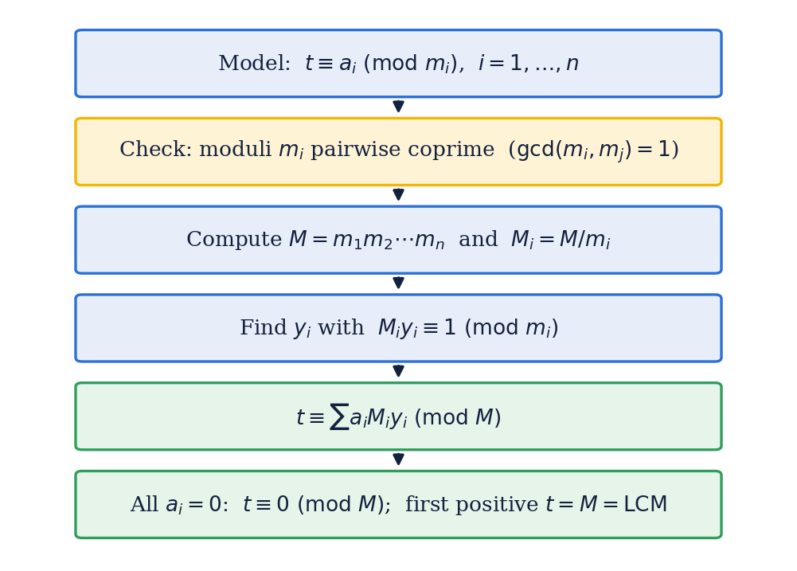
Fig. 1. Flow of solving a system of congruences with the Chinese Remainder Theorem.

2.4 Least Common Multiple and the Zero-Remainder Case
The least common multiple LCM(a, b) is the smallest positive integer divisible by both a and b, and LCM(a, b) = a·b / gcd(a, b). For several numbers the LCM is obtained by combining them two at a time. If the numbers are pairwise coprime, their LCM is simply their product, so LCM(3, 5, 7) = 3 × 5 × 7 = 105.
When every remainder in system (1) is zero, t must be divisible by every modulus, so the solutions are exactly the multiples of LCM(m₁, …, m_{n}). For pairwise coprime moduli this LCM equals M, which agrees with the CRT statement t ≡ 0 (mod M). In this special case no modular inverse is required: every term a_{i} M_{i} y_{i} in formula (2) is zero. CRT is the general framework, and the zero-remainder case reduces directly to finding the LCM.
The coprime condition matters. Fig. 2 compares two cases: cycles 3 and 5 first start together after 15 = 3 × 5 minutes, but cycles 4 and 6 share the factor 2 and start together after only 12 minutes, which is LCM(4, 6), not the product 24.
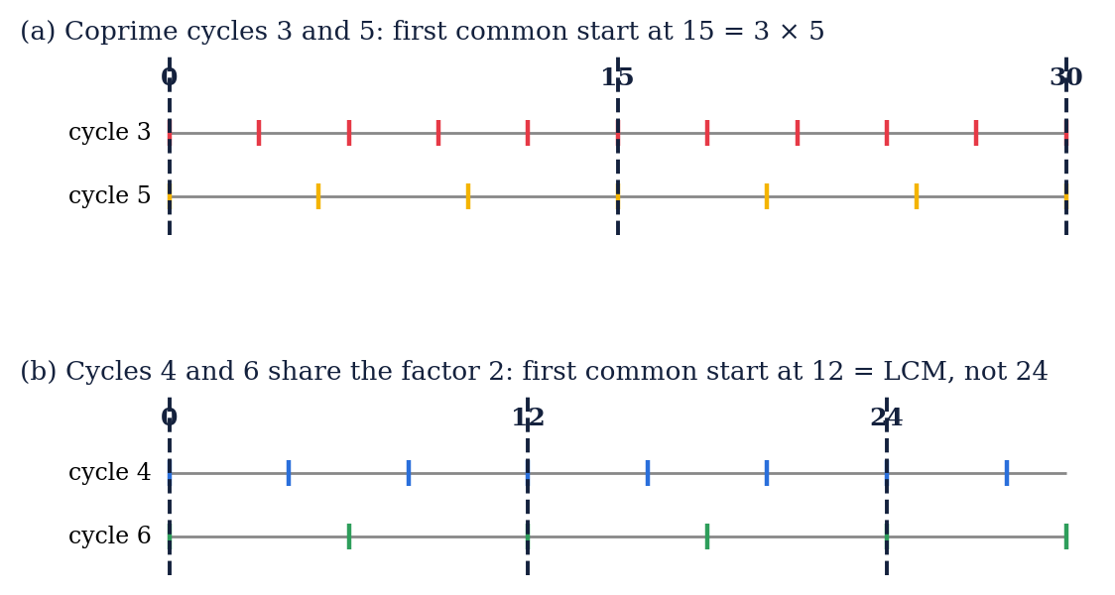
Fig. 2. Coprime cycles (a) meet after the product; cycles with a common factor (b) meet sooner.

2.5 Historical Development
The problem that gave the theorem its name appears in the Chinese text Sunzi Suanjing (“Master Sun's Mathematical Manual”), whose date is placed by scholars between the third and fifth centuries CE. It asks for a number that leaves remainders 2, 3 and 2 when divided by 3, 5 and 7, and the answer given is 23. This is the same system that is solved with the general CRT formula in Section 3.4 of this report [2], [5].
A complete general method, known as the “Dayan” rule, was given by the Chinese mathematician Qin Jiushao in his Shushu Jiuzhang (1247). In India, Aryabhata described the kuttaka method for linear indeterminate problems in the Aryabhatiya (499 CE), which is closely related to finding modular inverses. In Europe, the modern treatment of congruences and the notation a ≡ b (mod m) were introduced by Carl Friedrich Gauss in Disquisitiones Arithmeticae (1801) [10]. Today the theorem is a standard topic in discrete mathematics and number theory courses [1], [2] and a tool in algorithm design [3], [4].

2.6 Known Results for Cycle Sets
Table I collects the gcd, the LCM and the product for the cycle sets used in this report. The sets whose members are pairwise coprime have LCM equal to product, while the others show how the LCM can be much smaller than the product.
TABLE I
COMMON START TIME (LCM) VERSUS PRODUCT OF CYCLE LENGTHS
Cycle lengths (min) | Pairwise coprime? | Product | LCM = first common start | Difference
3, 5, 7 | Yes | 105 | 105 | none
3, 5 | Yes | 15 | 15 | none
4, 6 | No (gcd = 2) | 24 | 12 | LCM is half
6, 10, 15 | No (gcd = 2, 3, 5) | 900 | 30 | LCM is 1/30
9, 12, 18 | No | 1944 | 36 | LCM much smaller

Three consequences follow directly from the definitions: (a) the LCM always divides the product, so the first common start is never later than the product of the cycle lengths; (b) it equals the product exactly when the cycle lengths are pairwise coprime; and (c) every later common start is a multiple of the first one. For the example, the common starts are 0, 105, 210, 315, … minutes.

2.7 Alternative Ways of Solving the System

2.7.1 Prime Factorization Method
Write each cycle length as a product of prime powers; the LCM is the product of the highest power of each prime that occurs. For 3, 5 and 7 the primes are all different, so LCM = 3 × 5 × 7 = 105. For 4 = 2², 6 = 2 × 3 and 10 = 2 × 5 the LCM is 2² × 3 × 5 = 60.

2.7.2 Successive Substitution Method
A system with non-zero remainders can be solved two congruences at a time. Take t ≡ 2 (mod 3), t ≡ 3 (mod 5), t ≡ 2 (mod 7). From the first, t = 2 + 3k. Substituting into the second: 2 + 3k ≡ 3 (mod 5), so 3k ≡ 1 (mod 5), hence k ≡ 2 (mod 5) because 3·2 = 6 ≡ 1. Then t = 2 + 3(2 + 5j) = 8 + 15j. Substituting into the third: 8 + 15j ≡ 2 (mod 7), and since 8 ≡ 1 and 15 ≡ 1 (mod 7) this gives j ≡ 1 (mod 7), so t = 8 + 15 = 23, that is t ≡ 23 (mod 105). This agrees with the CRT formula in Section 3.4.

2.7.3 Simulation Method
The brute-force alternative is to test t = 1, 2, 3, … minute by minute and stop at the first value that satisfies every condition. It needs no theory, but its running time grows with the answer itself. It is used in this project as an independent check of the other two methods.

2.8 Modular Arithmetic in Programming
In programs the congruence t ≡ a (mod m) is tested with the remainder operator: t % m == a % m (for non-negative values). Clocks, circular buffers, hash tables and periodic schedulers all use this operator. A program that tests the condition for every signal is exactly a program that checks the system of congruences, which is how the simulation method of this project works.

2.9 Applications

2.9.1 Periodic Scheduling and Real-Time Systems
When several periodic tasks run on one system, the schedule repeats after the least common multiple of their periods, often called the hyperperiod. Computing it is the same calculation as the one in this report [3].

2.9.2 Clock Synchronization and Communication Systems
Repeating signals with different periods, such as frame counters or timing pulses, realign after an LCM of their periods. Congruence models help to reason about when such patterns coincide.

2.9.3 Cryptography and Computer Arithmetic
The CRT is used to speed up RSA decryption by working modulo each prime factor separately and recombining the results, and in residue number systems where large integers are stored as tuples of small remainders [4], [5].

2.9.4 Traffic Signal Timing (Model Only)
In traffic engineering, signals along a corridor are usually coordinated by giving them a common cycle length and suitable offsets, and real timing plans must also account for green durations, traffic demand, pedestrian crossings and safety clearances. The different-cycle example of this report is therefore only a mathematical illustration of simultaneous recurrence, not a design method for real signals.

Chapter 3 System Design

3.1 Overall Design
The software component of the project is a small C++ console program. It takes the cycle lengths (and, for the general CRT case, the remainders), evaluates the answer with three independent methods, prints the results and reports whether they agree. The design is deliberately simple so that attention stays on the mathematics. Fig. 3 shows the structure.
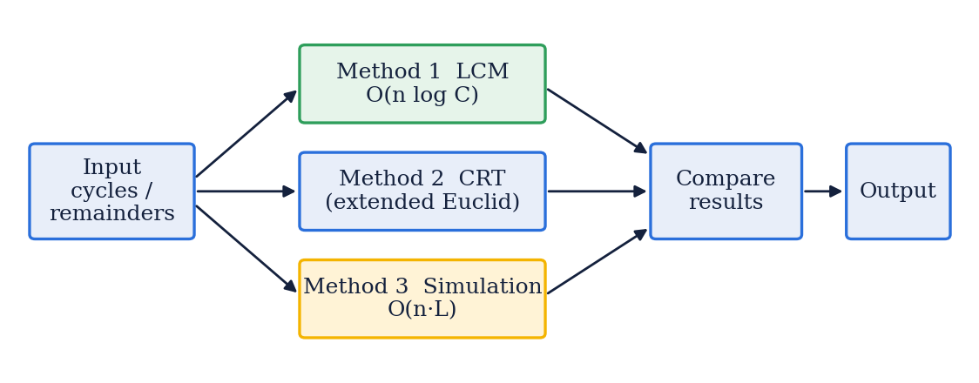
Fig. 3. Block diagram of the signal-synchronization program.

3.2 Mathematical Model
Let t denote the elapsed time in minutes, with t = 0 the moment at which all three signals start a complete cycle. Signal A, B and C repeat a complete cycle every m₁ = 3, m₂ = 5 and m₃ = 7 minutes. Signal i starts a new cycle at the times 0, m_{i}, 2m_{i}, …, that is, at the times t satisfying
t ≡ 0 (mod m_{i}), i = 1, 2, 3 (3)
All three signals start a cycle at the same moment when the three congruences hold together:
t ≡ 0 (mod 3), t ≡ 0 (mod 5), t ≡ 0 (mod 7) (4)
Assumption. A complete cycle is not the same as the green phase. The congruences model the simultaneous recurrence of the reference event “a cycle starts” and nothing else. If the green phase of each signal begins exactly at the cycle start, the same times are also the times at which all signals turn green together; otherwise the model must be extended with phase offsets (Section 6.2).

3.3 Theorem and Proof
Theorem. Let m₁, …, m_{n} be pairwise coprime positive integers, M = m₁ × … × m_{n}, and a₁, …, a_{n} any integers. Then the system t ≡ a_{i} (mod m_{i}), i = 1, …, n, has a solution that is unique modulo M.
Proof (existence). For each i, M_{i} = M / m_{i} is divisible by every modulus except m_{i}. Because the moduli are pairwise coprime, gcd(M_{i}, m_{i}) = 1, so M_{i} has an inverse y_{i} modulo m_{i}: M_{i} y_{i} ≡ 1 (mod m_{i}). Let t₀ = a₁ M₁ y₁ + … + a_{n} M_{n} y_{n}. Modulo m_{i} every term except the i-th contains the factor m_{i} and is therefore 0, while the i-th term is a_{i} M_{i} y_{i} ≡ a_{i} · 1 = a_{i}. Hence t₀ ≡ a_{i} (mod m_{i}) for every i.
Proof (uniqueness). Suppose t and t' both satisfy the system. Then m_{i} divides t − t' for every i. Since the m_{i} are pairwise coprime, their product M also divides t − t', that is, t ≡ t' (mod M). ∎
Corollary (zero remainders). If a₁ = … = a_{n} = 0, every term of t₀ vanishes, so t ≡ 0 (mod M). The solutions are t = 0, M, 2M, …; the first strictly positive one is t = M, which equals LCM(m₁, …, m_{n}) for pairwise coprime moduli.

3.4 Step-by-Step Numerical Solution
Step 1: Form the congruences. For Signal A, B and C with cycle intervals 3, 5 and 7 minutes the conditions are t ≡ 0 (mod 3), t ≡ 0 (mod 5) and t ≡ 0 (mod 7).
Step 2: Check the coprime condition. gcd(3, 5) = 1, gcd(3, 7) = 1 and gcd(5, 7) = 1, so the moduli are pairwise coprime and the CRT applies. The modulus product is
M = 3 × 5 × 7 = 105 (5)
Step 3: Apply the CRT. M₁ = 105 / 3 = 35, M₂ = 105 / 5 = 21 and M₃ = 105 / 7 = 15. With a₁ = a₂ = a₃ = 0, formula (2) gives t ≡ 0·35·y₁ + 0·21·y₂ + 0·15·y₃ = 0 (mod 105). The inverses y_{i} are not needed here, because 0 multiplied by anything is 0.
Step 4: Interpret the answer by divisibility. t ≡ 0 modulo 3, 5 and 7 means that t is divisible by 3, 5 and 7. Because the three numbers are pairwise coprime,
LCM(3, 5, 7) = 3 × 5 × 7 = 105 (6)
so the common cycle-start event repeats every 105 minutes: t = 0, 105, 210, … If t = 0 is allowed, the initial simultaneous event occurs at time zero; the first strictly positive simultaneous recurrence is 105 minutes. Since 105 = 60 + 45,
105 minutes = 1 hour 45 minutes (7)
Why the answer is correct. Any time at which all three cycles start must be a multiple of 3, of 5 and of 7, hence a multiple of 105. No positive time smaller than 105 can therefore work. Verification: 105 ÷ 3 = 35, 105 ÷ 5 = 21 and 105 ÷ 7 = 15 are exact, so 105 mod 3 = 105 mod 5 = 105 mod 7 = 0.
A separate illustration with non-zero remainders. To show how the general formula works, consider t ≡ 2 (mod 3), t ≡ 3 (mod 5), t ≡ 2 (mod 7). This is not the signal problem. Again M = 105 and M₁, M₂, M₃ = 35, 21, 15. The inverses are y₁ = 2 (because 35·2 = 70 ≡ 1 mod 3), y₂ = 1 (21 ≡ 1 mod 5) and y₃ = 1 (15 ≡ 1 mod 7). Then t ≡ 2·35·2 + 3·21·1 + 2·15·1 = 140 + 63 + 30 = 233 ≡ 233 − 210 = 23 (mod 105). Check: 23 = 7·3 + 2, 23 = 4·5 + 3 and 23 = 3·7 + 2, so the remainders are 2, 3 and 2.

3.5 Algorithm 1: LCM Method
The LCM method applies to the case where all remainders are zero. It folds the cycle lengths one at a time, using LCM(a, b) = a·b / gcd(a, b), and returns the first strictly positive common recurrence for an initial event at time zero. The division is performed before the multiplication to keep the intermediate value small.
Algorithm LCM_METHOD(c[1..n])
Input : positive cycle lengths c[1], ..., c[n]
Output: first strictly positive common recurrence
1. result <- 1
2. for i <- 1 to n do
3. result <- result / GCD(result, c[i]) * c[i]
4. return result

3.6 Algorithm 2: CRT Method
The CRT method solves the general system t ≡ a_{i} (mod m_{i}) for pairwise coprime moduli. It first checks the coprime condition, then computes M, each M_{i}, the inverse y_{i} with the extended Euclidean algorithm, and finally the sum of formula (2) reduced modulo M. For zero remainders it returns t = 0, and the first positive solution is M.
Algorithm CRT_METHOD(a[1..n], m[1..n])
1. if GCD(m[i], m[j]) != 1 for some i < j then return ERROR
2. M <- m[1] * m[2] * ... * m[n]
3. t <- 0
4. for i <- 1 to n do
5. Mi <- M / m[i]
6. yi <- INVERSE(Mi, m[i]) // by extended Euclid
7. t <- (t + a[i] * Mi * yi) mod M
8. return t // 0 <= t < M

3.7 Algorithm 3: Simulation Method
The simulation method tests t = 1, 2, 3, … in turn and returns the first t for which t mod c[i] = 0 for every cycle length. It is the most direct translation of the problem, needs no theory, and is used as an independent check.
Algorithm SIMULATION(c[1..n])
1. t <- 1
2. while true do
3. if t mod c[i] = 0 for every i then return t
4. t <- t + 1

Complexity. Let C be the largest cycle length and L the answer (the LCM). The LCM method performs n gcd computations of O(log C) steps each. The CRT method checks n(n−1)/2 pairs for coprimality and computes n inverses, giving O(n² log C). The simulation performs up to n modulo operations for each of L values of t, so O(n·L), which grows with the answer itself. The extra space is O(1) for all three.
TABLE II
COMPARISON OF THE THREE METHODS
Method | Time | Extra space | Main advantage | Main limitation
LCM | O(n log C) | O(1) | Fast and simple | Only for zero remainders
CRT | O(n² log C) | O(1) | Handles any remainders | Needs pairwise coprime moduli
Simulation | O(n·L) | O(1) | No theory needed | Slow when the LCM is large

3.8 Data Type and Overflow Analysis
All functions use the 64-bit signed type long long, whose largest value is 9 223 372 036 854 775 807 ≈ 9.22 × 10¹⁸. The LCM and the product M can grow quickly even when the individual cycle lengths are small. The product of the first fifteen primes, 2 × 3 × 5 × … × 47, is 614 889 782 588 491 410 ≈ 6.15 × 10¹⁷ and still fits, but multiplying it by the next prime, 53, gives 32 589 158 477 190 044 730 ≈ 3.26 × 10¹⁹, which exceeds even the unsigned 64-bit limit of about 1.84 × 10¹⁹.
In the CRT program the term (a_{i} mod m_{i})·M_{i} mod M is multiplied by y_{i}, which is less than m_{i}, so the intermediate value is below M·m_{i}. The program is therefore safe when M × max(m_{i}) < 2⁶³, which is true for the example (M = 105). For larger inputs a 128-bit integer type or an arbitrary-precision library can be used. The simulation method has a different limit: its running time grows with the LCM, so it is impractical when the LCM is very large.

3.9 Test Plan
The test plan combines the main example, small hand-checkable values, cases with non-coprime cycles, and exhaustive checks. The expected results in Table III were obtained by hand from the theory of Chapter 2 and Section 3.4. In addition, two exhaustive tests were run: the LCM method was compared with the simulation for every triple of cycle lengths from 1 to 30 (27 000 triples), and the CRT method was run for all 3 × 5 × 7 = 105 possible remainder triples of the moduli 3, 5 and 7.
TABLE III
TEST CASES AND EXPECTED RESULTS
Test | Method | Input | Expected result | Purpose
T1 | LCM | cycles 3, 5, 7 | 105 | Main example
T2 | LCM | cycles 2, 3 | 6 | Smallest coprime pair
T3 | LCM | cycles 4, 6 | 12 | Not coprime: not 24
T4 | LCM | cycles 5, 8 | 40 | Coprime pair
T5 | LCM | cycles 6, 10, 15 | 30 | Pairwise not coprime
T6 | CRT | a = (0,0,0), m = (3,5,7) | t = 0 (mod 105) | Zero remainders
T7 | CRT | a = (2,3,2), m = (3,5,7) | t = 23 | Classical example
T8 | CRT | a = (1,2,3), m = (3,5,7) | t = 52 | Non-zero remainders
T9 | CRT | a = (0,2,3), m = (3,5,7) | t = 87 | Offset start times
T10 | CRT | a = (3,4), m = (5,8) | t = 28 | Two moduli
T11 | CRT | a = (1,3), m = (4,6) | rejected | Moduli not coprime

Chapter 4 Implementation Details

4.1 Development Environment
TABLE IV
DEVELOPMENT AND TEST ENVIRONMENT
Item | Details
Programming language | C++ (ISO C++ standard [9]; default dialect of the compiler)
Compiler | GNU g++ 13.3.0
Operating system | Ubuntu Linux 24.04 (x86-64)
Optimisation level | -O0 (no optimisation)
Integer type | long long (64-bit signed)
Version control | Git / GitHub (see Annexure 1)

4.2 Main Program
Listing 1 gives the complete program. It contains the three methods of Chapter 3 and a main function that solves the example of this report and confirms that the methods agree.
Listing 1. crtsignal.cpp — three methods for the signal-synchronization example
#include <iostream>
#include <vector>
using namespace std;
typedef long long ll;

// Greatest common divisor (Euclid's algorithm)
ll gcdll(ll a, ll b) {
while (b != 0) { ll r = a % b; a = b; b = r; }
return a;
}

// Least common multiple
ll lcmll(ll a, ll b) { return a / gcdll(a, b) * b; }

// Method 1: LCM of all cycle lengths (all remainders zero)
ll methodLCM(const vector<ll>& c) {
ll result = 1;
for (ll x : c) result = lcmll(result, x);
return result;
}

// Extended Euclid: returns g = gcd(a,b) and x, y with a*x + b*y = g
ll extGcd(ll a, ll b, ll &x, ll &y) {
if (b == 0) { x = 1; y = 0; return a; }
ll x1, y1;
ll g = extGcd(b, a % b, x1, y1);
x = y1;
y = x1 - (a / b) * y1;
return g;
}

// Multiplicative inverse of a modulo m (gcd(a,m) must be 1)
ll modInverse(ll a, ll m) {
ll x, y;
extGcd(((a % m) + m) % m, m, x, y);
return ((x % m) + m) % m;
}

// Method 2: Chinese Remainder Theorem (moduli pairwise coprime)
// returns t in [0, M) with t = a[i] (mod m[i]); returns -1 if moduli are not coprime
ll methodCRT(const vector<ll>& a, const vector<ll>& m) {
int n = m.size();
for (int i = 0; i < n; i++)
for (int j = i + 1; j < n; j++)
if (gcdll(m[i], m[j]) != 1) return -1;
ll M = 1;
for (ll x : m) M *= x;
ll t = 0;
for (int i = 0; i < n; i++) {
ll Mi = M / m[i];
ll yi = modInverse(Mi, m[i]);
t = (t + (a[i] % m[i]) * Mi % M * yi) % M;
}
return t;
}

// Method 3: brute-force simulation, checks t = 1, 2, 3, ... minute by minute
ll methodSimulation(const vector<ll>& c) {
for (ll t = 1; ; t++) {
bool all = true;
for (ll x : c) if (t % x != 0) { all = false; break; }
if (all) return t;
}
}

int main() {
vector<ll> cycles = {3, 5, 7};
ll l1 = methodLCM(cycles);
ll l2 = methodCRT({0, 0, 0}, cycles); // t = 0 (mod 105)
ll l3 = methodSimulation(cycles);
cout << "Cycles: 3 5 7" << endl;
cout << "LCM method : " << l1 << " minutes" << endl;
cout << "CRT method (t mod M): " << l2 << " (M = 105, so first positive t = M = " << l1 << ")" << endl;
cout << "Simulation method : " << l3 << " minutes" << endl;
cout << "Converted : " << l1 / 60 << " h " << l1 % 60 << " min" << endl;
cout << ((l1 == l3 && l2 == 0) ? "All methods agree." : "Mismatch detected!") << endl;
return 0;
}

4.3 Explanation of the Code
- gcdll and lcmll. gcdll implements Euclid's algorithm; lcmll computes a / gcd × b, dividing first so that the intermediate value stays small (Section 3.8).
- methodLCM. Starts with result = 1 and folds in every cycle length with lcmll. For the cycles 3, 5, 7 the partial results are 3, 15 and 105.
- extGcd and modInverse. extGcd returns g = gcd(a, b) together with x and y such that a·x + b·y = g; modInverse uses x to give the inverse of a modulo m, reduced into the range 0 to m − 1.
- methodCRT. Returns −1 if two moduli are not coprime. Otherwise it computes M, then for each i the value M_{i} = M / m_{i} and its inverse y_{i}, and accumulates formula (2) modulo M. With all remainders 0 it returns 0.
- methodSimulation. Tests t = 1, 2, 3, … until every cycle length divides t.
- main. Solves the example, converts the result into hours and minutes with / 60 and % 60, and prints whether all methods agree. The comparison is an automatic self-check: agreement of three independently structured computations is strong evidence that the theory and the code are consistent.

4.4 Test Program
A second program, tests.cpp, contains the same functions and runs the exhaustive tests of Section 3.9. Listing 2 shows the two exhaustive loops.
Listing 2. tests.cpp — exhaustive tests (excerpt)
// exhaustive 1: LCM method vs simulation for all triples of cycles 1..30
long count = 0, bad = 0;
for (ll x = 1; x <= 30; x++)
for (ll y = 1; y <= 30; y++)
for (ll z = 1; z <= 30; z++) {
vector<ll> c = {x, y, z};
count++;
if (methodLCM(c) != methodSimulation(c)) bad++;
}

// exhaustive 2: CRT for all 105 remainder triples of moduli 3, 5, 7
vector<ll> m = {3, 5, 7};
vector<int> seen(105, 0);
for (ll a1 = 0; a1 < 3; a1++)
for (ll a2 = 0; a2 < 5; a2++)
for (ll a3 = 0; a3 < 7; a3++) {
ll t = methodCRT({a1, a2, a3}, m);
bool good = t >= 0 && t < 105 && t % 3 == a1
&& t % 5 == a2 && t % 7 == a3;
if (good) seen[t]++;
}

4.5 Implementation Notes
- The program can be compiled with g++ -O0 -o crtsignal crtsignal.cpp and run as ./crtsignal.
- The programs assume positive cycle lengths and moduli. A production version should validate input and warn when M × max(m_{i}) approaches the 64-bit limit (Section 3.8).
- The exhaustive tests reported zero mismatches (Section 5.1), and the eleven cases of Table III were also checked individually against hand-derived values.
- The source code was uploaded to a GitHub repository by the group (screenshot in Annexure 1), and each member contributed to coding, testing or documentation.

Chapter 5 Results and Analysis

5.1 Program Output
Output 1 shows the console output of crtsignal for the cycles 3, 5 and 7. Output 2 shows the results of the test program for the cases of Table III and the two exhaustive tests. These outputs were produced by compiling and running the programs of Chapter 4 with g++ 13.3.0; you may replace them with screenshots of your own run.
$ ./crtsignal
Cycles: 3 5 7
LCM method : 105 minutes
CRT method (t mod M): 0 (M = 105, so first positive t = M = 105)
Simulation method : 105 minutes
Converted : 1 h 45 min
All methods agree.
Output 1. Console output of crtsignal for the cycles 3, 5 and 7 minutes.
$ ./tests
cycles: 3 5 7 -> LCM 105, simulation 105
cycles: 2 3 -> LCM 6, simulation 6
cycles: 4 6 -> LCM 12, simulation 12
cycles: 5 8 -> LCM 40, simulation 40
cycles: 6 10 15 -> LCM 30, simulation 30
cycles: 9 12 18 -> LCM 36, simulation 36
cycles: 7 -> LCM 7, simulation 7
cycles: 1 1 1 -> LCM 1, simulation 1
CRT a=(2,3,2) m=(3,5,7) -> t = 23
CRT a=(1,2,3) m=(3,5,7) -> t = 52
CRT a=(0,2,3) m=(3,5,7) -> t = 87
CRT a=(0,0,0) m=(3,5,7) -> t = 0
CRT a=(3,4) m=(5,8) -> t = 28
CRT a=(1,3) m=(4,6) -> moduli not pairwise coprime
Exhaustive LCM vs simulation (cycles 1..30, all triples): 27000 cases, 0 mismatches
Exhaustive CRT (moduli 3,5,7): 105 of 105 remainder triples satisfied, 0 failures, 105 distinct solutions in 0..104
Output 2. Console output of the test program.
In every case the methods agree, the CRT results match the hand-derived values of Table III, and the pair (4, 6) is correctly rejected by the CRT program because the moduli are not coprime. The second exhaustive test also confirms the uniqueness part of the theorem for these moduli: the 105 remainder triples produce 105 different solutions in the range 0 to 104.

5.2 Timeline of the Signals
Fig. 4 shows the cycle starts of the three signals up to t = 105. Each tick is a time at which that signal starts a new cycle. Signal A has 36 ticks (0, 3, …, 105), Signal B has 22 (0, 5, …, 105) and Signal C has 16 (0, 7, …, 105). Pairs of signals meet earlier, for example A and B at 15, A and C at 21 and B and C at 35, but all three meet only at t = 0 and t = 105.
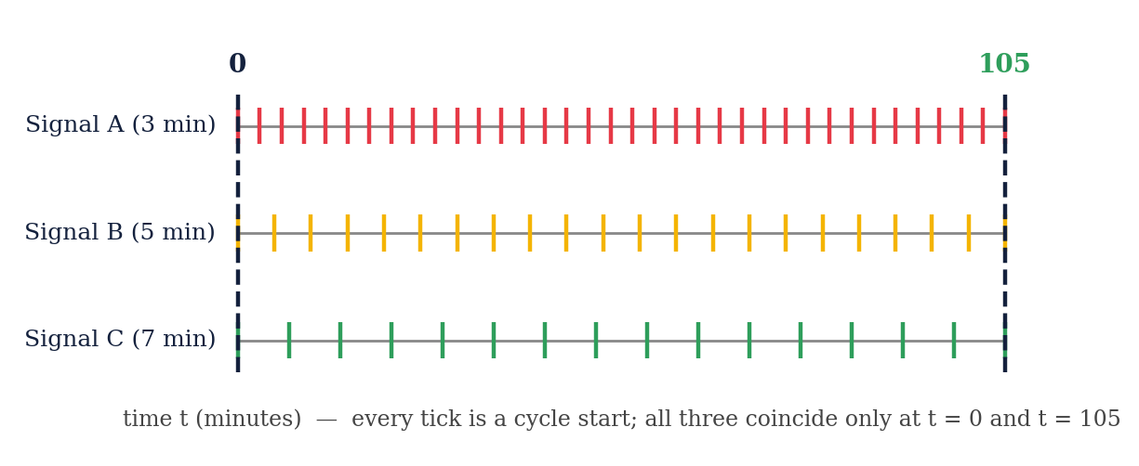
Fig. 4. Cycle starts of Signals A, B and C between t = 0 and t = 105 minutes.

5.3 Verification of the Result
Table V checks several candidate times against the three conditions. The times 15, 21 and 35 satisfy only two of the three congruences, while 105 and its multiples satisfy all of them.
TABLE V
CHECKING CANDIDATE TIMES AGAINST THE THREE CONGRUENCES
t (min) | t mod 3 | t mod 5 | t mod 7 | All three zero?
15 | 0 | 0 | 1 | No
21 | 0 | 1 | 0 | No
35 | 2 | 0 | 0 | No
105 | 0 | 0 | 0 | Yes
210 | 0 | 0 | 0 | Yes
315 | 0 | 0 | 0 | Yes

The divisions are 105 ÷ 3 = 35, 105 ÷ 5 = 21 and 105 ÷ 7 = 15, all exact. Fig. 5 compares the LCM with the product of the cycle lengths for the sets of Table I: the two coincide only for pairwise coprime cycles.
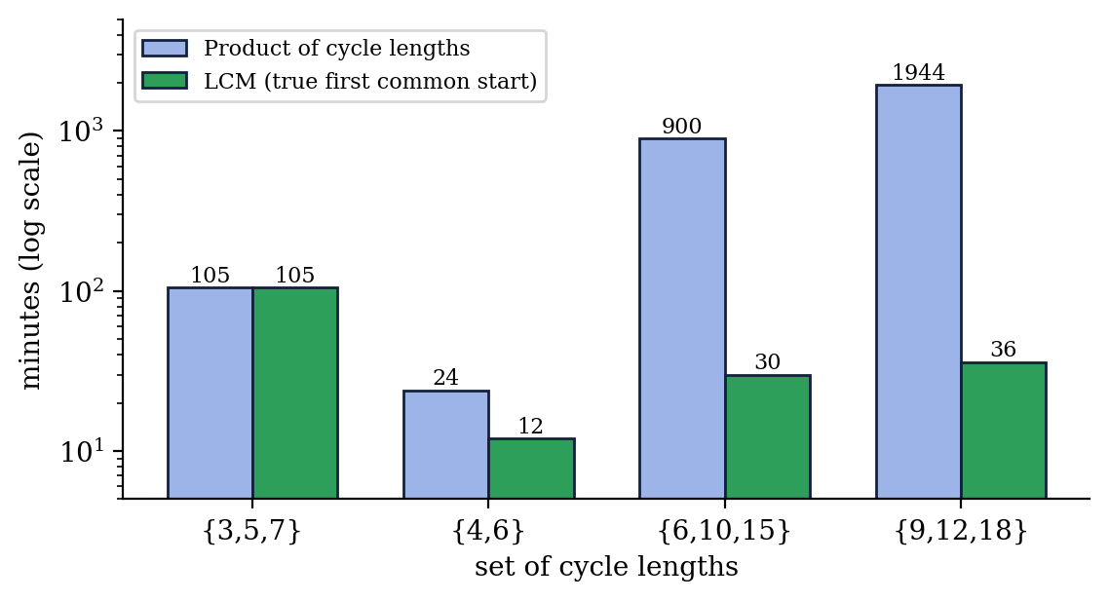
Fig. 5. LCM (true first common start) compared with the product of the cycle lengths.

5.4 Analysis of Results
- Correctness. The LCM method, the CRT method and the simulation agreed in all hand-checkable cases and in the exhaustive tests. This agrees with the theorem proved in Section 3.3.
- Role of CRT. For the zero-remainder example CRT immediately gives t ≡ 0 (mod 105), and the first positive solution is the LCM. The inverse calculation is needed only for non-zero remainders, as in the illustration of Section 3.4.
- Efficiency. By the analysis of Section 3.7, the LCM and CRT methods take time that grows only with the number and size of the cycle lengths, while the simulation takes time proportional to the answer. For the example the answer is only 105, so all three are instantaneous; no timing benchmark was measured for this report.
- Scalability. The methods are limited by the size of the product M in 64-bit arithmetic (Section 3.8), and the simulation by the size of the LCM.
- Scope of the model. The result holds under the stated assumptions: every signal starts a complete cycle at t = 0 and repeats it every 3, 5 and 7 minutes. It is a mathematical result, not a statement about any real traffic-control system.

5.5 Problem Solutions
The following problems illustrate how the technique applies to related situations. All answers were verified by hand and by the programs of Chapter 4.
Problem 1. Three signals have cycles of 4, 6 and 10 minutes and all start a cycle at t = 0. When do they next start together? Solution: 4 = 2², 6 = 2 × 3 and 10 = 2 × 5, so LCM = 2² × 3 × 5 = 60. They next start together after 60 minutes (1 hour). The moduli are not pairwise coprime, so the answer is not 4 × 6 × 10 = 240.
Problem 2. Solve t ≡ 2 (mod 3), t ≡ 3 (mod 5), t ≡ 2 (mod 7). Solution: M = 105, M_{i} = 35, 21, 15, y_{i} = 2, 1, 1, so t ≡ 2·35·2 + 3·21·1 + 2·15·1 = 233 ≡ 23 (mod 105). Check: 23 mod 3 = 2, 23 mod 5 = 3, 23 mod 7 = 2.
Problem 3. Solve t ≡ 1 (mod 3), t ≡ 2 (mod 5), t ≡ 3 (mod 7). Solution: with the same M_{i} and y_{i}, t ≡ 1·35·2 + 2·21·1 + 3·15·1 = 70 + 42 + 45 = 157 ≡ 52 (mod 105). Check: 52 mod 3 = 1, 52 mod 5 = 2, 52 mod 7 = 3.
Problem 4. Signal A (cycle 3) starts a cycle at t ≡ 0 (mod 3), Signal B (cycle 5) at t ≡ 2 (mod 5) and Signal C (cycle 7) at t ≡ 3 (mod 7). Find the first time all three start a cycle. Solution: t ≡ 0·35·2 + 2·21·1 + 3·15·1 = 42 + 45 = 87 (mod 105). Check: 87 mod 3 = 0, 87 mod 5 = 2, 87 mod 7 = 3, so the first time is 87 minutes.
Problem 5. How many times in the 1440 minutes of one day do the 3, 5 and 7 minute cycles start together, after t = 0? Solution: the common starts are 105k. Since 13 × 105 = 1365 ≤ 1440 and 14 × 105 = 1470 > 1440, there are 13 such times, the last at 1365 minutes = 22 hours 45 minutes. (If t = 0 is counted, there are 14.)
Problem 6. How many common starts of the 3, 5 and 7 minute cycles lie in 0 ≤ t ≤ 500? Solution: t = 0, 105, 210, 315, 420 (the next, 525, exceeds 500), so there are 5.
Problem 7. Show that for coprime a and b, LCM(a, b) = a·b. Solution: LCM(a, b) = a·b / gcd(a, b) and gcd(a, b) = 1. For example LCM(5, 8) = 40.
Problem 8. Solve t ≡ 1 (mod 4), t ≡ 3 (mod 6). Solution: the moduli are not coprime, so the basic CRT does not apply directly. A solution exists because 1 ≡ 3 (mod gcd(4, 6) = 2). Listing t = 1, 5, 9, 13, … (those ≡ 1 mod 4), the first with t mod 6 = 3 is t = 9, and the solutions repeat every LCM(4, 6) = 12: t ≡ 9 (mod 12). Check: 21 mod 4 = 1 and 21 mod 6 = 3.
TABLE VI
SOLUTIONS OF THE NON-ZERO-REMAINDER SYSTEMS AND CHECKS
Remainders (a₁, a₂, a₃) | Solution t (mod 105) | t mod 3 | t mod 5 | t mod 7
(0, 0, 0) | 0 (first positive: 105) | 0 | 0 | 0
(2, 3, 2) | 23 | 2 | 3 | 2
(1, 2, 3) | 52 | 1 | 2 | 3
(0, 2, 3) | 87 | 0 | 2 | 3

5.6 A Cautionary Example
The coprime condition is not a formality. First, using the product of the cycle lengths instead of the LCM gives wrong answers: for cycles 4 and 6 the product is 24, but the signals start together after 12 minutes. Second, a system with non-coprime moduli may have no solution at all. Consider t ≡ 1 (mod 4) and t ≡ 2 (mod 6). The first congruence forces t to be odd and the second forces t to be even, so no integer satisfies both. In general, two congruences t ≡ a₁ (mod m₁) and t ≡ a₂ (mod m₂) are compatible only if a₁ ≡ a₂ (mod gcd(m₁, m₂)); here gcd(4, 6) = 2 and 1 ≢ 2 (mod 2). With coprime moduli the gcd is 1 and compatibility is automatic, which is why the theorem requires pairwise coprime moduli. The CRT program of this report refuses such inputs (test T11).

Chapter 6 Conclusion

6.1 Conclusion
This project modelled the simultaneous cycle starts of three illustrative traffic signals with congruences and solved the model with the Chinese Remainder Theorem. Since the moduli 3, 5 and 7 are pairwise coprime, the system t ≡ 0 (mod 3), t ≡ 0 (mod 5), t ≡ 0 (mod 7) has a unique solution modulo 105. Because all remainders are zero, the solution is the LCM: the first strictly positive simultaneous recurrence is 105 minutes = 1 hour 45 minutes, and t = 0 is the initial simultaneous event. The result was verified by exact division and by checking candidate times.
The calculation was implemented in C++ in three ways. The LCM method and the simulation agreed for all 27 000 triples of cycle lengths from 1 to 30, and the CRT method produced a correct, distinct solution for all 105 remainder triples of the moduli 3, 5 and 7. The overflow analysis showed the range of the 64-bit implementation. The solved problems showed how the general CRT formula handles non-zero remainders and why the coprime condition matters.
The report also made the limits of the model clear. It treats the recurrence of a reference event, not the green phase; it uses illustrative cycle lengths; and it is not a real traffic-control system. Real traffic optimization needs a more comprehensive model that includes green durations, traffic demand, pedestrian crossings, safety constraints and vehicle flow, and the Chinese Remainder Theorem alone cannot optimize a real city's traffic.

6.2 Future Scope
- Extending the model with phase offsets and green-phase durations, so that “all signals are green together” can be studied as an interval problem and not only as a cycle-start event.
- Studying the generalized CRT for non-coprime moduli, where the system is solvable only under the compatibility condition of Section 5.6 and the solution is unique modulo the LCM.
- Using 128-bit or arbitrary-precision arithmetic to remove the overflow limits of Section 3.8, and adding input validation and a menu-driven interface.
- Comparing the mathematical model with data from a traffic simulator under proper supervision, and studying coordination strategies used in real traffic engineering.

References
[1] K. H. Rosen, Discrete Mathematics and Its Applications, 8th ed. New York, NY, USA: McGraw-Hill Education, 2019.
[2] D. M. Burton, Elementary Number Theory, 7th ed. New York, NY, USA: McGraw-Hill, 2011.
[3] T. H. Cormen, C. E. Leiserson, R. L. Rivest, and C. Stein, Introduction to Algorithms, 3rd ed. Cambridge, MA, USA: MIT Press, 2009.
[4] D. E. Knuth, The Art of Computer Programming, Vol. 2: Seminumerical Algorithms, 3rd ed. Reading, MA, USA: Addison-Wesley, 1997.
[5] I. Niven, H. S. Zuckerman, and H. L. Montgomery, An Introduction to the Theory of Numbers, 5th ed. New York, NY, USA: Wiley, 1991.
[6] S. S. Epp, Discrete Mathematics with Applications, 5th ed. Boston, MA, USA: Cengage Learning, 2019.
[7] R. Johnsonbaugh, Discrete Mathematics, 8th ed. Boston, MA, USA: Pearson, 2018.
[8] B. Stroustrup, The C++ Programming Language, 4th ed. Upper Saddle River, NJ, USA: Addison-Wesley, 2013.
[9] Programming Languages—C++, ISO/IEC Standard 14882:2020, International Organization for Standardization, Geneva, Switzerland, 2020.
[10] C. F. Gauss, Disquisitiones Arithmeticae. Leipzig, Germany: Gerhard Fleischer, 1801.
[11] R. L. Graham, D. E. Knuth, and O. Patashnik, Concrete Mathematics: A Foundation for Computer Science, 2nd ed. Reading, MA, USA: Addison-Wesley, 1994.

Annexure 1: GitHub Upload Screenshot
[ Paste the screenshot of your GitHub repository upload here ]
Screenshot of the project repository on GitHub showing crtsignal.cpp and the report.

Annexure 2: Presentation Geo-Tag Photo
[ Paste the geo-tagged presentation photo here ]
Geo-tagged photograph taken during the group PowerPoint presentation.

Annexure 3: Certificate of Online Course
[ Paste the online course certificate here ]
Certificate of an online course related to the Discrete Mathematics course.

