AI-Powered Sales Forecasting Dashboard
Overview
This repository contains all files and documentation for Task 1 of the Future Interns Machine Learning Internship (November 2025). The goal is to build a dashboard that predicts future sales trends using historical retail sales data.
Project Structure
- Superstore.csv: Raw sales data used for analysis and modeling.
- prophet_model.py: Python script implementing the sales forecasting model with Prophet.
- forecast_results.csv: Output file containing model forecast results.
- requirements.txt: List of Python libraries and versions needed to run the code.
- task1.pbix: Power BI dashboard visualizing actual and forecasted sales trends.
Approach
- Performed data preparation and cleaning on the retail sales dataset.
- Built a time series forecasting model using the Prophet library in Python.
- Visualized results including actual sales, predicted sales, and confidence intervals.
- Integrated outputs with Power BI for dynamic dashboarding.
How to Run
- Clone this repository.
- Install dependencies:
text
pip install -r requirements.txt
- Run the forecasting script:
text
python prophet_model.py
- Open task1.pbix in Power BI Desktop to view and interact with the dashboard.
Key Findings & Insights
- Identified seasonal patterns and trends in sales from 2014 to 2018.
- Delivered month-on-month forecasts and highlighted best/worst performing categories and regions.
- Demonstrated alignment between actual and predicted sales, supporting business planning and inventory management.
Screenshots
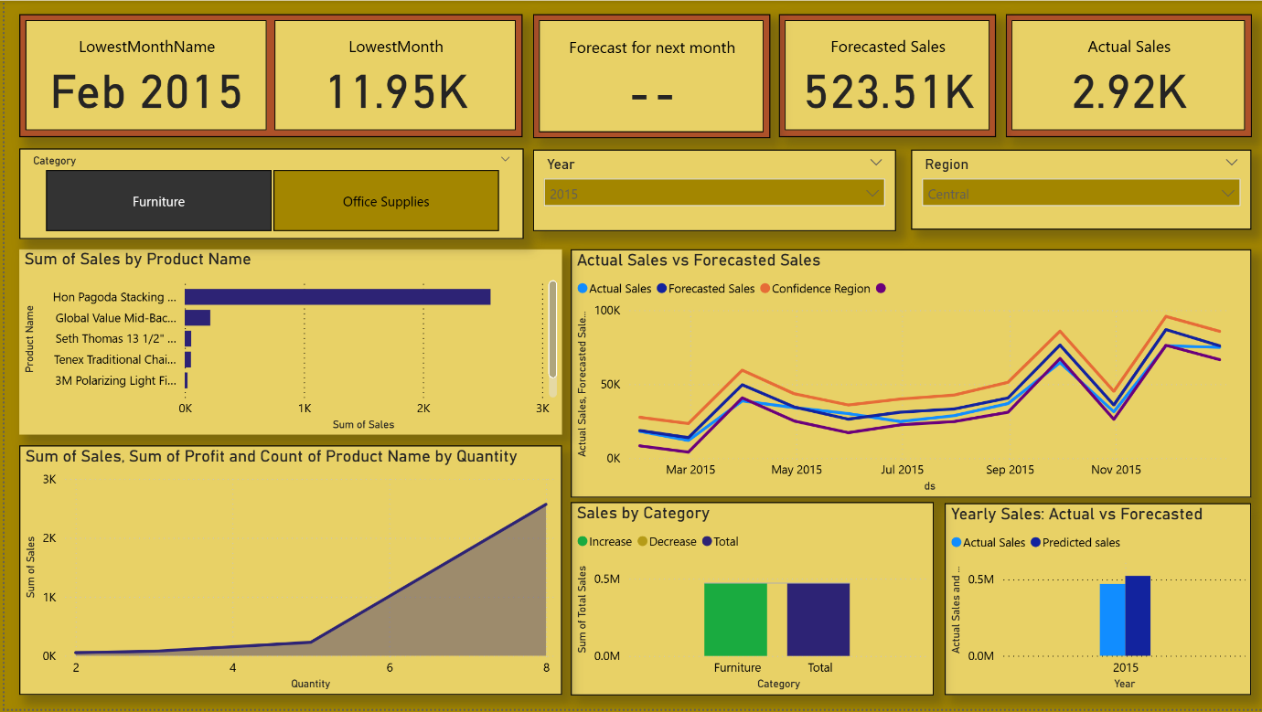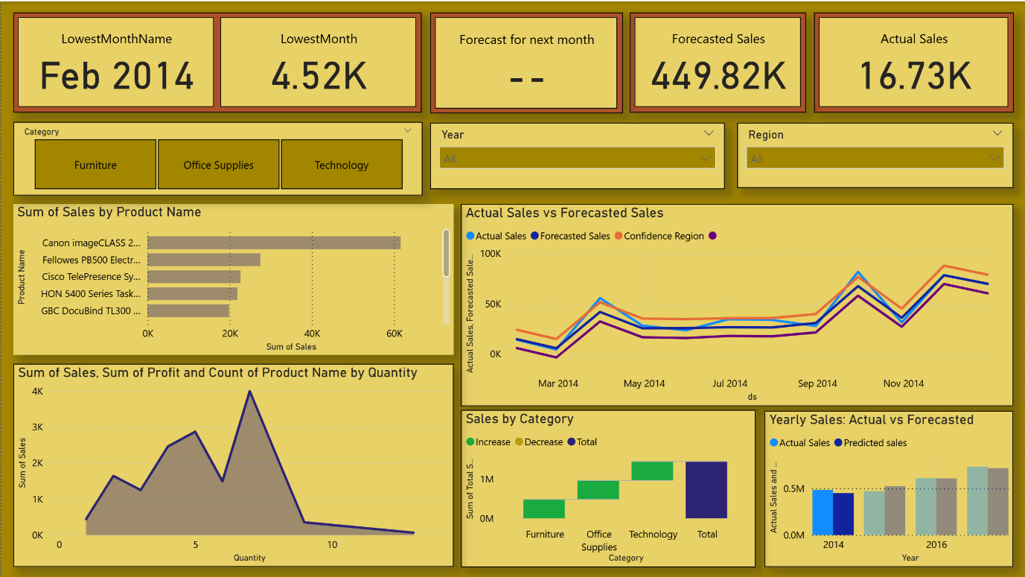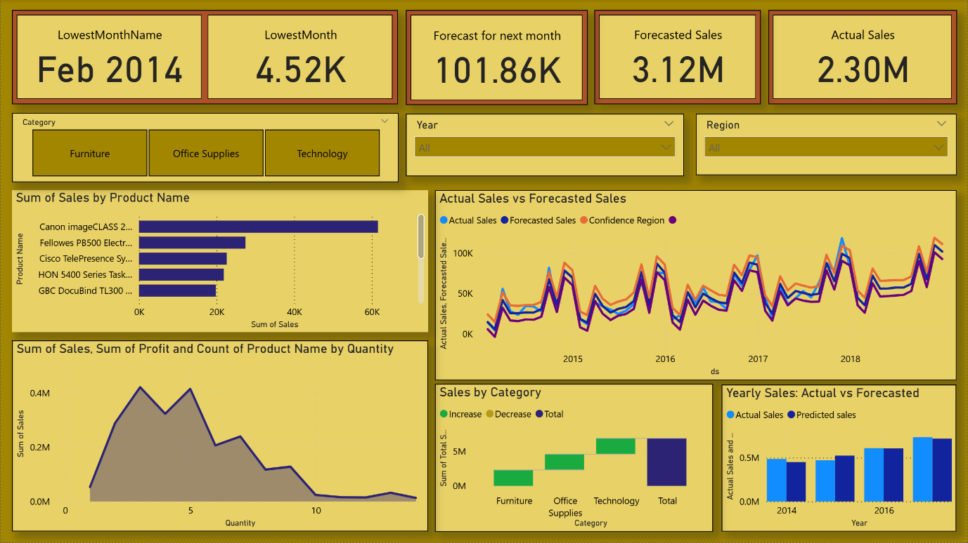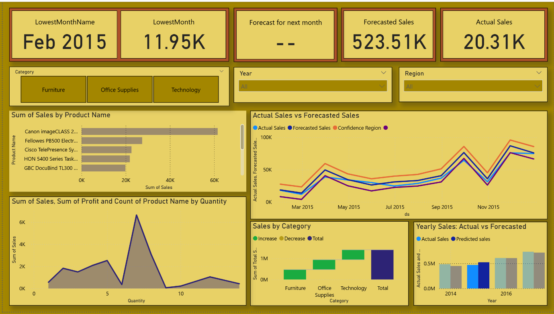

Author
Atharva Dhenge, Future Interns Machine Learning Track (2025)
For questions, contact: [atharvadhenge2006@gmail.com]

