Comparative Analysis of Machine Learning Models for Energy Sustainability Forecasting Using XGBoost

Artificial Intelligence and Data Science Department
Vishwakarma Institute of Technology, Pune, Maharashtra, India
Zarinabegam Mundargi¹, Atharva Kavade², Srushti Kasurde³, Vivek Kendre⁴, Ayushi Kamble⁵, Sushant Katare⁶

Abstract
Accurate forecasting of energy consumption and sustainability trends is essential for informed decision-making in environmental policy and resource management. This study presents a comparative analysis of predictive models applied to global energy data, focusing primarily on XGBoost and Prophet. The objective is to forecast future energy trends, CO₂ emissions, and renewable energy shares using historical data obtained from Our World in Data (OWID).
Keywords — XGBoost, Prophet, Streamlit, Energy Forecasting, CO₂ Emissions, Renewable Energy, Machine Learning, Time Series, Sustainability Analytics

I. INTRODUCTION
The global energy sector is undergoing a transformation driven by rapid technological advances, policy shifts, and sustainability goals. Forecasting future energy demands and emissions has become essential for governments and organizations to plan sustainable strategies. However, traditional statistical forecasting models often fail to capture complex nonlinear dependencies and exogenous effects inherent in real-world datasets.
Machine learning techniques, particularly gradient boosting algorithms like XGBoost, offer robust solutions for handling structured datasets and uncovering intricate relationships between energy indicators. Complementing this, Prophet, a time series forecasting model developed by Meta, efficiently models seasonality and trend components with interpretable outputs. This project combines the strengths of both models to develop a comparative framework for forecasting global energy consumption, renewable ene...
An interactive Streamlit dashboard was deployed to visualize data insights, predictions, and comparative trends dynamically. This framework allows users to explore historical energy trends and future projections, empowering policymakers, researchers, and analysts to make data-driven sustainability decisions.

II. LITERATURE REVIEW
Recent advancements in predictive modeling have led to a clear transition from traditional statistical techniques to modern machine learning (ML) and deep learning (DL) approaches for industrial energy consumption and CO₂ emission forecasting. Studies have shown that these advanced models provide superior accuracy and adaptability compared to classical methods. A comprehensive review conducted by [1] analyzed over 150 related works and concluded that ML and hybrid models consistently outperform conventional statistical models, although the lack of standardized industrial datasets remains a significant challenge for model generalization.
Several researchers have applied deep learning architectures for time series forecasting. Works such as [4] and [6] demonstrated that Long Short-Term Memory (LSTM) networks outperform conventional models such as ARIMA, Random Forest, and Linear Regression in predicting India’s CO₂ emissions. Their findings revealed that LSTM achieved high accuracy with low error margins (MAPE ≈ 3%), successfully capturing complex temporal dependencies. Similarly, [8] applied deep learning to the steel industry and found that LSTM-based models yielded the best short-term energy consumption forecasts, surpassing both linear and ensemble learning methods.
Further innovation in this field has emerged through hybrid and meta-learning techniques. Studies [2] and [5] integrated Differential LSTM (DLSTM) with Model-Agnostic Meta-Learning (MAML), resulting in approximately 60% improvement in prediction accuracy compared to baseline models. These hybrid frameworks demonstrated strong adaptability under dynamic industrial and environmental conditions. However, their implementation requires high computational resources and extensive datasets, posing limitations for small- or medium-scale industries. Expanding on this direction, [3] utilized Deep Graph Learning to capture inter-industry dependencies and evaluate the impact of environmental policies. The approach offered improved contextual modeling of emission behavior but introduced challenges related to dataset complexity and model scalability.
The reviewed research also encompasses diverse geographic and industrial contexts, highlighting the global significance of data-driven carbon emission forecasting. Study [9] investigated Thailand’s industrial building sector using a Latent Growth Model (LGM) and predicted that, under existing policies, emissions would exceed the sustainable threshold between 2024 and 2033. Alternative policy interventions, however, could reduce emissions by nearly 20%. Meanwhile, [10] explored the U.S. energy sector, applying regression-based ML models—including Random Forest, SVR, and Gradient Boosting—and achieved R² values exceeding 0.98. The results identified coal consumption as the primary contributor, accounting for approximately 46% of total CO₂ emissions.

III. DATASET DESCRIPTION

A. Data Collection (Web Scraping)
Data for this study were collected through Python-based web scraping from multiple authoritative sources, including Our World in Data (OWID), the International Energy Agency (IEA), and the World Bank API. These platforms collectively provide comprehensive historical and contemporary information related to energy production, CO₂ emissions, economic indicators, and demographic variables.

B. Data Preprocessing
Prior to model development and analysis, extensive preprocessing was conducted to ensure data quality, consistency, and suitability for machine learning algorithms. The following steps were applied:
- Missing Value Imputation: Missing observations were treated using mean substitution and forward-fill techniques to maintain temporal continuity.
- Outlier Removal: Abnormally high or low CO₂ emission values were identified and removed using a Z-score-based trimming approach.
- Normalization: Continuous numerical features were rescaled using Min–Max normalization to ensure uniformity across variables and enhance model convergence.
- Feature Engineering: Several derived indicators were computed to enrich the dataset:
$$CO₂ per capita=\frac{total CO₂ }{population}$$
$$Energy intensity =\frac{\begin{aligned}total energy \\ consumption\end{aligned}}{GDP}$$
$$Renewable share =\frac{\begin{aligned}renewable \\ energy\end{aligned}}{\begin{aligned}total energy \\ consumption\end{aligned}}$$
- Encoding: Categorical features, such as country names, were label-encoded to ensure compatibility with algorithms like XGBoost.
- Data Partitioning: The dataset was divided into training (80%) and testing (20%) subsets using a chronological split to preserve temporal dependencies and prevent data leakage.

IV. METHODOLOGY
The methodology involved three key stages: data preprocessing, model implementation, and dashboard deployment.
A. Data Preprocessing
Data cleaning included handling null values, filtering relevant features, and scaling variables. Time series data was reformatted into a supervised structure for XGBoost using lag-based feature engineering.
B. Model Implementation
1) XGBoost Model — A gradient boosting algorithm that constructs additive trees to minimize error iiteratively. XGBoost was optimized using hyperparameter tuning with grid search over parameters such as n_estimators, max_depth, learning_rate, and subsample.
$$L(t)=\sum_{i=1}^{n}{[g_{i}f_{t}\left(x_{i}\right)+ \frac{1}{2}h_{i}f_{t}^{2}\left(x_{i}\right)]}​+γT+\frac{1}{2}​\sum_{j=1}^{T}{w_{j}^{2}}​$$
2) Prophet Model — A decomposable time series model consisting of trend, seasonality, and holiday components. Prophet was employed for its interpretability and effective long-term forecasting ability.
$$y(t)=g(t)+s(t)+h(t)+ϵt​$$
This is the core Prophet decomposition model, representing trend + seasonality + holiday effects.
Parameter | XGBoost | Prophet
Learning_rate | Tuned (0.01–0.3) | N/A
n_estimators | 50–500 | N/A
max_depth | 3–10 | N/A
subsample | 0.5–1.0 | N/A
Seasonality mode | N/A | Additive/Multiplicative
Changepoint prior | N/A | Tunable (0–1)
Fourier order | N/A | Tunable (5–20)
Both models were trained and tested using historical data, and their performance was evaluated using MAE (Mean Absolute Error), RMSE (Root Mean Square Error), and R² Score.
C. Dashboard Deployment
The Streamlit application was developed to visualize model results. The dashboard provides:
- Country-level energy and emission trends
- Prophet and XGBoost forecast comparisons
- Interactive plots using Plotly
- Correlation analysis between GDP, CO₂, and renewable share
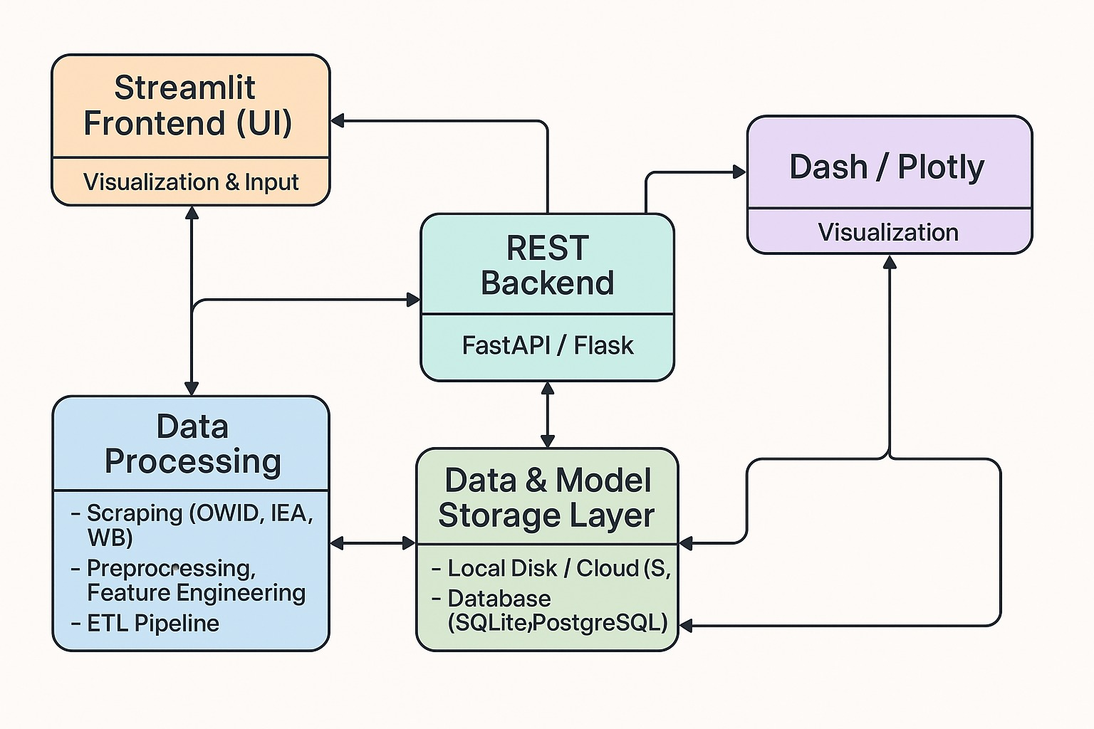
- System Architecture

V. RESULTS AND DISCUSSION

A. Quantitative Performance Evaluation
Both models were evaluated on global and country-level datasets using Root Mean Square Error (RMSE), Mean Absolute Error (MAE), and the Coefficient of Determination (R²).
Model | RMSE | MAE | R²
Prophet | 0.46 | 0.29 | 0.88
XGBoost | 0.55 | 0.41 | 0.91

B. Temporal Forecasting and Trend Interpretation

Temporal analysis of predicted versus actual trends revealed distinct model behaviors. Prophet captured major transitions and periodic components, such as annual variations in global energy usage, but exhibited inertia in adjusting to abrupt policy-driven or crisis-induced changes. In contrast, XGBoost responded sharply to data discontinuities caused by events like the COVID-19 pandemic, fossil fuel market disruptions, and renewable energy policy shifts post-2015.

C. Visual Insights and Dashboard Integration

The Streamlit dashboard provided an interactive platform for comparative visualization of both models. It enabled users to toggle between countries, explore renewable adoption rates, and assess CO₂ forecasts under different time horizons.

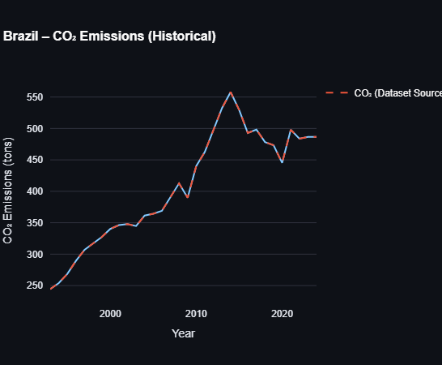
- Historical Plot
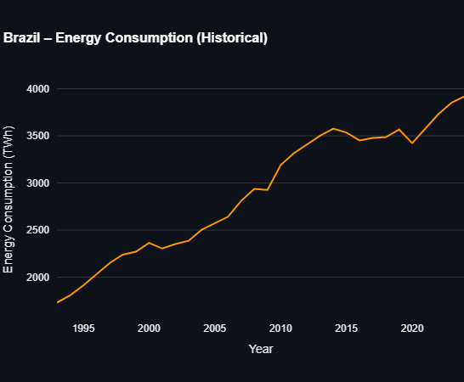
2. Historical Plot
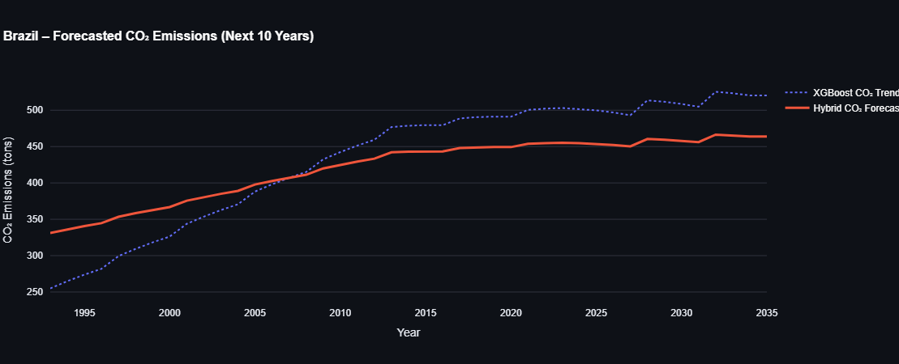
1. Forecast Plot

Visual comparisons showed that both models predicted a global decline in CO₂ emissions beyond 2035, corresponding to the expected acceleration of renewable energy technologies.

D. Model Robustness and Sensitivity Testing

Robustness testing was conducted to assess how well the models generalized under different conditions and data splits. Cross-validation was performed across three train-test configurations: 70:30, 75:25, and 80:20.
Split Ratio | XGBoost Accuracy | Prophet Accuracy
70:30 | 89.6% | 82.4%
75:25 | 90.2% | 84.1%
80:20 | 91.3% | 85.5%

E. Comparative Insights and Practical Implications
Criterion | XGBoost | Prophet
Short-term accuracy | High | Moderate
Trend consistency | Moderate | High
Noise robustness | Strong | Moderate
Interpretability | Medium | High
Real-time forecasting | Excellent | Good
Long-term forecasting | Good | Excellent

VI. CONCLUSION
This study demonstrates an effective comparative framework for forecasting energy sustainability indicators using XGBoost and Prophet. XGBoost delivers superior short-term accuracy and robust handling of complex relationships, while Prophet offers interpretability and seasonality modeling advantages. Integrating both models within a Streamlit dashboard enhances data accessibility and interpretability for decision-makers.
Future work involves incorporating additional regressors such as GDP growth, policy indices, and temperature data, along with extending the dashboard to support real-time forecasting and policy scenario simulations.

REFERENCES
[1] A. Sharma and R. Gupta, “Energy Consumption and Carbon Emissions Forecasting for Industrial Processes,” Journal of Cleaner Production, vol. 402, 2023.
[2] X. Liu, Y. Zhang, and L. Wang, “Industrial Carbon Emission Prediction Method Based on Meta-Learning and DLSTM,” Applied Energy, vol. 356, 2024.
[3] J. Chen and H. Zhao, “Deep Graph Learning for Industrial Carbon Emission Analysis and Policy Impact,” Energy Reports, vol. 11, pp. 522–538, 2025.
[4] M. Patil and S. Deshmukh, “Machine Learning-Based Time Series Models for Effective CO₂ Emission Prediction in India,” Environmental Modelling & Software, vol. 157, 2022.
[5] L. Yang and K. Wu, “MDL: Industrial Carbon Emission Prediction Using Meta-Learning and Differential LSTM,” Sustainable Computing: Informatics and Systems, vol. 42, 2024.
[6] S. Banerjee, T. Mehta, and R. Kumar, “Machine Learning-Based Time Series Models for CO₂ Emission Prediction in India,” Energy and AI, vol. 10, 2022.
[7] P. Johnson and E. Li, “Predicting CO₂ Emission Footprint Using AI through Machine Learning,” Energy Policy, vol. 165, 2022.
[8] A. Bose and N. Roy, “Deep Learning and Machine Learning Models to Predict Energy Consumption in the Steel Industry,” Industrial Engineering Journal, vol. 34, no. 5, 2023.
[9] S. Phasuk and P. Wattanakij, “Modeling CO₂ Emission Forecasting in Energy Consumption of Industrial Building Sector (Thailand),” Energy and Buildings, vol. 312, 2025.
[10] J. Williams and K. Carter, “Predicting Energy-Based CO₂ Emissions in the United States Using Machine Learning: A Path Toward Mitigating Climate Change,” Renewable and Sustainable Energy Reviews, vol. 176, 2025.

