29th July 24

Opening google website

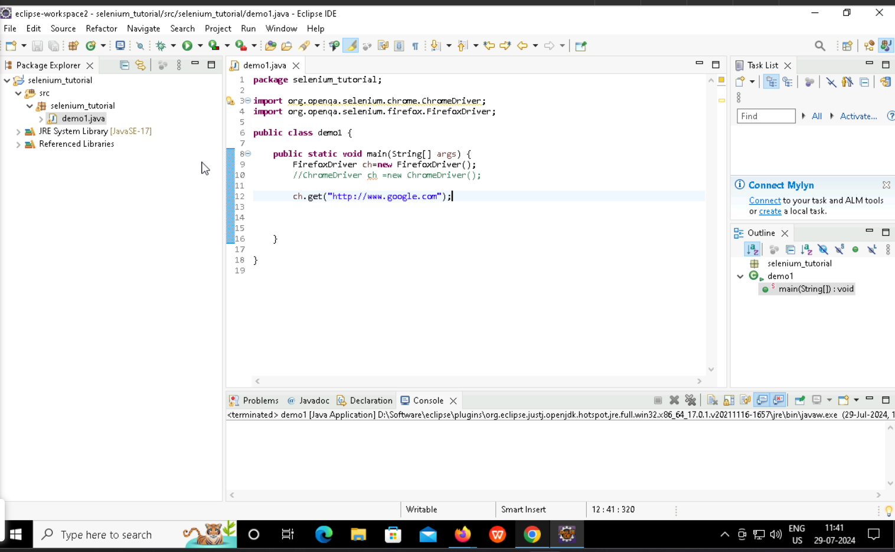

Opening google

Maximize the screen

Type something in text box

Search the thing by clicking the search button

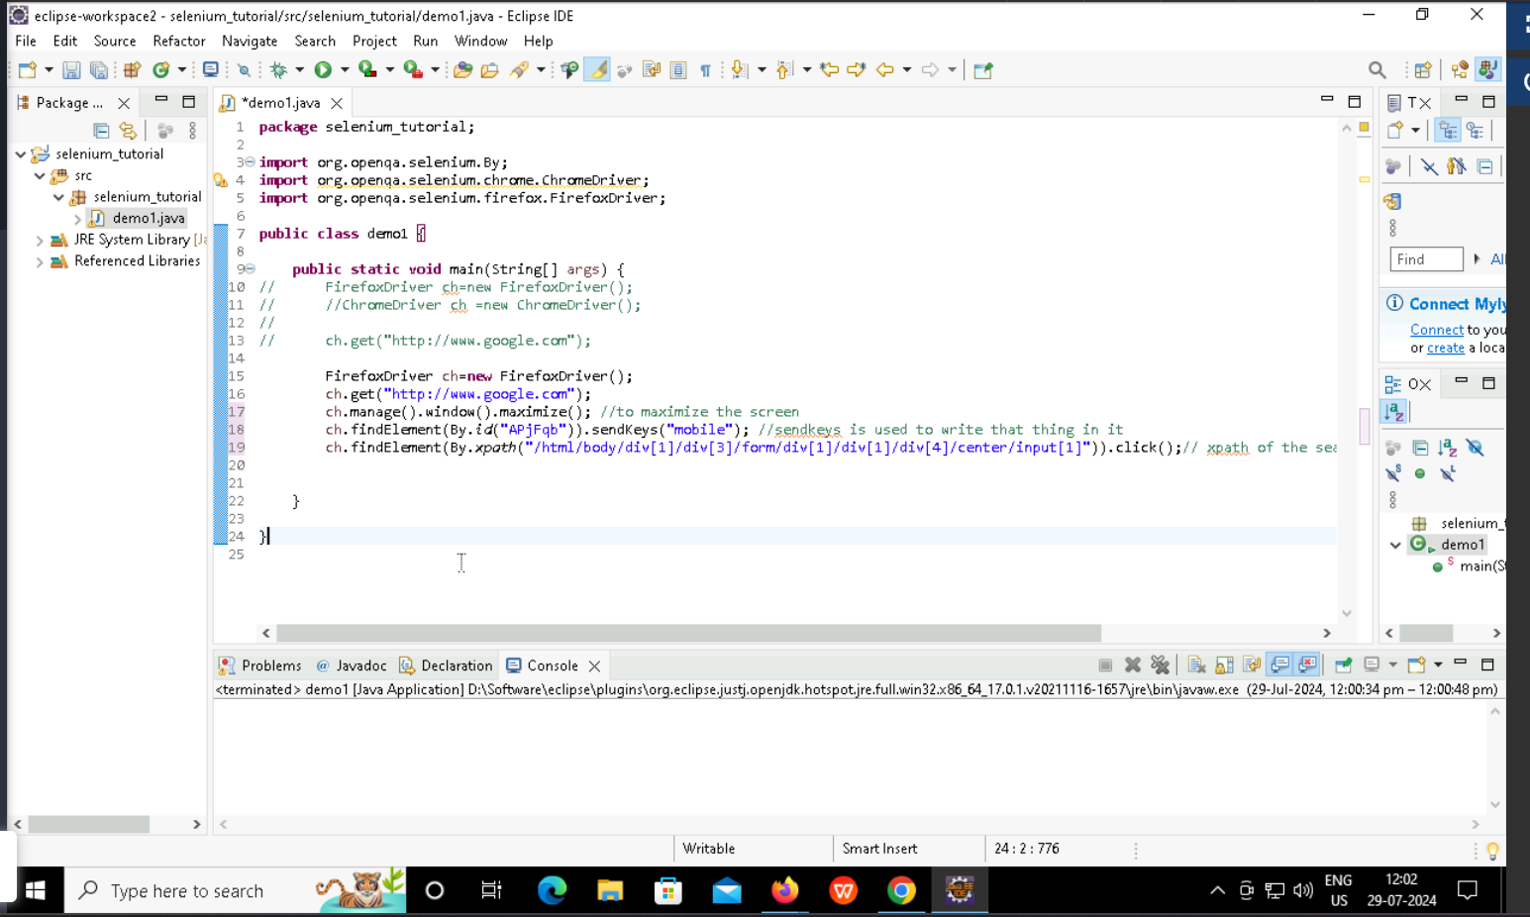

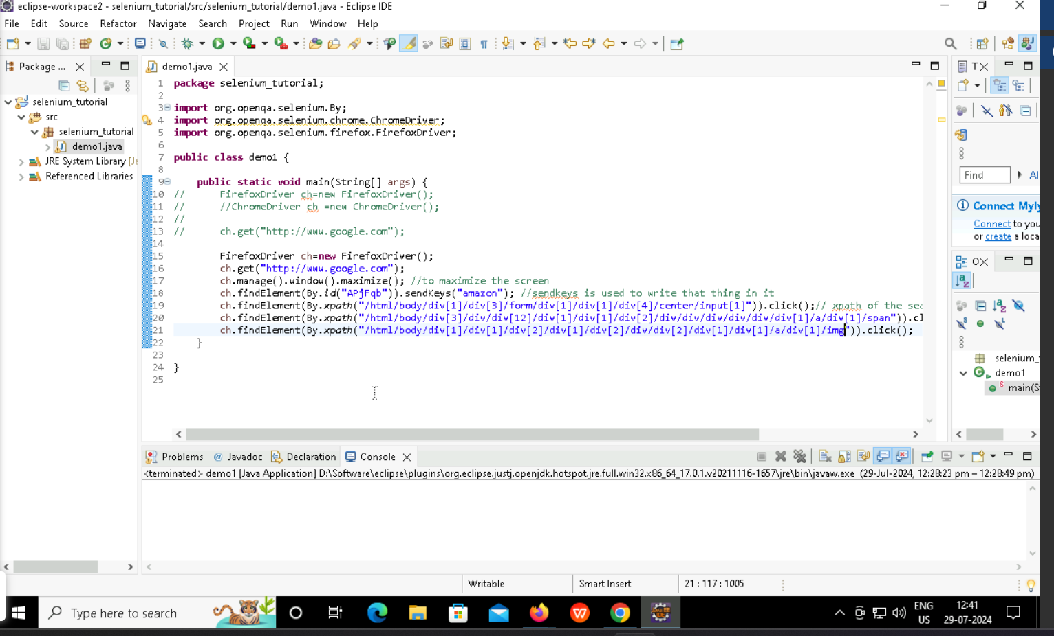

Testing using maven project

Web driver – asking the user which web driver he wants to use to test his website

Day 2 (30th July ’24)

Selecting radio button and checkbox for demo website

