**Name: Atharva Kesarkar**

**Class: AI&DS Batch -1**

**Roll no: 17**

**Experiment 1**

**AIM:** Experiment based on input and output, variables and operators in python.

**Tools:** Anaconda Navigator (Jupyter notebook)

**Objective:**

1. To understand and implement:
2. Basic input and output operations in Python.
3. Declaring and using variables.
4. Performing arithmetic and logical operations using operators.

**Theory:**

1. Input in Python:

* Python uses the input () function to get user input.
* The input is always taken as a string by default.
* Syntax:

variable_name = input ("Prompt message")

* Example:

name = input (“Enter your name:” ) # string input

1. Output in Python:

* Python uses the print () function to display output.
* Syntax:

print ("Message or variable")

* Example:

print ("Hello, World!")

1. Variables:

* A variable is a name that refers to a value.
* Python is dynamically typed, so you don't need to declare the type explicitly.
* Example:

age = 20

name = "Alice"

1. Operators in Python:

|  |  |  |
| --- | --- | --- |
| Type | Operators | Example |
| Arithmetic | + - * / // % ** | a + b, a ** b |
| Assignment | = += -= *= /= | x += 1 |
| Comparison | == != > < >= <= | a > b |
| Logical | and or not | a > 0 and b < 5 |
| Bitwise | `& | ^ ~ << >>` |

**CODE:**

1. Input from user and Output using print()

name = input("Enter your name: ")

age = int(input("Enter your age: "))

print("Hello", name + "!")

print("You are", age, "years old.")

Output:

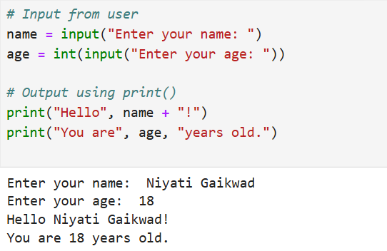

1. Variable assignment

a = 10

b = 5

1. Arithmetic operations

print("Addition:", a + b)

print("Subtraction:", a - b)

print("Multiplication:", a * b)

print("Division:", a / b)

print("Floor Division:", a // b)

print("Modulus:", a % b)

print("Exponent:", a ** b)

Output:

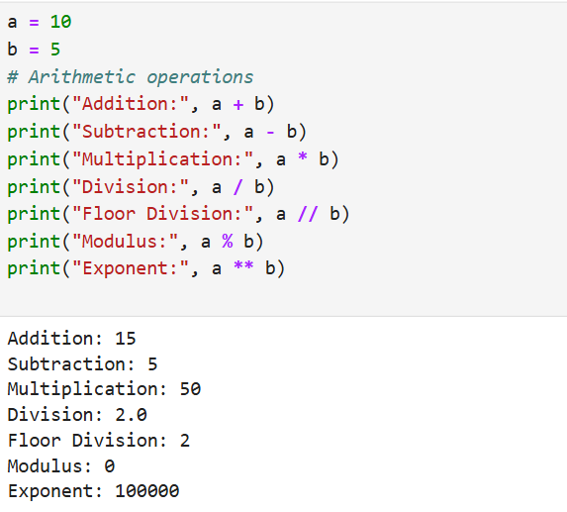

1. Comparison operators

print("Is a greater than b?", a > b)

print("Is a equal to b?", a == b)

Output:

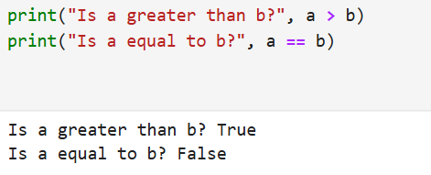

1. Logical operators

print("Is a > 5 and b < 10?", a > 5 and b < 10)

Output:

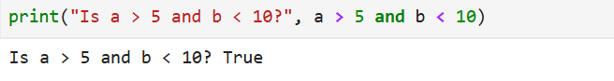

**Conclusion:**

In this experiment, we learned how to take user input, display output, use variables, and apply basic operators in Python. These concepts form the foundation for writing Python programs.

**For Faculty use only:**

|  |  |  |  |  |
| --- | --- | --- | --- | --- |
| **Correction Parameters** | **Formative Assessment [40%]** | **Timely completion of practical [40%]** | **Attendance/ Learning Attitude [20%]** |  |
| **Marks Obtained** |  |  |  |