**1.What is computer** - computer is the machine that follows the instructions given be the user to complete the task

_________________________________________________________________________________

 **Input** -means giving data or instructions to the computer.

**Output** -means receiving the result from the computer after it processes the input.

**2. RAM – Random Access Memory**- RAM is the temporary memory of a computer. It stores data only while the computer is ON.

**ROM – Read-Only Memory -** ROM is the **permanent memory** of a computer. It stores important instructions for the computer

**3**. **What is Software?**

**Software** is a set of **instructions** (or programs) that tell the **computer what to do**.

**So, the computer is the machine, and the software is the brain that runs inside it.**

**Types** : Application software and system software

**Example:**  
If you open **Google Maps** and type in "nearest hospital," the computer will follow your instruction, find your location using GPS, search for hospitals nearby, and show the best route to get there.

**Simple Example:**

Imagine you want to **type a letter**:

* You open **MS Word** → this is **software**
* The computer shows the displays text, saves your file
* All this happens because the **software gives instructions**, and the **computer follows them**

**Hardware** is **what you can touch** (like keyboard, mouse).

4. **What is Machine Language?**

**Machine language** is the **only language a computer truly understands**.  
It is written in **binary code**, which is made up of just **0s and 1s**.

**1 means ON (electricity is flowing)**

**0 means OFF (no electricity)**

**🧠 Can we code in Binary?**

Yes, we can write code in binary (0s and 1s), because that’s the only language the computer truly understands.

**Why Don’t We Code in Binary?**

It's too difficult for humans to read and writeA simple task would take hundreds of 0s and 1sOne small mistake can break everything!

**That’s Why We Use Programming Languages like:**

* **Python**
* **C++**
* **Java**
* **C programming**

**These languages are easy for humans to understand….**

**⚙️ How Does a Computer Understand Our Code?**

**🧑‍🏫 You might wonder...**

“If the computer only understands binary (0s and 1s), how does it understand my Python code?”

**💡 The Magic Tool: Interpreter (or Compiler)**

**We write code in easy-to-read languages like Python, but the computer doesn’t understand Python directly…**

**So... we need a translator — and that’s where the interpreter comes in!**

**📖 What is an Interpreter?**

An interpreter is like a real-time translator.  
It takes our high-level code (like Python) and translates it into machine language (binary) that the computer can understand and w run.

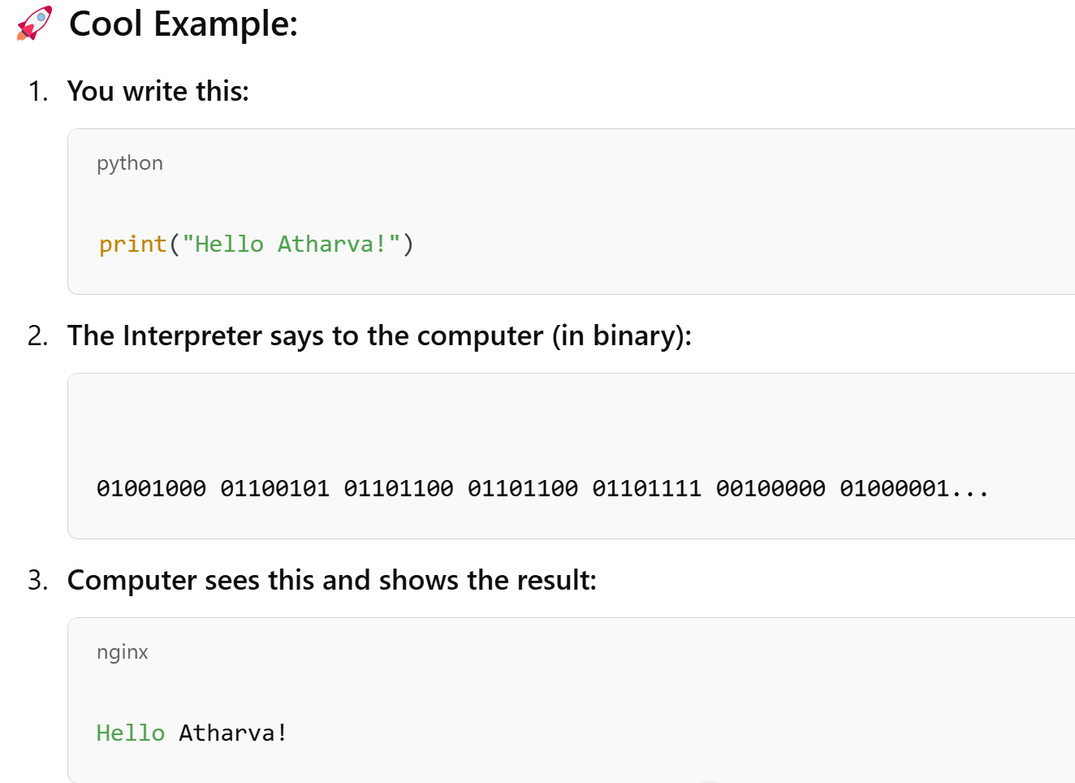When you install Python, it comes with an in-built translator called the interpreter, which converts your code into a language the computer can understand**.**

**🌟 What is PyCharm?**

**PyCharm** is a **free tool** (IDE – Integrated Development Environment) used to **write, run, and debug** Python code easily.

It’s like a smart notebook for Python programmers 🧠

**🧑‍🏫 Why Use PyCharm?**

✅ Highlights mistakes   
✅ Helps run code with just one click  
✅ Keeps your projects organized  
✅ Makes coding **faster and easier** for beginners & expert

**About python:**

Python is a programming language that is easy to learn and use, making it a popular choice for beginners. It has a simple, readable syntax that looks like English

**Key Features of Python:**

* **Easy to Learn:** Simple syntax makes it beginner-friendly.
* **Versatile:** Used in web development, data science, automation, and more.
* **Readability:** The code is easy to read and understand, even for beginners.