**✅ 1. Introduction to Tkinter**

**Tkinter** is Python’s built-in library to make **GUI apps** (Graphical User Interface), like windows, buttons, forms, etc.

**🔸 Code:**

import tkinter as tk # Import Tkinter module

**✅ 2. Creating a Basic Tkinter Window**

You need to create a window (called root) to start your app.

**🔸 Code:**

tkinter import as tk

root = tk.Tk() # Create the main window

root.title("My Tkinter App") # Set window title

root.geometry("300x200") # Set window size (width x height)

root.mainloop() # Start the app and keep it running

**✅ 3. Tkinter Widgets**

Widgets are the UI elements like buttons, labels, entry fields, etc.

**🔹 a) Label Widget**

**Used to display text or info.**

import tkinter as tk

root = tk.Tk()

label = tk.Label(root, text="Hello, Tkinter!", font=("Arial", 16))

label.pack()

root.mainloop()

**🔹 b) Button Widget**

**Used to create a clickable button.**

import tkinter as tk

def button_clicked():

print("Button was clicked!")

root = tk.Tk()

button = tk.Button(root, text="Click Me", command=button_clicked)

button.pack()

root.mainloop()

**🔹 c) Entry Widget**

**Used to take single-line text input.**

import tkinter as tk

root = tk.Tk()

entry = tk.Entry(root)

entry.pack()

root.mainloop()

**🔹 d) Text Widget**

**Used for multi-line text input.**

import tkinter as tk

root = tk.Tk()

text = tk.Text(root, height=5, width=40)

text.pack()

root.mainloop()

**🔹 e) Frame Widget**

**Used to group other widgets together.**

import tkinter as tk

root = tk.Tk()

frame = tk.Frame(root) # Create a section (frame)

frame.pack()

label = tk.Label(frame, text="This is inside the frame")

label.pack()

button = tk.Button(frame, text="Click Me")

button.pack()

root.mainloop()

**✅ 4. Layout Management**

**Layout** **means how widgets are placed in the windo**w.

**🔹 a) pack() → Puts widgets one below another (default vertical layout)**

import tkinter as tk

root = tk.Tk()

label = tk.Label(root, text="Name:")

label.pack()

entry = tk.Entry(root)

entry.pack()

button = tk.Button(root, text="Submit")

button.pack()

root.mainloop()

**🔹 b) grid() → Arranges widgets in rows and columns (like a table)**

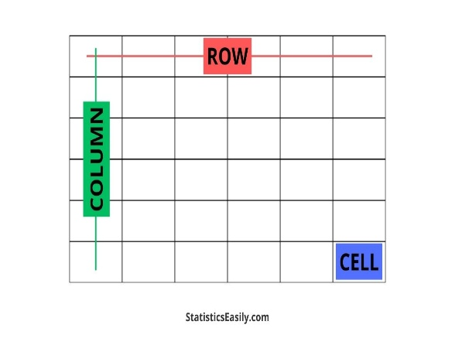import tkinter as tk

root = tk.Tk()

label = tk.Label(root, text="Name:")

label.grid(row=0, column=0)

entry = tk.Entry(root)

entry.grid(row=1, column=0)

button = tk.Button(root, text="Submit")

button.grid(row=2, column=0)

root.mainloop()

**🔹**

**c) place() → Puts widgets at exact (x, y) coordinates**

import tkinter as tk

root = tk.Tk()

root.geometry("200x100")

label = tk.Label(root, text="I'm placed!")

label.place(x=50, y=30)

root.mainloop()

**✅ 5. Event Handling**

Events are things like button clicks or key presses.

**🔹 a) Button Click Event**

import tkinter as tk

def on_click():

print("Button Clicked!")

root = tk.Tk()

button = tk.Button(root, text="Click Me", command=on_click)

button.pack()

root.mainloop()

**✅ 6. Message Boxes**

**Used to show pop-up messages.**

import tkinter as tk

from tkinter import messagebox

root = tk.Tk()

root.withdraw() # Hide main window if not needed

messagebox.showinfo("Info", "This is an information message.")

**✅ 7. File Dialogs**

**Used to open/save files.**

import tkinter as tk

from tkinter import filedialog

root = tk.Tk()

root.withdraw()

file = filedialog.askopenfilename(title="Open File")

print(f"Selected File: {file}")

**✅ 8. Styling and Themes (ttk)**

**ttk gives modern-looking widgets.**

import tkinter as tk

from tkinter import ttk

root = tk.Tk()

styled_button = ttk.Button(root, text="Stylish Button")

styled_button.pack()

root.mainloop()

**✅ 9. Closing the Window**

**Used to close the app.**

import tkinter as tk

root = tk.Tk()

button = tk.Button(root, text="Close", command=root.destroy)

button.pack()

root.mainloop()

**✅ 10. Complete Example App**

**💡 This app takes a name and greets the user in a pop-up.**

import tkinter as tk

from tkinter import messagebox

# Function to show greeting

def show_message():

messagebox.showinfo("Greeting", f"Hello, {entry.get()}!")

# Create main window

root = tk.Tk()

root.title("Tkinter Example")

root.geometry("300x150")

# Widgets

label = tk.Label(root, text="Enter your name:")

label.pack()

entry = tk.Entry(root)

entry.pack()

button = tk.Button(root, text="Greet Me", command=show_message)

button.pack()

# Start the GUI

root.mainloop()