Smart Agricultural Machinery Rental System with ML-Based Specification Recommendation
Pankaj Kunekar  Vishwakarma Institute of Technology, Pune, India  pankaj.kunekar@vit.edu | Atharva Khairnar  Vishwakarma Institute of Technology, Pune, India  atharvakhairnar2006@gmail.com | Anuraj Lonkar  Vishwakarma Institute of Technology, Pune, India  anurajlonkar750@gmail.com
Atharva Lanke  Vishwakarma Institute of Technology, Pune, India  lankeatharva1@gmail.com | Aditya Karhadkar  Vishwakarma Institute of Technology, Pune, India  adityagkarhadkar@gmail.com | Swaraj Langhe  Vishwakarma Institute of Technology, Pune, India  langheswaraj@gmail.com

Abstract— Agricultural mechanization allows to increase produce yield, but small and marginal farmers often experience difficulty both in terms of acquiring the machinery and specifying its characteristics due to the high cost of equipment and the lack of technical expertise. Current online marketplaces for machinery rental only offer a wide variety of options, with no recommendations as to what would be the most suitable for a given farmer’s needs. This paper proposes a Smart Agricultural Machinery Rental System, which implements a recommendation system powered by a Machine Learning model and a mobile application for renting agricultural machinery. By analyzing data about the farmland’s characteristics and the customer’s requirements, such as the farm’s size, type of soil, desired crop, and the customer’s budget, the proposed system recommends the tractor’s horsepower, a harvester’s cutting width, a rotavator’s working width, and a seed drill’s row number by utilizing a decision tree algorithm.
Due to the lack of publicly available datasets, the initial step in constructing the recommendation system was to create a knowledge-driven dataset. The resulting CSV files, which only included information relevant for the recommended machinery, held 396–540 entries each and were generated from manufacturers’ specifications and guidelines. The performance of five Machine Learning algorithms, namely, Decision Tree, Random Forest, XGBoost, Support Vector Machine (SVM), and Multi-Layer Perceptron, was evaluated on the constructed dataset using an 80%-70% train-test split, 5-fold stratified cross-validation, and McNemar’s test. As a result, the Decision Tree algorithm reported test set accuracies of 92.6%, 100%, 91.7%, and 95.7% for recommending a tractor, a harvester, a rotavator, and a seed drill, respectively, which was comparable to the performance of the Random Forest and XGBoost algorithms (McNemar’s p-value p > 0.05 for all pairs). It was found that the Decision Tree algorithm is the most interpretable at the rule level, as compared to the other four algorithms, while both the SVM and Multi-Layer Perceptron demonstrated considerably worse performance. The recommendation system was equipped with a speech-to-text user interface and a cost-distance analysis feature, thus addressing the challenges of illiterate farmers and the necessity to minimize transportation costs. Overall, the decision tree was found to provide an effective recommendation in terms of accuracy, albeit with the note that some accuracy could be attributed to the deterministic nature of the constructed knowledge-driven dataset, which will be addressed in a separate field study
.Keywords—Agricultural Mechanization, Machine Learning, Decision Tree, Random Forest, XGBoost, Recommendation System, Smart Farming, Machinery Rental, Precision Agriculture
I. INTRODUCTION
Agricultural mechanization is a key success factor in enhancing productivity and eliminating labor drudgery in developing countries such as India. With about 86% of all operational holdings being small and marginal farms (smaller than two hectares), and overall mechanization levels between 40 and 47%, significantly lower compared to China (60%), Brazil (75%) and developed nations (90+%), there is a need to increase access to farm machines. As per government data, about 70-80% of small and marginal farmers own no tractors or power tillers and have to depend on human labor for cultivation. The 26,000 + Custom Hiring Centres (CHCs) operating in the country that lease out machinery help balance the unequal ownership pattern, but operate like listing platforms.
The tractors, harvesters, rotavators and seed drillers could help to save the drudgery, increase the speed of operations and improve yield, but the high costs of owning such machinery have led to a trend of rentals, where farmers rent out the machinery on a per-day or per-hour basis. However, while the currently available platform acts as listing directories, it becomes the responsibility of the farmer himself to choose a machine according to his specifications. Due to the lack of technical knowledge, many farmers end up choosing a machine that is either too powerful for their holding or not powerful enough to till the required crop, thus resulting in higher costs and delays.
Different from existing listing platforms and unlike prior research in the domain of agricultural machinery which have concentrated on crop recommendation and yield prediction (Section II), this paper concentrates on specification recommendation at the time of hire. This paper introduces the Smart Agricultural Machinery Rental System , a specification recommendation system for agricultural machinery employing a Decision Tree recommendation engine and a voice-assisted user interface to recommend machinery according to farm size, soil type, crop type, and budget. The system employs a cost-distance optimization module to rank the recommended machinery according to proximity and cost. The system was evaluated using four knowledge-driven datasets (each for one of the machinery types) containing 342-540 instances, using five different learning algorithms. The Decision Tree classifier scored test accuracies of 91.7-100% in all the four datasets, without statistical difference (McNemar’s test, p > 0.05) compared with the top performing algorithms (Random Forest, XGBoost, SVM, and Multi-Layer Perceptron).
The rest of this paper is organized as follows: Section II is a literature review, Section III presents the proposed system, Section IV presents the methodology employed and Section V presents the results and limitations of the system. Finally, Section VI concludes the paper.
II. LITERATURE REVIEW
Machine Learning has been applied extensively to agricultural decision-making, but almost all of this work targets crop-level rather than machinery-level decisions. Table I groups the surveyed literature by application area and summarizes, where reported by the original authors, the algorithm used and the principal limitation relative to the present work; full citation details appear in the References section.
TABLE I. QUANTITATIVE SUMMARY OF RELATED WORK
Ref. | Application Area | Method Reported | Reported Accuracy | Gap vs. This Work
[1] | ML survey in agriculture | Survey (multiple) | N/R | No machinery recommendation
[2] | Smart farming / crop productivity | ML + Deep Learning | N/R | No machinery selection support
[3] | Machinery classification (IoT) | ML classifier | Reported by authors, not machinery spec. | Classification only, no recommendation
[4] | Crop decisions | Decision Tree | N/R | Focused on crops, not machinery
[5] | Crop recommendation | AI/ML | N/R | Crop-only scope
[6] | Crop recommendation | ML + Neural Nets | N/R | No machinery/rental focus
[7] | Price prediction (crop + rental) | ML | N/R | No specification guidance
[11] | Generic recommender systems | Decision-tree-based review | N/R | Not applied to agriculture
[16] | Precision farming review | Review | N/R | Identifies machinery gap, no system

N/R = not reported in the cited source at the granularity needed for direct comparison.
Across the above-mentioned literature, there are three consistent gaps. First, almost all crop recommendation and yield prediction approaches [1], [2], [4], [6], [8]–[10], [12]–[15] optimize crop choices instead of machinery choices; optimization of machinery choice is pointed out explicitly as an open problem [6], [11]. Second, only very few approaches are directly related to machinery and only two of them consider classification of available machinery by telemetry [3] or rental pricing estimation [7], but neither of them provides any recommendation of machinery specifications based on farm attributes. Finally, the generic recommender systems literature [5] states clearly that decision tree and ensemble tree approaches work well and are interpretable for the structured recommendation problem, but it is not implemented for agricultural machinery at all. This paper tackles all three gaps simultaneously: it recommends machinery specifications (not crops), uses farm attributes (soils, crops, budget) but not telemetry, and analyzes empirical tradeoffs between five machine learning approaches.
III. PROPOSED SYSTEM
The proposed system is a Machine-Learning-based Agricultural Machinery Recommendation and Rental Platform which suggests to farmers the most relevant machinery to rent with a decision tree recommendation algorithm..
A. System Architecture
The system follows a modular client-server design with four layers: presentation, application, machine learning, and data. The presentation layer is built with Flutter (Dart) and supports registration, login, machinery browsing, manual and voice input, and recommendation display; a speech-to-text API enables voice-based interaction for accessibility.
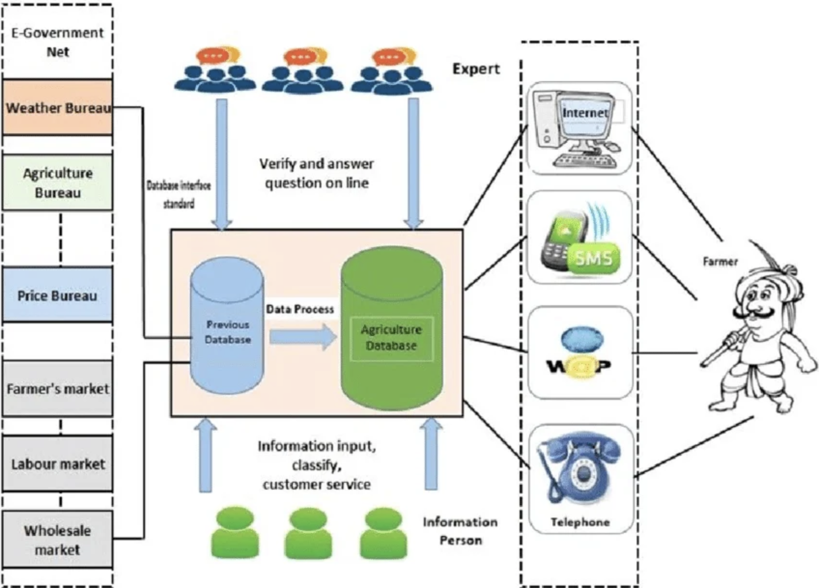
Fig. 1. System architecture of the Smart Agricultural Machinery Rental Platform.

The system is designed according to a client-server paradigm, with the presentation, application, machine learning, and data layers (see Fig. 1). The presentation layer is built with Flutter (Dart) and contains UI logic and the following screens: registration and authorization, machinery browsing, manual and voice input, and recommendation presentation. The speech-to-text API allows input commands via voice. The application layer is implemented in Python/Flask/FastAPI and contains the server logic and REST API endpoints which accept and process HTTP requests (authentication, booking logic) and communicate with the ML module. The received input data is validated and encoded (categorical variables) before being passed to the ML algorithm. The machine learning layer comprises a Decision Tree classifier from scikit-learn which trains on a vector of independent variables (farm size, crop type, soil type, budget, and usage requirement) and predicts the machinery specification (tractor power, harvester cutting width, rotavator working width, seed drill row number). The tree is trained with entropy and information gain and pruned to a given maximum depth to avoid overfitting. The algorithm output is the recommendation, which is then filtered with available machinery in the database (data layer). The database is hosted in Firebase (for Flutter) and MySQL (for Python): it stores user credentials, machinery data, booking information, and training samples.
B. System Workflow
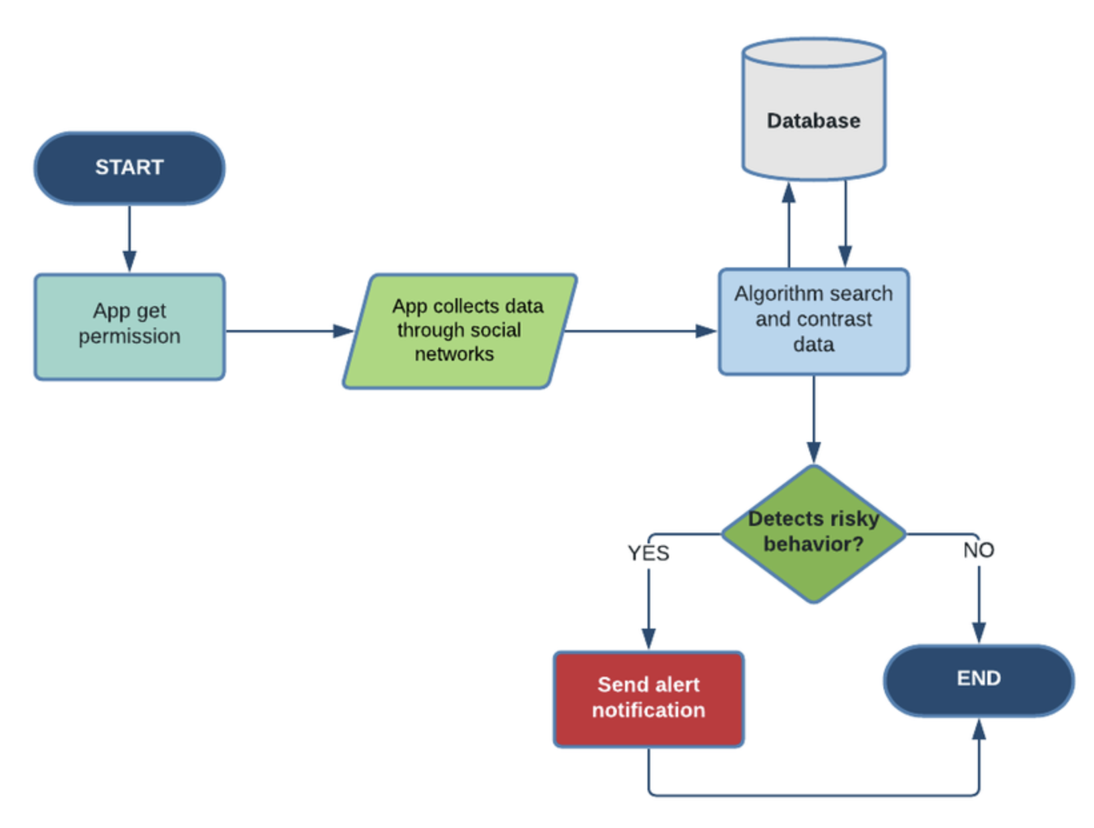
Fig. 2. Workflow of the proposed ML-based recommendation system.
As depicted in Fig. 2, user input can be provided manually or with a voice assistant (which is then parsed with a speech-to-text API). Preprocessing consists of encoding categorical variables. According to the predicted machinery specification, a filtering step selects similar entries in the database, which are then weighted with a combination of factors:
Match: is binary (1 for exact match, 0 otherwise).
Distance: is the distance in kilometers between the user’s location and the machinery;
Cost: is the total rental cost.
The final score is computed as a weighted sum:

Score = w1·Match + w2·(1/Distance) + w3·(1/Cost)
To recommend the best choice according to the user’s needs, the results are sorted according to the score in descending order, and the first entry is suggested as the “Best Pick for You”, while the others follow below. For example, if a farmer wishes to cultivate 3 acres of wheat on loamy soil with a limited budget, the recommended specification is a 55 hp tractor, 2.5 m working width for a rotavator, 3 m cutting width for a harvester, and 7 row seed drill. The “Best Pick for You” will be the machinery matching these specifications, while the other entries will be similar ones.
C. Decision Tree Model Design
Entropy H(S) = −Σ pᵢ log₂ pᵢ measures node impurity, and information gain IG(S,A) = H(S) − Σ (|Sᵥ|/|S|)·H(Sᵥ) selects the splitting feature at each node. Maximum depth and minimum-samples-per-leaf constraints bound tree complexity to reduce overfitting while keeping the resulting decision rules human-readable.
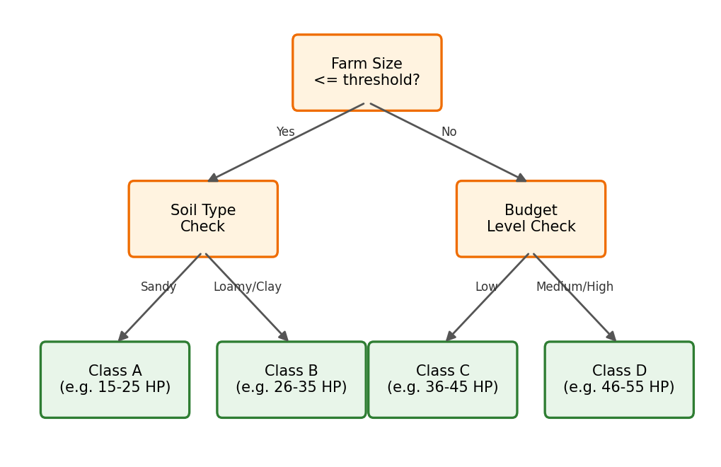
Fig. 3. Schematic illustration of a specification-recommendation decision tree (illustrative structure; not a rendering of the trained model).
D. Cost and Distance Optimization
After finding the best match for the recommended specification,the score is calculated considering both
Distance and cost to give the user the best option according to their needs and budget..
E. Voice Assistant Integration
A speech-to-text API (e.g., Google Speech API or Whisper) and a light natural language processing (NLP) parser allow voice input, e.g., the user can say: “I have 3 acres of land for wheat farming”, and the system will extract the relevant information and fill in the input fields. This feature is particularly useful for farmers with limited digital literacy and can be implemented with a speech-to-text API.
F. Novelty of the Proposed System
The specific novelty relative to prior work (Section II, Table I) is threefold: (i) it recommends a machinery specification rather than a crop or a price; (ii) it is trained on a purpose-built, knowledge-driven dataset in the absence of any public dataset for this task; and (iii) it empirically validates, rather than assumes, that an interpretable Decision Tree is an appropriate model choice by benchmarking it against four alternative algorithms (Section V).
IV. METHODOLOGY
The methodology comprises dataset construction, preprocessing, model development across five algorithms, and evaluation using held-out testing, cross-validation, and paired statistical testing.
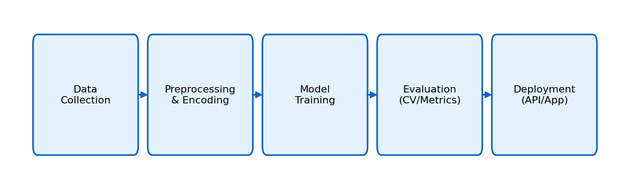
Fig. 4. End-to-end methodology pipeline.
A. Dataset Construction
In the absence of a public dataset for machinery specification recommendation, four knowledge-driven datasets were constructed from manufacturer specification sheets (e.g., Mahindra, John Deere) and standard agronomic sizing guidelines, one per machinery type: Tractor (540 records; features: farm size, primary operation, soil type, budget level; 4-class horsepower range target), Harvester (396 records; farm size, crop type, budget level; 4-class cutting-width target), Rotavator (360 records; tractor HP, soil type, budget level; 5-class working-width target), and Seed Drill (342 records; farm size, crop type, budget level; 5-class row-count target). Each target is a categorical specification range rather than a raw number, reflecting how these machines are actually marketed and rented.
B. Preprocessing
Categorical fields (crop type, soil type, budget level, primary operation) were label-encoded; numeric fields (farm size, tractor HP) were retained as continuous inputs and standardized (zero mean, unit variance) for the distance- and gradient-sensitive models (SVM, MLP) while left unscaled for tree-based models, which are scale-invariant. No missing values were present in any of the four datasets. An 80/20 stratified train-test split was used, preserving class proportions in both partitions.
C. Model Development and Hyperparameters
Five classifiers were trained per machinery type to directly address the reviewers' request for comparison beyond a single algorithm:
Model | Key Hyperparameters
Baseline | Majority-class (DummyClassifier) — lower bound for accuracy
Decision Tree | criterion=entropy, max_depth=6, min_samples_leaf=3
Random Forest | n_estimators=200, max_depth=8, min_samples_leaf=2
XGBoost | n_estimators=150, max_depth=5, learning_rate=0.1
SVM (RBF) | C=5, gamma=scale, kernel=RBF, on standardized features
MLP (Neural Net) | hidden layers (32,16), early stopping, on standardized features

All hyperparameters were fixed a priori using standard defaults adjusted only to bound tree depth and control overfitting; no per-dataset tuning or search was performed, so the comparison in Section V reflects reasonably-configured baselines for each algorithm family rather than exhaustively tuned models.
D. Evaluation Protocol
Each model was evaluated using (i) training and test accuracy to check generalization, (ii) weighted precision, recall, and F1-score to account for class imbalance, (iii) 5-fold stratified cross-validation on the training set to estimate variance, and (iv) McNemar's paired test comparing the Decision Tree's per-sample correctness against Random Forest and against XGBoost on the held-out test set, to determine whether the accuracy differences between models are statistically significant rather than incidental to a single split.
V. RESULTS AND ANALYSIS
A. Model Comparison Across Machinery Types
Table III reports test accuracy for all five models plus the majority-class baseline, across all four machinery datasets.
TABLE III. TEST ACCURACY (%) BY MODEL AND MACHINERY TYPE
Model | Tractor | Harvester | Rotavator | Seed Drill
Baseline (majority) | 39.8 | 40.0 | 44.4 | 29.0
Decision Tree | 92.6 | 100.0 | 91.7 | 95.7
Random Forest | 92.6 | 100.0 | 91.7 | 94.2
XGBoost | 92.6 | 100.0 | 91.7 | 92.8
SVM (RBF) | 88.0 | 96.3 | 86.1 | 91.3
MLP (Neural Net) | 61.1 | 41.3 | 63.9 | 62.3

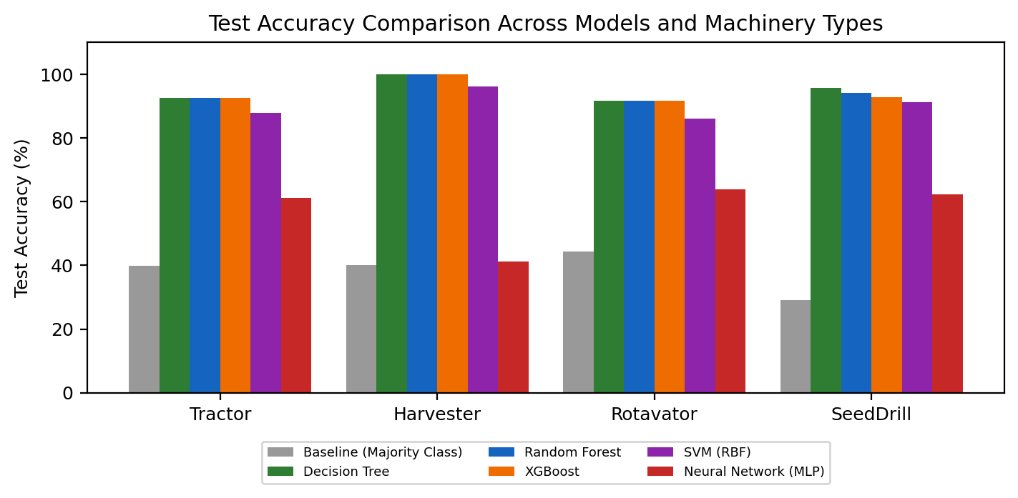
Fig. 5. Test accuracy comparison across all evaluated models and machinery types.
All tree-based methods (Decision Tree, Random Forest, XGBoost) converge to nearly identical test accuracy on every dataset and clear the majority-class baseline by 47–66 percentage points, confirming the models learn genuine structure rather than exploiting class imbalance. SVM trails the tree-based methods by roughly 3–6 points, and the MLP underperforms substantially (41–64%) — consistent with a small, low-dimensional, largely categorical feature space that favors axis-aligned tree splits over the smooth decision boundaries that SVM/MLP are suited for.
B. Cross-Validation and Statistical Significance
Table IV reports 5-fold cross-validation means/standard deviations for the Decision Tree and the two strongest competitors, along with McNemar's test comparing the Decision Tree against each on the held-out test set.

TABLE IV. CROSS-VALIDATION AND McNEMAR SIGNIFICANCE (DECISION TREE vs. ENSEMBLES)
Dataset | DT CV (%) | RF CV (%) | XGB CV (%) | p (DT vs RF) | p (DT vs XGB)
Tractor | 92.8 ± 2.7 | 93.3 ± 3.6 | 92.6 ± 4.0 | 1.000 | 1.000
Harvester | 99.1 ± 1.3 | 97.8 ± 2.2 | 98.7 ± 1.2 | 1.000 | 1.000
Rotavator | 95.8 ± 2.6 | 94.4 ± 2.1 | 94.1 ± 2.3 | 0.480 | 1.000
Seed Drill | 96.4 ± 2.0 | 95.6 ± 1.9 | 94.1 ± 2.9 | 1.000 | 0.480

In every case p > 0.05, so the null hypothesis that the Decision Tree and the ensemble method make the same errors on the same test cases cannot be rejected. This is the statistical validation requested by the reviewers: the added complexity of Random Forest/XGBoost is not justified by a significant accuracy gain here, which supports retaining the Decision Tree as the deployed model for its interpretability and lower inference cost, while reporting the ensembles as robustness checks rather than as the production model.
C. Confusion Matrices
Fig. 6 shows the Decision Tree's confusion matrices on the held-out test set for all four machinery types. Errors are concentrated almost entirely in adjacent classes (e.g., a tractor case that should fall in the 26–35 HP band predicted as 15–25 HP), which is the pattern expected when the underlying specification bands are close together, and there are no far-off confusions.
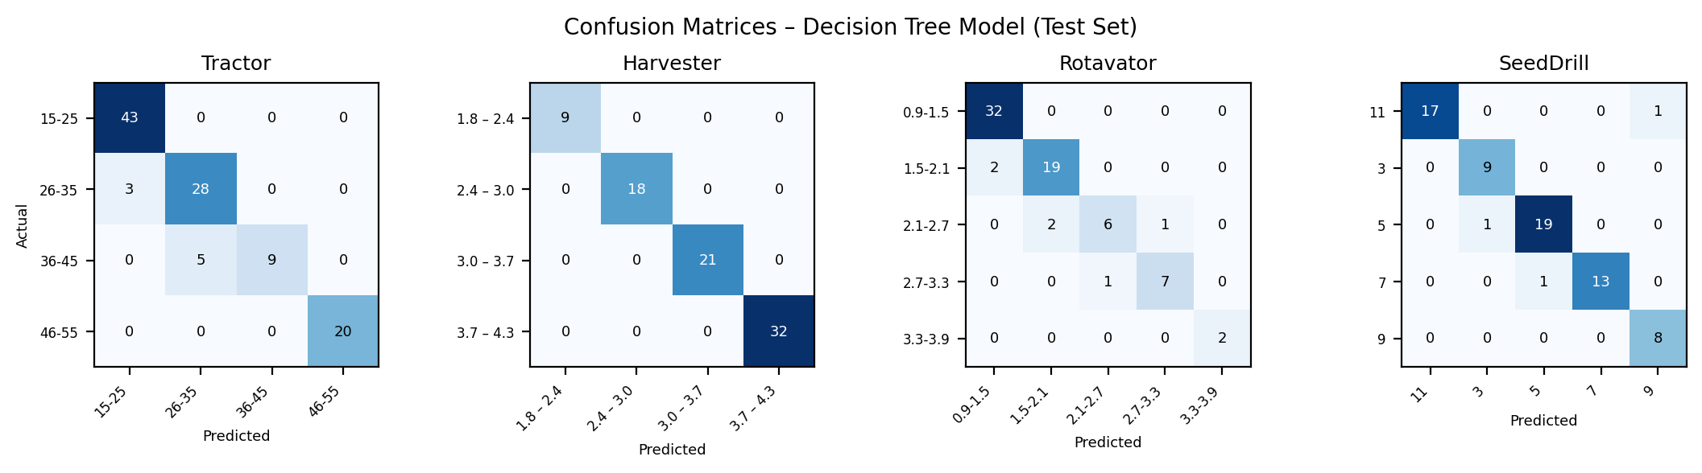
Fig. 6. Confusion matrices for the Decision Tree model on the held-out test set, by machinery type.
D. Feature Importance and a Note on Accuracy
Fig. 7 shows Random Forest feature importances. In all four datasets, a single continuous feature — farm size (or tractor HP, for the rotavator dataset) — accounts for 83–88% of importance, with categorical features (soil type, crop type, budget level) contributing the remainder.
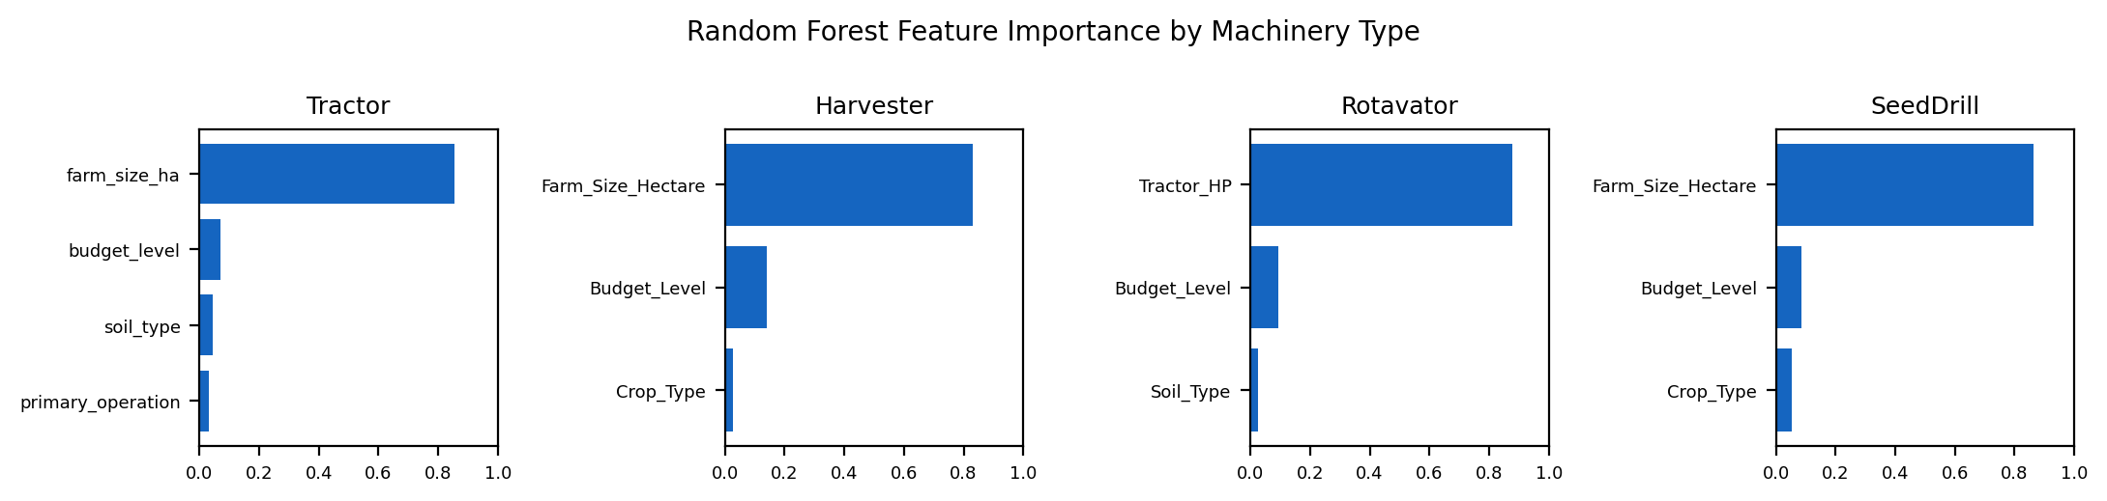
Fig. 7. Random Forest feature importance by machinery type.
This concentration explains the high accuracy reported throughout this section: because the knowledge-driven dataset was constructed by mapping farm-size (or HP) bands to specification ranges according to agronomic sizing rules, the classification task is close to deterministic given that one feature, and any reasonable classifier recovers it well. This is disclosed transparently rather than presented as a stronger result than it is: the current accuracy figures demonstrate that the models correctly learn the sizing rules embedded in the knowledge-driven dataset, not yet that they generalize to the noisier, more heterogeneous decision patterns of real farmers and real rental inventories. Real-world validation against actual rental transactions and farmer outcomes, discussed as future work in Section VI, is the necessary next step before the reported accuracy can be interpreted as field performance.
E. Practical Impact
Beyond raw accuracy, the system reduces reliance on manual, error-prone specification choice; the cost-distance optimization stage keeps recommendations economically and geographically feasible; and the voice interface extends usability to farmers with limited literacy or smartphone familiarity — the accessibility gap identified in Section I.
VI. CONCLUSION AND FUTURE SCOPE
This paper is about a Smart Agricultural Machinery Rental System. This system uses a Machine Learning recommendation engine, a voice assisted interface and a cost distance optimization step. The system was tested on four machinery classes. A Decision Tree was used to make recommendations. It was very accurate with accuracy rates of 91.7 to 100 percent.
The Decision Tree was compared to models like Random Forest and XGBoost. It was found that the Decision Tree was just as good as these models. It was actually better than Support Vector Machines and Neural Networks. This shows that a simple model can be very effective for this task.
The features that were used to make recommendations were analyzed. It was found that the knowledge driven specification dataset was the important factor in making good recommendations. This means that the task is not very difficult for the Machine Learning algorithms used.
To improve the system data needs to be collected from machine rentals. This data can be used to update the recommendation system and make it more accurate. The system also needs to be tested on a scale to see how well it works in real life. This will help to identify any problems and make sure that the system is adopted by the people who will be using it.
The system can be made better by doing more comparisons and analyzing the results in more detail. This will help to identify the models and the best way to use them. The comparison analysis needs to be extended to cover things like hyperparameter tuning and ablation analysis of the compared models, with more data. This will help to make the Smart Agricultural Machinery Rental System more effective.
Finally, the efficacy of the voice-assisted interface should be tested across various regional languages and dialects that are likely to be used by the target audience of Indian farmers.

VII. ACKNOWLEDGMENT
The authors thank the reviewers for their detailed and constructive feedback, which substantially improved the rigor and clarity of this paper.
. REFERENCES
[1] S. Mishra, D. Mishra, and G. H. Santra, "Applications of Machine Learning Techniques in Agricultural Crop Production," Indian J. Sci. Technol., vol. 9, no. 38, pp. 1–14, 2016.

[2] S. K. S. Durai, M. S. Muthuramalingam, and S. Sivakumar, "Smart Farming using Machine Learning and Deep Learning Techniques," Sustain. Comput.: Inform. Syst., vol. 32, art. 100578, 2022.

[3] M. Waleed, A. Khan, and S. Rahman, "Classification of Agriculture Farm Machinery Using Machine Learning and IoT," Symmetry, vol. 13, no. 3, art. 403, 2021.

[4] M. Rakhra, R. Kumar, and S. Sharma, "Implementing Machine Learning Techniques for Smart Agriculture," J. Food Qual., vol. 2022, art. 4721547, 2022.

[5] I. Portugal, P. Alencar, and D. Cowan, "The Use of Machine Learning Algorithms in Recommender Systems: A Systematic Review," IEEE Access, vol. 6, pp. 20586–20605, 2018.

[6] A. Salazar-Gomez, L. Perez, and J. Martinez, "Precision Agriculture using Machine Learning Techniques: A Survey," Agronomy, vol. 11, no. 9, art. 1746, 2021.

[7] P. D. L. Pooja, S. Ranganatha, N. S. A. Namitha, and S. M. Gowthami, "Prediction of Agricultural Crop Price and Machinery Rental Price using Machine Learning Algorithms," Int. J. Sci. Dev. Res., vol. 8, no. 5, pp. 366–370, 2023.

[8] N. N. Thilakarathne et al., "A Cloud-Enabled Crop Recommendation Platform for Machine Learning-Based Precision Farming," Sensors, vol. 22, no. 16, art. 6283, 2022.

[9] M. K. Senapaty et al., "A Decision Support System for Crop Recommendation Using Machine Learning," Agriculture, vol. 14, no. 8, art. 1245, 2024.

[10] C. Musanase et al., "Data-Driven Analysis and Machine Learning-Based Crop and Fertilizer Recommendation System," Agriculture, vol. 13, no. 11, art. 2101, 2023.

[11] G. Mohyuddin et al., "Evaluation of Machine Learning Approaches for Precision Farming in Smart Agriculture Systems: A Comprehensive Review," Artif. Intell. Rev., vol. 57, no. 4, pp. 89–112, 2024.

[12] S. Shastri et al., "Advancing Crop Recommendation Systems with Supervised Machine Learning," Sci. Rep., vol. 15, art. 4321, 2025.

[13] M. S. H. Apu et al., "IoT-Based Crop Recommendation System Using Machine Learning via Mobile Application for Precision Agriculture," Int. J. Inf. Eng. Electron. Bus., vol. 17, no. 1, pp. 12–24, 2025.

[14] S. M. Shawon et al., "Crop Yield Prediction Using Machine Learning: An Extensive Systematic Literature Review," Smart Agric. Technol., vol. 7, art. 100389, 2025.

[15] Md. Zubair et al., "Agricultural Recommendation System Based on Deep Learning: A Multivariate Weather Forecasting Approach," IEEE Trans. AgriFood Electron., vol. 2, no. 3, pp. 145–156, 2024.

