Stock Market Analysis Using R

1. Import Dataset
# Import the stock market dataset
my_stocks <- read.csv(
"stocks.csv",
header = TRUE,
stringsAsFactors = FALSE
)
# Display first few rows
head(my_stocks)
## exchange stock_symbol date stock_price_open stock_price_high
## 1 NYSE XL 2010-02-08 16.47 16.85
## 2 NYSE XL 2010-02-05 16.38 16.55
## 3 NYSE XL 2010-02-04 17.02 17.02
## 4 NYSE XL 2010-02-03 17.25 17.34
## 5 NYSE XL 2010-02-02 16.93 17.52
## 6 NYSE XL 2010-02-01 16.75 17.09
## stock_price_low stock_price_close stock_volume stock_price_adj_close
## 1 16.29 16.51 4793200 16.51
## 2 15.91 16.46 4760900 16.46
## 3 16.31 16.41 6716100 16.41
## 4 17.09 17.14 2657900 17.14
## 5 16.80 17.33 4282200 17.33
## 6 16.64 16.88 3258200 16.88

2. Data Preparation
# Load required libraries
library(dplyr)
library(readr)
library(tidyr)
library(ggplot2)
# Check structure of the dataset
str(my_stocks)
## 'data.frame': 65020 obs. of 9 variables:
## $ exchange : chr "NYSE" "NYSE" "NYSE" "NYSE" ...
## $ stock_symbol : chr "XL" "XL" "XL" "XL" ...
## $ date : chr "2010-02-08" "2010-02-05" "2010-02-04" "2010-02-03" ...
## $ stock_price_open : num 16.5 16.4 17 17.2 16.9 ...
## $ stock_price_high : num 16.9 16.6 17 17.3 17.5 ...
## $ stock_price_low : num 16.3 15.9 16.3 17.1 16.8 ...
## $ stock_price_close : num 16.5 16.5 16.4 17.1 17.3 ...
## $ stock_volume : int 4793200 4760900 6716100 2657900 4282200 3258200 4546200 4069700 3339600 4608300 ...
## $ stock_price_adj_close: num 16.5 16.5 16.4 17.1 17.3 ...
# Display summary of the dataset
summary(my_stocks)
## exchange stock_symbol date stock_price_open
## Length :65020 Length :65020 Length :65020 Min. : 0.16
## N.unique : 1 N.unique : 25 N.unique :10122 1st Qu.: 14.39
## N.blank : 0 N.blank : 0 N.blank : 0 Median : 25.47
## Min.nchar: 4 Min.nchar: 2 Min.nchar: 10 Mean : 33.41
## Max.nchar: 4 Max.nchar: 3 Max.nchar: 10 3rd Qu.: 47.63
## Max. :162.75
## stock_price_high stock_price_low stock_price_close stock_volume
## Min. : 0.17 Min. : 0.16 Min. : 0.16 Min. : 0
## 1st Qu.: 14.53 1st Qu.: 14.22 1st Qu.: 14.39 1st Qu.: 3200
## Median : 25.55 Median : 25.40 Median : 25.48 Median : 192550
## Mean : 33.73 Mean : 33.09 Mean : 33.42 Mean : 2094209
## 3rd Qu.: 48.00 3rd Qu.: 47.25 3rd Qu.: 47.63 3rd Qu.: 2178000
## Max. :164.00 Max. :161.38 Max. :162.50 Max. :142985300
## stock_price_adj_close
## Min. : 0.22
## 1st Qu.: 6.09
## Median : 12.23
## Mean : 17.73
## 3rd Qu.: 19.53
## Max. :171.50
# Display column names
colnames(my_stocks)
## [1] "exchange" "stock_symbol" "date"
## [4] "stock_price_open" "stock_price_high" "stock_price_low"
## [7] "stock_price_close" "stock_volume" "stock_price_adj_close"
# Display first 10 rows
head(my_stocks, 10)
## exchange stock_symbol date stock_price_open stock_price_high
## 1 NYSE XL 2010-02-08 16.47 16.85
## 2 NYSE XL 2010-02-05 16.38 16.55
## 3 NYSE XL 2010-02-04 17.02 17.02
## 4 NYSE XL 2010-02-03 17.25 17.34
## 5 NYSE XL 2010-02-02 16.93 17.52
## 6 NYSE XL 2010-02-01 16.75 17.09
## 7 NYSE XL 2010-01-29 16.92 17.16
## 8 NYSE XL 2010-01-28 17.08 17.08
## 9 NYSE XL 2010-01-27 16.74 17.08
## 10 NYSE XL 2010-01-26 16.67 17.34
## stock_price_low stock_price_close stock_volume stock_price_adj_close
## 1 16.29 16.51 4793200 16.51
## 2 15.91 16.46 4760900 16.46
## 3 16.31 16.41 6716100 16.41
## 4 17.09 17.14 2657900 17.14
## 5 16.80 17.33 4282200 17.33
## 6 16.64 16.88 3258200 16.88
## 7 16.68 16.77 4546200 16.77
## 8 16.66 16.75 4069700 16.75
## 9 16.49 16.99 3339600 16.99
## 10 16.56 16.74 4608300 16.74
The CSV file has been loaded using the read.csv() function. The dataset contains stock market information such as stock symbol, date, opening price, highest price, lowest price, closing price, trading volume and adjusted closing price.
The str() function is used to understand the structure of the dataset, while summary() provides a statistical summary of the columns. The head() function displays the first few records.

3. Convert Date and Numeric Columns
# Convert date column into Date format
my_stocks$date <- as.Date(my_stocks$date)
# List of numeric columns
numeric_cols <- c(
"stock_price_open",
"stock_price_high",
"stock_price_low",
"stock_price_close",
"stock_volume",
"stock_price_adj_close"
)
# Convert numeric columns to numeric format
for(col in numeric_cols) {
my_stocks[[col]] <- as.numeric(my_stocks[[col]])
}
# Check structure after conversion
str(my_stocks)
## 'data.frame': 65020 obs. of 9 variables:
## $ exchange : chr "NYSE" "NYSE" "NYSE" "NYSE" ...
## $ stock_symbol : chr "XL" "XL" "XL" "XL" ...
## $ date : Date, format: "2010-02-08" "2010-02-05" ...
## $ stock_price_open : num 16.5 16.4 17 17.2 16.9 ...
## $ stock_price_high : num 16.9 16.6 17 17.3 17.5 ...
## $ stock_price_low : num 16.3 15.9 16.3 17.1 16.8 ...
## $ stock_price_close : num 16.5 16.5 16.4 17.1 17.3 ...
## $ stock_volume : num 4793200 4760900 6716100 2657900 4282200 ...
## $ stock_price_adj_close: num 16.5 16.5 16.4 17.1 17.3 ...
The date column is converted into proper Date format so that it can be used for time-based analysis and graphs.
The stock price and volume columns are also converted into numeric format.

4. Check Missing Values
# Count missing values in each column
colSums(is.na(my_stocks))
## exchange stock_symbol date
## 0 0 0
## stock_price_open stock_price_high stock_price_low
## 0 0 0
## stock_price_close stock_volume stock_price_adj_close
## 0 0 0
The is.na() function is used to identify missing values in the dataset.

5. Remove Missing Values
my_stocks <- my_stocks %>%
drop_na(
stock_symbol,
date,
stock_price_open,
stock_price_high,
stock_price_low,
stock_price_close,
stock_volume
)
# Check the cleaned dataset
head(my_stocks)
## exchange stock_symbol date stock_price_open stock_price_high
## 1 NYSE XL 2010-02-08 16.47 16.85
## 2 NYSE XL 2010-02-05 16.38 16.55
## 3 NYSE XL 2010-02-04 17.02 17.02
## 4 NYSE XL 2010-02-03 17.25 17.34
## 5 NYSE XL 2010-02-02 16.93 17.52
## 6 NYSE XL 2010-02-01 16.75 17.09
## stock_price_low stock_price_close stock_volume stock_price_adj_close
## 1 16.29 16.51 4793200 16.51
## 2 15.91 16.46 4760900 16.46
## 3 16.31 16.41 6716100 16.41
## 4 17.09 17.14 2657900 17.14
## 5 16.80 17.33 4282200 17.33
## 6 16.64 16.88 3258200 16.88
Rows containing missing values in important stock-related columns are removed so that they do not affect the analysis.

6. Number of Different Stocks
num_stocks <- my_stocks %>%
summarise(
n_stocks = n_distinct(stock_symbol)
)
num_stocks
## n_stocks
## 1 25
The n_distinct() function is used to calculate the number of unique stock symbols present in the dataset.

7. List of Different Stocks
unique_stocks <- my_stocks %>%
distinct(stock_symbol) %>%
arrange(stock_symbol)
unique_stocks
## stock_symbol
## 1 XAA
## 2 XCJ
## 3 XCO
## 4 XEC
## 5 XEL
## 6 XFB
## 7 XFD
## 8 XFH
## 9 XFJ
## 10 XFL
## 11 XFP
## 12 XFR
## 13 XIN
## 14 XJT
## 15 XKE
## 16 XKK
## 17 XKN
## 18 XKO
## 19 XL
## 20 XOM
## 21 XRM
## 22 XRX
## 23 XTO
## 24 XVF
## 25 XVG
The distinct() function is used to identify the unique stock symbols. The arrange() function sorts the stock symbols alphabetically.

8. Calculate Daily Price Change
my_stocks <- my_stocks %>%
arrange(stock_symbol, date) %>%
group_by(stock_symbol) %>%
mutate(
daily_change = stock_price_close -
lag(stock_price_close)
) %>%
ungroup()
head(my_stocks)
## # A tibble: 6 × 10
## exchange stock_symbol date stock_price_open stock_price_high
## <chr> <chr> <date> <dbl> <dbl>
## 1 NYSE XAA 1995-08-18 12.1 12.2
## 2 NYSE XAA 1995-08-21 12.1 12.1
## 3 NYSE XAA 1995-08-22 12 12.1
## 4 NYSE XAA 1995-08-23 12.1 12.2
## 5 NYSE XAA 1995-08-24 12 12
## 6 NYSE XAA 1995-08-25 11.9 12
## # ℹ 5 more variables: stock_price_low <dbl>, stock_price_close <dbl>,
## # stock_volume <dbl>, stock_price_adj_close <dbl>, daily_change <dbl>
The daily change is calculated by subtracting the previous day’s closing price from the current day’s closing price.
The lag() function is used to obtain the previous day’s closing price.

9. Highest Single-Day Gain
highest_gain <- my_stocks %>%
filter(!is.na(daily_change)) %>%
filter(daily_change == max(daily_change)) %>%
select(
stock_symbol,
date,
daily_change
)
highest_gain
## # A tibble: 1 × 3
## stock_symbol date daily_change
## <chr> <date> <dbl>
## 1 XTO 1997-08-22 48.3
This identifies the stock that experienced the highest single-day increase in closing price and the date on which it occurred.

10. Highest Single-Day Loss
highest_loss <- my_stocks %>%
filter(!is.na(daily_change)) %>%
filter(daily_change == min(daily_change)) %>%
select(
stock_symbol,
date,
daily_change
)
highest_loss
## # A tibble: 1 × 3
## stock_symbol date daily_change
## <chr> <date> <dbl>
## 1 XRX 1996-06-07 -108.
This identifies the stock that experienced the highest single-day decrease in closing price and the date on which it occurred.

11. Visualization 1 - XOM Closing Price Over Time
xom_data <- my_stocks %>%
filter(stock_symbol == "XOM")
ggplot(
xom_data,
aes(
x = date,
y = stock_price_close
)
) +
geom_line(
color = "blue",
linewidth = 1
) +
labs(
title = "XOM Closing Price Over Time",
x = "Date",
y = "Closing Price"
) +
theme_minimal()
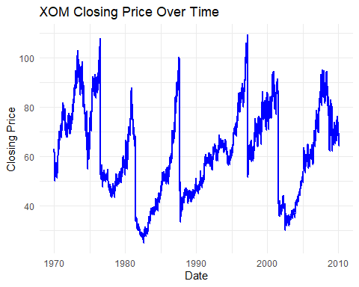
This graph shows the movement of XOM’s closing price over time.

12. Visualization 2 - XKK Closing Price Over Time
xkk_data <- my_stocks %>%
filter(stock_symbol == "XKK")
ggplot(
xkk_data,
aes(
x = date,
y = stock_price_close
)
) +
geom_line(
color = "red",
linewidth = 1
) +
labs(
title = "XKK Closing Price Over Time",
x = "Date",
y = "Closing Price"
) +
theme_minimal()
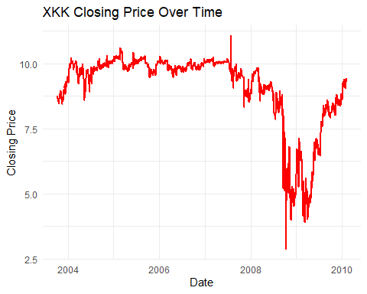
This graph shows the movement of XKK’s closing price over time.

13. Visualization 3 - XOM Open vs Closing Price
ggplot(
xom_data,
aes(x = date)
) +
geom_line(
aes(
y = stock_price_open,
color = "Opening Price"
),
linewidth = 0.8
) +
geom_line(
aes(
y = stock_price_close,
color = "Closing Price"
),
linewidth = 0.8
) +
labs(
title = "XOM Opening Price vs Closing Price",
x = "Date",
y = "Price",
color = "Price Type"
) +
theme_minimal()
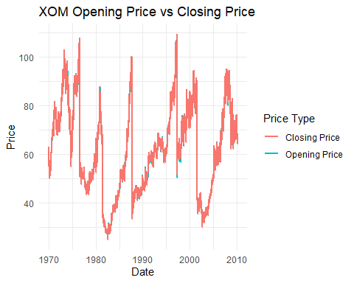
This graph compares XOM’s opening price and closing price for each trading day.

14. Visualization 4 - XOM High vs Low Price
ggplot(
xom_data,
aes(x = date)
) +
geom_line(
aes(
y = stock_price_high,
color = "High Price"
),
linewidth = 0.8
) +
geom_line(
aes(
y = stock_price_low,
color = "Low Price"
),
linewidth = 0.8
) +
labs(
title = "XOM High Price vs Low Price",
x = "Date",
y = "Price",
color = "Price Type"
) +
theme_minimal()
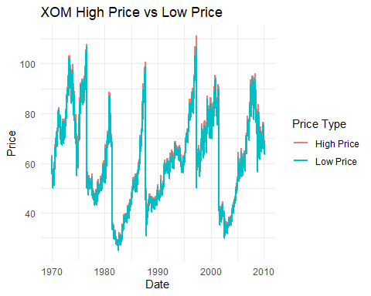
This graph compares the highest and lowest prices recorded for XOM during each trading day.

15. Visualization 5 - XOM Trading Volume
ggplot(
xom_data,
aes(
x = date,
y = stock_volume
)
) +
geom_line(
color = "darkgreen",
linewidth = 0.8
) +
labs(
title = "XOM Trading Volume Over Time",
x = "Date",
y = "Trading Volume"
) +
theme_minimal()
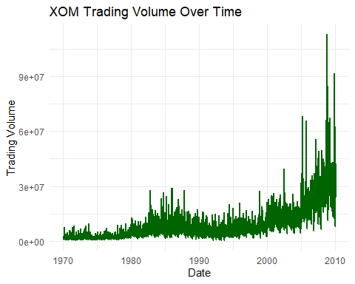
This graph shows the number of shares traded for XOM over time.

16. Average Closing Price of Stocks
average_close <- my_stocks %>%
group_by(stock_symbol) %>%
summarise(
average_closing_price =
mean(stock_price_close, na.rm = TRUE)
) %>%
arrange(desc(average_closing_price))
head(average_close, 10)
## # A tibble: 10 × 2
## stock_symbol average_closing_price
## <chr> <dbl>
## 1 XOM 62.1
## 2 XL 56.5
## 3 XRX 48.6
## 4 XEC 36.7
## 5 XEL 31.5
## 6 XTO 27.0
## 7 XFL 25.6
## 8 XCJ 25.1
## 9 XFB 24.6
## 10 XFJ 24.3
This calculates the average closing price for each stock in the dataset.

17. Visualization 6 - Top 10 Stocks by Average Closing Price
top_10_stocks <- average_close %>%
slice_head(n = 10)
ggplot(
top_10_stocks,
aes(
x = reorder(
stock_symbol,
average_closing_price
),
y = average_closing_price
)
) +
geom_col() +
coord_flip() +
labs(
title = "Top 10 Stocks by Average Closing Price",
x = "Stock Symbol",
y = "Average Closing Price"
) +
theme_minimal()
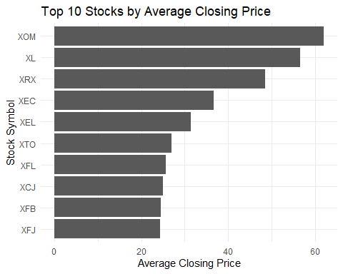
This bar chart compares the average closing prices of the top 10 stocks.

18. Final Results
cat("=====================================\n")
## =====================================
cat(" STOCK MARKET ANALYSIS\n")
## STOCK MARKET ANALYSIS
cat("=====================================\n\n")
## =====================================
cat(
"Number of different stocks:",
num_stocks$n_stocks,
"\n\n"
)
## Number of different stocks: 25
cat("Highest Single-Day Gain:\n")
## Highest Single-Day Gain:
print(highest_gain)
## # A tibble: 1 × 3
## stock_symbol date daily_change
## <chr> <date> <dbl>
## 1 XTO 1997-08-22 48.3
cat("\nHighest Single-Day Loss:\n")
##
## Highest Single-Day Loss:
print(highest_loss)
## # A tibble: 1 × 3
## stock_symbol date daily_change
## <chr> <date> <dbl>
## 1 XRX 1996-06-07 -108.

19. Conclusion
The stock market dataset was successfully imported and analyzed using R.
The analysis included data preparation, identification of different stocks, calculation of daily price changes, identification of the highest single-day gain and loss, and visualization of stock price and trading volume.
The visualizations provide a clear understanding of stock price movements, opening and closing prices, high and low prices, trading volume, and average closing prices.

