

A Project Report

*On*

**Employee Payroll Management System**

*By*

**VEDANT MAHANGADE (307123)  
ATHARVA KULKARNI (307124)  
SIDDHANT LODHA (307122)***Under the guidance of***Prof K.B. Sadafale**

**Department of Information Technology**

**Sinhgad College of Engineering**

**SAVITRIBAI PHULE PUNE UNIVERSITY**

**2019-2020**

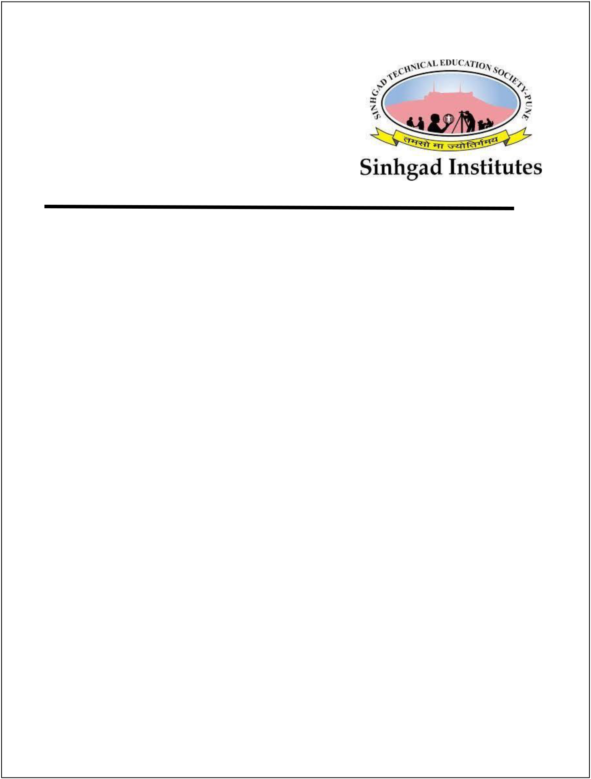

Sinhgad Technical Education Society,

Department of Information Technology Sinhgad College of Engineering, Pune-41

Date:

**CERTIFICATE**

This is to certify that,

**VEDANT MAHANGADE (307123)  
ATHARVA KULKARNI (307124)  
SIDDHANT LODHA (307122)**of class T.E. IT have successfully completed their project work on “**Employee Payroll Management System**’’ at SINHGAD COLLEGE OF ENGINEERING in the partial fulfilment of the Graduate Degree course in T.E at the Department of Information Technology, in the academic Year 2019-2020. Semester –I as prescribed by the Savitribai Phule Pune University.

Prof K.B. Sadafale

Guide

**Prof. G.R. Pathak**

Head of the Department

(Department of Information Technology)

(Department of Information Technology)



**Acknowledgement**

I feel great pleasure in expressing my deepest sense of gratitude and sincere thanks to my guide **Prof. K.B Sadafale** for his valuable guidance during the project work, without which it wouldhave been very difficult task. I have no words to express my sincere thanks for valuable guidance, extreme assistance and cooperation extended to all the **staff members** of my department.

This acknowledgement would be incomplete without expressing my special thanks to **Prof. G.R.**

**Pathak,** Head of the Department (Information Technology) for their support during the work.

I would also like to extend my heartfelt gratitude to my **Principal, Dr. S. D. Lokhande** who provided a lot of valuable support, mostly being behind the veils of college bureaucracy.

I would like to thank all the teaching, non-teaching staff members of my department, my parents, my mentors and my fellow students who helped me directly or indirectly for the completion of this Project successfully.

**VEDANT MAHANGADE (307123)  
ATHARVA KULKARNI (307124)  
SIDDHANT LODHA (307122)**



**Contents**

1. **TITLE OF THE PROJECT**
2. **ABSTRACT**
3. **INTRODUCTION**

* Problem definition

1. **SCOPE**
2. **SPECIFIC REQUIRMENTS**

* Hardware Interface
* Software Interface

1. **THEORY OF SOFTWERE USED**

* Java (JDK)
* MYSQL
* NetBeans IDE

1. **DATABASE FORMAT**
2. **ER DIAGRAM**
3. **OUTPUT SCREEN (GUI)**
4. **SAMPLE CODE**
5. **CONCLUSION**
6. **REFERENCES**



* + - 1. **TITLE OF PROJECT**

**Employee Payroll Management System**

**2.ABSTRACT**

**Database Management Systems** are the heart of many high functioning efficient organisations and systems. It is thus necessary to apply the databases to solve inefficient methodologies used in day to day life.

We tried to apply the Database Managed System’s approach to develop a core compliance software.

The project **Employee Payroll Management System** is developed with the intent of trying to simplify the process of management of the company’s employee’s financial records. This would include details of the employee’s salaries, incentives, bonuses, deductions, and net pay.

Software is developed for firms and companies to manage finance and business in market and to manage employee’s expenditure properly and systematically.



**3.INTRODUCTION**

**Project Definition:**

This project is aimed at developing a user friendly, aesthetic “Employee Payroll Management System”. A payroll system is software designed to organize all the task of employee payment and the filing of employee deductions and allowances. These tasks include calculating wages, setting rates, withholding deductions, generating reports and delivering payment to the employees.

**Need for the System:**

For a new firm or a new start-up, one might have to do many hats in the initial stages, one of them is managing payroll. Now instead of doing this manually and increasing the probability of introducing manual errors, this software can be established to handle the company’s finances. From small businesses to mid-sized company to up to 100 employees may benefit greatly by using the Payroll Management System.

**Purpose:**

Payroll Management System gives you ability to:

* Manage **Employee Information** Efficiently.
* Define the **emoluments, deductions** etc.
* **Generate Salary Payslip** at the convenience of a mouse click.
* Generate and Manage the **Payroll Processes** according to the **Salary Structure** assigned to the employee.
* Generate all **reports** related to **employee, deductions audit, allowances**.

**4.SCOPE**

The scope of this project extends to:

* Gross pay calculation.
* Calculation of allowances and deductions.
* Recording and processing of all activities.
* Generation of slips and other outputs in pdf format.
* Processing and storage of employee information and track login activities.
* Different level of accessibility of information for administration and employee.

Two divisions of users are maintained according to the access of information and features. The employer here is referred as an admin and has access to all the features of the software.

The admin can add another admin, can add an employee update or delete an employee’s profile, make deductions, provide allowances and pay salary, can generate reports on employee, the deductions made, and allowances given. He or she can view the past logins and manage audit trails but cannot change an employee’s login credentials.

An employee can view his or her own profile only, can generate their own allowance, deduction and salary report. An employee can also change his or her own password for login and view his or her past payments and login history.

**5.REQUIREMENTS**

Paragraphs below identify the minimum hardware requirements for the software to run successfully without any hinderance in the performance based on speed, and software requirements for running and implementing the database.

Hardware requirements stated below are estimation. Actual requirements may differ.

**Hardware Requirements:**

* PC running windows 10
* Intel Core i7
* 3.4GHz
* Minimum RAM 8GB
* Minimum Hard disk space 750 MB + extra for storage of database

**Software Requirements:**

* NetBeans IDE 8.2 or above
* MySQL 8.0 or above
* Java Development Kit 1.8 or above
* Java to MySQL connection driver



**6.THEORY OF SOFTWARE USED**

**Java**

Java is a programming language originally developed by James Gosling at Sun Microsystems (which is

now a subsidiary of Oracle Corporation) and released in 1995 as a core component of Sun Microsystems

Java platform. The language derives much of its syntax from C and C++ but has a simpler object model

and fewer low-level facilities. Java applications are typically compiled to byte code (class file) that can run

on any Java Virtual Machine (JVM) regardless of computer architecture. Java is a general-purpose,

concurrent, class-based, object-oriented language that is specifically designed to have as few

implementation dependencies as possible. It is intended to let application developers "write once, run any-

where". The java is independent to platform so it’s important. Java is currently one of the most popular

programming languages in use, and is widely used from application software to web

applications.

James Gosling, Mike Sheridan, and Patrick Naught on initiated the Java language project in June 1991.

Java was originally designed for interactive television, but it was too advanced for the digital cable

television industry at the time. The language was initially called Oak after an oak tree that stood outside

Gosling's office; it went by the name Green later, and was later renamed Java, from a list of random

words. Gosling aimed to implement a virtual machine and a language that had a familiar C/C++

of notation.

Java is an object-oriented programming language developed by Sun Microsystems in 1990s. Since then, Java has gained enormous popularity as a computer language. Java was chosen as the programming language for network computers. It is a universal front end for enterprise database. Sun Microsystems states that, “Java is a simple, object-oriented, distributed, secure, architecture, robust, multi-threaded and dynamic language. The program can be written once and run anywhere”. One of the most significant advantages of Java is that, it has the ability

to move easily from one computer to another. It also has the ability to run the same program on

many different operating systems. With such exemplary benefits, Java is a hot favourite among

techies and software professional it allows you to create modular programs and reusable codes.

**Java Features**

**1]** **Simple, Small and familiar:**

Java is a simple and small language. The Syntax of java is just like C++, so it is very easy to learn. It is simple because it i) does not use header files ii) eliminated the use of pointer iii) operator overloading and virtual base classes are eliminated.

**2] Object oriented:**

Java is a pure Object oriented. Everything in java is object. All programs and data reside inside objects and classes

**3] Distributed:**

Java has networking facilities. so java can create application on network.

**4] Robust:**

java gives importance to memory management by using the technique called Garbage Collection and Exception handling.

**5] Secure:**

since java is used on internet, security is an important issue. A security code is asked before a java code is interpreted on internet.

**6] Platform independent:**

Java compiler generates a platform independent code called byte code.

**7] Portable:**

The Byte code generated by java can be used on any machine. So, it can be portable.

**8] Compiled and Interpreted:**

Generally, computer languages are either complied or interpreted. But java combines both compiler and interpreted.



**9]** **High performance:**

The use of byte code makes the performance high. the speed is also high with comparing c, c++.

**10] Multithreading and interactive:**

Multithreading means handling more than one job at a time. Java supports Multithreading.

**11] Dynamic and extensible:**

Java is a dynamic language. So it can link dynamic new classes, methods and objects. Java supports functions written in C and C++ also. These functions are called native methods. During Run-Time Native methods can be linked dynamically.

**MySQL**

MySQL is free and open-source software under the terms of the GNU General Public License and is also available under a variety of proprietary licenses. MySQL was owned and sponsored by the Swedish company MySQL AB, which was bought by Sun Microsystems (now Oracle Corporation). In 2010, when Oracle acquired Sun, Widenius forked the open-source MySQL project to create MariaDB.

MySQL is used by many database-driven web applications, including Drupal, Joomla, phpBB, and WordPress. MySQL is also used by many popular websites, including Facebook, Flickr, MediaWiki, Twitter, and YouTube.

**MySQL features**

* A broad subset of ANSI SQL 99, as well as extensions
* Cross-platform support
* Stored procedures, using a procedural language that closely adheres to SQL/PSM
* Triggers
* Cursors
* Updatable views
* Online Data Definition Language (DDL) when using the InnoDB Storage Engine.
* Information schema
* Performance Schema that collects and aggregates statistics about server execution and query performance for monitoring purposes.
* A set of SQL Mode options to control runtime behavior, including a strict mode to better adhere to SQL standards.
* X/Open XA distributed transaction processing (DTP) support; two phase commits as part of this, using the default InnoDB storage engine
* Transactions with save points when using the default InnoDB Storage Engine. The NDB Cluster Storage Engine also supports transactions.
* ACID compliance when using InnoDB and NDB Cluster Storage Engines.
* SSL support.
* Query caching.
* Sub-SELECTs (i.e. nested SELECTs)
* Built-in replication support.
* Asynchronous replication: master-slave from one master to many slaves or many masters to one slave.
* Semi synchronous replication: Master to slave replication where the master waits on replication.
* Synchronous replication: Multi-master replication is provided in MySQL Cluster.
* Virtual Synchronous: Self-managed groups of MySQL servers with multi master support can be done using: Galera Cluster [84] or the built in Group Replication plugin.
* Full-text indexing and searching.
* Embedded database library.
* Unicode support.
* Partitioned tables with pruning of partitions in optimizer.
* Shared-nothing clustering through MySQL Cluster.
* Multiple storage engines, allowing one to choose the one that is most effective for each table in the application.
* Native storage engines InnoDB, MyISAM, Merge, Memory (heap), Federated, Archive, CSV, Blackhole, NDB Cluster.
* Commit grouping, gathering multiple transactions from multiple connections together to increase the number of commits per second.

**NetBeans IDE**

NetBeans IDE is an open-source integrated development environment. NetBeans IDE supports development of all Java application types (Java SE (including JavaFX), Java ME, web, EJB and mobile applications) out of the box. Among other features are an Ant-based project system, Maven support, refactoring, version control (supporting CVS, Subversion, Git, Mercurial and Clear case).

Modularity: All the functions of the IDE are provided by modules. Each module provides a well-defined function, such as support for the Java language, editing, or support for the CVS versioning system, and SVN. NetBeans contains all the modules needed for Java development in a single download, allowing the user to start working immediately. Modules also allow NetBeans to be extended. New features, such as support for other programming languages, can be added by installing additional modules. For instance, Sun Studio, Sun Java Studio Enterprise, and Sun Java Studio Creator from Sun Microsystems are all based on the NetBeans IDE.

License: The IDE is licensed under the Apache License 2.0. Previously, from July 2006 through 2007, NetBeans IDE was licensed under Sun's Common Development and Distribution License (CDDL), a license based on the Mozilla Public License (MPL). In October 2007, Sun announced that NetBeans would henceforth be offered under a dual license of the CDDL and the GPL version 2 licenses, with the GPL linking exception for GNU Class path. Oracle has donated NetBeans Platform and IDE to the Apache Foundation where it underwent incubation and graduated as a top-level project in April 2019.





**7.Database Format**

Tables in database:

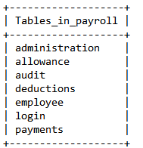

Table Administration:

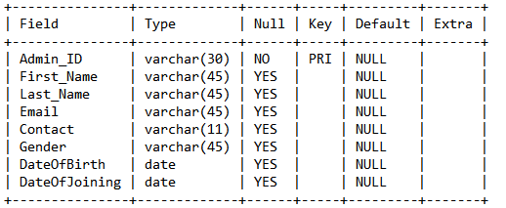

Table Allowance:

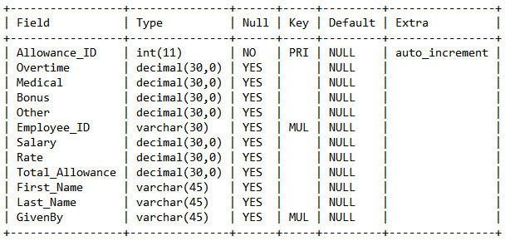

Table Audit:

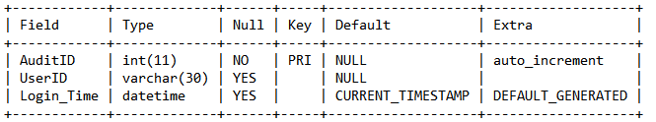

Table Deductions:

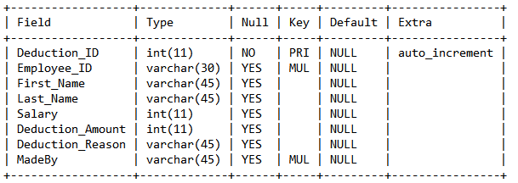

Table Employee:

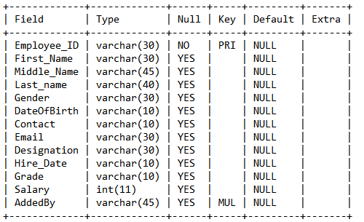

Table Login:

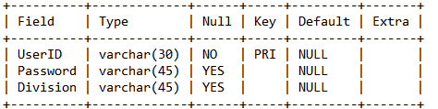

Table Payments:

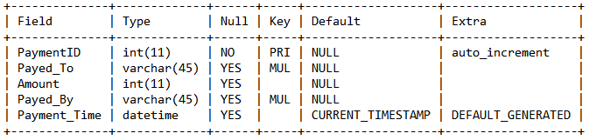



**8. E.R. DIAGRAM**

**Entity Relation Diagram:**

**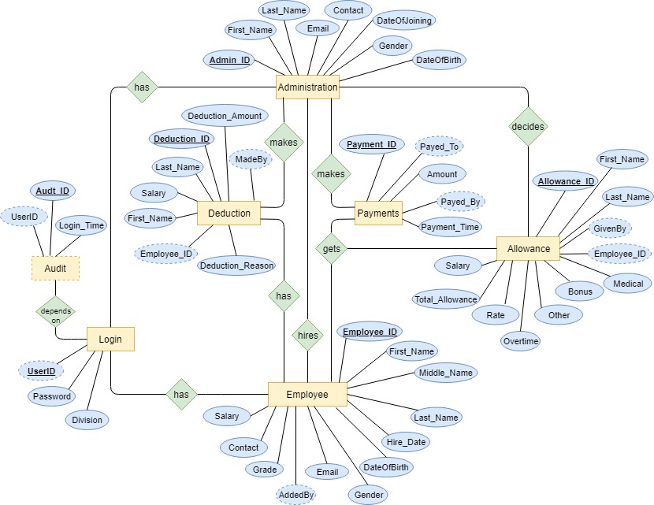****9. OUTPUT SCREEN(G.U.I.)**

Login:

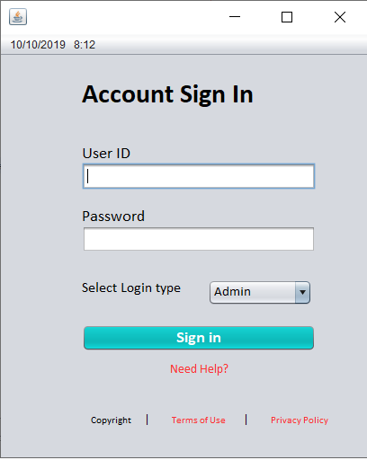

Admin Page:

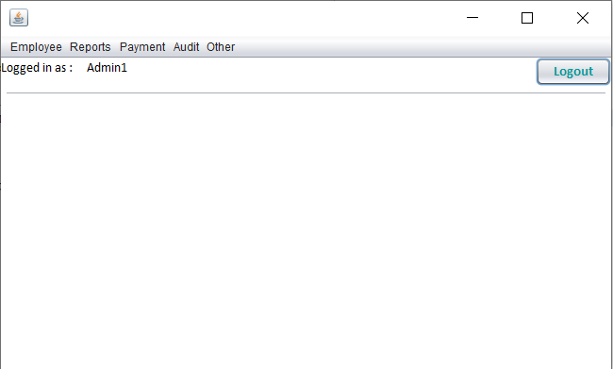

View/Add/Update /Delete Employee: 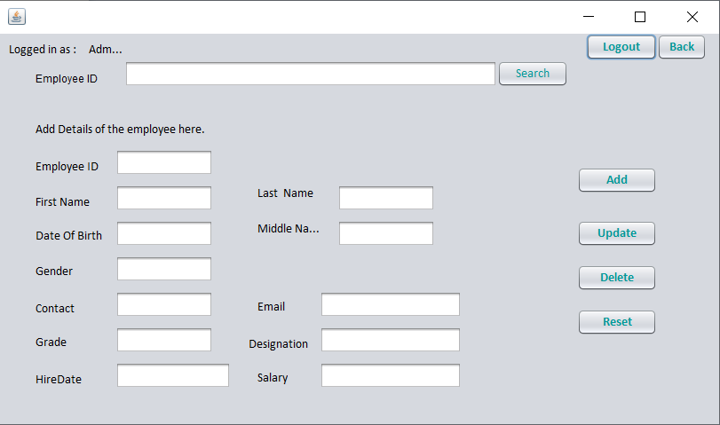

Update Allowance:

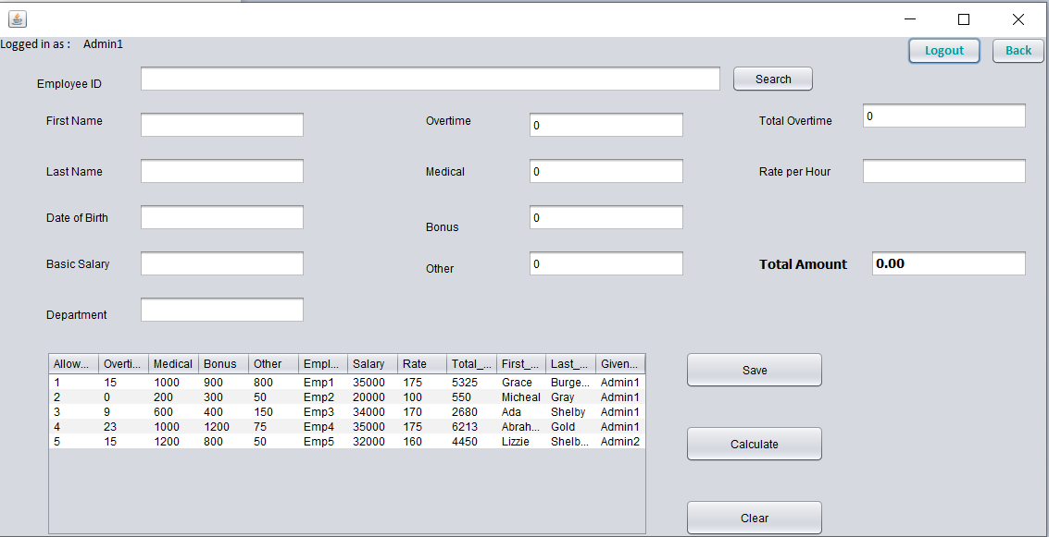

Update Deductions:

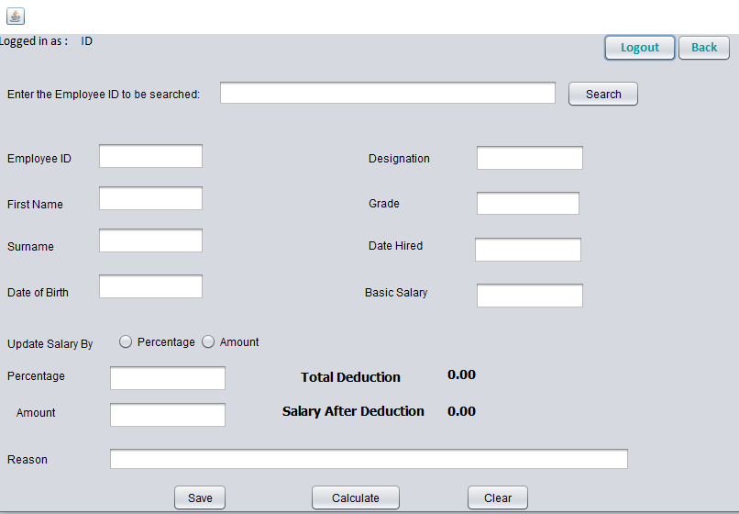

Generate Payslip:

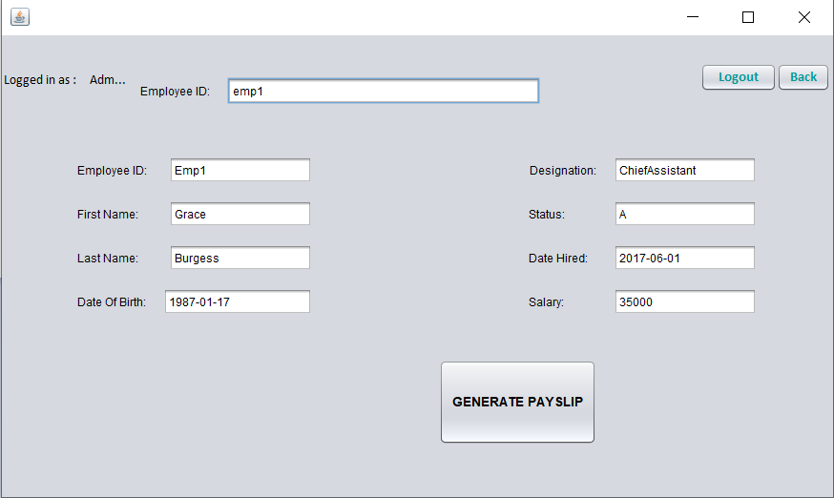



Past Payments:

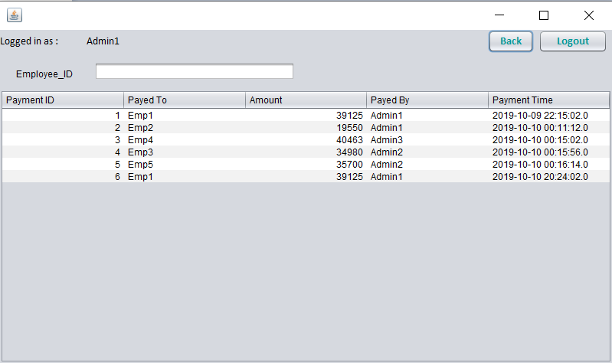

Employee Page:

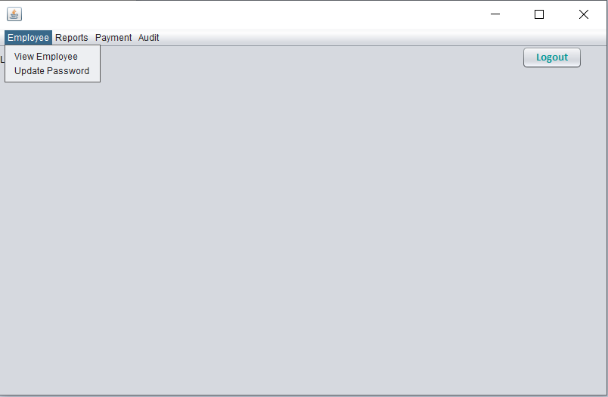



Audit Trail:

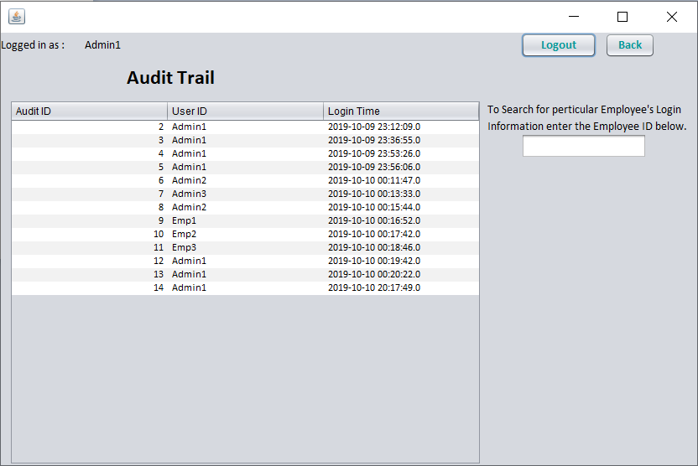

Pay Slip Generated: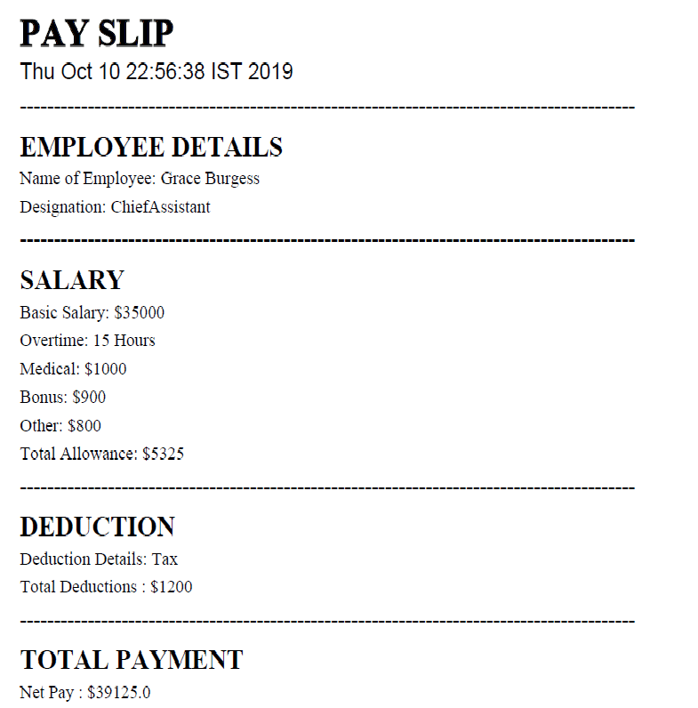

**10. SAMPLE CODE**

The following is the code for the login form of the Employee Payroll Management System.

/*PAYROLL MANAGEMENT SYSTEM LOGIN FORM*/

/*

*@author Vedant

*@author Atharva

*@author Siddhant

*/

package Payroll;

import java.awt.Dimension;

import java.awt.Toolkit;

import java.sql.Connection;

import java.sql.PreparedStatement;

import java.sql.ResultSet;

import java.sql.SQLException;

import javax.swing.JOptionPane;

import java.util.Calendar;

import java.util.GregorianCalendar;

public class LogIn extends javax.swing.JFrame {

Connection con= null;

PreparedStatement insert = null;

ResultSet rs=null;

public LogIn() {

initComponents();

Toolkit toolkit = getToolkit();

Dimension size = toolkit.getScreenSize();

setLocation(size.width/2 - getWidth()/2,size.height/2 - getHeight()/2);

con = con_class.java_con();

currentDateTime();

}

private void initComponents() {

jLabel5 = new javax.swing.JLabel();

jLabel7 = new javax.swing.JLabel();

txt_ID = new javax.swing.JTextField();

jLabel6 = new javax.swing.JLabel();

txt_pass = new javax.swing.JPasswordField();

jLabel1 = new javax.swing.JLabel();

 txt_div = new javax.swing.JComboBox<>();

SignIn = new javax.swing.JButton();

NH = new javax.swing.JButton();

jLabel15 = new javax.swing.JLabel();

jLabel16 = new javax.swing.JLabel();

jLabel9 = new javax.swing.JLabel();

jLabel10 = new javax.swing.JLabel();

jLabel8 = new javax.swing.JLabel();

jLabel2 = new javax.swing.JLabel();

jMenuBar1 = new javax.swing.JMenuBar();

lbl_date = new javax.swing.JMenu();

lbl_time = new javax.swing.JMenu();

setDefaultCloseOperation(javax.swing.WindowConstants.DISPOSE_ON_CLOSE);

setBackground(new java.awt.Color(255, 255, 255));

getContentPane().setLayout(new org.netbeans.lib.awtextra.AbsoluteLayout());

jLabel5.setBackground(new java.awt.Color(255, 255, 255));

jLabel5.setFont(new java.awt.Font("Calibri", 1, 30)); // NOI18N

jLabel5.setText("Account Sign In");

getContentPane().add(jLabel5, new org.netbeans.lib.awtextra.AbsoluteConstraints(90, 20, 200, 50));

jLabel7.setFont(new java.awt.Font("Calibri", 0, 18)); // NOI18N

jLabel7.setText("User ID");

getContentPane().add(jLabel7, new org.netbeans.lib.awtextra.AbsoluteConstraints(90, 100, 60, 20));

txt_ID.setBackground(javax.swing.UIManager.getDefaults().getColor("TextField.disabledBackground"));

txt_ID.setSelectionColor(new java.awt.Color(0, 153, 153));

getContentPane().add(txt_ID, new org.netbeans.lib.awtextra.AbsoluteConstraints(90, 120, 260, 30));

jLabel6.setFont(new java.awt.Font("Calibri", 0, 18)); // NOI18N

jLabel6.setText("Password");

getContentPane().add(jLabel6, new org.netbeans.lib.awtextra.AbsoluteConstraints(90, 170, 80, 20));

txt_pass.setBackground(javax.swing.UIManager.getDefaults().getColor("PasswordField.disabledBackground"));

 txt_pass.addActionListener(new java.awt.event.ActionListener() {

public void actionPerformed(java.awt.event.ActionEvent evt) {

txt_passActionPerformed(evt);

}

});

getContentPane().add(txt_pass, new org.netbeans.lib.awtextra.AbsoluteConstraints(90, 190, 260, 30));

jLabel1.setFont(new java.awt.Font("Calibri", 0, 16)); // NOI18N

jLabel1.setText("Select Login type");

getContentPane().add(jLabel1, new org.netbeans.lib.awtextra.AbsoluteConstraints(90, 250, -1, -1));

txt_div.setBackground(javax.swing.UIManager.getDefaults().getColor("ComboBox.disabledBackground"));

txt_div.setFont(new java.awt.Font("Calibri", 0, 15)); // NOI18N

txt_div.setModel(new javax.swing.DefaultComboBoxModel<>(new String[] { "Admin", "Employee" }));

getContentPane().add(txt_div, new org.netbeans.lib.awtextra.AbsoluteConstraints(230, 250, 116, -1));

SignIn.setBackground(new java.awt.Color(0, 153, 153));

SignIn.setFont(new java.awt.Font("Calibri", 1, 18)); // NOI18N

SignIn.setForeground(new java.awt.Color(255, 255, 255));

SignIn.setText("Sign in");

SignIn.setBorder(new javax.swing.border.LineBorder(new java.awt.Color(0, 0, 0), 0, true));

SignIn.setBorderPainted(false);

SignIn.addActionListener(new java.awt.event.ActionListener() {

public void actionPerformed(java.awt.event.ActionEvent evt) {

SignInActionPerformed(evt);

}

});

getContentPane().add(SignIn, new org.netbeans.lib.awtextra.AbsoluteConstraints(90, 300, 260, 30));

NH.setBackground(new java.awt.Color(255, 255, 255));

NH.setFont(new java.awt.Font("Calibri", 0, 14)); // NOI18N

NH.setForeground(new java.awt.Color(255, 51, 51));

NH.setText("Need Help?");

NH.setBorder(null);

NH.setBorderPainted(false);

 NH.setContentAreaFilled(false);

NH.addActionListener(new java.awt.event.ActionListener() {

public void actionPerformed(java.awt.event.ActionEvent evt) {

NHActionPerformed(evt);

}

});

getContentPane().add(NH, new org.netbeans.lib.awtextra.AbsoluteConstraints(180, 340, 80, 20));

jLabel15.setFont(new java.awt.Font("Calibri", 0, 11)); // NOI18N

jLabel15.setText("Copyright ");

getContentPane().add(jLabel15, new org.netbeans.lib.awtextra.AbsoluteConstraints(100, 400, 50, -1));

jLabel16.setFont(new java.awt.Font("Calibri", 0, 11)); // NOI18N

jLabel16.setForeground(new java.awt.Color(255, 51, 51));

jLabel16.setText("Terms of Use");

getContentPane().add(jLabel16, new org.netbeans.lib.awtextra.AbsoluteConstraints(190, 400, -1, -1));

jLabel9.setFont(new java.awt.Font("Calibri", 0, 11)); // NOI18N

jLabel9.setForeground(new java.awt.Color(255, 51, 51));

jLabel9.setText("Privacy Policy");

getContentPane().add(jLabel9, new org.netbeans.lib.awtextra.AbsoluteConstraints(300, 400, 70, -1));

jLabel10.setFont(new java.awt.Font("Tahoma", 0, 12)); // NOI18N

jLabel10.setText("|");

getContentPane().add(jLabel10, new org.netbeans.lib.awtextra.AbsoluteConstraints(270, 390, 10, 30));

jLabel8.setFont(new java.awt.Font("Tahoma", 0, 12)); // NOI18N

jLabel8.setText("|");

getContentPane().add(jLabel8, new org.netbeans.lib.awtextra.AbsoluteConstraints(160, 390, 10, 30));

jLabel2.setBackground(new java.awt.Color(255, 255, 255));

jLabel2.setIcon(new javax.swing.ImageIcon("C:\\Users\\Vedant\\Desktop\\MiniProject\\whit.png")); // NOI18N

getContentPane().add(jLabel2, new org.netbeans.lib.awtextra.AbsoluteConstraints(0, 0, 410, 460));

lbl_date.setText("Date");

 jMenuBar1.add(lbl_date);

lbl_time.setText("Time");

jMenuBar1.add(lbl_time);

setJMenuBar(jMenuBar1);

setSize(new java.awt.Dimension(425, 518));

setLocationRelativeTo(null);

}

public void currentDateTime(){

Calendar cal = new GregorianCalendar();

int month = cal.get(Calendar.MONTH);

int year = cal.get(Calendar.YEAR);

int day = cal.get(Calendar.DAY_OF_MONTH);

lbl_date.setText(day+"/"+(month+1)+"/"+year);

int minute = cal.get(Calendar.MINUTE);

int hour = cal.get(Calendar.HOUR);

lbl_time.setText(hour+":"+minute);

}

public void success() throws SQLException {

String user= txt_ID.getText();

insert = con.prepareStatement("insert into Audit(UserID) values(?)");

insert.setString(1, user);

insert.executeUpdate();

JOptionPane.showMessageDialog(this, "Successfully loged in");

}

public void invalid(){

JOptionPane.showMessageDialog(this, "Invalid Credentials");

txt_ID.setText("");

txt_pass.setText("");

txt_ID.requestFocus();

}

private void SignInActionPerformed(java.awt.event.ActionEvent evt) {

String sql = "select UserID, Password, Division from login where (UserID = ? and Password= ? and Division = ?)";

try{

 int count=0;

insert = con.prepareStatement(sql);

insert.setString(1, txt_ID.getText());

insert.setString(2, txt_pass.getText());

insert.setString(3, txt_div.getSelectedItem().toString());

rs = insert.executeQuery();

while(rs.next()){

String id=txt_ID.getText();

Emp.empID=id;

count++;

}

String access = (txt_div.getSelectedItem().toString());

if(access.equals("Admin")){

if(count == 1){

success();

MenuAdmin ma = new MenuAdmin();

ma.setVisible(true);

this.dispose();

}

else

invalid();

}

if(access.equals("Employee")){

if(count == 1){

success();

MenuEmp me = new MenuEmp();

me.setVisible(true);

this.dispose();

}

else

invalid();

}

}

catch(SQLException e){

JOptionPane.showMessageDialog(null, e);

}

finally{

try{

rs.close();

insert.close();

}

catch(SQLException e){

 JOptionPane.showMessageDialog(null, e);

}

}

 }

public static void main(String args[]) {

try {

for (javax.swing.UIManager.LookAndFeelInfo info : javax.swing.UIManager.getInstalledLookAndFeels()) {

if ("Nimbus".equals(info.getName())) {

javax.swing.UIManager.setLookAndFeel(info.getClassName());

break;

}

}

} catch (ClassNotFoundException | InstantiationException | IllegalAccessException | javax.swing.UnsupportedLookAndFeelException ex) {

java.util.logging.Logger.getLogger(LogIn.class.getName()).log(java.util.logging.Level.SEVERE, null, ex);

}

java.awt.EventQueue.invokeLater(() -> {

new LogIn().setVisible(true);

});

}

private javax.swing.JButton NH;

private javax.swing.JButton SignIn;

private javax.swing.JLabel jLabel1;

private javax.swing.JLabel jLabel10;

private javax.swing.JLabel jLabel15;

private javax.swing.JLabel jLabel16;

private javax.swing.JLabel jLabel2;

private javax.swing.JLabel jLabel5;

private javax.swing.JLabel jLabel6;

private javax.swing.JLabel jLabel7;

private javax.swing.JLabel jLabel8;

private javax.swing.JLabel jLabel9;

private javax.swing.JMenuBar jMenuBar1;

private javax.swing.JMenu lbl_date;

private javax.swing.JMenu lbl_time;

private javax.swing.JTextField txt_ID;

private javax.swing.JComboBox<String> txt_div;

private javax.swing.JPasswordField txt_pass;

}//END OF CODE

**11.CONCLUSION**

In today’s ever expanding and demanding world there is always a need as well as scope to enhance the capability of individual with the help of technology. In today’s world, where computers are used extensively so as to speed up various processes, this project of ours tries to comfort problems faced in maintaining and executing a payroll system and its backend database. Using this software, users can manage and keep track of payments and company’s finances. This software will reduce the manual work that is instead of manually paying each employee after calculating each employee’s allowance, deductions and the net amount to be payed, you just need to enter the employee’s ID and the few required fields and the system will do the rest of work for you.

Due to this project, we were able to learn many functions in NetBeans, Java as well as MySQL which is used as backend for database. During the completion of this project we learnt the development process of a software, the phases of planning, information gathering, designing, building, testing and deployment. This project also gave us the experience of working in group and securing nice co-ordination among all of the partners.

**12.REFERENCES**

**Online References:**

1. dev.mysql.com
2. [www.mysqltutorial.org](http://www.mysqltutorial.org)
3. [www.javatpoint.com](http://www.javatpoint.com)
4. [www.stackoverflow.com](http://www.stackoverflow.com)
5. ntu.edu.sg

**Books Reference:**

1)Java 8 - The Complete Reference by Herb Schildt

2)Core Java – by Cay S. Horstmann